Supplementary Material
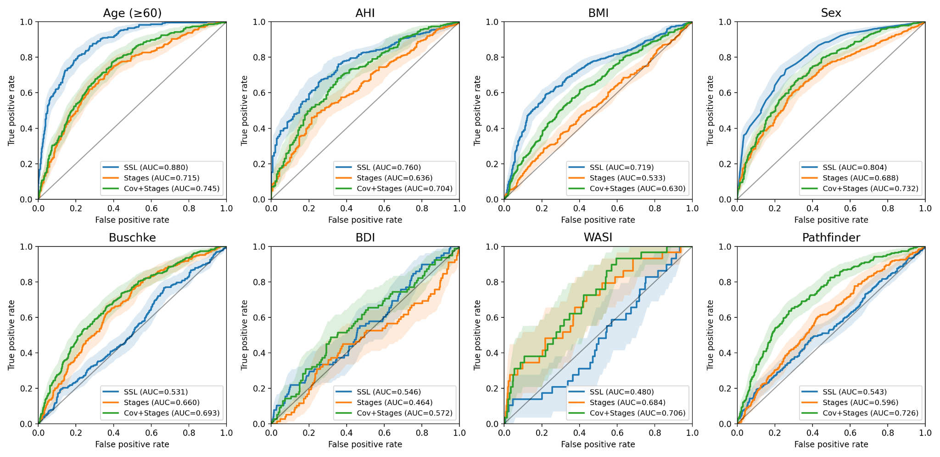
Supplementary Fig. S1 | EEG-derived screening scores provide incremental predictive value beyond demographic covariates and staging-derived sleep-report features. Receiver operating characteristic (ROC) curves for participant-level screening of Age ≥ 60, AHI ≥ 15, BMI ≥ 30, Sex (male), Buschke ≤ Q25, BDI ≥ 14, WASI ≤ 85, and Pathfinder ≤ Q25. Curves compare out-of-fold logistic models using the EEG-derived SSL outcome score (blue), staging-derived sleep-report features alone (orange), and covariates + staging-derived sleep-report features (green; stage proportions and standard sleep-architecture summaries including efficiency/latencies, transition metrics, and bout-duration statistics; see Methods). Shaded bands show 95% confidence intervals; insets report AUROC; the diagonal indicates chance performance.

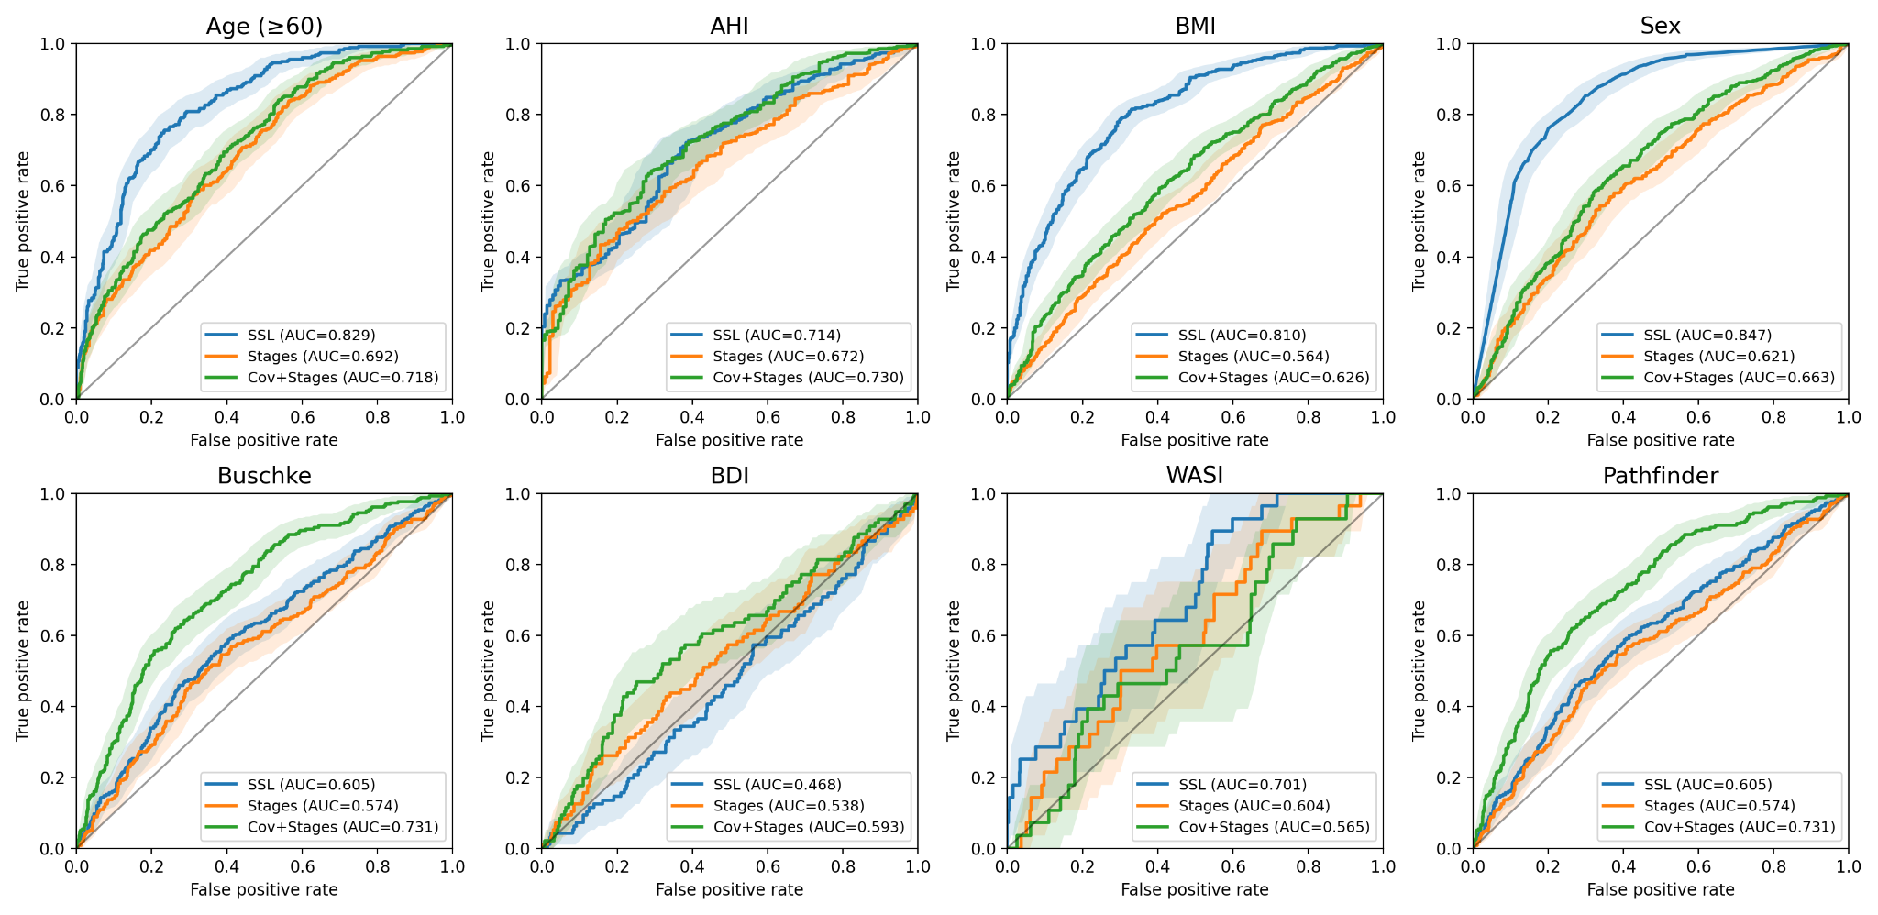
Supplementary Fig. S2 | PSG-derived screening scores retain incremental predictive value beyond demographic covariates and staging-derived sleep-report features. ROC curves for the same endpoints and modeling framework as Supplementary Fig. S1, but using SSL outcome scores derived from the multimodal PSG foundation model (PSG channels; see Methods). Curves compare the PSG-derived SSL score (blue) against staging-derived sleep-report features alone (orange) and covariates + staging-derived sleep-report features (green). Shaded bands show 95% confidence intervals and insets report AUROC.
Supplementary Table T1 | EEG-only screening analyses: functional outcomes.
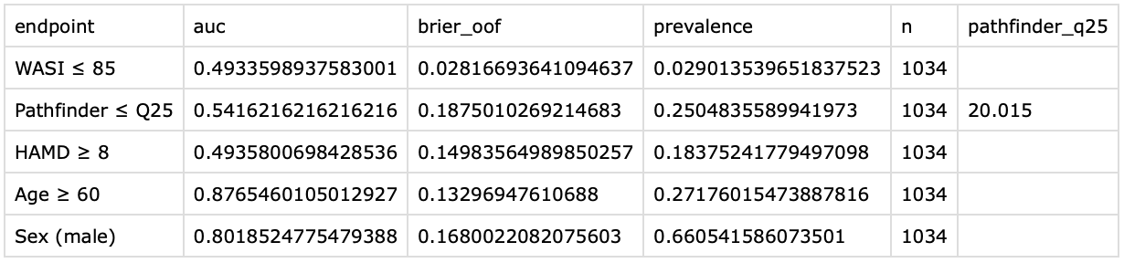

Supplementary Table T2 | PSG screening analyses: functional outcomes.
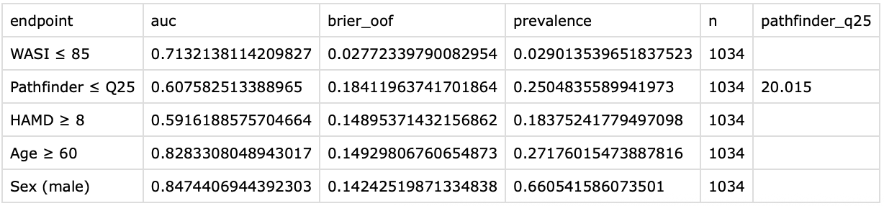

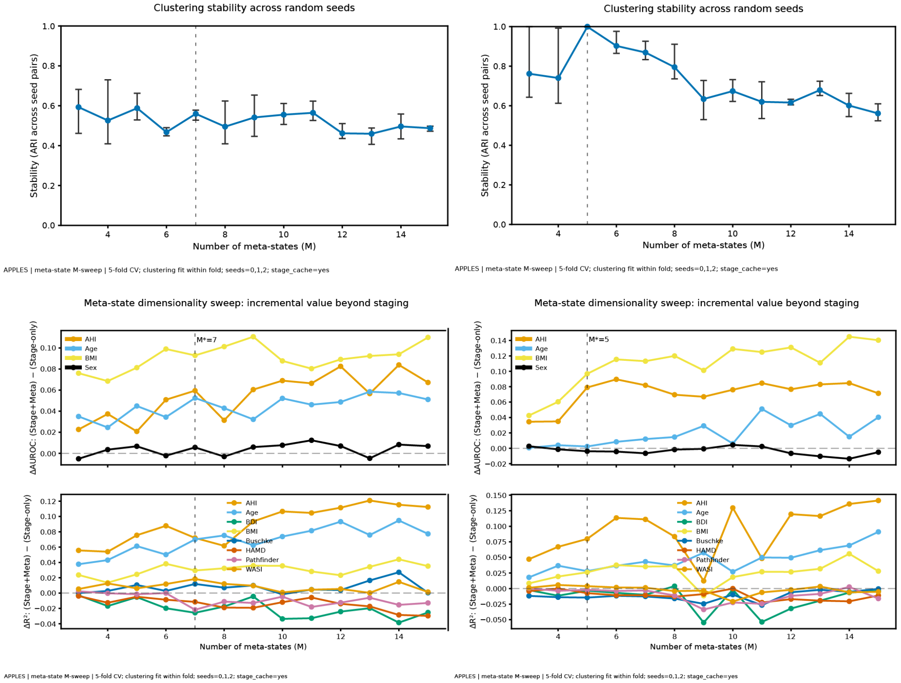
Supplementary Fig. S3 | Meta‑state dimensionality sweep and clustering stability (SSL vs. 5-stage embeddings).
Left column: Analysis applied to SSL-derived EEG-only embeddings. Right column: Same analysis applied to EEG-only embeddings from the five-stage supervised sleep stage classification model.
TOP: Clustering stability (top panels) is quantified as Adjusted Rand Index (ARI) computed between meta‑state labelings obtained from different random seeds at the same M; points show mean ARI and error bars indicate the min–max range across seed pairs. The dashed vertical line marks the recommended M*, selected by a predefined tradeoff rule combining predictive gain and stability: we first restrict to solutions with stability within 0.05 of the maximum observed mean ARI across the sweep; within this “stable” subset, we choose the smallest M whose AHI(binary) ΔAUROC is within 0.5 standard deviations of the best AHI(binary) ΔAUROC (fallback: use mean Δ across outcomes if AHI(binary) is unavailable). Using this rule, SSL-derived embeddings support a compact decomposition at M*=7 (mean ARI ≈0.56 at M=7). The validation analysis using embeddings from the five-stage supervised model arrived at the expected M*=5.
BOTTOM: For each candidate number of meta‑states M∈{3,…,15}, we fit an unsupervised meta‑state clustering model within each training fold of a 5‑fold cross‑validation procedure (repeated over three random seeds: 0,1,2). Using the resulting fold-specific meta‑state mapping, we computed participant‑level meta‑state features (meta‑state occupancies and entropy-style summaries) and evaluated the incremental predictive value beyond staging by comparing a stage‑only baseline to an augmented stage+meta model. The middle and bottom panels plot the fold‑averaged incremental value, ΔAUROC and ΔR2, defined as (Stage+Meta)−(Stage-only), across multiple clinical/demographic and functional endpoints.
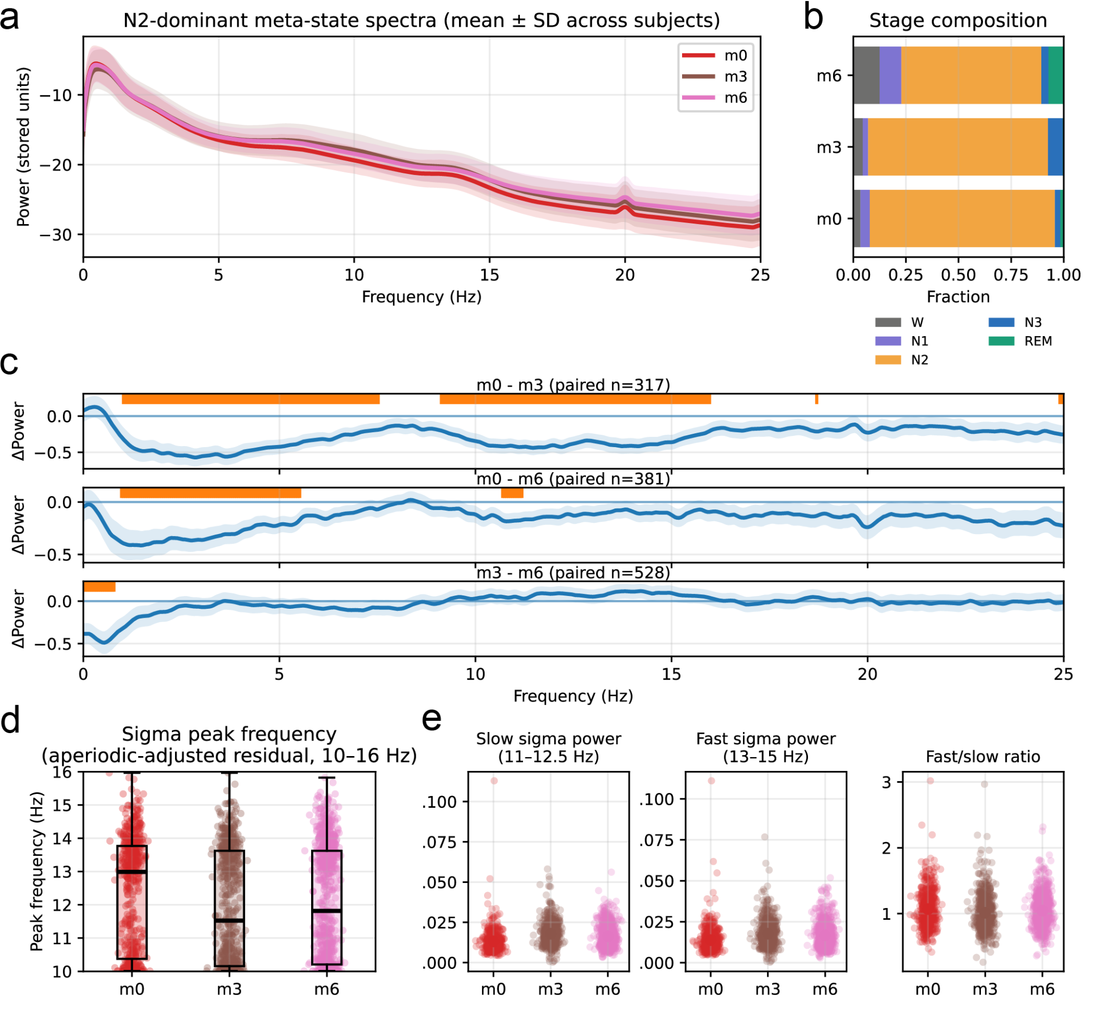
Supplementary Fig. S4 | Meta-state spectral signatures link N2 subdivision to interpretable sleep microphysiology. (a) Mean ± SD spectra for the three N2-dominant meta-states (m0, m3, m6), computed from subject-level meta-state spectra (each subject contributes at most one spectrum per meta-state). (b) Stage-composition bars for the three N2-dominant meta-states (m0, m3, and m6), demonstrating that m0 and m3 are relatively “N2-pure” whereas m6 exhibits greater Wake/N1/REM admixture. (c) Pairwise within-subject spectral differences (ΔPSD, dB) for m0–m3, m0–m6, and m3–m6; orange tick marks indicate frequency bins surviving FDR correction (α = 0.05) across bins. (d) Sigma peak frequency estimated from the aperiodic-adjusted residual spectrum (10–16 Hz; aperiodic component estimated by a log–log linear 1/f fit), showing overlapping peak-frequency distributions across N2-dominant meta-states. (e) Sigma-band summary metrics (slow sigma: 11–12.5 Hz; fast sigma: 13–15 Hz; and fast/slow ratio), shown as per-subject points with mean ± SEM. Together, these analyses indicate that the SSL-derived N2 subdivision corresponds to reproducible differences in sigma-band prominence and theta/alpha balance rather than reflecting a single homogeneous N2 physiology.
Supplementary Table T3 | Overview of polysomnography datasets and cohort demographics. Summary of the publicly available datasets utilized for model pretraining, internal validation, and downstream clinical evaluation (e.g., APPLES, HomePAP, Dreem, Sleep-EDF). For each dataset partition, the total number of PSG recordings, unique participants, and baseline demographic characteristics (such as age, sex distribution, and relevant clinical metrics) are provided. Total examples are the number of 50.5min input sequences derived from each corresponding dataset (note that Training data were augmented by 4x oversampling (12.5-epoch hop size; see Supplementary Methods).
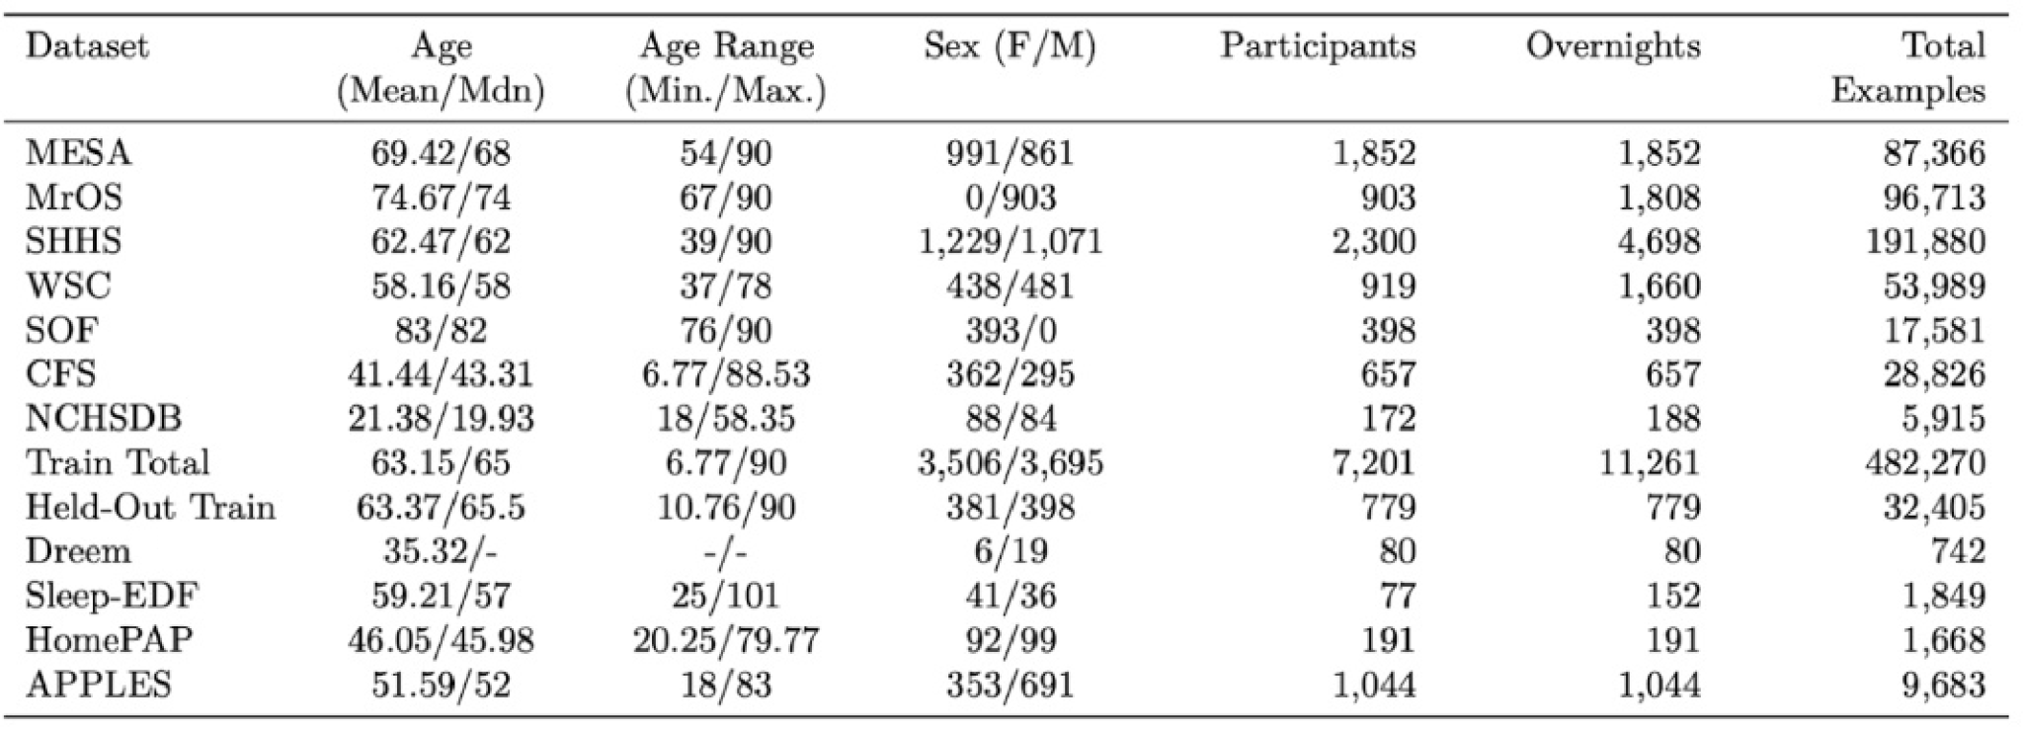

Supplementary Methods

S1. Detailed model architecture and training

S1.1 Self-supervised learning (SSL) objective and pseudo-label generation
We implemented a self-supervised learning (SSL) approach inspired by HuBERT in which a transformer is trained to predict sequences of discrete pseudo-labels derived from k-means clustering of the pretraining corpus (Fig. 1). For EEG-only models, each 101-epoch (50.5 min) segment was converted to a time–frequency power representation using 30-s time bins computed with YASA. To reduce the memory footprint of time–frequency decompositions (as in HuBERT), the k-means model was fit on a subset of the corpus: for each participant in the pretraining cohort, we selected one random 101-epoch segment and extracted spectral features from each 30 s epoch. Mini-batch k-means was then fit to these epoch-level spectral features to learn cluster centroids. The resulting cluster boundaries were applied to all epochs in the training and internal validation partitions to assign a pseudo-label to each epoch based on its spectral content.
For multimodal PSG models (EEG+EOG+EMG+ECG+respiration), pseudo-labels were derived analogously, except that time–frequency decompositions from all available input signals were concatenated along the frequency dimension before k-means fitting, yielding a joint spectral feature vector per epoch.

S1.2 Masked prediction training objective
During SSL training, contiguous portions of each input sequence were masked (set to zero) prior to transformer processing. Masking occurred in contiguous blocks of 10 epochs, with each epoch in the 101-epoch sequence having an 8% probability of initiating a masked block. The model was trained to predict the original k-means pseudo-labels for the masked segments by minimizing cross-entropy loss.

S1.3 Model architecture
All foundation and baseline models shared an identical backbone architecture. Inputs were processed by a convolutional front end comprising seven 1D convolutional layers (512 channels each), with strides [5, 2, 2, 2, 2, 2, 2] and kernel widths [21, 3, 3, 3, 3, 2, 2]. Each convolutional layer was followed by layer normalization and GELU activation. The convolutional output was linearly projected from 512 to 768 dimensions, passed through a GELU nonlinearity, and combined with positional encoding.
The transformer encoder consisted of 12 layers, each with 12 attention heads, a feed-forward dimension of 3,072, GELU activations, and 5% layer dropout. After transformer encoding, a 1D adaptive average pooling layer aligned the transformer output with the label sequence. Pooled outputs were projected to a 256-dimensional embedding (GELU activation), followed by a final output layer. Masking was applied immediately after the convolutional front end but before positional encoding and the transformer encoder. The complete model contained ~97.1 million trainable parameters (~404 MB).

S1.4 SSL optimization schedule
SSL pretraining proceeded for 40 epochs (complete passes through the pretraining corpus), using a batch size of 64 sequences. Optimization used Adam with a linear learning-rate schedule: the learning rate increased from 1e−5 to 5e−4 over the first 15 epochs and then decreased to 5e−9 over the remaining 25 epochs.

S1.5 Second-stage SSL pretraining (iterative label refinement)
A second stage of SSL pretraining was performed (as in HuBERT) to refine the learned units. Instead of spectral features, k-means pseudo-labels were derived from embeddings extracted from the final transformer layer of the first-stage model. This second stage used the transformer’s native temporal resolution (946 labels per 50.5 min sequence, up from 101 in the first stage; approximately 3 s resolution) and increased the pseudo-label granularity by fitting a 500-cluster k-means solution (vs 100 clusters in the first stage). The second-stage SSL model was initialized from the first-stage checkpoint, with an updated output layer corresponding to the new pseudo-label set.

S1.6 Fine-tuning and baseline models
To probe health-relevant information in learned representations, models were fine-tuned on APPLES outcomes. Fine-tuning consisted of 15 epochs of end-to-end training with a task-specific output head, using a learning-rate schedule with a linear ramp up over the first third of epochs and ramp down over the final two thirds (all weights updated; no layers frozen). Regression tasks used a single-unit output trained with mean squared error and evaluated via Pearson correlation. Classification tasks used a multi-class (or binary) output trained with cross-entropy and evaluated via accuracy.
Two matched baselines were used throughout:
- Five-stage supervised pretraining baseline: an identical transformer trained to predict conventional five-stage sleep labels using provided AASM annotations. In pretraining (before any downstream fine-tuning), this model achieved sleep-stage classification performance comparable to human expert raters (~82% accuracy^{7,8}), with benchmark accuracies of 86.9% (internal validation), 86.3% (Dreem-H), 84.2% (Dreem-O), 78.8% (HomePAP), 76.4% (APPLES), and 78.1% (Sleep-EDF).
- No-pretraining (from-scratch) baseline: an identical transformer initialized randomly and trained directly on each downstream task. To match the total training budget of pretrained models (40 pretraining + 15 fine-tuning epochs), from-scratch models were trained for 55 epochs using the same proportional learning-rate schedule.
To enable statistical comparisons between models, fine-tuning experiments used 10-fold participant-level cross-validation: in each fold, participants were split into 80% training, 10% validation, and 10% testing; the checkpoint with best validation performance was evaluated on the held-out test partition. This 10-fold CV for network training is distinct from the participant-level 5-fold CV used in downstream confound-control and meta-state analyses.

S2. Probability calibration and decision curve analysis

S2.1 Participant-level aggregation
Model outputs were generated for multiple fixed-length (~50.5 min) segments per participant. To avoid pseudo-replication and inflation due to within-subject correlation, all screening analyses treated the participant as the unit of analysis. Segment-level predictions were averaged to yield a single subject-level score per endpoint, which was paired with subject-level ground-truth labels (e.g., AHI, BMI, age, sex).

S2.2 Discrimination (ROC/AUROC)
Screening discrimination was quantified using ROC curves and AUROC computed on raw (uncalibrated) subject-level scores, consistent with the invariance of AUROC to monotonic score transformations.

S2.3 Platt scaling (post-hoc probability calibration) and Brier score
Because calibration and decision-analytic utility require probabilities, we mapped each endpoint’s continuous subject-level score to an estimated probability of the positive class using Platt scaling (univariate logistic regression with the model score as the single predictor). To reduce optimistic bias, calibrated probabilities were computed using an out-of-fold (OOF) procedure with stratified K-fold cross-validation (K=5, automatically reduced if minority-class counts required fewer folds):
- split subjects into stratified folds by the binary label;
- fit logistic regression on K−1 folds;
- predict probabilities on the held-out fold;
- concatenate held-out predictions across folds to obtain an OOF probability for every subject.
Calibration curves were plotted as observed fraction positive versus mean predicted probability using quantile-based binning (10 equal-frequency bins). Overall calibration quality was summarized with the Brier score (mean squared error between the OOF predicted probabilities and the binary outcome).

S2.4 Decision curve analysis (DCA)
Clinical utility was assessed using decision curve analysis (DCA) for the AHI ≥ 30 endpoint (Fig. 3c), using the out-of-fold (OOF) calibrated probabilities described above. For a range of threshold probabilities $∀p_{t}∈\left[0.01,0.80\right]$, subjects were classified as positive when $p̂≥p_{t}$. Net benefit was computed as:
$NB(p_{t})=\frac{TP}{N}-\frac{FP}{N}\left(\frac{p_{t}}{(1-p_{t})}\right)$,
where TP and FP are the number of true and false positives at threshold p_{t}, and N is the number of subjects. We plotted model net benefit against two reference strategies. Treat-none assigns no subjects to treatment and has:
$NB_{none}(p_{t}) = 0,∀p_{t}$
Treat-all assigns all subjects to treatment. Let $Prev=\frac{TP+FN}{N}$ denote the observed prevalence of the endpoint. Under treat-all, $TP_{all}=Prev⋅N$ and $FP_{all}=(1-Prev)⋅N$, giving:
$$NB_{all}({p_{t})=Prev-(1-Prev)⋅\left(\frac{p_{t}}{(1-p_{t})}\right)}_{}$$We additionally applied the same subject-level screening framework to thresholded functional outcomes (BDI ≥ 14, HAM‑D ≥ 8, Buschke ≤ Q25, Pathfinder ≤ Q25, and WASI ≤ 85; Supplementary Table T1).

S3. Nested model definitions and statistical multiplicity controls

S3.1 Screening endpoint definitions and subgroup analyses

Continuous ground-truth variables were converted into binary screening tasks using standard thresholds: (i) apnea severity: AHI ≥ 15 and AHI ≥ 30 events/hour; (ii) obesity: BMI ≥ 30 kg/m²; (iii) age: age ≥ 60 years; (iv) sex: male vs female (model outputs treated as a continuous “male score”). The same participant-level screening framework was also applied to thresholded functional outcomes (BDI ≥ 14, HAM-D ≥ 8, Buschke ≤ Q25, Pathfinder ≤ Q25, and WASI ≤ 85; Supplementary Table T1).

Subgroup robustness was assessed by computing AUROC within strata while keeping the same endpoint definitions and using the same raw subject-level scores: (i) stratified by sex for AHI ≥ 15, AHI ≥ 30, BMI ≥ 30, and age ≥ 60; and (ii) stratified by age bin (<60 vs ≥60) for AHI ≥ 15, AHI ≥ 30, BMI ≥ 30, and sex classification.

S3.2 Staging-derived sleep-report features
To evaluate incremental value beyond conventional sleep architecture summaries, staging-derived features were computed from ground-truth AASM hypnograms, including stage proportions (Wake, N1, N2, N3, REM), sleep efficiency, sleep onset latency, wake after sleep onset (WASO), REM latency, transition rate (transitions/hour), transition entropy, and bout-duration summaries (mean/median bout length).

S3.3 Nested confound-control model variants
For each screening endpoint, we compared five nested participant-level models: (i) covariates only, (ii) staging-derived features only, (iii) covariates + staging-derived features, (iv) SSL-derived score only, and (v) covariates + staging-derived features + SSL-derived score.
Covariates were chosen to reflect common clinical confounds, with outcome-specific exclusions to avoid circularity: apnea models adjusted for age, sex, and BMI; BMI models adjusted for age, sex, and AHI; age models adjusted for sex, BMI, and AHI; sex models adjusted for age, BMI, and AHI; and functional outcomes (BDI, Buschke, Pathfinder, WASI) were adjusted for age, sex, BMI, and AHI.
Because REM latency is undefined for participants without REM sleep, REM-latency–dependent staging features were computed under a complete-case criterion for the staging feature set; this yielded n=1,017 participants for core diagnostic/demographic endpoints, with smaller n for functional endpoints depending on assessment availability.

S3.4 Model fitting and residual association analyses
Nested screening models were L2-regularized logistic regressions trained under stratified 5-fold participant-level cross-validation. AUROC was computed on each held-out fold and summarized as mean ± s.d. across folds. For continuous residual analyses (e.g., Fig. 4i–k), out-of-fold ridge regression models (5-fold CV) predicted each continuous outcome from covariates + staging-derived features; participant-level residuals were then correlated with SSL-derived scores using Spearman correlation, with nominal p-values reported for the correlation tests.

S3.5 Statistical testing and multiplicity correction
For fine-tuning comparisons (Fig. 2), fold-wise performance distributions (10-fold CV) were compared using paired Wilcoxon signed-rank tests. For composite AUROC panel comparisons (e.g., Fig. 4), differences between models were assessed using an exact paired sign-flip test applied to fold-wise AUROC differences (one-sided).
When multiple hypothesis tests were performed within an analysis family (e.g., 15 APPLES outcomes in Fig. 2; 32 SSL-only comparisons in the 8-panel Fig. 4; or sets of outcomes within meta-state analyses), nominal p-values were adjusted using Benjamini–Hochberg false discovery rate (FDR) control and reported as q-values. Unless stated otherwise, q < 0.05 was considered statistically significant.

S4. Microstate and meta-state construction formulas

S4.1 Subject-level microstate extraction and stage anchoring
Microstates were estimated independently within each subject-night by clustering epoch embeddings within that recording using k-means (with K selected by a Bayesian Information Criterion sweep; main Methods). Each epoch was assigned a microstate label $m_{t}∈\{1,⋯,K\}$ and a five-stage label $g_{t}∈${Wake,_N1,_N2,_N3,_REM } using either ground-truth staging or model-derived staging outputs. For each microstate K, stage composition $P(g∣k)$ was estimated by averaging per-epoch stage indicators (or per-epoch stage probability vectors) over all epochs assigned to that microstate; each microstate was mapped to its dominant stage $g^{*}(k)=arg\max_{g}P(g∣k)$.

S4.2 Cohort-level meta-state construction from microstate descriptors
Because microstates are identified independently within each recording, their indices are not comparable across individuals. Meta-states provide a shared cohort-level vocabulary by clustering microstate descriptors across the cohort. For each microstate, descriptors included (i) the microstate centroid in embedding space and (ii) optionally its 5-element stage-distribution vector. Descriptors were pooled from training subjects within a given cross-validation fold, projected with PCA (fit on training descriptors only), and clustered via k-means into M clusters. Each microstate was assigned to a meta-state by nearest-centroid assignment in descriptor space.

S4.3 Meta-state occupancy and diversity features
For each subject-night i and meta-state m∈{0,…,M−1}, we computed an occupancy feature:
$meta_{i,m}=\frac{\sum_{s∈m}{}w(s)}{\sum_{s_{j}∈S}{}w(s_{j})}$,
where w(s) is the “mass” (number of epochs) of microstate s, and S is the set of microstates for that subject-night.
To summarize how concentrated versus distributed occupancy was across meta-states, we also computed:
- Shannon entropy:
$H(meta_{i})= -\sum_{m=1}^{M}{}meta_{i,m}⋅ln\left(meta_{i,m}≥0.01\right)$,
- normalized entropy:
$\hat{H}(meta_{i})=\frac{H(meta_{i})}{ln(M)}$,
- active meta-state count (“richness”):
$metaN_{active}=\sum_{m=1}^{M}{}1\left(meta_{i,m}≥0.01\right)$.

S4.4 Stage-only baseline features and predictive evaluation models
Incremental-value analyses compared a Stage-only model (stage-derived features per subject-night, read from a stage-feature cache table and including all numeric architecture summary columns) to a Stage + Meta model (stage features augmented with meta-state occupancy and diversity features). For binary endpoints, we fit L2-regularized logistic regression; for continuous endpoints, ridge regression. Features were standardized within each training split and applied to held-out splits. Performance was summarized using AUROC (binary) or R² (continuous).
Binary endpoints for meta-state selection and incremental-value analyses used “extreme group” thresholds to improve interpretability of separability (e.g., AHI < 15 vs AHI ≥ 30; BMI < 25 vs BMI ≥ 35; age < 35 vs age > 65). These extreme thresholds were used for meta-state model selection and incremental-value plots; clinically standard screening thresholds (e.g., AHI ≥ 15) were used in separate screening analyses.

S5. Nested cross-validation for meta-state selection
Meta-state dimensionality (M) controls the granularity of cohort-level microstructure summaries. To characterize the tradeoff between interpretability and predictive utility, we evaluated a sweep of candidate M values (M = 3–15). For each M, meta-states were fit on cross-validation training splits and then applied to held-out splits to compute meta-state features and evaluate Stage-only vs Stage + Meta performance.

S5.1 Clustering stability (ARI across k-means seeds)
To quantify sensitivity of the meta-state solution to k-means initialization, we repeated meta-state clustering for each M using multiple random seeds and measured stability as the adjusted Rand index (ARI) between the resulting microstate-to-meta assignments. Stability at each M was summarized as the mean ARI across seed pairs (and across folds where applicable).

S5.2 Nested CV procedure (inner selection; outer evaluation)
To avoid optimistic bias from selecting M on the same data used for evaluation, we implemented nested cross-validation on APPLES:
- Outer loop (evaluation): subjects were split into K_{outer} = 5 folds. For each outer fold, one fold was held out as test and the remaining folds formed the outer training split.
- Inner loop (M selection): within each outer training split, we ran an inner cross-validation procedure that (1) fit meta-states for each candidate M (and multiple random seeds) on inner-training subjects; (2) evaluated the incremental gain of Stage + Meta over Stage-only on inner-validation subjects; (3) computed clustering stability (ARI) across seeds; and (4) selected M* using a stability-constrained performance-plateau rule, favoring compact M values that achieve near-maximal incremental gain while remaining close to the highest observed stability.
- Final outer-fold evaluation: after selecting M*, we re-fit meta-states on the full outer training split (selected M*, multiple seeds), computed features for outer test subjects, and generated predictions on the held-out outer fold. When multiple clustering seeds were used, predictions were averaged across seeds to reduce initialization variance.

S6. Within-stage conditional occupancy and meta-state ablations

S6.1 Conditional (within-stage) occupancy features
To test whether meta-states capture information beyond gross stage totals and stage-level dynamics, we constructed stage-conditional occupancy features within heterogeneous stages (notably N2 and Wake). For each subject i and meta-state m:
- Conditional occupancy within N2:
$occ_{i,m|N2}=\frac{Σ_{e∈E_{N2}}1(m_{e}=m)}{\left|E_{N2}\right|}$​,
- Conditional occupancy within Wake:
$occ_{i,m|Wake}=\frac{Σ_{e∈E_{Wake}}1(m_{e}=m)}{\left|E_{Wake}\right|}$.
Predictive models compared:
(i) Stage-only baseline;
(ii) Stage + cond(N2) (stage features plus {$occ_{i,m|N2}$ for all m});
(iii) Stage + cond(Wake) (stage features plus {$occ_{i,m|Wake}$ for all m}); and
(iv) Stage + cond(N2,Wake) (both conditional feature sets). Models used the same logistic (binary) or ridge (continuous) framework as in S4.

S6.2 Dominant-stage ablation of meta-state features
To localize incremental predictive gain to specific portions of the five-stage taxonomy, we performed ablations at fixed M by categorizing each meta-state by its dominant stage (largest component of its stage-composition vector). Stage + Meta models were then re-fit under: (i) the full meta-feature set; (ii) excluding occupancy features from N2-dominant meta-states; (iii) excluding occupancy features from Wake-dominant meta-states; and (iv) excluding both N2- and Wake-dominant meta-states (retaining remaining meta-state features). Attenuation of Stage + Meta gains when excluding N2- and/or Wake-dominant meta-states provides a quantitative decomposition of where within-stage microstructure contributes to predictive performance.

S6.3 Statistical inference for Stage-only vs Stage + Meta comparisons
All tests treated the subject as the unit of analysis. For nested CV evaluations, per-fold performance (AUROC or R²) was computed for Stage-only and Stage + Meta on each outer held-out fold, and differences were tested using a paired sign-flip test on fold-wise performance differences. When multiple outcomes were evaluated within a family, p-values were adjusted with Benjamini–Hochberg FDR control and reported as q-values.

S6.4 Spectral quantification of N2-dominant meta-states
For each subject, we averaged epoch-level spectra within each meta-state to obtain one subject-level spectrum per meta-state. Bandpower metrics were computed by integrating linear PSD units within canonical frequency bands, and sigma peaks were quantified after removing a fitted aperiodic 1/f component (log–log linear fit) to focus on oscillatory residual structure. Pairwise meta-state comparisons used within-subject paired tests, with FDR correction applied across frequency bins (Supplementary Fig. S4c) and across summary metrics (Supplementary Fig. S4e).

