SUPPLEMENTARY DATA
Predictors of Death and Therapeutic Failure in Patients Treated with a
Shortened All-Oral Regimen for Multidrug- or Rifampicin-Resistant
Tuberculosis (MDR/RR-TB) in Lesotho

Appendix A. Exclusion Criteria for Initiation of a Shortened All-Oral Regimen, STEM-TB Lesotho Cohort
- Inability to take oral medications
- Baseline fluoroquinolone resistance
- Previous fluoroquinolone use longer than one month
- Known fluoroquinolone intolerance
- Baseline TB DST indicating a strain with evidence of resistance against at least two drugs in the all-oral regimen
- Previous exposure to at least two drugs in the all-oral regimen for more than one month
- Isolated extrapulmonary MDR/RR-TB without pulmonary involvement
- Baseline AST or ALT greater than 5 times the upper limit of normal
- Baseline corrected QT interval (per Fridericia's formula) ≥500 milliseconds;
- Known medical contra-indications or allergy to at least two drugs in the all-oral regimen

Supplementary Figure 1. Flow Diagram of Participant Inclusion in End-of-Treatment and Final Treatment Outcome Analyses, STEM-TB Lesotho Cohort
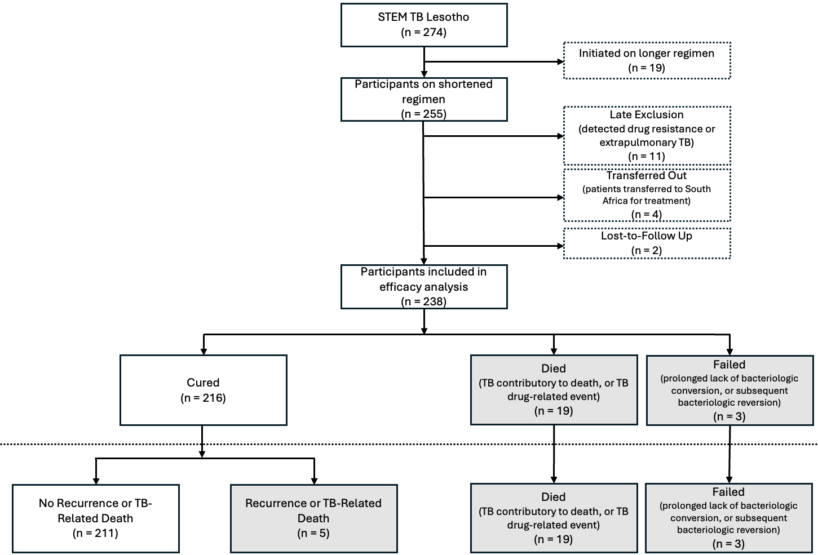

Supplementary Figure 2. Venn Diagram of Clinical Phenotypes for Participants included in End of Treatment and Final Outcomes Analyses, STEM-TB Lesotho (N = 179)

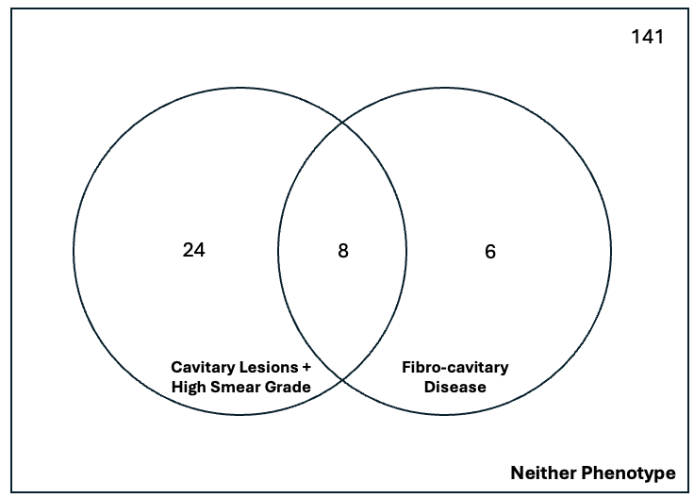

Supplementary Table 1. Analyses of Baseline Chest X-Ray Findings and Sputum Smear Grade on End of Treatment and Final Post-Treatment Outcomes Among Patients With HIV, Stratified by CD4 Status, STEM-TB Lesotho Cohort

 | Univariable  Odds Ratio (95% Confidence Interval) |  | Multivariable  Odds Ratio (95% Confidence Interval)
 | CD4 < 200  (N = 65) | CD4 ≥ 200  (N = 82) | CD4 < 200  (N = 65) | CD4 ≥ 200  (N = 82)
Favorable End-of-Treatment Outcome
Cavitary Disease | 0.22 | 0.83 | 0.38 | 0.96
 | (0.04 - 1.15) | (0.17 - 3.94) | (0.06 - 2.30) | (0.16 - 6.00)
P-value | 0.07 | 0.81 | 0.29 | 0.97
Fibrosis | 0.46 | 0.18 | 1.11 | 0.16
 | (0.08 - 2.46) | (0.03 - 0.94) | (0.15 - 8.41) | (0.02 - 1.02)
P-value | 0.36 | 0.04 | 0.92 | 0.05
Bilateral Disease | 0.24 | 1.21 | 0.31 | 2.09
 | (0.04 - 1.24) | (0.25 - 5.78) | (0.04 - 2.23) | (0.34 - 12.64)
P-value | 0.09 | 0.81 | 0.25 | 0.42
High Smear Grade | 0.25 | 0.56 | 0.40 | 1.08
 | (0.04 - 1.44) | (0.12 - 2.68) | (0.06 - 2.50) | (0.17 - 6.73)
P-value | 0.12 | 0.47 | 0.32 | 0.94
Favorable Final Treatment Outcome
Cavitary Disease | 0.21 | 0.62 | 0.32 | 0.84
 | (0.05 - 0.92) | (0.14 - 2.73) | (0.05 - 1.78) | (0.15 - 4.72)
P-value | 0.04 | 0.53 | 0.19 | 0.84
Fibrosis | 0.69 | 0.14 | 2.10 | 0.14
 | (0.14 - 3.46) | (0.03 - 0.69) | (0.26 - 16.82) | (0.02 - 0.83)
P-value | 0.65 | 0.02 | 0.49 | 0.03
Bilateral Disease | 0.26 | 0.91 | 0.28 | 1.77
 | (0.06 - 1.13) | (0.21 - 4.03) | (0.04 - 1.87) | (0.32 - 9.96)
P-value | 0.07 | 0.91 | 0.19 | 0.52
High Smear Grade | 0.18 | 0.42 | 0.25 | 0.89
 | (0.03 - 0.97) | (0.10 - 1.85) | (0.04 - 1.50) | (0.16 - 4.95)
P-value | 0.05 | 0.25 | 0.13 | 0.89

Firth logistic regression; missing indicator method applied to all regressions shown.
¹ Regressions containing all four features adjusted for each other

Supplementary Table 2. Analyses of Baseline Chest X-Ray Findings and Sputum Smear Grade on Time to Culture Conversion, Complete Case Analysis, STEM-TB Lesotho Cohort

 | Univariable  Hazard Ratio (95% Confidence Interval) |  |  |  |  |  | Multivariable¹  Hazard Ratio (95% Confidence Interval)
 | Overall |  | No HIV |  | HIV |  | Overall | No HIV | HIV
 | N | HR | N | HR | N | HR | (N = 121) | (N = 42) | (N = 79)
Cavitary Disease | 129 | 0.75 | 45 | 0.51 | 84 | 0.91 | 0.94 | 0.65 | 1.23
Cavitary Disease |  | (0.52 - 1.09) |  | (0.26 - 0.98) |  | (0.59 - 1.42) | (0.62 - 1.43) | (0.31 - 1.35) | (0.72 - 2.09)
P-value |  | 0.13 |  | 0.04 |  | 0.67 | 0.77 | 0.24 | 0.44
Fibrosis | 128 | 0.80 | 45 | 0.43 | 83 | 1.21 | 1.04 | 0.51 | 1.562
Fibrosis |  | (0.54 - 1.19) |  | (0.22 - 0.84) |  | (0.73 - 2.00) | (0.66 - 1.64) | (0.21 - 1.22) | (0.87 - 2.81)
P-value |  | 0.26 |  | 0.01 |  | 0.46 | 0.87 | 0.13 | 0.14
Bilateral Disease | 129 | 0.52 | 45 | 0.60 | 84 | 0.46 | 0.58 | 0.93 | 0.47
Bilateral Disease |  | (0.36 - 0.75) |  | (0.32 - 1.15) |  | (0.29 - 0.72) | (0.37 - 0.90) | (0.43 - 2.00) | (0.28 - 0.81)
P-value |  | <0.001 |  | 0.12 |  | 0.001 | 0.01 | 0.86 | 0.01
High Smear Grade | 138 | 0.61 | 48 | 0.52 | 90 | 0.66 | 0.79 | 1.03 | 0.68
High Smear Grade |  | (0.44 - 0.87) |  | (0.29 - 0.96) |  | (0.43 - 1.01) | (0.51 - 1.22) | (0.49 - 2.18) | (0.39 - 1.17)
P-value |  | 0.01 |  | 0.04 |  | 0.06 | 0.29 | 0.93 | 0.16

¹ Regressions containing all four features adjusted for each other

Supplementary Table 3. Analyses of High-Risk Combinatory Chest X-Ray and Sputum Smear Grade Phenotypes on Primary Outcomes, Complete Case Analysis, STEM-TB Lesotho Cohort

 | Time-to-Conversion |  | Favorable End-of-Treatment Outcome |  | Favorable Final Treatment  Outcome
Baseline Variable | N | HR  (95% CI) | N | OR  (95% CI) | N | OR  (95% CI)
Both cavitary disease and high smear grade | 122 | 0.57 | 180 | 0.33 | 180 | 0.28
Both cavitary disease and high smear grade |  | (0.37 - 0.88) |  | (0.11 - 0.98) |  | (0.10 - 0.75)
P-value |  | 0.01 |  | 0.05 |  | 0.01
Severe Fibrocavitary Disease¹ | 128 | 0.49 | 206 | 0.20 | 206 | 0.19
Severe Fibrocavitary Disease¹ |  | (0.24 - 1.01) |  | (0.06 - 0.71) |  | (0.06 - 0.62)
P-value |  | 0.05 |  | 0.01 |  | 0.01

¹ Participants with large cavitations (>5cm) and any concomitant degree of both fibrosis, or multi-lobar fibrosis and any concomitant degree of cavitation

Supplementary Table 4. Analysis of Baseline Chest X-Ray Findings and Sputum Smear Grade on Primary Outcomes, Complete Case Analysis, STEM-TB Lesotho Cohort

 | Univariable  Odds Ratio (95% Confidence Interval) |  |  |  |  |  | Multivariable¹  Odds Ratio (95% Confidence Interval)
 | Overall |  | No HIV |  | HIV |  | Overall | No HIV | HIV
 | N | OR | N | OR | N | OR | (N=179) | (N=71) | (N=108)
End-of-Treatment Outcome
Cavitary Disease | 207 | 0.39 | 81 | 0.28 | 126 | 0.48 | 0.62 | 0.35 | 0.86
Cavitary Disease |  | (0.15 - 1.02) |  | (0.06 - 1.35) |  | (0.15 - 1.59) | (0.19 - 2.07) | (0.05 - 2.51) | (0.18 - 4.20)
P-value |  | 0.05 |  | 0.11 |  | 0.23 | 0.44 | 0.30 | 0.85
Fibrosis | 206 | 0.28 | 81 | 0.34 | 125 | 0.25 | 0.30 | 0.47 | 0.25
Fibrosis |  | (0.11 - 0.76) |  | (0.07 - 1.64) |  | (0.07 - 0.87) | (0.09 - 0.97) | (0.06 - 3.36) | (0.06 - 1.12)
P-value |  | 0.01 |  | 0.18 |  | 0.03 | 0.04 | 0.45 | 0.07
Bilateral Disease | 207 | 0.37 | 81 | 0.14 | 126 | 0.54 | 0.72 | 0.32 | 0.97
Bilateral Disease |  | (0.13 - 1.00) |  | (0.02 - 1.24) |  | (0.16 - 1.80) | (0.21 - 2.51) | (0.03 - 3.60) | (0.21 - 4.59)
P-value |  | 0.05 |  | 0.08 |  | 0.31 | 0.60 | 0.36 | 0.97
High Smear Grade | 206 | 0.39 | 80 | 0.42 | 126 | 0.38 | 0.95 | 0.90 | 1.02
High Smear Grade |  | (0.15 - 1.07) |  | (0.08 - 2.26) |  | (0.11 - 1.33) | (0.29 - 3.10) | (0.14 - 5.88) | (0.22 - 4.85)
P-value |  | 0.07 |  | 0.31 |  | 0.13 | 0.94 | 0.92 | 0.98
Final Post-Treatment Outcome
Cavitary Disease | 207 | 0.35 | 81 | 0.29 | 126 | 0.40 | 0.51 | 0.35 | 0.60
Cavitary Disease |  | (0.15 - 0.84) |  | (0.07 - 1.18) |  | (0.14 - 1.20) | (0.17 - 1.53) | (0.06 – 1.99) | (0.14 - 2.54)
P-value |  | 0.02 |  | 0.08 |  | 0.10 | 0.23 | 0.23 | 0.49
Fibrosis | 206 | 0.32 | 81 | 0.35 | 125 | 0.29 | 0.36 | 0.54 | 0.32
Fibrosis |  | (0.13 - 0.77) |  | (0.09 - 1.44) |  | (0.09 - 0.91) | (0.13 - 1.02) | (0.10 - 3.02) | (0.08 - 1.24)
P-value |  | 0.01 |  | 0.15 |  | 0.03 | 0.06 | 0.48 | 0.10
Bilateral Disease | 207 | 0.31 | 81 | 0.10 | 126 | 0.49 | 0.48 | 0.16 | 0.80
Bilateral Disease |  | (0.12 - 0.79) |  | (0.01 - 0.84) |  | (0.16 - 1.47) | (0.15 - 1.55) | (0.02 - 1.55) | (0.19 - 3.45)
P-value |  | 0.01 |  | 0.03 |  | 0.20 | 0.22 | 0.11 | 0.77
High Smear Grade | 206 | 0.40 | 80 | 0.73 | 126 | 0.27 | 1.02 | 1.87 | 0.70
High Smear Grade |  | (0.16 - 0.98) |  | (0.16 - 3.34) |  | (0.08 - 0.88) | (0.35 - 2.98) | (0.32 - 10.88) | (0.17 - 2.85)
P-value |  | 0.05 |  | 0.69 |  | 0.03 | 0.97 | 0.49 | 0.62

¹ Regressions containing all four features adjusted for each other

Supplementary Table 5. Analyses of High-Risk Combinatory Chest X-Ray and Sputum Smear Grade Phenotypes on Primary Outcomes, Lost to Follow-Up Sensitivity Analysis ¹, STEM-TB Lesotho Cohort (N = 240)

 | Favorable End-of-Treatment Outcome | Favorable Final Treatment Outcome
Baseline Variable | Odds Ratio  (95% Confidence Interval) | Odds Ratio  (95% Confidence Interval)
Both cavitary disease and high smear grade | 0.39 | 0.32
Both cavitary disease and high smear grade | (0.14 - 1.14) | (0.12 - 0.85)
P-value | 0.09 | 0.02
Severe Fibrocavitary Disease² | 0.24 | 0.22
Severe Fibrocavitary Disease² | (0.07 - 0.84) | (0.07 - 0.71)
P-value | 0.03 | 0.01

¹ Two participants with “lost to follow-up” outcome status included as having had unfavorable end of treatment and final post-treatment outcomes.
² Participants with large cavitations (>5cm) and any concomitant degree of both fibrosis, or multi-lobar fibrosis and any concomitant degree of cavitation

Supplementary Table 6. Analysis of Baseline Chest X-Ray Findings and Sputum Smear Grade on Primary Outcomes, Lost to Follow-Up Sensitivity Analysis, STEM-TB Lesotho Cohort (N = 240)

 | Univariable  Odds Ratio (95% Confidence Interval) |  | Multivariable  Odds Ratio (95% Confidence Interval)
 | Overall  (N = 240) | HIV  (N = 150) | Overall  (N = 240) | HIV  (N = 150)
Favorable End-of-Treatment Outcome
Cavitary Disease | 0.48 | 0.64 | 0.80 | 1.01
 | (0.19 - 1.19) | (0.21 - 1.98) | (0.28 - 2.25) | (0.281 - 3.605)
P-value | 0.11 | 0.44 | 0.67 | 0.99
Fibrosis | 0.39 | 0.39 | 0.53 | 0.48
 | (0.16 - 0.97) | (0.13 - 1.24) | (0.20 - 1.43) | (0.14 - 1.65)
P-value | 0.04 | 0.11 | 0.21 | 0.25
Bilateral Disease | 0.49 | 0.75 | 0.72 | 1.08
 | (0.19 - 1.23) | (0.25 - 2.29) | (0.25 - 2.06) | (0.30 - 3.87)
P-value | 0.13 | 0.62 | 0.54 | 0.90
High Smear Grade | 0.32 | 0.29 | 0.41 | 0.31
 | (0.12 - 0.84) | (0.09 - 0.93) | (0.15 - 1.15) | (0.09 - 1.10)
P-value | 0.02 | 0.04 | 0.09 | 0.07
Favorable Final Treatment Outcome
Cavitary Disease | 0.42 | 0.52 | 0.71 | 0.85
 | (0.18 - 0.96) | (0.18 - 1.46) | (0.28 - 1.81) | (0.26 - 2.74)
P-value | 0.04 | 0.21 | 0.47 | 0.78
Fibrosis | 0.40 | 0.42 | 0.59 | 0.56
 | (0.17 - 0.93) | (0.14 - 1.20) | (0.24 - 1.47) | (0.18 - 1.75)
P-value | 0.03 | 0.11 | 0.26 | 0.32
Bilateral Disease | 0.40 | 0.65 | 0.58 | 0.98
 | (0.17 - 0.95) | (0.23 - 1.82) | (0.22 - 1.53) | (0.30 - 3.19)
P-value | 0.04 | 0.41 | 0.27 | 0.97
High Smear Grade | 0.33 | 0.22 | 0.46 | 0.25
 | (0.14 - 0.81) | (0.07 - 0.68) | (0.18 - 1.19) | (0.07 - 0.84)
P-value | 0.02 | 0.01 | 0.11 | 0.03

Two participants with an outcome of lost to follow-up included as having had unfavorable end-of-treatment and final treatment outcomes. Both participants who were lost to follow-up were living with HIV.

