SUPPLEMENTARY INFORMATION
Supplementary Table 1 Scoring system used during three scoring rounds. Scorers were instructed on the protocol for assigning scores on each scale (see ‘Methods’). For impacts, participants gave separate confidence scores for each element.
Score | Five point scale |  |  |  |  | unknown
IMPACT | 1 | 2 | 3 | 4 | 5
Probability | very low | low | moderate | high | very high | unknown
Scale | very small | small | medium | large | very large | unknown
Severity | very small | small | medium | large | very large | unknown
Confidence (repeated x3 for each scale) | low | medium | high |  |  | unknown
DRIVERS | 1 | 2 | 3 | 4 | 5
Driver x in region y | not important | a little important | important | very important | the most important | unknown
Confidence (repeated for every driver) | low | medium | high |  |  | unknown

Figure S1 Definition of global regions according to biogeographical and geopolitical conditions.
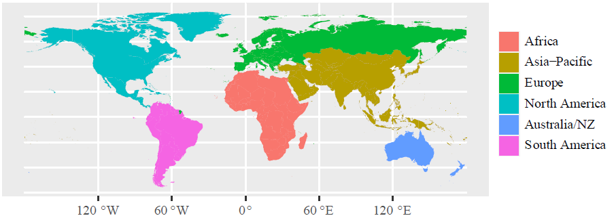

Supplementary Table 2 Final driver scores summarised
Median scores for importance (1-5) and confidence (1-3) are shown from the final third round scores, according to the scales defined in Supplementary Table 1. Interquartile ranges are shown in brackets. Number of scorers and percentage scoring ‘unknown’ are shown, along with the confidence category, assigned according to the rules in Table 2.
Region | Driver | Importance  (IQR) | Confidence score  (IQR) | Number of scores | % unknown | Confidence category
Africa | Climate Change | 4 (0.5) | 3 (1.5) | 10 | 70 | Established but incomplete
Africa | GMOs | 1 (0) | 1.5 (2) | 10 | 30 | Established but incomplete
Africa | Invasive Alien Species | 1.5 (1) | 2 (0.75) | 10 | 40 | Established but incomplete
Africa | Land Cover & Configuration | 4 (1.5) | 2 (0.75) | 10 | 0 | Inconclusive
Africa | Land Management | 2 (1) | 1.5 (1) | 10 | 50 | Established but incomplete
Africa | Pesticide Use | 4 (1) | 1 (1) | 10 | 0 | Established but incomplete
Africa | Pests & Pathogens | 2 (0) | 2 (1.5) | 10 | 0 | Established but incomplete
Africa | Pollinator Management | 2 (0) | 2 (0.75) | 10 | 0 | Established but incomplete
Asia-Pacific | Climate Change | 3 (1) | 2 (1) | 10 | 10 | Established but incomplete
Asia-Pacific | GMOs | 2 (1) | 2 (1) | 10 | 20 | Established but incomplete
Asia-Pacific | Invasive Alien Species | 3 (1) | 2 (0) | 10 | 10 | Established but incomplete
Asia-Pacific | Land Cover & Configuration | 4 (0) | 3 (1) | 10 | 0 | Well established
Asia-Pacific | Land Management | 4 (0) | 3 (1) | 10 | 0 | Well established
Asia-Pacific | Pesticide Use | 4 (0.75) | 2.5 (1) | 10 | 0 | Well established
Asia-Pacific | Pests & Pathogens | 3 (0) | 2 (0) | 10 | 10 | Established but incomplete
Asia-Pacific | Pollinator Management | 3 (1) | 2 (0.25) | 9 | 0 | Established but incomplete
Australia/  NZ | Climate Change | 3.5 (1) | 2 (0.75) | 10 | 0 | Established but incomplete
Australia/  NZ | GMOs | 2 (0.5) | 1 (1) | 9 | 22 | Established but incomplete
Australia/  NZ | Invasive Alien Species | 4 (1.25) | 2 (0) | 9 | 11 | Inconclusive
Australia/  NZ | Land Cover & Configuration | 4 (1) | 2 (1) | 9 | 0 | Established but incomplete
Australia/  NZ | Land Management | 4 (1) | 2 (0) | 10 | 0 | Established but incomplete
Australia/  NZ | Pesticide Use | 3 (1) | 2 (1) | 9 | 0 | Established but incomplete
Australia/  NZ | Pests & Pathogens | 2 (1) | 2 (0) | 9 | 0 | Established but incomplete
Australia/  NZ | Pollinator Management | 3 (1) | 1.5 (1) | 9 | 22 | Established but incomplete
Europe | Climate Change | 3 (0) | 2 (1.75) | 10 | 0 | Established but incomplete
Europe | GMOs | 2 (0) | 2 (0) | 10 | 10 | Established but incomplete
Europe | Invasive Alien Species | 2 (1) | 2 (0.75) | 10 | 0 | Established but incomplete
Europe | Land Cover & Configuration | 4 (1) | 3 (0) | 10 | 0 | Well established
Europe | Land Management | 5 (1) | 3 (0) | 10 | 0 | Well established
Europe | Pesticide Use | 3.5 (1) | 2 (0.75) | 10 | 0 | Established but incomplete
Europe | Pests & Pathogens | 3 (0.75) | 3 (1) | 10 | 0 | Well established
Europe | Pollinator Management | 3 (1) | 2 (1) | 10 | 0 | Established but incomplete
North America | Climate Change | 3 (0.75) | 2 (0.75) | 10 | 0 | Established but incomplete
North America | GMOs | 2 (1.5) | 1 (1) | 10 | 30 | Inconclusive
North America | Invasive Alien Species | 3 (1.5) | 2 (0) | 10 | 30 | Inconclusive
North America | Land Cover & Configuration | 4 (0.75) | 2 (0) | 10 | 0 | Established but incomplete
North America | Land Management | 4 (0.75) | 2.5 (1) | 10 | 0 | Well established
North America | Pesticide Use | 3.5 (1) | 2 (0) | 10 | 0 | Established but incomplete
North America | Pests & Pathogens | 4 (0) | 2 (1) | 10 | 0 | Established but incomplete
North America | Pollinator Management | 3 (1.75) | 2 (1) | 10 | 0 | Inconclusive
South America | Climate Change | 3 (0.75) | 2 (0.75) | 10 | 0 | Established but incomplete
South America | GMOs | 4 (1) | 2 (0) | 10 | 20 | Established but incomplete
South America | Invasive Alien Species | 3 (1) | 2 (0) | 10 | 0 | Established but incomplete
South America | Land Cover & Configuration | 4 (0.75) | 3 (0) | 10 | 0 | Well established
South America | Land Management | 4 (0) | 3 (0.75) | 10 | 10 | Well established
South America | Pesticide Use | 4 (0) | 3 (0) | 10 | 0 | Well established
South America | Pests & Pathogens | 3.5 (1) | 2 (1) | 10 | 0 | Established but incomplete
South America | Pollinator Management | 3.5 (1) | 2 (0) | 10 | 0 | Established but incomplete
Global | Climate Change | 3 (0.75) | 2 (0.875) | 60 | 13 | Established but incomplete
Global | GMOs | 2 (0.75) | 1.75 (1) | 59 | 22 | Established but incomplete
Global | Invasive Alien Species | 3 (1) | 2 (0) | 59 | 15 | Established but incomplete
Global | Land Cover & Configuration | 4 (0.875) | 2.5 (0.375) | 59 | 0 | Well established
Global | Land Management | 4 (0.875) | 2.75 (0.875) | 60 | 10 | Well established
Global | Pesticide Use | 3.75 (1) | 2 (0.875) | 59 | 0 | Established but incomplete
Global | Pests & Pathogens | 3 (0.375) | 2 (1) | 59 | 2 | Established but incomplete
Global | Pollinator Management | 3 (1) | 2 (0.875) | 58 | 3 | Established but incomplete

Supplementary Table 3 Final risk scores summarised Median risk scores for probability, scale and severity (1-5) and confidence (1-3) are shown from the final third round scores, according to the scales defined in Supplementary Table 1. Interquartile ranges are shown in brackets. Risk score = probability x scale x severity. Total number of scores given across the three elements of risk and percentage of these scores that were ‘unknown’ are shown, along with the confidence category, assigned according to the rules in Table 2. We present the mean risk score for each region, as a measure of overall risk that reflects the spread of values across the ten impacts.
Region | Impact | Probability (IQR) | Probability confidence (IQR) | Scale (IQR) | Scale confidence (IQR) | Severity (IQR) | Severity confidence (IQR) | Risk score | Total number of scores | % unknowns | Confidence category
Africa | Pollination Deficits | 4 (1.5) | 2 (0) | 4 (1) | 2 (0) | 4 (0.75) | 1.5 (1) | 64 | 30 | 0.00 | Inconclusive
Africa | Yield Instability | 3 (0) | 1 (1) | 3 (0) | 1 (0) | 3.5 (1) | 1 (1) | 31.5 | 30 | 13.33 | Established but incomplete
Africa | Honey Production | 1 (0) | 2 (0) | 3 (0) | 2 (1) | 3 (1) | 2 (1) | 9 | 30 | 16.67 | Established but incomplete
Africa | Food System Resilience | 3 (0.5) | 2 (2) | 3.5 (1) | 2 (1) | 4 (0) | 2 (1) | 42 | 30 | 33.33 | Established but incomplete
Africa | Wild Fruit Availability | 3 (0.75) | 1 (1) | 4 (0) | 1.5 (1) | 4 (1) | 2 (0.75) | 48 | 30 | 13.33 | Established but incomplete
Africa | Wild Plant Diversity | 3 (0) | 2 (0) | 4 (0) | 2 (1) | 4 (0) | 1 (0) | 48 | 30 | 0.00 | Established but incomplete
Africa | Wild Pollinator Diversity | 3.5 (1) | 3 (1) | 3 (1) | 1 (1.75) | 4 (0.75) | 1 (1) | 42 | 30 | 50.00 | Established but incomplete
Africa | Managed Pollinators | 2 (0.75) | 2 (0) | 2 (1) | 2 (0.75) | 2 (1) | 2 (1) | 8 | 30 | 3.33 | Established but incomplete
Africa | Aesthetic Values | 2 (1) | 1 (0.75) | 1 (1) | 2 (1) | 2 (1.5) | 2 (0.25) | 4 | 30 | 23.33 | Inconclusive
Africa | Cultural Values | 3 (0.25) | 2 (1) | 4 (1) | 1.5 (1.75) | 4 (0.75) | 1.5 (1) | 48 | 30 | 23.33 | Established but incomplete
Mean risk score, Africa |  |  |  |  |  |  |  | 34.45
Asia-Pacific | Pollination Deficits | 4 (0.75) | 3 (0) | 4 (1) | 3 (1) | 3 (1) | 2 (1) | 48 | 30 | 3.33 | Well established
Asia-Pacific | Yield Instability | 4 (1.5) | 3 (1) | 4 (0.75) | 2 (0) | 4 (1) | 2 (0) | 64 | 30 | 3.33 | Unresolved
Asia-Pacific | Honey Production | 2 (1.75) | 2 (1) | 4 (1.75) | 2 (0) | 3 (1) | 2 (1) | 24 | 30 | 0.00 | Inconclusive
Asia-Pacific | Food System Resilience | 3 (0.75) | 2 (1) | 4 (1) | 2 (0) | 3.5 (1) | 2 (0) | 42 | 30 | 3.33 | Established but incomplete
Asia-Pacific | Wild Fruit Availability | 3.5 (1.75) | 1 (1) | 2.5 (1) | 1.5 (1) | 4 (1) | 2 (0.75) | 35 | 30 | 3.33 | Inconclusive
Asia-Pacific | Wild Plant Diversity | 4 (1) | 1 (1) | 3.5 (1) | 1 (1) | 3 (1) | 1 (1) | 42 | 30 | 3.33 | Established but incomplete
Asia-Pacific | Wild Pollinator Diversity | 4 (0) | 2 (0) | 4 (0.75) | 2 (0) | 3 (1) | 1 (1) | 48 | 29 | 3.45 | Established but incomplete
Asia-Pacific | Managed Pollinators | 2 (1.5) | 2 (1) | 4 (0.75) | 2 (0) | 3 (0.25) | 2 (1) | 24 | 30 | 6.67 | Established but incomplete
Asia-Pacific | Aesthetic Values | 3 (0.75) | 2 (1) | 2 (1) | 2 (1) | 3 (1) | 2 (0.5) | 18 | 30 | 6.67 | Established but incomplete
Asia-Pacific | Cultural Values | 3.5 (1.75) | 2 (0) | 3 (0) | 2 (0.75) | 4 (1) | 2 (0) | 42 | 30 | 3.33 | Established but incomplete
Mean risk score, Asia-Pacific |  |  |  |  |  |  |  | 38.7
Australia/  New Zealand | Pollination Deficits | 4 (2) | 2 (1) | 3 (1) | 2 (1) | 3 (0.25) | 2 (0.25) | 36 | 27 | 3.70 | Inconclusive
Australia/  New Zealand | Yield Instability | 4 (0) | 2 (1) | 3 (1) | 2 (0) | 3 (1.25) | 2 (1) | 36 | 27 | 3.70 | Established but incomplete
Australia/  New Zealand | Honey Production | 2 (1) | 2 (0) | 2 (1) | 2 (1) | 3 (1) | 1 (1) | 12 | 27 | 0.00 | Established but incomplete
Australia/  New Zealand | Food System Resilience | 2 (1) | 2 (0) | 3 (0.75) | 2 (0.25) | 2 (1) | 2 (0) | 12 | 29 | 0.00 | Established but incomplete
Australia/  New Zealand | Wild Fruit Availability | 2.5 (2.5) | 1 (1) | 1.5 (1) | 1 (0) | 1.5 (1.25) | 1 (0) | 5.625 | 28 | 42.86 | Inconclusive
Australia/  New Zealand | Wild Plant Diversity | 4 (1) | 2 (0) | 3 (0.75) | 2 (0) | 2 (0.75) | 1 (1) | 24 | 28 | 10.71 | Established but incomplete
Australia/  New Zealand | Wild Pollinator Diversity | 4 (0) | 2 (1) | 4 (0) | 2 (1) | 3 (1.5) | 2 (0.75) | 48 | 26 | 7.69 | Established but incomplete
Australia/  New Zealand | Managed Pollinators | 3 (1) | 2 (1) | 3 (1) | 2 (1) | 1.5 (1.25) | 1 (1) | 13.5 | 28 | 3.57 | Inconclusive
Australia/  New Zealand | Aesthetic Values | 3 (0.5) | 2 (0.25) | 2 (0.5) | 1 (1) | 3 (1.5) | 1 (0) | 18 | 24 | 8.33 | Established but incomplete
Australia/  New Zealand | Cultural Values | 4 (0) | 2 (0) | 2 (0.25) | 1 (1) | 3 (1) | 2 (0) | 24 | 28 | 0.00 | Established but incomplete
Mean risk score, Australia/New Zealand |  |  |  |  |  |  |  | 22.9
Europe | Pollination Deficits | 4 (0) | 3 (1) | 3 (0) | 2 (0) | 3 (0.75) | 2 (0) | 36 | 30 | 0.00 | Well established
Europe | Yield Instability | 3 (0) | 2 (1.5) | 3 (0.75) | 2 (1) | 2 (0) | 2 (1.5) | 18 | 30 | 3.33 | Established but incomplete
Europe | Honey Production | 2 (1) | 2 (0.75) | 3.5 (1.75) | 2 (1) | 2 (0) | 2 (0) | 14 | 30 | 0.00 | Established but incomplete
Europe | Food System Resilience | 1.5 (1) | 3 (1.25) | 3 (1) | 2 (1) | 2 (0) | 2 (1) | 9 | 30 | 43.33 | Established but incomplete
Europe | Wild Fruit Availability | 3 (1.5) | 1.5 (1) | 1 (1) | 2 (1) | 1 (0) | 2 (1.25) | 3 | 30 | 26.67 | Established but incomplete
Europe | Wild Plant Diversity | 3 (1) | 2 (1) | 3 (0.5) | 2 (1) | 2.5 (1) | 1 (1.25) | 22.5 | 30 | 26.67 | Established but incomplete
Europe | Wild Pollinator Diversity | 5 (1) | 3 (0) | 3 (0.75) | 2 (0.75) | 3 (1) | 2 (0.75) | 45 | 30 | 6.67 | Well established
Europe | Managed Pollinators | 2.5 (1.75) | 2 (0) | 3 (0.75) | 2 (0) | 3 (1) | 2 (0.75) | 22.5 | 30 | 0.00 | Inconclusive
Europe | Aesthetic Values | 3 (1) | 2 (1) | 3 (0) | 2 (0.75) | 2 (0) | 2 (0.75) | 18 | 29 | 10.34 | Established but incomplete
Europe | Cultural Values | 2 (1.75) | 1 (1) | 2 (0.75) | 1 (1) | 2 (1) | 1 (0) | 8 | 30 | 3.33 | Inconclusive
Mean risk score, Europe |  |  |  |  |  |  |  | 19.6
North America | Pollination Deficits | 4 (1) | 2 (0) | 3.5 (1) | 2 (0) | 3 (1) | 2 (0) | 42 | 30 | 0.00 | Established but incomplete
North America | Yield Instability | 3 (0.75) | 1 (0) | 3 (0.75) | 1 (0) | 2 (0) | 1 (1) | 18 | 30 | 3.33 | Established but incomplete
North America | Honey Production | 3 (1) | 2 (1) | 2 (1) | 1 (1) | 2 (1) | 1 (0.25) | 12 | 30 | 10.00 | Established but incomplete
North America | Food System Resilience | 2 (1) | 1 (2) | 3 (0.5) | 1 (2) | 2 (0.5) | 1.5 (2) | 12 | 30 | 56.67 | Established but incomplete
North America | Wild Fruit Availability | 1 (0) | 2 (1) | 1 (0) | 1 (1) | 1 (0.25) | 1 (1) | 1 | 30 | 46.67 | Established but incomplete
North America | Wild Plant Diversity | 2 (1) | 1 (1) | 3 (1) | 1 (1) | 2 (0.75) | 2 (2) | 12 | 30 | 33.33 | Established but incomplete
North America | Wild Pollinator Diversity | 4.5 (1) | 3 (1) | 4 (1) | 2 (0.75) | 3 (1) | 2 (1.5) | 54 | 30 | 20.00 | Well established
North America | Managed Pollinators | 4 (1) | 2 (1) | 3 (0.75) | 2 (1) | 4 (0.75) | 1.5 (1) | 48 | 30 | 0.00 | Established but incomplete
North America | Aesthetic Values | 2.5 (1.75) | 1 (1) | 2 (0.75) | 1 (1) | 1.5 (1.25) | 1 (1.5) | 7.5 | 30 | 46.67 | Inconclusive
North America | Cultural Values | 2 (0) | 1 (1) | 2 (1.75) | 1 (0) | 2 (1) | 1 (1) | 8 | 30 | 16.67 | Established but incomplete
Mean risk score, North America |  |  |  |  |  |  |  | 21.45
South America | Pollination Deficits | 4 (0.75) | 3 (0) | 4.5 (1) | 3 (0) | 3 (0) | 2 (0) | 54 | 25 | 0.00 | Well established
South America | Yield Instability | 4 (0) | 3 (1) | 4 (1) | 2 (1) | 4 (1) | 2 (1) | 64 | 25 | 0.00 | Well established
South America | Honey Production | 3 (1) | 2 (0) | 4 (1.75) | 2 (1.75) | 3 (1.5) | 2 (0.25) | 36 | 30 | 3.33 | Inconclusive
South America | Food System Resilience | 4 (1) | 2 (0) | 4 (0.75) | 2 (0) | 4 (1) | 2 (1) | 64 | 30 | 0.00 | Established but incomplete
South America | Wild Fruit Availability | 4 (1.5) | 2 (0.75) | 3 (0) | 1 (1) | 2.5 (1.75) | 1 (0.25) | 30 | 23 | 17.39 | Inconclusive
South America | Wild Plant Diversity | 4 (1) | 2 (1) | 4 (1) | 1 (0) | 3 (1) | 1.5 (1) | 48 | 24 | 12.50 | Established but incomplete
South America | Wild Pollinator Diversity | 5 (1) | 2 (1) | 4 (0) | 2 (1) | 4 (1) | 2 (0) | 80 | 27 | 3.70 | Established but incomplete
South America | Managed Pollinators | 1 (2) | 3 (1) | 4 (1.5) | 2 (0) | 4 (1) | 2 (1) | 16 | 29 | 3.45 | Unresolved
South America | Aesthetic Values | 3.5 (1) | 2 (1.75) | 3 (0) | 2 (1) | 4 (1) | 2 (0.25) | 42 | 30 | 6.67 | Established but incomplete
South America | Cultural Values | 4 (0.75) | 2 (0.75) | 3 (1) | 2 (0) | 4 (0.5) | 2 (0.75) | 48 | 29 | 6.90 | Established but incomplete
Mean risk score, South America |  |  |  |  |  |  |  | 48.2

Figure S2 Final breakdown of scoring of direct drivers by world regions and importance
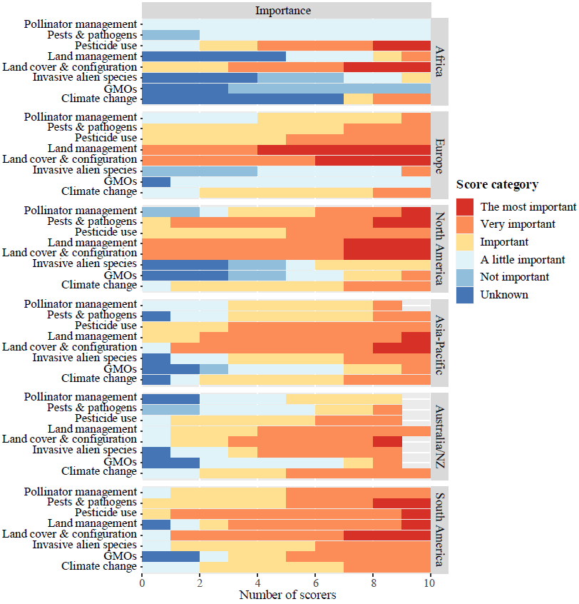

Figure S3 Final breakdown of scoring of risks by world regions, impact and components of risk (probability, scale, severity)
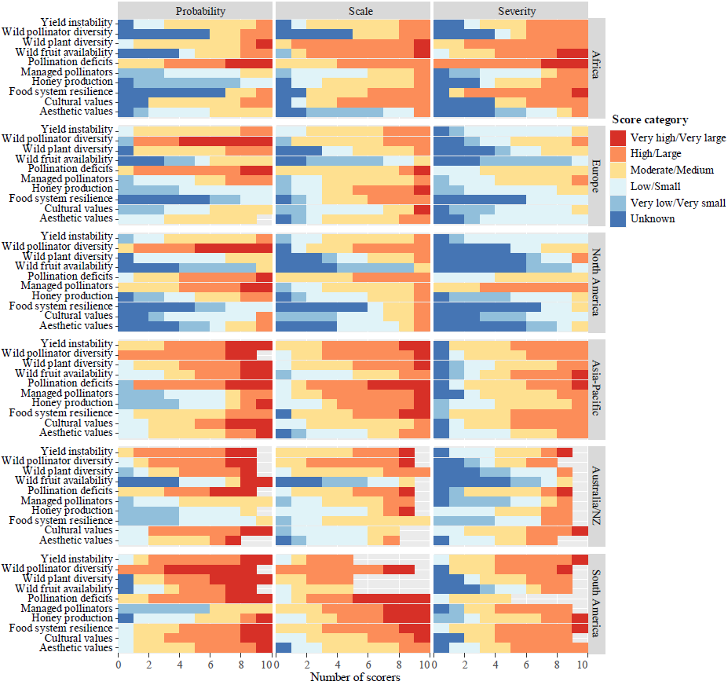

Supplementary Information - Ordinal logistic regression analysis
Results and discussion
In Supplementary Tables 4 and 7, we present results of Cumulative Link Models for drivers and risks respectively, along with scale and nominal tests of the proportional odds assumption for each independent variable. In Supplementary Tables 5 and 8, we present partial proportional odds models, where the original models failed the nominal test and these models were significantly different from the scale models, according to a likelihood ratio test.
In Supplementary Tables 6 and 9, we report the results of Cumulative Link Mixed Models separately for each discussion group, for drivers and risks respectively, including scorer as a random effect. These results show that scorer identity had a significant effect on risk scores, but not on driver scores. Most of the differences among impacts and regions persist, when variation among individual scorers is accounted for. For risk scores, all the independent variables that are significantly different in the overall model (Supplementary Table 7) are also significant in either one or both groups in separate models taking account of scorer effects (Supplementary Table 9). There is, however, one risk variable – the severity of cultural values - that is not scored significantly differently from others in the overall model (Supplementary Table 7), but is significantly different in both groups in the separate models (Supplementary Table 9). In group 2, it was the only impact for which severity was scored significantly higher than the baseline comparison, aesthetic values. This implies that variation among scorers influenced the way this variable was scored overall, and could be explained for example, if individual scorers who tended to score lower than others across the board scored particularly highly on this aspect.
There is a significant effect of discussion group, if Region is replaced by Group in the basic Cumulative Link Models (i.e. Score ~ Group + Driver; Score ~ Group + Impact; results not shown) but it cannot be separated from the effect of Region, because of the design of our workshop. However, it is clear from the results in Supplementary Tables 4 and 7 that there was not a consistent bias, whereby one group always scored higher than the other. The regions in group 2 are significantly different from each other, and from those in group 1, in both directions. If there is any inter-regional pattern in the drivers of pollinator decline, they seem to be stronger in the Americas than in the western biogeographic regions. For risks, regions of the Global South (Asia-Pacific, South America, Africa) tend to score more highly than regions of the Global North (Europe, North America, Australia/NZ), a pattern that can be seen clearly in Figure 2.
The coefficient values in Supplementary Tables 4-9 cannot be taken as indicators of an absolute change in impact/driver scores, but instead must be interpreted relative to one another. Effects of region are relative to Africa. Effects of impact are reported relative to Aesthetic Values. Effects of drivers are relative to the effect of Climate change. A negative location coefficient for a particular level of an image element indicates that it will tend to reduce ratings, while positive coefficients lead to increased ratings.
Supplementary Table 4 Cumulative Link Model results for drivers. Outputs include location coefficients (effects on score values) and scale parameters (effects on score ranges), where scale was not homogenous across score categories (i.e. failure of scale_test). Standard errors in brackets. Regions organised by discussion group (Group). Effects are shown relative to an arbitrary base category, indicated by 0. p-values for model estimates are based on the Wald statistic. Likelihood ratio test results for nominal test and scale test (Pr>Chisq) are given for the basic model in each case: Score ~ Region + Driver.
Group | Region/Driver | Importance
Group | Region/Driver | Coefficient | Scale coefficient
1 | Africa | 0 | 0
1 | Europe | 1.389**  (0.372) | -0.944**  (0.311)
1 | North America | 2.029**  (0.497) | ns
2 | Asia-Pacific | 1.769**  (0.454) | ns
2 | Australia/NZ | 1.278**  (0.441) | ns
2 | South America | 2.624**  (0.646) | ns
 | Climate Change | 0 | -
 | GMOs | -1.405**  (0.484) | -
 | Invasive Alien Species | -0.876*  (0.349) | -
 | Land Cover & Configuration | 2.478**  (0.710) | -
 | Land Management | 1.634**  (0.470) | -
 | Pesticide Use | 0.848*  (0.342) | -
 | Pests & Pathogens | ns | -
 | Pollinator Management | -0.530*  (0.300) | -
McFadden’s Pseudo R² |  | 0.259
 |  | Nominal test result | Scale test result
 | Region | 0.178 | 0.000**
 | Driver | 0.045* | 0.066
**p<0.01; * p<0.05

Supplementary Table 5 Results of Cumulative Link Models with partial proportional odds, for importance of drivers. Outputs are location coefficients (effects on score values), with odds allowed to vary among levels of the dependent variable. Standard errors in brackets. Regions organised by discussion group (Group). Effects are shown relative to an arbitrary base category, indicated by 0. p-values for model estimates are based on the Wald statistic. Likelihood ratio test results for comparison with full proportional odds models (Score ~ Region + Impact) are given (Pr>Chisq).
Group | Region/Driver | Importance
Group | Region/Driver | Coefficient | Not important|  important | Important|  very important
1 | Africa | 0 | - | -
1 | Europe | 1.604**  (0.391) | - | -
1 | North America | 2.514**  (0.413) | - | -
2 | Asia-Pacific | 2.083**  (0.400) | - | -
2 | Australia/NZ | 1.376**  (0.403) | - | -
2 | South America | 2.957**  (0.418) | - | -
 | Climate Change | - | 0
 | GMOs | - | -2.378  (0.519) | -0.950  (0.507)
 | Invasive Alien Species | - | -1.423  (0.502) | -0.458  (0.456)
 | Land Cover & Configuration | - | 1.908*  (0.742) | 3.175**  (0.530)
 | Land Management | - | 0.949  (0.634) | 2.163**  (0.465)
 | Pesticide Use | - | 1.655*  (0.729) | 1.293**  (0.423)
 | Pests & Pathogens | - | -0.541  (0.507) | 0.032  (0.422)
 | Pollinator Management | - | -1.151*  (0.495) | -0.774  (0.464)
McFadden’s Pseudo R² |  | 0.249
Likelihood ratio test vs proportional odds model (Pr>Chisq) |  | 0.045*
**p<0.01; * p<0.05
Supplementary Table 6 Cumulative Link Mixed Models by Discussion Group for importance of drivers Outputs are location coefficients (effects on score values), standard errors in brackets. Effects are shown relative to an arbitrary base category, indicated by 0. p-values for model estimates are based on the Wald statistic. Likelihood ratio test results are given for comparison with a proportional odds model not accounting for the random effect of scorer within each group (Score ~ Region + Impact) (Pr>Chisq), and indicate that individual scorers did not differ significantly from one another when scoring importance of drivers. These results should be compared with those in Supplementary Table 3, where the random effect of scorer could not be taken into account.
Region/Driver | Importance
Region/Driver | Discussion group 1 | Discussion group 2
Africa | 0 | -
Europe | 2.142**  (0.471) | -
North America | 3.250**  (0.517) | -
Asia-Pacific | - | 0
Australia/NZ | - | ns
South America | - | 0.869*  (0.345)
Climate Change | 0 | 0
GMOs | -3.256**  (0.791) | ns
Invasive Alien Species | -2.465**  (0.678) | ns
Land Cover & Configuration | 4.261**  (0.859) | 2.059**  (0.630)
Land Management | 2.642**  (0.734) | 1.556**  (0.563)
Pesticide Use | 1.482*  (0.588) | 1.257*  (0.535)
Pests & Pathogens | ns | ns
Pollinator Management | -1.128*  (0.572) | ns
McFadden’s Pseudo R² | 0.385 | 0.143
Likelihood ratio test vs proportional odds model | 0.324 | 0.065
**p<0.01; * p<0.05

Supplementary Table 7 Cumulative Link Model results for elements of risk. Outputs include location coefficients (coeff = effects on score values) and scale parameters (scale coeff = effects on score ranges), where scale was not homogenous across score categories (failure of scale_test). Standard errors in brackets. Regions organised by discussion group. Effects are shown relative to an arbitrary base category, indicated by 0. p-values for model estimates are based on the Wald statistic. Likelihood ratio test results for nominal test and scale test (Pr>Chisq) are given for the basic model in each case: Score ~ Region + Impact.
Group | Region/Impact | Probability |  | Scale |  | Severity
Group | Region/Impact | Coeff | Scale coeff | Coeff | Scale coeff | Coeff | Scale coeff
1 | Africa | 0 | 0 | 0 | - | 0 | 0
 | Europe | ns | ns | -0.627**  (0.228) | - | -1.580**  (0.506) | -1.157**  (0.328)
 | North America | ns | 0.672*  (0.262) | -0.738**  (0.258) | - | -1.632**  (0.530) | -0.915*  (0.401)
2 | Asia-Pacific | 2.603**  (0.880) | ns | ns | - | -0.556*  (0.228) | ns
 | Australia/NZ | ns | ns | -0.566*  (0.234) | - | -1.149**  (0.400) | ns
 | South America | 3.853**  (1.165) | 0.489*  (0.232) | ns | - | ns | ns
 | Aesthetic Values | 0 | 0 | 0 | 0 | 0 | 0
 | Cultural Values | ns | ns | ns | ns | ns | -0.952*  (0.378)
 | Food System Resilience | ns | ns | 1.187**  (0.355) | -0.781*  (0.304) | ns | ns
 | Honey Production | -4.944*  (1.977) | ns | 0.806*  (0.390) | ns | ns | ns
 | Managed Pollinators | ns | 0.924**  (0.288) | 0.930**  (0.337) | ns | 1.242*  (0.495) | ns
 | Pollination Deficits | 4.978**  (1.483) | ns | 1.638**  (0.422) | -0.715*  (0.303) | 0.909*  (0.396) | -0.914*  (0.386)
 | Wild Fruit Availability | ns | 0.668*  (0.328) | ns | ns | ns | ns
 | Wild Plant Diversity | 2.032**  (0.768) | ns | 1.312**  (0.380) | -0.651*  (0.321) | ns | ns
 | Wild Pollinator Diversity | 7.836*  (3.216) | ns | 1.846**  (0.473) | ns | 0.965*  (0.416) | ns
 | Yield Instability | ns | ns | 1.259**  (0.366) | -0.674*  (0.295) | ns | -0.827*  (0.357)
McFadden’s Pseudo R² |  | 0.242 |  | 0.149 |  | 0.214
 |  | Nominal test result | Scale test result | Nominal test result | Scale test result | Nominal test result | Scale test result
 | Region | 0.011* | 0.000** | 0.607 | 0.101 | 0.023* | 0.001**
 | Impact | 0.083 | 0.001** | 0.020* | 0.024* | 0.010* | 0.001**
*p<0.05; **p<0.01

Supplementary Table 8 Results of Cumulative Link Models with partial proportional odds, for scale and severity elements of risk. Outputs are location coefficients (effects on score values), with proportional odds allowed to vary among levels of the dependent variable, for independent variables where the proportional odds assumption is not met (shown by failure of nominal_test, results in Ext Data Table 6). Standard errors in brackets. Regions organised by discussion group (Group). Effects are shown relative to an arbitrary base category, indicated by 0. p-values for model estimates are based on the Wald statistic. Likelihood ratio test results for comparison with full proportional odds models (Score ~ Region + Impact) are given (Pr>Chisq). The probability dependent variable is not included, because the partial proportional odds model was not significantly different from the proportional odds models with scale effects, shown in Ext Data Table 7 (Pr>Chisq = 0.1389).
Group | Region/Impact | Scale |  |  | Severity
Group | Region/Impact | Coefficient | Small|med | Med|high | Coefficient | Small|med | Med|high
1 | Africa | 0 |  |  |  | 0 | 0
 | Europe | -0.935**  (0.295) | - | - | - | -2.796**  (0.406) | -4.210**  (0.763)
 | North America | -1.236**  (0.309) | - | - | - | -2.685**  (0.421) | -2.625**  (0.468)
2 | Asia-Pacific | ns | - | - | - | ns | -1.006**  (0.323)
 | Australia/NZ | -0.985**  (0.301) | - | - | - | -1.769**  (0.387) | -1.643**  (0.369)
 | South America | 0.754*  (0.310) | - | - | - | ns | ns
 | Aesthetic Values |  | 0 | 0 |  | 0 | 0
 | Cultural Values | - | ns | ns | - | 1.229*  (0.489) | ns
 | Food System Resilience | - | 2.306**  (0.542) | 1.180*  (0.490) | - | ns | ns
 | Honey Production | - | ns | 1.050*  (0.482) | - | ns | ns
 | Managed Pollinators | - | 1.364**  (0.434) | ns | - | 1.256**  (0.480) | 1.120*  (0.511)
 | Pollination Deficits | - | 3.365**  (0.674) | 1.979**  (0.478) | - | 2.484**  (0.529) | ns
 | Wild Fruit Availability | - | ns | ns | - | ns | ns
 | Wild Plant Diversity | - | 2.211**  (0.520) | 1.455**  (0.492) | - | ns | ns
 | Wild Pollinator Diversity | - | 3.232**  (0.676) | 2.342**  (0.494) | - | 2.055**  (0.548) | ns
 | Yield Instability | - | 2.354**  (0.518) | 1.236*  (0.489) | - | 0.913*  (0.477) | ns
McFadden’s Pseudo R² |  | 0.149 |  |  | 0.191
Likelihood ratio test vs proportional odds model Pr>Chisq |  | 0.020* |  |  | 0.003**
*p<0.05; **p<0.01

Supplementary Table 9 Cumulative Link Mixed Models by Discussion Group Outputs are location coefficients (effects on score values), standard errors in brackets. Effects are shown relative to an arbitrary base category, indicated by 0. p-values for model estimates are based on the Wald statistic. Likelihood ratio test results are given for a comparison with a proportional odds model not accounting for the random effect of scorer within each group (Score ~ Region + Impact) (Pr>Chisq), and indicate significant differences between individual scorers in every case. These results should be compared with those in Supplementary Table 7, where the random effect of scorer could not be taken into account.
Region/Impact | Probability |  | Scale |  | Severity
Region/Impact | Group 1 | Group 2 | Group 1 | Group 2 | Group 1 | Group 2
Africa | 0 | - | 0 | - | 0 | -
Europe | ns | - | -0.948**  (0.298) | - | -3.741**  (0.455) | -
North America | ns | - | -1.229**  (0.310) | - | -3.376**  (0.455) | -
Asia-Pacific | - | 0 | - | 0 | - | 0
Australia/NZ | - | ns | - | -1.516**  (0.321) | - | -1.256**  (0.316)
South America | - | ns | - | ns | - | 0.381  (0.301)
Aesthetic Values | 0 | 0 | 0 | 0 | 0 | 0
Cultural Values | ns | 1.185*  (0.556) | ns | ns | 1.816*  (0.919) | 1.358*  (0.571)
Food System Resilience | ns | ns | 1.797**  (0.615) | 1.805**  (0.563) | 3.248**  (0.946) | ns
Honey Production | -1.680**  (0.652) | -2.327**  (0.586) | ns | 1.154*  (0.579) | 1.757  (0.896) | ns
Managed Pollinators | ns | -1.902**  (0.550) | ns | 2.133**  (0.582) | 4.058**  (0.925) | ns
Pollination Deficits | 3.492**  (0.618) | 2.262**  (0.629) | 2.218**  (0.571) | 2.878**  (0.623) | 4.085**  (0.882) | ns
Wild Fruit Availability | ns | ns | ns | ns | 1.832*  (0.893) | ns
Wild Plant Diversity | ns | 1.121*  (0.552) | 1.745**  (0.600) | 2.201**  (0.598) | 3.395**  (0.911) | ns
Wild Pollinator Diversity | 4.197**  0.748 | 3.341**  (0.854) | 2.113**  (0.599) | 3.880**  (0.710) | 3.670**  (0.934) | ns
Yield Instability | ns | 2.162**  (0.621) | 1.111**  (0.562) | 2.779**  (0.630) | ns | ns
McFadden’s Pseudo R² | 0.239 | 0.278 | 0.106 | 0.213 | 0.309 | 0.107
Likelihood ratio test for effect of scorer Pr>Chisq | 0.000** | 0.000** | 0.004** | 0.000** | 0.002** | 0.000**
*p<0.05; **p<0.01

