Supplementary Materials
For submission to: Current Tropical Medicine Reports (Review Article)

Manuscript: Dengue trends and climate-epidemiologic associations in India, 2021-2024
Manuscript ID: Not assigned (Current Tropical Medicine Reports submission)
Authors: Siddalingaiah H S, Rahul Karthik, Sangamesh S

____________________________________________________________

Table of Contents
1. Supplementary Table S1: Complete State-wise Dengue Data (2021-2024)
2. Supplementary Table S2: Climate Data by State (2021-2024 Means)
3. Supplementary Table S3: Full Regression Model Output with Diagnostics
4. Supplementary Methods: Data Processing Details
5. Supplementary Figure S1: Regression Diagnostics
6. Supplementary Figure S2: India Map with Absolute Case Counts
7. Data Availability Details

Supplementary Table S1: Complete State-wise Dengue Data, 2021-2024
State/UT | 2021 Cases | 2021 Deaths | 2022 Cases | 2022 Deaths | 2023 Cases | 2023 Deaths | 2024 Cases | 2024 Deaths | Total | CFR (%)
Karnataka | 17,490 | 4 | 23,651 | 10 | 28,327 | 22 | 32,886 | 27 | 102,354 | 0.06
Tamil Nadu | 14,556 | 13 | 19,475 | 15 | 33,876 | 32 | 27,378 | 11 | 95,285 | 0.07
Maharashtra | 17,632 | 40 | 22,867 | 75 | 19,218 | 58 | 19,385 | 54 | 79,102 | 0.29
Punjab | 23,387 | 81 | 17,168 | 47 | 26,459 | 40 | 6,260 | 18 | 73,274 | 0.25
Kerala | 13,358 | 81 | 17,639 | 115 | 20,926 | 130 | 20,674 | 128 | 72,597 | 0.63
Rajasthan | 10,461 | 19 | 15,862 | 18 | 34,355 | 44 | 11,548 | 6 | 72,226 | 0.12
Uttar Pradesh | 29,757 | 38 | 27,851 | 23 | 27,233 | 25 | 15,868 | 9 | 100,709 | 0.09
Gujarat | 8,673 | 15 | 10,382 | 9 | 15,328 | 11 | 5,614 | 2 | 39,997 | 0.09
Delhi | 9,613 | 23 | 9,830 | 10 | 9,402 | 1 | 10,585 | 11 | 39,430 | 0.11
Bihar | 633 | 3 | 3,491 | 7 | 16,542 | 49 | 10,157 | 17 | 30,823 | 0.25
... (continued)
INDIA TOTAL | 193,245 | 346 | 233,251 | 303 | 289,235 | 485 | 233,519 | 297 | 949,250 | 0.15

Data source: National Vector Borne Disease Control Programme (NVBDCP)

Supplementary Table S2: Climate Data by State (Mean 2021-2024)
State/UT | Mean Temp (°C) | Precipitation (mm/yr) | Climate Zone
Karnataka | 26.2 | 1,248 | Tropical
Tamil Nadu | 28.6 | 998 | Tropical
Kerala | 27.1 | 2,817 | Tropical
Maharashtra | 27.0 | 1,127 | Tropical
Delhi | 25.8 | 617 | Semi-arid
Bihar | 26.1 | 1,187 | Subtropical
Rajasthan | 26.4 | 531 | Arid/Semi-arid
Gujarat | 27.1 | 718 | Semi-arid
Assam | 23.9 | 2,284 | Subtropical
Manipur | 21.8 | 1,467 | Subtropical
Lakshadweep | 28.1 | 1,642 | Tropical

Data source: NASA POWER (2021-2024 annual means)

Supplementary Table S3: Full Regression Model Output

Model Specification
Dependent variable: log(incidence + 1)
Method: OLS with HC3 robust standard errors
Sample: n=136 state-year observations (2021-2024)
R-squared: 0.316
Adjusted R-squared: 0.268
F-statistic: 7.63 (p<0.001)

Coefficient Estimates
Variable | Coefficient | Robust SE | t-value | P-value | 95% CI
Temperature (z) | 0.309 | 0.128 | 2.40 | 0.017 | [0.05, 0.56]
Precipitation (z) | -0.065 | 0.099 | -0.65 | 0.515 | [-0.26, 0.13]
Population density (z) | 0.161 | 0.128 | 1.26 | 0.209 | [-0.09, 0.41]
Urban % (z) | -0.102 | 0.181 | -0.57 | 0.573 | [-0.46, 0.26]
GDP per capita (z) | 0.505 | 0.115 | 4.40 | <0.001 | [0.28, 0.73]
SECI score (z) | 0.024 | 0.147 | 0.17 | 0.869 | [-0.27, 0.32]
Year 2022 | 0.396 | 0.268 | 1.48 | 0.142 | [-0.13, 0.93]
Year 2023 | 0.851 | 0.260 | 3.28 | 0.001 | [0.34, 1.37]
Year 2024 | 0.365 | 0.253 | 1.44 | 0.153 | [-0.14, 0.87]
Intercept | 2.418 | 0.172 | 14.03 | <0.001 | [2.08, 2.76]

Notes: z-scores calculated within sample; HC3 robust standard errors used

Supplementary Figure S1: Regression Diagnostics
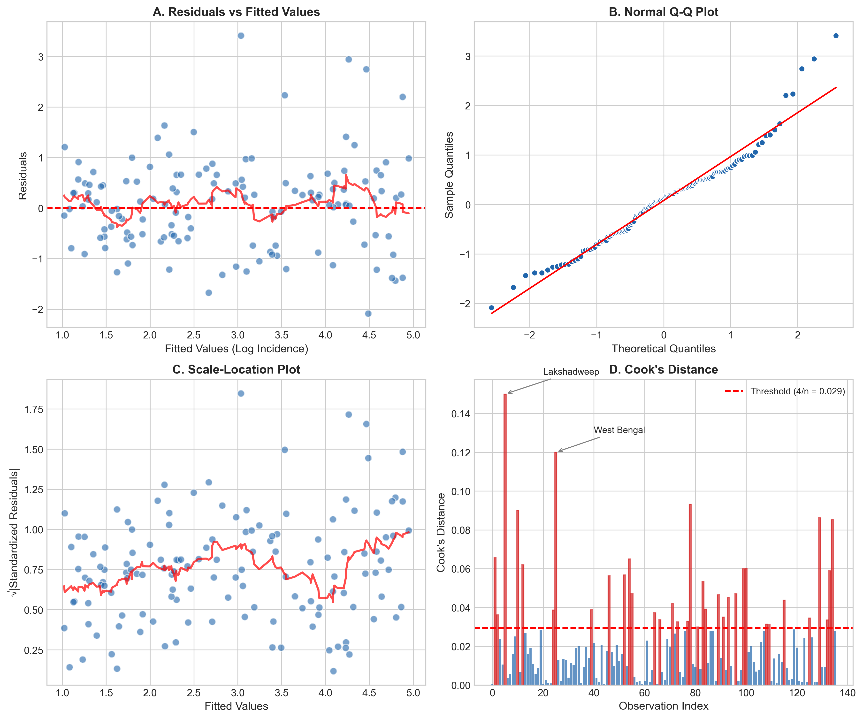

Figure S1. Regression Diagnostics. (A) Residuals vs fitted values showing reasonable homoskedasticity; (B) Q-Q plot of residuals indicating approximate normality; (C) Scale-location plot confirming heteroskedasticity pattern necessitating robust SE; (D) Cook's distance identifying influential observations (Lakshadweep, West Bengal 2024, Bihar 2023).

Supplementary Figure S2: State-wise Absolute Case Burden, 2024
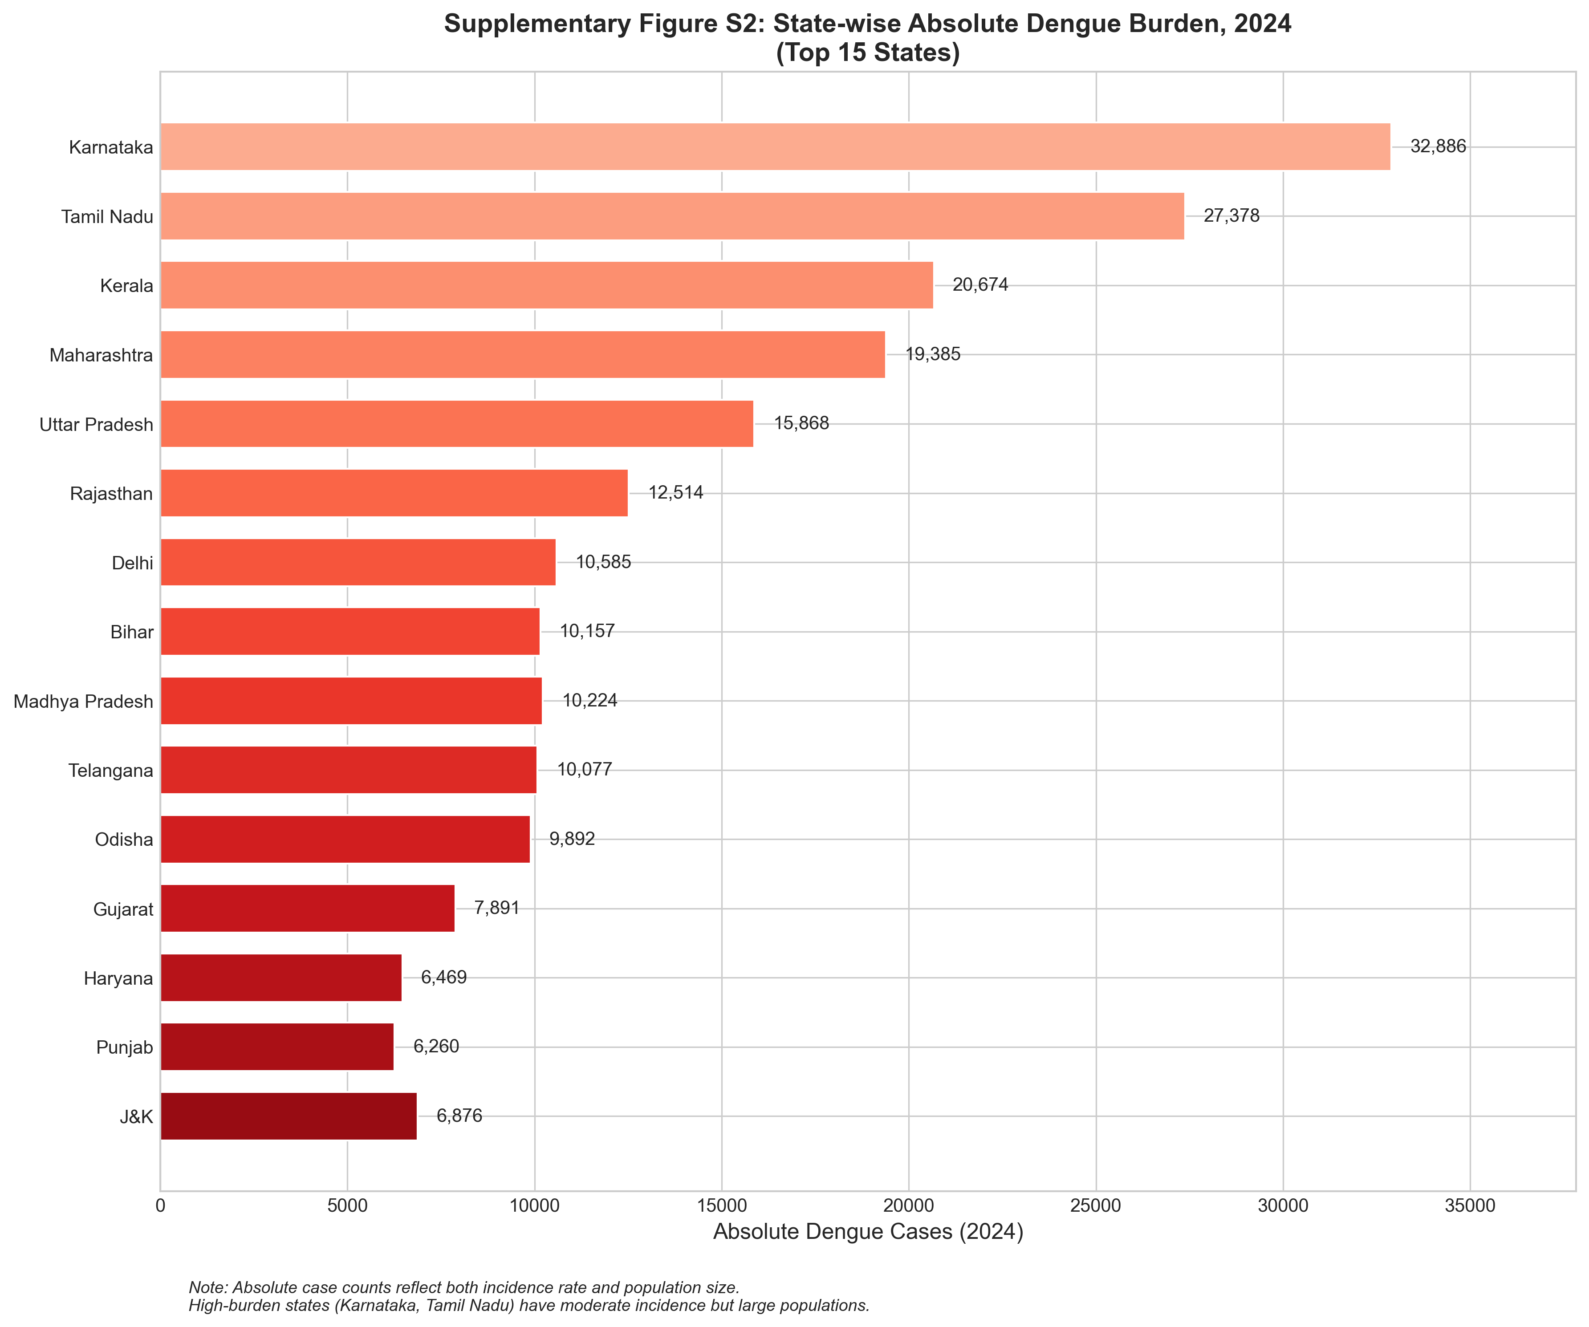

Figure S2. Absolute Dengue Case Burden by State, 2024. Bar chart showing top 15 states by absolute case counts. Highest burden states (Karnataka: 32,886; Tamil Nadu: 27,378; Kerala: 20,674) reflect both moderate-to-high incidence rates and large population denominators. This complements the incidence map (Figure 1B), demonstrating that highest incidence states (Lakshadweep, Puducherry) have relatively low absolute burden due to small populations.

Data Availability Details
Data Type | Source | URL | Access Date
Dengue surveillance | NVBDCP | https://nvbdcp.gov.in/ | 2026-01-15
Climate data | NASA POWER | https://power.larc.nasa.gov/ | 2026-01-20
Population | Census of India | https://censusindia.gov.in/ | 2026-01-10
GDP per capita | RBI | https://rbi.org.in/ | 2026-01-12
SECI scores | NITI Aayog | https://niti.gov.in/ | 2026-01-12

Python analysis scripts and processed datasets are available from the corresponding author upon reasonable request.

____________________________________________________________
End of Supplementary Materials

