GEL IMAGE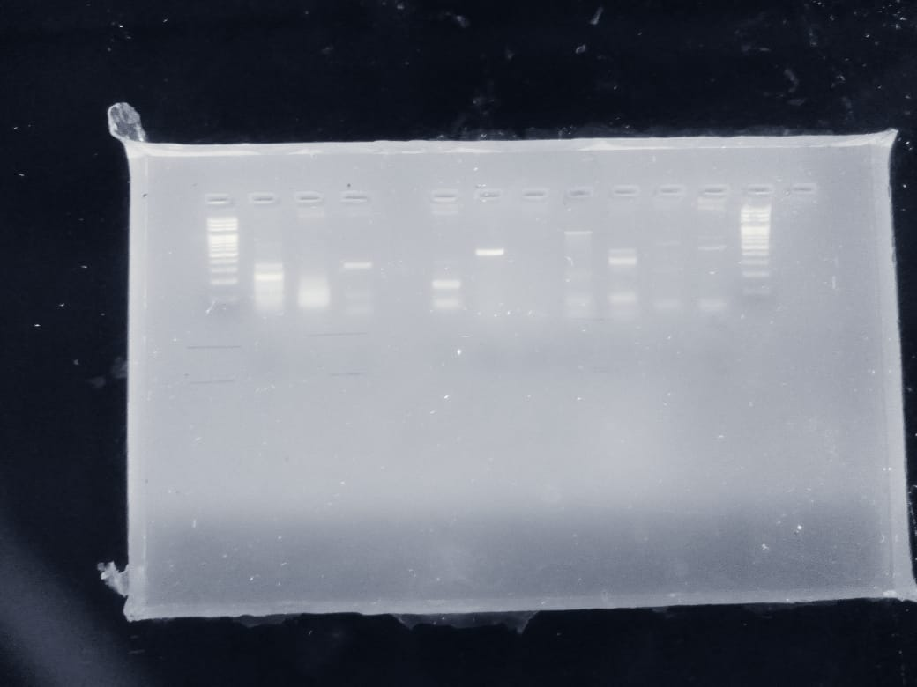

Isolates | Primers | Number assigned on bands
M | Ladder | Ladder
PC12 | afaCc | 1
PC19 | afaCc | 2
PC12 | fimH | 3
PC19 | fimH | 4
PC12 | type 1 fimbriae (FimH) | 5
PC19 | type 1 fimbriae (FimH) | 6
PC12 | papC | 7
PC19 | papC | 8
PC12 | rmpA | 9
PC19 | rmpA | 10
M | Ladder | Ladder
NOTE:
PC12- Klebsiella pneumoniae
PC19- Chromobacteriun violaceum

LADDDER
1000 bp
900 bp
800 bp
700 bp
600 bp
500 bp
400 bp
300 bp
200 bp
100 bp

