Thank you for agreeing to take part in this interview in connection with my research project entitled ‘Innovative models for the financial organisation of primary care practices in Switzerland: a modelling study’. It is part of my MD thesis, under the supervision of Prof. N. Senn and Dr. C. Cohidon. This part of the work is qualitative in nature.
With your permission, we would like the interview to be recorded and the data coded and analysed. The data will be de-identified when the results are published.
The project will provide food for thought for the various professionals and politicians currently seeking innovative solutions for the financing of primary care, based on elements drawn from the Swiss context, its constraints but also its opportunities. We have no identified conflicts of interest.

Data recorded :
Yes / No (circle as appropriate)

Place / Date :

Name / Signature :

Annexe I (French/English) : Grille d’entretien MD Luc Mussard printemps 2025
Numéro de personnes interviewées :
Date :
Temps estimé 20-30min.
Questionnaire socio-démographique simple (entourer ce qui convient) :
Age : <30 ans, 30-50 ans, >50 ans :
Sexe : H, F, autre
Profession : Médecin, paramédical, Administratif, RH, autre
Région linguistique : Romand ? Suisse-allemande ? Canton ?

Thème | Modèle de questions | Relances
- Type of structure/presentation | What is the name of your care structure?  Is it a ‘Medical Home’? What do you think a ‘Medical Home is ?  Can you describe its structure and composition? | What is included (emergencies, homecare (Spitex,..), etc.)?  Target population  Staff (How many doctors, how many paramedics? Nurses? Social workers? Psychologists? Pharmacists? Other “new roles”)
- Coordination time and new roles | How does inter-professional coordination work within your organisation? | For example, around ‘complex cases  With what tools (shared care plan, IT tool, dedicated time, etc.)?
- 1.Source of funding  - Project launch ?  - Operation  - Coordination Time  - « New roles » | How was the project launched?  Can you tell me about the sources of funding for the “care structure”?  In financial terms, how is the time spent coordinating the work of professionals valued?  What are the sources of funding for the ‘new roles’ within the care structure (by which I mean professionals who are not usually integrated into primary care structures or who cannot bill in primary care)? | Renovation of the building, purchase of equipment, etc.  Public/private partnership? Help from the commune or canton? From a foundation? Help with computer files?  Tarmed uniquement ou avez-vous eu d’autres sources de financement ?  Cantonal aid?
- Remuneration and status of professionals | What is the status of the various professionals?  How are they paid? | (self-employed? employees? setting up a common fund and redistribution?)
- General philosophy | What do you think of these 2 quotes?  - ‘Pay primary care teams to care for people, not doctors to provide services.’ (Implementing high quality primary care)  - ‘Exclusive fee-for-service payment is restrictive and does not respond to new multi-professional or even inter-professional practices, just as it no longer responds to needs...’ (What future for the organisation of primary care in France?)  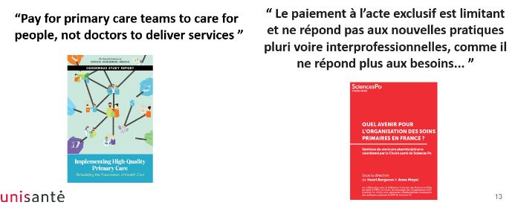
- Do you have any other comments or questions that we haven't yet addressed? | Do you have any other comments or questions that we haven't yet addressed?

