Table 1. Collagen cross-linkers used in this study
Cross-linker | Chemical structure | Manufacturer and details
Proanthocyanidin (PA) | 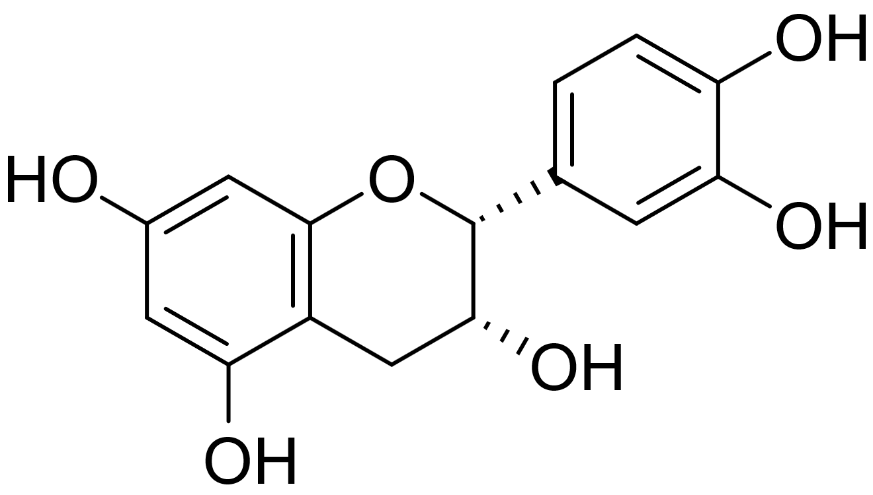 | CAS: 4852-22-6 (generic)  Molecular weight: variable (oligomeric mixture)  Sigma-Aldrich, St. Louis, MO, USA
Theaflavin (TF) | 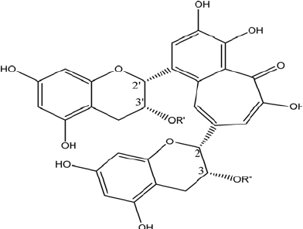 | CAS: 4670-05-7  Molecular weight: 564.49 g/mol  Sigma-Aldrich, St. Louis, MO, USA

Table 2. Comparison of immediate and 6-month microtensile bond strength values within each group

Group | Time | Mean ± SD (MPa) | Median (min–max) | p
U | Immediate | 32,7 ± 13,63 | 31,5 (8,1 - 65) | 0,048
U | 6 months | 27,61 ± 9,65 | 26,15 (11 - 49,1) | 0,048
E+U | Immediate | 41,32 ± 15,67 | 40,9 (5,6 - 83) | <0,001
E+U | 6 months | 28,94 ± 9,35 | 27,9 (12,3 - 50,3) | <0,001
E+PA+U | Immediate | 34,84 ± 13,45 | 32,6 (15,4 - 69,3) | <0,001
E+PA+U | 6 months | 25,49 ± 9,53 | 23,3 (11,3 - 58,2) | <0,001
E+PAU | Immediate | 25,48 ± 9,98 | 22,5 (9,2 - 51,8) | 0,025
E+PAU | 6 months | 21,38 ± 7,17 | 18,9 (12,1 - 38,5) | 0,025
PAFL | Immediate | 24,18 ± 9,76 | 21,85 (9,2 - 48,9) | 0,004
PAFL | 6 months | 19,47 ± 6,27 | 18,75 (7,7 - 33,5) | 0,004
PA+U | Immediate | 11,85 ± 4,46 | 11,35 (5,2 - 24,3) | 0,001
PA+U | 6 months | 15,03 ± 4,87 | 13,3 (9,2 - 33) | 0,001
PAU | Immediate | 11,3 ± 4,68 | 10,9 (5,2 - 23,2) | 0,253
PAU | 6 months | 12,22 ± 3,03 | 12,35 (6,5 - 19,4) | 0,253
E+TF+U | Immediate | 21,01 ± 10,14 | 19,6 (5,6 - 42,2) | 0,597
E+TF+U | 6 months | 20,62 ± 9,67 | 18,3 (6,5 - 60,4) | 0,597
E+TFU | Immediate | 24,48 ± 9,66 | 20,5 (12,4 - 45,6) | 0,003
E+TFU | 6 months | 19,07 ± 6,97 | 18,6 (8,3 - 41,2) | 0,003
TF+U | Immediate | 12,58 ± 3,98 | 12 (5,3 - 21,9) | 0,961
TF+U | 6 months | 12,54 ± 4,09 | 12,4 (4,3 - 22,4) | 0,961
TFU | Immediate | 12,78 ± 6,74 | 12,1 (5,2 - 31,2) | 0,561
TFU | 6 months | 11,63 ± 4,5 | 11,2 (6,3 - 26,3) | 0,561

Table 3. SEM evaluation of resin–dentin interface at different magnifications

Group | SEM Imaging (X1,000) | SEM Imaging (X5,000) | SEM Imaging (X10,000)
U | 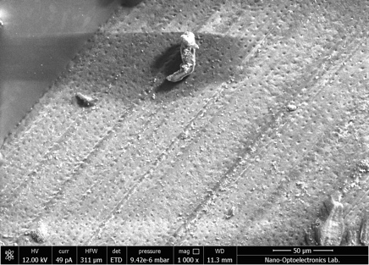 | 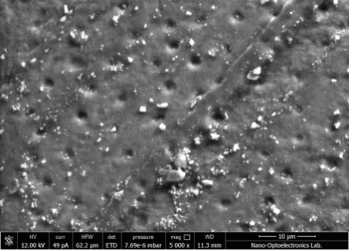 | 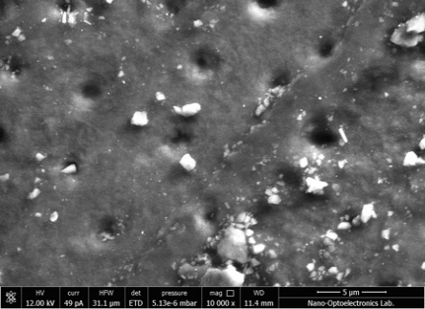
E+U | 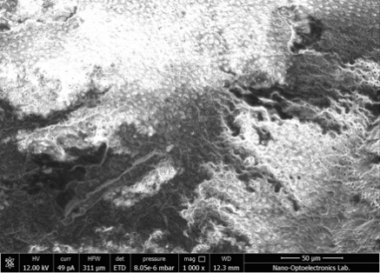 | 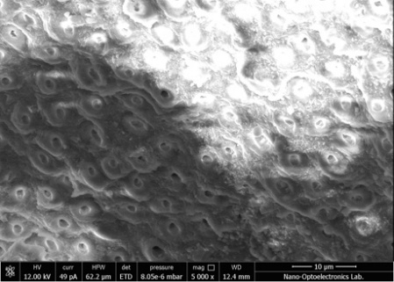 | 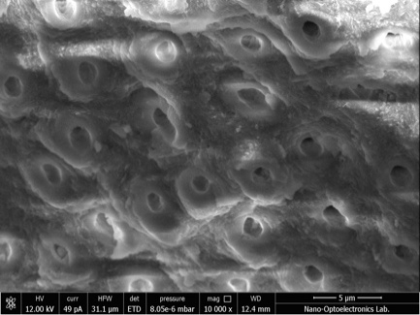
E+PA+U | 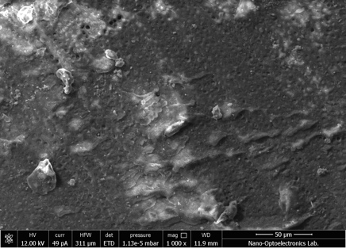 | 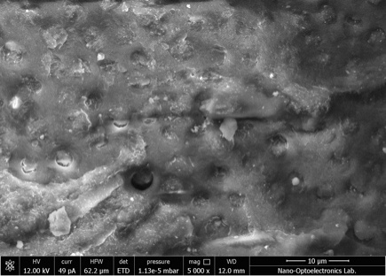 | 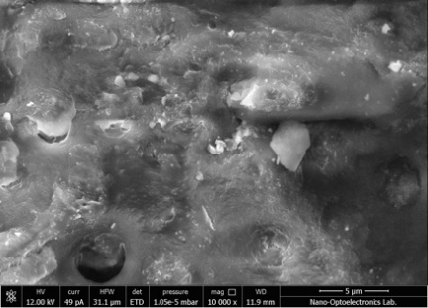
E+PAU | 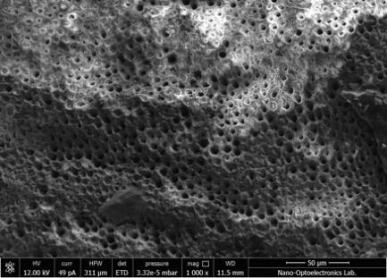 | 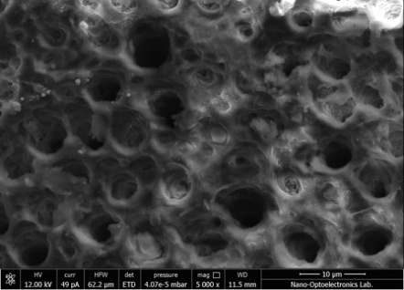 | 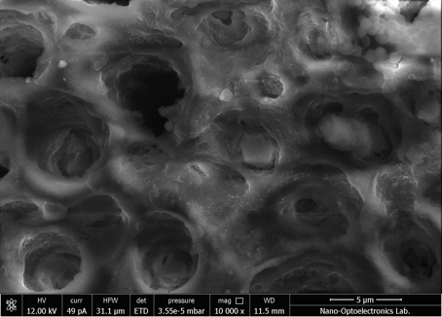
PA+U | 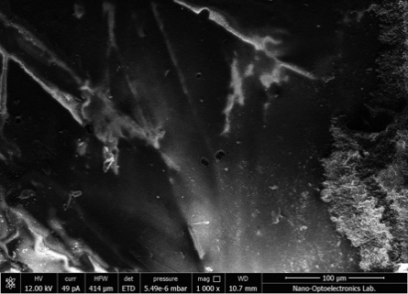 | 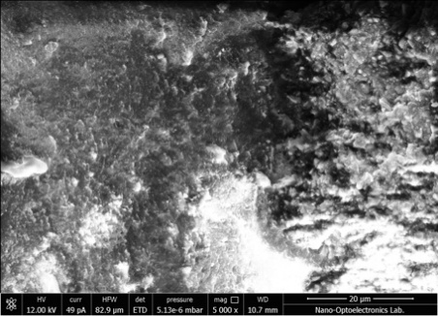 | 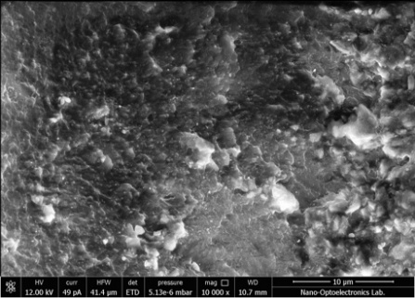
PAU | 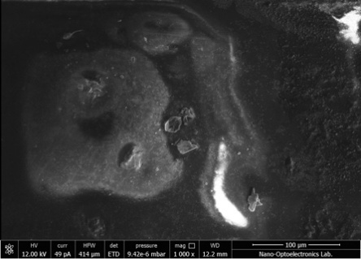 | 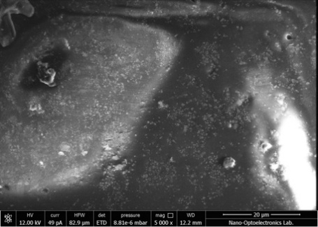 | 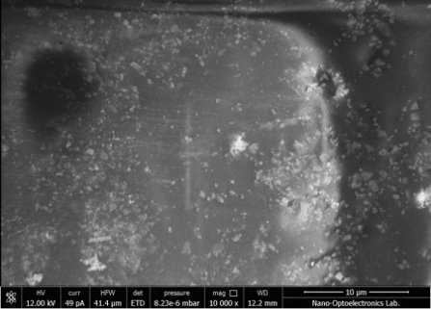
E+TF+U | 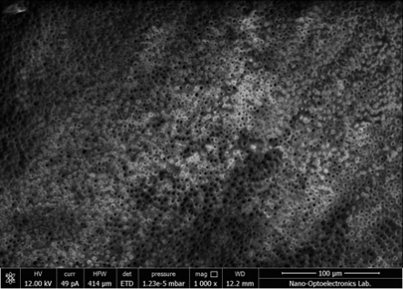 | 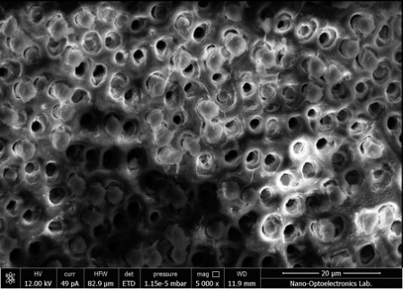 | 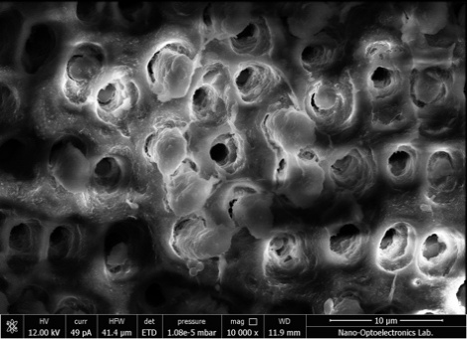
E+TFU | 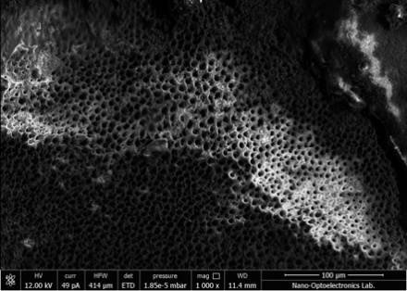 | 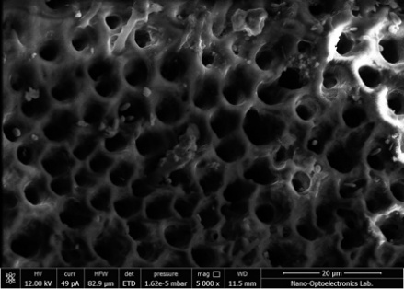 | 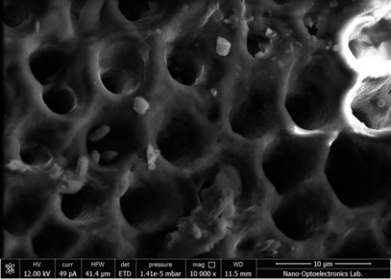
TF+U | 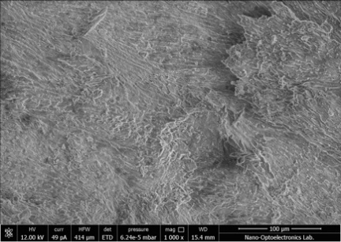 | 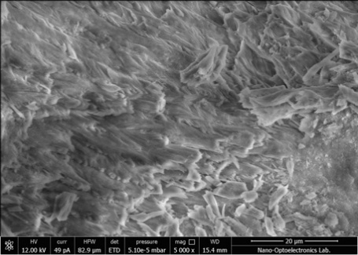 | 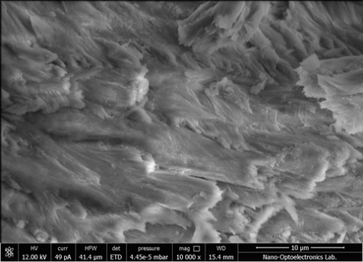
TFU | 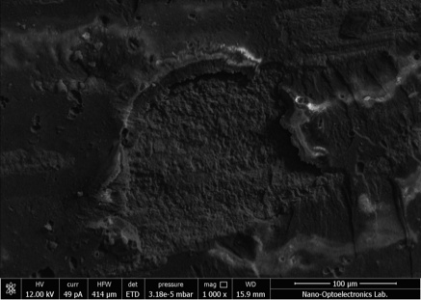 | 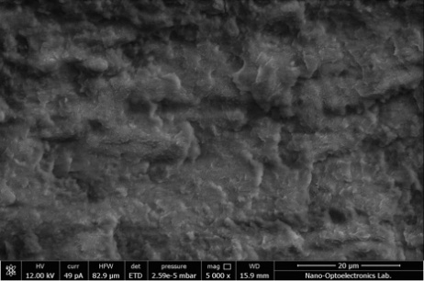 | 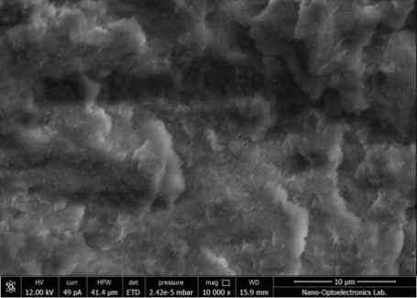
Group | SEM Imaging (X1,000) | SEM Imaging (X5,000) | SEM Imaging (X10,000)
U
E+U
E+PA+U
E+PAU
PA+U
PAU
E+TF+U
E+TFU
TF+U
TFU

Table 4. Fingerprint region of FTIR spectra of dentin specimens treated with proanthocyanidin (PA) and theaflavin (TF) at different stages of the adhesive protocol

