Supporting Information
Topological Structuring of Adhesive Layers to Enhance Resistance Against Interfacial Fracture
Shunto Arai^{1*}
¹ Research Centre for Macromolecules and Biomaterials, National Institute for Materials Science (NIMS), 1-1 Namiki, Tsukuba, Ibaraki 305-0044, Japan.
*Corresponding author. Email: arai.shunto@nims.go.jp

Methods
Materials. Poly(vinylidene fluoride-trifluoroethylene) (P(VDF-TrFE), Mw = 350–550 kg⋅mol⁻¹) was obtained from Piezotech® FC45 (Arkema, France). Poly(vinylidene fluoride-co-hexafluoropropylene) (PVDF-HFP, Mw ≈ 470 kg·mol⁻¹) and poly(methyl methacrylate) (PMMA) were purchased from Sigma-Aldrich. Styrene-ethylene-butylene-styrene (SEBS) block copolymer (Tuftec® H1052) was supplied by Asahi Kasei (Japan). Anhydrous acetone and chlorobenzene were purchased from FUJIFILM Wako, Japan, 2-butanone (MEK) from Sigma-Aldrich, and N-methyl-2-pyrrolidone (NMP) from Tokyo Chemical Industry Co., Ltd. (Japan). All materials were used as received without further purification.

Fabrication of Porous Films and Composite Structures. Porous polymer films were prepared by dissolving P(VDF-TrFE) or PVDF-HFP in anhydrous acetone at a concentration of 4 wt%. These solutions also contained 2 wt% water to induce viscoelastic phase separation (VPS). For pore size tuning, solutions of P(VDF-TrFE) in MEK (4 wt% polymer, 8 wt% water) and PVDF-HFP in NMP (4 wt%) were prepared and mixed with the acetone-based solutions at various ratios. While various coating techniques (e.g., brush-coating, spray-coating) are applicable, spin-coating was mainly employed in this study to ensure uniform film thickness. The polymer solutions were spin-coated onto glass substrates at 2000 rpm for 60 s. After coating, the P(VDF-TrFE) films were annealed at 150 °C for over 60 min to induce crystallization into the all-trans conformation (β phase) and enhance adhesion to the glass substrate. To form the composite structures, SEBS and PMMA were dissolved in chlorobenzene (a non-solvent for the PVDF-based layer) at concentrations of 7 wt% and 8 wt%, respectively. These solutions were then cast onto the porous P(VDF-TrFE) films and dried, allowing the solution to infiltrate the pores.

Structural Characterization. The surface morphology of the porous films was characterized using an atomic force microscope (AFM; MFP-3D, Oxford Instruments, England) operating in tapping mode. The piezo response was measured by applying a voltage from the cantilever of this AFM system. The phase images were obtained by scanning at a speed of 0.4 Hz in the contact mode. Cross-sectional images of the composite structures were obtained using a field-emission scanning electron microscope (FE-SEM; SU-8230, Hitachi High-Tech, Japan) at an accelerating voltage of 5 kV.

Mechanical Tensile Testing. The adhesive strength of the composite joints was evaluated via pull-off tensile tests in accordance with the ISO 4624 standard. Aluminum dollies (diameter: 20 mm; Cotec, Japan) were bonded to the top surface of the composite structures using a two-part epoxy adhesive. The excess film material extending beyond the dolly's circumference was carefully removed with a blade to define the test area. Tensile tests were performed using a universal testing machine (AGS-10kNX, Shimadzu, Japan) at a crosshead speed of 1 mm·min⁻¹. At least three specimens were tested for each condition, and the curve with the median breaking strength was plotted in Figure 2d and S5b. In all tests, failure occurred at the targeted PPA/infiltrated polymer interface, with no delamination observed at the epoxy/dolly or epoxy/composite interfaces. A custom-designed fixture enabled in-situ observation of the fracture process through the glass substrate with a video camera, as illustrated in Figure 3a.

Particle-based model simulation. To investigate the fracture mechanism of the composites, we performed Langevin dynamics simulations. The motion of each particle i is governed by the following equation of motion:
where m_{i}, v_{i}, ζ_{i}, and θ _{i} (t) represent the mass, velocity, friction coefficient, and random force acting on particle i, respectively. We determined the value of θ _{i} (t) to satisfy the fluctuation-dissipation theorem. U_{ij} is the interaction potential between particles i and j.
1. Interaction Potentials.
In our adhesive system, both the interfacial interactions and the Young's modulus of the constituent materials play essential roles. To account for the material stiffness, we employed the Morse potential for the pairwise interaction U_{ij}^{Morse}:
In this potential, r_{ij} is the equilibrium distance between particles i and j, and D_{ij} represents the depth of the potential well, corresponding to the interaction energy. The particle radius was set to 2.71ξ regardless of the type of particles (i.e., soft or hard phase), where ξ shows the unit length. The parameter a_{ij} defines the stiffness of the interaction and is proportional to the square root of the spring constant (k_{ij}) under the harmonic approximation. Furthermore, when particles are too soft, the repulsive force weakens even at a short distance between particles, and the phase becomes prone to volume shrinkage. To avoid this artificial shrinkage, a repulsive force is introduced at short distances. This is given by the hard-core potential . The total interaction potential can be written as , where S is called the quintic switching function, satisfying S(r) = 0 for r > 0.8r_{ij} and S(r) = 1 for r < 0.7r_{ij} in our calculations. To prevent particles from recombining even when the structure undergoes significant changes, interparticle bonds were predefined according to the interaction range (8.7ξ in the hard phase and 25ξ in the soft one). Particles that did not originally exist within this range interact solely through repulsive forces.
2. Material and Interaction Parameters.
To distinguish between the soft and hard materials, we introduced a parameter φ _{i} for each particle i, assigning φ_{i} = 1 for soft particles and φ_{i} = 0 for hard particles. The spring constants and interaction energies for a pair of particles (i, j) were then defined as follows:
Here, we set the spring constants for the hard and soft materials to k^{hh}/k^{ss} = 5, and for the dissimilar materials to k^{sh} = k^{hs} = k^{ss}. The interaction energies were also set as: βD^{hh} = 4.0, βD^{ss}= 3.0, and βD^{sh}= βD^{hs} =1.3.
3. System Setup
The simulation system consisted of 10,000 particles at an area fraction of 0.88. The initial structure is formed in three steps, as described in Figure S6: (1) introduction and relaxation of hard-phase particles, (2) removal of a subset of hard particles to create the porous geometry, and (3) introduction and relaxation of soft-phase particles into the empty space. For each relaxation step, calculations are performed with periodic boundary conditions imposed in the x-direction, followed by removal of the periodic boundary conditions for further relaxations. To avoid unphysically sharp interfaces in this coarse-grained model, the initial phase field profile φ shown in Figure S6 was smoothed using the following function:, where w is the position of the interface centre, and λ is the interface width, which was set to λ = ξ. For the tensile simulations, the system was subjected to a tensile load by moving the top and bottom walls apart at a constant velocity v_{wall} = 0.005ξ/τ , where τ is the unit of time.

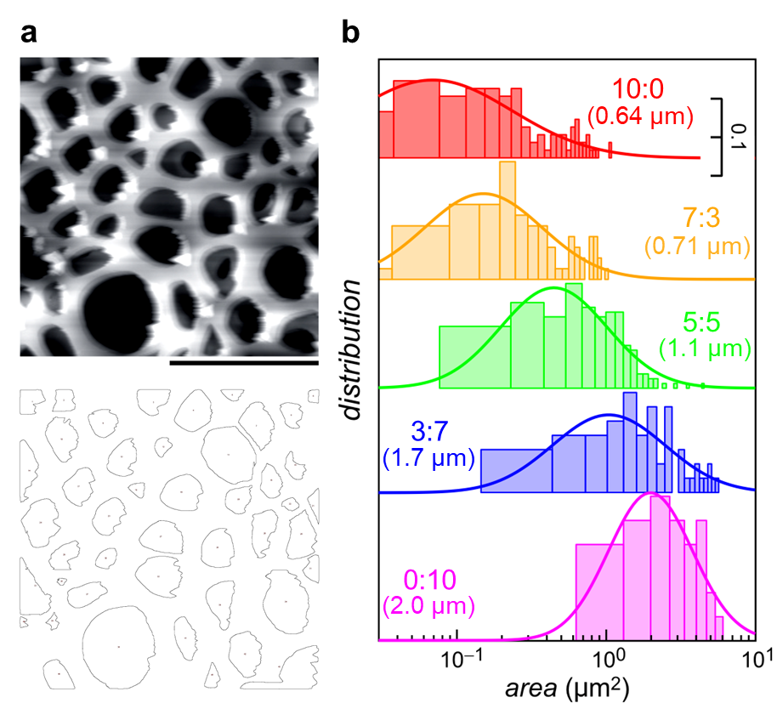
Figure S1 | Pore size distribution analysis. a, AFM image (top) of a P(VDF-TrFE) porous layer prepared from an MEK-based solution, and the corresponding map of analysed pores (bottom). b, Pore size (area) distributions for films prepared with different mixing ratios of acetone- and MEK-based solutions. The calculated average pore diameters are shown in parentheses.

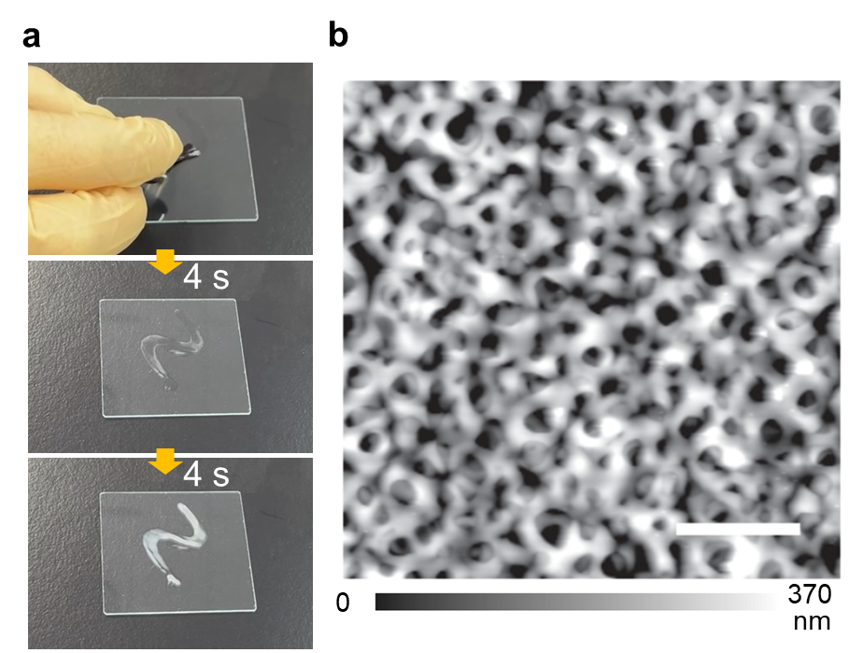
Figure S2 | PPA fabrication by brush coating. a, Photographs of the brush-coating process with an acetone-based solution at 4-second intervals. The solution turns opaque immediately after coating, indicating rapid formation of a porous structure. b, AFM image of the resulting PPA film. The formation of submicron-sized pores confirms that the pore size is primarily determined by the solution properties, not the coating method. Scale bar is set to 5 µm.

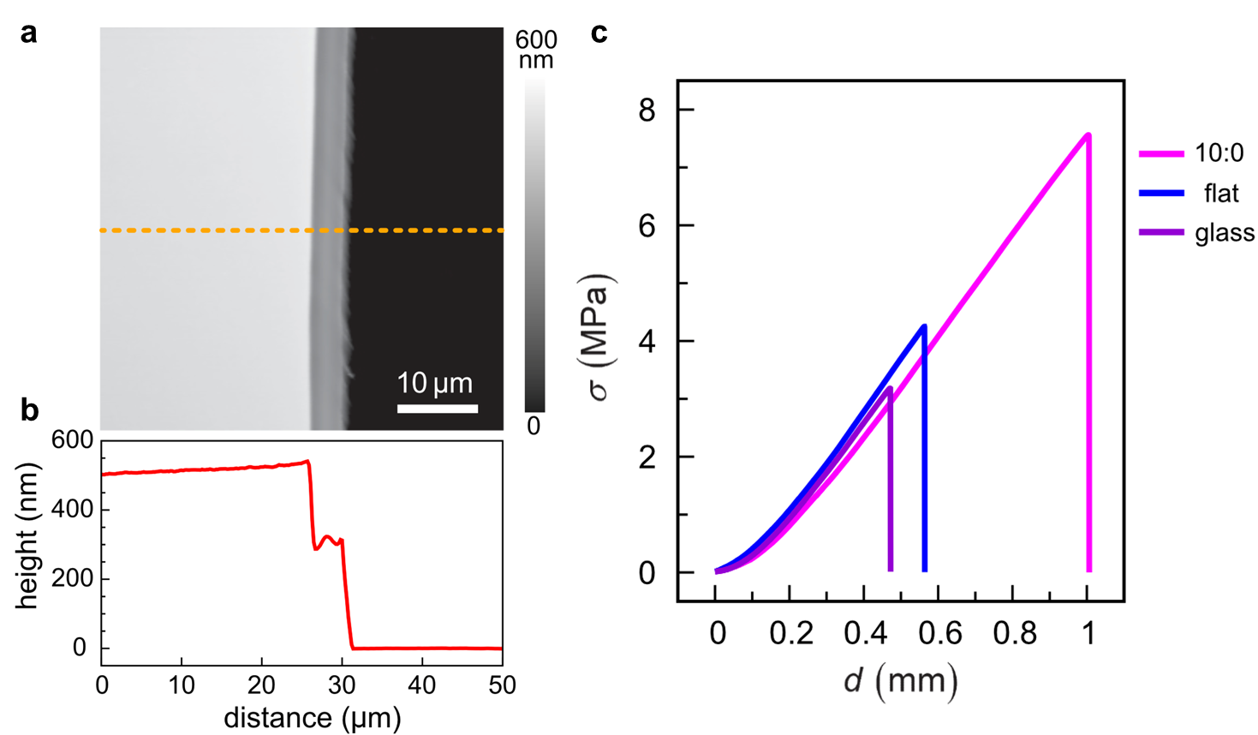
Figure S3 | Characterization of a flat P(VDF-TrFE) reference film. a, AFM image of the film edge, intentionally scratched with a needle to form a step. b, Cross-sectional profile along the dashed line in panel a, showing a flat surface and a film thickness of approximately 500 nm. c, Typical stress-displacement curves. The flat P(VDF-TrFE) surface appears slightly more compatible with SEBS than the hydrophilic glass surface. On the other hand, this durability is significantly lower than that observed for the PPA with small pore sizes, produced using an acetone-based solution (i.e., the mixture ratio of 10:0).

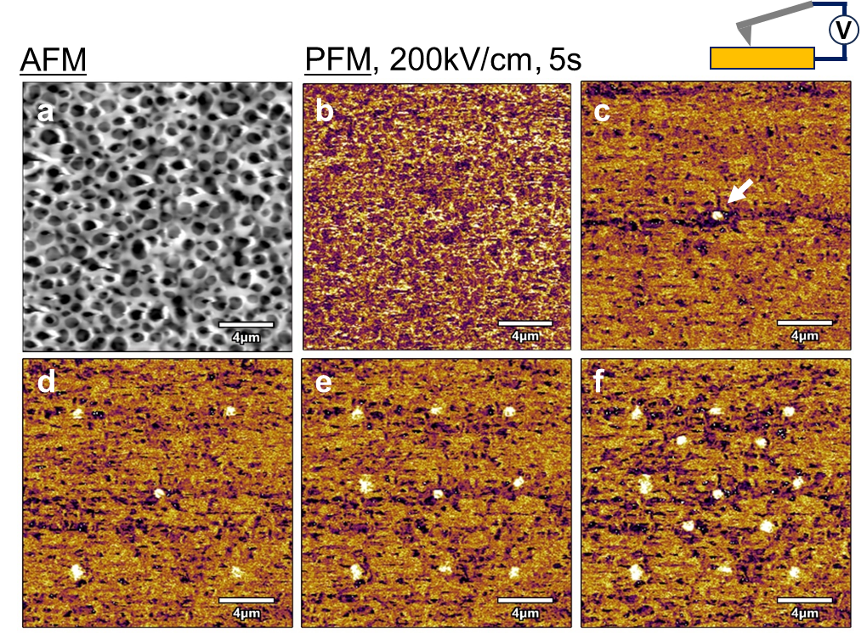
Figure S4 | Piezoresponse force microscopy (PFM) of the PPA film. a, AFM topography of the porous film surface. b-f, Corresponding PFM phase images. b, Initial state without an applied voltage. c, After applying a 200 kV/cm electric field for 5 s to the central region, showing a clear switch in polarization (bright region). d-f, Subsequent writing of polarization domains at four additional points with the same voltage application conditions, demonstrating robust and locally switchable ferroelectric behaviour.

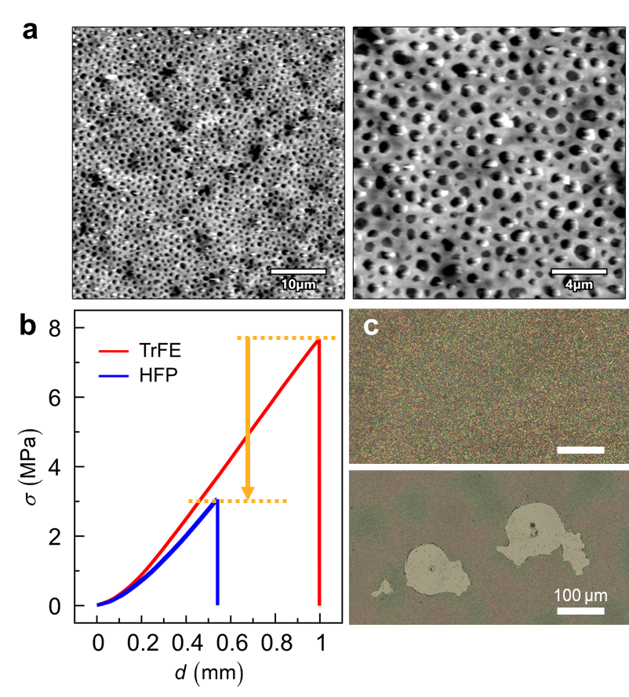
Figure S5 | Fracture behaviour of a PVDF-HFP-based PPA composite. a AFM images of the porous PVDF-HFP film. Scale bars are set to 10 µm (left) and 4 µm (right). b Typical stress-displacement curves. The bonding strength of HFP-PPA tends to decrease compared to TrFE. c Optical microscope images of the PVDF-HFP layer on glass. (Top) As-fabricated porous film. (Bottom) After the fracture test, a large area of the film has delaminated from the glass substrate, exposing the bare glass substrate. This indicates adhesive failure occurs at the polymer/glass interface.

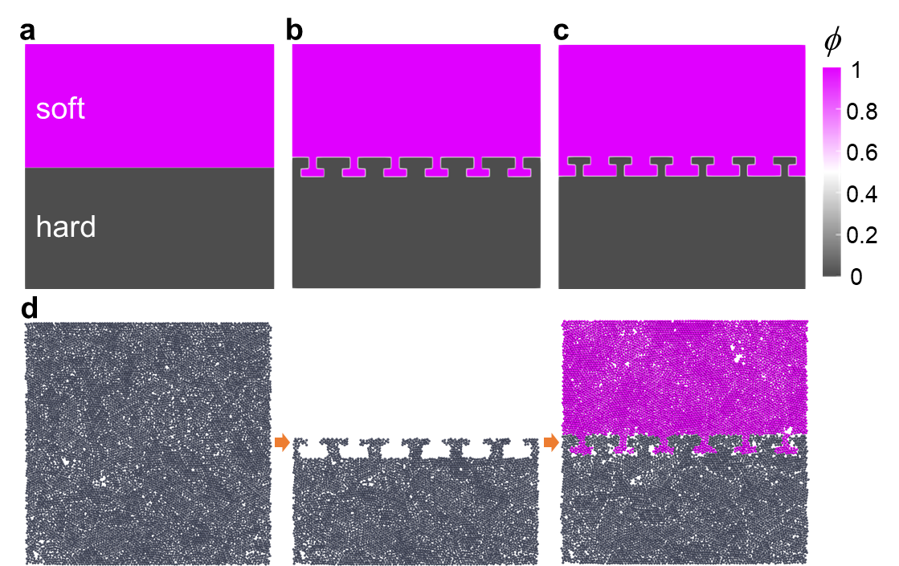
Figure S6 | Initial configurations for the numerical simulations. Each phase with different stiffness is described by the phase field, φ (0≦φ≦1). This field parameter determines whether the particle belongs to the hard or soft state in the numerical simulations in Figure 4. a, A flat interface, used as a reference (corresponding to Figure 4b). b, An interlocked structure with a high areal fraction of the hard phase, representing the small-pore PPA. This configuration corresponds to the tough interface, as simulated in Figure 4c. c, An interlocked structure with a low areal fraction of the hard phase, representing the large-pore PPA. This structure is produced by inverting the soft and hard phases from panel b, with the width of the hard phase reduced to half that in panel b. This configuration corresponds to the weak interface simulated in Figure 4d. d, Method for placing particles. (left) Inorganic/hard particles are put in the simulation box, and the structure is relaxed. (centre) The anchor structure is trimmed out. (right) Soft particles are incorporated into the anchor structure, and the structure is relaxed.

