Deep Learning Enables Genome-Wide Association Studies of Microvascular Features
Adham Elwakil ^{1,2}; Sophie Strebel ^{1,2}; Mathieu Charbonnier ^{1,2}; Belatchane Lahcen ³; Nastasia Foa ²; Andrea Montesel²; Laura Mauring ²; José Vargas Quiros ^{3,4}; Bart Liefers ^{3,4}; Sven Bergmann ^{5,6}; Caroline Klaver ^{1,2,7,8}; Ciara Bergin ²; Reinier Schlingemann ^{2,9}; the VascX Research Consortium *;
Mattia Tomasoni ^{1,2,†,✉} & Ilenia Meloni ^{1,2,†}
¹ Platform for Research in Ocular Imaging, Fondation Asile des Aveugles, Jules Gonin Eye Hospital, Lausanne, Switzerland. ² Department of Ophthalmology, University of Lausanne, Fondation Asile des Aveugles, Jules Gonin Eye Hospital, Lausanne, Switzerland. ³ Faculty of Medicine and Maieutics, Claude Bernard University Lyon 1, Lyon, France. ³ Department of Ophthalmology, Erasmus University Medical Center, Rotterdam, The Netherlands. ⁴ Department of Epidemiology, Erasmus University Medical Center, Rotterdam, The Netherlands. ⁵ Department of Computational Biology, University of Lausanne, Lausanne, Switzerland. ⁶Swiss Institute of Bioinformatics, Lausanne, Switzerland. ⁷ Department of Ophthalmology, Radboud University Medical Center, Nijmegen, the Netherlands. ⁸ Institute of Molecular and Clinical Ophthalmology, University of Basel, Switzerland. ⁹ University Medical Centres, Amsterdam, The Netherlands.
* A full list of members of the VascX Research Consortium is provided in Supplementary Material.
† Co-last authors; ✉ Corresponding author : mattia.tomasoni@fa2.ch

Annex
The VascX Research Consortium (in alphabetical order):
Ciara Bergin ¹; Sven Bergmann ^{1,2,4}; Michael Beyeler ^{1,2,5}; Dennis Bontempi ^{1,2}; Sacha Bors ^{1,2}; Leah Böttger ^{1,2}; Bogdan Draganski ^{5,6,7}; Adham Elwakil ^{3,8}; Györgyi V. Hamvas ^{9,10}; Janna Hastings ^{11,12}; Ilaria Iuliani ^{1,2}; Caroline C.W. Klaver ^{13,14,15,16}; Ihor Kuras ^{6,7}; Bart Liefers ^{13,14}; Ilenia Meloni ^{3,8}; Sofia Ortin Vela ^{1,2}; David Presby ^{1,2}; Ian Quintas ^{1,2}; José Vargas Quiros ^{13,14,}; Marc Schindewolf ^{9,10}; Reinier O. Schlingemann ^{3,17}; Mattia Tomasoni ^{3,8}; Olga Trofimova ^{1,2}.

¹ Department of Computational Biology, University of Lausanne, Lausanne, Switzerland
² Swiss Institute of Bioinformatics, Lausanne, Switzerland
³ Department of Ophthalmology, University of Lausanne, Fondation Asile des Aveugles, Jules Gonin Eye Hospital, Lausanne, Switzerland.
⁴ Department of Integrative Biomedical Sciences, University of Cape Town, Cape Town, South Africa
⁵ Insel University Hospital Bern, Switzerland
⁶ Department of Neurology, Max Planck Institute for Human Cognitive and Brain Sciences, Germany
⁷ Department of Clinical Neuroscience, Lausanne University Hospital and University of Lausanne, Switzerland
⁸ Platform for Research in Ocular Imaging, Fondation Asile des Aveugles, Jules Gonin Eye Hospital, Lausanne, Switzerland.
⁹ Inselspital, Bern University Hospital, University of Bern, Switzerland.
¹⁰ Department for BioMedical Research, Bern University Hospital, University of Bern, Switzerland.
¹¹ Institute for Implementation Science in Health Care, Faculty of Medicine, University of Zurich, Zürich, Switzerland
¹² School of Medicine, University of St Gallen, St. Gallen, Switzerland
¹³ Department of Ophthalmology, Erasmus University Medical Center, Rotterdam, The Netherlands.
¹⁴ Department of Epidemiology, Erasmus University Medical Center, Rotterdam, The Netherlands.
¹⁵ Department of Ophthalmology, Radboud University Medical Center, Nijmegen, the Netherlands.
¹⁶ Institute of Molecular and Clinical Ophthalmology, University of Basel, Switzerland.
¹⁷ University Medical Centres, Amsterdam, The Netherlands.
Supplementary Material
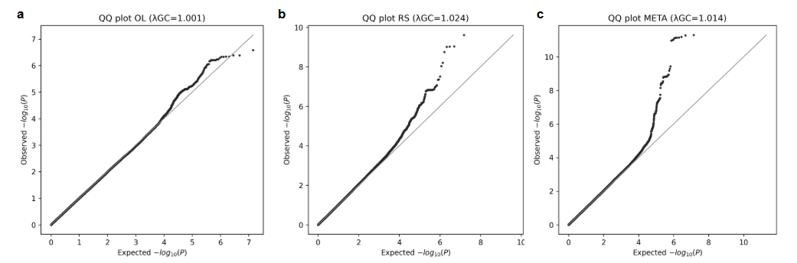

Supplementary Figure S1. Quantile–quantile plots of GWAS results. Quantile–quantile (QQ) plots showing the distribution of observed versus expected −log₁₀(P values) for genome-wide association analyses of foveal avascular zone (FAZ) area in (a) the OphtalmoLaus (OL) cohort, (b) the Rotterdam Study (RS), and (c) the fixed-effects meta-analysis. Minimal deviation from the null expectation is observed in all analyses, consistent with low genomic inflation and absence of substantial residual population stratification (λGC = 1.001 in OL, 1.024 in RS, and 1.014 in the meta-analysis).

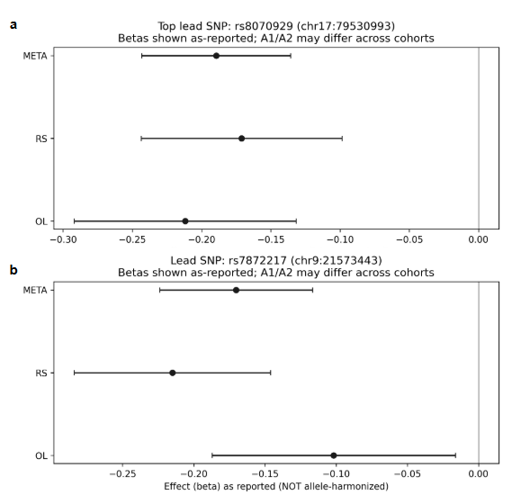

Supplementary Figure S2. Forest plots for lead genome-wide significant FAZ area loci. Forest plots showing cohort-specific and meta-analytic effect estimates (β ± 1.96 × SE) for lead single-nucleotide polymorphisms at genome-wide significant loci associated with foveal avascular zone (FAZ) area. Panel (a) shows the chromosome 17 locus (rs8070929; chr17:79,530,993, GRCh37), and panel (b) shows the chromosome 9 locus (rs7872217; chr9:21,573,443, GRCh37). Effect estimates are shown for the OphtalmoLaus (OL) cohort, the Rotterdam Study (RS), and the fixed-effects meta-analysis. Betas and alleles are reported as provided by each cohort without allele harmonization; therefore, effect directions should be interpreted with caution.

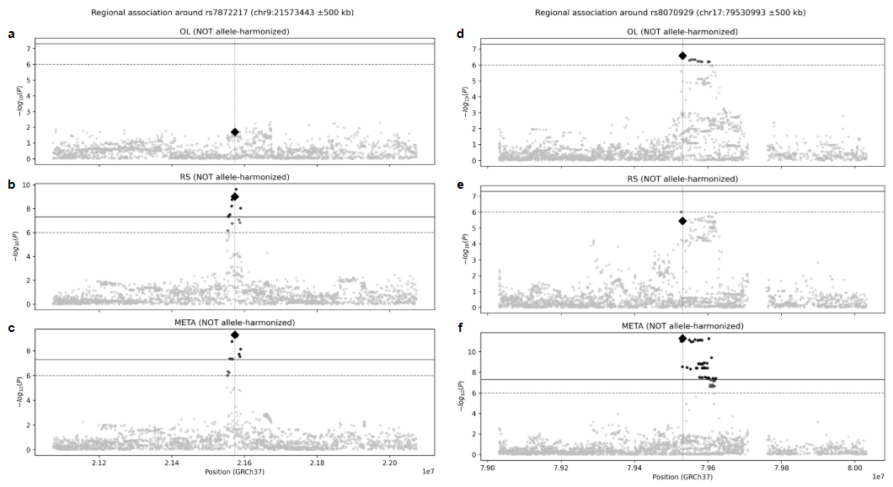

Supplementary Figure S3. Regional association plots for genome-wide significant FAZ area loci. Regional association plots (±500 kb) around lead single-nucleotide polymorphisms at genome-wide significant loci associated with foveal avascular zone (FAZ) area. Panels (a–c) show the locus on chromosome 9 (rs7872217; chr9:21,573,443, GRCh37) in (a) the OphtalmoLaus (OL) cohort, (b) the Rotterdam Study (RS), and (c) the fixed-effects meta-analysis. Panels (d–f) show the locus on chromosome 17 (rs8070929; chr17:79,530,993, GRCh37) in (d) OL, (e) RS, and (f) the meta-analysis. Each point represents a variant plotted by genomic position (x-axis) and −log₁₀(P value) (y-axis). The lead SNP is indicated by a diamond, vertical dashed lines mark its genomic position, and horizontal lines denote the genome-wide significance threshold (P = 5 × 10⁻⁸) and the suggestive threshold (P = 1 × 10⁻⁶). Effect estimates are shown as reported by each cohort without allele harmonization.

