Optimization of nano-encapsulation on neonatal porcine islet-like cell clusters using polymersomes
Running title : Nano-encapsulation of islets

Authors
Sang Hoon Lee^{1*}, Hyun-Ouk Kim^{2*}, Jung-Taek Kang^{1†}

¹ MGENPLUS Biotechnology Research Institute, Mgenplus Co., Ltd., Seoul, 06688, Republic of Korea
²Department of Biotechnology and Bioengineering, Kangwon National University, Chuncheon, Gangwon-do, 24341, Republic of Korea

* These authors contributed equally.
† Corresponding author: Dr. Jung-Taek Kang, MGENPLUS Biotechnology Research Institute, Mgenplus Co., Ltd., Seoul, 06688, Republic of Korea

Email: exodus78@mgenplus.com
Tel: 82-70-5083-6422
Figure legends

Supplement 1 The morphologies and functionalities of NPCCs. A. The morphologies of NPCCs at day.1, 3, 5 after isolation (BF ; bright field). The scale bars represent 200 um; B. AO/PI staining of NPCCs at day.5 after isolation. AO stained the live cells (green) and PI stained the dead cells (red) (n=5). The scale bars represent 200 um; C: The viability of NPCCs was quantified from the result of AOPI staining at day.5 after isolation (n=5); D: Stimulation index (SI) was calculated by dividing the insulin quantities at high glucose (28.0 mM) by that at low glucose (2.8 mM) at day.5 after isolation (n=5).

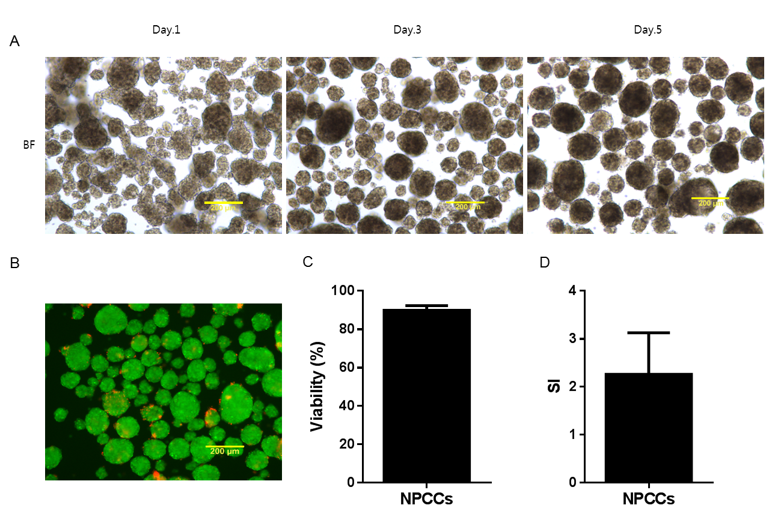
Supplement 1 The morphologies and functionalities of NPCCs .

