Supplementary Tables and Figures

Supplementary Table 1 The sequence of miRNA primers
miRs | miRbase ID | Assay ID | miRNA Sequence
RNU6B | 568915 | 001093 | CGCAAGGATGACACGCAAATTCGTGAAGCGTTCCATATTTTT
miR-451 | has-miR-451a | 001141 | AAACCGUUACCAUUACUGAGUU
miR-1 | has-miR-1-3p | 002222 | UGGAAUGUAAAGAAGUAUGUAU
miR-21 | has-miR-21-3p | 002438 | CAACACCAGUCGAUGGGCUGU
miR-126 | has-miR-126-3p | 002228 | UCGUACCGUGAGUAAUAAUGCG
miR-133 | has-miR-133a-3p | 002246 | UUUGGUCCCCUUCAACCAGCUG
miR-146 | has-miR-146a-5p | 000468 | UGAGAACUGAAUUCCAUGGGUU
miR-155 | has-miR-155-5p | 467534-mat | UUAAUGCUAAUCGUGAUAGGGGUU
miR-486 | has-miR-486-5p | 001278 | UCCUGUACUGAGCUGCCCCGAG
miR-499 | has-miR-499a-5p | 001253 | UUAAGACUUGCAGUGAUGUUU

Supplementary Table 2 The expression of selected miRNAs in different cancer subtypes
miRNA | Healthy | Luminal A |  |  | Luminal B |  |  | HER2+ |  |  | Basal
 | Mean (SD) | Mean (SD) | Fold change | P | Mean (SD) | Fold change | P | Mean (SD) | Fold change | P | Mean (SD) | Fold change | P
miR-451 | 3.05 (0.69) | 2.72 (1.57) | 0.89 | 0.634 | 4.13 (0.39) | 1.36 | 0.012 | 3.89 (0.66) | 1.28 | 0.115 | 3.34 (0.89) | 1.09 | 0.570
miR-1 | 0.37 (0.85) | 0.21 (0.57) | 0.58 | 0.636 | 0.72 (0.66) | 1.94 | 0.493 | 0.42 (0.38) | 1.13 | 0.833 | 0.28 (0.87) | 0.75 | 0.872
miR-21 | 0.05 (0.43) | 0.21 (0.82) | 4.21 | 0.682 | 0.97 (0.43) | 19.32 | 0.008 | 0.70 (0.25) | 14.10 | 0.042 | 0.53 (0.38) | 10.69 | 0.118
miR-126 | 2.79 (0.62) | 2.91 (0.77) | 1.04 | 0.758 | 3.55 (0.53) | 1.27 | 0.062 | 3.29 (0.29) | 1.18 | 0.203 | 3.06 (0.33) | 1.10 | 0.459
miR-133 | 1.01 (0.81) | 0.06 (1.15) | 0.06 | 0.081 | 1.47 (0.47) | 1.45 | 0.297 | 1.05 (0.35) | 1.04 | 0.855 | 0.96 (0.85) | 0.95 | 0.927
miR-146 | 2.61 (0.68) | 2.19 (1.43) | 0.84 | 0.503 | 3.42 (0.59) | 1.31 | 0.065 | 3.19 (0.27) | 1.22 | 0.196 | 3.09 (0.48) | 1.18 | 0.258
miR-155 | 1.41 (0.67) | 0.77 (1.18) | 0.54 | 0.228 | 1.79 (0.52) | 1.27 | 0.326 | 1.44 (0.37) | 1.02 | 0.778 | 1.32 (0.41) | 0.94 | 0.815
miR-486 | 3.25 (0.61) | 2.20 (1.65) | 0.68 | 0.047 | 3.75 (0.36) | 1.15 | 0.143 | 3.51 (0.27) | 1.08 | 0.507 | 2.95 (0.73) | 0.91 | 0.494
miR-499 | -0.66 (0.70) | -0.41 (0.60) | - | 0.252 | 0.09 (0.77) | -- | 0.106 | -0.20 (0.29) | - | 0.146 | 0.23 (1.91) | -- | 0.338
The expression of target miRNA was normalized by RNU6B and log10-transformed. Data were presented mean±SD; Fold change was calculated by healthy controls and the comparison of selected miRNA was performed by Mann-Whitney test or Student’s t test.

Supplementary Table 3 The distribution of treatment duration (day)
Group | N | Median | Minimum | Maximum
Pre | 29 | 7.00 | -15 | 50
0-91 | 7 | 35.00 | 28 | 91
92-182 | 16 | 147.00 | 109 | 182
183-365 | 16 | 199.50 | 187 | 343
>365 | 3 | 707.00 | 700 | 2112
Total | 71 | 91.00 | -15 | 2112
Note: Treatment duration for each sample was calculated from the day of diagnosis to the day of blood sampling as the exact day of treatment was not able to be known from the patient’s data. A negative day in this table means the sampling date was ahead of the diagnosis date.

Supplementary Table 4 The age distribution in the pre-treated and post-treated groups
 | Age (year) | N | Median | Minimum | Maximum
Pre-treated | <=50 | 15 | 44.00 | 35 | 50
Pre-treated | >50 | 14 | 74.00 | 51 | 86
Post-treated | <=50 | 12 | 45.50 | 24 | 50
Post-treated | >50 | 30 | 74.50 | 51 | 88
 | Total | 71 | 59.00 | 24 | 88

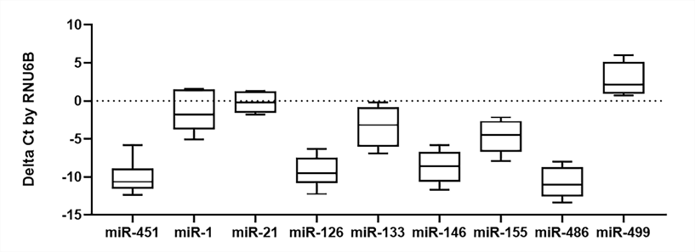

Supplementary Figure 1 The expression of selected miRNAs in healthy controls
Each miRNA for each sample was performed in three triplicates. The Delta Ct value of each sample was calculated by RNU6B. Data were presented as Mean±SD.

