Amygdala shows heterogeneous atrophy and tauopathy patterns across the AD continuum - Supplementary material

Supplementary Figure 1 : Relationships between amygdala subnuclei, SUVR, plasma biomarkers, and cognition, adjusting for global hippocampal volume/SUVr.
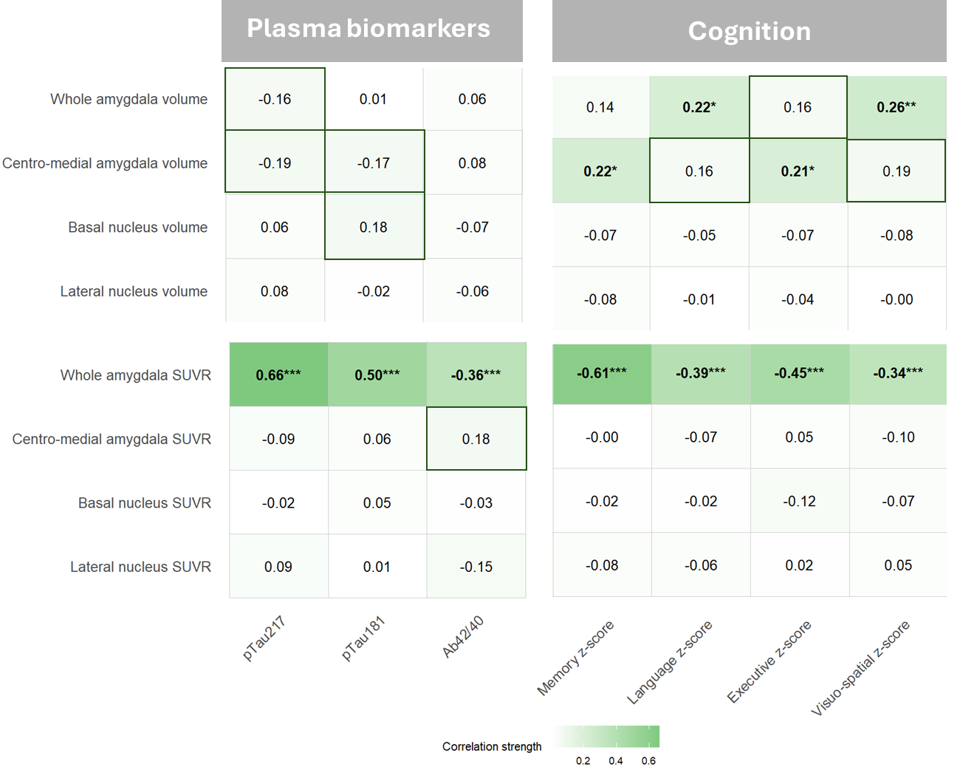
Heatmap of partial Spearman correlations between amygdala volumes or SUVr and blood-based biomarkers (pTau217, pTau181, Aβ42/40) and cognitive z-scores (Memory, Language, Executive, Visuo-spatial). Correlations were adjusted for age, sex, total intracranial volume, and global hippocampus volume or SUVr; correlations involving cognition were additionally adjusted for education. Each cell shows the R value (green intensity = stronger correlation). Reported p-values: *p < 0.05; **p < 0.01; ***p < 0.001; ****p < 0.0001. Boxes indicate associations that were significant before FDR correction (p = 0.01–0.03; pFDR = 0.06–0.11). Sample sizes (N): pTau217 = 161, pTau181 = 152, Aβ42/40 = 160, cognition & volumes = 197, cognition & SUVR = 186.

Supplementary Figure 2 : Relationships between amygdala subnuclei, SUVR, plasma biomarkers, and cognition, adjusting for global entorhinal volume/SUVr.

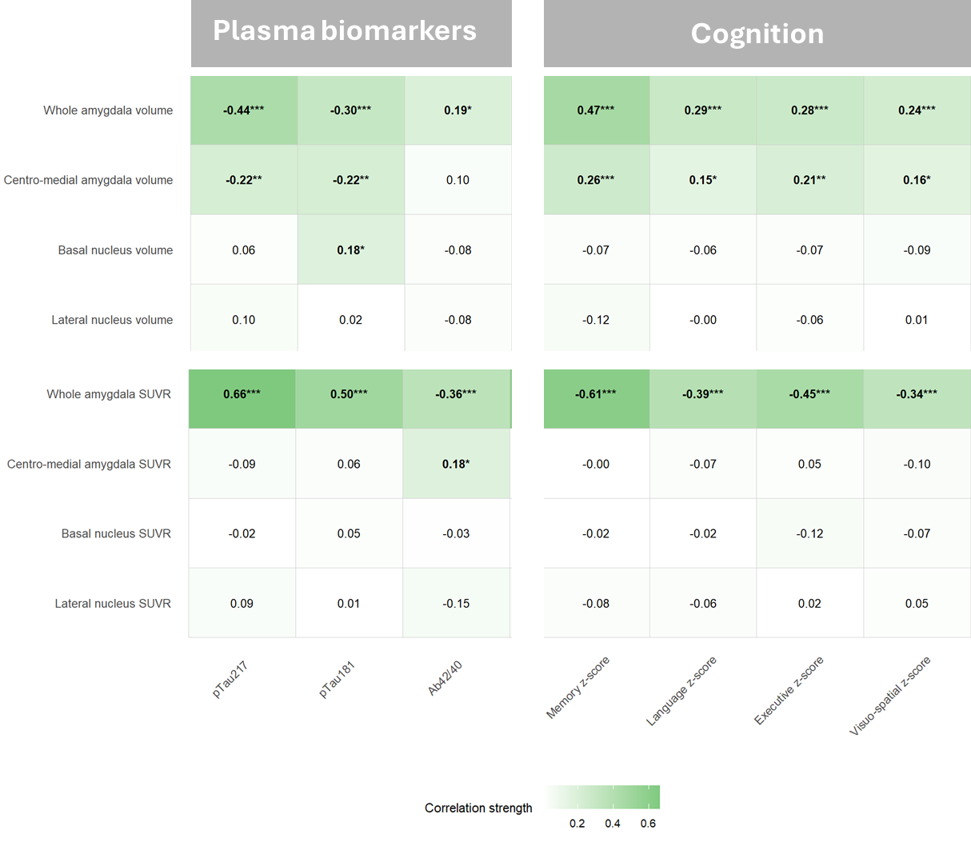
Heatmap of partial Spearman correlations between amygdala volumes or SUVr and blood-based biomarkers (pTau217, pTau181, Aβ42/40) and cognitive z-scores (Memory, Language, Executive, Visuo-spatial). Correlations were adjusted for age, sex, total intracranial volume, and entorhinal volume or SUVr; correlations involving cognition were additionally adjusted for education. Each cell shows the R value (green intensity = stronger correlation). Reported p-values: *p < 0.05; **p < 0.01; ***p < 0.001; ****p < 0.0001. Sample sizes (N): pTau217 = 161, pTau181 = 152, Aβ42/40 = 160, cognition & volumes = 197, cognition & SUVR = 186.

Supplementary Figure 3 : Mediation model pathways relating plasma pTau, amygdala tau SUVr, centromedial amygdala volume, and executive function.

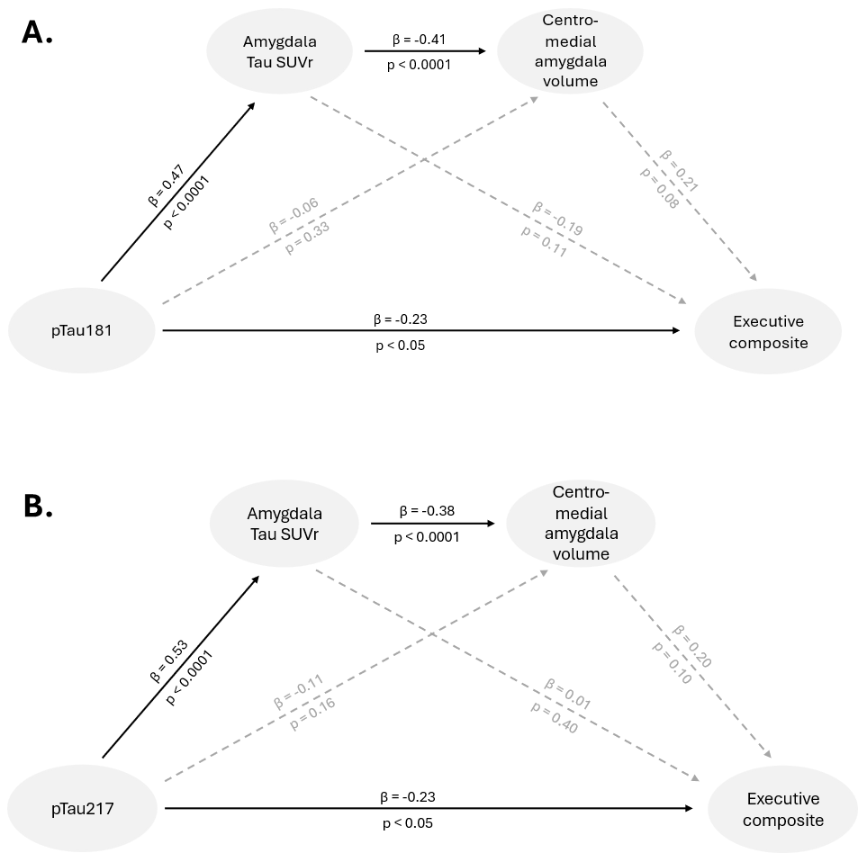
Schematic representation of the mediation model examining the direct and indirect relationships among plasma pTau, amygdala tau SUVr, centromedial amygdala volume, and executive functions. Solid black lines indicate statistically significant pathways, whereas grey dotted lines represent alternative pathways that were not statistically significant. The model was adjusted for age, sex, and education. Sample sizes (N): 152

