Comprehensive methylome-wide association study with methylation-based WGCNA profiling and functional enrichment analyses in drug-induced liver injury.
de los Santos-Fernández Romina Lorena (1), Paz-López Guillermo (2), Niu Hao (1,3), Álvarez-Álvarez Ismael (1,3), Díaz-Alberola Irene (1), Sanabria-Cabrera Judith (1), Villanueva-Paz Marina (1,3), González-Jiménez Andrés (2), Stephens Camilla (1,3), Lucena M Isabel (1,3), Medina-Cáliz Inmaculada (1,3), Andrade Raúl J (1,3).
1 Servicio de Aparato Digestivo y Farmacología clínica, Instituto de Investigación Biomédica de Málaga-IBIMA Plataforma BIONAND, Hospital Universitario Virgen de la Victoria, Universidad de Málaga, Málaga, España.
2 Bioinformatics Platform, Biomedical Research Institute of Malaga and Platform in Nanomedicine – IBIMA-BIONAND, Malaga, Spain
3 Centro de Investigación Biomédica en Red en el Área Temática de Enfermedades Hepáticas y Digestivas (CIBERehd), Madrid, España.

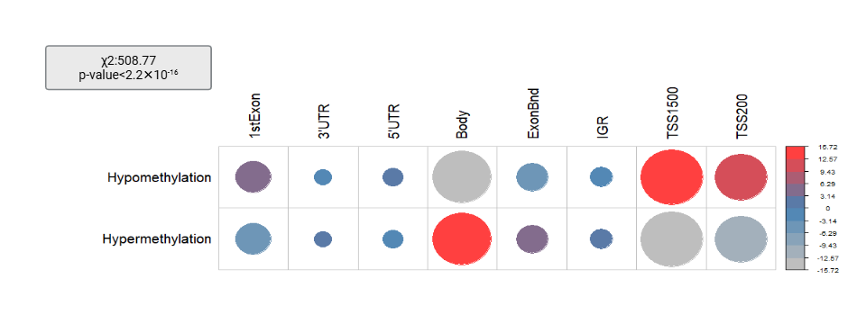
Figure S1. χ2 test and correlation plot of the standardised residues for the significant CpG sites distribution across genomic regions. In red and at a larger scale are shown the genomic regions where significant hypermethylated or hypomethylated CpG sites are most abundant. Abbreviations: 1stExon: first exon, ExonBnd: Exon boundary, IGR: intergenic region. TSS1500: transcriptional start site 1500, TSS200: transcriptional start site 200.

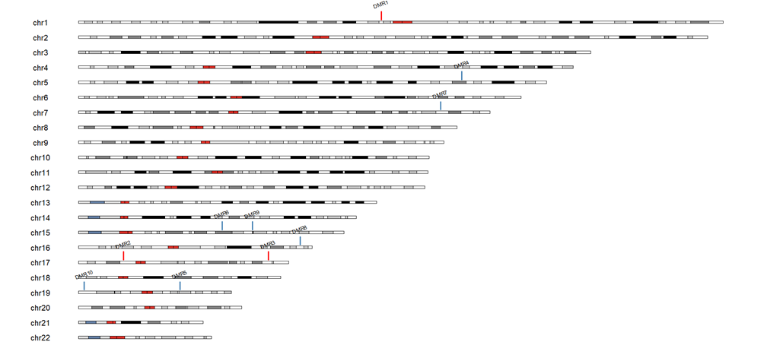
Figure S2.Top ten significant DMRs karyo plot. Abbreviations: DMR: differentially methylated region.

