Supplementary Information
A Self-Powered Ultrafast Polarization-Sensitive Multifunctional Photodetector Driven by Phonon Anisotropy in a PtSe₂/MoSe₂ Heterostructure
Priya Rani^{1,2}, Rohit Dahiya¹, Chaitanya B Auti², Pradeep Kumar^{2*} and Mukesh Kumar^{1*}
¹Functional and Renewable Energy Materials Laboratory, Department of Physics, Indian Institute of Technology Ropar, Rupnagar, Punjab – 140001, India
²School of Physical Sciences, Indian Institute of Technology Mandi, Mandi-175005, India.
*Corresponding email – mkumar@iitrpr.ac.in , pkumar@iitmandi.ac.in

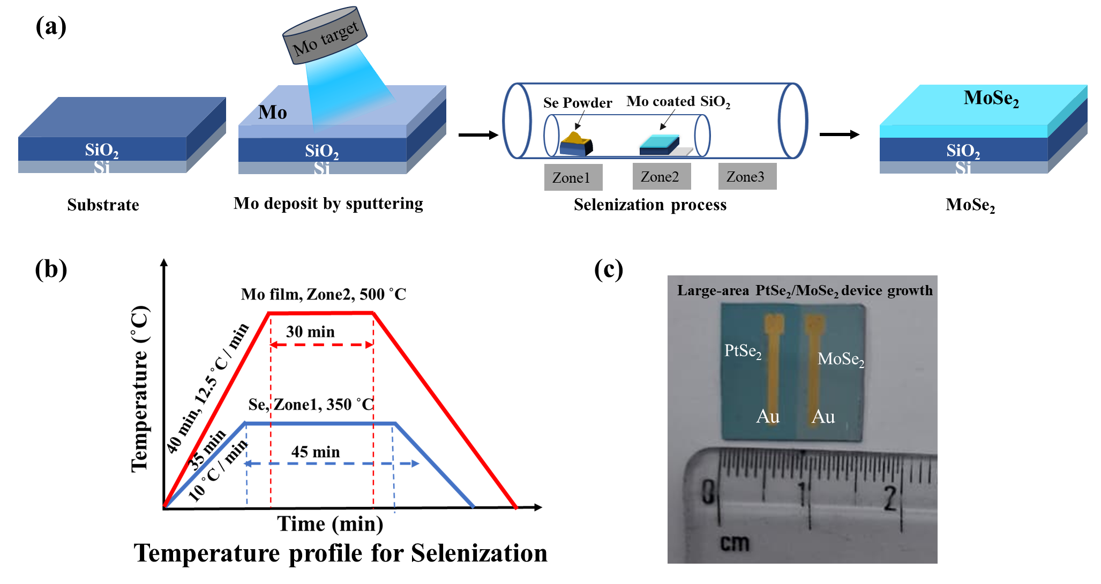
Figure S1: Growth of MoSe₂ thin film by the TAC method. (a) The schematic of the growth of the MoSe₂ film on the SiO₂/Si substrate (sputtering + CVD). (b) Temperature profile for CVD during selenization of Mo-coated thin film. (c) Large area (1.5x1.5 cm²) growth of PtSe₂/MoSe₂ device.
Note-S1. Polarization-dependent Raman measurements
Polarization-dependent Raman measurements of PtSe₂ and PtSe₂/MoSe₂ heterostructure were carried out by rotating the polarization of the incident light with a half-wave plate (λ/2 plate) in 10˚ increments, over a range of 0˚ to 360˚, while the scattered light polarization was kept fixed using an analyzer. The Raman active modes A_{1g} (~207.6 cm⁻¹) and E_{g} (~176.4 cm⁻¹) of PtSe₂ and modes of PtSe₂/MoSe₂ at E_{1g} (~169 cm⁻¹), E_{1g} (~176.4 cm⁻¹), A_{1g} (~207 cm⁻¹), and A_{1g} (~239 cm⁻¹) show a periodic variation of intensities with the rotation of incident light polarization. The angular variation of the Raman intensity can be described within a semi-classical framework. The Raman scattering intensity (I) is expressed as:
$I ∝\left|{\hat{e}}_{s}^{T}\right..R.{\left.{\hat{e}}_{i}\right|}^{2}$ (1)
where T denotes the transpose of the vector, and R represents the Raman tensor ¹. ${\hat{e}}_{i}$ and ${\hat{e}}_{s}$ representing the unit polarization vectors of the incident and scattered light, respectively. For this configuration, the polarization unit vectors of the incident and scattered light are given as ${\hat{e}}_{i}=\left[\cos\left(θ+ θ_{0}\right) \sin\left(θ+ θ_{0}\right) 0\right]$and${\hat{e}}_{s}=\left[\cos\left( θ_{0}\right) \sin\left( θ_{0}\right) 0\right]$, where $θ$ represents the relative angle between ${\hat{e}}_{i}$ and ${\hat{e}}_{s}$, whereas $θ_{0}$ defines the arbitrary angle of scattered light from the X-axis when polarization unit vectors are projected in the XY-plane (ab-plane) as illustrated in Figure S2(a). The Raman tensors corresponding to the phonon modes with $A_{1g}$ symmetry is given by:
R(A_{1g}) = $\left(\begin{matrix}a & 0 & 0 \\ 0 & a & 0 \\ 0 & 0 & b\end{matrix}\right)$,
The angular dependence of the Raman intensity for these modes can be expressed as:
$$I\left(A_{1g}\right)={(a\cos{θ_{0}}{\cos{(θ+θ_{0})}}+a\sin{θ_{0}\sin{(θ+θ_{0})}})}^{2}$$
Without the loss of generality, $θ_{0}$ may be taken as zero, resulting in the expression:
$I\left(A_{1g}\right)=a^{2}\cos^{2}θ$ (1)
As shown in Figure S2(b), the intensities of the Raman modes exhibit a periodic variation with the rotation angle, indicating a strong vibration anisotropy in PtSe₂/MoSe₂ heterostructure. The Raman intensity gives a maximum value at 0˚/180˚ and a minimum value at 90˚/270˚ angle. 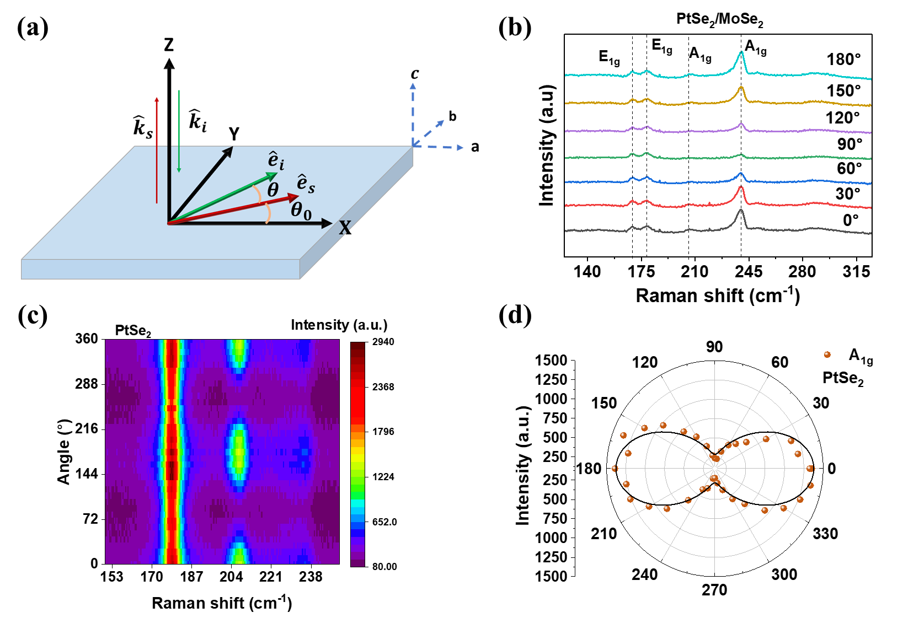Figure S2: (a) Schematic representation of the in-plane projection of the polarization vectors of the incident (${\hat{e}}_{i}$) and scattered (${\hat{e}}_{s}$) light, oriented at angles $\left(θ + θ_{0}\right)$and $θ_{0}$with respect to the X-axis, respectively. ${\hat{k}}_{i}$ and ${\hat{k}}_{s}$ represent the propagation directions of the incident and scattered beams. (b) Angle-resolved polarized Raman spectra of the PtSe₂/MoSe₂ heterostructure. (c) Polarization-dependent Raman intensity mapping of PtSe₂ as a function of polarization angle. (d) Polar plot showing the angular variation of the $A_{1g}$ mode intensity at ~205 cm⁻¹.
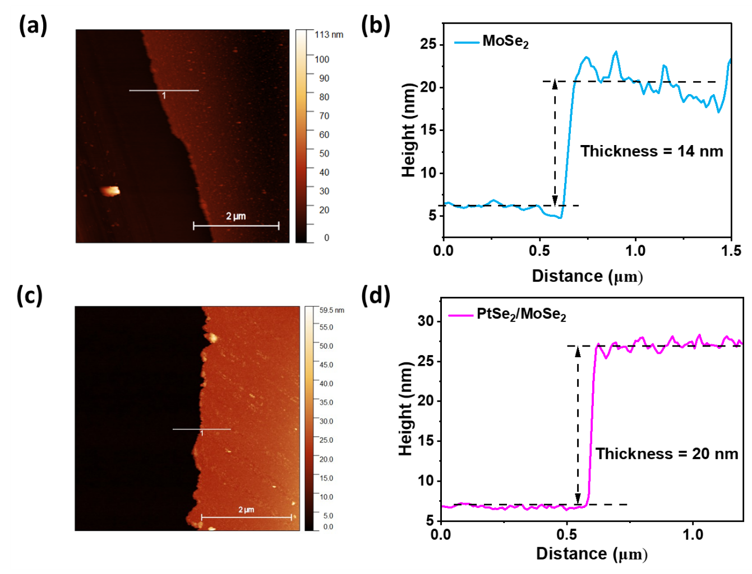
Figure S3: (a) AFM images show the step on the MoSe₂ film on SiO₂/Si substrate for the measured film thickness. (b) The height profile of the MoSe₂ film. (c) AFM characterization of the PtSe₂/MoSe₂ heterostructure. (d) The height profile and corresponding thickness.
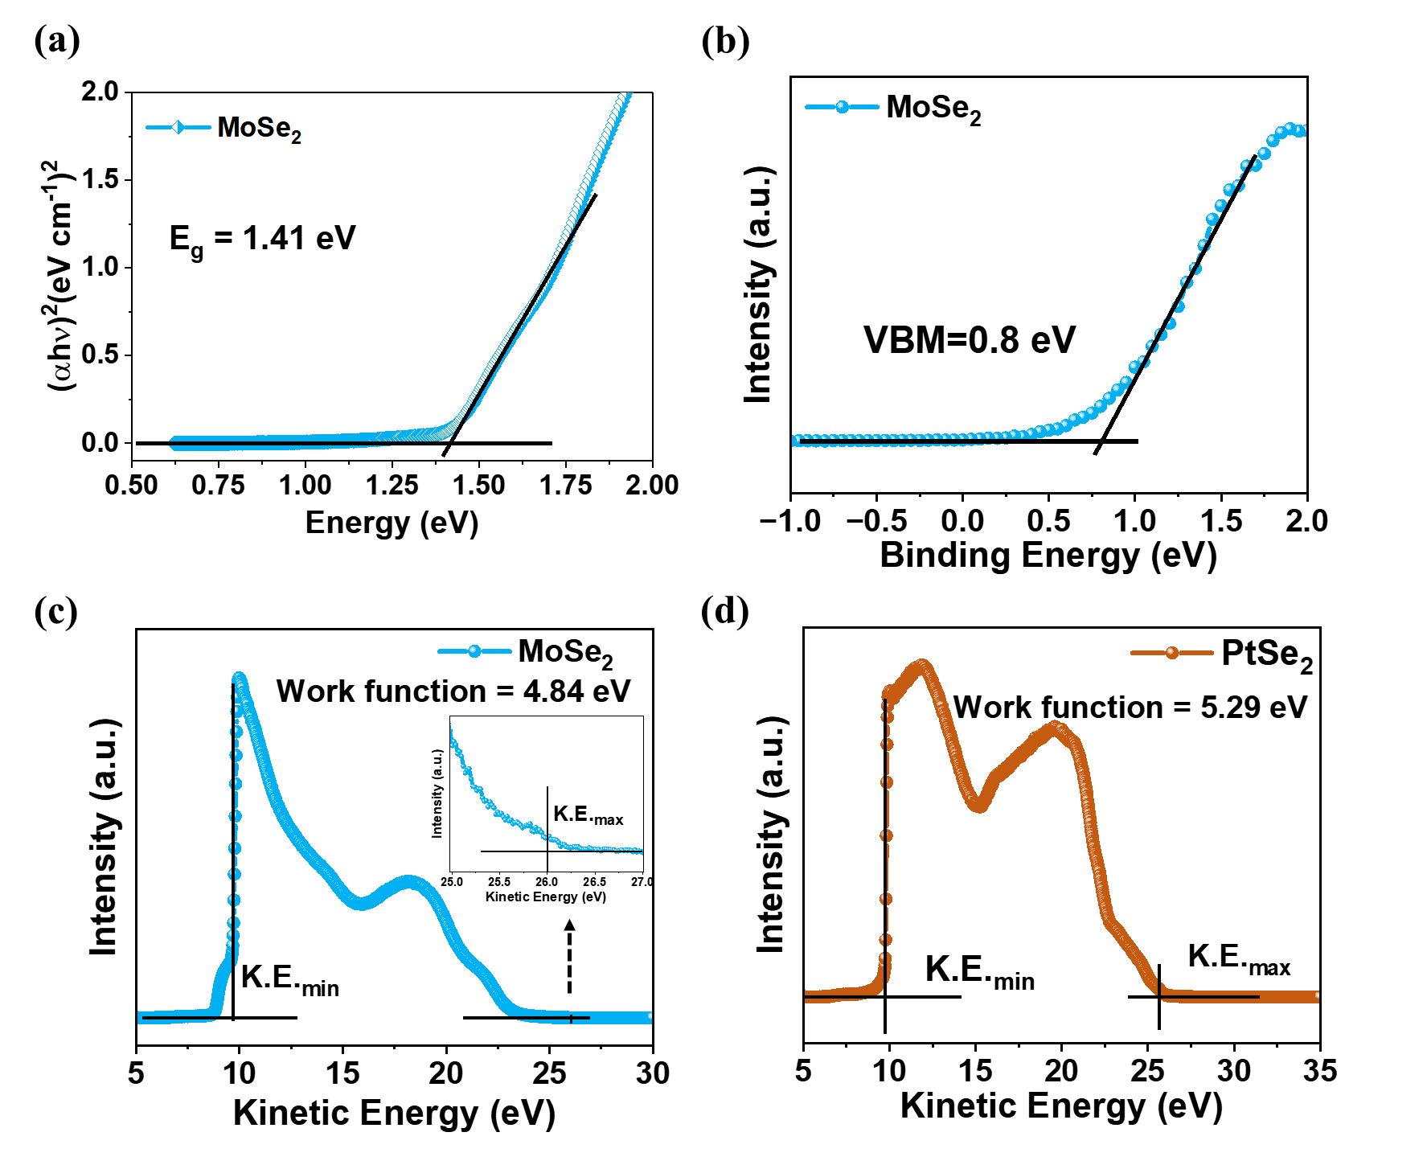
Figure S4: (a) Bandgap of MoSe₂ obtained by TAUC plot. (b) VBM of MoSe₂ from valence-band spectra data. (c) UPS spectrum of the MoSe₂ thin film and (d) PtSe₂ thin film, highlighting the secondary electron cutoff region for extracting the work function.
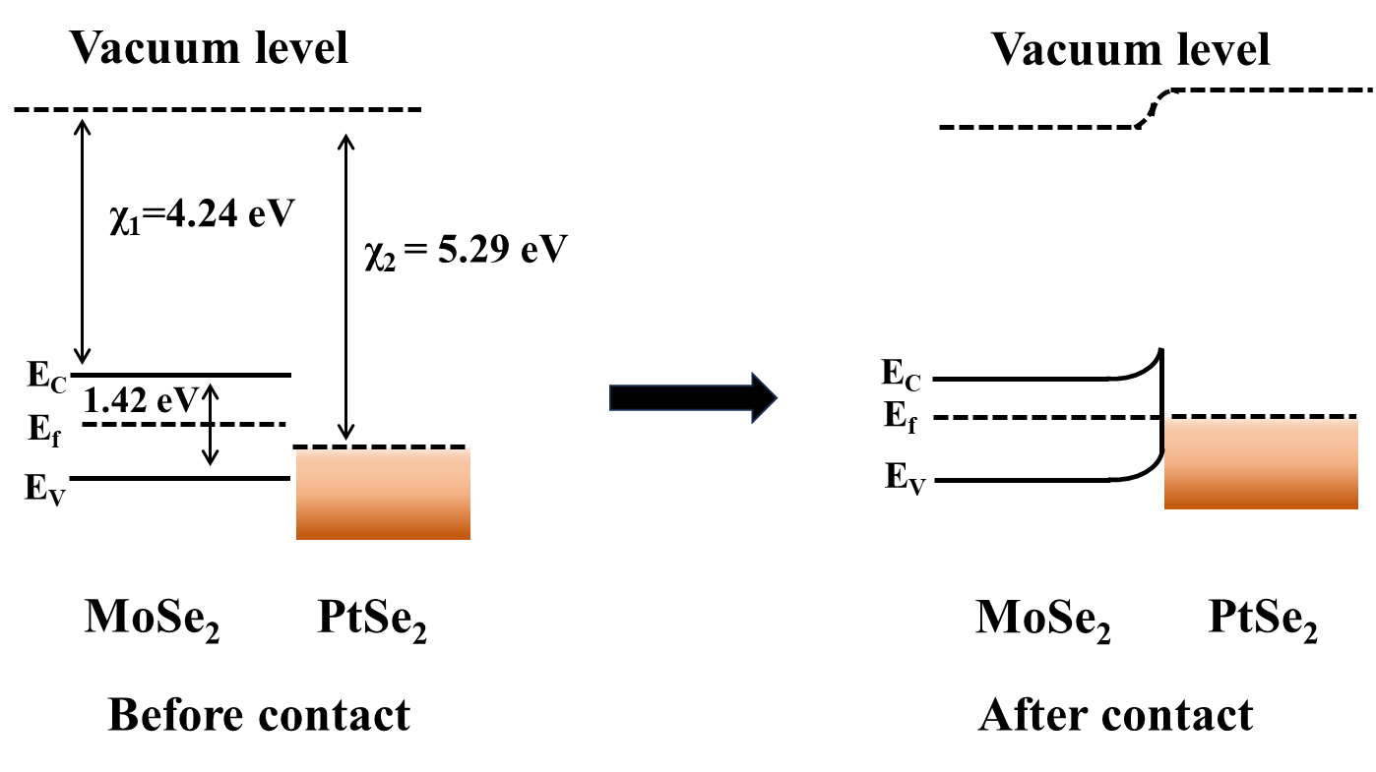
Figure S5: Energy band diagram of PtSe₂/MoSe₂ heterojunction (a) the band alignment of the individual PtSe₂ and MoSe₂ layers before forming the junction, and (b) the band structure after contact, illustrating Fermi level alignment and the formation of a built-in electric field at the interface.
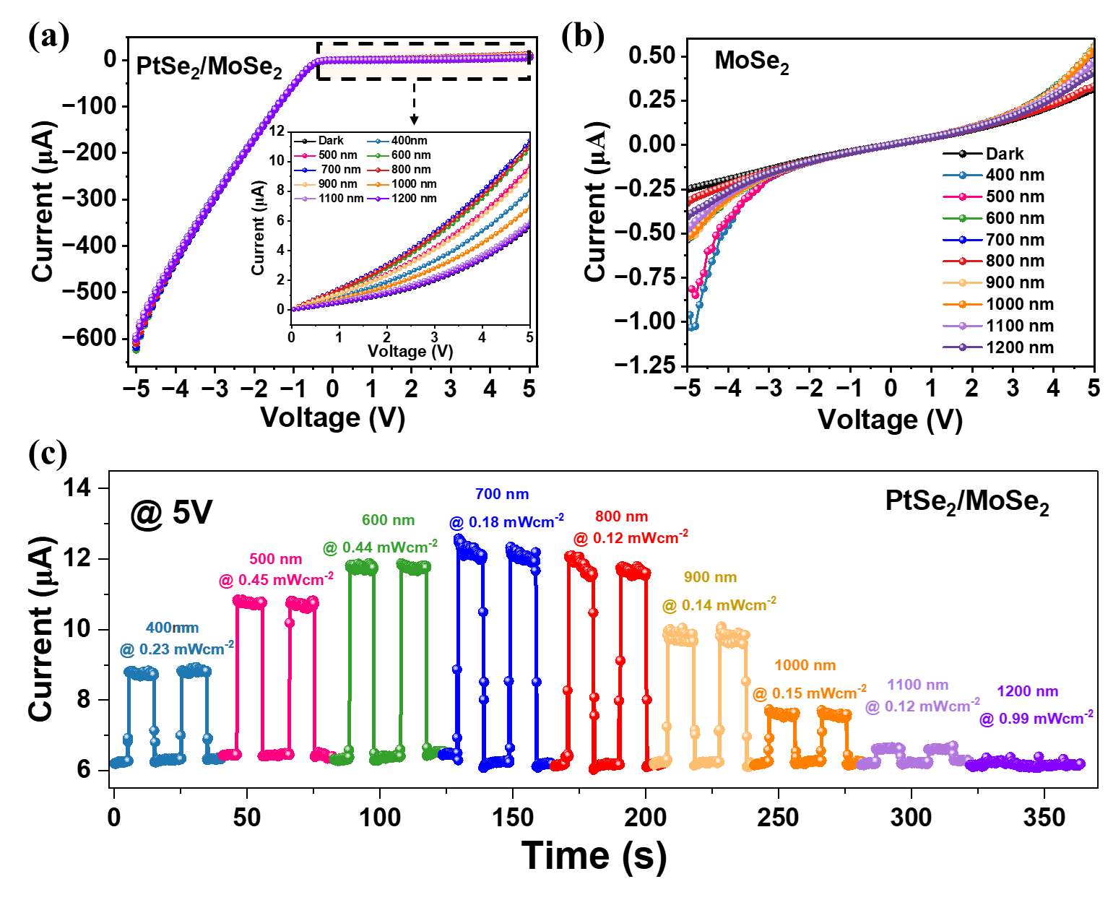
Figure S6: Device characteristics of PtSe₂/MoSe₂ and MoSe₂. (a) I-V characteristics of the heterostructure measured under dark conditions and 400-1200 nm illumination are inserted to enlarge the view of the I-V form from 0 to 5V, highlighting the device performance. (b) The I-V characteristic of the bare MoSe₂ device, showing broadband detection capability. (c) The I-T characteristics of the PtSe₂/MoSe₂ heterostructure device confirm its broadband detection performance under the 5V bias.
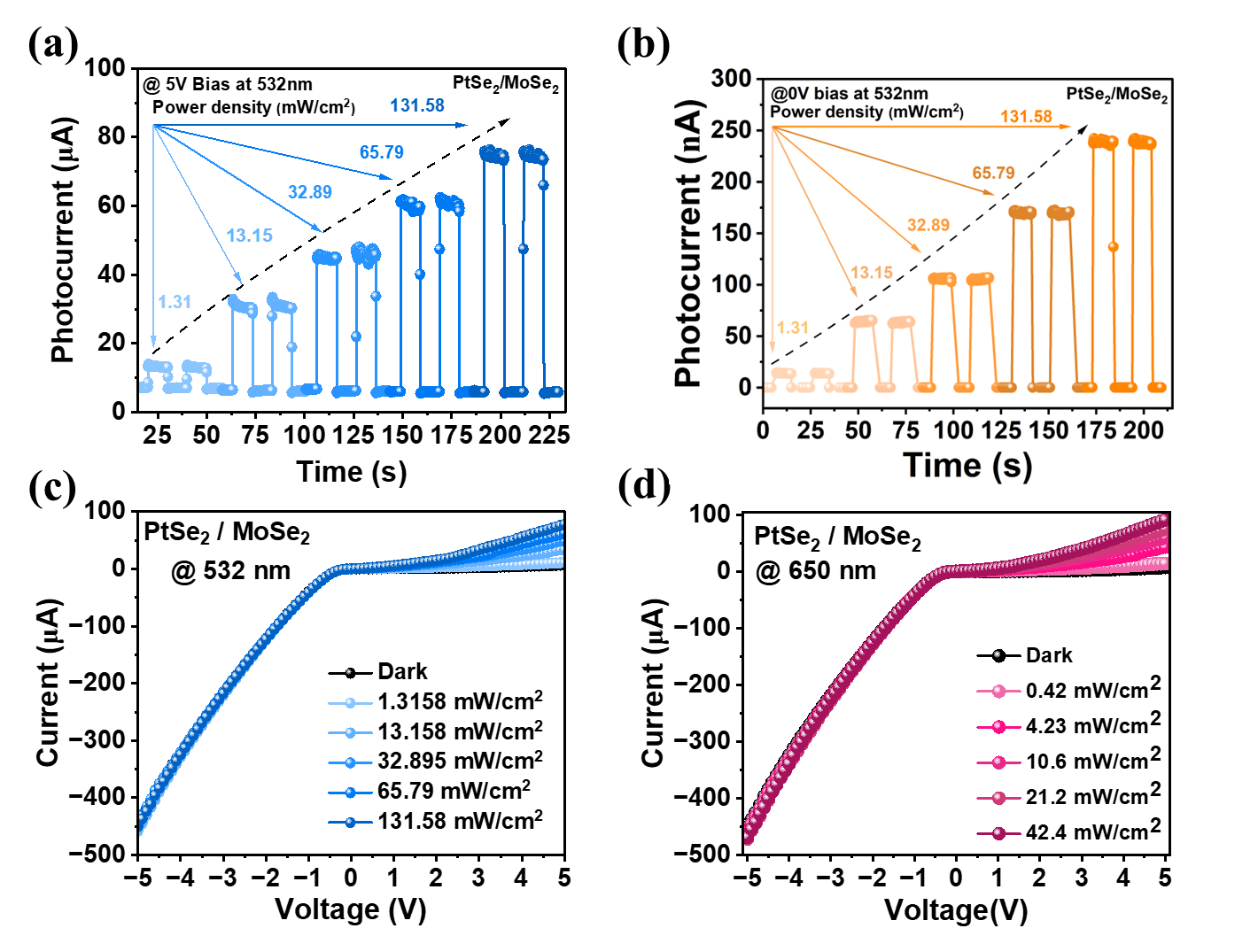
Figure S7: Power density dependent measurements of PtSe₂/MoSe₂ heterostructure device: Temporal response under 532 nm illumination at (a) 5V bias and (b) at 0V bias. Current-voltage characteristics measurement at different light intensities for (c) 532 nm and (d) 650 nm excitation.
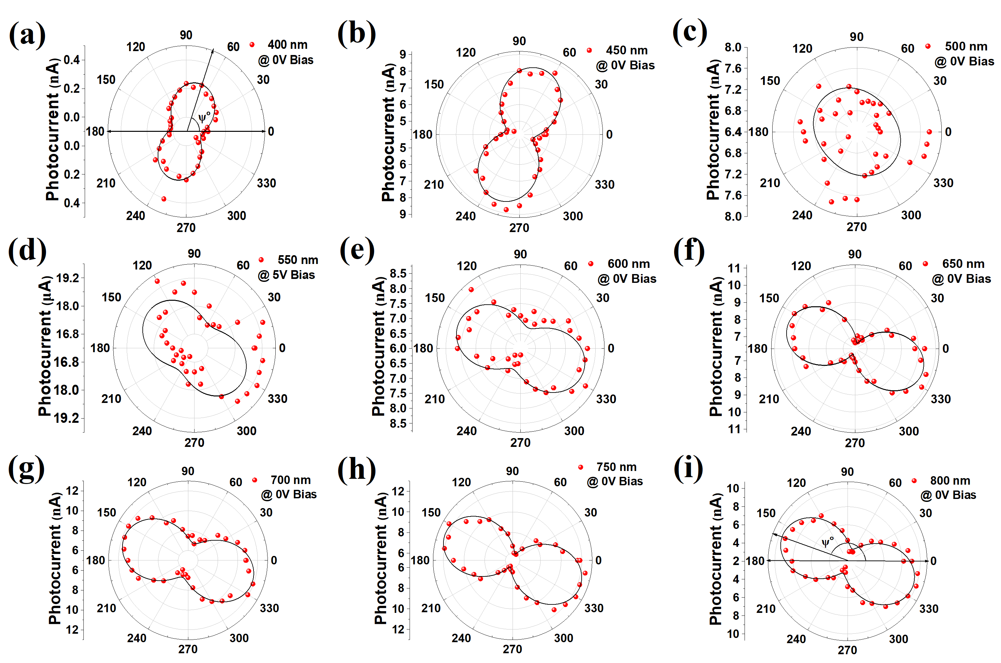
Figure S8: (a-i) Wavelength-dependent polarization response of the PtSe₂/MoSe₂ heterostructure device under illumination from 400 nm to 800 nm in self-bias condition.
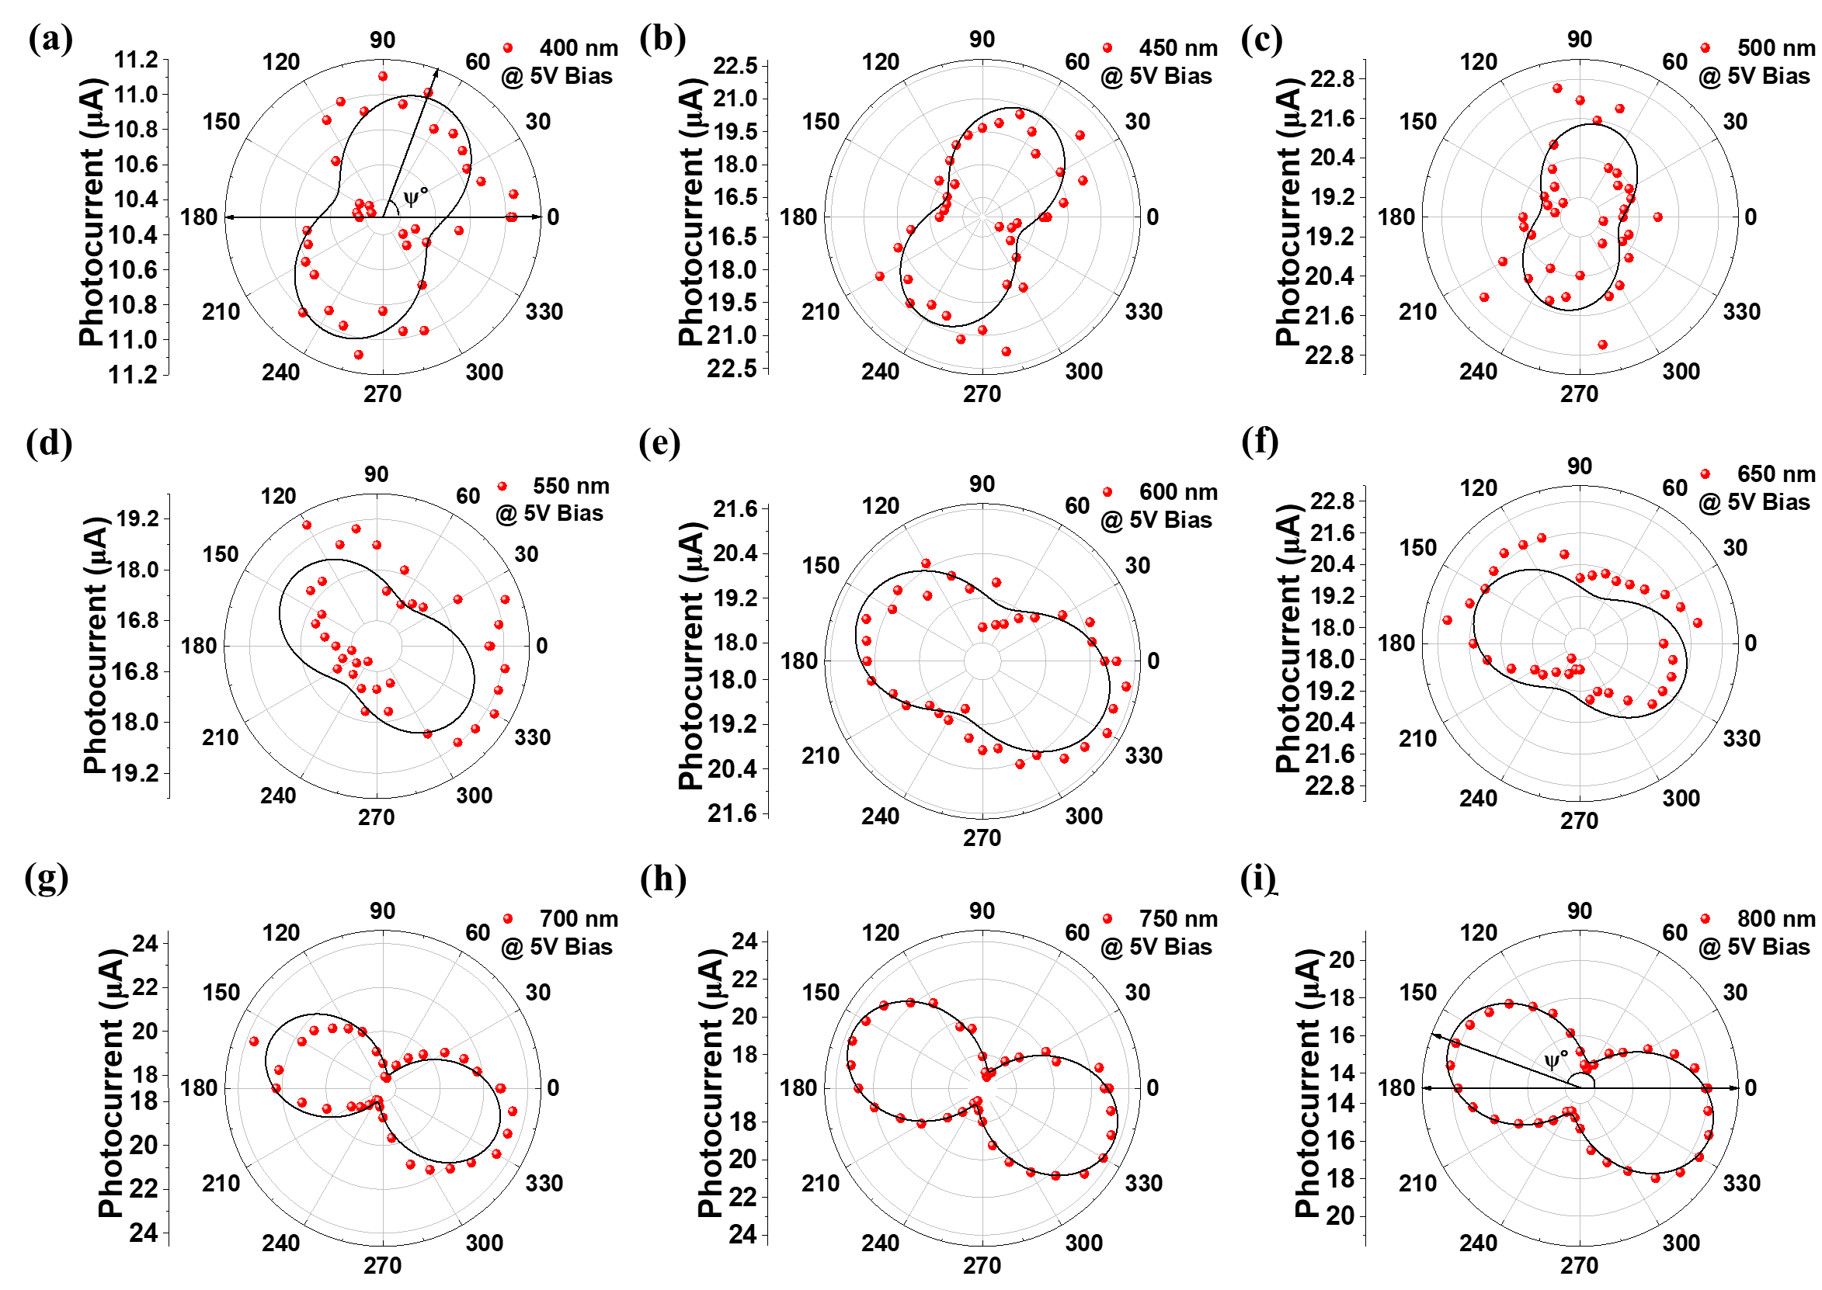
Figure S9: (a-i) Wavelength-dependent polarization response of the PtSe₂/MoSe₂ heterostructure device under illumination from 400 nm to 800 nm at a bias of 5V.
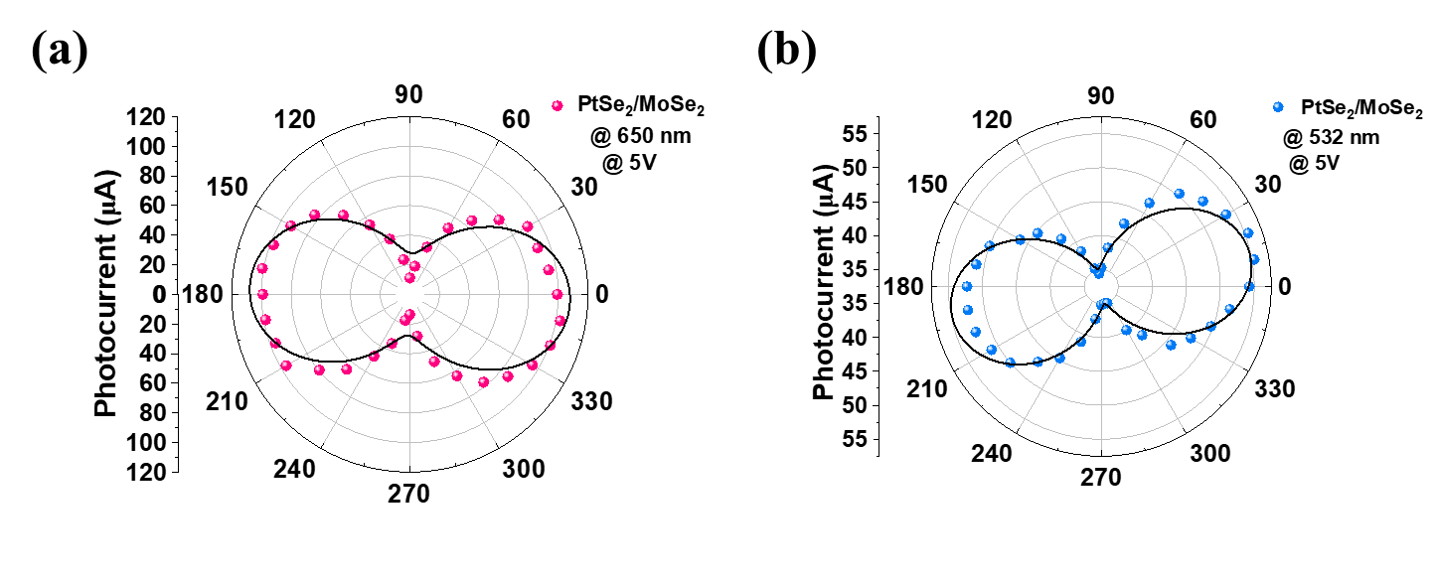
Figure S10: (a) Polar plot of polarized photocurrents under 650 nm illumination at 5V bias. Photocurrent versus polarization angle under 532 nm illumination (b) at 0V bias and (c) 5V bias.
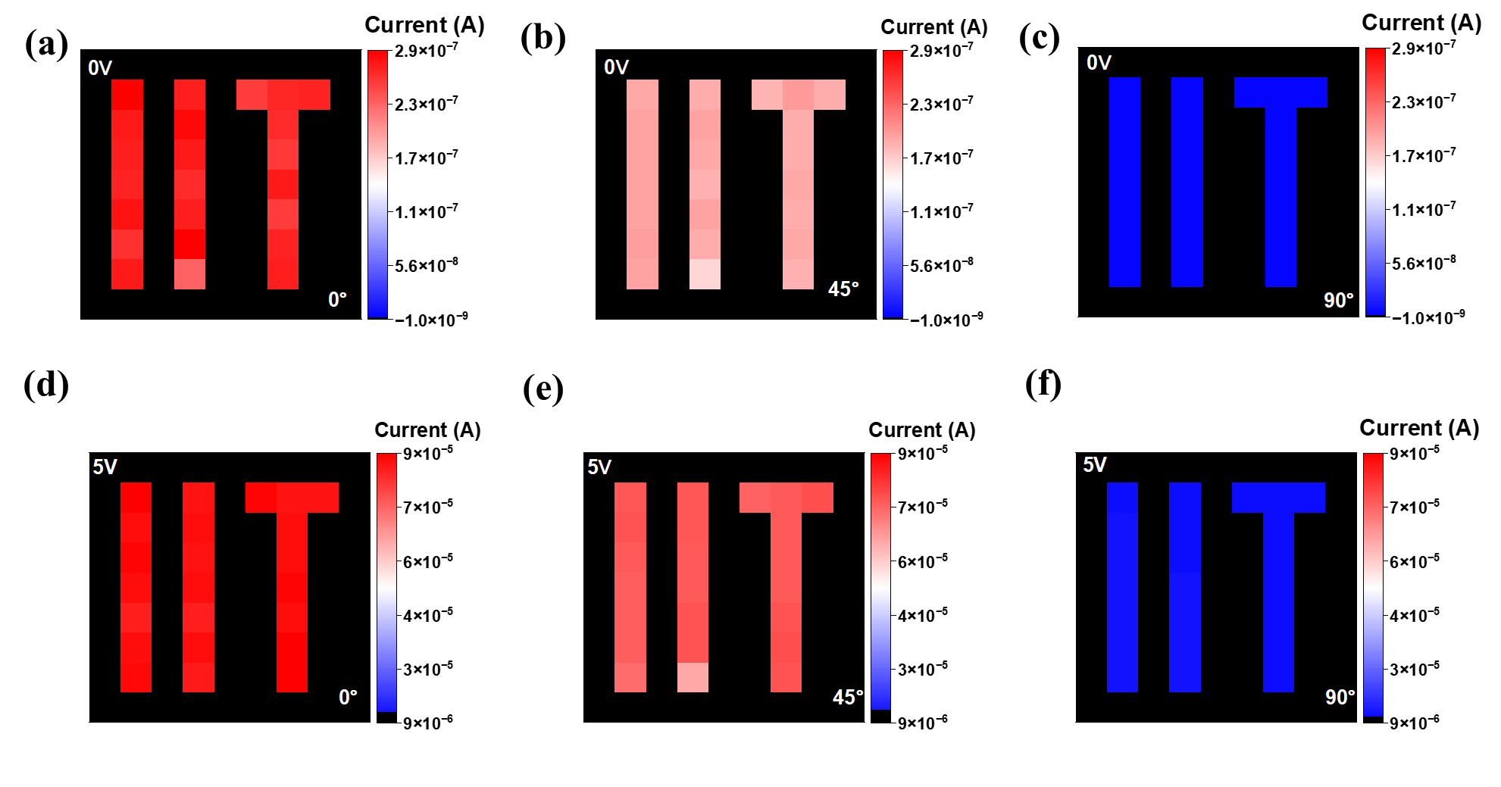
Figure S11: Polarization-dependent photocurrent mapping images at 0˚ , 45˚ , and 90˚ polarization angles: (a–c) under self-biased conditions, (d–f) at 5 V bias.
Table S1: The incident optical power density of 400 nm -1200 nm wavelength range.
Wavelength (nm) | 400 | 500 | 600 | 700 | 800 | 900 | 1000 | 1100 | 1200
Optical Power density (mW/cm⁻²) | 0.23 | 0.45 | 0.44 | 0.18 | 0.12 | 0.14 | 0.15 | 0.12 | 0.99

Table S2: Comparison of the polarization ratio of the PtSe₂/MoSe₂ heterostructure device with other self-powered polarization sensitive based photodetector.
Device | Wave-length (nm) | Detectivity (Jones) | Responsivity | Response time | Polarization Ratio | Reference
PtSe₂/MoSe₂ | 400-1200 | 1.6×10¹⁰ | 0.74 mA/W | 68 µs | 38 | This Work
MoSe₂/PdSe₂ | 785 | 0.6 × 10¹¹ | 10.1 A/W | 256/278 µs | 1.97 | ²
GeSe/MoS₂ | 532 | 1.46 × 10¹⁰ | 105 mA/W | 110/750ms | 0.35 | ³
MoTe₂/MoSe₂ | 405 | 1.15 × 10¹¹ | 130.89 mA/W | 362/480 µs | 15.48 | ⁴
T-MoSe₂/GeSe/B-MoSe₂ | 635 | 6.6 × 10¹⁰ | 206 mA W⁻¹ | 5.19/1.32 ms | 12.5 | ⁵
MoSe₂/GeSe vdWH | 635 | 6.8 × 10⁹ | 43 mA W⁻¹ | 6.62/3.32 ms, | ≈3.5 | ⁵
1T'-MoTe₂/WS₂ | 635 | 1.2 × 10¹² | 2.04 A/W | 45 µs | 5 | ⁶
WSe₂/ReSe₂ | 520 | 10⁷-10⁹ | 0.48 A/W | 2 µs | 1.67 | ⁷
PdSe₂/GaN | 405 | 7.9 × 10¹² | 249.9 mA/W | 28.5/122.6 µs | 4.5 | ⁸
GeAs/InSe | 635 | 2 × 10¹¹ | 357 mA/W | 25ms | 18 | ⁹
MoS₂/GaAs | 780 | 1.96 × 10¹³ | 35.2 mA W⁻¹ | 3.4/15.6 µs | 4.8 | ¹⁰
SnS/InSe | 635 | 1.05 × 10¹⁰ | 215 mA W⁻¹ | 8.6/4.2 ms | 4.6 | ¹¹
p-Te/n-MoSe₂ | 405 | 2.91 × 10¹³ | 2106 mA W⁻¹ | 25/22ms | 16.39 | ¹²
MoTe₂/MoS₂ | 405 | 1.2 × 10¹⁰ | 79 mA/W | 180/202 µs | 1.10 | ¹³
PdSe₂/2H–MoTe₂ | 532 | 6.46 × 10¹⁰ | 0.243A/W | 3.5/3.7 ms | 2 | ¹⁴
Te/PdSe₂ | 1550 | 5.27 × 10¹⁰ | 0.617 A/W | 4.5 μs | 3.56 | ¹⁵
PdSe₂/Perovskite | 808 | 10¹³ | 0.313 A/W | 3.5/4 μs | 6.04 | ¹⁶
GeAs/WS₂ | 1310 | 1.08 × 10¹² | 0.51 A/W | 1.3 ms | 4.5 | ¹⁷
ReS₂/WS₂ | 532 | - | 1.85 mA/W | 1.3 ms | 1.85 | ¹⁸

References
1. Auti CB, et al. Antipolar and short- and long-range magnetic ordering in quasi-two-dimensional AgCrP2S6. Journal of Materials Chemistry C, (2026).

2. Liu M, et al. Uncooled near- to long-wave-infrared polarization-sensitive photodetectors based on MoSe2/PdSe2 van der Waals heterostructures. Nature Communications 16, 2774 (2025).

3. Xin Y, et al. Polarization-Sensitive Self-Powered Type-II GeSe/MoS2 van der Waals Heterojunction Photodetector. ACS Applied Materials & Interfaces 12, 15406-15413 (2020).

4. Gao P, et al. MoTe2/MoSe2 vdW Schottky Photodetector for Polarized Photodetection. Chip, 100147 (2025).

5. An K, et al. High-Performance Self-Driven Polarization-Sensitive Imaging Photodetectors based on Fully Depleted T-MoSe2/GeSe/B-MoSe2 Van der Waals Dual-Heterojunction. Advanced Functional Materials 34, 2409331 (2024).

6. Wu J, et al. Engineering the Polarization Sensitivity in All-2D Photodetectors Composed of Semimetal MoTe2 and Semiconductor WS2. Advanced Optical Materials 10, 2201902 (2022).

7. Ahn J, et al. Near-Infrared Self-Powered Linearly Polarized Photodetection and Digital Incoherent Holography Using WSe2/ReSe2 van der Waals Heterostructure. ACS Nano 15, 17917-17925 (2021).

8. Wu D, et al. In Situ Fabrication of PdSe2/GaN Schottky Junction for Polarization-Sensitive Ultraviolet Photodetection with High Dichroic Ratio. ACS Nano 16, 5545-5555 (2022).

9. Xiong J, et al. High Performance Self-Driven Polarization-Sensitive Photodetectors Based on GeAs/InSe Heterojunction. Advanced Optical Materials 9, 2101017 (2021).

10. Jia C, et al. A self-powered high-performance photodetector based on a MoS2/GaAs heterojunction with high polarization sensitivity. Journal of Materials Chemistry C 7, 3817-3821 (2019).

11. Gao P, et al. Low-pressure PVD growth SnS/InSe vertical heterojunctions with type-II band alignment for typical nanoelectronics. Nanoscale 14, 14603-14612 (2022).

12. Zhao Q, et al. High performance polarization-sensitive self-powered imaging photodetectors based on a p-Te/n-MoSe2 van der Waals heterojunction with strong interlayer transition. Materials Horizons 8, 3113-3123 (2021).

13. Kong L, et al. Polarization-Sensitive, Self-Powered, and Broadband Semimetal MoTe2/MoS2 van der Waals Heterojunction for Photodetection and Imaging. ACS Applied Materials & Interfaces 15, 43135-43144 (2023).

14. Che M, et al. PdSe2/2H–MoTe2 Heterojunction Self-Powered Photodetector: Broadband Photodetection and Linear/Circular Polarization Capability. ACS Nano 18, 30884-30895 (2024).

15. Wang P, et al. Anisotropic Te/PdSe2 Van Der Waals Heterojunction for Self-Powered Broadband and Polarization-Sensitive Photodetection. Small 20, 2401216 (2024).

16. Zeng L-H, et al. Multilayered PdSe2/Perovskite Schottky Junction for Fast, Self-Powered, Polarization-Sensitive, Broadband Photodetectors, and Image Sensor Application. Advanced Science 6, 1901134 (2019).

17. Xiong J, et al. Multifunctional GeAs/WS2 Heterojunctions for Highly Polarization-Sensitive Photodetectors in the Short-Wave Infrared Range. ACS Applied Materials & Interfaces 14, 22607-22614 (2022).

18. Tang Y, et al. Distinctive Interfacial Charge Behavior and Versatile Photoresponse Performance in Isotropic/Anisotropic WS 2 /ReS 2 Heterojunctions. ACS Applied Materials & Interfaces 12, 53475-53483 (2020).

