Computational design and immunoinformatic validation of a multistage mRNA vaccine candidate against Mycobacterium tuberculosis
Manika Sharma¹, Parul Bhatt¹, Kiran Bharat Lokhande², Shailendra Asthana²
Medha Singh,# Monika Sharma¹, Sadhna Sharma*

Supplementary Data
Supplementary F1- Sequence similarity with the human genome – Using NCBI blastp, the designed vaccine predicted no sequence similarity with the human genome proteins.

Expression Stage | Protein name | Antigenic Score | Proinflammatory Score
Early Expressing Antigens | CFP10 | 0.7826 | 0.6768
Early Expressing Antigens | MPT-64 | 0.6006 | 0.7045
Early Expressing Antigens | Ag85B | 0.5842 | 0.7375
Early Expressing Antigens | ESAT-6 | 0.5577 | 0.6972
Early Expressing Antigens | PPE18 | 0.4625 | 0.6872
Early Expressing Antigens | TB18.5 | 0.4263 | 0.7202
Early Expressing Antigens | Mce4F | 0.4823 | 0.7088
Early Expressing Antigens | Mce4A | 0.3984 | 0.7202
Constitutive Expressing Antigens | Wag22 | 2.0041 | 0.4011
Constitutive Expressing Antigens | Rv1803c | 1.9060 | 0.4824
Constitutive Expressing Antigens | Rv1818c | 1.6972 | 0.4632
Constitutive Expressing Antigens | Rv2315 | 0.4572 | 0.7147
Late Expressing Antigens | Rv1733c | 0.4655 | 0.7267
Late Expressing Antigens | Rv1738 | 0.5034 | 0.7413
Late Expressing Antigens | Rv2006 | 0.5483 | 0.7191
Late Expressing Antigens | Rv2032 | 0.3631 | 0.6511
Late Expressing Antigens | Rv2627 | 0.2374 | 0.7409
Late Expressing Antigens | Rv2628 | 0.5355 | 0.7655

Table S1. Selection of proteins for designing mRNA vaccine-The early expressing proteins incorporated in our vaccine includes CFP10, ESAT-6, MPT64 Mce4A and Mce4F. Two late expressing proteins were selected from DosR family; Rv1738 and Rv1733c and one from Glycosyl hydrolases family 65 otsb1 (Rv2006). WAG22 (Rv1759c) was chosen from the constitutive expressing PE-PGRS family. All these proteins(yellow highlighted) are scoring good antigenic and pro-inflammatory score.

Server | Parameter | Mce4A |  | Rv3875 | Rv3874 | Rv1980c | Rv2006 | Rv1733c | Rv1738 | Rv1759c
NetMHC4.0  [Prediction of MHC Class I binders] | No. of overlapping nonamers | 392 |  | 87 | 92 | 220 | 1319 | 202 | 86 | 906
NetMHC4.0  [Prediction of MHC Class I binders] | Total no. of binding Epitopes | 245 |  | 45 | 41 | 245 | 845 | 128 | 56 | 232
NetMHC4.0  [Prediction of MHC Class I binders] | Total no. of Promiscuous epitopes | 108 |  | 23 | 20 | 153 | 597 | 80 | 33 | 109
NetMHC4.0  [Prediction of MHC Class I binders] | No. of promiscuous antigenic epitopes | 77 |  | 15 | 16 | 77 | 320 | 43 | 17 | 72
IEDB [Prediction of MHC Class II binders] | No. of overlapping nonamers | 392 |  | 87 | 92 | 220 | 1319 | 202 | 86 | 906
IEDB [Prediction of MHC Class II binders] | Total no. of binding Epitopes | 116 |  | 15 | 14 | 50 | 325 | 53 | 18 | 101
IEDB [Prediction of MHC Class II binders] | Total no. of Promiscuous epitopes | 26 |  | 2 | 1 | 11 | 179 | 13 | 4 | 14
IEDB [Prediction of MHC Class II binders] | No. of promiscuous antigenic epitopes | 8 |  | 2 | 1 | 3 | 94 | 5 | 2 | 7
NetMHC4.0  And IEDB | Overlapping  (MHC I and II)Promiscuous antigenic epitopes | 7 |  | 2 | - | - | 25 | 3 | 2 | 7

Table S2. Prediction based results of promiscuous antigenic epitopes from selected stage specific Mtb proteins- Mce4F generated more overlapping nonamers than Mce4A because of its large size. Using NETMHC4.0, both of these proteins generated same number of MHC class I restricted epitopes, promiscuous epitopes and promiscuous antigenic epitopes. Using IEDB server, Mce4F generated more MHC class II restricted epitopes as well as promiscuous antigenic epitopes than Mce4A. Rv2006 protein generated maximum number of overlapping nonamers as well as promiscuous antigenic epitopes, among all the seven proteins whereas Rv3875 generated least number of binding epitopes for both MHC class I and II. Common promiscuous epitopes for MHC class I and class II were numerous in Rv2006 and Rv1759c whereas Rv3874 and 1980c generated no common promiscuous antigenic epitope.

Proteins | Epitopes | Vaxijen Score | Pro-inflammatory | Anti-inflammatory | No. of Binders  MHCclass I(I) and MHC class II(II) | Class I Alleles | Class II Alleles
Rv3874 | EMKTDAATL | 1.282 | 0.4753 | 0.3814 | I=10,II=0 | HLA-A*02:50 , HLA-A*25:01, HLA-B*08:01, HLA-B*08:02, HLA-B*08:03 , HLA-B*15:03 , HLA-B*15:09, HLA-B*35:03, HLA-B*39:01, HLA-C*04:01 , HLA-C*07:02, HLA-C*14:02, HLA-E*01:01 | -
Rv3875 | MTEQQWNFA | 0.6826 | 0.5065 | 0.3628 | I=7,II=0 | HLA-A*01:01, HLA-A*30:01, HLA-A*66:01, HLA-A*68:02, HLA-A*68:23, HLA-A*69:01, HLA-C*05:01
Rv1980c | TSVRVAAAL | 0.82 | 0.6328 | 0.5209 | I=16,II=0 | HLA-A*26:02, HLA-A*68:02, HLA-A*69:01, HLA-B*15:09, HLA-B*42:01, HLA-B*46:01, HLA-B*48:01, HLA-B*57:01, HLA-B*58:01, HLA-C*03:03, HLA-C*14:02, HLA-C*15:02
 | YNINISLPS | 1.6693 | 0.6008 | 0.5349 | I=0 ,II=7 |  | HLA-DRB1*04:01, HLA-DRB1*09:01, HLA-DRB1*04:05, HLA-DRB1*04:04, HLA-DRB1*12:01, HLA-DRB1*13:02, HLA-DRB1*15:01
Rv2006 | LSAVVHAWV | 0.5624 | 0.5642 | 0.5163 | I= 6 ,II=3 | HLA-A*68:02, HLA-A*69:01, HLA-B*15:17, HLA-B*58:01, HLA-C*05:01, HLA-C*15:02 | HLA-DRB1*09:01, HLA-DRB1*01:01, HLA-DRB1*07:01
 | YRQLSSQHL | 0.6968 | 0.573 | 0.3535 | I= 13 , II=10 | HLA-B*08:03, HLA-B*14:02, HLA-B*15:03, HLA-B*15:09, HLA-B*27:05, HLA-B*27:20, HLA-B*39:01, HLA-B*48:01, HLA-B*73:01, HLA-C*06:02, HLA-C*07:01, HLA-C*07:02, HLA-C*14:02 | HLA-DRB1*01:01, HLA-DRB1*07:01, HLA-DRB1*09:01, HLA-DRB1*11:01, HLA-DRB1*15:01, HLA-DRB5*01:01, HLA-DRB4*01:01, HLA-DRB1*04:01, HLA-DRB1*04:04, HLA-DRB1*04:05
Rv1738 | IEAVTHQPA | 0.4704 | 0.5346 | 0.4512 | I=4,II=3 | HLA-B*40:02, HLA-B*45:01, HLA-B*18:01, HLA-B*40:01 | HLA-DRB4*01:01, HLA-DRB1*08:02, HLA-DRB1*09:01
 | VLQHWTVDI | 0.6122 | 0.5447 | 0.4209 | I=13,II=0 | HLA-A*02:19 , HLA-C*07:01, HLA-C*08:02, HLA-A*02:01, HLA-A*02:03, HLA-A*02:05, HLA-A*02:11, HLA-A*02:12, HLA-A*02:16, HLA-A*02:17 , HLA-A*02:50 , HLA-A*32:01, HLA-A*32:01, HLA-A*32:07
Rv1733c | IADAALAAL | 0.4038 | 0.5186 | 0.4651 | I=13,II=0 | HLA-A*02:06,  HLA-A*69:01,  HLA-B*14:02,  HLA-B*15:09,  HLA-B*35:01 , HLA-B*35:03,  HLA-B*39:01,  HLA-B*48:01,  HLA-C*03:03,  HLA-C*05:01,  HLA-C*08:02,  HLA-C*12:03,  HLA-C*15:02
 | ATSAPPRTK | 0.8273 | 0.5278 | 0.4047 | I=3,II=0 | HLA-A*03:01, HLA-A*11:01, HLA-A*30:01
Rv1759c | YAAAEAAAV | 0.6356 | 0.5149 | 0.5 | I=23,II=5 |  | HLA-DRB1*01:01, HLA-DRB1*04:01, HLA-DRB1*07:01, HLA-DRB1*09:01, HLA-DRB5*01:01
 | EAAAVTPLL | 0.5504 | 0.5670 | 0.5442 | I=16,II=1 | HLA-A*26:01, HLA-A*26:02, HLA-A*66:01, HLA-A*66:01, HLA-A*68:02, HLA-A*68:23, HLA-A*69:01, HLA-B*14:02, HLA-B*35:01, HLA-B*39:01, HLA-B*48:01, HLA-B*51:01, HLA-B*53:01, HLA-B*58:01, HLA-C*03:03, HLA-C*04:01, HLA-E*01:01 | HLA-DRB1*01:01
Mce4A | VQLEVNTLF | 0.6468 | 0.6243 | 0.4442 | I=17  II=3 | HLA-A*02:06,HLA-A*23:01,HLA-A*24:02,HLA-A*32:01,HLA-A*32:07,HLA-A*66:01,  HLA-B*08:03,HLA-B*15:01,HLA-B*15:02,HLA-B*15:03,HLA-B*18:01,HLA-B*38:01,  HLA-B*40:13,HLA-B*48:01,HLA-B*58:02,  HLA-C*04:01,HLA-C*05:01 | HLA-DRB1*03:01,  HLA-DRB1*04:04,  HLA-DRB1*04:01
 | TSVRVAAAL | 0.82 | 0.5945 | 0.5209 | I=16  II=0 | HLA-A*26:02, HLA-A*68:02, HLA-A*69:01, HLA-B*08:02, HLA-B*14:02, HLA-B*15:09, HLA-B*15:17, HLA-B*39:01, HLA-B*42:01¸ HLA-B*46:01, HLA-B*48:01, HLA-B*57:01, HLA-B*58:01, HLA-C*03:03, HLA-C*14:02, HLA-C*15:02 | -
 | RQANPKLPA | 1.1125 | 0.5543 | 0.3791 | I=8  II=0 | HLA-A*02:06, HLA-A*66:01, HLA-B*15:01, HLA-B*15:03, HLA-B*27:20, HLA-B*40:13, HLA-B*48:01, HLA-B*83:01 | -
Mce4F | FPALAASLA | 0.793 | 0.5358 | 0.5209 | I=9  II=6 | HLA-B*07:02, HLA-B*15:09, HLA-B*35:01, HLA-B*35:03, HLA-B*39:01, HLA-B*42:01, HLA-B*51:01, HLA-B*54:01, HLA-B*83:01 | HLA-DRB1*01:01, HLA-DRB1*09:01, HLA-DRB1*04:04, HLA-DRB1*08:02, HLA-DRB1*04:01, HLA-DRB1*04:05, HLA-DRB1*01:01,HLA-DRB1*09:01, HLA-DRB1*04:04
 | LLVVFPALF | 2.1352 | 0.5332 | 0.5209 | I=8  II=9 | HLA-A*23:01, HLA-A*29:02, HLA-B*08:02, HLA-B*08:03, HLA-B*15:01, HLA-B*15:02, HLA-B*15:03, HLA-B*58:01 | HLA-DRB1*08:02, HLA-DRB1*01:01, HLA-DRB1*09:01, HLA-DRB1*04:05, HLA-DRB1*07:01, HLA-DRB1*04:01, HLA-DRB1*15:01, HLA-DRB1*12:01, HLA-DRB5*01:01
 | LVVFPALFA | 1.5953 | 0.4998 | 0.4256 | I=3  II=4 | HLA-A*66:01, HLA-A*68:02, HLA-A*69:01 | HLA-DRB1*04:04, HLA-DRB1*09:01, HLA-DRB1*08:02, HLA-DRB1*04:01
Table S3. Characteristics of shortlisted epitopes used for vaccine designing- Predicted binding of 18 promiscuous antigenic epitopes with MHC Class I and MHC Class II along with their vaxijen score, pro-inflammatory score and anti-inflammatory score. Peptide ‘YRQLSSQHL’ of Rv2006 was found to bind with maximum 13 MHC Class I alleles and 10 MHC Class II alleles.

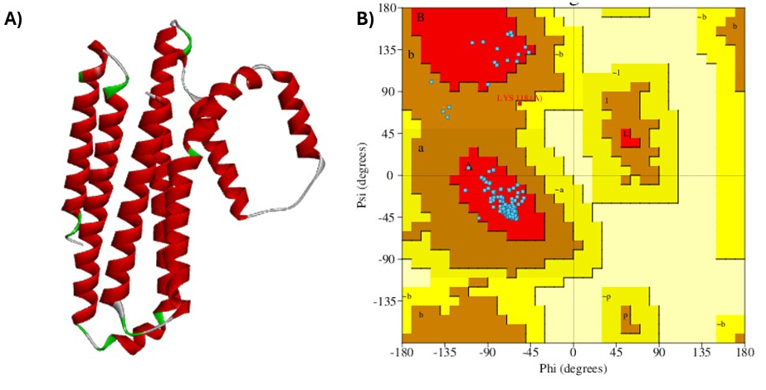
Supplementary F2- Homology Modelling using AlphaFold server- A) Visualization of 3Dmodel structure of vaccine construct where red region represents the helical region, green represents the β sheet and the grey color represents the coil area. B) Ramachandran plot of the selected model of vaccine construct.

Characteristics | Multiple Protein Profiler1.0 | ExPaSy Protparam
Length | 232 | 232
GRAVY | 0.6 | 0.6
Aliphatic Index | 110.69 | 110.69
Instability Index | 30.56 | 30.56
Stability | Stable | Stable
Molecular Weight | 24592.37 | 24592.37
Aromaticity | 0.13 | -
Isoelectric Point | 9.38 | 9.38
Charge at pH 7 | 7.07 | -
Secondary Structure Fraction (helix, turn, sheet) | [0.35, 0.12, 0.47] | -
Table S4. Physicochemical properties of designed vaccine- The scores obtained from both Multiple Protein Profiler 1.0 and the ExPASy ProtParam server for GRAVY, aliphatic index, instability index, theoretical isoelectric point (pI), and molecular weight were identical.

Vaccine Residue | TLR type | TLR Residue | Bond type | LRR region | Vaccine Residue Interacted
Glu216 | TLR2 | Arg155 | H- Bond;Electrostatic | LRR5 | Rv1759c
Asp120 | TLR2 | Lys347 | Electrostatic | - | Rv3874
Tyr211 | TLR2 | Ser60 | H- Bond | LRR1 | AAY Linker
Ala219 | TLR2 | Tyr109 | H- Bond | LRR3 | Rv1759c
Tyr212 | TLR2 | Arg155 | H- Bond | LRR5 | Rv1759c
Tyr223 | TLR2 | Ser184 | H- Bond | LRR6 | AAY Linker
Tyr127 | TLR2 | Lys422 | H- Bond | LRR15 | AAY Linker
Gln2 | TLR2 | Arg447 | H- Bond | LRR16 | Mce4A
His179 | TLR2 | Asn258 | H- Bond | LRR9 | Rv1738
Tyr211 | TLR2 | Asp58 | H- Bond | LRR1 | AAY Linker
Tyr223 | TLR2 | Asp231 | H- Bond | - | AAY Linker
Tyr151 | TLR2 | Lys37 | H- Bond;Electrostatic | - | AAY Linker
Tyr187 | TLR2 | Arg257 | Electrostatic | LRR9 | AAY Linker
His179 | TLR2 | Asn258 | H-Bond | LRR9 | Rv1738
Phe64 | TLR2 | Gln396 | H-bond | LRR14 | Mce4F
Tyr223 | TLR2 | Met159 | Hydrophobic | LRR5 | AAY Linker
Val148 | TLR2 | Lys37 | Hydrophobic | - | Rv2006
Val182 | TLR2 | Arg316 | Hydrophobic | LRR11 | Rv1738
Ala150 | TLR2 | Lys37 | Hydrophobic | - | Mce4F
Ala226 | TLR2 | Met159 | Hydrophobic | LRR5 | Rv1759c
Ala219 | TLR2 | Tyr109 | Hydrophobic | LRR3 | Rv1759c
Ala222 | TLR2 | Tyr109 | Hydrophobic | LRR3 | AAY linker
Val176 | TLR2 | His318 | Hydrophobic | LRR11 | Rv1738
Leu177 | TLR2 | His318 | Hydrophobic | LRR11 | Rv1738
Tyr151 | TLR2 | Lys37 | Hydrophobic | - | AAY linker
Thr119 | TLR4 | Val32 | H-bond | LRR2 | Rv3874
Lys208 | TLR4 | Gly267 | H-bond | LRR11 | Rv1733c
Lys208 | TLR4 | Asn268 | H-bond | LRR11 | Rv1733c
Tyr104 | TLR4 | His552 | H-bond | LRR23 | Rv1980c
Lys208 | TLR4 | Asp294 | H-bond/ Electrostatic | LRR12 | Rv1733c
Tyr212 | TLR4 | Phe263 | Hydrophobic | LRR11 | Rv1759c
Leu232 | TLR4 | Phe500 | Hydrophobic | LRR21 | Rv1759c
Tyr212 | TLR4 | Leu293 | Hydrophobic | LRR12 | Rv1759c
Table S5. TLR2 and TLR4 specified LRR regions interaction of the designed vaccine -Our designed vaccine residues show strong interaction with TLR2 and TLR4 involving hydrogen bond(H-bond), electrostatic and hydrophobic bond. Most of the interactions involved hydrogen bonding. Various LRRs regions were also analysed in which TLR2 involve 19 LRR regions and TLR4 involve 8 LRR regions specified interactions. Selected epitopes involved in interaction were also identified.

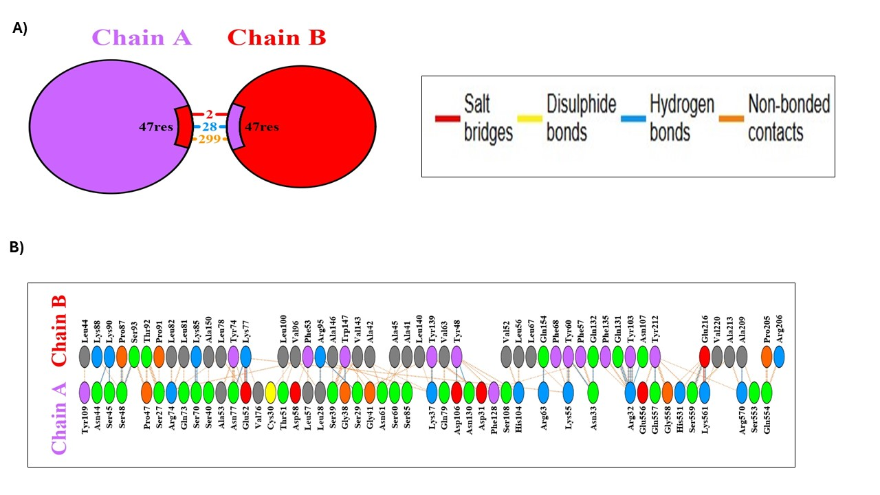
Supplementary F3. Interactions obtained via translated vaccine with TLR2- A)Chain A represents the receptor(TLR2) and Chain B represents the Ligand(translated vaccine). The interactions includes 28 hydrogen bonds(blue), two salt bridges(red) and 299 non-bonded contacts(orange). Out of total residues 47 residues are involved in generating interactions. B) Represents the interactions between the amino acids of chain A( TLR2) and chain B(translated vaccine).

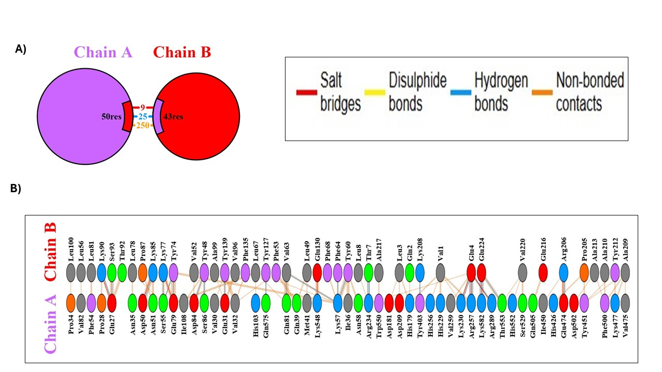

Supplementary F4. Interactions obtained via translated vaccine with TLR4- A)Chain A represents the receptor(TLR4) and Chain B represents the Ligand(translated vaccine). The interactions includes 25 hydrogen bonds(blue), 9 salt bridges(red) and 250 non-bonded contacts(orange). Of total residues, 50 residues of TLR4 and 43 residues of translated vaccine are involved in generating interactions. B) Represents the interactions between the amino acids of chain A( TLR4) and chain B(translated vaccine).

