SUPPLEMENTAL DATA

Supplemental Data 1. Partner emergency departments involved in the prospective recruitment of patients.
Hospital | No. of patients
A | 15/513 (2.9%)
B | 24/513 (4.7%)
C | 19/513 (3.7%)
D | 52/513 (10.1%)
E | 23/513 (4.5%)
F | 31/513 (6%)
G | 40/513 (7.8%)
H | 1/513 (0.2%)
I | 25/513 (4.9%)
J | 151/513 (29.4%)
K | 103/513 (20.1%)
L | 1/513 (0.2%)
M | 2/513 (0.4%)
N | 12/513 (2.3%)
O | 14/513 (2.7%)

NOTE. – Data refer to numbers of patients with percentage in parentheses.

Supplemental Data 2. Radiological variables assessed in the study. Conclusions were adapted from the French Society of Radiology proposals, as follows: (1) normal chest CT; (2) lung abnormalities but non-consistent with a pulmonary infection (herein, cardiogenic pulmonary edema); (3) consistent with a lung infection but not with COVID-19 (herein, acute community-acquired pneumonia); (4) indeterminate, however compatible with COVID-19; (5) strongly suspicious of COVID-19 (bilateral peripheral basal-predominant GGO). Abbreviations: GGO : ground-glass opacities
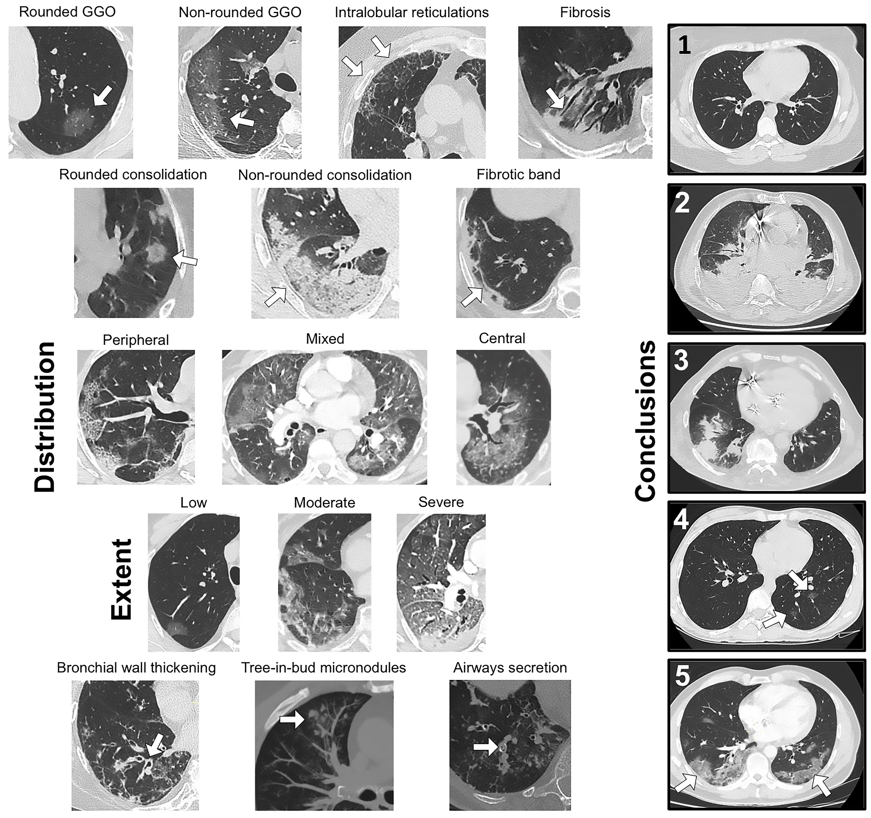

Supplemental Data 3. Final models performances on the training cohort

Performance measures | Models
Performance measures | Step-LR | CART
Radiological models (n = 412)
Accuracy§ | 0.88 (0.84 - 0.91) | 0.87 (0.83 - 0.90)
OR§ | 52.7 (29.1 - 95.3) | 43.8 (24.7 - 77.7)
Se§ | 0.88 (0.83 - 0.92) | 0.86 (0.81 - 0.91)
Sp§ | 0.87 (0.82 - 0.92) | 0.87 (0.82 - 0.92)
VPP§ | 0.87 (0.82 - 0.90) | 0.86 (0.81 - 0.9)
VPN§ | 0.89 (0.85 - 0.92) | 0.87 (0.83 - 0.91)
AUC | 0.92 (0.89 - 0.95) | 0.90 (0.87 - 0.93)
Clinical-radiological models (n = 295)§§
Accuracy§ | 0.91 (0.87 - 0.94) | 0.87 (0.83 - 0.91)
OR§ | 107. (47.8 - 239.3) | 48.9 (24.5 - 97.5)
Se§ | 0.91 (0.85 - 0.95) | 0.86 (0.79 - 0.91)
Sp§ | 0.91 (0.86 - 0.95) | 0.89 (0.83 - 0.93)
VPP§ | 0.91 (0.85 - 0.94) | 0.87 (0.82 - 0.92)
VPN§ | 0.92 (0.87 - 0.95) | 0.88 (0.82 - 0.91)

NOTE. – §. The diagnostic performance measures were calculated after dichotomizing the predicted probability for RT-PCR+ per 0.5 (i.e. < 0.5 corresponds to predicted RT-PCR- and > 0.5 to predicted RT-PCR+).
§§. 118 of the 413 (28.6%) patients from the validation cohort were excluded because of missing values (all from clinical variables).
Accuracy, OR, sensitivity, specificity, PPV, NPV and AUROC are given with 95% confidence interval.
The highest diagnostic performance measure for each line is highlighted in bold.
Abbreviations: AUC: area under the ROC curve, CART: classification and regression tree; NPV: negative predictive value; OR: odds ratio; PPV: positive predictive value; Step-LR: stepwise binary logistic regression.

