Supporting Information

Symmetry-Breaking-Driven Terahertz Nonlinearity in Topological van der Waals Heterostructures for Broadband Wireless Communication

Yichong Zhang^{1,2#}, Xiaokai Pan^{2#}, Shijian Tian^{1#}, Libo Zhang^{4*}, Mengjie Jiang⁴, Zhen Hu², Kening Xiao⁴, Yingdong Wei², Shiqi Lan^{1,2}, Jinqiu Huang⁴, Kaixuan Zhang⁴, Li Han⁵, Xijiang Chang^{1*}, Renchao Che^{1, 3*} and Lin Wang^{2*}

¹College of Physics, Donghua University, Shanghai 201620 , China.
²State Key Laboratory of Infrared Physics, Shanghai Institute of Technical Physics, Chinese Academy of Sciences, Shanghai 200083, China.
³Laboratory of Advanced Materials, Shanghai Key Lab of Molecular Catalysis and Innovative Materials, State Key Laboratory of Coatings for Advanced Equipment, College of Smart Materials and Future Energy, Fudan University, Shanghai 200438, China.
⁴College of Physics and Optoelectronic Engineering, Hangzhou Institute for Advanced Study, University of Chinese Academy of Sciences, Hangzhou 310024, China.
⁵College of Optical and Electronic Technology, China Jiliang University, Hangzhou 310018, China.

Supplementary Note 1: First-principles analysis of electronic structure and interfacial electrostatics in graphene/NiTe₂ heterostructures

In this study, the Vienna ab-initio simulation package is employed, which utilizes the projector augmented plane-wave basis for density functional theory calculations^{[1-2]}. The generalized gradient approximation proposed by Perdew, Burke, and Ernzerhof is used to describe the exchange-correlation effects of electrons^{[3]}. A plane-wave cut-off energy of 500 eV is applied. The self-consistent Kohn–Sham equations are solved with an energy convergence criterion of 10⁻⁵ eV. All structures are fully relaxed until the Hellman-Feynman forces are less than 0.001 eV/Å. The Monkhorst-Pack scheme is used to sample the Brillouin zone with a 18×18×1 k-point mesh^{[4]}. Moreover, to describe the vdW interaction accurately, we employed the DFT-D3 method with Becke-jonson damping^{[5]}.

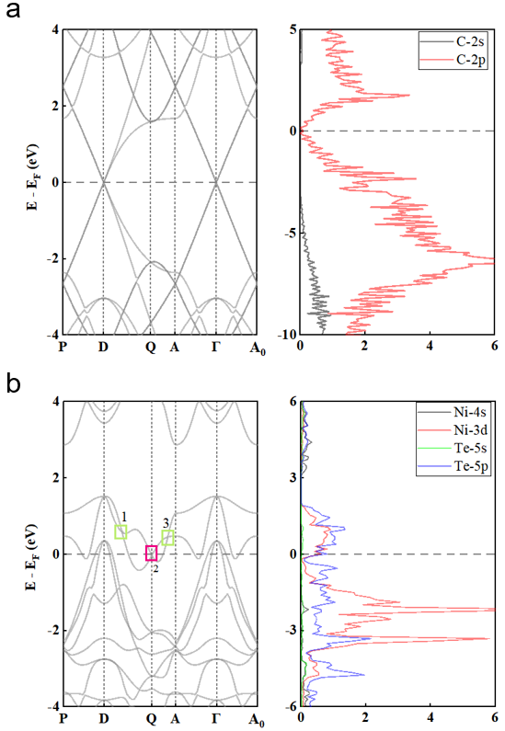

Fig. S1 a Calculated band structure and orbital-resolved density of states (DOS) of monolayer graphene. b Calculated band structure and orbital-resolved DOS of monolayer NiTe₂.

From the band structures shown in Figure S3, graphene exhibits a zero-band-gap electronic dispersion, where the conduction-band minimum and valence-band maximum touch along the Γ-D path, forming a typical type-I semimetal configuration with its Dirac point located exactly at the Fermi level. In contrast, NiTe₂ displays a type-II semimetal character, whose topological band crossings are labeled as points 1, 2, and 3 in Figure S3b, with point 2 originally situated at the Fermi level.

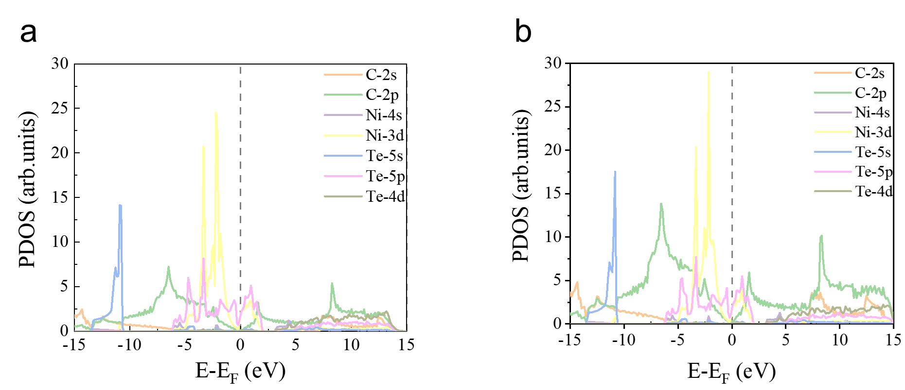
Fig. S2 Projected density of states (PDOS) for NiTe₂/graphene(a) and graphene/NiTe₂/graphene(b) structures, with the Fermi level set to zero indicated by the dashed line.

In the graphene/NiTe₂/graphene trilayer structure, the Ni 3d states exhibit higher intensity near the Fermi level, indicating a greater electronic density of states compared to the bilayer structure. This enhancement may arise from the additional graphene layer in the trilayer configuration, which provides more electronic states that interact with the d-orbital electrons of NiTe₂, thereby increasing the density of states near the Fermi level. Furthermore, the interfacial interaction between graphene and NiTe₂ is stronger in the trilayer, potentially leading to enhanced localization of electrons around the Fermi level. Such an enhanced interface effect may also contribute to the increased density of states. In addition, interlayer coupling between the graphene sheets in the trilayer structure may further influence the spatial distribution of electrons. These combined effects offer improved potential for optoelectronic device applications based on the graphene/NiTe₂/graphene trilayer system.

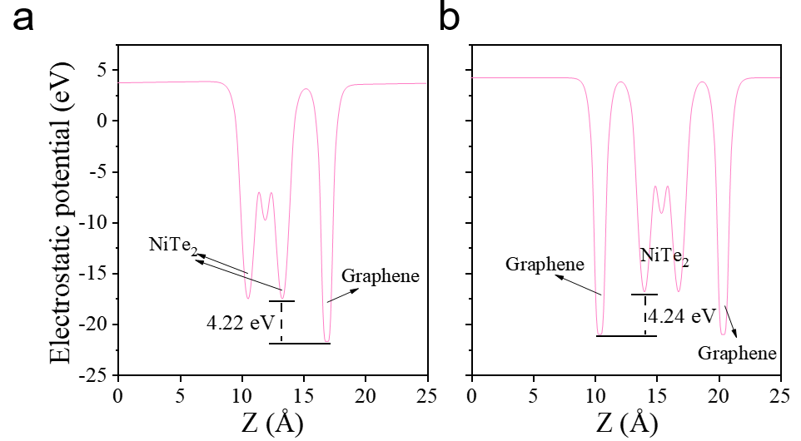
Fig. S3 Electrostatic potential energy along the Z-direction for NiTe₂/graphene(a) and graphene/NiTe₂/graphene(b) structures.

The electrostatic potential of the Graphene/NiTe2 vdWH at an equilibrium interlayer spacing of 3.59 Å is indicated in Figure S3(a). A strong electrostatic field across the vdWH results from a large potential drop of 4.22 eV between graphene and NiTe₂, which may influence the carrier dynamics and charge injection when graphene is used as an electrode. Figure S3(b) indicates a potential drop of 4.24 eV between the graphene and NiTe₂ in Graphene/NiTe₂/Graphene vdWHs, which confirms interface field enhancement due to the sandwich structure. The strength of the built-in electric field is directly related to the electrostatic potential drop, following the relation E_{built-in}=ΔV/d, where ΔV and d denote the electrostatic potential difference and the corresponding spatial separation (3.59 Å), respectively. This relation clearly indicates that the heterostructure hosts a pronounced built-in electric field. Such an internal field plays a crucial role in charge separation, band bending, and interfacial effects, thereby enhancing the performance of optoelectronic devices, catalytic reactions, and electronic applications.

Supplementary Note 2: Nonlinear mixing performance of the device

2.1 Fundamental frequency-multiplication capability of the device

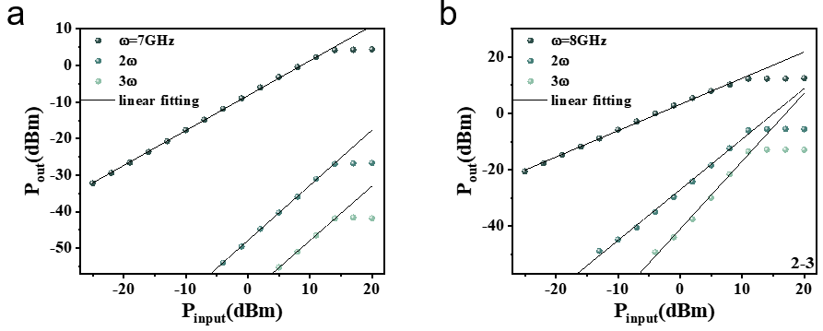
Fig. S4 Output power of the fundamental signal and its harmonic components generated from a single-frequency excitation source as a function of input power. a Fundamental signal at 7 GHz together with the corresponding second- and third-order harmonics generated from the same incident radiation. b Fundamental signal at 8 GHz with the associated higher-order harmonic responses under identical single-tone excitation. The solid black lines represent linear fits. The systematic reduction in output power for higher-order harmonics arises from the intrinsically weaker higher-order nonlinear susceptibilities and the increasing impedance mismatch and propagation loss at higher frequencies, which collectively limit the efficiency of high-order frequency multiplication.

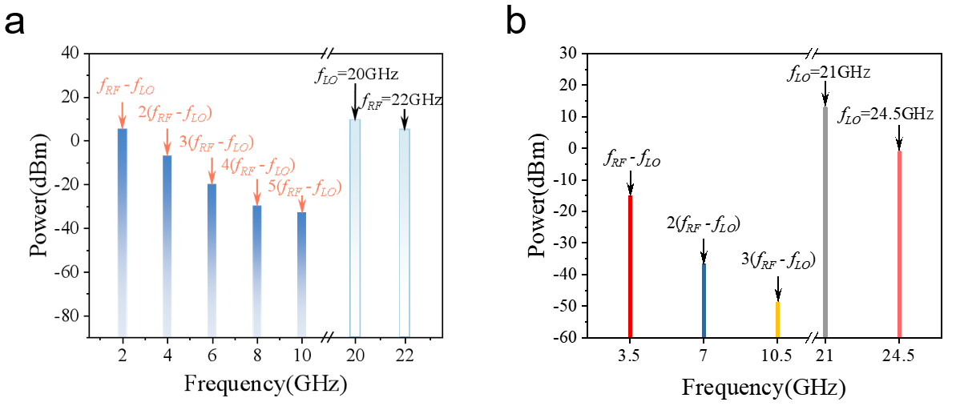

Fig. S5 a Spectrum recorded by the spectrum analyzer under the condition of ${\text{f}}_{\text{LO}}\text{=20}\text{GHz}$ and ${\text{f}}_{\text{RF}}\text{=22}\text{GHz}$. The intermediate-frequency (IF) signal at ${\text{f}}_{\text{IF}}\text{=}{{\text{f}}_{\text{RF}}\text{−}\text{f}}_{\text{LO}}$, together with its higher-order harmonic components $\text{n}\text{(}{\text{f}}_{\text{RF}}{\text{−}\text{f}}_{\text{LO}}\text{)}$ (from second to fifth order), are clearly resolved and labeled. b Frequency spectrum measured under a different heterodyne configuration with ${\text{f}}_{\text{LO}}\text{=2}\text{1}\text{GHz}$ and ${\text{f}}_{\text{RF}}\text{=2}\text{4.5}\text{GHz}$, showing consistent generation of the IF signal and its higher-order harmonics. In both cases, the gradual reduction in signal intensity with increasing harmonic order reflects the intrinsic attenuation associated with higher-order nonlinear mixing processes in the device.

2.2 Power Dependence of the Device Mixing Performance
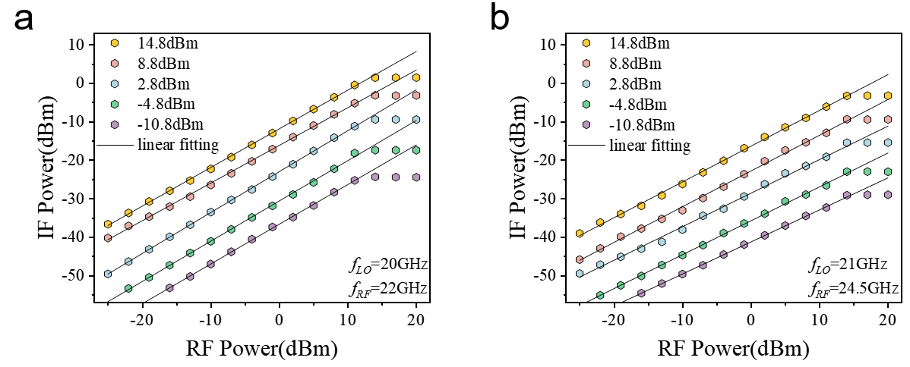
Fig. S6 Dependence of the intermediate-frequency (IF) output power on the input radio-frequency (RF) power measured under different local oscillator (LO) power levels. Panels (a) and (b) correspond to two representative heterodyne configurations with ${\text{f}}_{\text{LO}}\text{=20}\text{GHz}$，${\text{f}}_{\text{RF}}\text{=22}\text{GHz}$ and ${\text{f}}_{\text{LO}}\text{=2}\text{1}\text{GHz}$, ${\text{f}}_{\text{RF}}\text{=2}\text{4.5}\text{GHz}$, respectively. Each data set represents a fixed LO power, while the black lines indicate linear fits to the experimental data, confirming the linear scaling of the IF signal with RF input power.

To reveal the relationship between the output power and input power, we consider the following relationship: ${\text{P}}_{\text{out}}\text{=}\text{α}{{\text{P}}_{\text{LO}}\text{P}}_{\text{RF}}^{\text{β}}$, where $\text{α}$ is the proportional constant, ${\text{P}}_{\text{LO}}$ and ${\text{P}}_{\text{RF}}$ represent the LO and RF signal powers, respectively, and $\text{β}$ is the power dependence exponent. Figure S5 evaluates the dependence of the IF output power on the RF signal power under different LO signal powers. The fitting shows that the ${\text{P}}_{\text{IF}}$-${\text{P}}_{\text{RF}}$ follows a linear relationship. The minimum detectable RF signal power is -25 dBm. More importantly, even when the LO signal is as low as -10.8 dBm and the RF signal is as low as -16 dBm, the IF signal can still be clearly detected (with actual detectable power being even lower due to the resolution bandwidth limitation), demonstrating that our mixer possesses a high dynamic range and a strong capability for detecting weak signals.

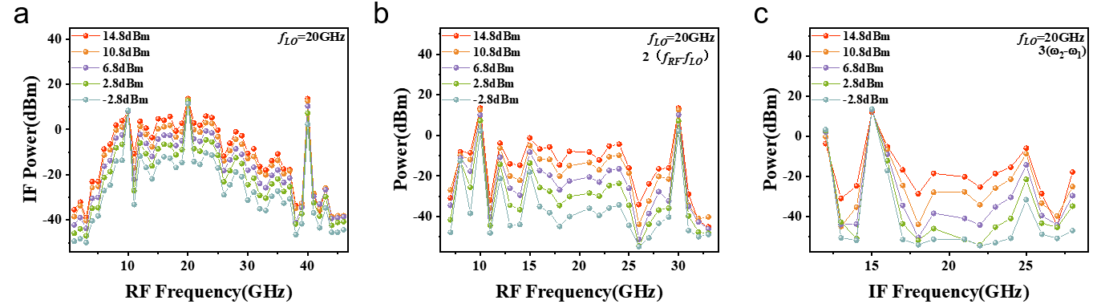
Fig. S7 Power dependence of the intermediate-frequency (IF) output under higher-order nonlinear mixing. a IF power as a function of RF frequency at different LO input power levels with a fixed local oscillator frequency of ${\text{f}}_{\text{LO}}\text{=20}\text{GHz}$, showing broadband frequency down-conversion. b Corresponding second-order harmonic mixing components at $\text{2}\text{(}{\text{f}}_{\text{RF}}{\text{−}\text{f}}_{\text{LO}}\text{)}$) under the same LO condition. c Third-order mixing products at $\text{3}\text{(}{\text{f}}_{\text{RF}}{\text{−}\text{f}}_{\text{LO}}\text{)}$, plotted as a function of IF frequency for different LO input powers.

In all panels, increasing RF input power leads to a systematic enhancement of the IF output. And Higher-order harmonic components show reduced intensity with increasing order, consistent with the expected attenuation in nonlinear mixing processes.

2.3 Broadband Bandwidth of Intermediate-Frequency and Harmonic Mixing Signals
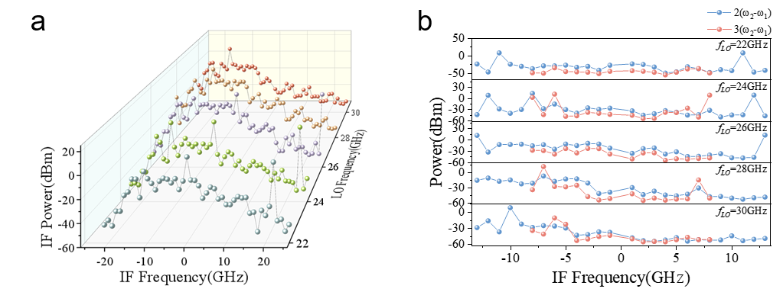
Fig. S8 a Intermediate-frequency (IF) spectra measured at different local oscillator (LO) frequencies. The IF power distribution is plotted as a function of IF frequency for LO frequencies of 22, 24, 26, 28, and 30 GHz. For each LO setting, the IF spectrum spans a bandwidth of ±26.5 GHz, demonstrating the broadband down-conversion capability of the device. The observable bandwidth is limited by the frequency range of the spectrum analyzer, indicating that the intrinsic IF bandwidth may extend beyond the measured range. b IF spectra of higher-order harmonic mixing components measured at corresponding LO frequencies. The power distributions of the second- and third-order IF harmonics are plotted as a function of IF frequency, showing continuous and broadband frequency coverage across the measured range. The persistence of wide bandwidth for higher-order harmonics further confirms the robust broadband nonlinear mixing capability of the device.

2.4 High-order harmonic-assisted access to W-band mixing using low-frequency LO signals
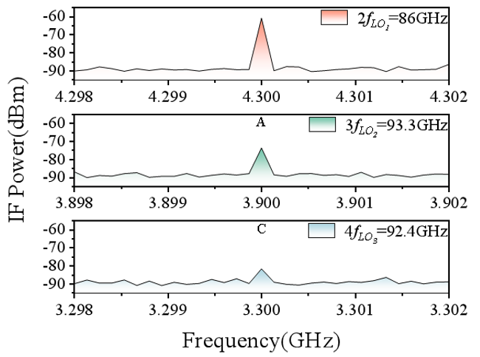
Fig. S9 Intermediate-frequency (IF) spectra of high-order harmonic mixing enabled by the intrinsic frequency multiplication of the device. By setting the fundamental local oscillator (LO) frequency between 21 and 31 GHz, second-, third-, and fourth-order LO harmonics are generated near 90 GHz, allowing heterodyne mixing at W-band frequencies using a low-frequency LO source. Although the output power decreases for higher-order harmonics, distinct IF peaks remain clearly resolvable, demonstrating that the device supports high-frequency mixing through its inherent harmonic generation capability.

Supplementary Note 3: Long-Range Free-Space Heterodyne Mixing Demonstration
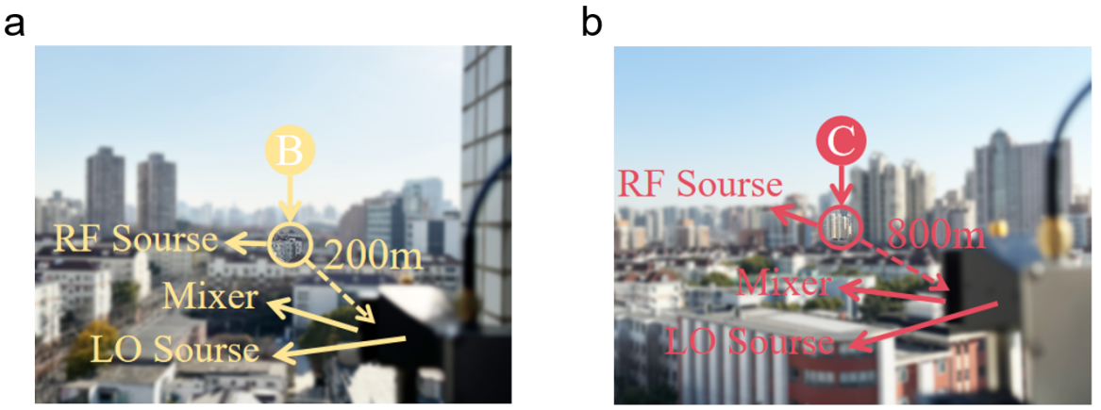
Fig. S10 Photographs of the free-space experimental setup demonstrating long-range heterodyne mixing. The mixer directly receives radio-frequency (RF) signals transmitted over free-space distances of 200 m (a) and 800 m (b), while the local oscillator (LO) signal is supplied locally. The clear identification of mixed signals at both distances confirms the robustness of the device for long-range wireless heterodyne operation under realistic outdoor propagation conditions.

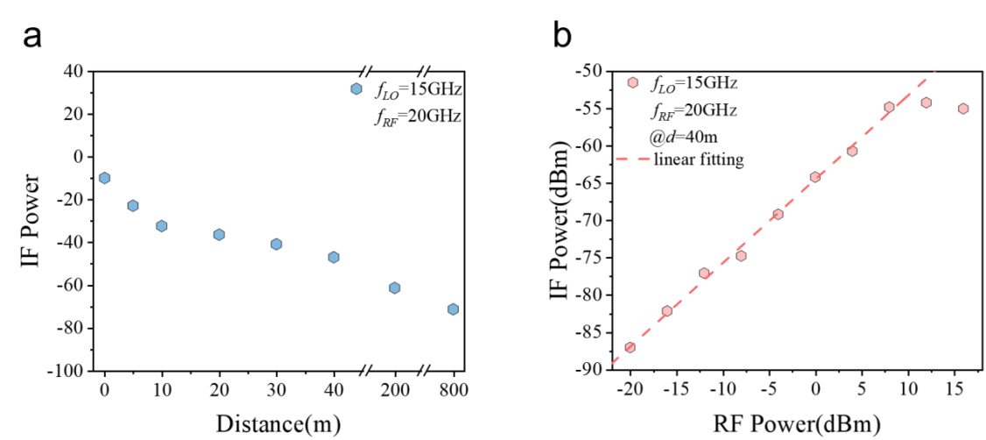
Fig. S11 a Variation of the intermediate frequency(IF) signal as a function of the distance between the radio frequency(RF) source and the mixer, under the condition of $f_{LO}=15GHz$ and $f_{RF}=20GHz$. b Dependence of the intermediate frequency (IF) signal on the radio frequency(RF) power under the mixing condition of $f_{LO}=15GHz$ and $f_{RF}=20GHz$, with a fixed distance of 40 meters between the radio frequency(RF) source and the mixer.

References
[1] Kresse, G.; Joubert, D. From Ultrasoft Pseudopotentials to the Projector Augmented-Wave Method. Physical Review B 1999, 59.
[2] Kresse, G.; Furthmuller, J. Efficiency of Ab-Initio Total Energy Calculations for Metals and Semiconductors Using a Plane-Wave Basis Set. Comput. Mater. Sci 1996, 6, 15-50.
[3] Perdew, J. P.; Burke, K.; Ernzerhof, M. Generalized Gradient Approximation Made Simple. Physical Review Letters 1996, 77, 4.
[4] Monkhorst, H. J.; Pack, J. D. Special Points for Brillouin-Zone Integrations. Physical Review B 1976, 13, 5.
[5] E.R. Johnson, A.D. Becke, A post-Hartree-Fock model of intermolecular interactions: Inclusion of higher-order corrections. J. Chem. Phys., 124 (2006), 174104.

