Appendix
Table S1. Unadjusted Cox proportional hazards models for all-cause mortality
Characteristic | Category | HR (95% CI) | p-value
Age group (years) | 0–14 (Ref) | Ref
 | 15–44 | 1.31 (1.14, 1.52) | <0.001
 | 45–54 | 1.94 (1.68, 2.24) | <0.001
 | 55–64 | 2.78 (2.41, 3.19) | <0.001
 | 65–74 | 4.04 (3.52, 4.65) | <0.001
 | 75+ | 8.09 (7.04, 9.30) | <0.001
 | Unknown | 0.78 (0.66, 0.93) | 0.006
Sex | Female (Ref) | Ref
 | Male | 1.15 (1.14, 1.17) | <0.001
Race | White (Ref) | Ref
 | American Indian/Alaska Native | 1.09 (1.01, 1.17) | 0.025
 | Asian or Pacific Islander | 1.02 (0.99, 1.04) | 0.213
 | Black | 1.00 (0.98, 1.03) | 0.705
 | Unknown | 0.28 (0.25, 0.30) | <0.001
Rurality | Counties in metropolitan areas ge 1 million pop (Ref) | Ref
 | Counties in metropolitan areas of 250,000 to 1 million pop | 1.02 (1.01, 1.04) | 0.004
 | Counties in metropolitan areas of lt 250 thousand pop | 1.14 (1.12, 1.17) | <0.001
 | Nonmetropolitan counties adjacent to a metropolitan area | 1.20 (1.17, 1.22) | <0.001
 | Nonmetropolitan counties not adjacent to a metropolitan area | 1.27 (1.23, 1.31) | <0.001
 | Unknown | 0.74 (0.58, 0.94) | 0.016
Median household income (quartile) | Q1 (Lowest) (Ref) | Ref
 | Q2 | 1.02 (1.01, 1.04) | 0.011
 | Q3 | 0.98 (0.96, 1.00) | 0.013
 | Q4 (Highest) | 0.91 (0.89, 0.92) | <0.001
Chemotherapy | Unknown/No (Ref) | Ref
 | Yes | 0.85 (0.84, 0.86) | <0.001
Radiation/Surgery sequence | Any radiation (any timing) (Ref) | Ref
 | Other | 2.67 (0.38, 18.98) | 0.327
 | Unknown | 2.81 (2.59, 3.05) | <0.001
Time to treatment initiation (days) | 0–14 (Ref) | Ref
 | 15–30 | 0.90 (0.88, 0.92) | <0.001
 | >30 | 0.67 (0.66, 0.69) | <0.001
 | Unknown | 1.17 (1.15, 1.18) | <0.001
Diagnosis period(Year) | Pre-COVID-19 (Ref) | Ref
 | Post-COVID-19 | 1.04 (1.03, 1.06) | <0.001
Hematologic malignancy subtype (AYA site recode) | 1.1 Acute lymphoblastic leukemia (Ref) | Ref
 | 1.2.1 Acute promyelocytic leukemia | 1.03 (0.93, 1.14) | 0.603
 | 1.2.2 Other acute myeloid leukemia | 4.90 (4.69, 5.12) | <0.001
 | 1.3 Chronic myeloid leukemia | 1.21 (1.15, 1.28) | <0.001
 | 1.4 Chronic lymphocytic leukemia | 0.68 (0.65, 0.71) | <0.001
 | 1.5 Polycythemia vera | 0.44 (0.41, 0.47) | <0.001
 | 1.6 Essential thrombocythemia | 0.43 (0.40, 0.46) | <0.001
 | 1.7 Primary myelofibrosis | 1.41 (1.30, 1.52) | <0.001
 | 1.8 Myelodysplastic syndrome (MDS) | 2.64 (2.53, 2.76) | <0.001
 | 1.9.1 Hairy cell leukemia | 0.42 (0.36, 0.49) | <0.001
 | 1.9.2 Other lymphocytic/lymphoblastic leukemias | 1.27 (1.16, 1.38) | <0.001
 | 1.9.3 Other myeloid leukemias | 3.27 (2.96, 3.61) | <0.001
 | 1.9.4 Leukemias of mixed phenotype | 2.12 (1.77, 2.53) | <0.001
 | 1.9.5 Mast cell diseases | 0.72 (0.58, 0.89) | 0.003
 | 1.9.6 Other | 2.03 (1.92, 2.14) | <0.001
 | 2.1.1 Lymphoblastic | 1.39 (1.25, 1.54) | <0.001
 | 2.1.2 Burkitt | 1.24 (1.12, 1.38) | <0.001
 | 2.1.3 Diffuse large B-cell (DLBCL) | 1.65 (1.58, 1.72) | <0.001
 | 2.1.4 Primary mediastinal large B-cell excluded from DLBCL | 0.26 (0.20, 0.35) | <0.001
 | 2.1.5 Anaplastic T- and null-cell excluding NK/T-cell | 1.25 (1.18, 1.32) | <0.001
 | 2.1.6 Follicular | 0.57 (0.54, 0.60) | <0.001
 | 2.1.7 NK/T-cell (excluded from anaplastic T-cell) | 2.21 (1.89, 2.58) | <0.001
 | 2.1.8 MALT (mucosa-associated lymphoid tissue) | 0.53 (0.50, 0.56) | <0.001
 | 2.1.9 Other non-Hodgkin lymphoma NOS | 1.15 (1.09, 1.21) | <0.001
 | 2.2.1 Hodgkin NLP | 0.15 (0.12, 0.20) | <0.001
 | 2.2.2 Hodgkin classic - other | 0.47 (0.44, 0.50) | <0.001
 | 2.3 Myeloma | 1.37 (1.31, 1.43) | <0.001
 | 2.4 Cutaneous lymphomas | 0.54 (0.44, 0.65) | <0.001
 | 2.5 Other B- and T-cell lymphomas | 1.12 (1.03, 1.22) | 0.007
 | 2.6.1 Histiocytic and dendritic cell neoplasms | 0.40 (0.33, 0.48) | <0.001
 | 2.6.2 Lymphoma NOS | 1.50 (1.41, 1.60) | <0.001
Abbreviations: HR, hazard ratio; CI, confidence interval. Reference categories are indicated as (Ref).

Table S2. Global log-rank tests for overall survival across baseline characteristics
Characteristics | Log-rank χ² | df | p-value
Diagnosis period(year) | 31.80 | 1 | <0.001
Age group at diagnosis(years | 33,219.03 | 6 | <0.001
Sex | 474.73 | 1 | <0.001
Race/ethnicity | 911.13 | 4 | <0.001
Rurality | 511.23 | 5 | <0.001
Median household income (quartile) | 197.43 | 3 | <0.001
Hematologic malignancy subtype | 50,044.00 | 30 | <0.001
Chemotherapy | 582.24 | 1 | <0.001
Radiation/Surgery sequence | 689.63 | 2 | <0.001
Time to treatment initiation | 3,479.97 | 3 | <0.001

Table S3. Interaction effects between time to treatment initiation and baseline characteristics on overall survival
Effect modifier | Interaction HR range | 95% CI range | Global interaction p-value
Age group at diagnosis(years) | 0.40–1.69 | 0.22–3.45 | <0.001
Diagnosis period(Year) | 1.16–1.33 | 1.11–1.39 | <0.001
Hematologic malignancy type (AYA site recode) | 0.23–1.50 | 0.13–2.11 | <0.001
Median household income (quartile) | 0.95–1.05 | 0.90–1.11 | 0.111
Race/ethnicity | 0.88–1.00 | 0.70–1.31 | 0.705
Rurality | 0.98–1.08 | 0.90–1.17 | 0.116
Sex | 1.04–1.09 | 0.99–1.13 | <0.001
Abbreviations: HR, hazard ratio; CI, confidence interval; TTT, time to treatment initiation. Interaction effects were assessed using likelihood ratio tests.
*Radiation/surgery sequence was dropped from this analysis because it was mostly unknown
† Chemotherapy was excluded because it is a post-baseline mediator and could introduce overadjustment or collider bias.

Table S4. Interaction effects between diagnosis period and baseline characteristics on overall survival
Effect modifier | Interaction HR range | 95% CI range | Global interaction p-value
Age group at diagnosis(years) | 0.65–1.00 | 0.49–1.42 | <0.001
Sex | 0.97–0.97 | 0.94–1.00 | 0.022
Race/ethnicity | 0.92–1.10 | 0.79–1.32 | 0.275
Rurality | 0.61–1.00 | 0.35–1.06 | 0.263
Median household income (quartile) | 0.99–1.06 | 0.95–1.10 | <0.001
Hematologic malignancy type (AYA site recode) | 0.59–1.55 | 0.34–1.97 | <0.001
Chemotherapy | 0.87 | 0.85–0.89 | <0.001
Radiation/Surgery sequence | 1.33 | 1.10–1.60 | 0.008
Time to treatment initiation | 0.81–1.07 | 0.78–1.10 | <0.001
Abbreviations: HR, hazard ratio; CI, confidence interval.

Figure S1. Kaplan–Meier Estimates of Overall survival by major hematologic malignancy subtype (2017–2022)
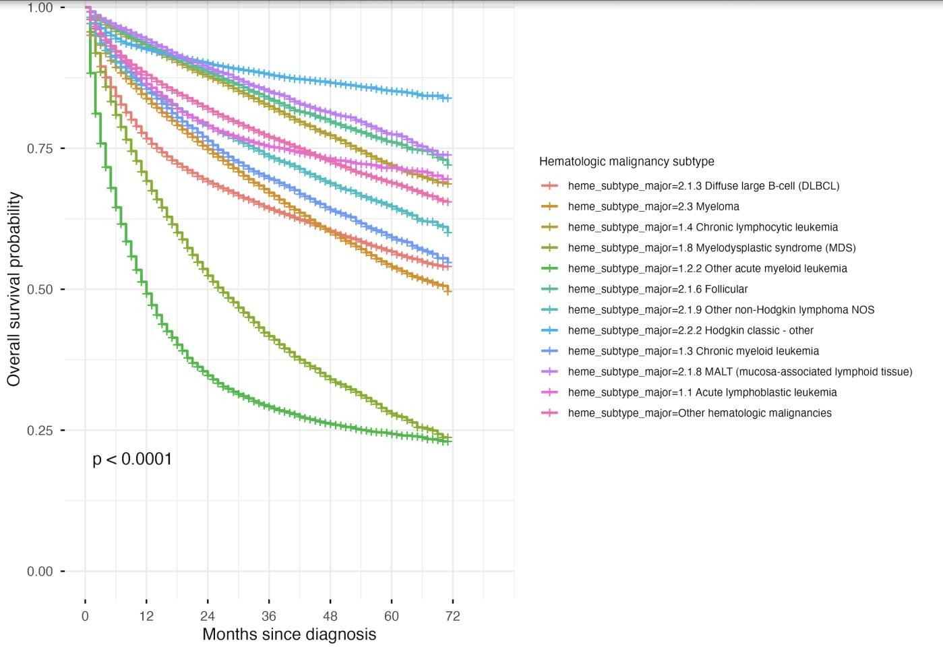

Figure S2. Kaplan–Meier Estimates of Overall Survival by Age Group at Diagnosis from 2017–2022

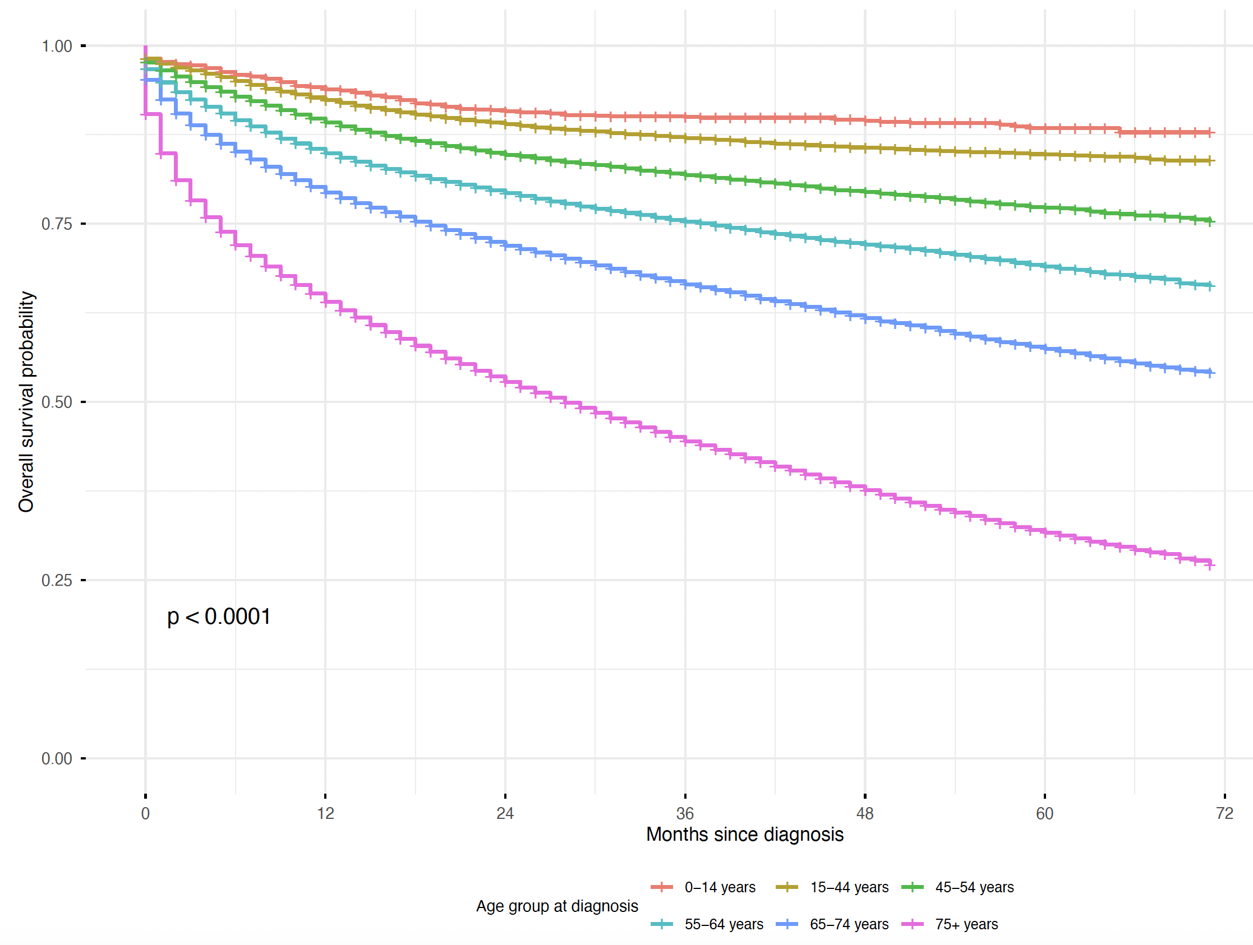

Figure S3. Assessment of the proportional hazard assumption using log–log survival plots.

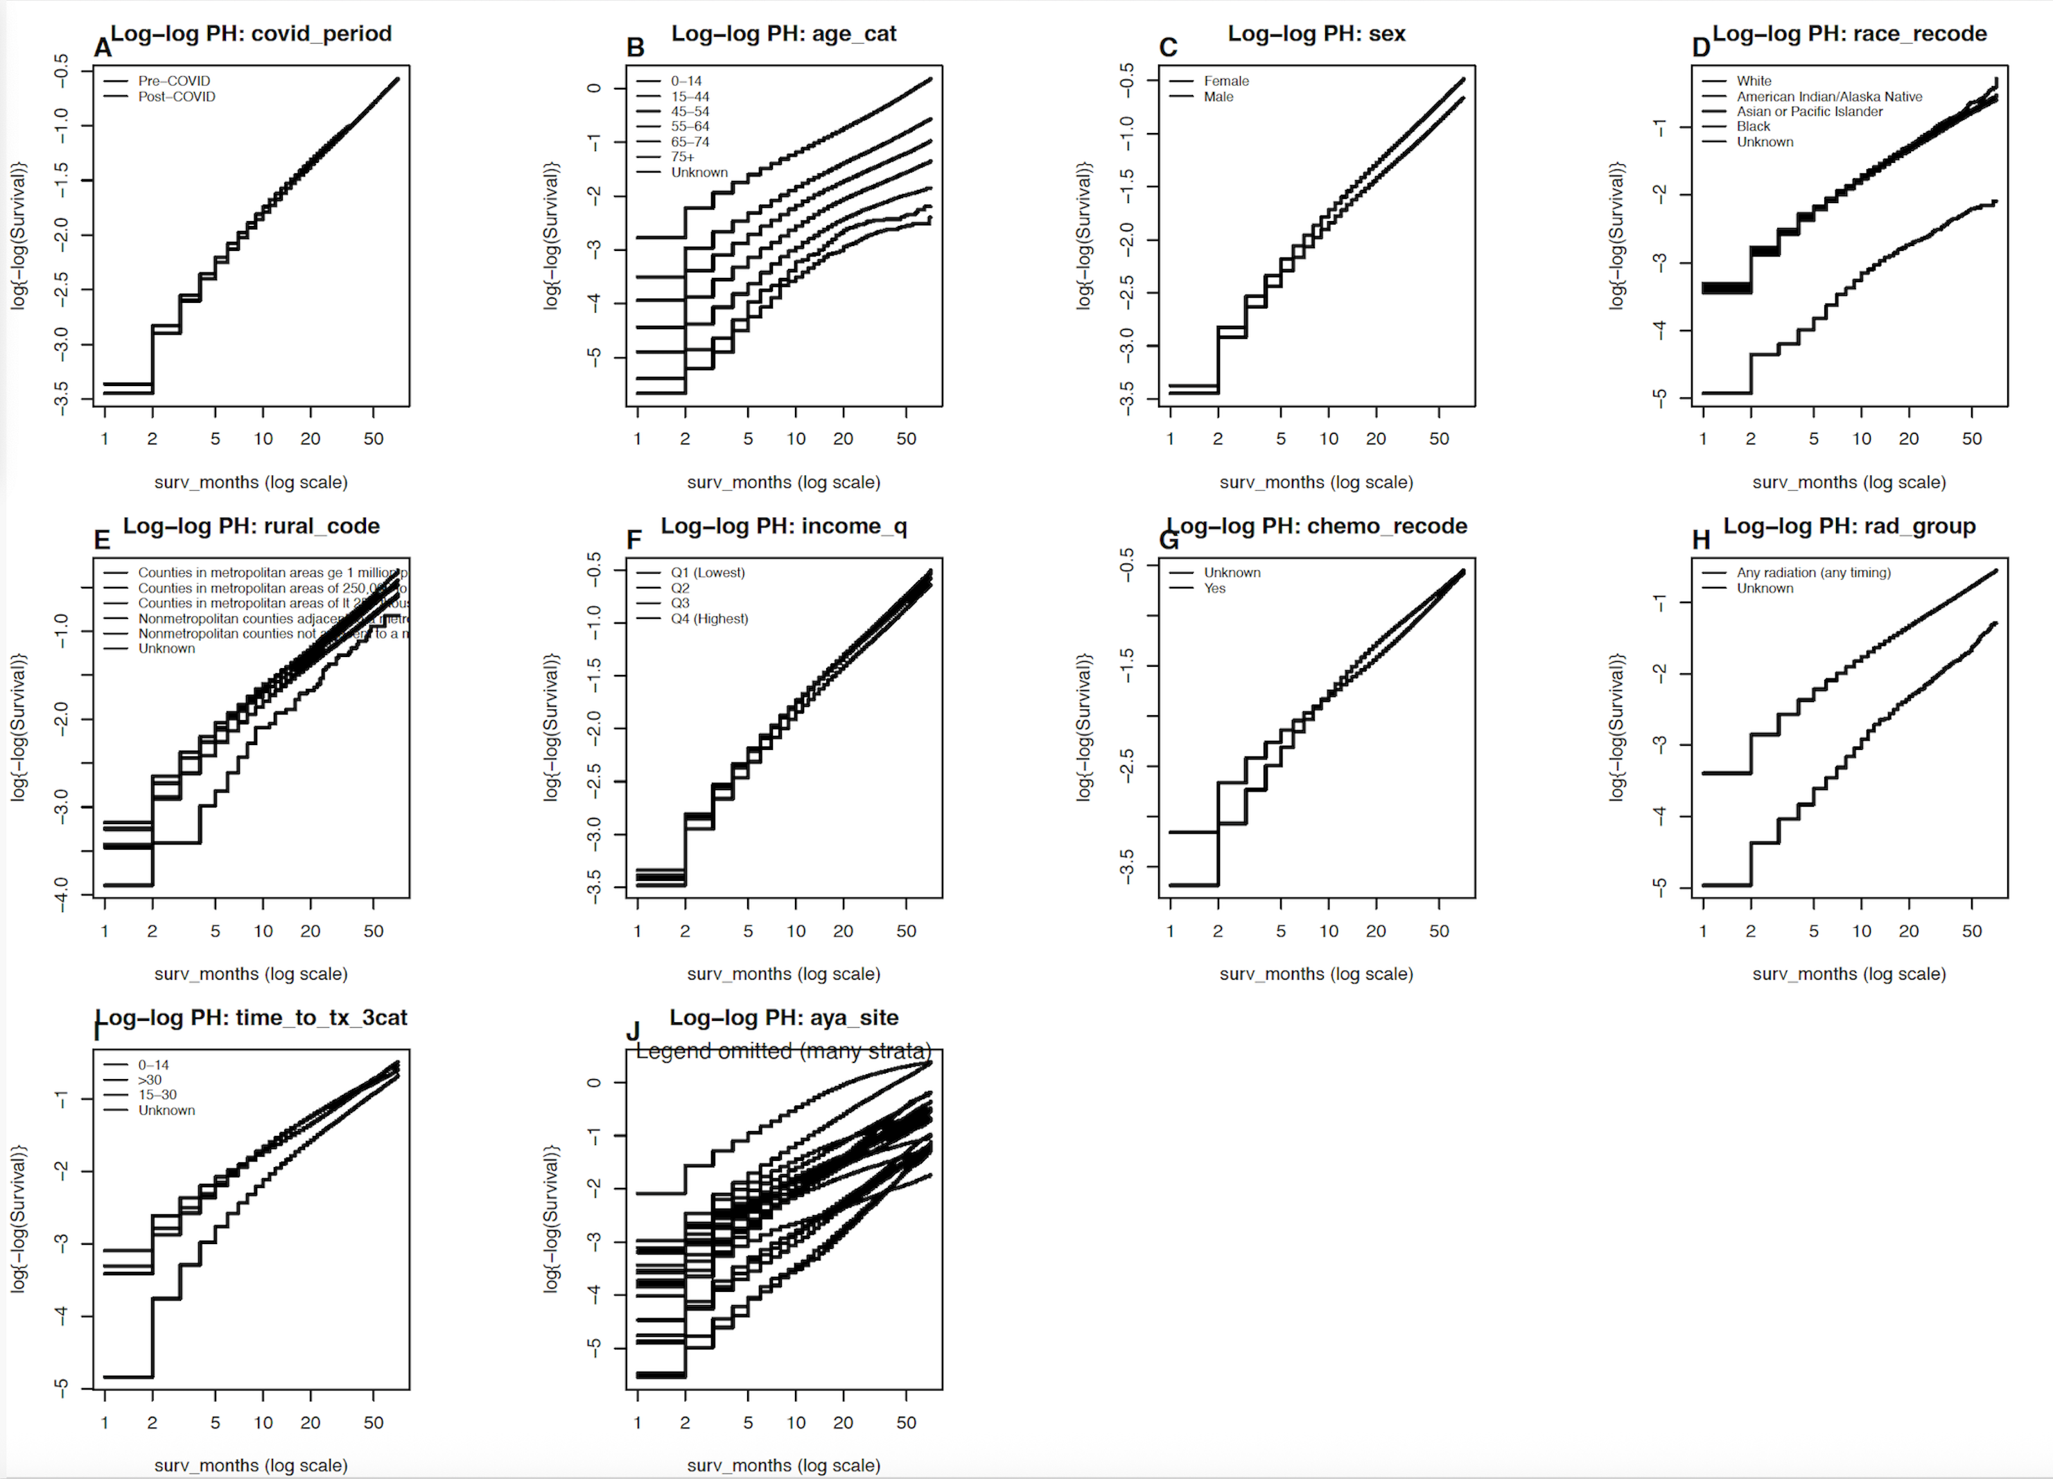
*Proportional hazard assumption not violated

