Supplementary Information for

Extending Conformational Ensemble Prediction to Multidomain Proteins and Protein Complex
Junjie Zhu¹, Sören von Bülow², Hongyi Liu¹, Kresten Lindorff-Larsen², Hai-Feng Chen^{1,*}
¹State Key Laboratory of Microbial Metabolism, Department of Bioinformatics and Biostatistics, SJTU-Yale Joint Center for Biostatistics, National Experimental Teaching Center for Life Sciences and Biotechnology, School of Life Sciences and Biotechnology, Shanghai Jiao Tong University, 200240, Shanghai, China.
²Department of Biology, Structural Biology and NMR Laboratory, Linderstrøm-Lang Centre for Protein Science, University of Copenhagen, Copenhagen 2200, Denmark.

*Corresponding Author
Email: haifengchen@sjtu.edu.cn

Notes
K.L.-L. holds stock options in, is a consultant for, and receives sponsored research from Peptone. The remaining authors declare that there is no conflict of interest.

Supplementary Algorithms
Algorithm S1. Inference loop.
Algorithm S1: Inference loop
Input: Protein sequence $s$, Features $\{f^{*}\}$, Time schedule $[t_{1}, t_{2}, …, t_{200}]$, $N_{layers}=12$
def InferenceLoop($s, \{f^{*}\}$):
- $x_{l}\sim N(0,1)$
- for all $t_{i}∈\left[t_{1}, t_{2}, …, t_{200}\right]$ do
- $r_{s}^{init}, r_{c}^{init}, r_{p}^{init}=$ InputEmbedder($s, \left\{f^{*}\right\}, t_{i}, x_{l}$)
- $r_{s}^{l}=r_{s}^{init}+$ LinearNoBias($x_{l}$)
- for all $n∈[1, …, N_{layers}$] do
- $a_{s}^{l}=$ AttentionPairBias($r_{s}^{l}, r_{c}^{l}, r_{p}^{l}$)
- $r_{s}^{l} +=$ MoE($a_{s}^{l}, r_{c}^{l}$)
- $v_{l}=$ LinearNoBias(LayerNorm($r_{s}^{l}$))
- $x_{l} +=v_{l}∙|t_{i+1}-t_{i}|$
- return $x_{l}$

Algorithm S2. Input embedder.
Algorithm S2: Input Embedder
Input: Protein sequence $s$, Features $\{f^{*}\}$, Time step $t$, Noisy data $x_{l}$
def InputEmbedder($s, \left\{f^{*}\right\}, t, x_{l}$):
# Process features seperately
- $e, s_{one hot}=$ ESM2_650M(s)$,$OneHot($s$)
- $f^{seq idx}, f^{chain idx}, f^{chain break}=\left\{f^{*}\right\}$
- $t←$ SinusoidalPositionEncoding($t, dim=256, len_{max}=2056$)
- $idx_{seq}=$ SinusoidalPositionEncoding($f^{seq idx}, dim=128, len_{max}=2056$)
- $idx_{pair}=$ RelativePositionEncoding($f^{seq idx}, f^{chain idx}$)
- $d_{l}=$ binned_dist($x_{l}$)
# Concatenate processed features
- $r_{s}^{init}=$ concat($e, s_{one hot}, idx_{seq}, f^{chain break}$)
- $r_{p}^{init}=$ concat($idx_{pair}, d_{l}$)
# Output projection
- $r_{s}^{init}←$ LayerNorm(LinearNoBias($r_{s}^{init}$))
- $r_{p}^{init}←$ LayerNorm(LinearNoBias($r_{p}^{init}$))
- $r_{c}^{init}=$ LayerNorm(LinearNoBias($t$))
- return $r_{s}^{init}, r_{c}^{init}, r_{p}^{init}$

Algorithm S3. Pair-biased attention.
Algorithm S3: Pair-biased Attention
Input: Single repr. $r_{s}^{l}∈R^{s}$, Condition repr. $r_{c}^{l}$, Pair repr. $r_{p}^{l}$, Attention heads $N_{head}$
def AttentionPairBias($r_{s}^{l}, r_{c}^{l}, r_{p}^{l}$):
# Input projection
- $r_{s}^{l}←$ AdaLN($r_{s}^{l}, r_{c}^{l}$)
- $q^{h}, k^{h}, v^{h}=$ LinearNoBias($r_{s}^{l}$)
- $b^{h}=$ LinearNoBias(LayerNorm($r_{p}^{l}$))
- $g^{h}=$ sigmoid(LinearNoBias($r_{s}^{l}$))
# Attention
- $A^{h}=$ softmax($\frac{1}{\sqrt{s/N_{head}}}q^{h^{T}}k^{h}+b^{h}$)
- $r_{s}^{l}←$ LinearNoBias(concat_{h}($g^{h}⊙\sum_{ }{A^{h}v^{h}}$))
# Output projection
- $r_{s}^{l}←$ sigmoid(Linear($r_{c}^{l}$))$⊙r_{s}^{l}$
- return $r_{s}^{l}$

Algorithm S4. Mixture-of-Experts (MoE).
Algorithm S4: Mixture-of-Experts
Input: Single repr. $r_{s}^{l}∈R^{s}$, Condition repr. $r_{c}^{l}$
def MixtureOfExperts($r_{s}^{l}, r_{c}^{l}$):
- $w_{exp}=$ softmax(LinearNoBias($r_{s}^{l}$))
- for all $r_{token}^{l}$ in $r_{s}^{l}$ do:
- $idx_{exp}=$ topk($w_{expert}, k=2$)
- $r_{token}^{l}←\frac{1}{3}$ Transition_{shared}($r_{token}^{l}$) $+\sum_{idx_{exp}}{w_{expert}}$Transition_{routed}($r_{token}^{l}$)
- return $r_{s}^{l}$

Supplementary Tables
Table S1. Source of IDRs and MDPs in Rg benchmark.
System name | Length | Experimental Rg
IDRs
Hst5 | 24 | 13.8
FCP1 | 32 | 15.6
Nup49 | 38 | 16.0
NLS | 46 | 24.0
TRF2_BR | 49 | 17.0
HMPVP_NTD | 61 | 27.4
p532070 | 62 | 23.9
MenVL | 62 | 26.0
NWASPV | 67 | 24.3
IB5 | 70 | 27.0
RpII215_CTD2 | 75 | 28.0
HeV_PNT3_CTD | 77 | 27.5
HeV_PNT3_CTD_3Y3A | 77 | 27.3
Nup153_82 | 79 | 24.0
Ash1 | 81 | 29.0
NUS | 82 | 25.0
CTD2 | 83 | 26.1
SMAD_linker | 90 | 29.9
Sic1 | 92 | 28.0
SH4UD | 95 | 27.1
GRB14_PIR | 98 | 26.0
ColNT | 98 | 28.0
Bmal1_CTD_P624A | 98 | 28.0
IBB | 99 | 32.0
MV_PNTD | 100 | 29.0
PAGE4_WT | 102 | 36.0
Fez1 | 103 | 36.0
p15PAF | 110 | 28.1
HAdV5E1A | 114 | 36.0
NUL | 114 | 30.0
GON7_NTD | 114 | 31.0
hNL3cyt | 118 | 33.0
KISS1 | 120 | 34.7
ERM | 122 | 39.6
hNHE1cdt | 130 | 37.0
HeV_PNT3_3Y3A | 133 | 39.5
HeV_PNT3_WT | 133 | 36.7
A1 | 137 | 27.6
NiV_PNT3_WT | 137 | 37.4
aSyn | 140 | 35.5
Calpastatin | 141 | 39.0
II1_ng | 141 | 40.0
P300 | 141 | 30.0
HvASR1 | 144 | 34.6
CAF1_p150L_CTD | 144 | 41.0
LOXPP | 147 | 37.0
TIF2_NRID | 150 | 37.4
AavLEA1 | 163 | 41.0
Syndecan4 | 163 | 41.5
K27 | 167 | 37.0
K10 | 168 | 40.0
Nsp1 | 178 | 41.0
ERD14 | 184 | 46.0
ERNTD_S118D | 184 | 36.9
AN16 | 185 | 50.0
K25 | 185 | 41.0
N_FATZ_1 | 191 | 35.0
K32 | 198 | 42.0
Delta91_FATZ_1 | 209 | 39.0
CAHSD | 227 | 48.4
K23 | 254 | 49.0
tau35 | 255 | 46.4
NCoR_NID | 271 | 47.0
K44 | 283 | 52.0
RpII215_CTD | 312 | 52.0
Msh6_NTR | 313 | 56.0
CortactinCRH | 324 | 47.4
GHRICD | 351 | 60.0
Syndecan3 | 373 | 65.0
NiVPNT | 412 | 61.0
MDPs
THB_C2 | 137 | 19.1
Ubq2 | 162 | 21.9
Ubq3 | 228 | 26.2
Gal3 | 250 | 29.1
TIA1 | 275 | 27.5
hnRNPA1S | 314 | 31.2
hSUMO_hnRNPA1S | 433 | 33.7

Table S2. Source of local unfolding cases.
UniProt ID | PDB ID | Chain ID | Length | Unfolding Regions
trp-cage | 2JOF | A | 20 | 12-19
P15337 | 1KDX | B | 28 | 1-13
P09391 | 2LEP | A | 69 | 24-39
Q16595 | 1EKG | A | 127 | 113-122
A0A0M3KL39 | 4ZRB | G | 137 | 7-16
A0A1B2CW14 | 8DP9 | A | 148 | 97-140
O88273 | 4JPH | B | 148 | 35-47
P01112 | 5P21 | A | 166 | 58-67
Q8E473 | 4RMB | B | 166 | 145-159
P61586 | 1FTN | A | 193 | 63-73
P73184 | 5M82 | A | 215 | 95-104
P21964 | 4PYI | A | 221 | 196-216
Q13557 | 2VN9 | A | 301 | 293-300
Q8WZ42 | 1TKI | A | 321 | 294-302
O15075 | 6KYQ | A | 328 | 300-325
Q8IU85 | 2JC6 | A | 334 | 305-313
P19726 | 3J7V | G | 345 | 23-42
Q29599 | 4RWN | A | 357 | 58-76

Table S3. Source of domain motion cases.
UniProt ID | Ref. 1 | Chain ID  in Ref. 1 | Ref. 2 | Chain ID  in Ref. 2 | Length
A0A0H3AFX3 | 6PWJ | A | 6PWK | A | 418
B0F0C5 | 6PQN | A | 6PQX | A | 497
P0205 | 1URP | A | 2DRI | A | 271
P02911 | 6ML0 | A | 6MLP | A | 238
P03047 | 7UBJ | A | 7UBL | A | 147
P06766 | 1BPD | A | 2BPG | E | 335
P0A8W0 | 6ON4 | A | 6WFQ | A | 263
P0AEQ3 | 1WDN | A | 1GGG | A | 226
P0DP23 | 1CLL | A | 5GGM | A | 148
P24182 | 1DV1 | A | 1DV2 | A | 449
P28366 | 1M74 | A | 1TF2 | A | 844
P33284 | 3O80 | A | 3O8M | A | 485
P37487 | 1K23 | C | 1WPM | B | 309
P67701 | 6JQ4 | A | 6KML | B | 138
P69441 | 1AKE | A | 4AKE | A | 214
P71447 | 2WFA | A | 2WF5 | A | 221
Q18A65 | 6HNK | A | 6HNI | A | 319
Q5F9M1 | 3ZSF | A | 2YLN | A | 283
Q83VS8 | 7E8R | A | 7EDB | A | 351

Table S4. Hyperparameters of IDPFold2.
Hyperparameter | Value
General parameters
Batch size | 64
Iterations per epoch | 1,102
Total epochs | 250
Training times (days on 8 Ascend 910B) | ≈4
Data parameters
Crop size | 256
Probability of sampling multimers | 0.8
Training/validation proportion | 99:1
Model parameters
Token dimension | 768
Pair dimension | 512
Condition dimension | 512
Number of layers | 10
Number of attention heads | 12
Total parameters | ≈330M
MoE parameters
Number of routed experts | 5
Number of activated experts | 2
Capacity factor (only in training) | 1.3
Weight of load balancing loss | 0.1

Supplementary Figures
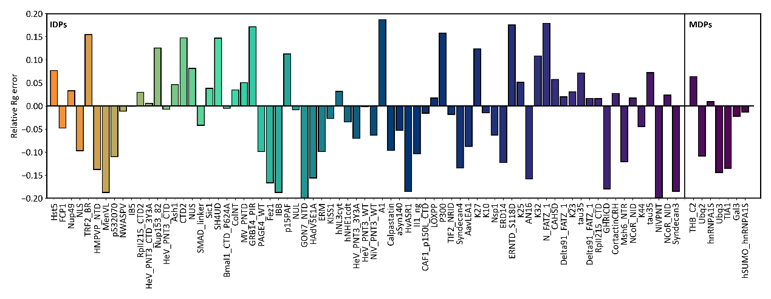
Figure S1. Relative error of IDPFold2 in Rg benchmark.

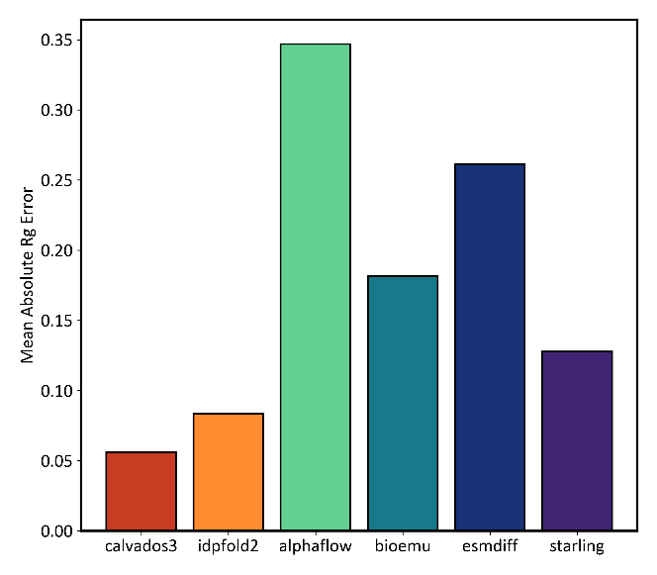
Figure S2. Mean absolute Rg error of baseline methods in Rg benchmark.

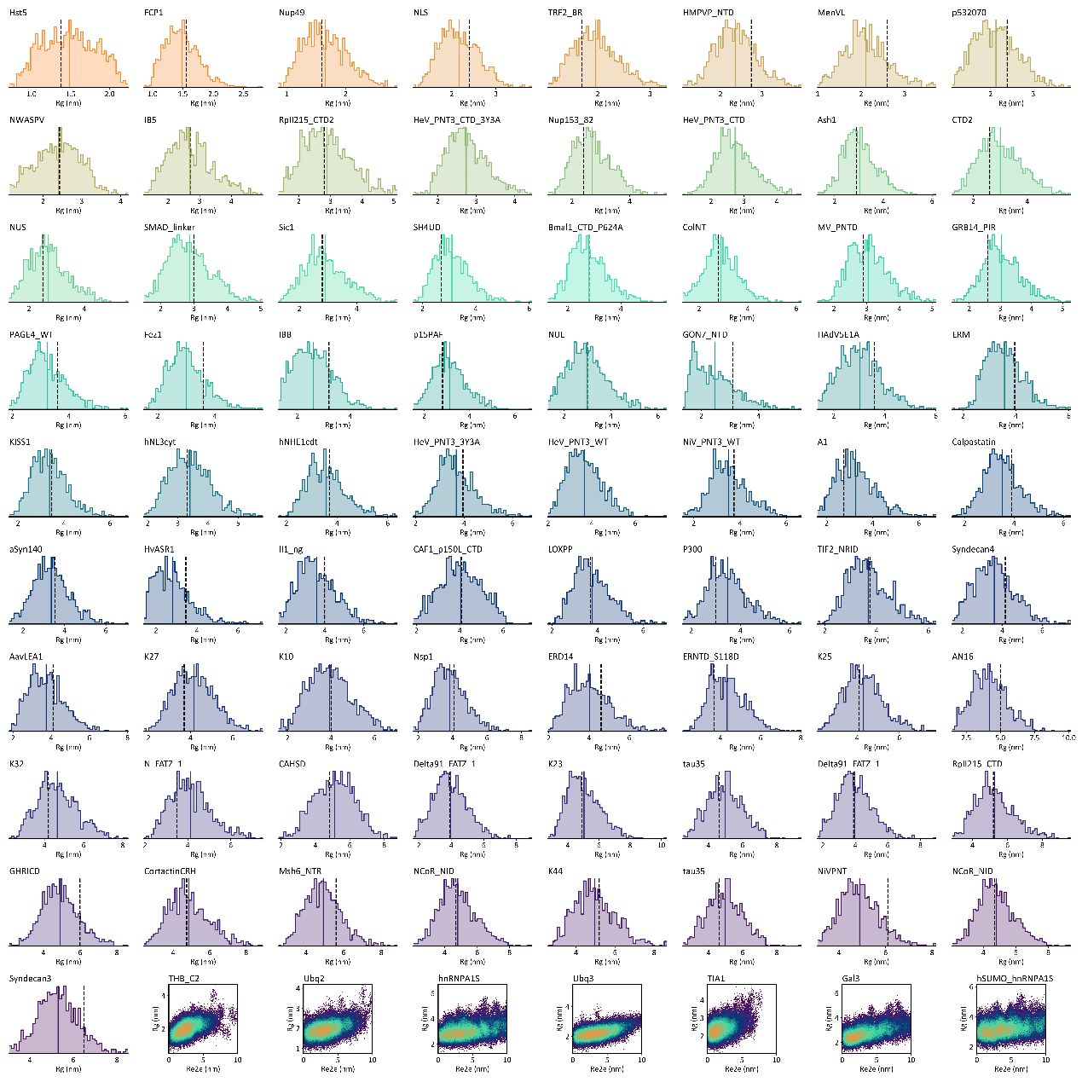
Figure S3. Generated Rg distributions on 73 IDRs, and Rg-Re2e distributions on 7 MDPs.

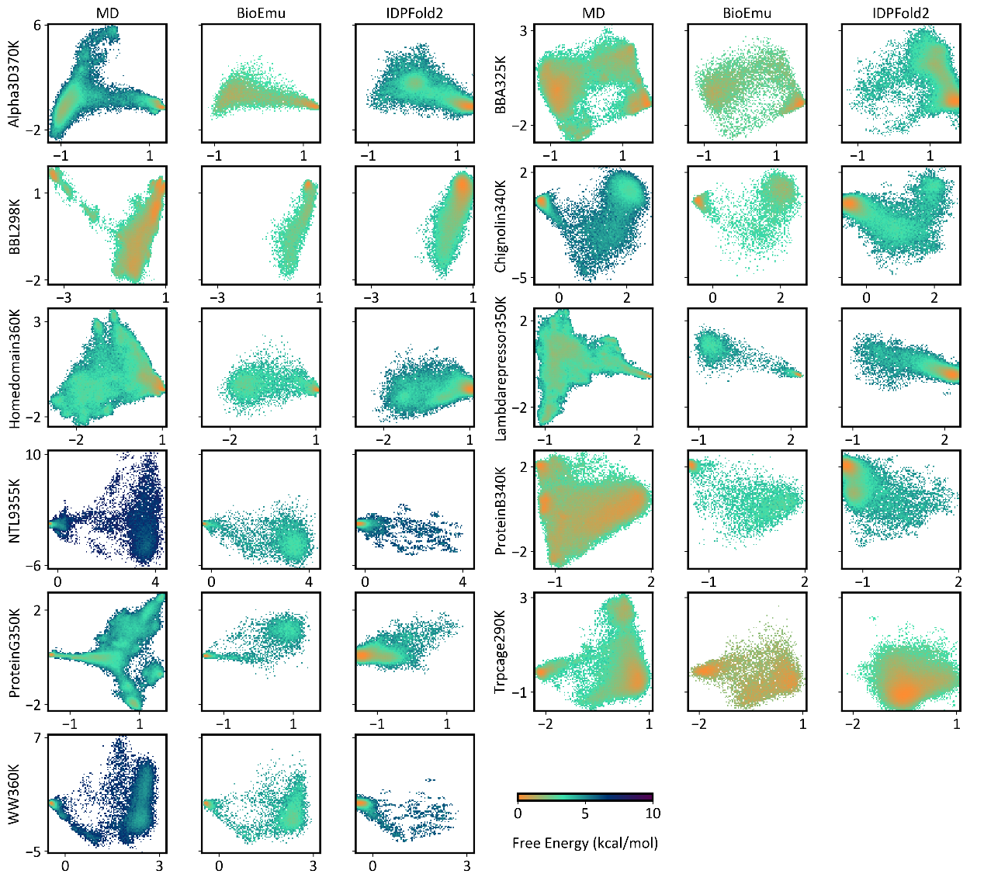
Figure S4. Generated free energy landscapes in the TIC space on 11 fast-folding proteins.

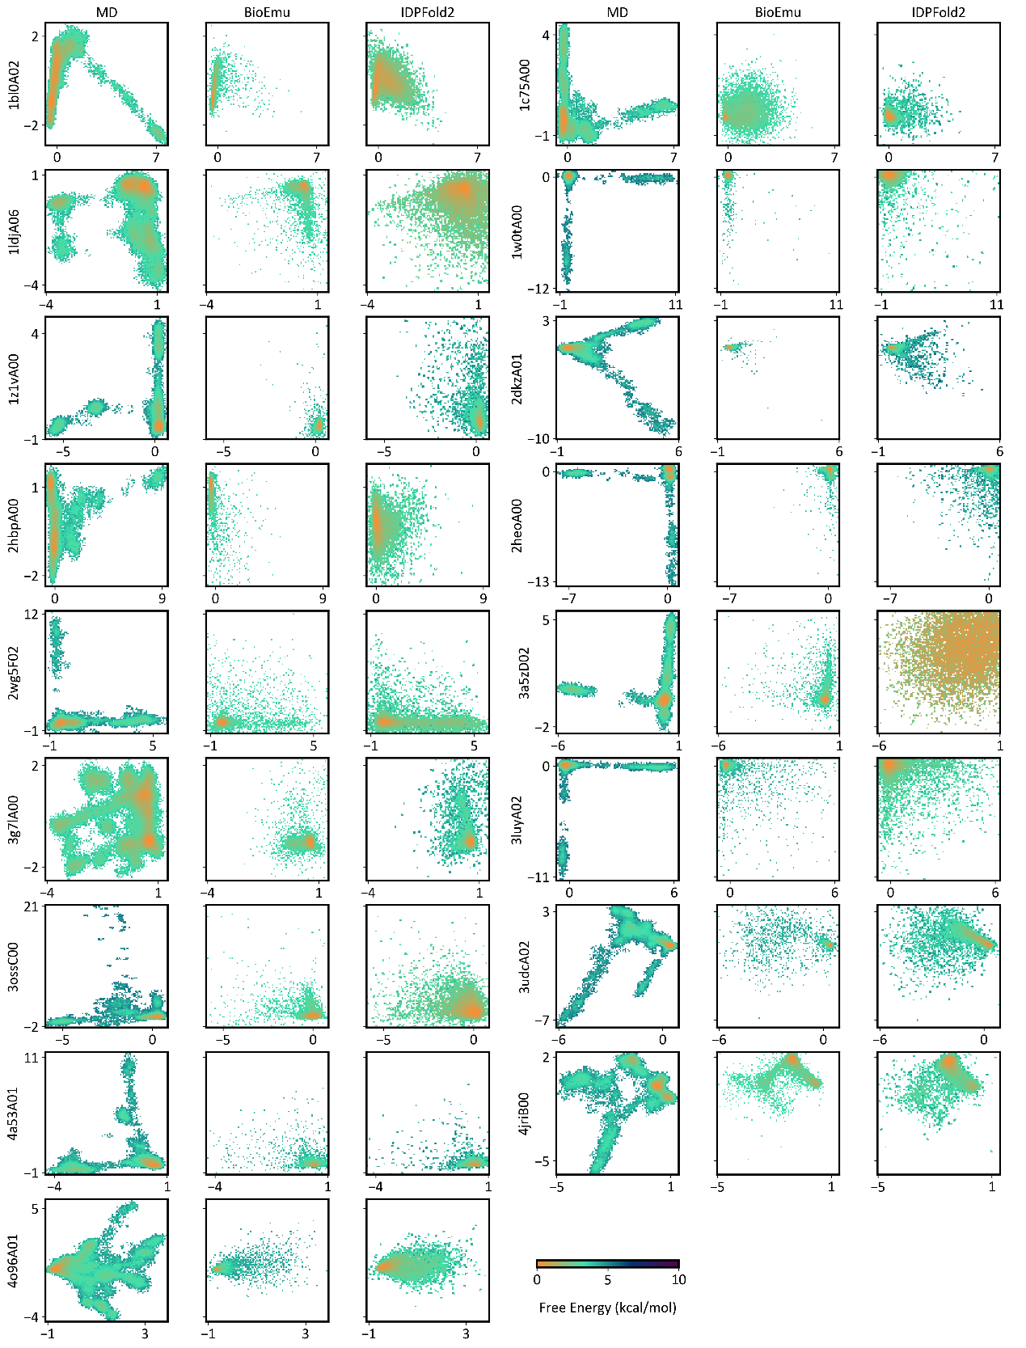
Figure S5. Generated free energy landscapes in the TIC space on 17 CATH domains.

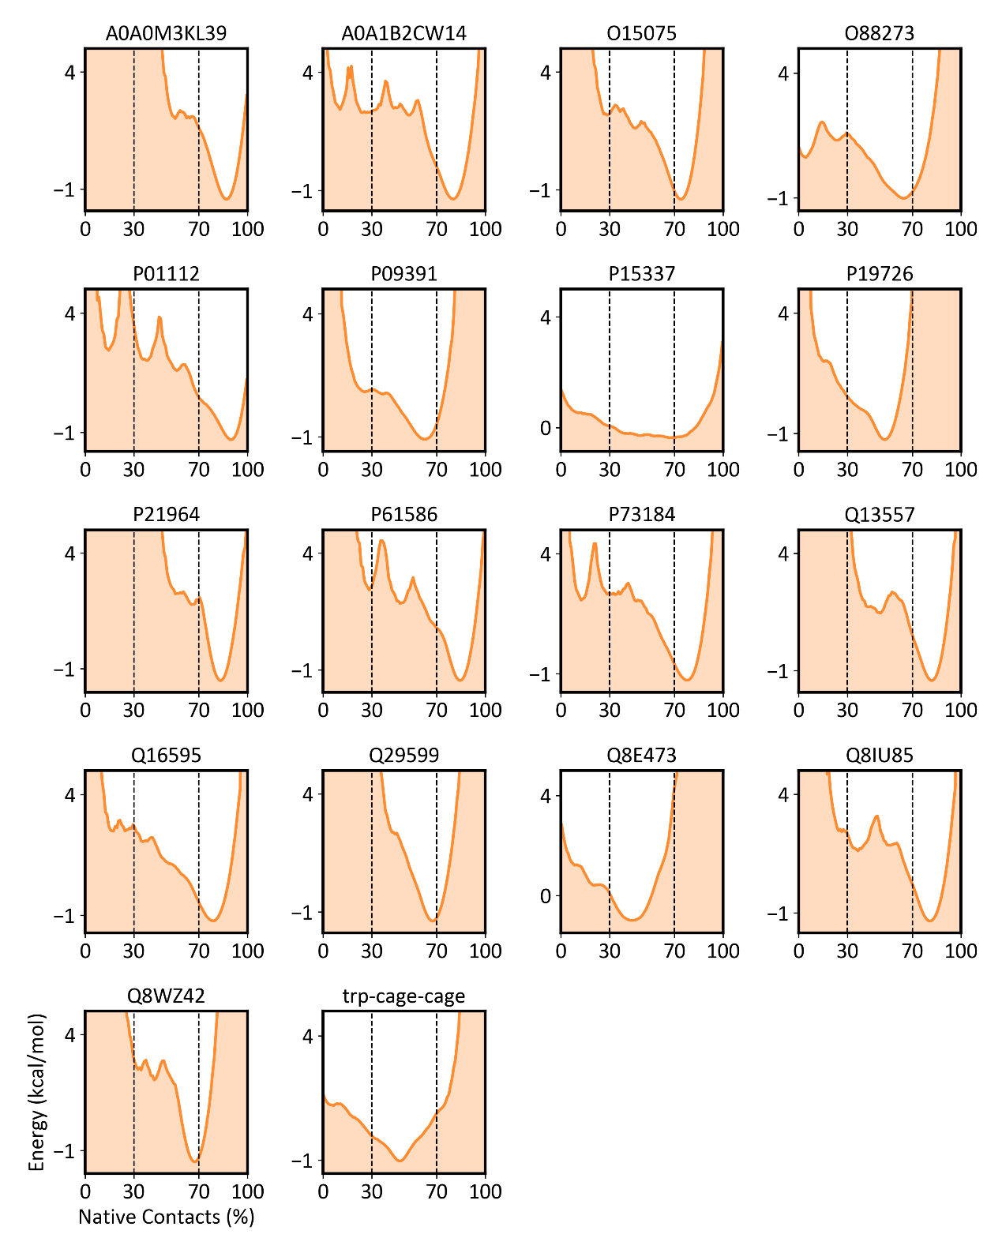
Figure S6. Fraction of native contacts in predicted conformational ensembles on 18 local unfolding cases.

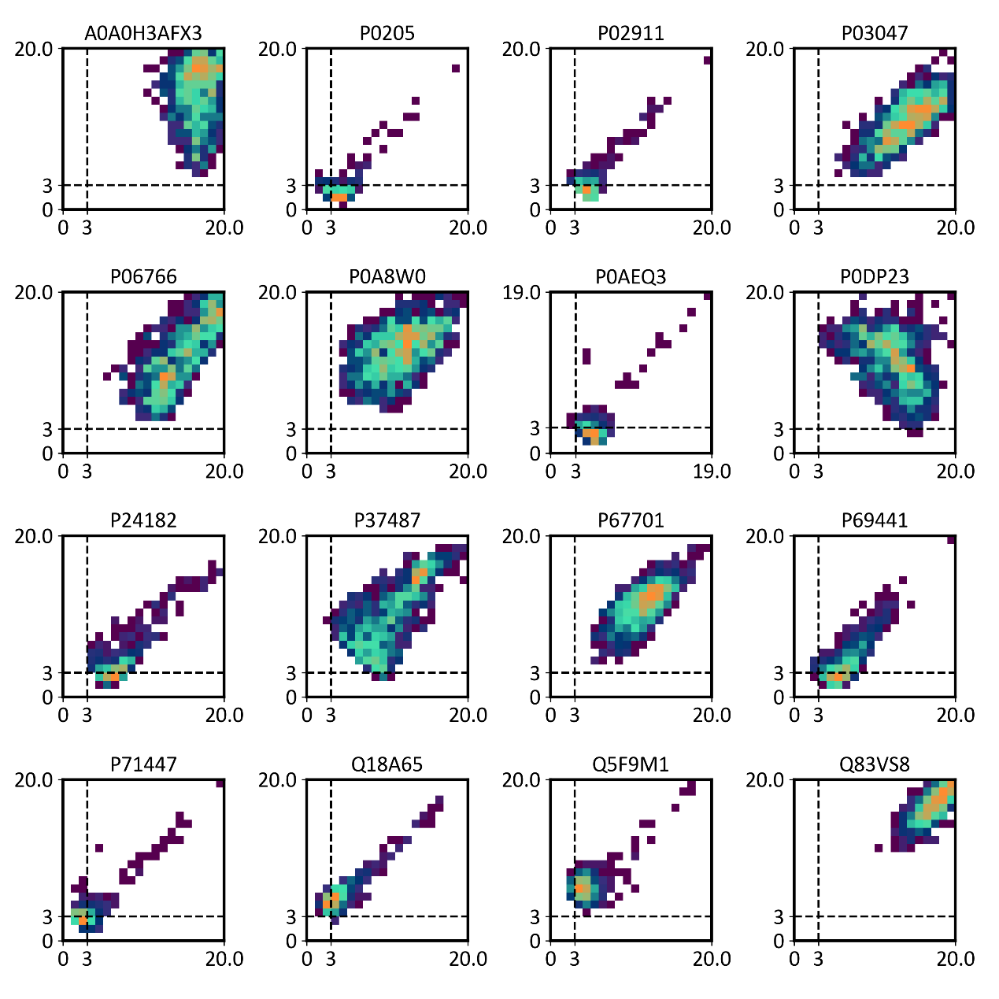
Figure S7. RMSD against resolved static structures on 16 domain motion cases.

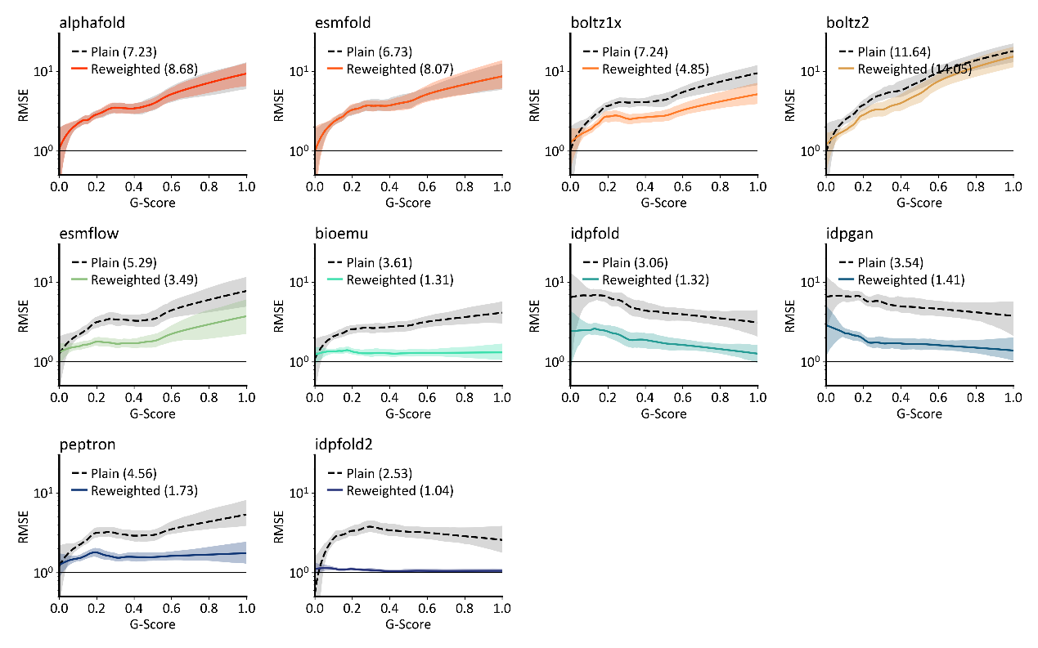
Figure S8. LOWESS curves of baseline methods, fitted on normalized RMSEs against G-scores in PeptoneDB-SAXS. AUCs are reported in the legends.

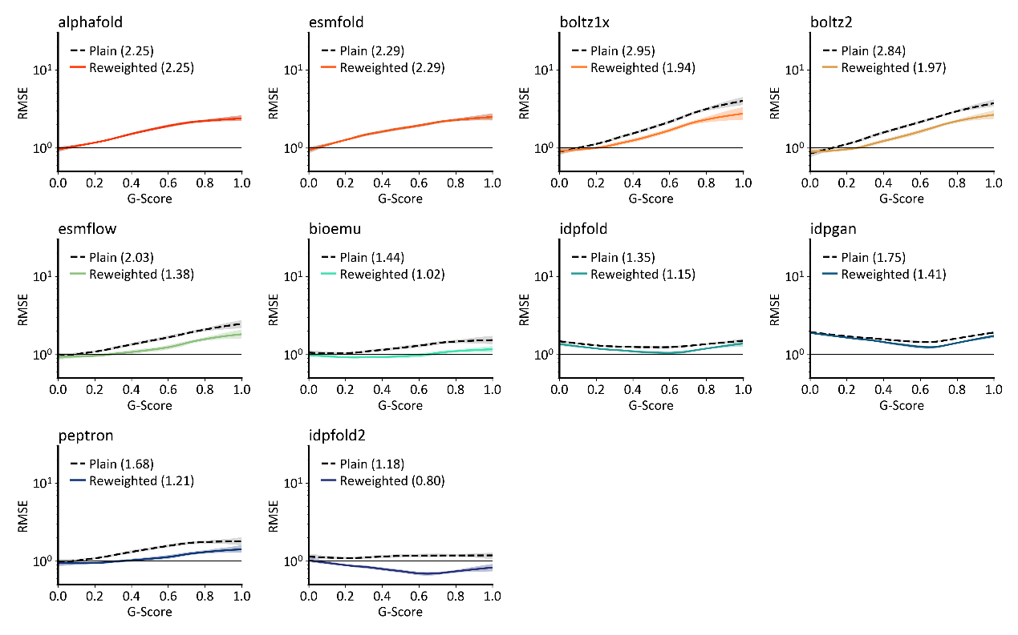
Figure S9. LOWESS curves of baseline methods, fitted on normalized RMSEs against G-scores in PeptoneDB-CS. AUCs are reported in the legends.

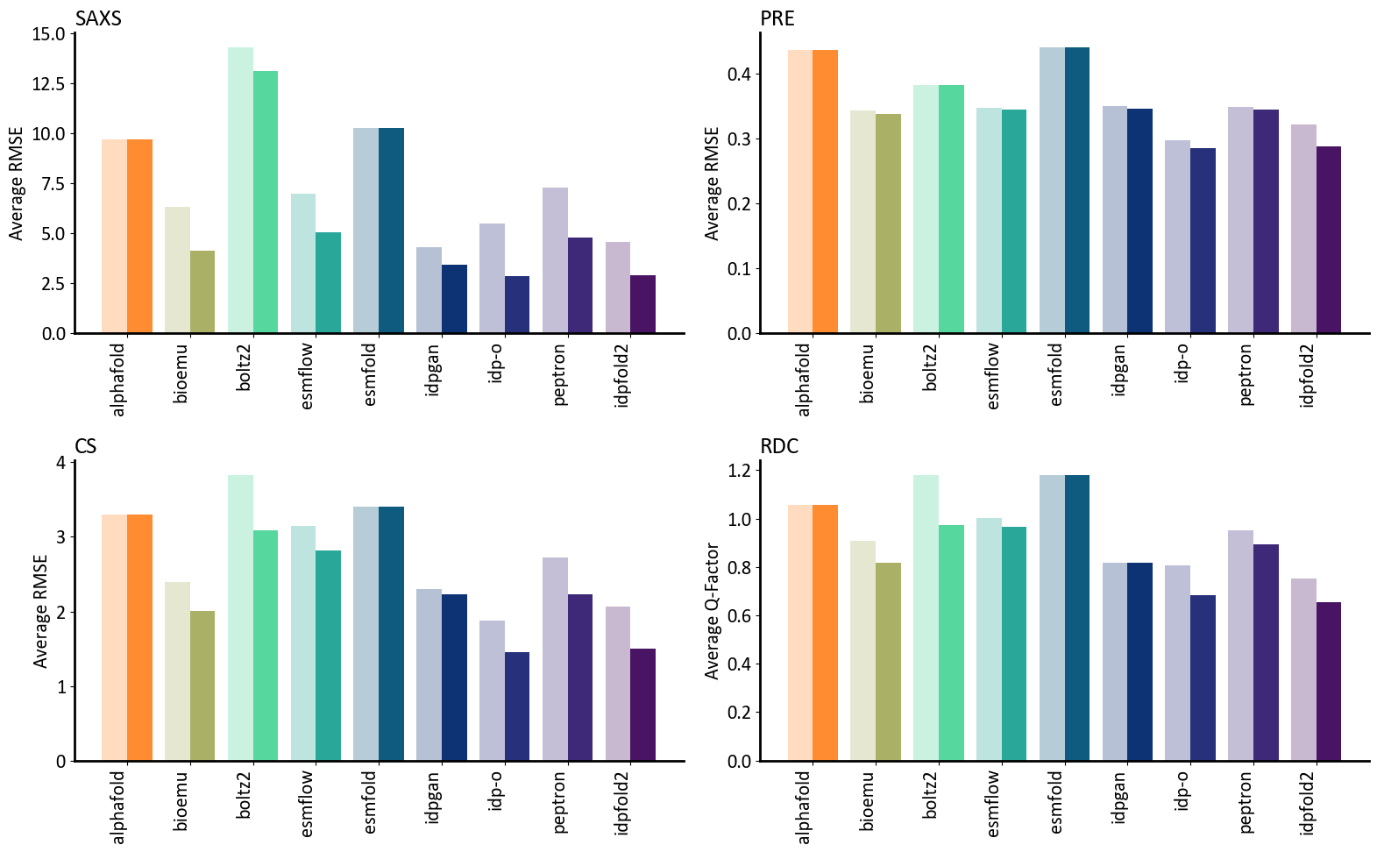
Figure S10. Average RMSE (Q-factor for RDC) on SAXS, PRE, CS and RDC data in PeptoneDB-Integrative.

