Supplementary Information:
A Take-Home Message: Spillovers from Workplace Food Waste Campaigns to the Home
Authors: Feiyang Wang^, Ganga Shreedhar^, Matteo Galizzi^, Susana Mourato^
^ London School of Economics and Political Science
Corresponding author: Ganga Shreedhar (g.s.shreedhar@lse.ac.uk)

This file contains Supplementary Methods, Supplementary Figures S1 to S6 and Supplementary Tables S1 to S7.

Table of Contents
Supplementary Methods 2
Variables included in the DID regression models 2
DID: detailed model outputs 3
Variables included in regression model testing the work-to-home spillovers 4
Work-to-home spillovers: detailed model outputs 5
Other details about the field study 6
Other details about the survey study 9
Supplementary References 14

Supplementary Methods

Variables included in the Differences-In-D regression models
Table S1: Independent variables included in the DID regression models
Estimation Methods | OLS | Random-effects GLS | Fixed-effects
site dummies (site B & site C) | ✓ | ✓
campaign periods (during campaign & after campaign) | ✓ | ✓ | ✓
interactions between the site dummies and campaign periods | ✓ | ✓ | ✓
dummies for days of the week (Monday-Saturday) | ✓ | ✓ | ✓
monthly dummies (Jan to May 2021) | ✓ | ✓ | ✓

Formally, we ran the DID regression using the fixed effects model to control for any time-invariant site-specific characteristics. However, since we were unable to cluster the standard errors at the site level due to the limited degrees of freedom, we conducted extra robustness tests using the OLS model and the random-effects model. The results did not differ substantially across models (see Table S2).

The dummy variables for the days of the week and months were introduced into the model to address control for time trends. Research shows that people’s dietary practices differ across weekends and weekdays⁴. Moreover, the company initiated a Green Monday campaign on 11/01/2021 and provided more vegetarian options every Monday since then, which could also influence the weight of food waste. The days of the week dummies minimized the confounding effects of those factors. There were several festival seasons in our study period (e.g., Christmas 25/12/2020, New Year 01/01/2021, Spring Festival 11/02/2021-26/02/2021, Ching Ming Festival 04/04/2021, Labour Day 01/05/2021), and the canteens had special menus on some festival dates.

DID: detailed model outputs
Table S2 DID regression models using different estimation methods
Dependent variable: grams per cover per day | OLS | Random-effects GLS | Fixed-effects
site B (Environmental) | 8.89  (4.90)* | 8.89  (3.54)**
site C (Anthropomorphic) | −17.68  (5.14)*** | −17.68  (3.54)***
during campaign | 12.21  (4.10)*** | 12.21  (3.95)*** | 12.21  (3.95)***
after campaign | 46.63  (4.54)*** | 46.63  (5.00)*** | 46.63  (5.00)***
treatment 1 (site B) × during campaign | −8.92  (5.76) | −8.92  (4.65)* | −8.92  (4.65)*
treatment 1 (site B) × after campaign | −42.80  (5.61)*** | −42.80  (5.10)*** | −42.80  (5.10)***
treatment 2 (site C) × during campaign | −17.49  (5.92)*** | −17.49  (4.65)*** | −17.49  (4.65)***
treatment 2 (site C) ×after campaign | − 66.33  (6.00)*** | − 66.33  (5.20)*** | − 66.33  (5.20)***
Monday | 0.16  (2.64) | 0.16  (2.73) | 0.16  (2.73)
Tuesday | −0.36  (2.90) | −0.36  (2.73) | −0.36  (2.73)
Wednesday | −0.05  (2.84) | −0.05  (2.74) | −0.05  (2.74)
Thursday | 0.44  (2.76) | 0.44  (2.72) | 0.44  (2.72)
Friday | 1.48  (3.01) | 1.48  (2.72) | 1.48  (2.72)
Saturday | 2.07  (2.76) | 2.07  (2.72) | 2.07  (2.72)
January | −13.40  (3.92)*** | −13.40  (3.72)*** | −13.40  (3.72)***
February | −12.49  (5.54)** | −12.49  (4.45)*** | −12.49  (4.45)***
March | −19.00  (6.12)*** | −19.00  (5.08)*** | −19.00  (5.08)***
April | −5.54  (6.38) | −5.54  (5.36) | −5.54  (5.36)
May | −1.15  (6.78) | −1.15  (6.27) | −1.15  (6.27)
constant | 87.84  (6.17)*** | 87.84  (4.93)*** | 84.71  (3.86)***
N of observations | 433 | 433 | 433
R² | 0.71 | 0.71 | 0.56
Notes: Table reports estimated coefficients with standard errors in parentheses. The OLS standard errors are corrected for heteroscedasticity.
*** Significant at the one percent level.
** Significant at the five percent level.
* Significant at the ten percent level.

Variables included in regression model testing the work-to-home spillovers
Table S3: Independent variables included in the regression models testing the work-to-home spillovers
Variable name | Description
efforts_at_work 1 | “Have you done any of the following in the past 4 months?” – “Had a conversation with work colleagues about food waste?”  1 = “Never” 2 = “Rarely”, 3 = “Sometimes”, 4 = “Often”, 5 = “Always”
efforts_at_work 2 | “Have you done any of the following in the past 4 months?” – “Tried to reduce food waste at work?”  1 = “Never” 2 = “Rarely”, 3 = “Sometimes”, 4 = “Often”, 5 = “Always”
site dummies (site B & site C) | “Which site do you mainly work at?”  0 = [site A], 1 = [site B];, 2 =[site C]
catalyzing beliefs | The mean of two items adapted from previous research¹ (Spearman-Brown ρ = 0.63³):  “Being environmentally friendly is not about taking small actions; it is a complete approach to life.”  “Doing something positive for the environment in my everyday life makes me want to do other similar things.”  1 = “Strongly Disagree”, 2 = “Disagree”, 3 = “Undecided”, 4 = “Agree”, 5 = “Strongly Agree”
compensatory beliefs | The mean of two items adapted from previous research¹ (Spearman-Brown ρ = 0.65):  “The environmental impact of wasting food at home can be made up for by saving food at work.”  “It doesn’t matter how much energy I waste when I’m at work or out of the house, as long as I try to minimize my environmental impact at home.”  1 = “Strongly Disagree”, 2 = “Disagree”, 3 = “Undecided”, 4 = “Agree”, 5 = “Strongly Agree”
environmental identity | The mean of two items adapted from previous research² (Spearman-Brown ρ = 0.75):  “I think of myself as an environmentally-friendly person.”  “I think of myself as someone who is very concerned with environmental issues.”  1 = “Strongly Disagree”, 2 = “Disagree”, 3 = “Undecided”, 4 = “Agree”, 5 = “Strongly Agree”
motivation 1-8 | “To what extent do you agree that the following reasons have motivated you to reduce food waste?”  “Wasting food is a waste of money.”  “Wasting food is a waste of resources like water and energy.”  “Wasting food is a national security issue because food is difficult to secure and supply.”  “Wasting food is unfair to those who do not have enough to eat.”  “Wasting food causes global warming and climate change due to emissions from food.”  “It is a Chinese traditional virtue to cherish food and reduce food waste.”  “It is [the company]'s culture to cherish food and reduce food waste at work.”  “It is in line with my personal principles to cherish food and reduce food waste.”  1 = “Strongly Disagree”, 2 = “Disagree”, 3 = “Undecided”, 4 = “Agree”, 5 = “Strongly Agree”
age | “Please indicate your age (please enter the number)”
female | “Please indicate your gender”  0 = “Male” 1 = “Female”
education | “Please indicate your highest education level”  0 = “No school”, 1 = “Primary school”, 2 = “Junior high school”, 3 = “Senior high school”, 4 = “Junior college diploma”, 5 = “Bachelor degree”, 6 = “Master degree”, 7 = “Doctor degree”
income | “Please indicate your personal monthly income (after taxes) in MOP”  1 = “<=10,000”, 2 = “10,001-15,000”; 3 = “15,001-20,000”; 4 = “20,001-25,000”; 5 = “25,001-30,000”, 6 = “>30,000”

Work-to-home spillovers: detailed model outputs
Table S4: Regression models showing the effects of efforts to reduce food waste at work on efforts to reduce food at home (the composite & the four items), with all control variables included
 | efforts at_home (mean) | efforts_at_home 1 | efforts_at_home 2 | efforts_at_home 3 | efforts_at_home 4
efforts_at_work 1 | 0.23  (0.02)*** | 0.56  (0.03)*** | 0.04  (0.02)* | 0.14  (0.03)*** | 0.18  (0.04)***
efforts_at_work 2 | 0.39  (0.02)*** | 0.18  (0.03)*** | 0.66  (0.04)*** | 0.40  (0.04)*** | 0.31  (0.04)***
site B | −0.05  (0.03) | −0.10  (0.04)** | −0.02  (0.04) | 0.02  (0.07) | −0.09  (0.07)
site C | −0.06  (0.06) | 0.05  (0.09) | −0.10  (0.07) | −0.07  (0.12) | −0.11  (0.14)
catalyzing beliefs | 0.07  (0.04)** | 0.09  (0.05)* | 0.02  (0.04) | 0.15  (0.07)** | 0.04  (0.07)
compensatory beliefs | −0.03  (0.01)** | 0.01  (0.02) | −0.03  (0.01)* | −0.12  (0.02)*** | 0.002  (0.028)
environmental identity | 0.15  (0.03)*** | 0.19  (0.04)*** | 0.08  (0.04)** | 0.14  (0.05)** | 0.18  (0.06)***
motivation 1 | 0.08  (0.03)** | 0.03  (0.04) | 0.16  (0.05)*** | 0.06  (0.06) | 0.08  (0.08)
motivation 2 | −0.02  (0.04) | −0.02  (0.06) | −0.02  (0.06) | 0.03  (0.07) | −0.07  (0.08)
motivation 3 | −0.01  (0.04) | −0.04  (0.05) | −0.02  (0.04) | −0.03  (0.07) | 0.06  (0.08)
motivation 4 | − 0.05  (0.03) | −0.02  (0.05) | −0.03  (0.04) | −0.06  (0.06) | −0.08  (0.07)
motivation 5 | 0.05  (0.03)* | 0.05  (0.04) | 0.05  (0.04) | −0.05  (0.06) | 0.17  (0.06)***
motivation 6 | 0.01  (0.03) | −0.01  (0.05) | −0.0003  (0.0365) | 0.10  (0.06)* | −0.04  (0.07)
motivation 7 | −0.03  (0.04) | −0.06  (0.05) | −0.03  (0.05) | −0.02  (0.08) | −0.02  (0.08)
motivation 8 | 0.08  (0.05)* | 0.08  (0.06) | 0.04  (0.06) | 0.03  (0.08) | 0.17  (0.09)*
age | −0.002  (0.002) | 0.001  (0.002) | −0.001  (0.002) | −0.012  (0.003)*** | 0.005  (0.004)
female | −0.002  (0.031) | 0.12  (0.04)*** | −0.03  (0.04) | −0.03  (0.06) | −0.07  (0.07)
education | −0.01  (0.02) | −0.03  (0.02) | 0.02  (0.02) | −0.03  (0.03) | −0.01  (0.03)
income | 0.01  (0.01) | 0.02  (0.02) | −0.01  (0.01) | 0.03  (0.02) | 0.01  (0.03)
constant | 0.05  (0.18) | −0.43  (0.26) | 0.41  (0.20) | 0.93  (0.36)*** | −0.70  (0.33)**
N of observations | 1,145 | 1,145 | 1,145 | 1,145 | 1,145
R² | 0.56 | 0.55 | 0.54 | 0.24 | 0.20
Notes: Table reports OLS coefficients. Standard errors in parentheses are corrected for heteroscedasticity.
*** Significant at the 1% level.
** Significant at the 5% percent level.
* Significant at the 10% percent level.

Other details about the field study
Table S5: The detailed design of the field study
Feedback Rounds | Round 1: 09/02/2021-22/02/2021 | Round 2: 23/02/2021-08/03/2021 | Round 3: 09/03/2021-22/03/2021 | Round 4: 23/03/2021-05/04/2021 | Round 5:  06/04/2021-19/04/2021
Control | no feedback | no feedback | feedback | feedback | feedback
Treatment 1 | feedback | feedback | feedback & environmental message | feedback & environmental message | feedback & environmental message
Treatment 2 | feedback | anthropomorphic feedback | anthropomorphic feedback & anthropomorphic environmental message | anthropomorphic feedback & anthropomorphic environmental message | anthropomorphic feedback & anthropomorphic environmental message

Table S6: Posters used in the food waste campaign
 | feedback | anthropomorphic feedback | environmental message | anthropomorphic environmental message
Round 1: 09/02/2021-22/02/2021 | 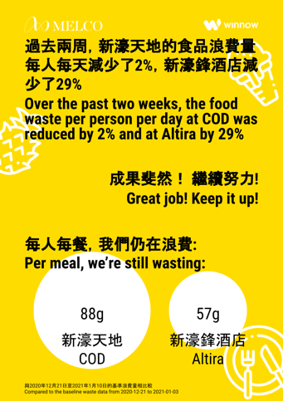
Round 2: 23/02/2021-08/03/2021
Round 3: 09/03/2021-22/03/2021 | 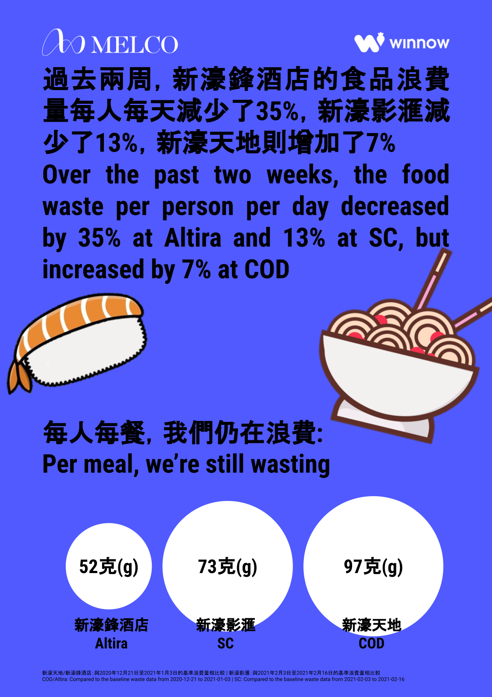 | 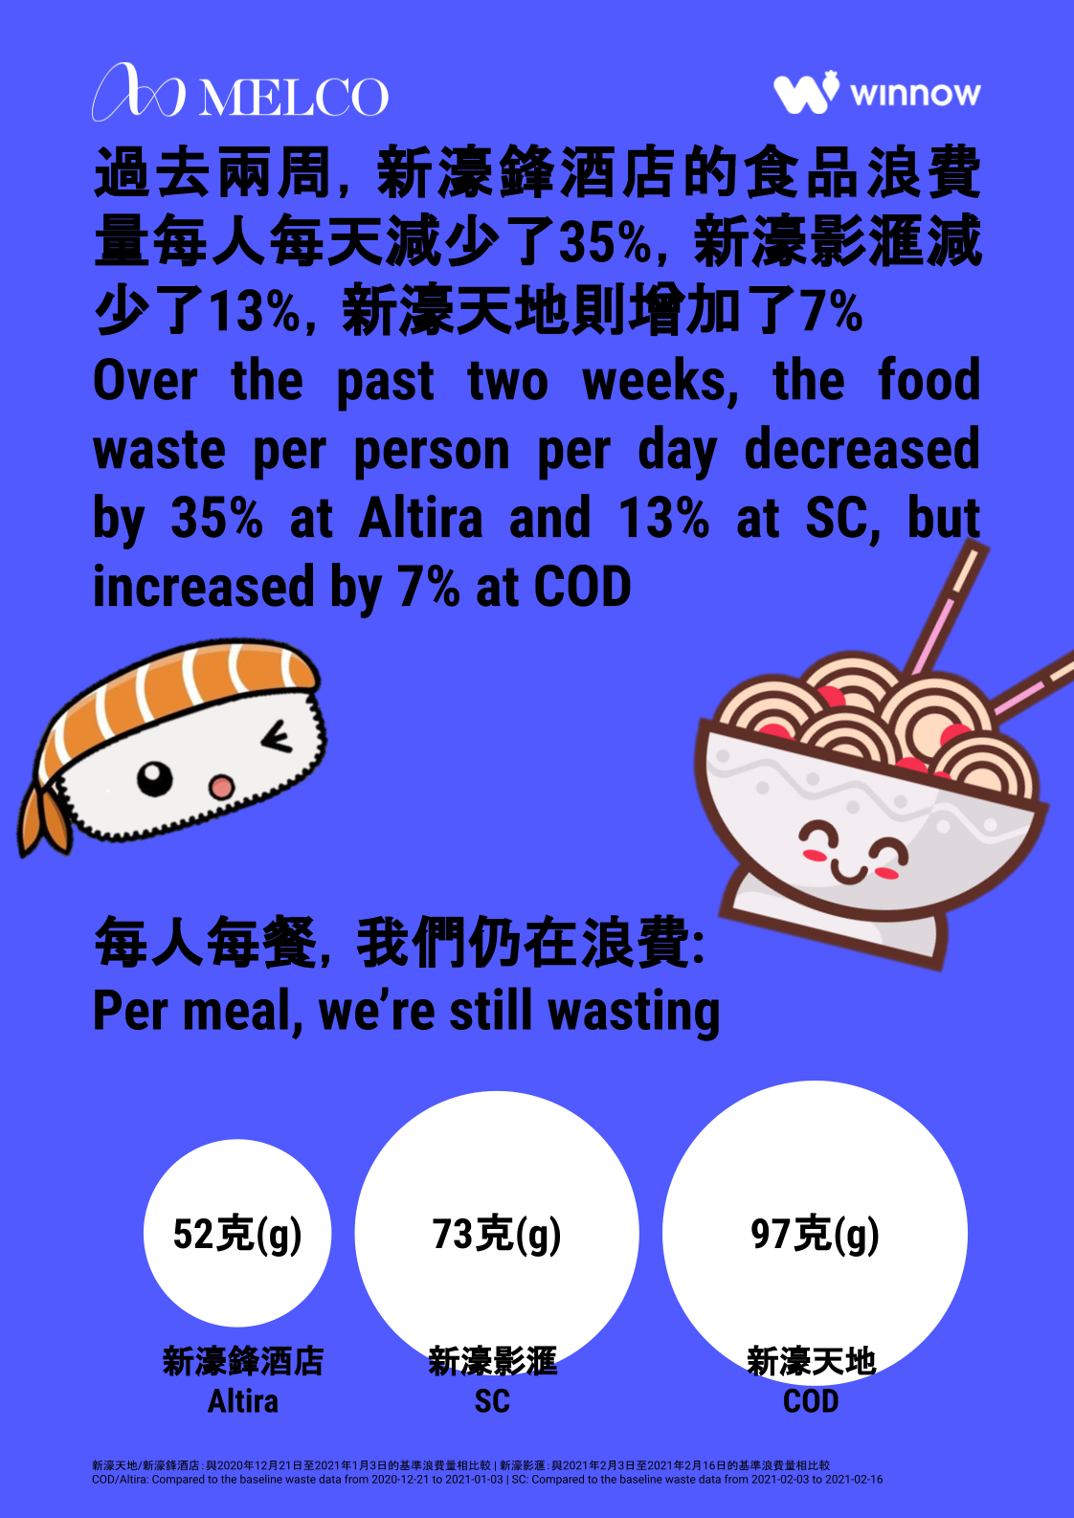 | 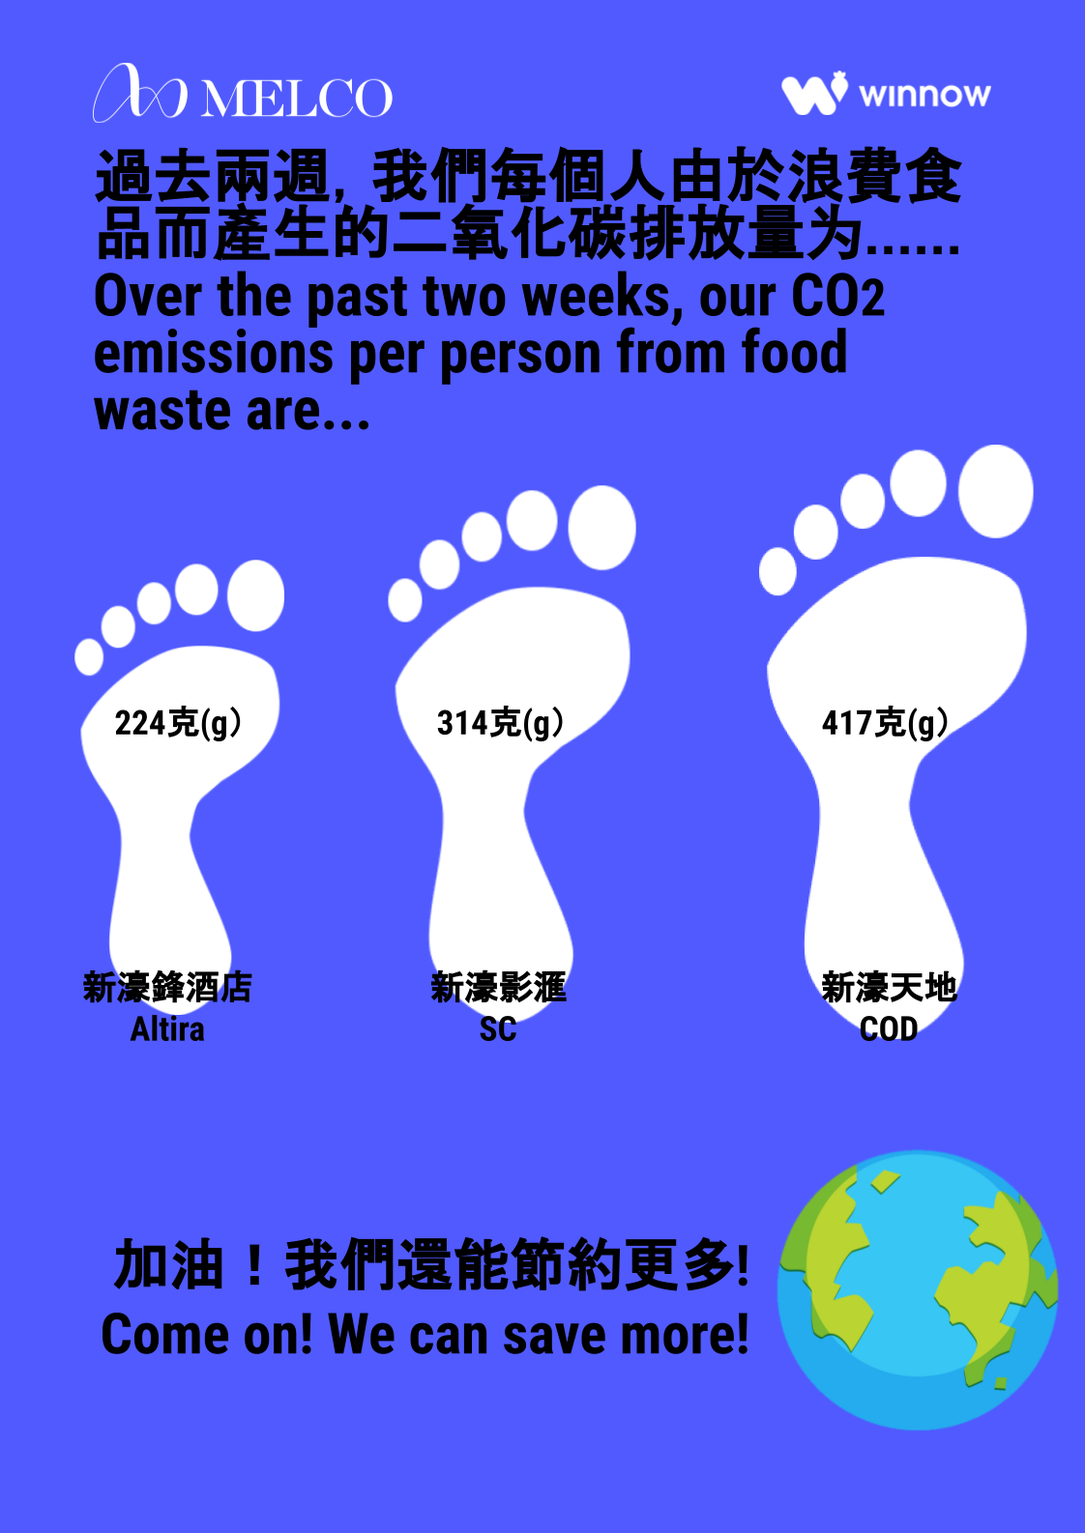 | 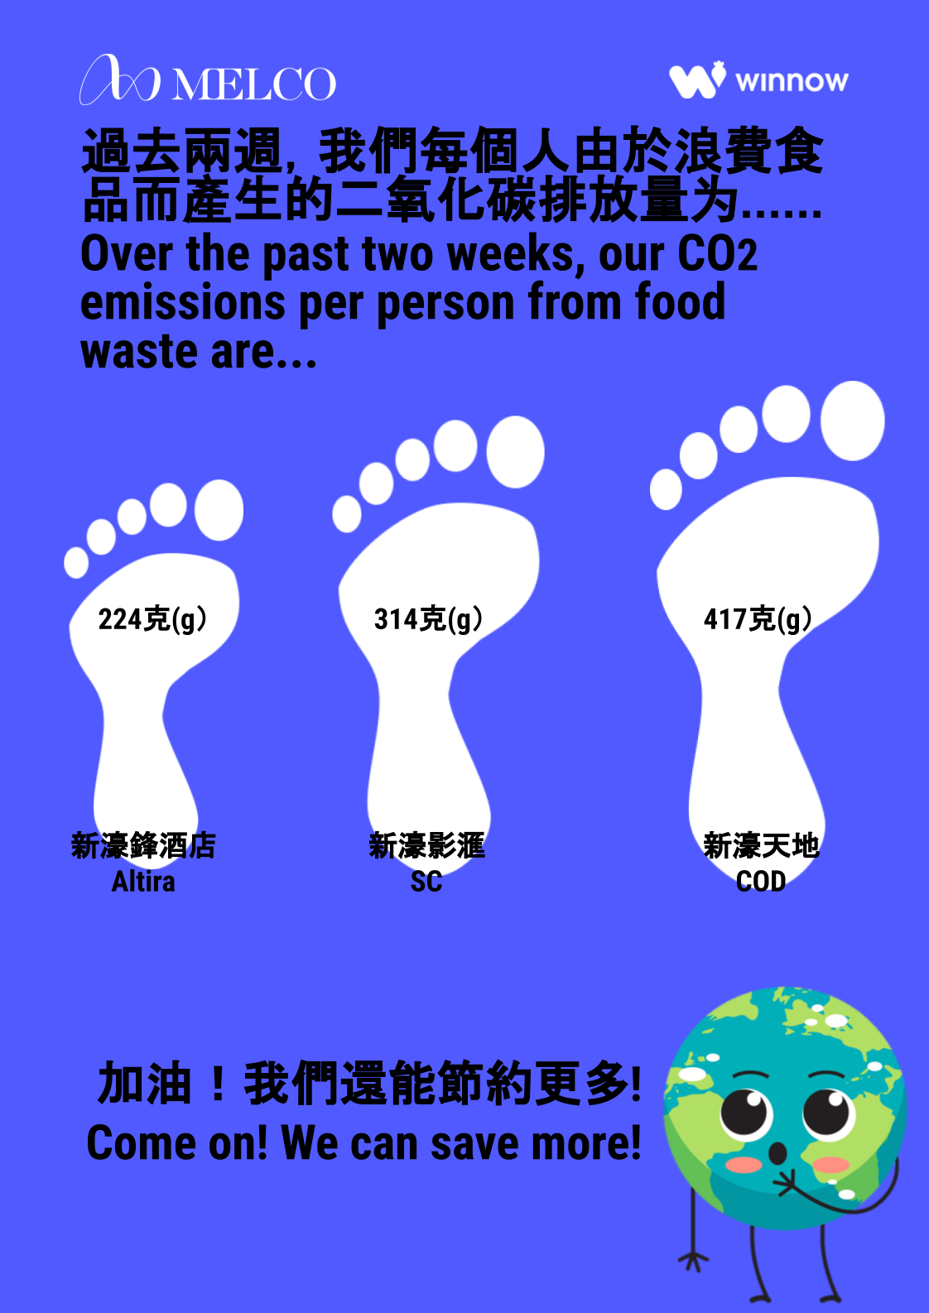
Round 4: 23/03/2021-05/04/2021 | 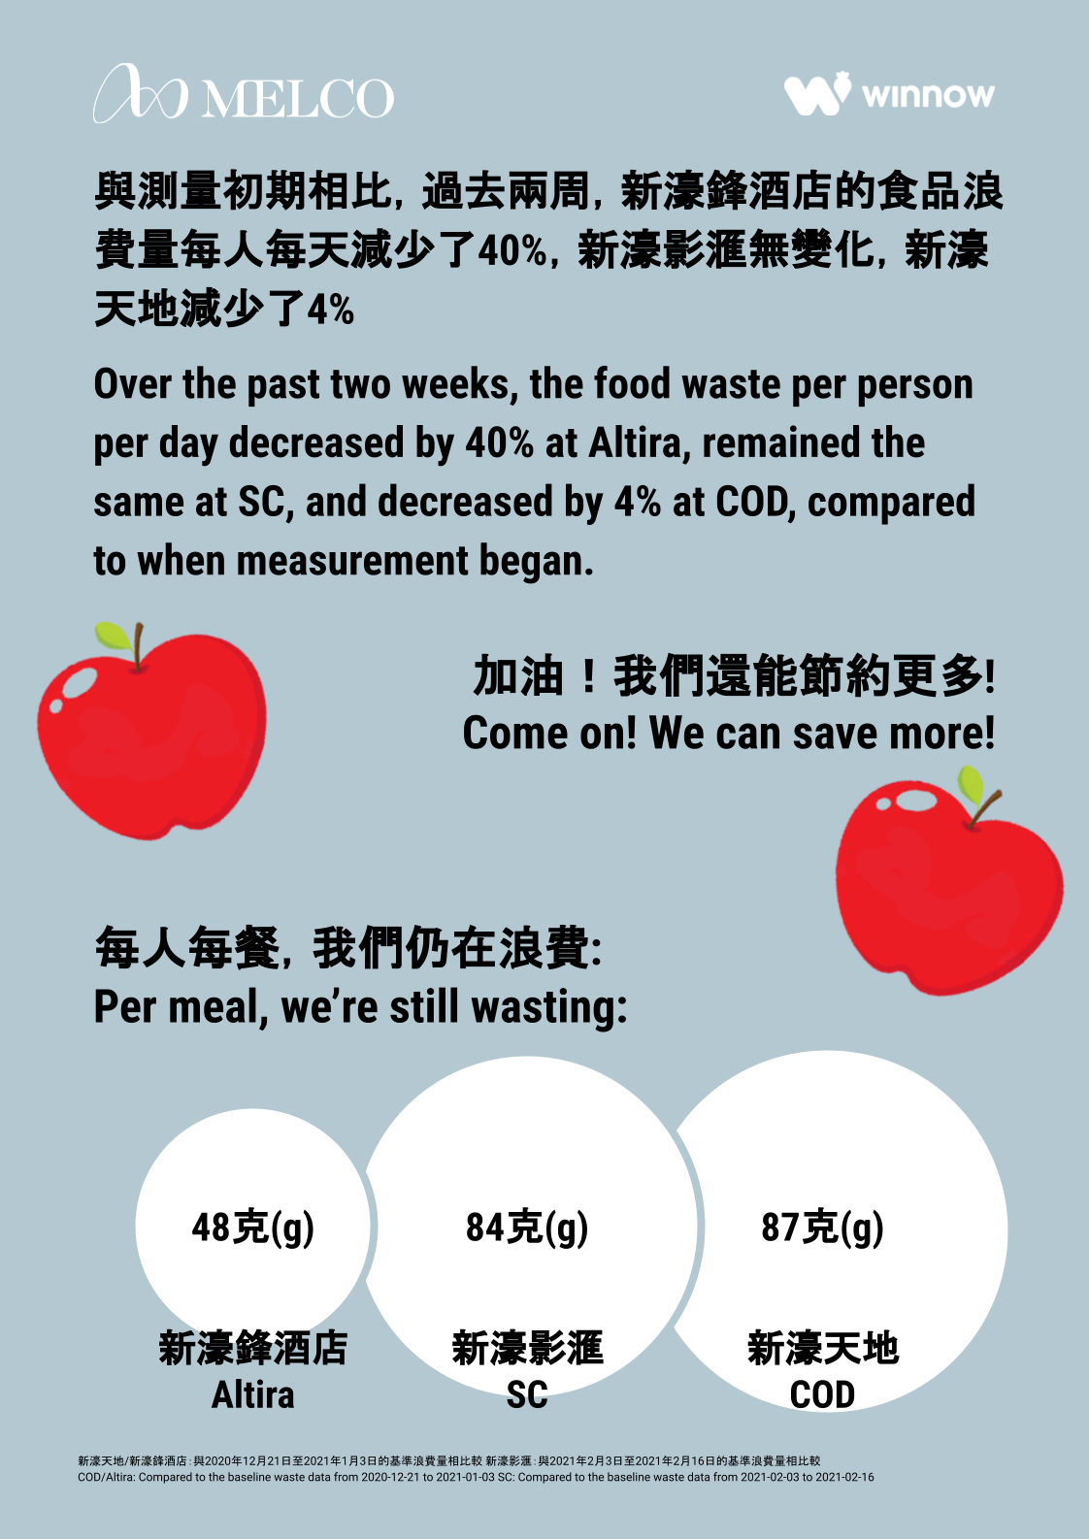 | 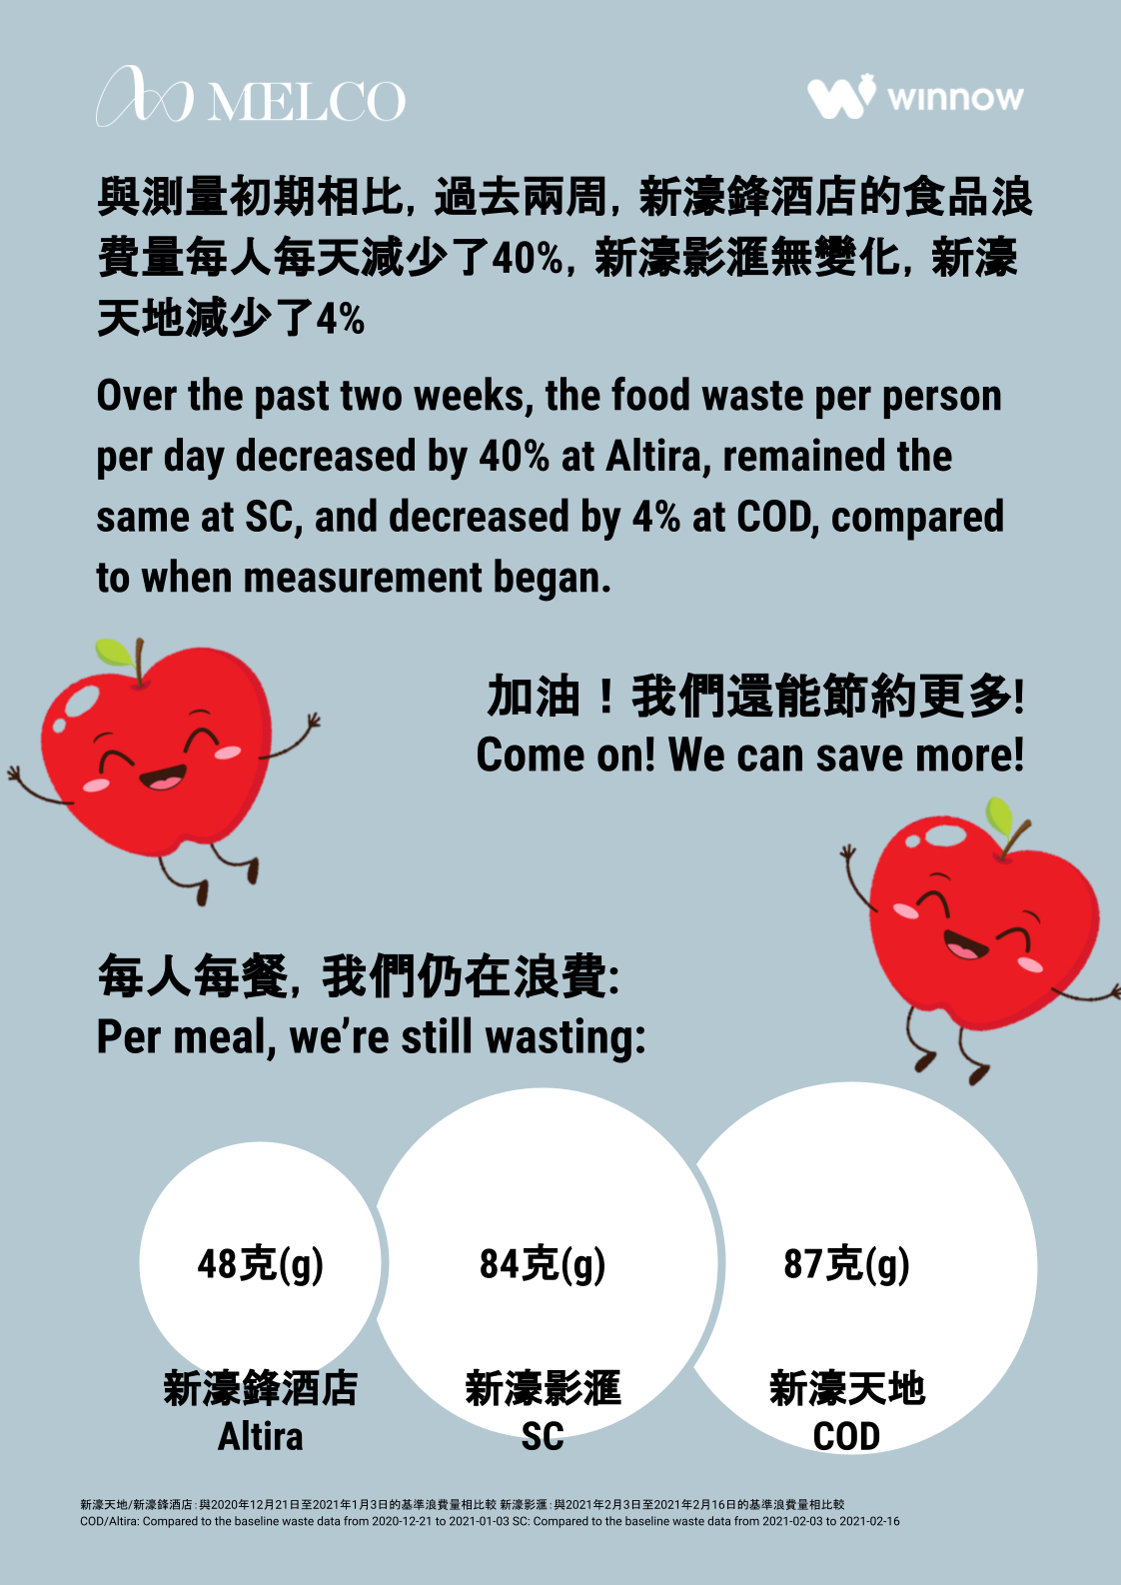 | 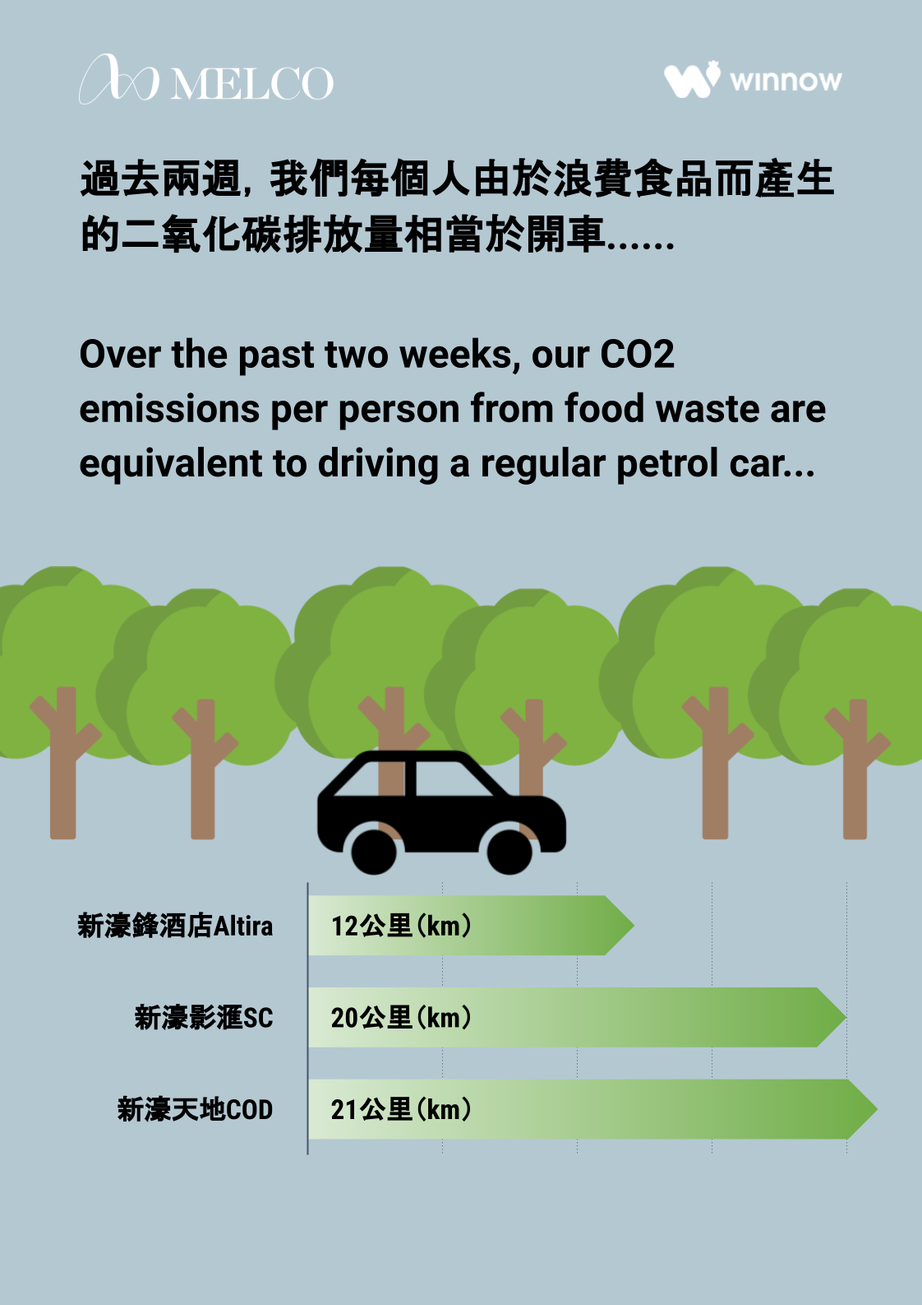 | 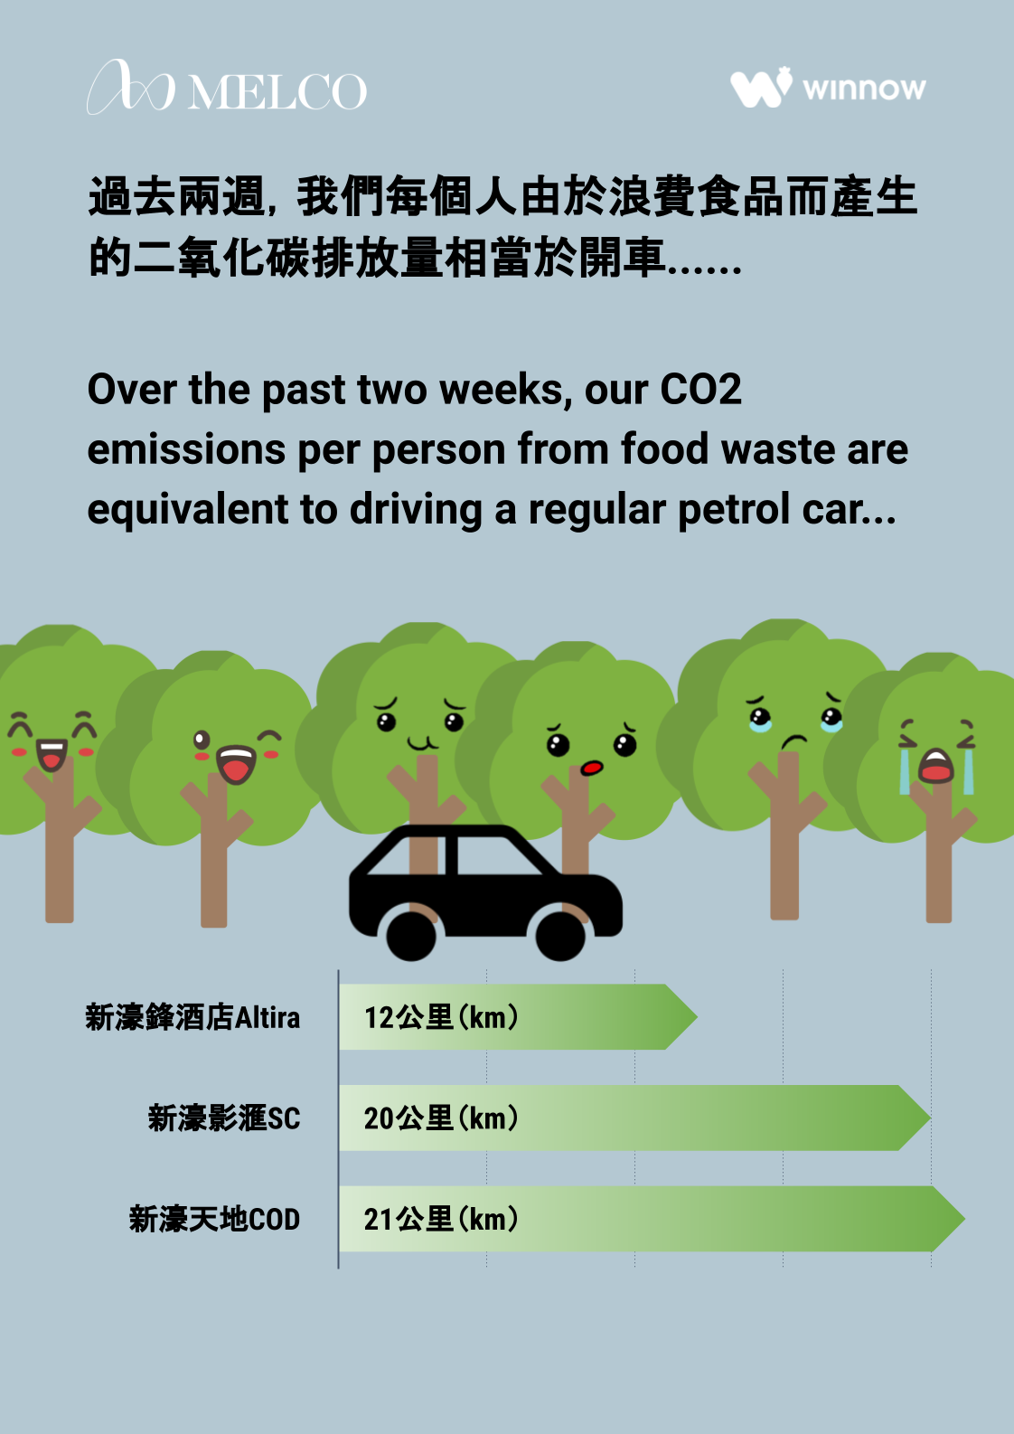
Round 5:
06/04/2021-19/04/2021

Figure S1: The on-site implementations
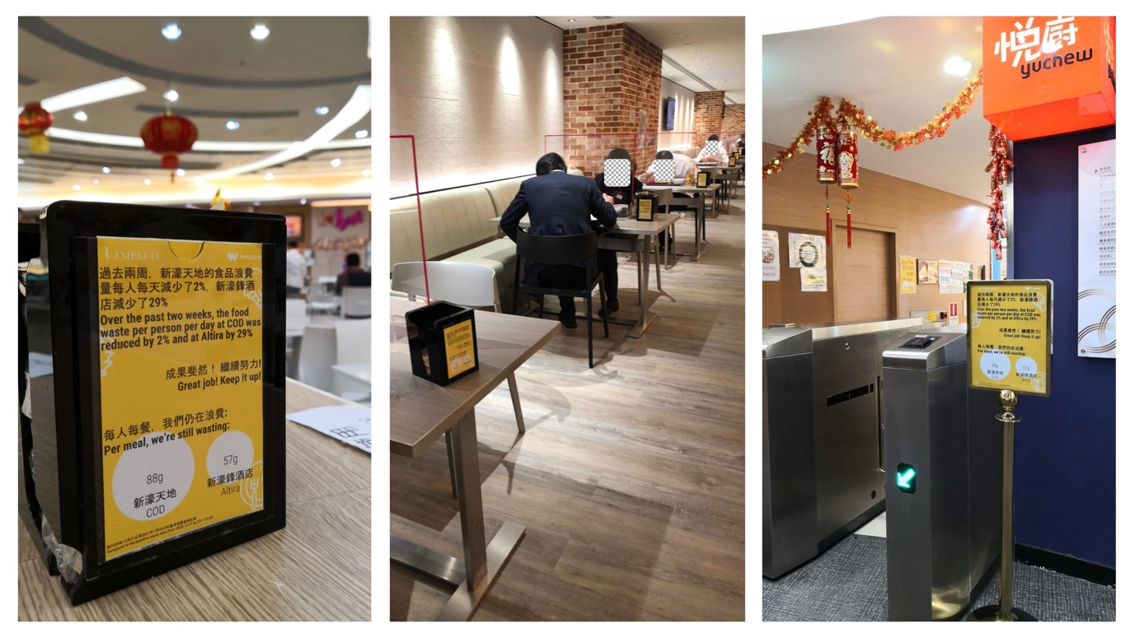

Baselines:
Winnow recommended we use the first two weeks after the installation of the WS system as the baseline period for feedback, which we did for sites B and C. Unfortunately, workers at site A failed to use the system properly when newly received it, so the data was inaccurate during the first two weeks. We had to wait for them to solve this problem and then used 03/02/2021 to 16/02/2021 as the baseline period for site A.

Other details about the survey study
Survey development:
The survey was developed by native Chinese and English speakers. We piloted the survey amongst a small group of on-site teams to ensure comprehension amongst the workers.

Data Cleaning:
Responses were invalidated if the respondent filled in the survey for more than one time (27 responses), or if the time spent on the experimental stimuli page or the whole survey was 3 SDs higher than the average (28 responses).

Survey Structure:
Apart from the variables reported, the survey also contained an experimental manipulation towards the end, where the participants were asked to read a poster similar to the environmental message, we gave them in the last round of the food waste campaign. We randomly assigned participants to one of three posters – the control poster which focused on the total amount of food saved, the environmental poster which highlighted the total CO2 emissions saved out of food waste reduction, or the anthropomorphic poster which showed information about the CO2 emissions saved along with smiling trees and earth. However, the variables analyzed in the current paper (except for the socio-demographic data) were collected before the experimental stimuli and thus uninfluenced by it.

Sample characteristics:
We allowed people to skip questions in the survey, and the characteristics described below did not take missing data into account.
N_{Female} = 628, N_{Male} =562; M_{age} = 37, SD_{age} = 10.
N_{siteA} = 381, N_{siteB} = 726, N_{siteC} = 86. There were fewer survey participants from site C because sites A and B are much larger sites and have more workers than site C overall. Site A is also larger than site B.

Table S7: Regression models testing the cross-site differences in self-reported food-saving efforts at work, with control variables included
 | efforts at_work 1  “Had a conversation with work colleagues about food waste” | efforts at_work 2  “Tried to reduce food waste at work”
site B | −0.06  (0.06) | 0.04  (0.05)
site C | 0.17  (0.12) | 0.39  (0.07)***
environmental identity | 0.33  (0.05)*** | 0.08  (0.04)*
motivation 1 | 0.04  (0.07) | 0.03  (0.05)
motivation 2 | 0.11  (0.07) | 0.14  (0.06)**
motivation 3 | 0.05  (0.06) | 0.10  (0.06)*
motivation 4 | −0.10  (0.05)* | 0.04  (0.05)
motivation 5 | 0.003  (0.053) | −0.12  (0.04)***
motivation 6 | 0.07  (0.06) | −0.00004  (0.04420)
motivation 7 | 0.15  (0.07)** | 0.06  (0.05)
motivation 8 | −0.11  (0.08) | 0.17  (0.06)***
age | 0.012  (0.003)*** | 0.0004  (0.0028)
female | 0.01  (0.06) | −0.01  (0.05)
education | −0.04  (0.03) | 0.09  (0.02)***
income | −0.04  (0.02)* | −0.01  (0.02)
constant | −0.13  (0.37) | 1.93  (0.32)***
N of observations | 1,146 | 1,145
R² | 0.19 | 0.14
Notes: Table reports OLS coefficients. Standard errors in parentheses are corrected for heteroscedasticity.
*** Significant at the 1% level.
** Significant at the 5% percent level.
* Significant at the 10% percent level.

Figure S2: The sample distribution of income
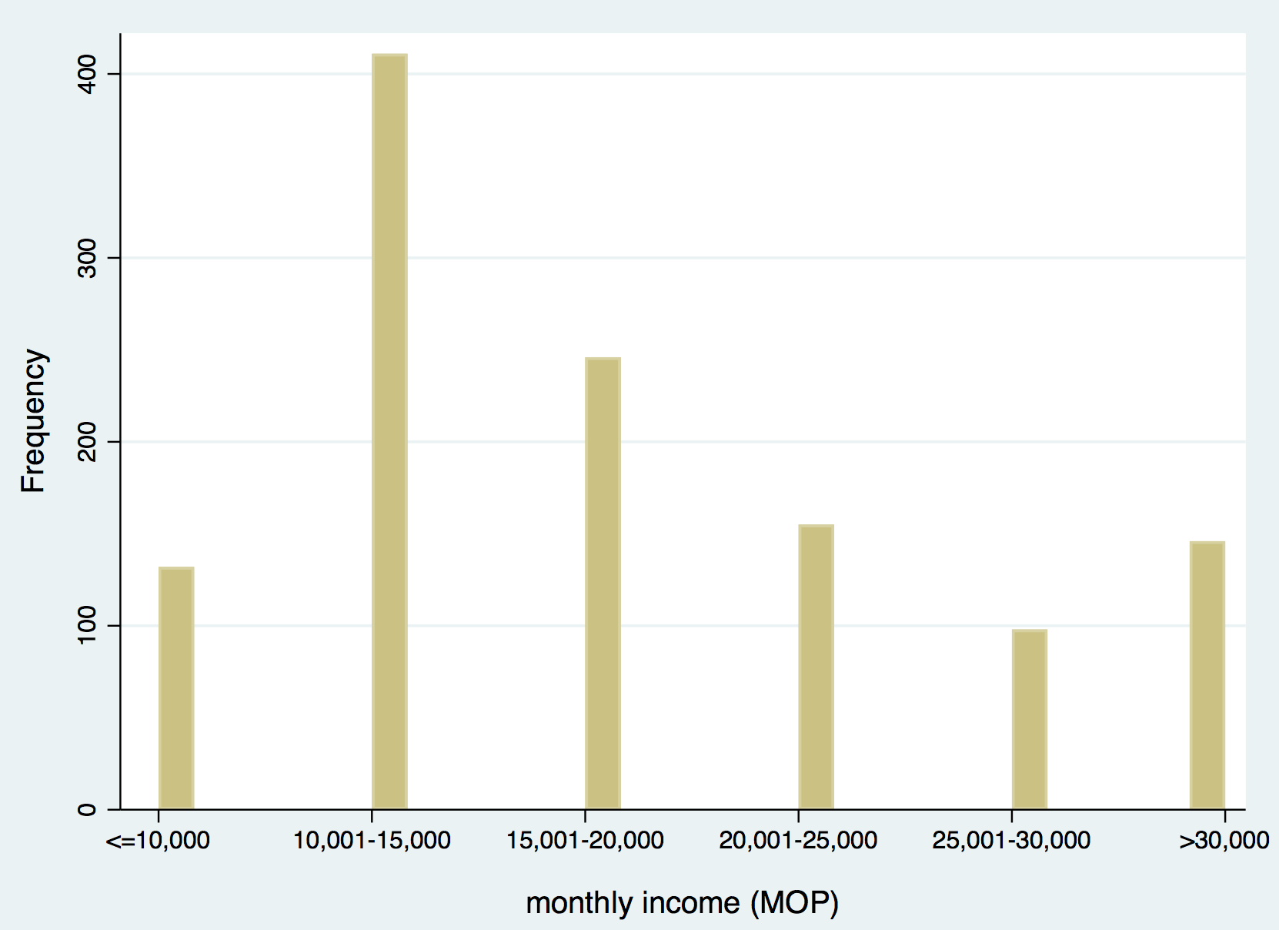
Figure S3: The sample distribution of education
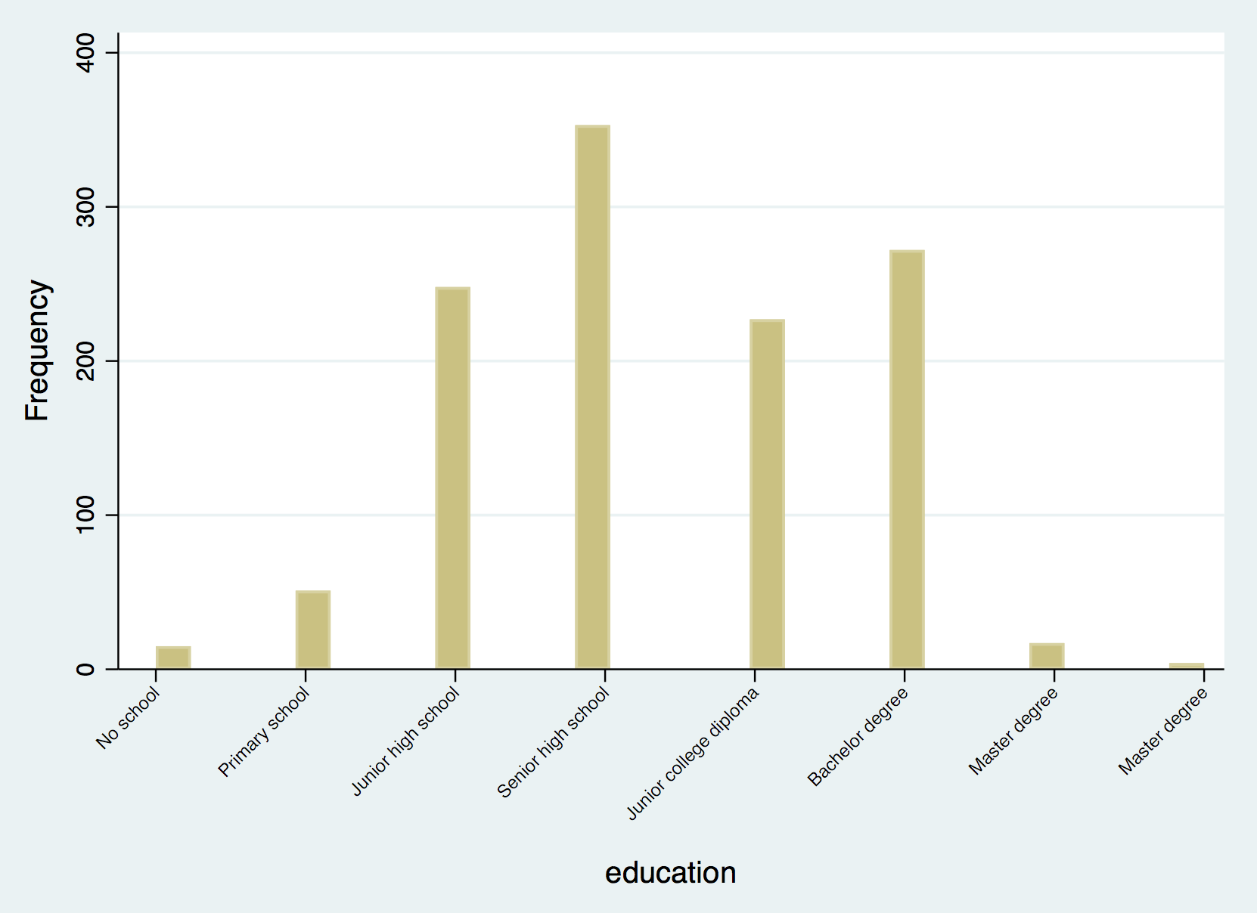
Normality assumption:
The distributional plots (histogram, P-P plots and Q-Q plots) indicate that the distribution of our main outcome variable efforts to reduce food at home was approximately normal.

Figure S4: The distribution histogram of our outcome variable efforts to reduce food at home
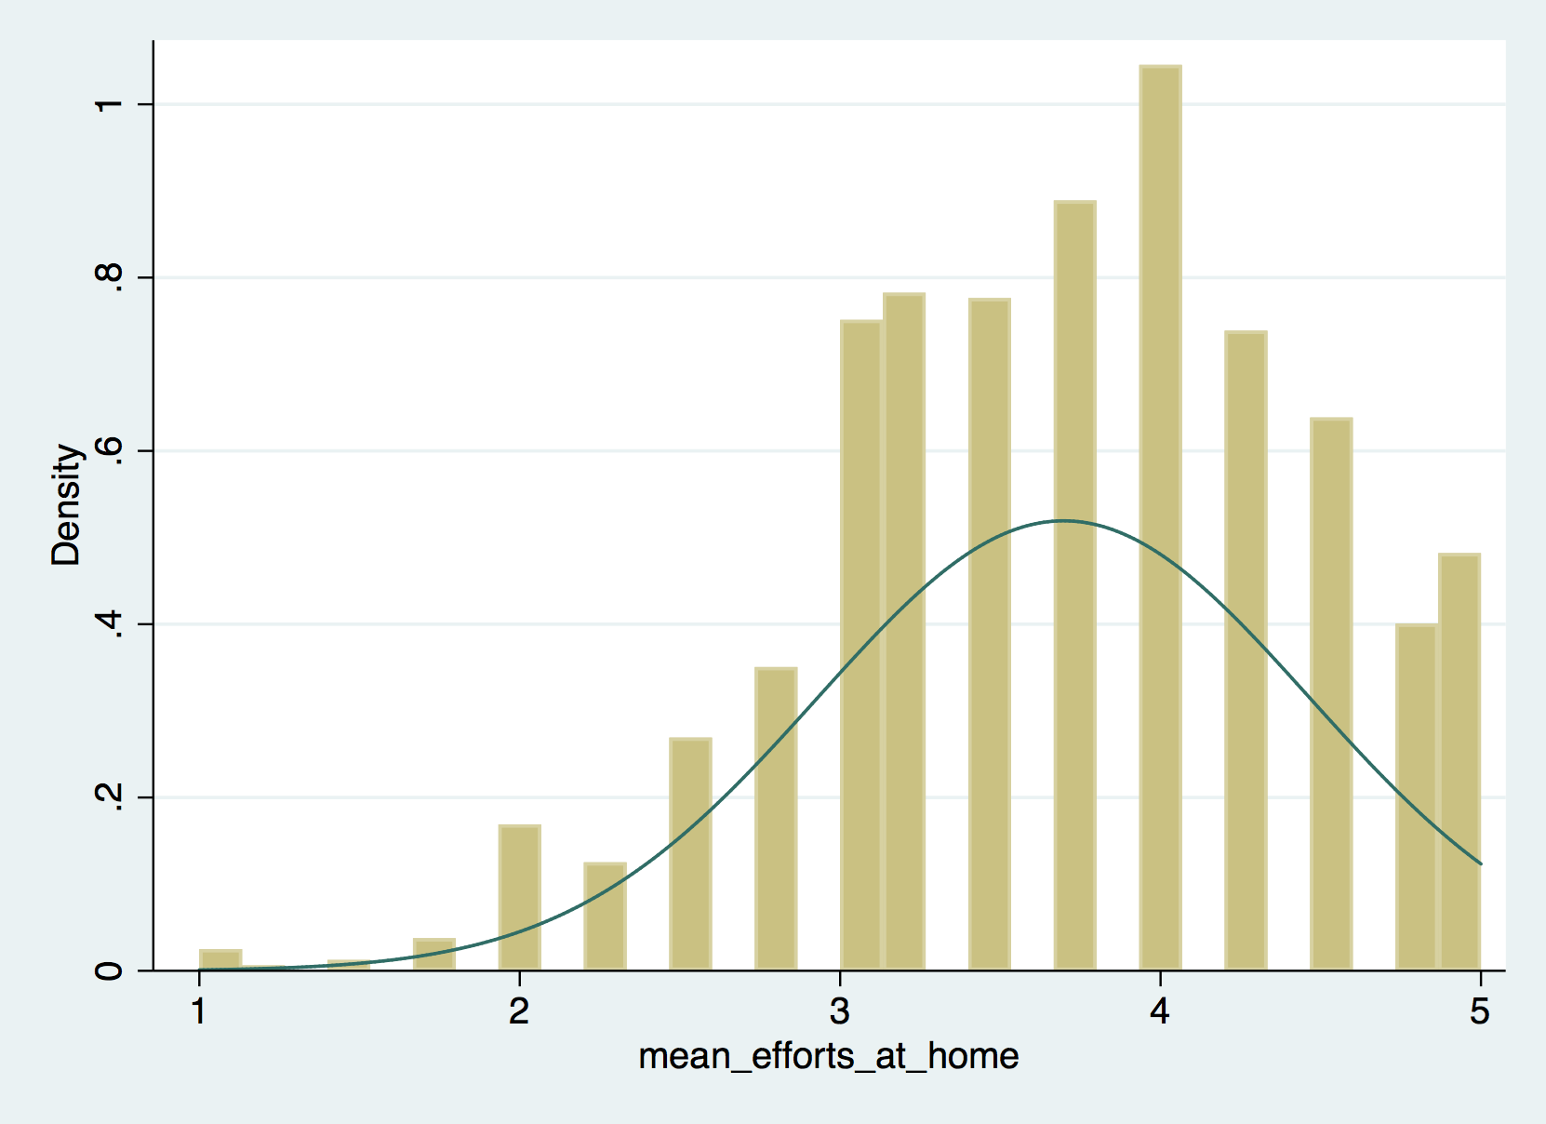
Figure S5: The P-P plots of our outcome variable efforts to reduce food at home
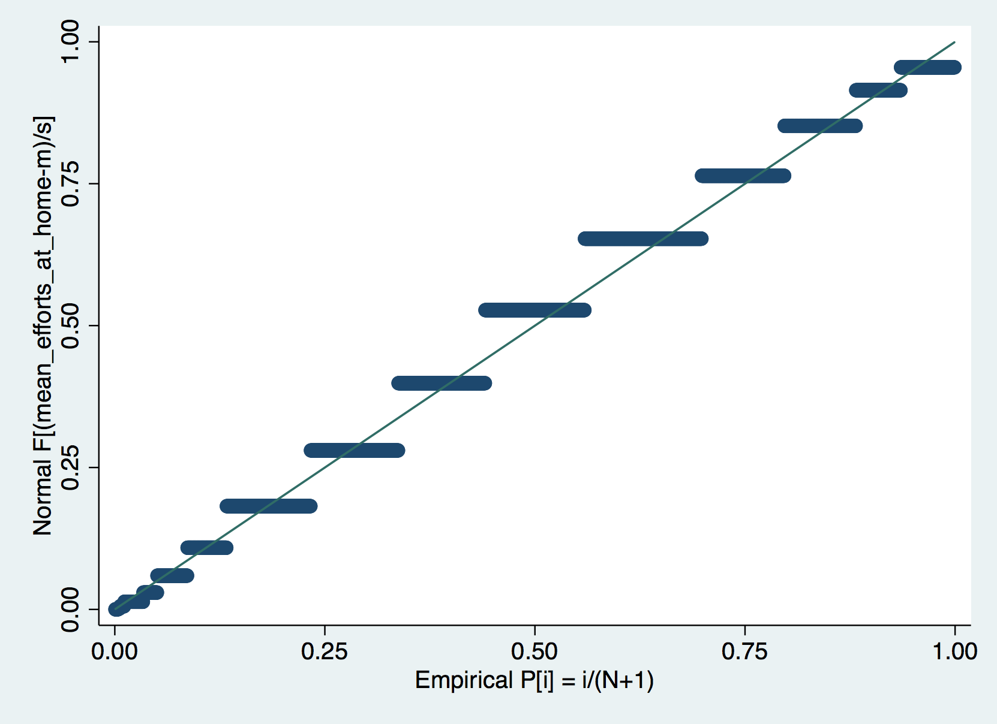
Figure S6: The Q-Q plots of our outcome variable efforts to reduce food at home
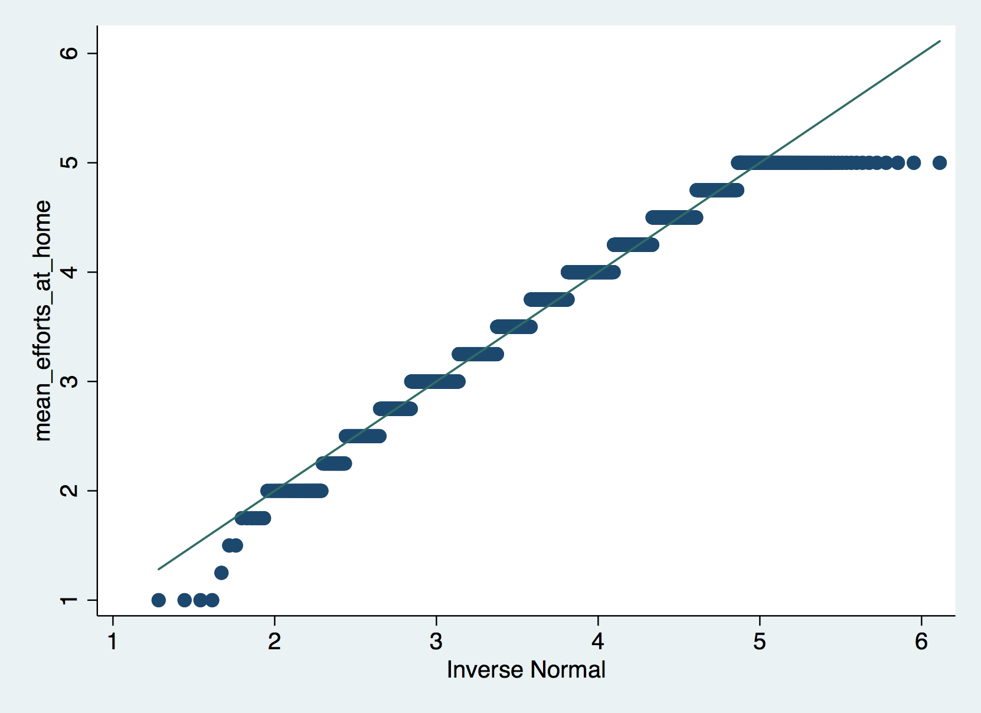

Supplementary References

1. Capstick, S., Whitmarsh, L., Nash, N., Haggar, P. & Lord, J. Compensatory and Catalyzing Beliefs: Their Relationship to Pro-environmental Behavior and Behavioral Spillover in Seven Countries. Front. Psychol. 10, 963 (2019).
2. Whitmarsh, L. & O’Neill, S. Green identity, green living? The role of pro-environmental self-identity in determining consistency across diverse pro-environmental behaviours. Journal of Environmental Psychology 30, 305–314 (2010).
3. Eisinga, R., Grotenhuis, M. te & Pelzer, B. The reliability of a two-item scale: Pearson, Cronbach, or Spearman-Brown? Int J Public Health 58, 637–642 (2013).
4. Thompson, F. E., Larkin, F. A. & Brown, M. B. Weekend-weekday differences in reported dietary intake: The nationwide food consumption survey, 1977–78. Nutrition Research 6, 647–662 (1986).

