Supplementary Materials

Table S1. Summary data used for model development.
Dose (mg/kg) | No. of mice | No. of observations
0.3 | 8 | 24
1 | 20 | 37
3 | 21 | 39
5 | 10 | 10
10 | 11 | 11
Total | 70 | 121

Table S2. Summary data used for model development.
Model | - 2LL (OFV)
2 compartment, linear CL  IIV on CL | 2236.62
1 compartment, linear CL  IIV on CL and V | 2232.57
1 compartment, linear CL  IIV on CL and V with dose as a covariate on CL | 2206.38

Table S3. Base population PK model parameters.
Parameter |  | Estimate  (%RSE) | Bootstrap (n=1000) |  | Shrinkage (%)
 |  | Estimate  (%RSE) | Median | 95% CI | Shrinkage (%)
Fixed effect
 | CL (mL/h/kg) | 45.57 (4.89) | 45.75 | 38.96 – 53.65 | -
 | V (mL/kg) | 57 (10.2) | 56.03 | 43.84 – 72.51 | -
Interindividual variability
 | IIV on CL (CV%) | 15 (23.9) | 0.22 | 0.1 – 0.34 | 60.4
 | IIV on V (CV%) | 58 (15.3) | 0.5 | 0.34 – 0.68 | 19.1
Residual variability
 | b (%) | 0.44 (9.09) | 0.43 | 0.34 – 0.52 | 18.6

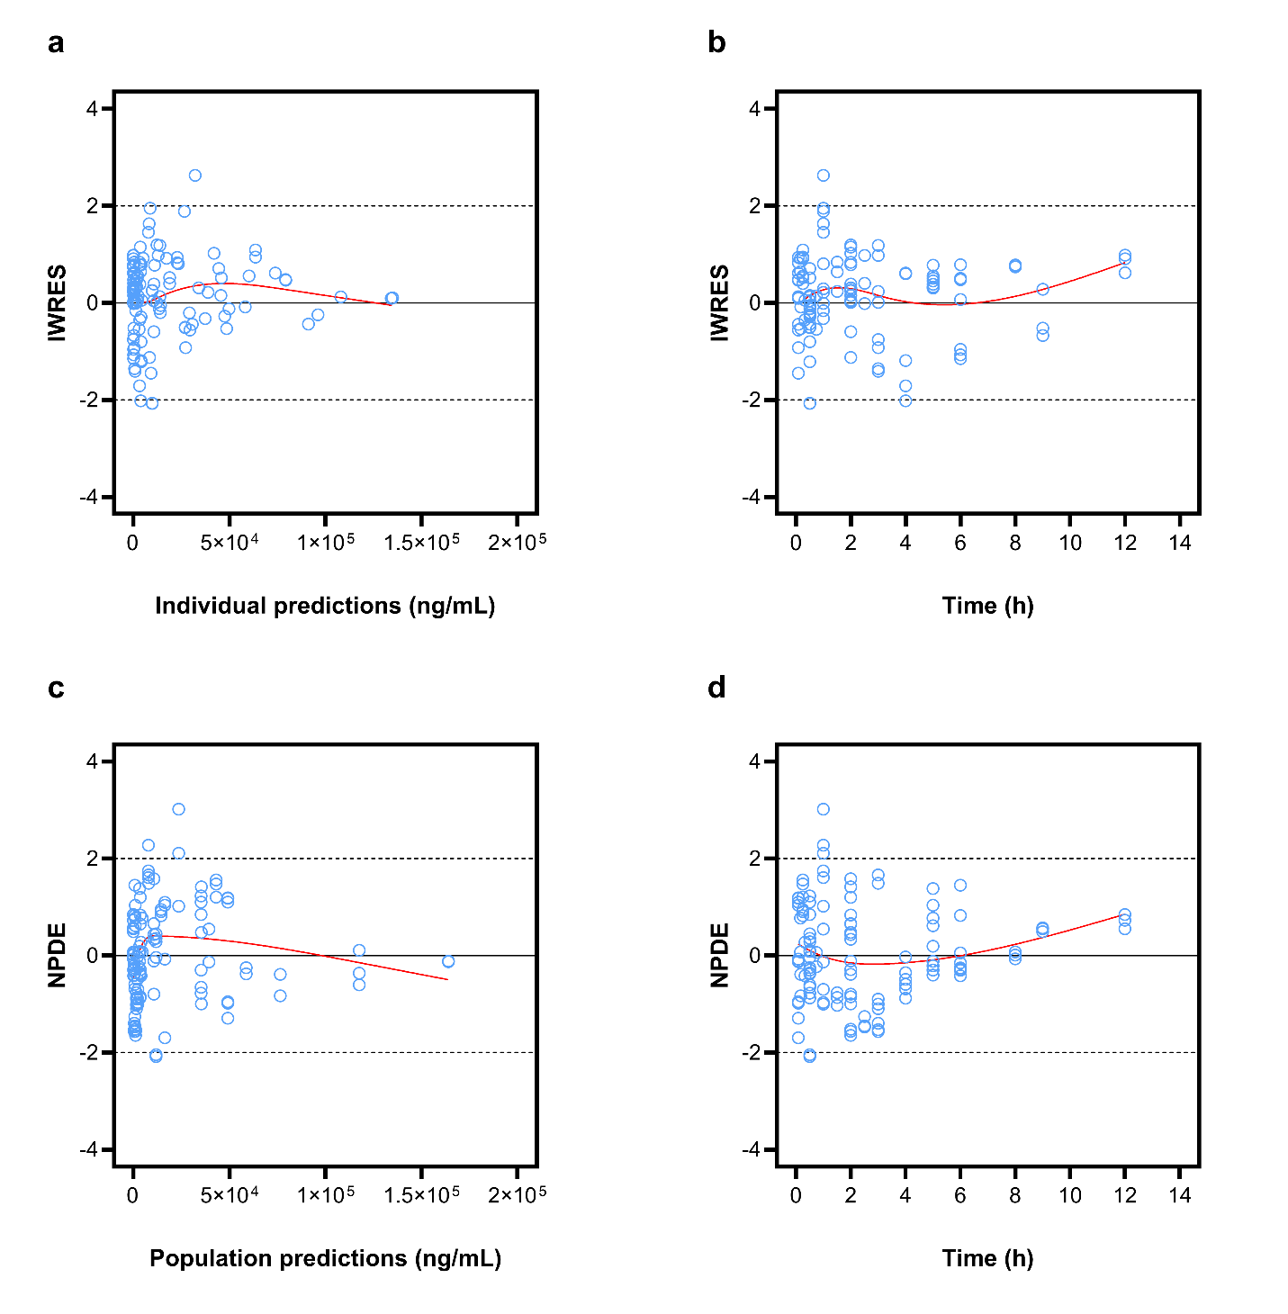
Fig. S1 Goodness-of-fit plots of final popPK model. Panel a and b show individual weighted residuals (IWRES) versus individual predictions and time, respectively. Panel c and d show normalized prediction distribution errors (NPDE) versus population predictions and time, respectively.

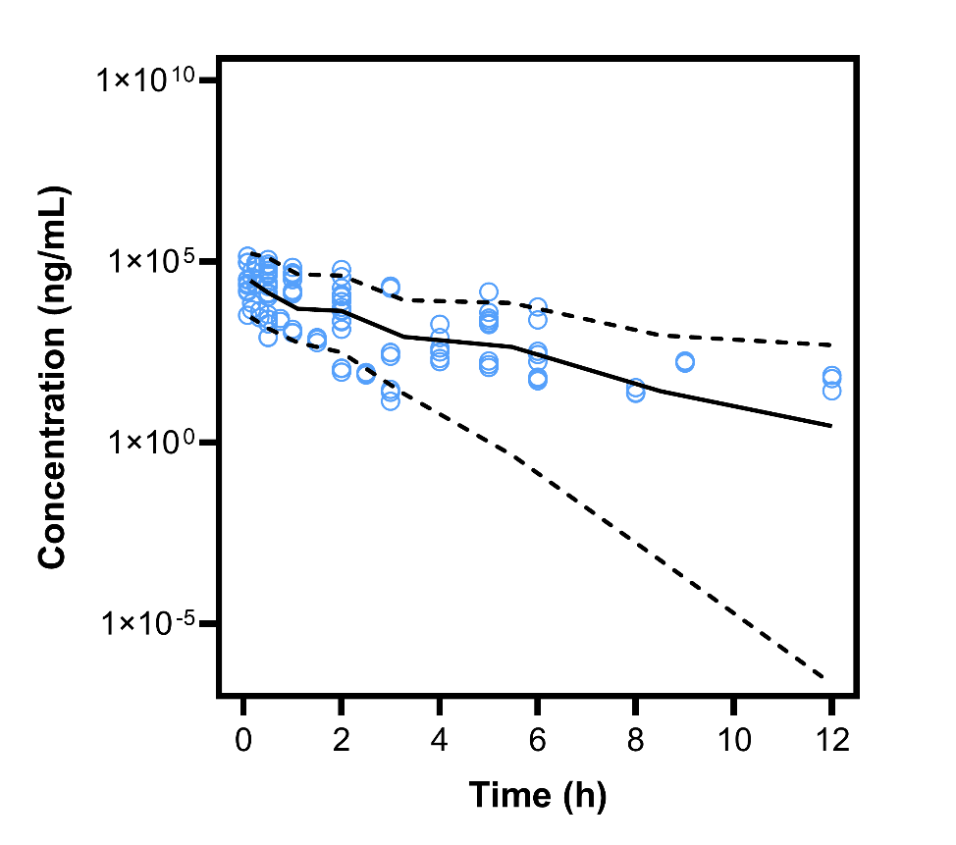
Fig. S2 Visual predictive check of base popPK model following 1000 simulations. Solid line represents median and dashed lines represent 5th and 95th percentiles. Blue circles represent observations.

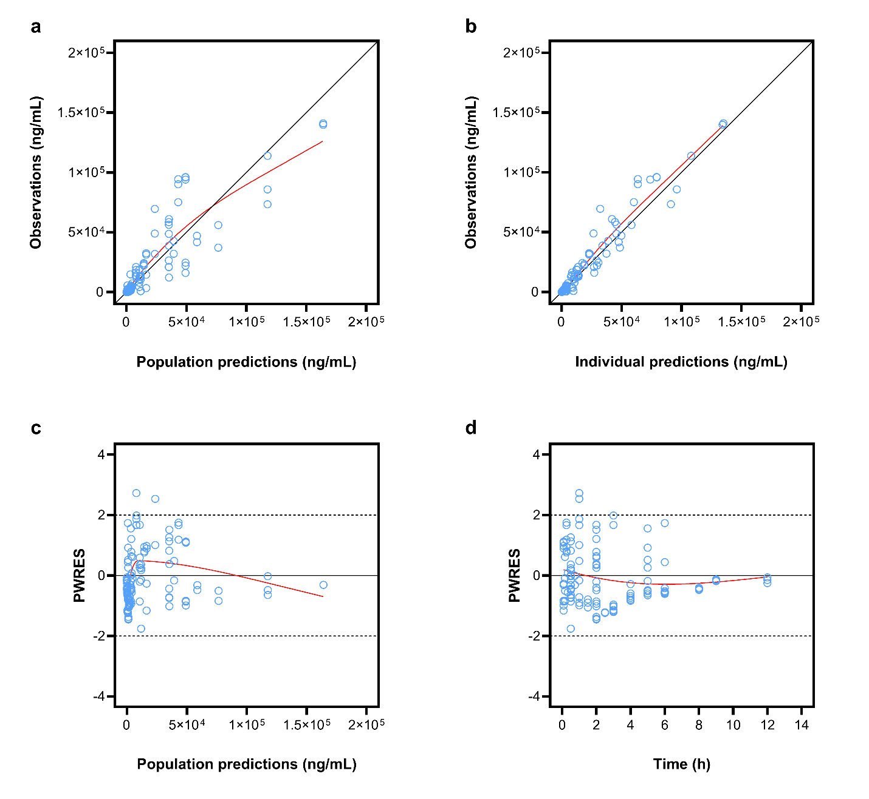
Fig. S3 Goodness-of-fit plots of base popPK model. Panel a and b show the observations versus population (PPRED) and individual predictions (IPRED), respectively. Panel c and d show population weighted residuals (PWRES) versus population predictions and time, respectively.

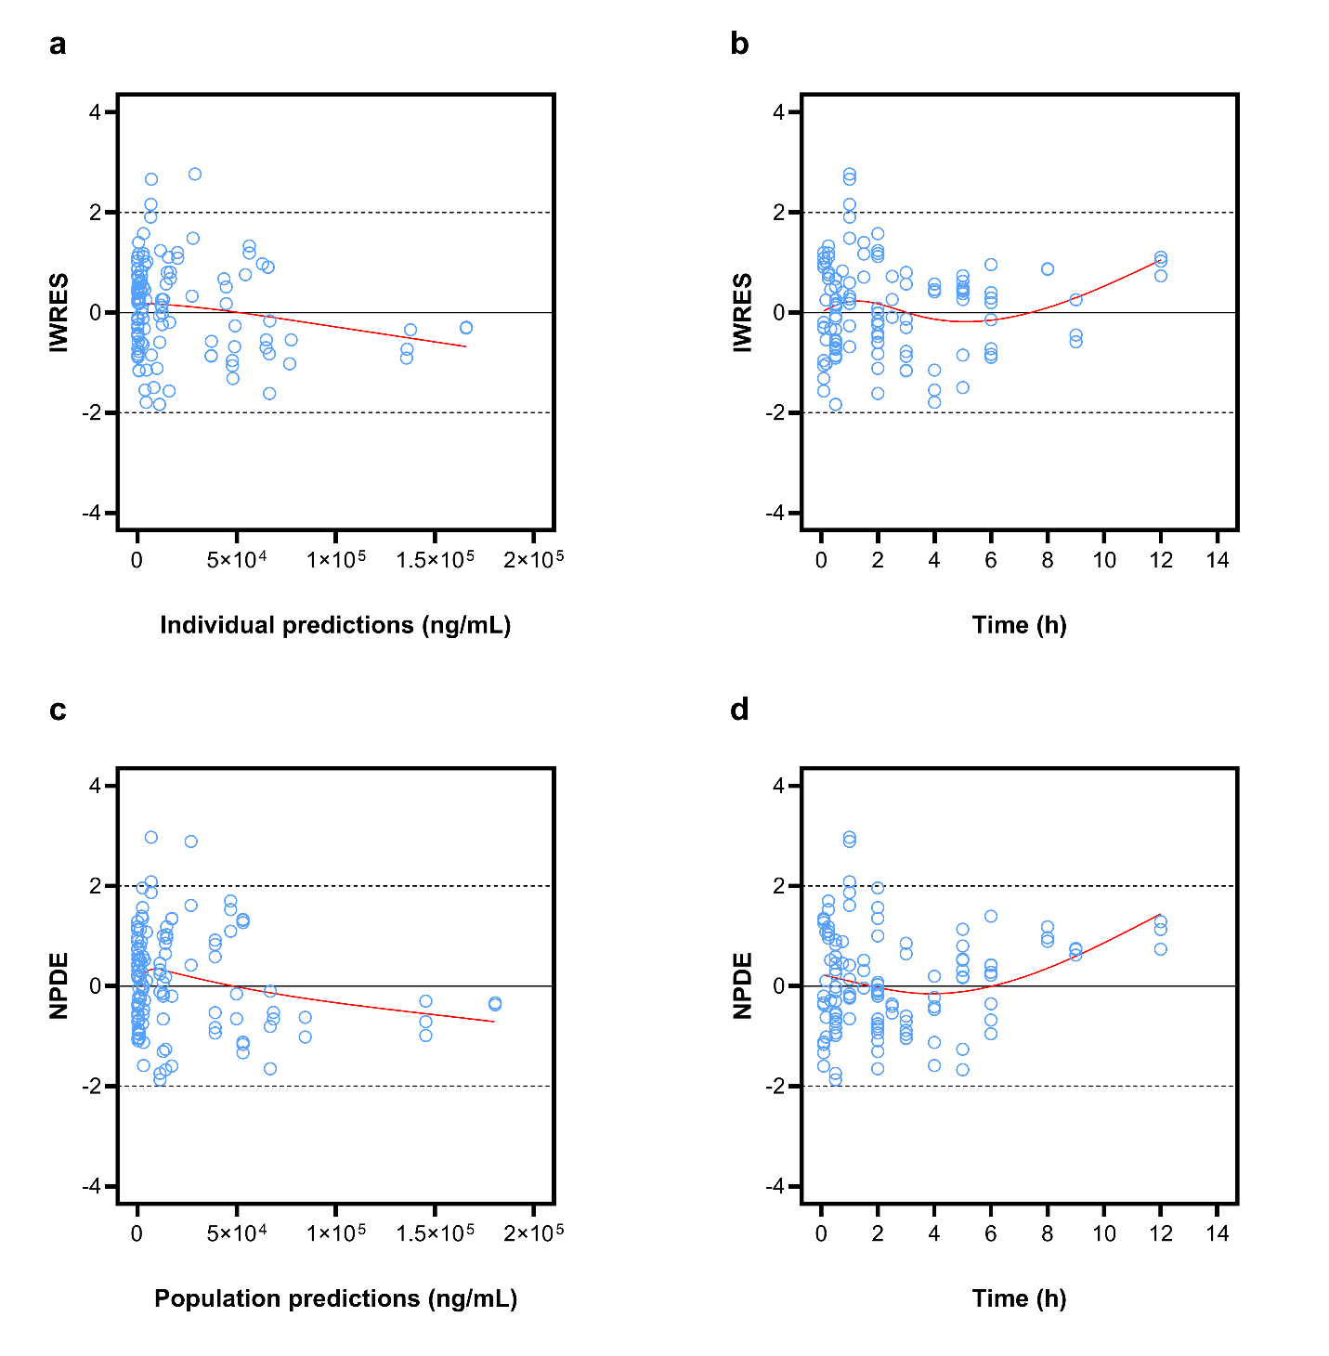
Fig. S4 Goodness-of-fit plots of base popPK model. Panel a and b show individual weighted residuals (IWRES) versus individual predictions and time, respectively. Panel c and d show normalized prediction distribution errors (NPDE) versus population predictions (PPRED) and time, respectively.

