Chiral microwave metasurface for controlling spins in diamond
Kosuke Takada^{1, 2}, Ryota Katsumi^{1, 2}, Shusuke Akagi¹, Kazunobu Hashimoto¹, and Takashi Yatsui^{1, 2}
¹ Graduate School of Engineering, Toyohashi University of Technology, 1-1 Hibarigaoka, Tempaku-cho, Toyohashi, Aichi 441-8580, Japan
² Graduate School of Engineering, The University of Tokyo, 7-3-1 Hongo, Bunkyo-ku, Tokyo 113-8656, Japan
³ Department of Electrical Engineering, Columbia University, New York, NY 10027, USA
Corresponding authors: Kosuke Takada, Ryota Katsumi, and Takashi Yatsui
E-mail: takada.kosuke.wu@tut.jp, katsumi.ryota.ti@tut.jp, yatsui.takashi.rv@tut.jp

Supplementary Note 1
Three dimensionally oriented texture of magnetic-field polarization for asymmetric and mirror-symmetric spoof surface plasmon polariton (SSPP) metasurfaces
Two additional types of SSPP metasurfaces are investigated in this section, the unit cell structures of which are illustrated in Supplementary Figs. S1(a) and (b) with spatial periodicity along the $x$ direction. The structure in Supplementary Fig. S1(a) is asymmetric, with grooves on one side ($+y$ direction). The second supports grooves on both sides ($±y$ directions) and has mirror symmetry with respect to the $y$-axis inversion, as shown in Supplementary Fig. S1(b). The geometric parameter definitions are also clarified in Supplementary Figs. S1(a) and (b) and are the same as those of the glide-symmetric structure in the main text. Supplementary Figure S1(c) presents the numerically calculated dispersion relationships for $h=18 mm$, $a=1 mm$, $b=4 mm$, and $w=1 mm$.

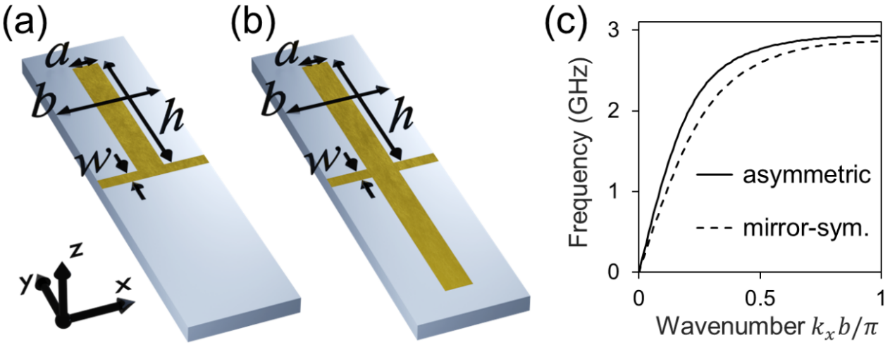
Supplementary Fig. S1 Other symmetric types of the SSPP metasurface. (a) asymmetric and (b) mirror-symmetric unit cells of the metasurface with the geometric parameter definitions, which are one-dimensionally periodic along the x-direction. (c) Calculated dispersion relations when $h=18 mm, a=1 mm, b=4 mm, w=1 mm$.

Supplementary Figure S2 shows the distributions of $V$ (red arrows) and $D$ (color map) at different heights above the asymmetric and mirror-symmetric metasurfaces. These plots all correspond to the eigenmodes at ${k_{x}d}/π=0.9$ in Supplementary Fig. S1(c). The area near which $D≈1$ is smaller than the result in Figs. 2(c)–(f) of the main text. In addition, orientations of $V$ are not broadly distributed, as well as those in Figs. 2(c)–(f). Compared with the glide-symmetric SSPP metasurface, these polarization properties are not attractive for our purpose.

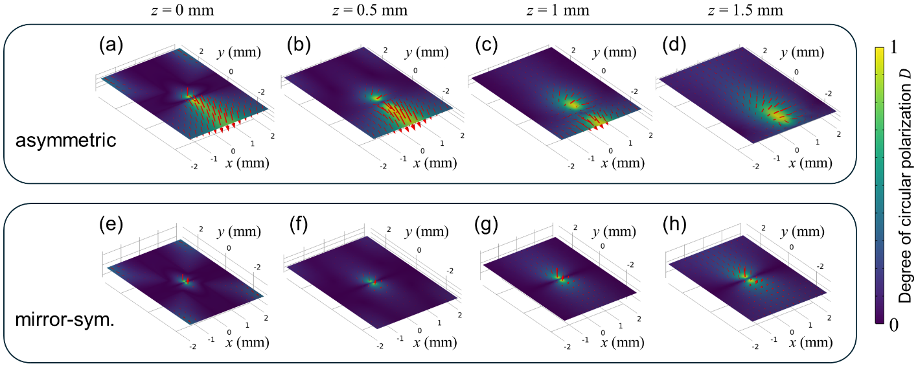
Supplementary Fig. S2 3D polarization distributed within the unit cells of the SSPP metasurface. Simulated $V$ (red arrows) and $D$ (colormap) distributions for the asymmetric structure at (a) $z=0 mm$, (b) $z=0.5 mm$, (c) $z=1 mm$, and (d) $z=1.5 mm$ planes, where $z=0 mm$ corresponds to the surface of the metal pattern. Simulated $V$ and $D$ distributions for the mirror-symmetric structure at (e) $z=0 mm$, (f) $z=0.5 mm$, (g) $z=1 mm$, and (h) $z=1.5 mm$ planes.

Supplementary Note 2
Numerical verification of spin-momentum locking in a propagating SSPP mode
The experimentally observed spin-momentum locking behavior in the main text can be numerically reproduced, as presented in this section. We simulated the device structure and conducted frequency-domain calculations of electromagnetic-field distributions around the device. Supplementary Figures S3(a) and (b) show the numerically simulated distributions of in-plane Stokes parameters for the $+x$ and $-x$ directions of SSPP propagation, respectively, on the surface of the cover glass at a frequency of 2.88 GHz. The stars in Supplementary Figs. S3(a) and (b) mark the approximate position of the diamond microring structure used in the measurement (Supplementary Fig. S4 shows the position of the measured device). The simulations confirm nearly pure circular polarization ($\left|{S_{3}}/{S_{0}}\right|≈1$) close to the marked position, with the handedness determined by the direction of SSPP propagation via spin-momentum locking.

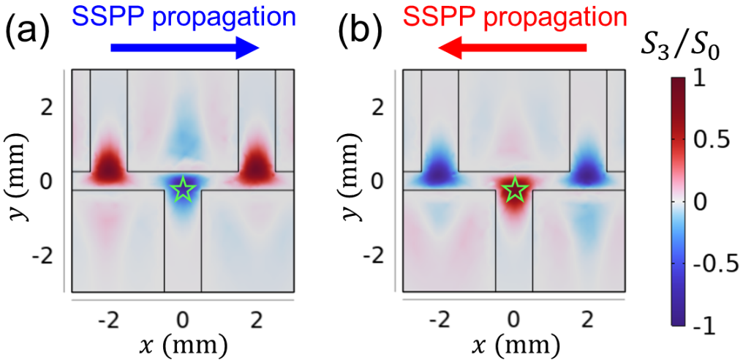
Supplementary Fig. S3 Propagation-dependent in-plane polarization of the microwave magnetic field on the SSPP metasurface. Stokes parameter ${S_{3}}/{S_{0}}$ distributions on the cover glass for the (a) $+x$ and (b) $-x$ SSPP propagation, confirming a reversal in handedness.

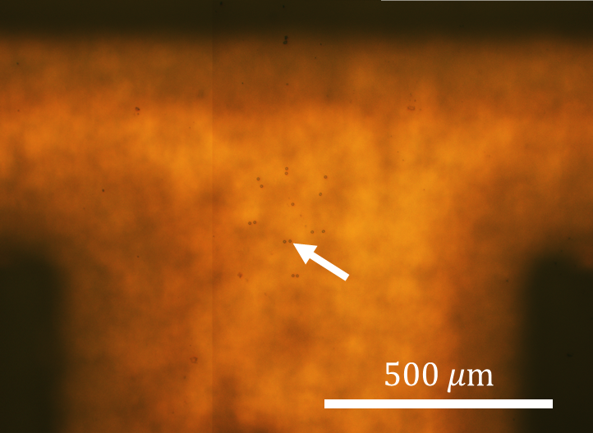
Supplementary Fig. S4 Transfer-printed diamond ring structures on the cover glass, in which the white arrow indicates the position of the measured sample.

Supplementary Note 3
Microwave-device requirements for zero-field magnetometry
This section outlines the requirements for operating diamond quantum magnetometry in the zero-field regime, in which all nitrogen-vacancy (NV) spin levels are degenerated owing to the absence of Zeeman splitting. The zero-field configuration offers advantages, such as the protection of magnetically fragile samples¹, minimization of crosstalk among sensors², and reduction of sensor size³. A straightforward approach is to engineer a circularly polarized (CP) microwave magnetic field with polarization aligned to the NV axis.
NV-based magnetometry in the zero- or low-field regime has been demonstrated in several studies^{1, 4-10}. The difficulty in the regime lies in the frequency overlap of multiple spin states, which arises from different NV axes and spin magnetic quantum numbers $m_{s}$. The specific spin state can be selectively read out via two experimental schemes: optical and microwave polarization, as summarized in Supplementary Table S1. First, optical transitions of an NV center are associated with electric transition dipoles orthogonal to an NV axis, which enables the polarization-dependent selective readout of a specific NV axis by a Fourier optical setup⁴ or a combination of a linearly polarized (LP) pump laser and LP microwave irradiation^{5, 6}. This scheme is compatible with vector magnetometry even in the low-field regime. The drawback of this scheme is the finite value of minimum detectable field intensity $Min\left(B_{meas}\right)$, or equivalently, bias-field intensity $Min\left(B_{bias}\right)$, owing to the remaining overlap of different $m_{s}$ at the zero-field regime⁴. The degeneracy in $m_{s}$ can be lifted by the second scheme via a spin-selective interaction with a CP microwave magnetic field. Consequently, the sensor can linearly respond to external magnetic fields even in the zero-field regime⁷⁻⁹. This CP-polarization-enabled zero-field magnetometry is valid even for an ensemble of NV centers when the polarization is aligned to one of the NV axes⁷, as indicated in Supplementary Table 1. However, the CP-field direction is fixed at any given space and time, resulting in the scalar-type magnetometry (Supplementary Table S1), where only a single component of the magnetic field is detectable. Extending this to vector magnetometry may require a physical rotation of the NV centers with respect to the CP field.

Ref. | NV information | Type | Experimental scheme | $Min\left(B_{meas}\right)$ or $Min\left(B_{bias}\right)$
⁴ | Ensemble coupled to ¹⁴N | Vector | Optical polarization | 140 $μT$
⁵ | Ensemble | Vector | Optical polarization | -
⁶ | Ensemble coupled to ¹⁴N | Vector | Optical polarization | 200 $μT$
¹ | Ensemble coupled to ¹⁵N | Scalar | CP microwave along [100] | 20 $μT$
⁷ | Ensemble coupled to ¹⁴N | Scalar | CP microwave along [111] | 0
⁸ | Single NV coupled to ¹⁴N | Scalar | CP microwave along [110] | 0
⁹ | Few NVs coupled to ¹⁵N and ¹³C | Scalar | LP microwave | 0 (when CP MW is used)
Supplementary Table S1. Earlier works on zero- or low-field magnetometry.

Supplementary Note 4
Zero-field vector magnetometry utilizing the SSPP metasurface
The SSPP metasurface possesses a three-dimensional (3D) texture of the CP microwave magnetic field, which can enable vector magnetometry even in the zero-field regime. The required polarization-aligned conditions, particularly $\left|\cos{θ_{m}}\right|≈1$, are satisfied for all NV axes in a unit cell of the structure, as confirmed in Supplementary Fig. S5(a) [illustrated in Supplementary Fig. S5 (b)]. The plot is another version of Fig. 4(e) in the main text. By integrating NV centers into positions satisfying the polarization-aligned conditions, magnetic-field components along the NV axes can be measured simultaneously, enabling vector magnetometry. Furthermore, the SSPP metasurface can be engineered to be reconfigurable, enabling temporal control of the polarization orientation (see Supplementary Note 5 for details), thereby enabling zero-field vector magnetometry at a single point.

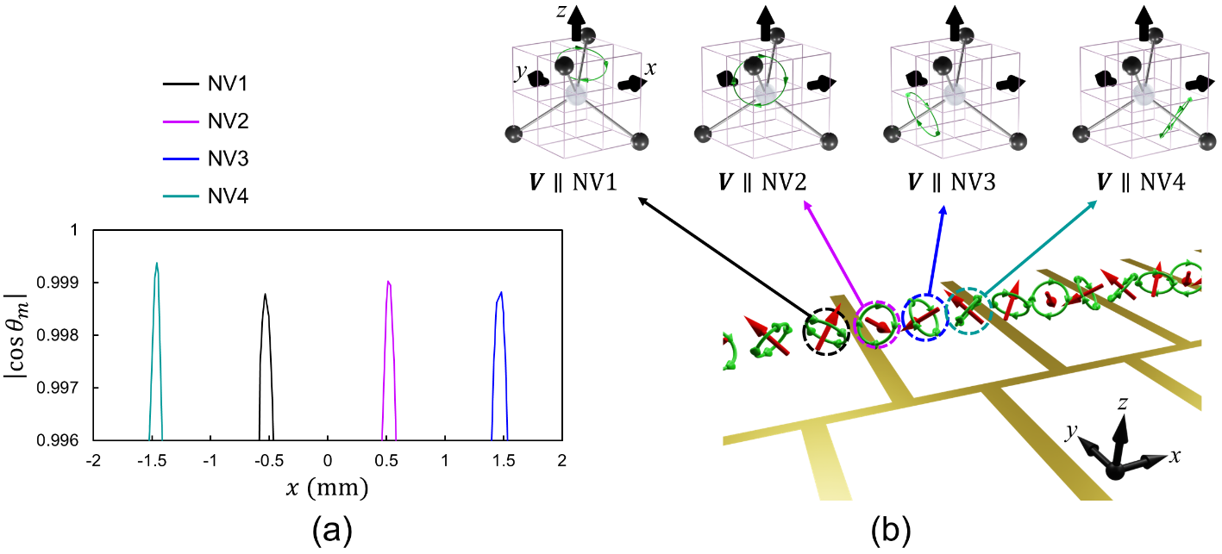
Supplementary Fig. S5 CP microwave magnetic field simultaneously aligned with different NV axes. (a) $\left|\cos{θ_{m}}\right|$ distributions in a unit cell of the SSPP metasurface confirming $\left|\cos{θ_{m}}\right|≈1$ for all the NV axes. (b) Illustration of the polarization-aligned scheme, which can enable zero-field vector magnetometry when the NV centers are integrated to the positions satisfying $\left|\cos{θ_{m}}\right|≈1$.

Supplementary Note 5
Programmable SSPP metasurface for temporally controlling CP-field orientations
Incorporating radio frequency (RF) switch components into the SSPP metasurface enables temporal control of CP microwave magnetic-field orientations. In Supplementary Fig. S5, the polarization-aligned conditions are maintained at the same position in every quarter period. Here, the RF switches enable a quarter-period spatial shift of the field distribution, thereby achieving the polarization-aligned condition on demand for an arbitrary $NVm$ axis, as shown in Supplementary Fig. S6. We note that RF switches operating near the few GHz frequency range are commercially available as surface-mount devices. In addition, the RF switches are compatible with wafer-scale fabrication based on complementary metal-oxide semiconductor (CMOS)¹¹ or microelectromechanical systems (MEMS)¹² technology, thereby enabling on-chip device configurations.

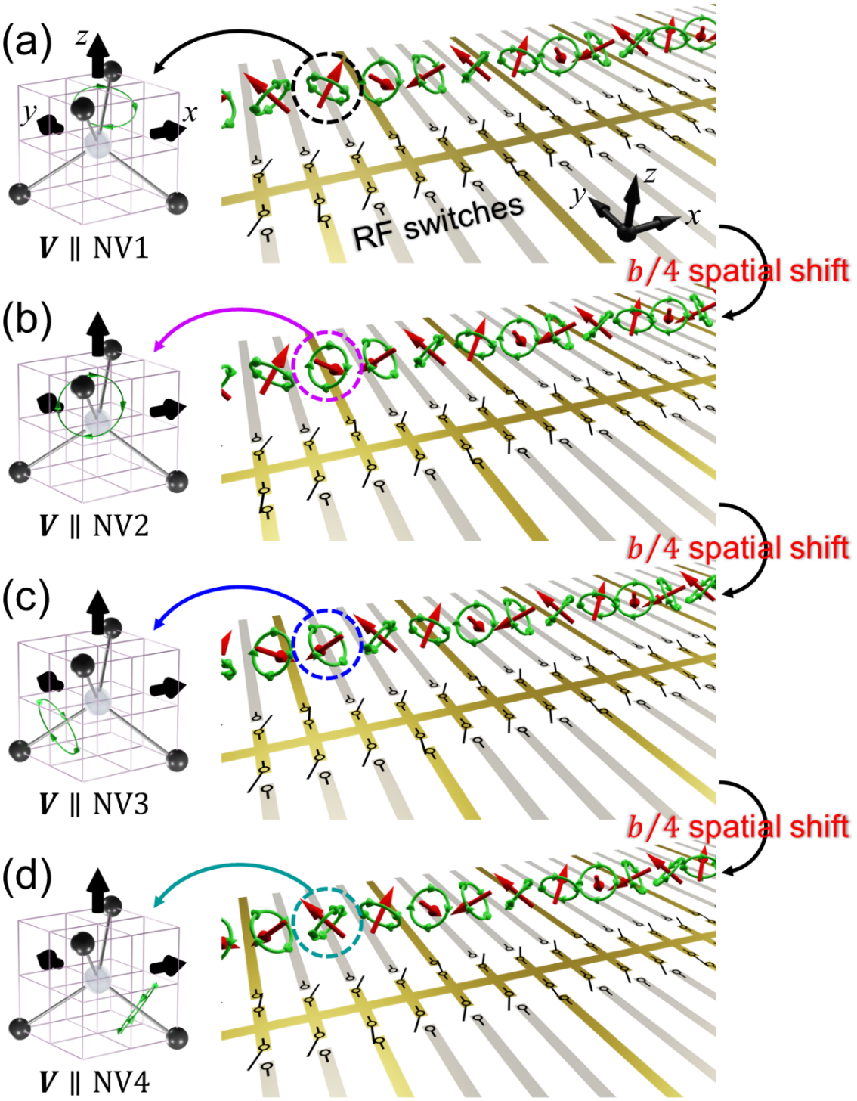
Supplementary Fig. S6 Programmable SSPP metasurface for controlling the CP microwave magnetic-field orientations in a temporal manner. (a–d) Basic device configuration, in which the grooves are reconfigurable between the on (gold color) and off (dark color) states via RF switches. This enables the temporal switching of the microwave field between polarization-aligned conditions: (a) $\left|\cos{θ_{1}}\right|≈1$, (b) $\left|\cos{θ_{2}}\right|≈1$, (c) $\left|\cos{θ_{3}}\right|≈1$, and (d) $\left|\cos{θ_{4}}\right|≈1$.
References
1. Glenn, D. R., et al. Micrometer‐scale magnetic imaging of geological samples using a quantum diamond microscope. Geochem. Geophys. Geosyst. 18, 3254-3267 (2017).

2. Jimenez-Martinez, R., Knappe, S., & Kitching, J. An optically modulated zero-field atomic magnetometer with suppressed spin-exchange broadening. Rev. Sci. Instrum. 85, 045124 (2014).

3. Dai, Y., et al. A fully-integrated diamond nitrogen-vacancy magnetometer with nanotesla sensitivity. Adv. Quantum Technol. 8, 2300438 (2024).

4. Backlund, M. P., Kehayias, P., & Walsworth, R. L. Diamond-based magnetic imaging with Fourier optical processing. Phys. Rev. Appl. 8, 054003 (2017).

5. Münzhuber, F., et al. Polarization-assisted vector magnetometry with no bias field using an ensemble of nitrogen-cacancy centers in diamond. Phys. Rev. Appl. 14, 014055 (2020).

6. Li, C., Shi, F.-Z., Zhou, J., & Wang, P.-F. Vector magnetometry in zero bias magnetic field using nitrogen-vacancy ensembles. Chin. Phys. B 33, 100701 (2024).

7. Zheng, H., et al. Zero-field magnetometry based on nitrogen-vacancy ensembles in diamond. Phys. Rev. Appl. 11, 064068 (2019).

8. Lenz, T., Wickenbrock, A., Jelezko, F., Balasubramanian, G., & Budker, D. Magnetic sensing at zero field with a single nitrogen-vacancy center. Quantum Sci. Technol. 6, 034006 (2021).

9. Wang, N., et al. Zero-field magnetometry using hyperfine-biased nitrogen-vacancy centers near diamond surfaces. Phys. Rev. Res. 4, 013098 (2022).

10. Vetter, P. J., et al. Zero- and low-field sensing with nitrogen-vacancy centers. Phys. Rev. Appl. 17, 044028 (2022).

11. Petrou, L., Kossifos, K. M., Antoniades, M. A., & Georgiou, J. The first family of application-specific integrated circuits for programmable and reconfigurable metasurfaces. Sci. Rep. 12, 5826 (2022).

12. Chang, Y., Wei, J., & Lee, C. Metamaterials – from fundamentals and MEMS tuning mechanisms to applications. Nanophotonics 9, 3049-3070 (2020).

