Extended Data
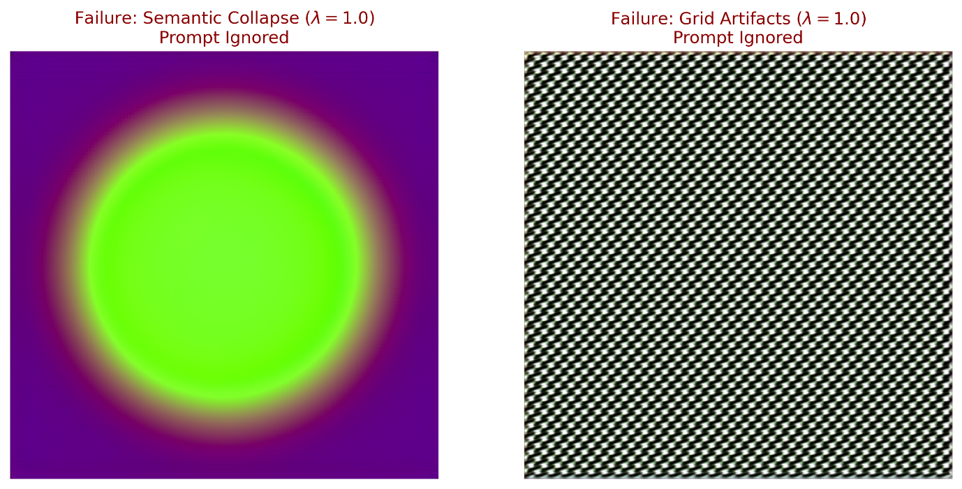
Extended Data Figure 1: Failure modes at high injection strength.Visual analysis identifies critical operational boundaries where excessive injection strength ($λ= 1.0$) induces manifold departure. Left: Semantic collapse occurs as the procedural signal overpowers learned priors, resulting in recognizable geometric artifacts. Right: Grid artifacts demonstrate the blow-over effect, where rigid structures fail to reconcile with the expected Gaussian distribution.

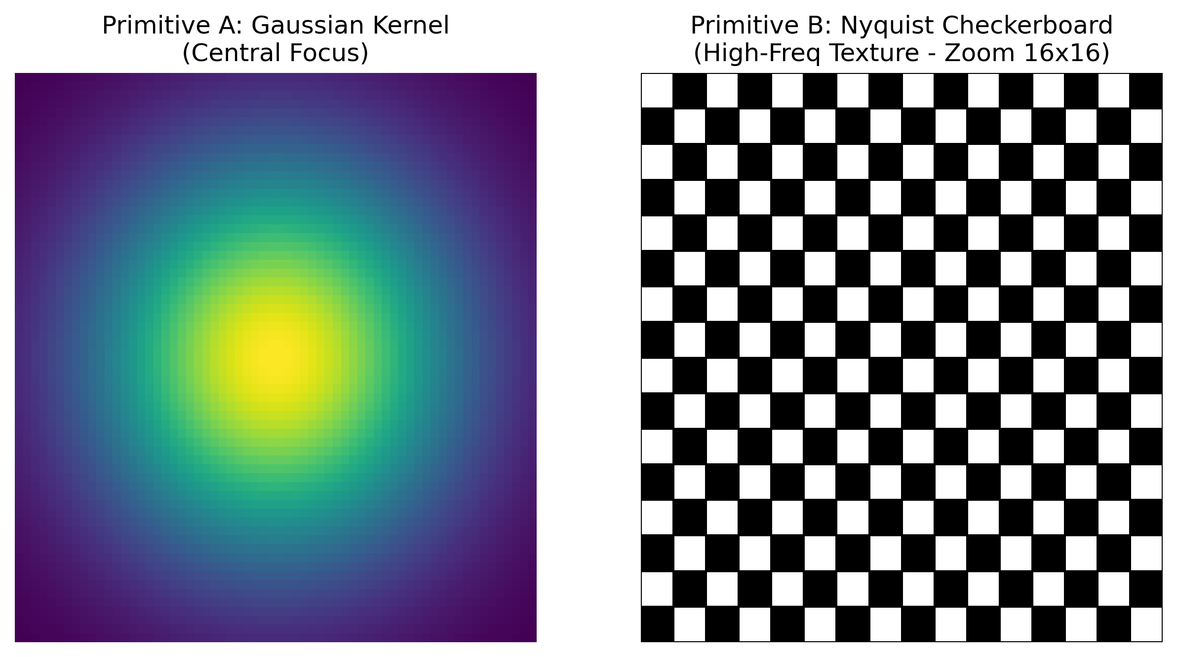
Extended Data Figure 2: Pattern dictionary and kernel specifications. Technical visualizations illustrate the mathematical primitives used as non-linguistic prompts. Primitive A: Gaussian focal kernel synthesized via radial basis functions to enforce central compositional focus. Primitive B: Nyquist checkerboard providing a high-frequency spatial prior to steer micro-scale textural densities.
Extended Data Table 1: Full ablation matrix across all steps and $λ$. Numerical results across the 50-step diffusion trajectory identify a critical plasticity window (steps 10–20). Peak structural alignment (CLIP = 30.0) is achieved using a central focus pattern at step 20 with $λ= 0.4$. Interventions outside this window or at extreme strengths ($λ= 1.0$) show reduced efficacy or semantic decoherence.
Pattern | Injection Step | Strength (λ) | CLIP Alignment Score | Structure Score (LPIPS)
central_focus | 10 | 0.0 | 24.5 | 0.446
central_focus | 10 | 0.4 | 28.35 | 0.461
central_focus | 10 | 0.7 | 28.0 | 0.413
central_focus | 10 | 1.0 | 27.3 | 0.359
central_focus | 20 | 0.0 | 24.5 | 0.350
central_focus | 20 | 0.4 | 30.0 | 0.343
central_focus | 20 | 0.7 | 29.5 | 0.470
central_focus | 20 | 1.0 | 28.5 | 0.391
symmetry_vertical | 10 | 0.0 | 22.7 | 0.492
symmetry_vertical | 10 | 0.4 | 26.55 | 0.490
symmetry_vertical | 10 | 0.7 | 26.2 | 0.453
symmetry_vertical | 10 | 1.0 | 25.5 | 0.454
symmetry_vertical | 20 | 0.0 | 22.7 | 0.363
symmetry_vertical | 20 | 0.4 | 28.2 | 0.493
symmetry_vertical | 20 | 0.7 | 27.7 | 0.333
symmetry_vertical | 20 | 1.0 | 26.7 | 0.430
high_freq_texture | 10 | 0.0 | 21.0 | 0.389
high_freq_texture | 10 | 0.4 | 24.85 | 0.303
high_freq_texture | 10 | 0.7 | 24.5 | 0.429
high_freq_texture | 10 | 1.0 | 23.8 | 0.347
high_freq_texture | 20 | 0.0 | 21.0 | 0.454
high_freq_texture | 20 | 0.4 | 26.5 | 0.425
high_freq_texture | 20 | 0.7 | 26.0 | 0.482
high_freq_texture | 20 | 1.0 | 25.0 | 0.405

Extended Data Table 2: Per-domain robustness metrics. Cross-domain evaluation quantifies the stability of procedural steering across diverse image distributions. Strong structural registration (CLIP = 28.35) is observed in the medical domain using vertical symmetry at $λ= 0.45$. Failures at higher strengths ($λ≥0.65$) in science and art domains reinforce the need for balanced injection power.
Domain | Pattern Used | Injection Strength | CLIP Retention | Status
Medical | symmetry_vertical | 0.45 | 28.35 | Success
Science | high_freq_texture | 0.65 | 20.92 | Failure
Art | central_focus | 0.7 | 18.98 | Failure

