Title: The correlation between different expressed SEMA and immune cell infiltration (TIMER)
Fan Jiang ^{1, #}, Yanbo Yang ^{3, #}, Zilan Wang ¹, Guangjie Liu ¹, Xiaohong Du ^{2,} *, Zhong Wang ^{1,} *
¹Department of Neurosurgery & Brain and Nerve Research Laboratory, The First Affiliated Hospital of Soochow University, Suzhou, Jiangsu Province, 215006, China
² Department of Anesthesiology, First Affiliated Hospital of Soochow University, Suzhou, Jiangsu, China.
³ Department of Neurosurgery, China-Japan Friendship Hospital, Beijing, PR China.

Supplement figure I
Correlation between differentially expressed SEMA3A and immune cell infiltration (TIMER).
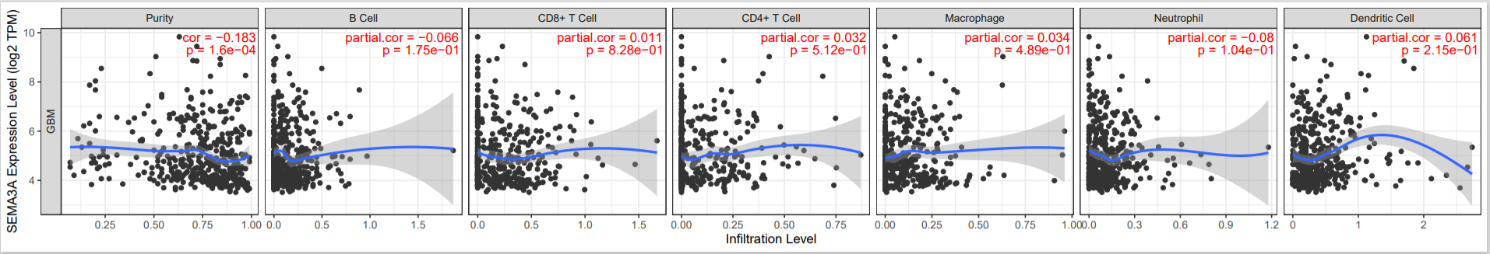
Supplement figure II
Correlation between differentially expressed SEMA3B and immune cell infiltration (TIMER).
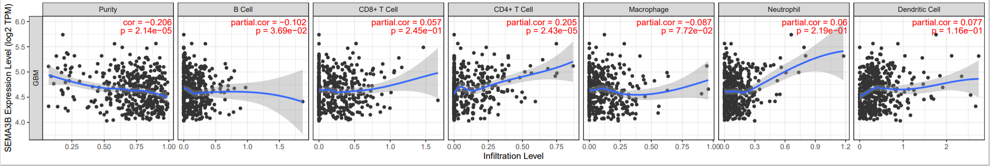

Supplement figure III
Correlation between differentially expressed SEMA3E and immune cell infiltration (TIMER).

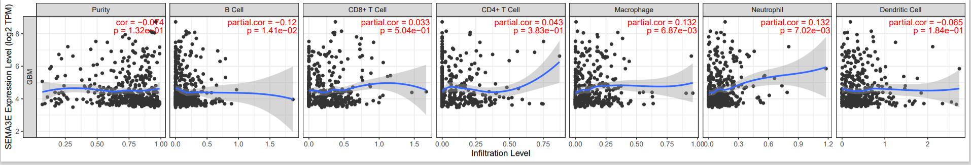
Supplement figure IV
Correlation between differentially expressed SEMA3F and immune cell infiltration (TIMER).
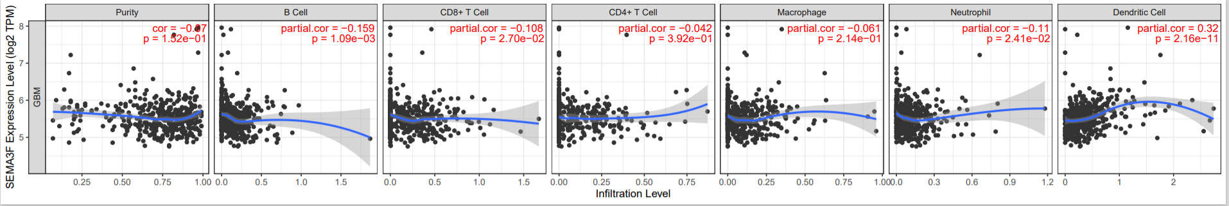
Supplement figure V
Correlation between differentially expressed SEMA3G and immune cell infiltration (TIMER).
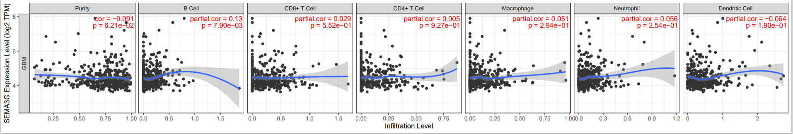
Supplement figure VI
Correlation between differentially expressed SEMA4A and immune cell infiltration (TIMER).
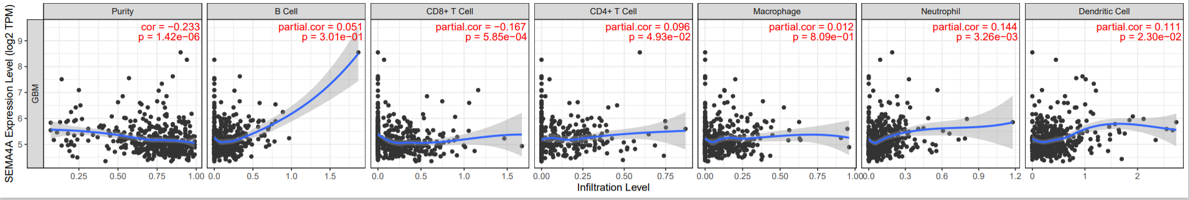
Supplement figure VII

Correlation between differentially expressed SEMA4D and immune cell infiltration (TIMER).
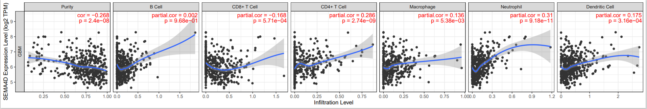
Supplement figure VIII

Correlation between differentially expressed SEMA4F and immune cell infiltration (TIMER).
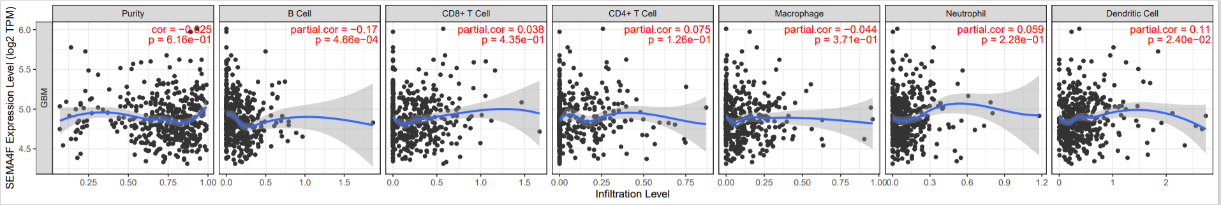
Supplement figure IX

Correlation between differentially expressed SEMA5A and immune cell infiltration (TIMER).
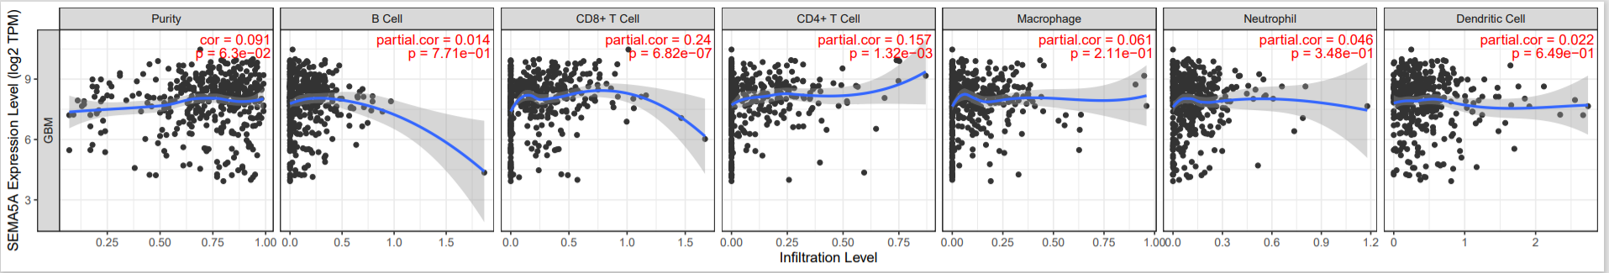
Supplement figure X

Correlation between differentially expressed SEMA5B and immune cell infiltration (TIMER).
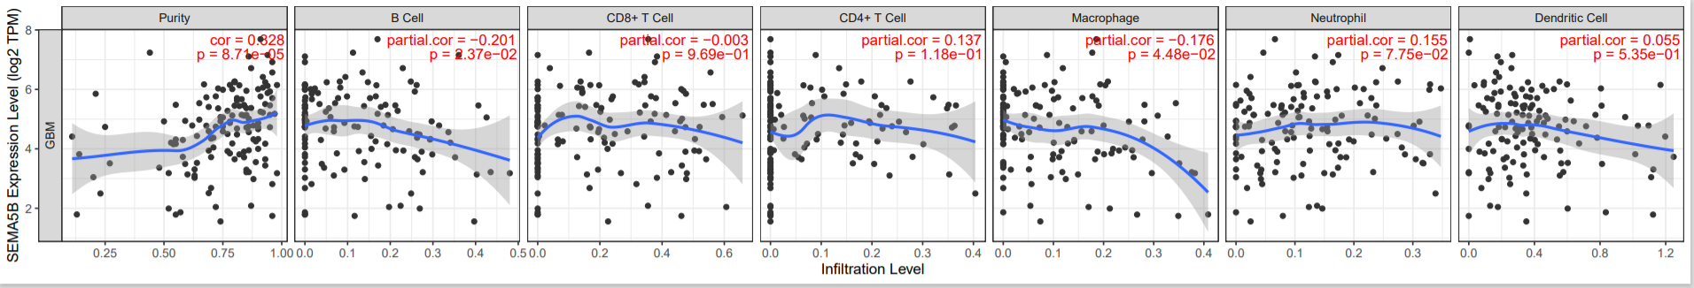
Supplement figure XI
Correlation between differentially expressed SEMA6A and immune cell infiltration (TIMER).
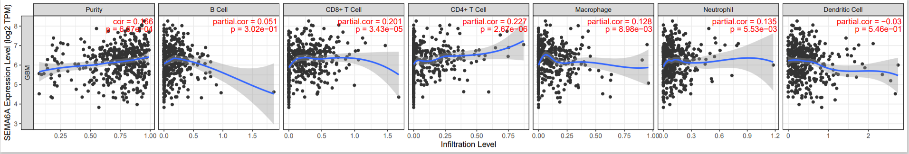

Annotation: The scatterplots show the purity-corrected partial Spearman’s cor value and statistical significance. The gene expression levels against tumor purity are always displayed on the left-most panel.

