Suppl. data:
Supplementary Table S1. 16S rDNA sequences available in GenBank related to the species of the genus Phytoplasma were used for the phylogenetic analyses of phytoplasma 16S rDNA sequences identified in cassava plants with frogskin and oversprouting disease symptoms.
Species/Name | Strain | Sympthoms | Location | 16S | Nº GenBank
‘Candidatus Phytoplasma mali’ | AP15 | Shoot proliferation | Italy | 16SrX-A | EF193366
‘Ca. Phytoplasma phoenicium’ | A4 | Witches'-broom | Lebanon | 16SrlX | AF515636
Texas Phoenix palm phytoplasma | TPD | Lethal yellow | Texas | 16SrlV | AF434989
Coconut lethal yellowing phytoplasma | LYF-C5 | Lethal yellow | Florida | 16SrlV-A | AF498308
‘Ca. Phytoplasma palmicola’ | 90-3-50 | Lethal Yellowing | Côte d’Ivoire | 16SrXXII-A | KY563222
Potato purple top phytoplasma | AKpot6 | Purple top | Alaska | 16Srlll-N | GU004365
Goldenrod yellows phytoplasma | GR1 | Goldenrod yellows | New York | 16Srlll-D | GU004372
Potato purple top phytoplasma | Akpot7 | Purple top | Alaska | 16Srlll-F | GU004370
Montana potato purple top phytoplasma | PPT-MT117-1 | Purple top | Montana | 16Srlll-M | FJ226074
Pecan bunchy top phytoplasma | PBT | X-disease | Geórgia | 16Srlll-C | GU004371
Blueberry stunt phytoplasma | BBS3 | Aster yellows | EUA | 16Srl-E | AY265213
Aster yellows phytoplasma | CVB | Aster yellows | Germany | 16Srl-F | AY265212
Grey dogwood stunt phytoplasma | GD1 | Aster yellows | Maryland | 16Srl-A | DQ112021
‘Ca. Phytoplasma americanum’ | PPT10-NE | Purple top | Texas | 16SrXIII-B | DQ174121
Clover phyllody phytoplasma | KVG | Aster yellows | Germany | 16Srl-C | AY265218
Cassava witches'-broom aster yellows phytoplasma | 06/03 | Aster yellows | Vietnam | 16Srl-C | KJ173677
Plantago virescence phytoplasma | PVM | Aster yellows | Germany | 16Srl-A | AY265216
Phormium yellow leaf phytoplasma | - | Yellow wave | New Zealand | 16SrXII-B | U43570
Phytoplasma sp. STRAWB2 | STRAWB2 | Yellows | Florida | 16Srl-K | U96616
Aster yellows phytoplasma | - | Aster yellows | Wallis | 16Srl-B | AY787139
Primrose virescence phytoplasma | PRIVC | Aster yellows | Germany | 16Srl-B | AY265210
Chrysanthemum yellows phytoplasma | CY | Yellows | Italy | 16Srl-B | EF634457
Chrysanthemum yellows phytoplasma | CHRYM | Yellows | Germany | 16Srl-A | AY265214
Aster yellows phytoplasma | IOWB | Aster yellows | USA | 16Srl-N | AY265205
Aster yellows phytoplasma | PaWB | Aster yellows | USA | 16Srl-D | AY265206
Aster yellows phytoplasma | AVUT | Aster yellows | Germany | 16Srl-M | AY265209
Clover phyllody phytoplasma | CPh | Phyllody | Canada | 16Srl-C | AF222065
‘Ca. Phytoplasma solani’ | 2642BN | Yellows | Catalonia | 16SrXII-A | AJ964960
Rubus stunt phytoplasma | RuS | yellows | USA | 16SrV-E | AY197648
‘Ca. Phytoplasma pyri’ | PD1 | Shoot proliferation | Baden Wuerttemberg | 16SrX-C | AJ542543
‘Ca. Phytoplasma prunorum’ | ESFY-G2 | Shoot proliferation | Baden Wuerttemberg | 16SrX-B | AJ542545
Brinjal little leaf phytoplasma | BLL | Shoot proliferation | India | 16SrVI-D | EF186820
Cyperus sp.' white leaf phytoplasma | Minab4 | white leaf | Iran | 16SrXI | MF136620
‘Ca. Phytoplasma ulmi’ | EY-626 | Yellows | USA | 16SrV-A | AY197657
Jujube witches'-broom phytoplasma | JWB | Yellows | USA | 16SrV-B | AY197661
‘Ca. Phytoplasma fraxini’ | CfS-Br10 | Ash yellows | Brazil | 16SrVII-B | KR270802
‘Ca. Phytoplasma fraxini’ | AshY1 | Ash yellows | USA | 16SrVII-A | AF092209
‘Ca. Phytoplasma trifolii’ | CP | Shoot proliferation | Canada | 16SrV-C | AY500130
Alder yellows phytoplasma’ | ALY | Yellows | China | 16SrV-C | AY197646
‘Ca. Phytoplasma vitis | FD-D | Yellows | USA | 16SrV-D | AY197644
Alder yellows phytoplasma | ALY882 | Yellows | USA | 16SrV-C | AY197642
Hemp dogbane yellows phytoplasma | HD1 | Yellows | USA | 16SrV-C | AY197654
Sesame phyllody phytoplasma | SEPT | Phyllody | Thailand | 16Srll-A | GU004373
Picris echioides' phyllody phytoplasma | - | Phyllody | Southern Italy | 16Srll-E | Y16393
Sweet potato witches'-broom phytoplasma | - | witches' broom | USA | 16Srll-A | L33770
Cassava witches'-broom phytoplasma | alp4 | witches' broom | USA | 16SrII | JQ957931
Cassava witches'-broom phytoplasma | Ry2 | witches' broom | Thailand | 16Srll | LN897457
Cassava witches'-broom phytoplasma | R16mR1 | witches' broom | Thailand | 16SrII | MW624432
Cassava witches'-broom phytoplasma | T7-DN | witches' broom | Viet Nam | 16SrII | KM280679
Cassava witches'-broom phytoplasma | T19-BRVT | witches' broom | Viet Nam | 16SrII | KM280682
Crotalaria phyllody phytoplasma | CrP | phyllody | Thailand | 16Srll-C | EF193355
Cassava witches'-broom phytoplasma | CWBUBB1 | witches' broom | Cambodia | 16SrII | MK942731
Phytoplasma sp. | - | Big Bud | Australian | 16Srll-D | Y08173 1
‘Ca. Phytoplasma manihotii’ sp. nov. | CMF422 | Oversprouting | Laje-BA | 16SrIII-B | PX515205
Cassava frogskin disease symptoms | CMF295 | Frogskin | Cruz das Almas-BA | 16SrIII-B | PX515201
Cassava frogskin disease symptoms | CMF178 | Frogskin | Brazil | 16SrIII-L | KF019184.1
‘Ca. Phytoplasma manihotii’ sp. nov. | CMF419 | Oversprouting | Laje-BA | 16SrIII-B | PX515203
‘Ca. Phytoplasma manihotii’ sp. nov. | CMF421 | Oversprouting | Laje-BA | 16SrIII-B | PX515205
Cassava frogskin disease symptoms | CMF292 | Frogskin | Cruz das Almas-BA | 16SrIII-B | PX515194
Cassava frogskin disease symptoms | CMF291 | Frogskin | Cruz das Almas-BA | 16SrIII-B | PX515193
- | CMF289 | Frogskin | Cruz das Almas-BA | 16SrIII-B | PX515192
Manihot esculenta' phytoplasma | JC | Oversprouting | Japan | 16S | LC228770
'Manihot esculenta' witches'-broom phytoplasma | CaWB-Br01 | Oversprouting | Sao Paulo | 16Srlll-B | GU193976
‘Ca. Phytoplasma manihotii’ sp. nov. | CMF420 | Oversprouting | Laje-BA | 16SrIII-B | PX515204
‘Ca. Phytoplasma manihotii’ sp. nov. | CMF418 | Oversprouting | Laje-BA | 16SrIII-B | PX515202
‘Ca. Phytoplasma manihotii’ sp. nov. | CMF417 | Oversprouting | Laje-BA | 16SrIII-B | PX515201
‘Ca. Phytoplasma manihotii’ sp. nov. | CMF416 | Oversprouting | Laje-BA | 16SrIII-B | PX515200
Cassava frogskin disease symptoms | CMF299 | Frogskin | Cruz das Almas-BA | 16SrIII-B | PX515199
Cassava frogskin disease symptoms | CMF298 | Frogskin | Cruz das Almas-BA | 16SrIII-B | PX515198
Cassava frogskin disease symptoms | CMF297 | Frogskin | Cruz das Almas-BA | 16SrIII-B | PX515197
Cassava frogskin disease symptoms | CMF293 | Frogskin | Cruz das Almas-BA | 16SrIII-B | PX515195
Cassava frogskin disease symptoms | CMF296 | Frogskin | Cruz das Almas-BA | 16SrIII-B | PX515196
‘Ca. Phytoplasma manihotii’ sp. nov. | OVSP L01 | Oversprouting | Salitre-CE | 16SrIII-B | PX515191
‘Ca. Phytoplasma manihotii’ sp. nov. | OVSP S01 | Oversprouting | Salitre-CE | 16SrIII-B | PX515190
Walnut witches'-broom phytoplasma | WWB | witches' broom | USA | 16Srlll-G | AF190227
Poinsettia branch-inducing phytoplasma | PoiBI | X-disease | USA | 16Srlll-H | AF190223
Spiraea stunt phytoplasma | SP1 | stunt | USA | 16Srlll-E | AF190228
Cassava frogskin disease phytoplasma | CFSD_Br1 | frogskin | Brazil | 16Srlll-A | KF667079
Canadian peach X phytoplasma | - | - | Canada | 16Srlll-A | L33733
Loofah witches'-broom mycoplasma-like | LfWB | Lwitches'-broom | Germany | 16Srlll-A | L33764
‘Ca. Phytoplasma luffae’ | Loofah | witches'-broom | USA | 16SrVIII | AF248956
‘Ca. Phytoplasma luffae’ | CWB17b | witches'-broom | Philippines | CWB17b | MN784934

Supplementary Table S2. DNA sequence of secY genes available at NCBI/GenBank representing species of the genus Phytoplasma.
Isolate | Strain | Associated Disease | Location | 16S | Nº GenBank
Alder yellows phytoplasma | ALY | Elm yellows | Italy | 16SrV-C | AY197684
‘Candidatus Phytoplasma vitis’ | FD-D | Elm yellows | Italy | 16SrV-D | AY197685
‘Ca. Phytoplasma vitis’ | FD70 | Elm yellows | França | 16SrV-C | AY197686
‘Ca. Phytoplasma vitis’ | FD-C | Elm yellows | Italy | 16SrV-C | AY197688
‘Ca. Phytoplasma spartii’ | SpaWB 229 | Elm yellows | Italy | 16SrV-C | AY197689
Alder yellows phytoplasma | ALY882 | Elm yellows | Germany | 16SrV-C | AY197692
Rubus stunt phytoplasma | RuS | Elm yellows | Italy | 16SrV-E | AY197696
Hemp dogbane yellows phytoplasma | HD1 | Elm yellows | EUA | 16SrV-C | AY197687
‘Ca. Phytoplasma ulmi’ | EY1 | Elm yellows | New York | 16SrV-A | GU004330
‘Ca. Phytoplasma ulmi’ | EY1 | Elm yellows | EUA | 16SrV-A | AY197690
‘Ca. Phytoplasma ulmi’ | EY-626 | Elm yellows | Italy | 16SrV-A | AY197691
Cherry lethal yellows phytoplasma | CLY-5 | Elm yellows | China | 16SrV-B | AY197693
Peach yellows phytoplasma | PY-Entrada | Elm yellows | Italy | 16SrV-B | AY197694
Jujube witches'-broom phytoplasma | JWB | Elm yellows | China | 16SrV-B | AY197695
‘Ca. Phytoplasma fraxini’ | AshY | Ash yellows | New York | 16SrVI-A | GU004329
Dry bean phyllody phytoplasma | DBPh2 | Dry bean phyllody | Washington | 16SrVI-A | GU004352
Dry bean phyllody phytoplasma | DBPh3 | Dry bean phyllody | Washington | 16SrVI-A | GU004353
Vinca virescence phytoplasma | VR | vinca virescence | California | 16SrVI-A | GU004317
Lucerne virescence phytoplasma | LUM | vinca virescence | França | 16SrVI-A | GU004318
Brinjal little leaf phytoplasma | BLL | small eggplant leaves | Índia | 16SrVI-D | GU004356
‘Ca. Phytoplasma trifolii’ | CP | trifolii | Canada | 16SrVI-A | GU004315
Potato purple top phytoplasma | AKpot1 | clover proliferation | Alaska | 16SrVI-A | GU004351
Potato witches'-broom phytoplasma | PWB | potato witch's broom PWB | Canada | 16SrVI-A | GU004316
Potato purple top phytoplasma | AKpot4 | purple potato top | Alaska | 16SrVI-A | GU004343
Potato purple top phytoplasma | AKpot2 | Potato purple top | Alaska | 16SrVI-A | GU004342
Potato purple top phytoplasma | AKpot5 | Potato purple top | Alaska | 16SrVI-A | GU004344
‘Ca. Phytoplasma luffae’ | LfWB | Loofah witches'-broom | Taiwan | 16SrVIII-A | GU004319
Coconut lethal yellowing phytoplasma | LYF | Coconut lethal yellows | Florida | 16SrIV-A | GU004320
Cactus witches'-broom phytoplasma | CaWBYN16 | Cactus witches'-broom | China | 16SrlI-C | GU004323
Soybean phyllody phytoplasma | SOYP | Soybean phyllody | Thailand | 16SrlI-C | GU004324
Crotalaria phyllody phytoplasma | CrP | Crotalaria phyllody | USA | 16SrlI-C | GU004349
Cotton phyllody phytoplasma | CoP | Cotton phyllody | USA | 16SrlI-C | GU004350
'Picris echioides' phytoplasma | PEP | 'Picris echioides' | USA | 16Srll-E | GU004348
Peanut witches'-broom phytoplasma | L15 | Peanut witches'-broom | Taiwan | 16Srll-A | GU004331
Sweet potato witches'-broom phytoplasma | SPWB | Sweet potato witches'-broom | Taiwan | 16Srll-A | GU004321
Australian tomato big bud phytoplasma | TBB | Australian tomato big bud | Australia | 16SrlI-D | GU004347
Sesame phyllody phytoplasma | SEPT | Sesame phyllody | Thailand | 16SrlI-A | GU004322
Sesame phyllody phytoplasma | SEPN | Sesame phyllody | Thailand | 16SrlI-A | GU004362
‘Ca. phytoplasma manihotii’ sp. nov. | OVSP-L01 | Oversprouting | Brazil | 16SrIII-B | PV883012
‘Ca. phytoplasma manihotii’ sp. nov. | OVSP-S01 | Oversprouting | Brazil | 16SrIII-B | PV883013
'Manihot esculenta' phytoplasma | JC | infecting cassava | Japan | 16SrIII | LC228771
Peach X-disease phytoplasma | CX | Peach X-disease | Canada | 16SrllI-A | GU004327
Western X phytoplasma | WX | Western X disease | Canada | 16SrllI-A | GU004354
Poinsettia branch-inducing phytoplasma | JR1Ph | Poinsettia branch-inducing | USA | 16SrlI-H | GU004328
Walnut witches'-broom phytoplasma | WWB | Walnut witches'-broom | Georgia | 16SrlII-G | GU004325
Spirea stunt phytoplasma | SP1 | Spirea stunt | New York | 16SrilI-E | GU004326
Clover yellow edge phytoplasma | CYE | Clover yellow edge | Lithuania | 16SrllI-B | GU004332
Pecan bunchy top phytoplasma PBT | PBT | Pecan bunchy top | Georgia | 16SrllI-C | GU004361
Milkweed yellows phytoplasma | MW1 | Milkweed yellows | New York | 16Srlll-F | GU004340
Potato purple top phytoplasma | MT117 | Potato purple top | Montana | 16SrlII-M | GU004333
Potato purple top phytoplasma | AKpot7 | Potato purple top | Alaska | 16Srill-F | GU004358
Goldenrod yellows phytoplasma | GR1 | Goldenrod yellows | New York | 16Srill-D | GU004364. 1
Potato purple top phytoplasma | AKpot6 | Potato purple top | Alaska | 16SrlII-N | GU004359
Vaccinium witches' broom phytoplasma | Vac | Witches' broom | Germany | 16SrllI-F | GU004360
Plum leptonecrosis phytoplasma | PLN | Plum leptonecrosis | Italy | 16SrX-B | GU004334
‘Ca. Phytoplasma pyri’ | PD1 | Apple proliferation | Italy | 16SrX-C | GU004363
‘Ca. Phytoplasma mali’ | AP15 | Apple proliferation | Germany | 16SrX-A | GU004335
‘Ca. Phytoplasma solani’ | PO | Stolbur | França | 16SrXII-A | FM163376
Stolbur-Rus phytoplasma | Rus93 | Stolbur | Russia | 16SrXII-A | GU004346
Stolbur-It phytoplasma | PTV | Stolbur | Italy | 16SrXII-A | GU004355
American potato purple top wilt phytoplasma | APPTW10NE | potato purple top | Nebraska | 16SrXIII-Е | GU004338
‘Ca. Phytoplasma hispanicum | MPV | periwinkle virescence | Mexico | 16SrXII | GU004336
Blueberry stunt phytoplasma | BBS3 | Blueberry stunt | Michigan | 16Srl-E | GU004357
Aster yellows phytoplasma | PRVIC | Aster yellows | USA | 16Srl-B | AY803176
Aster yellows phytoplasma | AY1 | Aster yellows | USA | 16Srl-B | AY803177
Aster yellows phytoplasma | HyPH | Aster yellows | USA | 16Srl-B | AY803173
Chrysanthemum yellows phytoplasma | CY | Chrysanthemum yellows | Italy | 16Srl-B | DQ787851
Aster yellows phytoplasma | AV2192 | Aster yellows | USA | 16Srl-B | AY803167
Aster yellows phytoplasma | AVUT | Aster yellows | USA | 16Srl-M | AY803168
Aster yellows phytoplasma | MBS | Aster yellows | USA | 16Srl-B | AY803175
Maize bushy stunt phytoplasma | MBS | Aster yellows | Mexico | 16Srl-B | GU004341
Aster yellows phytoplasma | PaWB | Aster yellows | USA | 16Srl-D | AY803184
Paulownia witches'-broom phytoplasma | PaWB | Aster yellows | Taiwan | 16Srl-D | GU004337
Aster yellows phytoplasma | IOWB | Aster yellows | USA | 16SrI-N | AY803182
Aster yellows phytoplasma | KVE | Aster yellows | USA | 16Srl-C | AY803174
Aster yellows phytoplasma | CPh | Aster yellows | USA | 16Srl-C | AY803179
Aster yellows phytoplasma | KVG | Aster yellows | USA | 16Srl-C | AY803183
Clover phyllody phytoplasma | CPh-a | Aster yellows | Canada | 16Srl-C | GU004339
Aster yellows phytoplasma | GD1 | Aster yellows | USA | 16Srl-A | AY803171
Aster yellows phytoplasma | BBS-3 | Aster yellows | USA | 16SrI-E | AY803169
Aster yellows phytoplasma | STRAWB2 | Aster yellows | USA | 16SrI-K | AY803180
Aster yellows phytoplasma | ACLR-AY | Aster yellows | USA | 16Srl-F | AY803166
Aster yellows phytoplasma | CVB | Aster yellows | USA | 16Srl-F | AY803172
New Jersey aster yellows phytoplasma | NJAY | Aster yellows | USA | 16Srl-A | GU004345
Aster yellows phytoplasma | BB | Aster yellows | USA | 16Srl-A | AY803178
Plantago virescence phytoplasma | PVM | Plantago virescence | Germany | 16Srl-A | AY265216
Aster yellows phytoplasma | CHRYM | Aster yellows | USA | 16Srl-A | AY803170
Aster yellows phytoplasma | HYDP | Aster yellows | USA | 16Srl-A | AY803181
Aster yellows phytoplasma | PVM | Aster yellows | USA | 16Srl-A | AY803185

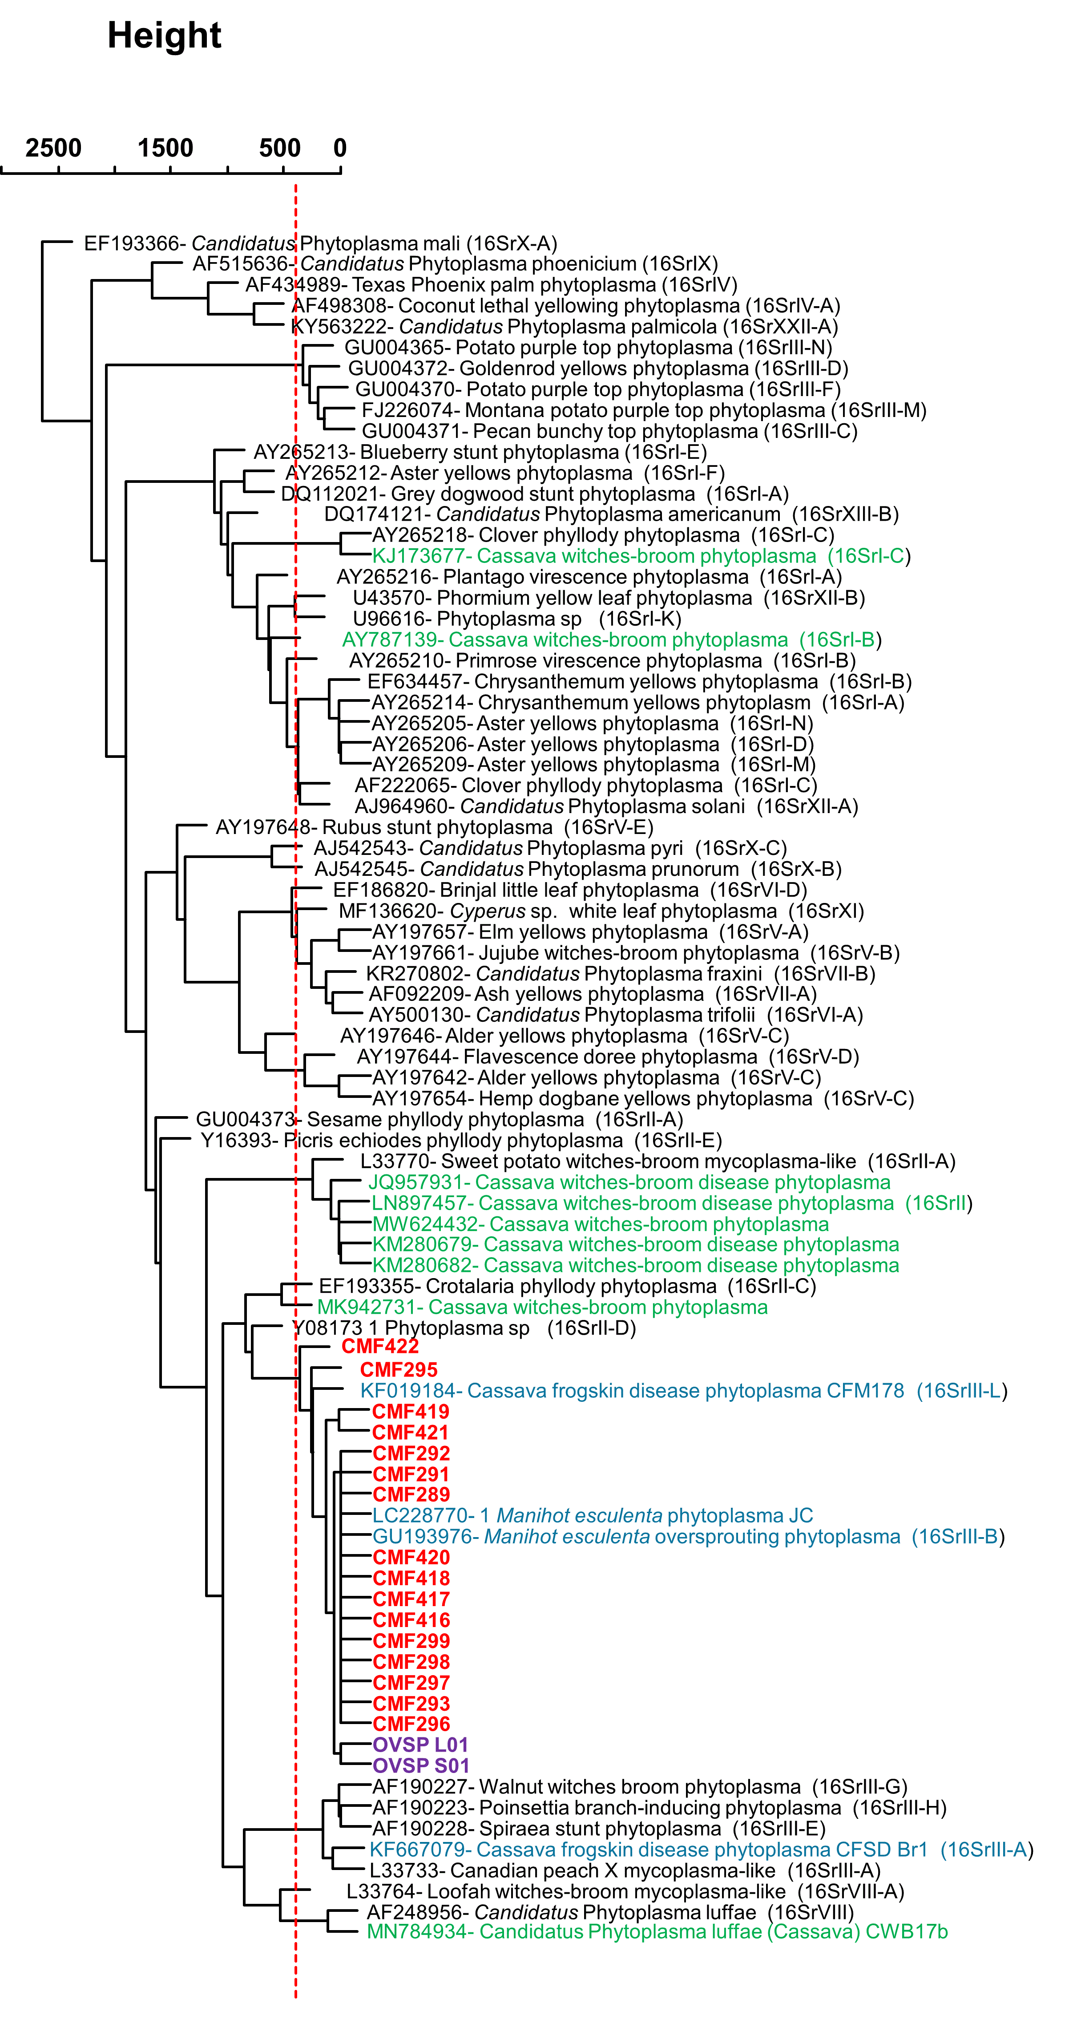
Supplementary Fig. S1. Dendrogram based on the 16S rRNA gene, constructed using the UPGMA (Unweighted Pair Group Method with Arithmetic Mean) clustering method. The analysis was performed on the PCR-RFLP F2nR2 region of the 16S rRNA gene, generated through in silico digestion using 17 restriction enzymes. Red lines whose the threshold limit for the dissimilarities.

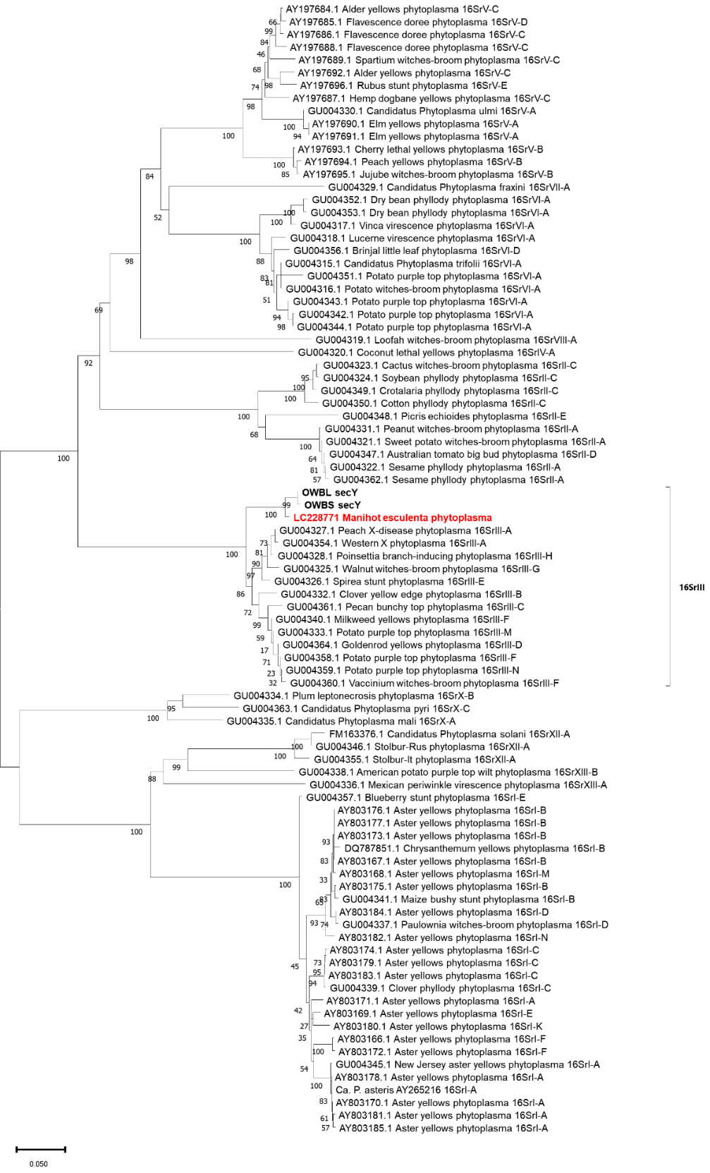
Supplementary Fig. S2. Unrooted phylogenetic tree inferred from secY gene sequences (1,333 nucleotides) using the Maximum Likelihood method under the T92+G model. The dataset comprised sequences retrieved from NCBI. Bootstrap values (1,000 replicates) are shown next to the branches, and branch lengths (substitutions per site) are indicated by the scale bar at the bottom of the figure. Cassava oversprouting phytoplasma isolates (OVSP-S01 and OVSP-L01) are highlighted in bold.
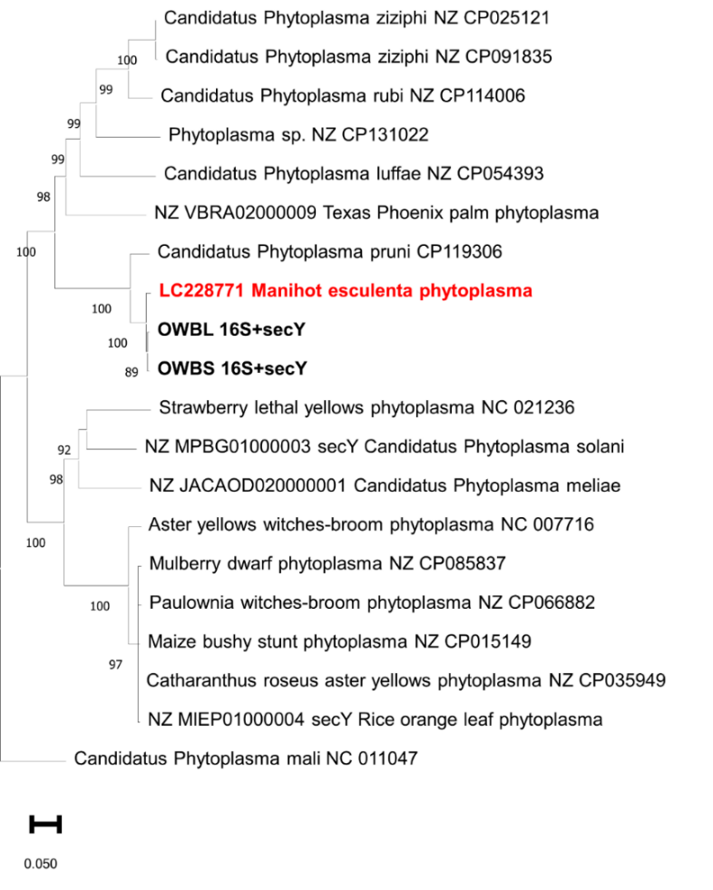
Supplementary Fig. S3. Phylogenetic tree inferred from Multi-Locus Sequence Analysis (MLSA) of the concatenated alignment of 16S rRNA (1,515 nucleotides; GTR+G model) and secY (1,333 nucleotides; T92+G model) gene sequences using the Maximum Likelihood method. The dataset comprised representative phytoplasma sequences retrieved from NCBI, with ‘Candidatus Phytoplasma mali’ included as the outgroup. Bootstrap values (1,000 replicates) are shown next to the branches, and branch lengths (substitutions per site) are indicated by the scale bar at the bottom of the figure. Cassava oversprouting phytoplasma isolates (OVSP-S01 and OVSP-L01) are highlighted in bold. The phytoplasma previously described in cassava in Japan is highlighted in bold red (Koinuma et al., 2018).

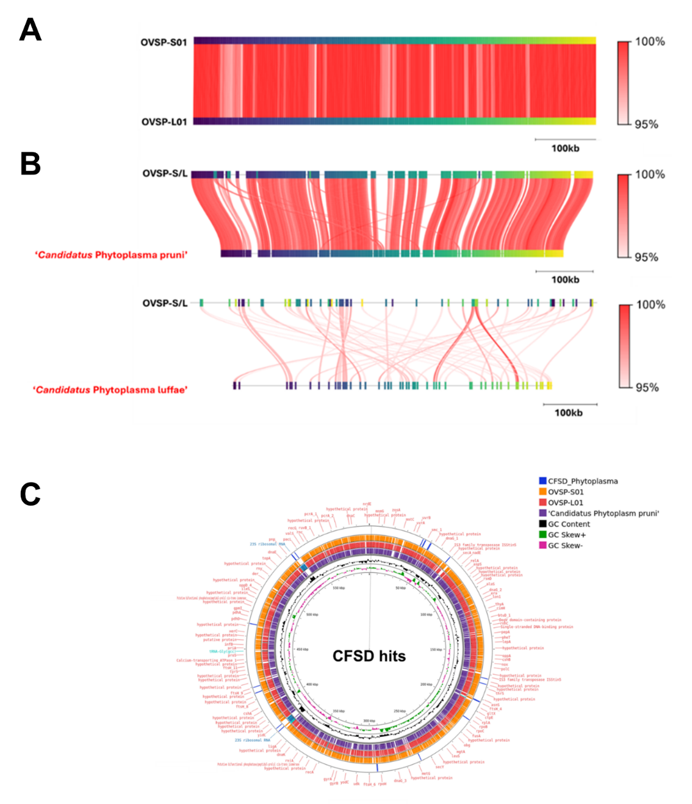
Supplementary Fig. S4. Pairwise genome sequence comparisons illustrating the order and orientation of ‘Candidatus Phytoplasma manihotii’ sp. nov. (A) Contigs of ‘Ca. Phytoplasma manihotii’ sp. nov. aligned with the complete genome sequence of ‘Candidatus Phytoplasma pruni’ (GCA_013391955), with an ANI score of 92.44%. (B) Contigs of ‘Ca. Phytoplasma manihotii’ sp. nov. was aligned against the complete genome sequence of ‘Candidatus Phytoplasma luffae’ (GCA_0180224475), with an ANI score of 83.76%. Colored connecting lines indicate homologous genomic regions between the compared sequences, with shading intensity proportional to the nucleotide identity. The scale bar on the right represents the pairwise identity, ranging from 95% to 100%. Circular genomic representation of for an expected genome from the “frogskin disease phytoplasma” (CFSD_Phytoplasma) if it is real (outside circle in blue). Coding sequences (CDSs), rRNA genes, and tRNA genes were identified using PROKSEE on the CGView Server with Prokka annotation, displayed on the outermost circle. The inner ring corresponds to the genomic representation of ‘Candidatus Phytoplasma pruni’ (purple), followed by the genome representations of OVSP-L01 (red) and OVSP-S01 (orange), assigned to ‘Candidatus Phytoplasma manihotii’ sp. nov. The inner rings depict GC content (black) and GC skew, with positive values in green (GC skew+) and negative values in pink (GC skew-).

