CuET Radiosensitizes FAP-Targeted Radioligand Therapy in Lung Cancer by inhibiting DNA Repair
Jiahao Xie^{1,2}, Yijin Zou^{1,2}, Yuzhao Zheng^{1,2}, Dazhi Shi^{1,2}, Wenlan Zhou^{1,2}, Ying Tian^{1,2}, Lijuan Wang^{1,2*}, Hubing Wu^{1,2*}
¹ Department of Nuclear Medicine, Nanfang Hospital, Southern Medical University, Guangzhou, Guangdong, China.
² Key Laboratory Project of Guangdong Provincial Department of Education for Ordinary Universities and GDMPA Key Laboratory for Quality Control and Evaluation of Radiopharmaceuticals, Nanfang Hospital, Southern Medical University, Guangzhou, Guangdong, China.
*Corresponding Authors:
Lijuan Wang, email: wljhaiyin@163.com; Hubing Wu, email:wuhbym@163.com.
Jiahao Xie, Yijin Zou and Yuzhao Zheng contributed equally to this work.

Table of contents
Methods
- General
- Treatment Protocols
- Radiolabeling and Quality Control
- Vitro Cell Studies
Results
1. Biodistribution study of [¹⁷⁷Lu]Lu-FAP‐2286
2. Survival time in different treatment groups
3. Changes in body weight of mice
4. Safety assessment

Methods
- General
All reagents were purchased from commercial suppliers and required no additional purification. Precursor DOTA-FAP-2286 was commercially obtained from Nanchang TanzhenBio Co., Ltd. (China) with a purity higher than 95%. Reagent CuET was commercially obtained from Shanghai Aladdin Biochemical Technology Co., Ltd (China) with a purity higher than 97%. [⁶⁸Ga]GaCl₃ was eluted from a ⁶⁸Ge/⁶⁸Ga generator (ITG Isotope Technologies, Garching, Germany) using 0.05 M HCl (4 mL). Carrier-free [¹⁷⁷Lu]LuCl₃ was purchased from China Academy of Engineering Physics (China) as a 0.1 M HCl solution. Radio-analytical high-performance liquid chromatography (HPLC; Shimadzu, Kyoto, Japan) was used to determine the radiochemical purity on a Kromasil 100−5-C18 analytical column (4.6 × 250 mm, 5 μm). Radioactivity was measured with a CAPRAC-R γ-counter (Capintec, Inc., Ramsey, NJ, USA). All compounds used exhibited >95% purity by HPLC analysis.
The A549 cells (ATCC, USA) utilized in this study were authenticated via STR profiling within the past three years. All cells utilized in this study were confirmed to be free of microbial contamination. Following cell transfection and drug screening, A549 cells were successfully engineered into A549-FAP cells that stably express FAP.

2. Treatment Protocols
Figure S1. The treatment protocols for the five treatment groups and the evaluation methods for therapeutic efficacy in A549-FAP tumor-bearing mice.

3. Radiolabeling and Quality Control
For ⁶⁸Ga radiolabeling, 25 μg of DOTA-FAP-2286 was dissolved in 1 mL of sodium acetate buffer (0.25 M) and reacted with 4 mL of [⁶⁸Ga]GaCl₃ (370−740 MBq) at 100 °C for 15 min. The reaction mixture was subsequently cooled and diluted with water, then purified using Sep-Pak C18 columns (Waters Corporation, Milford, Massachusetts) and eluted with 1 mL of ethanol/water (1:1, v/v). For ¹⁷⁷Lu radiolabeling, 100 μg of DOTA-FAP-2286 dissolved in 0.4 mL of sodium acetate buffer (0.4 M, pH 5.5) was added to a mixture containing 4.0 mg of gentisic acid and ¹⁷⁷LuCl3 (1.85 GBq), reacted at 95 °C for 15 min, and purified in the same manner as the ⁶⁸Ga radiolabeling process. The radiochemical purity of both [⁶⁸Ga]Ga-FAP-2286 and [¹⁷⁷Lu]Lu-FAP-2286 was assessed using Radio-HPLC. To assess the in vitro stability of [¹⁷⁷Lu]Lu-FAP-2286, the compound was incubated with FBS and PBS at 37°C for 24 hours. Subsequently, both qualitative and quantitative analyses were performed via HPLC. For the in vivo stability assessment, three Kunming mice received an intravenous injection of 37 MBq [¹⁷⁷Lu]Lu-FAP-2286; 24 hours post-injection, peripheral blood samples were collected, and analyses were conducted using the identical HPLC protocol.Analytical HPLC (LC 20A, Shimadzu, Japan) with DAD-UV detector (254 nm) and B-FC-3200 high energy PMT detector (Bioscan. Inc, Washington DC, USA) was used for the identification, radiochemical purity and chemicals on ZORBAX Eclipse XDB-C18 analytic column (4.6 × 150 mm, 5 μm; Agilent Technologies, USA). A linear gradient ranging from 90% solvent A (0.1% TFA in water): 10% solvent B (0.1% TFA in MeCN) for 2 min to 20% solvent A: 80% solvent B at 14 min was used at a flow rate of 1 mL/min.
Figure S2. Radio-HPLC profiles for quality control and stability assessment of [⁶⁸Ga]Ga-FAP-2286 and [¹⁷⁷Lu]Lu-FAP-2286. (A) HPLC chromatogram of [⁶⁸Ga]Ga-FAP-2286. (B) HPLC chromatogram of [¹⁷⁷Lu]Lu-FAP-2286. (C) HPLC chromatogram of [¹⁷⁷Lu]Lu-FAP-2286 in mouse blood at 24 h post-injection. (D) Stability of [¹⁷⁷Lu]Lu-FAP-2286 in human serum following incubation at 37 °C for 24 h. (E) Stability of [¹⁷⁷Lu]Lu-FAP-2286 in PBS following incubation at 37 °C for 24 h.

4. Vitro Cell Studies
The A549-FAP cell line, derived from the A549 cell line (ATCC, USA), is a stable cell line that constitutively expresses human FAP via lentiviral transduction. Briefly, stably transfected A549-FAP cells were cultured in DMEM medium (GIBCO) supplemented with 10% fetal bovine serum (FBS, GIBCO) and 1% penicillin-streptomycin (Gibco). For subsequent cell studies, A549-FAP cells were inoculated into 24-well plates and cultured overnight until reaching 80–90% confluence (3–6×10⁵ cells/well). A competitive binding assay was performed in A549-FAP cells using [¹⁷⁷Lu]Lu-FAP-2286 (18.5 kBq/mL) as the radioactive ligand. Concurrently, cells were exposed to unlabeled DOTA-FAP-2286 at concentrations ranging from 10⁻¹¹ to 10⁻⁵ M for 60 minutes. For in vitro cell binding experiments, A549-FAP cells were seeded in 24-well plates and cultured overnight prior to experimentation until achieving 80–90% confluence (3–6×10⁵ cells/well). Cells were then incubated with [¹⁷⁷Lu]Lu-FAP-2286 for 10, 30, 60, and 120 minutes, as well as 24 and 48 hours, either in the presence of the competitor DOTA-FAP-2286 or in its absence. For radioactive quantification, the radioactive medium was aspirated, and cells were washed and lysed in a lysis buffer (1 M NaOH, 2% SDS). The lysate was transferred to a test tube, and radioactivity was measured using a gamma counter. Finally, radioactivity was calculated as a percentage of the applied dose (% ID per million cells).

Figure S3. The cellular uptake and the affinity of [¹⁷⁷Lu]Lu-FAP-2286 to A549-FAP cells. (A) Cellular uptake of [¹⁷⁷Lu]Lu-FAP-2286 in A549-FAP cells at different time points and their blocking tests with excess DOTA-FAP-2286. (B) The affinity assay for [¹⁷⁷Lu]Lu-FAP-2286 to A549-FAP cells measured by competitive inhibition.

Results
1. Biodistribution study of [¹⁷⁷Lu]Lu-FAP‐2286
Table S1. In vivo biodistribution of [¹⁷⁷Lu]Lu-FAP‐2286 in A549-FAP xenografts mice at 1, 4, 24, 72, and 168 hours post-injection.
Organ  (n=4) | 1 h, % ID/g (mean ± SD) | 4 h, % ID/g (mean ± SD) | 24 h, % ID/g (mean ± SD) | 72 h, % ID/g (mean ± SD) | 168 h, % ID/g (mean ± SD)
Bone | 1.0 ± 0.3 | 0.1 ± 0.0 | 0.0 ± 0.0 | 0.0 ± 0.0 | 0.0 ± 0.0
Muscle | 0.5 ± 0.0 | 0.1 ± 0.0 | 0.0 ± 0.0 | 0.0 ± 0.0 | 0.0 ± 0.0
Lung | 0.9 ± 0.2 | 0.1 ± 0.0 | 0.0 ± 0.0 | 0.0 ± 0.0 | 0.0 ± 0.0
Brain | 0.1 ± 0.0 | 0.0 ± 0.0 | 0.0 ± 0.0 | 0.0 ± 0.0 | 0.0 ± 0.0
Heart | 0.2 ± 0.0 | 0.0 ± 0.0 | 0.0 ± 0.0 | 0.0 ± 0.0 | 0.0 ± 0.0
Liver | 0.7 ± 0.2 | 0.2 ± 0.1 | 0.1 ± 0.0 | 0.0 ± 0.0 | 0.0 ± 0.0
Kidney | 6.9 ± 2.6 | 3.0 ± 0.4 | 1.3 ± 0.3 | 0.8 ± 0.2 | 0.1 ± 0.0
Spleen | 0.4 ± 0.1 | 0.1 ± 0.0 | 0.0 ± 0.0 | 0.0 ± 0.0 | 0.0 ± 0.0
Stomach | 0.6 ± 0.2 | 0.1 ± 0.0 | 0.0 ± 0.0 | 0.0 ± 0.0 | 0.0 ± 0.0
Intestine | 0.4 ± 0.2 | 0.1 ± 0.0 | 0.0 ± 0.0 | 0.0 ± 0.0 | 0.0 ± 0.0
Gallbladder | 5.0 ± 2.5 | 1.4 ± 0.8 | 0.2 ± 0.7 | 0.0 ± 0.0 | 0.0 ± 0.0
Blood | 1.3 ± 0.4 | 0.0 ± 0.0 | 0.0 ± 0.0 | 0.0 ± 0.0 | 0.0 ± 0.0
Tumor | 19.0 ± 1.8 | 19.1 ± 4.9 | 9.9 ± 2.7 | 4.5 ± 0.2 | 1.0 ± 0.3

2. Survival time in different treatment groups
Table S2. The survival time of different groups after treatment.
Treatment (n=9) | Survival time (Day) | P-value
PBS | 21.7±2.5
CuET | 33.1±3.9 | <0.001
¹⁷⁷Lu-FAP-2286 (37 MBq) | 38.7±6.0 | <0.001
CuET+¹⁷⁷Lu-FAP-2286 (18.5 MBq) | 41.3±3.8 | <0.001
CuET+¹⁷⁷Lu-FAP-2286 (37 MBq) | 55.3±9.7 | <0.001

3.Changes in body weight of mice
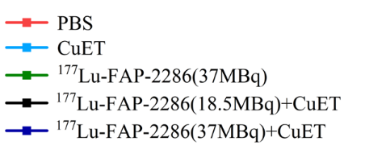
Figure S4. The changes of body weight (W_{X}/W₀) of mice of different treatment groups after treatment.

4. Safety assessment

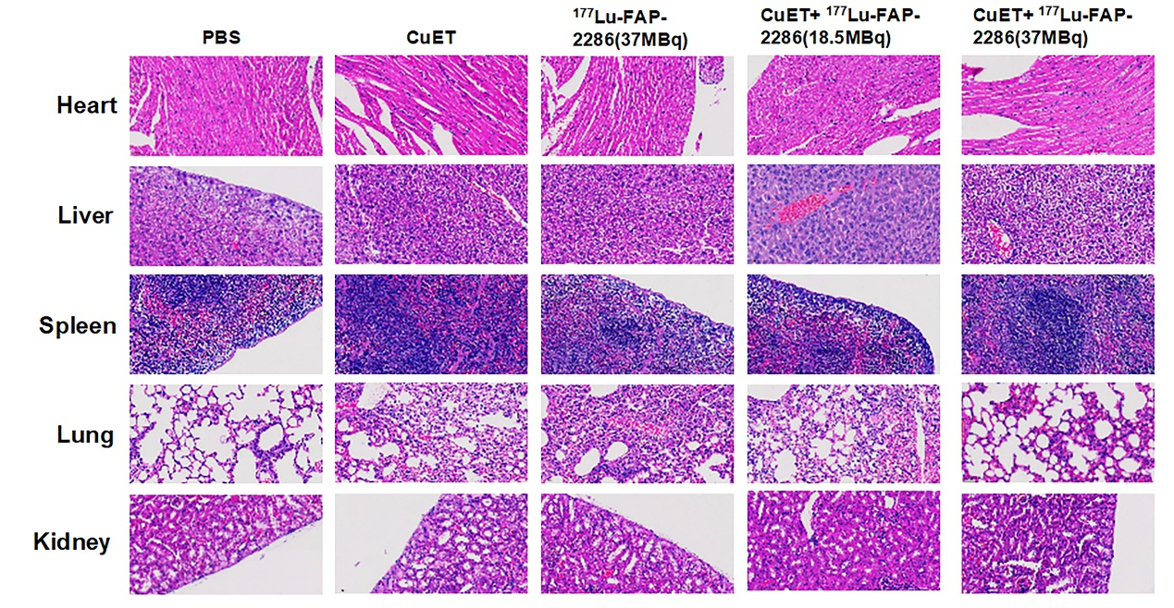
Figure S5. HE staining was performed on the heart, liver, spleen, lung, and kidney tissues of mice in each treatment group.

