Supplementary file 1

Size and surface modification of silica nanoparticles affect the severity of lung toxicity by modulating endosomal ROS generation in macrophages

Masahide Inoue^{1*}, Koji Sakamoto^{1*}, Atsushi Suzuki¹, Shinya Nakai², Akira Ando¹, Yoshio Nakahara¹, Ikuhiko Nakase², Makoto Sawada ³, and Naozumi Hashimoto¹

Supplementary figure 1.

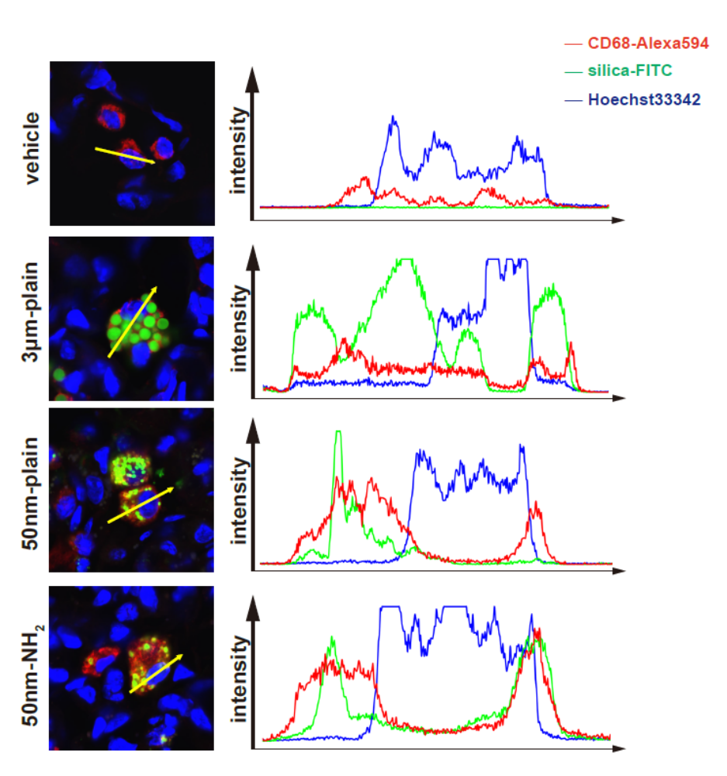

Line scan images assessing the intracellular localization of silica NPs in alveolar macrophages. Distribution of silica particles in murine lungs was studied by confocal fluorescence microscopy, as shown in Figure 3A. Representative images showing the localization of silica-NPs and macrophages labelled with anti-CD68 antibody. Plots of the fluorescence intensity of CD68 (red), FITC-labelled silica-NPs (green), and nucleus (blue) over a cross-section along the indicated yellow arrows. Data are representative of at least three independent experiments.
Supplementary figure 2.

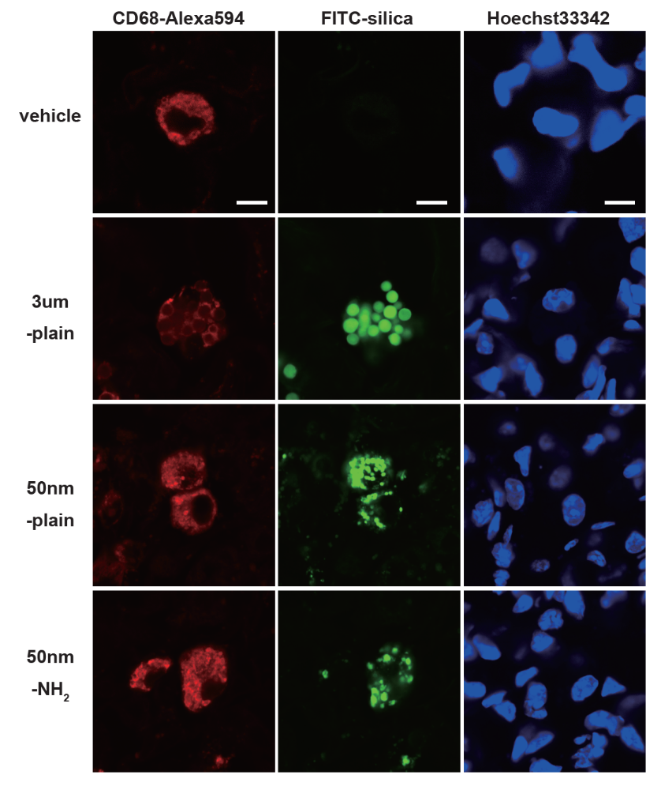

Non-merged images for immunofluorescent study of lung tissue shown in Figure 3A.
Scale bars = 10 μm.

Supplementary figure 3.

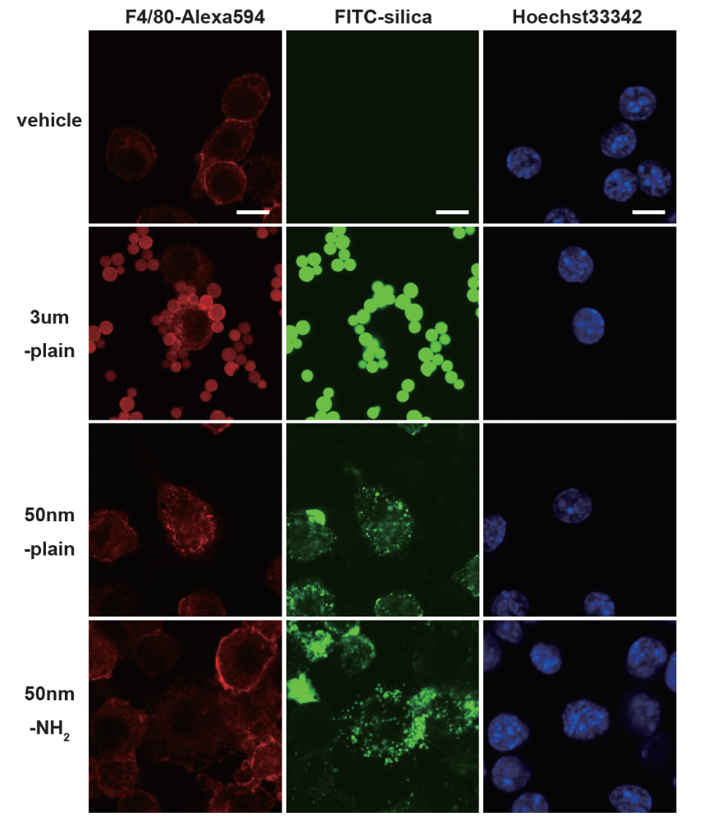
Non-merged images for immunofluorescent study of RAW267.4 cells shown in Figure 4A.
Scale bars = 10 μm.

Supplementary figure 4.

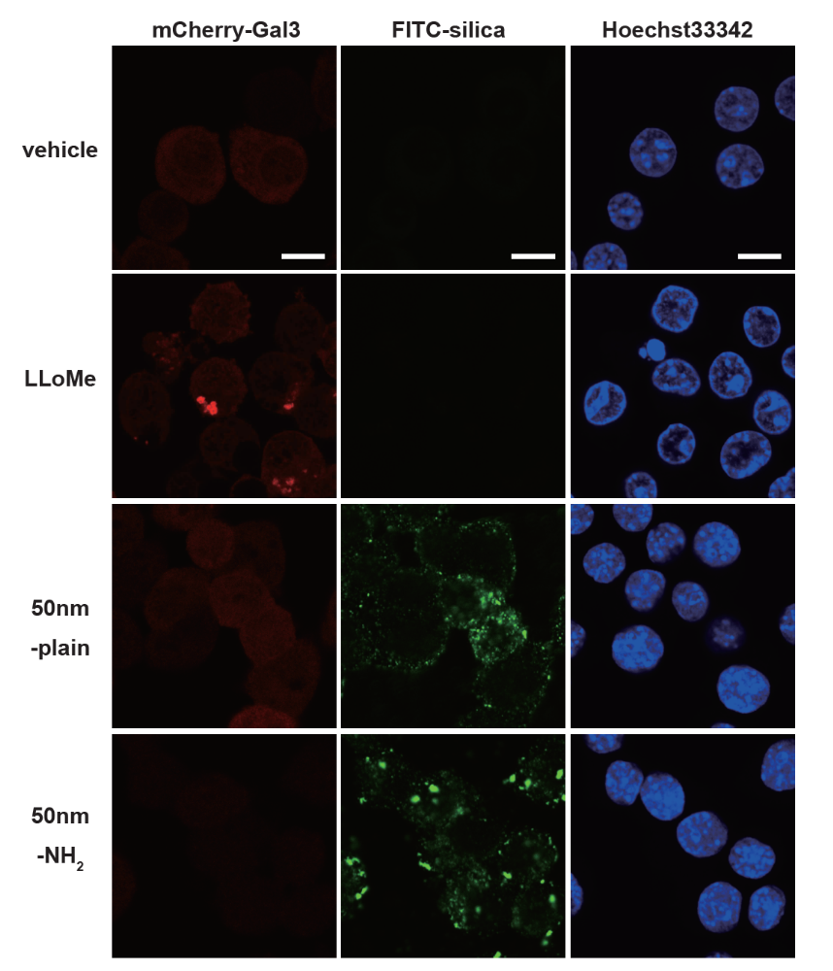
Non-merged images of confocal microscopy of RAW267.4-pmCherry-Gal3 cells shown in Figure 5C.
Scale bars = 10 μm.

