Supplemental Materials

Table S1 – Search Strategy for Health Utilities
 | Search Strategy | Results
Lung Cancer (#1) | "Lung Neoplasms"[MeSH Terms] OR "Pulmonary Neoplasms"[All Fields] OR "neoplasms lung"[All Fields] OR "Lung Neoplasm"[All Fields] OR "neoplasm lung"[All Fields] OR "neoplasms pulmonary"[All Fields] OR "neoplasm pulmonary"[All Fields] OR "Pulmonary Neoplasm"[All Fields] OR "Lung Cancer"[All Fields] OR "cancer lung"[All Fields] OR "cancers lung"[All Fields] OR "Lung Cancers"[All Fields] OR "Pulmonary Cancer"[All Fields] OR "cancer pulmonary"[All Fields] OR "cancers pulmonary"[All Fields] OR "Pulmonary Cancers"[All Fields] OR "Cancer of the Lung"[All Fields] OR "Cancer of Lung"[All Fields] OR "NSCLC"[All Fields] | 363.967
Health Utilities (#2) | "health utilit*"[Title/Abstract] OR "health state utilit*"[Title/Abstract] | 3.909
Total (#1 AND #2) |  | 107
Review Filter | ("review"[Filter] OR "systematic review"[Filter]) OR ("meta-analysis"[Filter]) | 8
The last search was conducted on July 3, 2024.

Table S2 – Search Strategies for Transition Probabilities Between States
 | Search Strategy | Results
Lung Cancer (#1) | "Lung Neoplasms"[MeSH Terms] OR "Pulmonary Neoplasms"[All Fields] OR "neoplasms lung"[All Fields] OR "Lung Neoplasm"[All Fields] OR "neoplasm lung"[All Fields] OR "neoplasms pulmonary"[All Fields] OR "neoplasm pulmonary"[All Fields] OR "Pulmonary Neoplasm"[All Fields] OR "Lung Cancer"[All Fields] OR "cancer lung"[All Fields] OR "cancers lung"[All Fields] OR "Lung Cancers"[All Fields] OR "Pulmonary Cancer"[All Fields] OR "cancer pulmonary"[All Fields] OR "cancers pulmonary"[All Fields] OR "Pulmonary Cancers"[All Fields] OR "Cancer of the Lung"[All Fields] OR "Cancer of Lung"[All Fields] OR "NSCLC"[All Fields] | 363.967
Radiotherapy (#2) | "radiotherapy, conformal"[MeSH Terms] OR "Radiosurgery"[Title/Abstract] OR "CyberKnife Radiosurgery"[Title/Abstract] OR "Gamma Knife Radiosurgeries"[Title/Abstract] OR "Gamma Knife Radiosurgery"[Title/Abstract] OR "LINAC Radiosurgery"[Title/Abstract] OR "Linear Accelerator Radiosurgery"[Title/Abstract] OR "radiation therapy stereotactic"[Title/Abstract] OR "radiation stereotactic"[Title/Abstract] OR "radiosurgery cyberknife"[Title/Abstract] OR "radiosurgery gamma knife"[Title/Abstract] OR "radiosurgery linac"[Title/Abstract] OR "radiosurgery linear accelerator"[Title/Abstract] OR "radiosurgery stereotactic"[Title/Abstract] OR "radiotherapy stereotactic body"[Title/Abstract] OR "Stereotactic Body Radiotherapies"[Title/Abstract] OR "Stereotactic Body Radiotherapy"[Title/Abstract] OR "Stereotactic Radiation"[Title/Abstract] OR "Stereotactic Radiation Therapies"[Title/Abstract] OR "Stereotactic Radiation Therapy"[Title/Abstract] OR "Stereotactic Radiations"[Title/Abstract] OR "Stereotactic Radiosurgeries"[Title/Abstract] OR "Stereotactic Radiosurgery"[Title/Abstract] OR "therapy stereotactic radiation"[Title/Abstract] OR "radiofrequency ablation"[Title/Abstract] OR "stereotactic body radiation therapy"[Title/Abstract] OR "radio-surgery"[Title/Abstract] OR "SABR"[Title/Abstract] OR "SABRT"[Title/Abstract] OR "SBRT"[Title/Abstract] OR "stereotactic ablative body radiation therapy"[Title/Abstract] OR "stereotactic ablative body radiotherapy"[Title/Abstract] OR "stereotactic ablative radiation therapy"[Title/Abstract] OR "stereotactic ablative radiotherapy"[Title/Abstract] OR "stereotaxic body radiation therapy"[Title/Abstract] OR "stereotaxic body radiotherapy"[Title/Abstract] OR "srs stereotactic radiosurgery"[Title/Abstract] OR "stereotactic radio-surgery"[Title/Abstract] OR "stereotaxic radio-surgery"[Title/Abstract] OR "stereotaxic radiosurgery"[Title/Abstract] OR "Radiosurgery"[MeSH Terms] | 70.414
Outcomes (#3) | "overall survival"[Title/Abstract] OR "OS"[Title/Abstract] OR "local control"[Title/Abstract] OR "lung cancer specific survival"[Title/Abstract] OR "cancer specific survival"[Title/Abstract] OR "LCSS"[Title/Abstract] OR "CSS"[Title/Abstract] OR "progression free survival"[Title/Abstract] OR "PFS"[Title/Abstract] OR "progression rate"[Title/Abstract] OR "progression"[Title/Abstract] | 995.848
Total (#1 AND #2 AND #3) |  | 3.057
Review Filter | ("review"[Filter] OR "systematic review"[Filter]) OR ("meta-analysis"[Filter]) | 473
The last search was conducted on July 3, 2024.

Table S3 – Probabilities of Death from Other Causes based on the Brazilian mortality tab
Age | Probabilities of Death
65 | 0,016
66 | 0,017
67 | 0,019
68 | 0,020
69 | 0,022
70 | 0,024
71 | 0,026
72 | 0,028
73 | 0,030
74 | 0,033
75 | 0,037
76 | 0,040
77 | 0,044
78 | 0,048
79 | 0,053
80 | 0,057
81 | 0,063
82 | 0,069
83 | 0,076
84 | 0,085
85 | 0,095
86 | 0,105
87 | 0,115
88 | 0,123
89 | 0,131
90 ou mais | 1,000
Source: Brazilian mortality table (IBGE, 2024)²⁸
Table S4 - Resources and Costs Used in the Model – Base Case and Alternative scenario 1
 | Unit Value (R$) | Quantity | Total (R$) | Quantity | Total (R$)
No Evidence of Disease |  | Year 1 |  | Year 2 - 5
Exams
Chest CT | 156,86 | 2 | 313,72 | 2 | 313,72
PET-CT | 2.152,35 | 0,2 | 430,47 | 0,2 | 430,47
Abdominal CT | 156,86 | 2 | 313,72 | 2 | 313,72
Pulmonary Function Test | 304,17 | 1 | 304,17 | 1 | 304,17
Urea | 7,04 | 1 | 7,04 | 1 | 7,04
AST (TGO) | 7,04 | 1 | 7,04 | 1 | 7,04
ALT (TGP) | 7,04 | 1 | 7,04 | 1 | 7,04
Total and Fractionated Bilirubin | 7,04 | 1 | 7,04 | 1 | 7,04
Creatinine | 7,04 | 1 | 7,04 | 1 | 7,04
Complete Blood Count | 7,04 | 1 | 7,04 | 1 | 7,04
Electrolytes | 7,04 | 1 | 7,04 | 1 | 7,04
Consultations
Medical Consultation | 354,69 | 4 | 1.418,76 | 2 | 709,38
Nursing Consultation | 82,97 | 4 | 331,88 | 2 | 165,94
Totals |  |  | 3.162,00 |  | 2.286,68
Local Recurrence |  | Year 1 |  | Year 2 and beyond
Exams
Chest CT | 156,86 | 2 | 313,72 |  | -
PET-CT | 2.152,35 | 1 | 2.152,35 |  | -
Abdominal CT | 156,86 | 2 | 313,72 |  | -
Pulmonary Function Test | 304,17 | 1 | 304,17 |  | -
Urea | 7,04 | 1 | 7,04 |  | -
AST (TGO) | 7,04 | 1 | 7,04 |  | -
ALT (TGP) | 7,04 | 1 | 7,04 |  | -
Total and Fractionated Bilirubin | 7,04 | 1 | 7,04 |  | -
Creatinine | 7,04 | 1 | 7,04 |  | -
Complete Blood Count | 7,04 | 1 | 7,04 |  | -
Electrolytes | 7,04 | 1 | 7,04 |  | -
Brain MRI | 355,83 | 1 | 355,83 |  | -
Bronchoscopy with Biopsy | 1.150,23 | 1 | 1.150,23 |  | -
Consultations
Medical Consultation | 354,69 | 4 | 1.418,76 |  | -
Nursing Consultation | 82,97 | 4 | 331,88 |  | -
Physiotherapy Consultation | 82,97 | 4 | 331,88 |  | -
Treatment
Chemotherapy | 1.214,90 | 8 | 9.719,20 |  | -
Palliative Care | 11.787,84 |  | - | 1 | 11.787,84
Totals |  |  | 16.441,02 |  | 11.787,84
Regional Recurrence |  | Year 1 |  | Year 2 and beyond
Exams
Chest CT | 156,86 | 2 | 313,72 |  | -
PET-CT | 2.152,35 | 1 | 2.152,35 |  | -
Abdominal CT | 156,86 | 2 | 313,72 |  | -
Pulmonary Function Test | 304,17 | 1 | 304,17 |  | -
Urea | 7,04 | 1 | 7,04 |  | -
AST (TGO) | 7,04 | 1 | 7,04 |  | -
ALT (TGP) | 7,04 | 1 | 7,04 |  | -
Total and Fractionated Bilirubin | 7,04 | 1 | 7,04 |  | -
Creatinine | 7,04 | 1 | 7,04 |  | -
Complete Blood Count | 7,04 | 1 | 7,04 |  | -
Electrolytes | 7,04 | 1 | 7,04 |  | -
Brain MRI | 355,83 | 1 | 355,83 |  | -
Bronchoscopy with Biopsy | 1.150,23 | 1 | 1.150,23 |  | -
Consultations
Medical Consultation | 354,69 | 4 | 1.418,76 |  | -
Nursing Consultation | 82,97 | 4 | 331,88 |  | -
Physiotherapy Consultation | 82,97 | 4 | 331,88 |  | -
Treatment
Chemotherapy | 1.214,90 | 8 | 9.719,20 |  | -
Palliative Care | 11.787,84 |  | - | 1 | 11.787,84
Totals |  |  | 16.441,02 |  | 11.787,84
Distant Metastasis |  | Year 1 |  | Year 2 and beyond
Exams
Chest CT | 156,86 | 1 | 156,86 |  | -
PET-CT | 2.152,35 | 1 | 2.152,35 |  | -
Abdominal CT | 156,86 | 1 | 156,86 |  | -
Pulmonary Function Test | 304,17 | 1 | 304,17 |  | -
Urea | 7,04 | 1 | 7,04 |  | -
AST (TGO) | 7,04 | 1 | 7,04 |  | -
ALT (TGP) | 7,04 | 1 | 7,04 |  | -
Total and Fractionated Bilirubin | 7,04 | 1 | 7,04 |  | -
Creatinine | 7,04 | 1 | 7,04 |  | -
Complete Blood Count | 7,04 | 1 | 7,04 |  | -
Electrolytes | 7,04 | 1 | 7,04 |  | -
Brain MRI | 355,83 | 1 | 355,83 |  | -
Bronchoscopy with Biopsy | 1.150,23 | 1 | 1.150,23 |  | -
Consultations
Medical Consultation | 354,69 | 1 | 354,69 |  | -
Nursing Consultation | 82,97 | 1 | 82,97 |  | -
Physiotherapy Consultation | 82,97 | 1 | 82,97 |  | -
Treatment
Chemotherapy | 1.214,90 | 8 | 9.719,20 |  | -
Palliative Care | 11.787,84 | 1 | 11.787,84 | 1 | 11.787,84
Totals |  |  | 26.353,25 |  | 11.787,84
Grade 3-4 Toxicity
Consultations | Unit Value (R$) | Quantity | Total (R$)
Medical Consultation | 354,69 | 4 | 1.418,76
Nursing Consultation | 82,97 | 4 | 331,88
Physiotherapy Consultation | 82,97 | 4 | 331,88
Treatment
Clinical Hospitalization Day | 1.426,12 | 5 | 7.130,60
Totals |  |  | 9.213,12

Table S5 - Resources and Costs Used in the Model – Alternative scenario 2
 | Unit Value (R$) | Quantity | Total (R$) | Quantity | Total (R$)
No Evidence of Disease |  | Year 1 |  | Year 2 - 5
Exams
Chest CT | 136,41 | 2 | 272,82 | 2 | 272,82
PET-CT | 2.107,22 | 0,2 | 421,44 | 0,2 | 421,44
Abdominal CT | 138,63 | 2 | 277,26 | 2 | 277,26
Pulmonary Function Test | 6,36 | 1 | 6,36 | 1 | 6,36
Urea | 1,85 | 1 | 1,85 | 1 | 1,85
AST (TGO) | 2,01 | 1 | 2,01 | 1 | 2,01
ALT (TGP) | 2,01 | 1 | 2,01 | 1 | 2,01
Total and Fractionated Bilirubin | 2,01 | 1 | 2,01 | 1 | 2,01
Creatinine | 1,85 | 1 | 1,85 | 1 | 1,85
Complete Blood Count | 4,11 | 1 | 4,11 | 1 | 4,11
Electrolytes | 1,85 | 1 | 1,85 | 1 | 1,85
Consultations
Medical Consultation | 10,00 | 4 | 40,00 | 2 | 20,00
Nursing Consultation | 6,30 | 4 | 25,20 | 2 | 12,60
Totals |  |  | 1.058,77 |  | 1.026,17
Local Recurrence |  | Year 1 |  | Year 2 and beyond
Exams
Chest CT | 136,41 | 2 | 272,82 |  | -
PET-CT | 2.107,22 | 1 | 2.107,22 |  | -
Abdominal CT | 138,63 | 2 | 277,26 |  | -
Pulmonary Function Test | 6,36 | 1 | 6,36 |  | -
Urea | 1,85 | 1 | 1,85 |  | -
AST (TGO) | 2,01 | 1 | 2,01 |  | -
ALT (TGP) | 2,01 | 1 | 2,01 |  | -
Total and Fractionated Bilirubin | 2,01 | 1 | 2,01 |  | -
Creatinine | 1,85 | 1 | 1,85 |  | -
Complete Blood Count | 4,11 | 1 | 4,11 |  | -
Electrolytes | 1,85 | 1 | 1,85 |  | -
Brain MRI | 268,75 | 1 | 268,75 |  | -
Bronchoscopy with Biopsy | 36,02 | 1 | 36,02 |  | -
Consultations
Medical Consultation | 10,00 | 4 | 40,00 |  | -
Nursing Consultation | 6,30 | 4 | 25,20 |  | -
Physiotherapy Consultation | 6,30 | 4 | 25,20 |  | -
Treatment
Chemotherapy | 1.100,00 | 8 | 8.800,00 |  | -
Palliative Care | 2.204,64 |  | - | 1 | 2.204,64
Totals |  |  | 11.874,52 |  | 2.204,64
Regional Recurrence |  | Year 1 |  | Year 2 and beyond
Exams
Chest CT | 136,41 | 2 | 272,82 |  | -
PET-CT | 2.107,22 | 1 | 2.107,22 |  | -
Abdominal CT | 138,63 | 2 | 277,26 |  | -
Pulmonary Function Test | 6,36 | 1 | 6,36 |  | -
Urea | 1,85 | 1 | 1,85 |  | -
AST (TGO) | 2,01 | 1 | 2,01 |  | -
ALT (TGP) | 2,01 | 1 | 2,01 |  | -
Total and Fractionated Bilirubin | 2,01 | 1 | 2,01 |  | -
Creatinine | 1,85 | 1 | 1,85 |  | -
Complete Blood Count | 4,11 | 1 | 4,11 |  | -
Electrolytes | 1,85 | 1 | 1,85 |  | -
Brain MRI | 268,75 | 1 | 268,75 |  | -
Bronchoscopy with Biopsy | 36,02 | 1 | 36,02 |  | -
Consultations
Medical Consultation | 10,00 | 4 | 40,00 |  | -
Nursing Consultation | 6,30 | 4 | 25,20 |  | -
Physiotherapy Consultation | 6,30 | 4 | 25,20 |  | -
Treatment
Chemotherapy | 1.100,00 | 8 | 8.800,00 |  | -
Palliative Care | 2.204,64 |  | - | 1 | 2.204,64
Totals |  |  | 11.874,52 |  | 2.204,64
Metástase a distância |  | Ano 1 |  | Ano 2 e +
Exams
Chest CT | 136,41 | 1 | 136,41 |  | -
PET-CT | 2.107,22 | 1 | 2.107,22 |  | -
Abdominal CT | 138,63 | 1 | 138,63 |  | -
Pulmonary Function Test | 6,36 | 1 | 6,36 |  | -
Urea | 1,85 | 1 | 1,85 |  | -
AST (TGO) | 2,01 | 1 | 2,01 |  | -
ALT (TGP) | 2,01 | 1 | 2,01 |  | -
Total and Fractionated Bilirubin | 2,01 | 1 | 2,01 |  | -
Creatinine | 1,85 | 1 | 1,85 |  | -
Complete Blood Count | 4,11 | 1 | 4,11 |  | -
Electrolytes | 1,85 | 1 | 1,85 |  | -
Brain MRI | 268,75 | 1 | 268,75 |  | -
Bronchoscopy with Biopsy | 36,02 | 1 | 36,02 |  | -
Consultations
Medical Consultation | 10,00 | 1 | 10,00 |  | -
Nursing Consultation | 6,30 | 1 | 6,30 |  | -
Physiotherapy Consultation | 6,30 | 1 | 6,30 |  | -
Treatment
Chemotherapy | 1.100,00 | 8 | 8.800,00 |  | -
Palliative Care | 2.204,64 | 1 | 2.204,64 | 1 | 2.204,64
Totals |  |  | 13.736,32 |  | 2.204,64
Grade 3-4 Toxicity
Consultations |  | Ano | Total
Medical Consultation | 10,00 | 4 | 40,00
Nursing Consultation | 6,30 | 4 | 25,20
Physiotherapy Consultation | 6,30 | 4 | 25,20
Treatment
Clinical Hospitalization Day | 367,44 | 5 | 1.837,20
Totals |  |  | 1.927,60

Table S6 - Estimated Annual Transition Probabilities for Alternative Scenario 1
Probability | Minimum (1) | Base (2) | Maximum (3)
Probability of progression to DM after CRT* | 0,016 | 0,0384 | 0,0618
Probability of progression to DM after SABR* | 0,0355 | 0,0606 | 0,0871
Probability of progression to LR after CRT* | 0,0348 | 0,0637 | 0,0946
Probability of progression to LR after SABR* | 0,0232 | 0,0453 | 0,0684
Probability of progression to RR after CRT* | 0,0049 | 0,0228 | 0,0414
Probability of progression to RR after SABR* | 0 | 0,0069 | 0,0158
Probability of toxicity after CRT | 0,0099 | 0,0303 | 0,0516
Probability of toxicity after SABR | 0,0259 | 0,0486 | 0,0725
Source: Own elaboration, based on data from the CHISEL study²⁵ and the SPACE study²⁶ .
CRT: Conventional Radiotherapy; DM: Distant Metastasis; LR: Local Recurrence; RR: Regional Recurrence; SABR: Stereotactic Ablative Radiotherapy; NED: No Evidence of Disease.
*Probabilities up to the fifth year; after this period, the value was set to 0.

Table S7 – Cost Estimates Used in Alternative Scenario 2
Cost Estimates | Value
Cost of treatment with CRT | R$ 3.563,00
Cost of treatment with SABR | R$ 3.563,00
Cost of follow-up in NED state (1st year) | R$ 1.058,77
Cost of follow-up in NED state (Years 2 -5) | R$ 1.026,17
Cost of follow-up in DM state (1st year) | R$ 13.736,32
Cost of follow-up in DM state (Subsequent years) | R$ 2.204,64
Cost of follow-up in LR state (1st year) | R$ 11.874,52
Cost of follow-up in LR state (Subsequent years | R$ 2.204,64
Cost of follow-up in RR state (1st year) | R$ 11.874,52
Cost of follow-up in RR state (Subsequent years) | R$ 2.204,64
Cost of follow-up with grade 3-4 toxicity | R$ 1.927,60
CRT: Conventional Radiotherapy; DM: Distant Metastasis; LR: Local Recurrence; RR: Regional Recurrence; SABR: Stereotactic Ablative Radiotherapy; NED: No Evidence of Disease.

Figure S1 – Incremental cost-effectiveness scatterplot
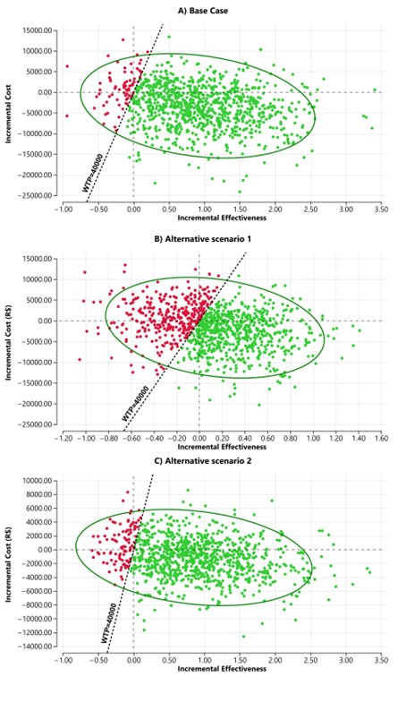

CRT: Conventional Radiotherapy; SABR: Stereotactic Ablative Radiotherapy. WTP: Willingness-to-pay (R$ 40,000)
The green points represent the simulation outcomes where SABR was cost-effective compared to CRT. The red points represent the simulation outcomes where SABR was not cost-effective compared to CRT.
Figure S2 - Univariate Sensitivity Analysis - Probability of Progression to LR after CRT – Base Case
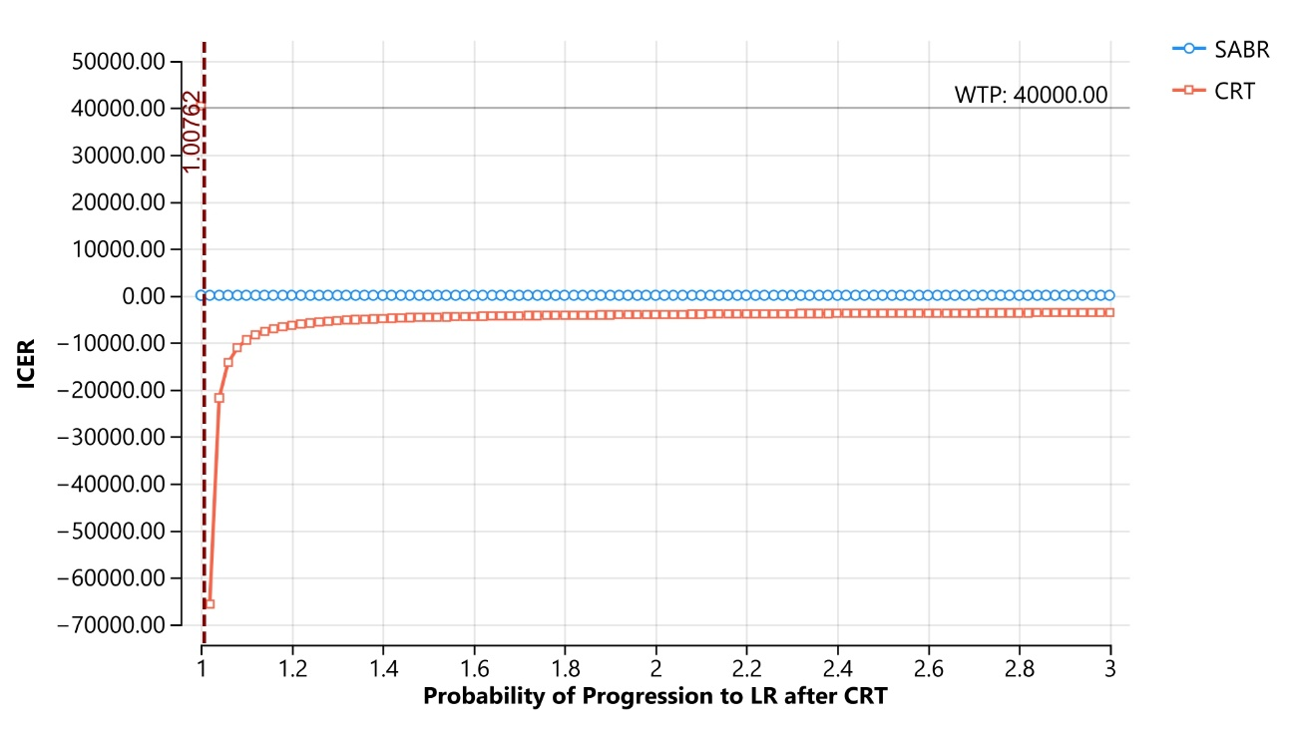
CRT: Conventional Radiotherapy; LR: Local Recurrence; SABR: Stereotactic Ablative Radiotherapy.

Figure S3 - Bivariate Cost Analysis - Base Case
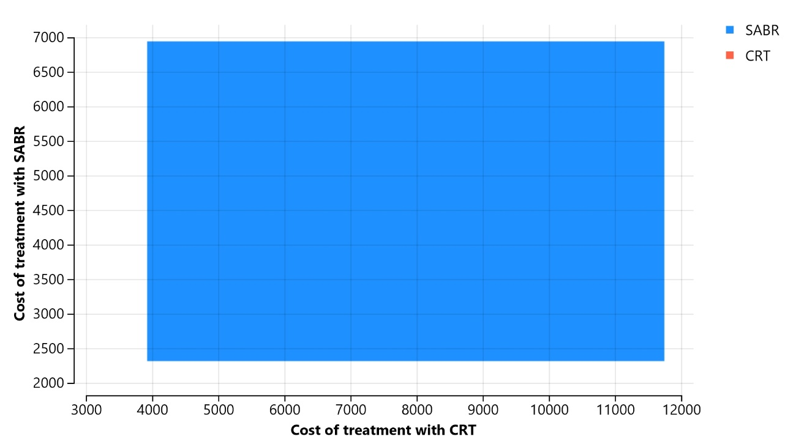
CRT: Conventional Radiotherapy; SABR: Stereotactic Ablative Radiotherapy.

Figure S4 - Bivariate Analysis of Progression Probabilities to DM - Base Case
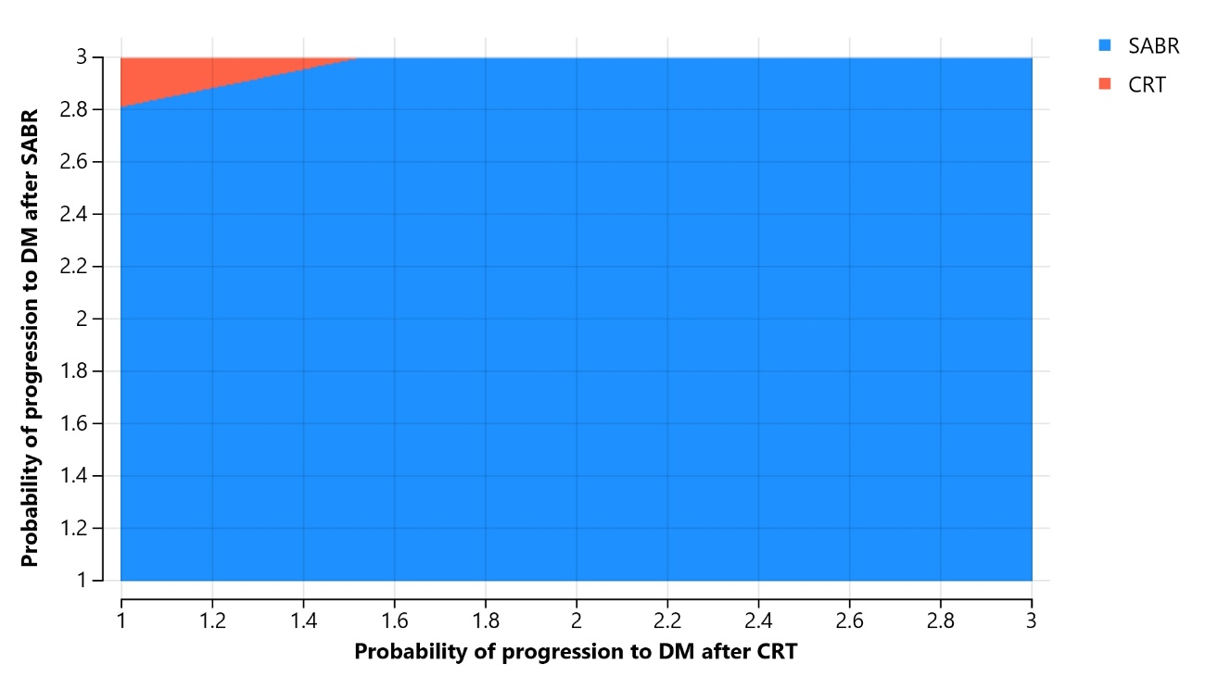
CRT: Conventional Radiotherapy; DM: Distant Metastasis; SABR: Stereotactic Ablative Radiotherapy.

Figure S5 - Bivariate Analysis of Progression Probabilities to LR – Base Case
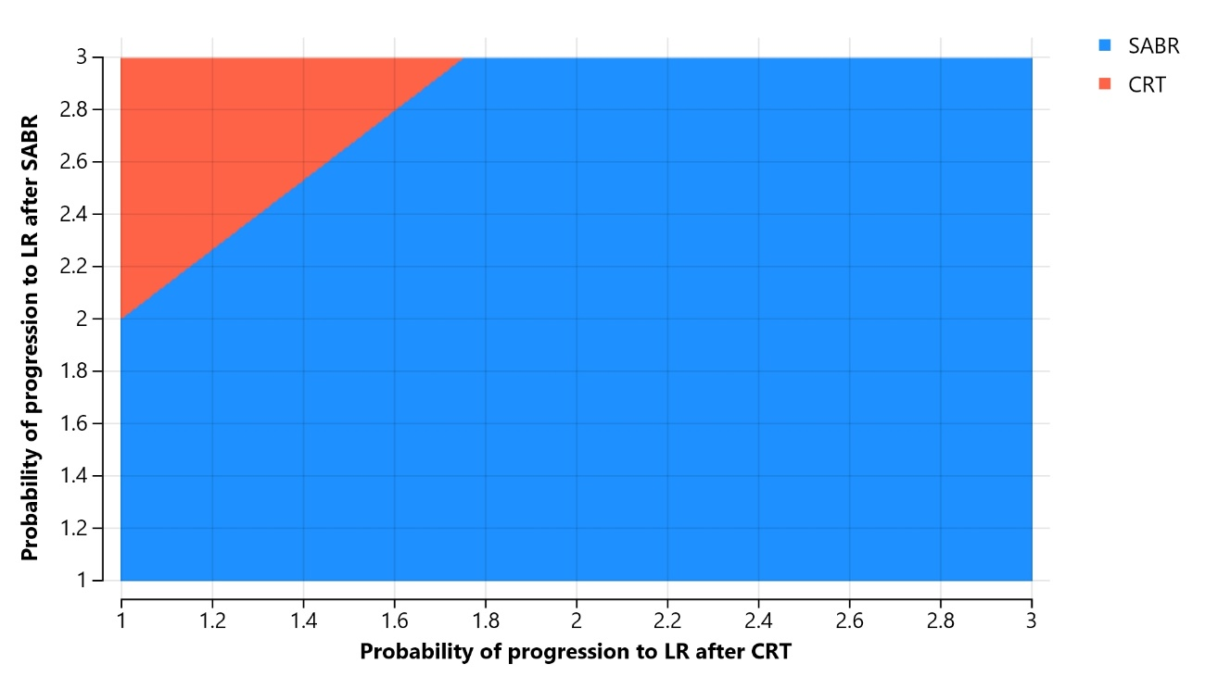
CRT: Conventional Radiotherapy; LR: Local Recurrence; SABR: Stereotactic Ablative Radiotherapy.
Figure S6 - Bivariate Analysis of Progression Probabilities to RR - Base Case
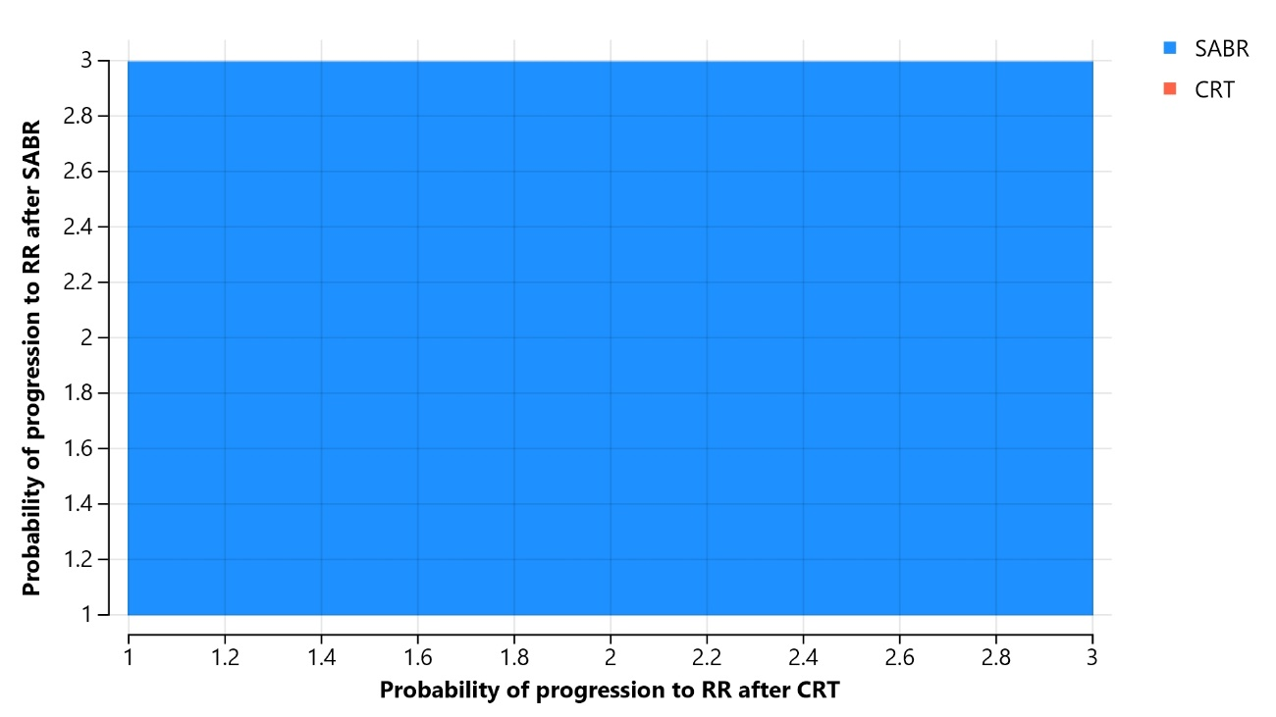
CRT: Conventional Radiotherapy; RR: Regional Recurrence; SABR: Stereotactic Ablative Radiotherapy.
Figure S7 - Bivariate Analysis of Progression Probabilities to DM – Alternative Scenario 1
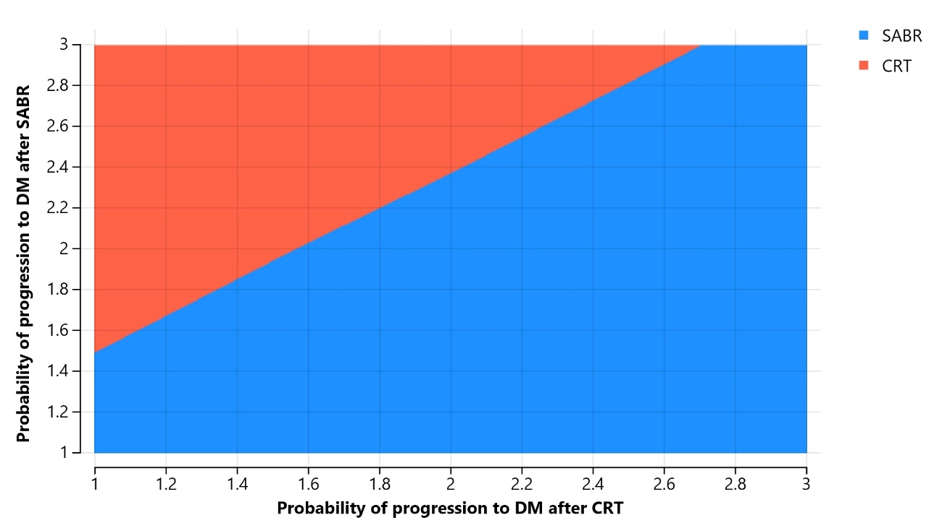
CRT: Conventional Radiotherapy; DM: Distant Metastasis; SABR: Stereotactic Ablative Radiotherapy.
Figure S8 - Bivariate Analysis of Progression Probabilities to LR – Alternative Scenario 1
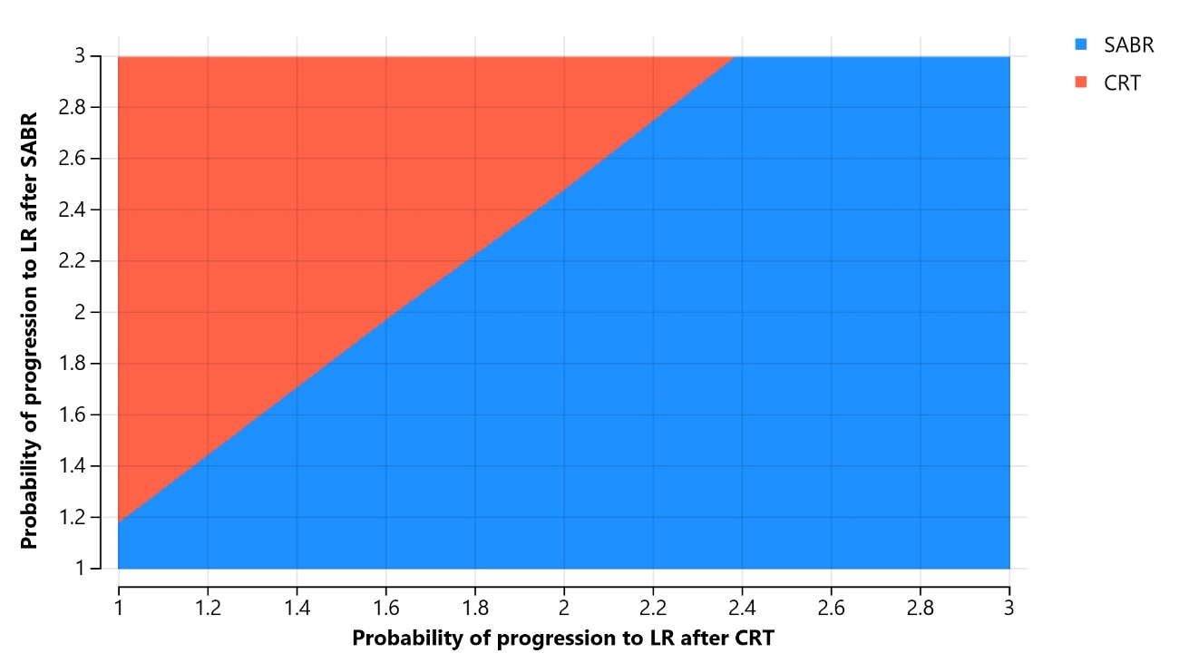
CRT: Conventional Radiotherapy; LR: Local Recurrence; SABR: Stereotactic Ablative Radiotherapy.
Figure S9 - Bivariate Analysis of Progression Probabilities to RR – Alternative Scenario 1
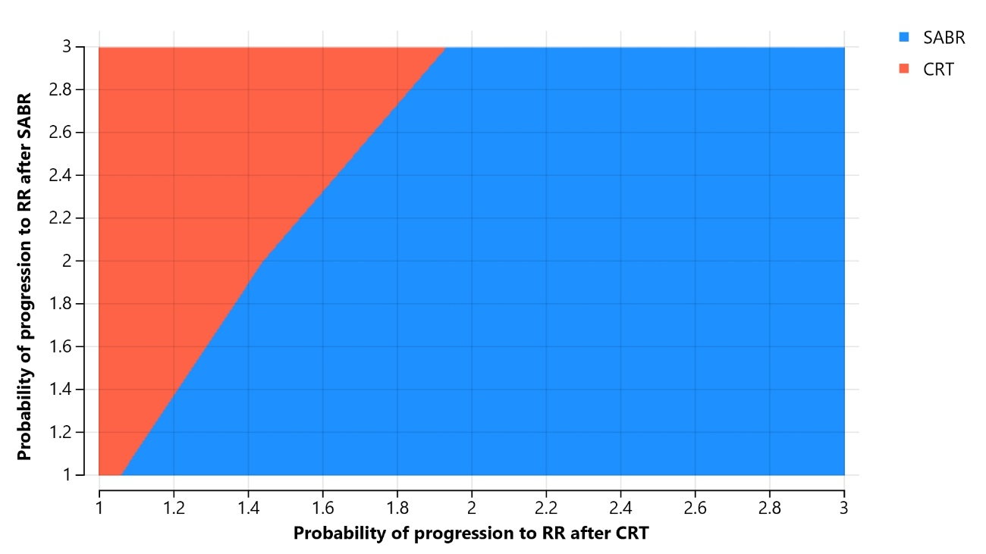
CRT: Conventional Radiotherapy; RR: Regional Recurrence; SABR: Stereotactic Ablative Radiotherapy.

