Supplementary Materials
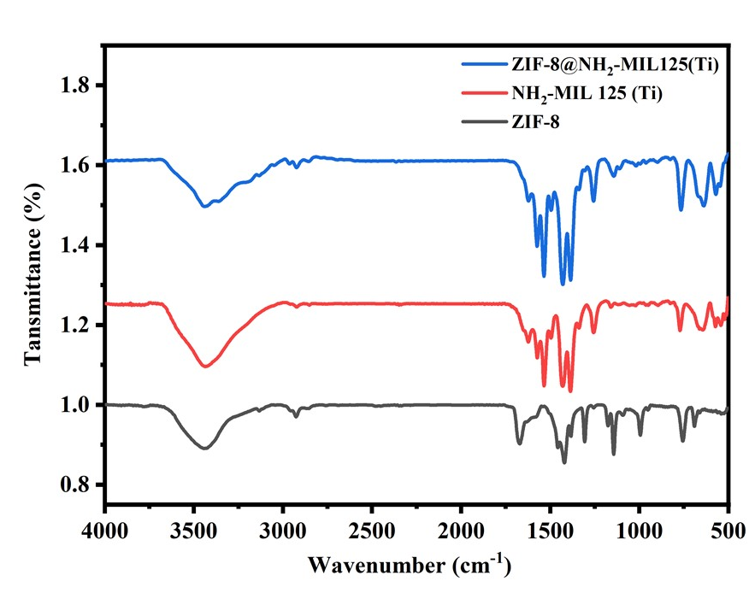
SM:1 FTIR spectrum of ZIF-8, NH₂₋MIL125(Ti), and ZIF8@NH₂₋MIL125(Ti) composite

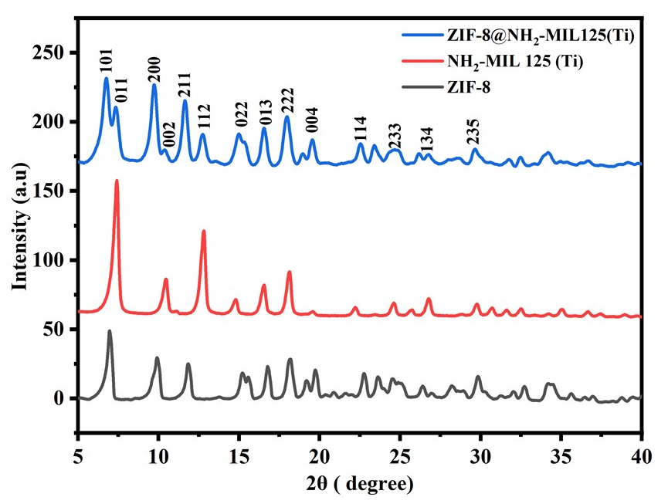
SM:2. P-XRD spectrum of ZIF-8, NH₂-MIL125(Ti), and ZIF8@NH₂-MIL125(Ti) MOF composite
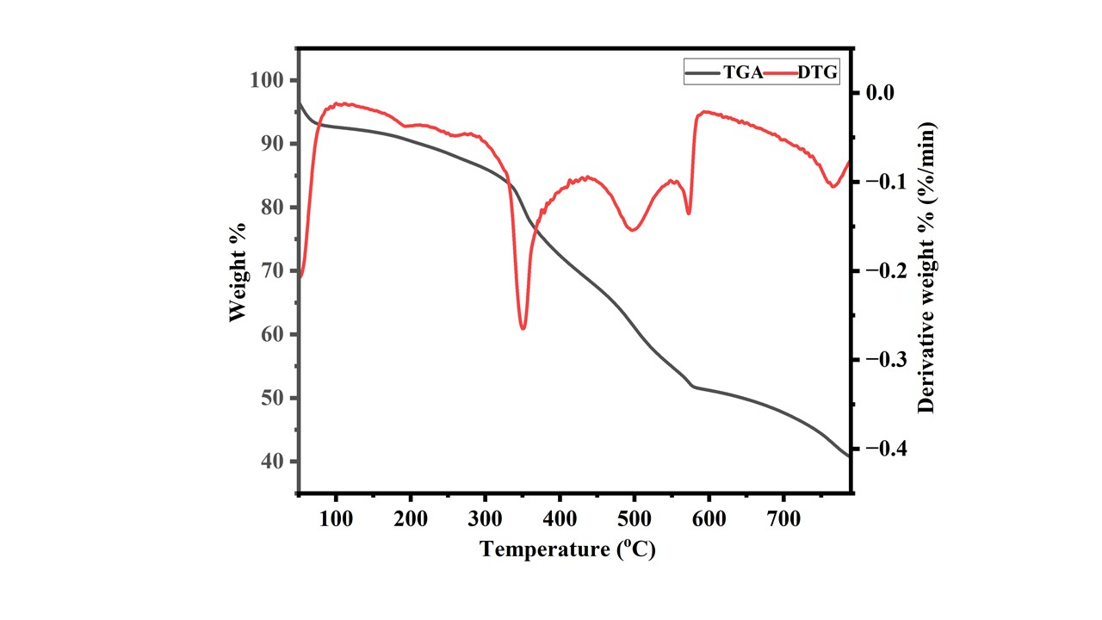
SM:3. TGA-DTG of ZIF-8@NH₂-MIL125(Ti) composite
SM:4. Raman spectra of poly (styrene-co-methyl methacrylate) MPs
Membranes | Average Roughness R_{a} (nm) | RMS Roughness R_{q} (nm)
ZM-0 | 33.30 | 45.08
ZM-2 | 25.88 | 38.45
SM:5. Surface roughness of the membrane

SM:6. WCA and surface energy of ZM-0 and ZM-2 HF membranes
SM:7. Water uptake capacity and porosity of the fabricated membranes

SM:8. Mechanical properties of the neat and optimized membrane
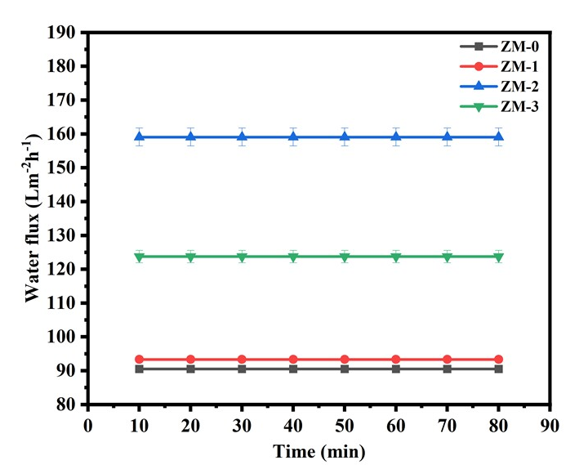
SM:9. Pure water flux (Lm⁻²h⁻¹)
SM:10. Rejection of dyes (CV and RO 16)

SM:11. Rejection of heavy metals (Hg and Pb)

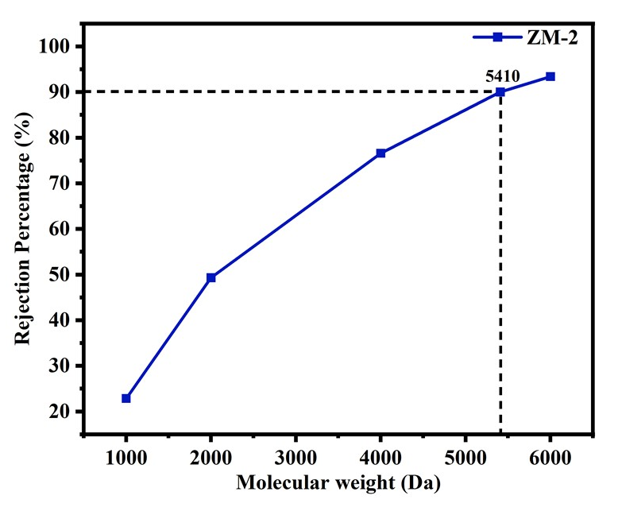
SM:12 MWCO of the optimized membrane

