 | Df | Sum Sq | Mean Sq | F value | Pr(>F)
Line | 406 | 9166 | 22.575 | 77.62 | < 2e-16 ***
Rep | 2 | 16 | 8.081 | 27.78 | 1.26e-12 ***
Residuals | 2000 | 582 | 0.291
Supplementary Table 1 Analysis of variance (ANOVA) for phenotypic scores of 412 wheat lines measured across three replications. The table shows degrees of freedom (Df), sum of squares (Sum Sq), mean squares (Mean Sq), F values, and significance levels (Pr(>F)) for the effects of genotype (Line), replication (Rep), and residual error. Highly significant effects are indicated by *** (p < 0.001)

---
Signif. codes: 0 ‘***’ 0.001 ‘**’ 0.01 ‘*’ 0.05 ‘.’ 0.1 ‘ ’ 1

Supplementary Table 2 Descriptive statistics of bacterial leaf streak (BLS) disease scores for 412 wheat genotypes, including mean, mode, median, standard deviation (SD), and standard error (SE).
Sr No | Line No | Mean | Mode | Median | SD | SE
1 | TAM-107 | 4.93 | 5.00 | 4.95 | 0.12 | 0.02
2 | Mattern | 5.17 | 5.20 | 5.20 | 0.15 | 0.02
3 | Overland | 5.83 | 5.90 | 5.90 | 0.15 | 0.03
4 | 22Nord-169 | 1.83 | 2.00 | 2.00 | 0.41 | 0.07
5 | 22Nord-170 | 3.67 | 3.00 | 3.50 | 0.82 | 0.14
6 | 22Nord-171 | 6.83 | 7.00 | 7.00 | 0.41 | 0.07
7 | 22Nord-172 | 3.17 | 3.00 | 3.00 | 0.41 | 0.07
8 | 22Nord-173 | 3.33 | 3.00 | 3.00 | 0.52 | 0.09
9 | 22Nord-174 | 7.17 | 7.00 | 7.00 | 0.41 | 0.07
10 | 22Nord-175 | 5.00 | 5.00 | 5.00 | 0.00 | 0.00
11 | 22Nord-176 | 6.00 | 6.00 | 6.00 | 0.63 | 0.11
12 | 22Nord-177 | 6.00 | 6.00 | 6.00 | 0.00 | 0.00
13 | 22Nord-178 | 5.00 | 5.00 | 5.00 | 0.00 | 0.00
14 | 23SeniorA-20 | 6.67 | 7.00 | 7.00 | 0.52 | 0.09
15 | 23SeniorA-25 | 5.67 | 6.00 | 6.00 | 0.52 | 0.09
16 | 23SeniorA-41 | 3.17 | 3.00 | 3.00 | 0.41 | 0.07
17 | 23SeniorA-47 | 2.33 | 2.00 | 2.00 | 0.52 | 0.09
18 | 23SeniorA-48 | 2.00 | 2.00 | 2.00 | 0.00 | 0.00
19 | 23SeniorB-6 | 3.17 | 3.00 | 3.00 | 0.75 | 0.13
20 | 23SeniorB-7 | 3.00 | 3.00 | 3.00 | 0.00 | 0.00
21 | 23SeniorB-8 | 3.50 | 3.00 | 3.50 | 0.55 | 0.09
22 | 23SeniorB-9 | 4.67 | 4.00 | 4.50 | 0.82 | 0.14
23 | 23SeniorB-12 | 5.00 | 5.00 | 5.00 | 0.89 | 0.15
24 | 23SeniorB-23 | 3.33 | 3.00 | 3.00 | 0.52 | 0.09
25 | 23SeniorB-48 | 4.67 | 5.00 | 5.00 | 0.52 | 0.09
26 | 23SeniorB-49 | 5.33 | 5.00 | 5.00 | 0.52 | 0.09
27 | 23SeniorC-6 | 4.00 | 4.00 | 4.00 | 0.00 | 0.00
28 | 23SeniorC-11 | 3.33 | 3.00 | 3.00 | 0.52 | 0.09
29 | 23SeniorC-29 | 2.67 | 3.00 | 3.00 | 0.52 | 0.09
30 | 23SeniorC-36 | 1.33 | 1.00 | 1.00 | 0.52 | 0.09
31 | 23SeniorC-37 | 5.00 | 5.00 | 5.00 | 0.63 | 0.11
32 | 23SeniorC-40 | 6.00 | 6.00 | 6.00 | 0.00 | 0.00
33 | 23SeniorC-41 | 5.80 | 6.00 | 6.00 | 0.45 | 0.09
34 | VA21HRW-2 | 6.00 | 6.00 | 6.00 | 0.00 | 0.00
35 | VA21HRW-9 | 7.00 | 7.00 | 7.00 | 0.00 | 0.00
36 | VA21HRW-11 | 6.33 | 6.00 | 6.00 | 0.52 | 0.09
37 | VA21HRW-12 | 7.17 | 7.00 | 7.00 | 0.41 | 0.07
38 | VA21HRW-20 | 6.33 | 6.00 | 6.00 | 0.52 | 0.09
39 | VA21HRW-24 | 4.00 | 4.00 | 4.00 | 0.00 | 0.00
40 | VA21HRW-29 | 7.33 | 7.00 | 7.00 | 0.52 | 0.09
41 | VA21HRW-34 | 7.67 | 8.00 | 8.00 | 0.52 | 0.09
42 | VA21HRW-36 | 6.17 | 6.00 | 6.00 | 0.41 | 0.07
43 | VA21HRW-37 | 3.50 | 3.00 | 3.00 | 0.84 | 0.14
44 | VA21HRW-39 | 1.83 | 2.00 | 2.00 | 0.41 | 0.07
45 | VA21HRW-46 | 3.67 | 4.00 | 4.00 | 0.52 | 0.09
46 | VA21HRW-47 | 5.33 | 5.00 | 5.00 | 0.52 | 0.09
47 | VA21HRW-50 | 2.17 | 2.00 | 2.00 | 0.41 | 0.07
48 | VA21HRW-54 | 3.67 | 4.00 | 4.00 | 0.52 | 0.09
49 | VA21HRW-58 | 5.17 | 6.00 | 5.50 | 0.98 | 0.16
50 | VA21HRW-68 | 5.17 | 5.00 | 5.00 | 0.41 | 0.07
51 | VA21HRW-84 | 4.33 | 4.00 | 4.00 | 0.52 | 0.09
52 | VA21HRW-85 | 4.17 | 4.00 | 4.00 | 0.75 | 0.13
53 | VA21HRW-87 | 4.00 | 4.00 | 4.00 | 0.00 | 0.00
54 | VA21HRW-88 | 5.00 | 5.00 | 5.00 | 0.00 | 0.00
55 | VA21HRW-90 | 6.17 | 6.00 | 6.00 | 0.41 | 0.07
56 | VA21HRW-94 | 8.33 | 8.00 | 8.00 | 0.52 | 0.09
57 | VA21HRW-99 | 6.83 | 7.00 | 7.00 | 0.41 | 0.07
58 | VA21HRW-100 | 7.00 | 7.00 | 7.00 | 0.00 | 0.00
59 | VA21HRW-102 | 8.00 | 8.00 | 8.00 | 0.63 | 0.11
60 | VA21HRW-105 | 8.83 | 9.00 | 9.00 | 0.41 | 0.07
61 | DH19HRW01-45 | 7.50 | 7.00 | 7.50 | 1.05 | 0.17
62 | DH19HRW04-21 | 6.83 | 7.00 | 7.00 | 0.41 | 0.07
63 | DH19HRW04-86 | 8.33 | 8.00 | 8.00 | 0.52 | 0.09
64 | KS22H19 | 9.00 | 9.00 | 9.00 | 0.00 | 0.00
65 | KS22H21 | 5.50 | 5.00 | 5.50 | 0.55 | 0.09
66 | KS22H23 | 9.00 | 9.00 | 9.00 | 0.00 | 0.00
67 | KS22H28 | 9.00 | 9.00 | 9.00 | 0.00 | 0.00
68 | KS22H38 | 8.67 | 9.00 | 9.00 | 0.52 | 0.09
69 | KS22H40 | 9.00 | 9.00 | 9.00 | 0.00 | 0.00
70 | KS22HW44 | 6.33 | 6.00 | 6.00 | 0.52 | 0.09
71 | KS22HW54 | 5.67 | 6.00 | 6.00 | 0.52 | 0.09
72 | KS22H57 | 6.83 | 7.00 | 7.00 | 0.41 | 0.07
73 | KS22HW60 | 5.67 | 6.00 | 6.00 | 0.52 | 0.09
74 | KS22H75 | 7.00 | 7.00 | 7.00 | 0.00 | 0.00
75 | KS22H88 | 7.00 | 7.00 | 7.00 | 0.00 | 0.00
76 | KS22H89 | 6.67 | 7.00 | 7.00 | 0.52 | 0.09
77 | KS22H100 | 8.67 | 9.00 | 9.00 | 0.52 | 0.09
78 | KS22H108 | 9.00 | 9.00 | 9.00 | 0.00 | 0.00
79 | KS22H112 | 8.33 | 8.00 | 8.00 | 0.52 | 0.09
80 | KS22HW118 | 8.17 | 8.00 | 8.00 | 0.75 | 0.13
81 | KS22H126 | 8.50 | 8.00 | 8.50 | 0.55 | 0.09
82 | KS22H147 | 8.00 | 8.00 | 8.00 | 0.00 | 0.00
83 | KS22H149 | 7.33 | 8.00 | 8.00 | 1.03 | 0.17
84 | KS22HW150 | 8.00 | 8.00 | 8.00 | 0.00 | 0.00
85 | KS22HW152 | 8.00 | 7.00 | 8.00 | 0.89 | 0.15
86 | KS22HD156 | 6.83 | 7.00 | 7.00 | 0.75 | 0.13
87 | KS22HD157 | 6.33 | 6.00 | 6.00 | 0.52 | 0.09
88 | KS22HD158 | 5.00 | 5.00 | 5.00 | 0.00 | 0.00
89 | KS22H163 | 5.83 | 6.00 | 6.00 | 0.75 | 0.13
90 | KS22H170 | 6.67 | 7.00 | 7.00 | 0.52 | 0.09
91 | KS22H172 | 7.33 | 7.00 | 7.00 | 0.52 | 0.09
92 | KS22HW175 | 8.17 | 8.00 | 8.00 | 0.41 | 0.07
93 | KS22H178 | 8.67 | 9.00 | 9.00 | 0.52 | 0.09
94 | BASF-23-23 | 8.50 | 8.00 | 8.50 | 0.55 | 0.09
95 | BASF-23-24 | 8.00 | 8.00 | 8.00 | 0.00 | 0.00
96 | BASF-23-1 | 7.00 | 7.00 | 7.00 | 0.00 | 0.00
97 | BASF-23-22 | 4.00 | 4.00 | 4.00 | 0.63 | 0.11
98 | BASF-23-12 | 2.33 | 2.00 | 2.00 | 0.52 | 0.09
99 | BASF-23-6 | 3.33 | 3.00 | 3.00 | 0.52 | 0.09
100 | BASF-23-3 | 5.83 | 5.00 | 5.50 | 0.98 | 0.16
101 | BASF-23-18 | 7.00 | 7.00 | 7.00 | 0.00 | 0.00
102 | BASF-23-10 | 8.50 | 9.00 | 8.50 | 0.55 | 0.09
103 | BASF-23-4 | 4.83 | 5.00 | 5.00 | 0.41 | 0.07
104 | BASF-23-11 | 8.33 | 8.00 | 8.00 | 0.52 | 0.09
105 | BASF-23-19 | 6.33 | 6.00 | 6.00 | 0.52 | 0.09
106 | BASF-23-14 | 6.83 | 7.00 | 7.00 | 0.41 | 0.07
107 | BASF-23-20 | 6.00 | 6.00 | 6.00 | 0.00 | 0.00
108 | BASF-23-8 | 5.17 | 5.00 | 5.00 | 0.41 | 0.07
109 | BASF-23-17 | 5.00 | 5.00 | 5.00 | 0.63 | 0.11
110 | BASF-23-9 | 2.75 | 3.00 | 3.00 | 0.50 | 0.13
111 | BASF-23-15 | 5.00 | 5.00 | 5.00 | 0.00 | 0.00
112 | BASF-23-16 | 3.33 | 4.00 | 3.50 | 0.82 | 0.14
113 | BASF-23-2 | 3.00 | 3.00 | 3.00 | 0.00 | 0.00
114 | BASF-23-21 | 4.67 | 5.00 | 5.00 | 0.52 | 0.09
115 | BASF-23-5 | 1.83 | 2.00 | 2.00 | 0.75 | 0.13
116 | BASF-23-13 | 3.00 | 3.00 | 3.00 | 0.00 | 0.00
117 | BASF-23-7 | 3.50 | 3.00 | 3.50 | 0.55 | 0.09
118 | TX21M5051 | 2.83 | 3.00 | 3.00 | 0.75 | 0.13
119 | TX21M5081 | 4.17 | 4.00 | 4.00 | 0.75 | 0.13
120 | TX21M5090 | 3.33 | 3.00 | 3.00 | 0.52 | 0.09
121 | TX21M5102 | 3.67 | 4.00 | 4.00 | 0.52 | 0.09
122 | TX21M5106 | 5.00 | 5.00 | 5.00 | 0.00 | 0.00
123 | TX21M5110 | 5.33 | 5.00 | 5.00 | 0.52 | 0.09
124 | TX21M5111 | 1.00 | 1.00 | 1.00 | 0.00 | 0.00
125 | TX21M5132 | 3.17 | 3.00 | 3.00 | 0.75 | 0.13
126 | TX21M5141 | 3.00 | 2.00 | 3.00 | 0.89 | 0.15
127 | TX21M5145 | 3.00 | 2.00 | 3.00 | 0.89 | 0.15
128 | TX21M5167 | 3.17 | 3.00 | 3.00 | 0.41 | 0.07
129 | TX21M5175 | 2.67 | 3.00 | 3.00 | 0.52 | 0.09
130 | TX21M5184 | 2.50 | 2.00 | 2.00 | 0.84 | 0.14
131 | TX21M5202 | 4.00 | 5.00 | 4.00 | 0.89 | 0.15
132 | TX21M5311 | 2.17 | 2.00 | 2.00 | 0.75 | 0.13
133 | TX21M5327 | 3.17 | 3.00 | 3.00 | 0.41 | 0.07
134 | TX21M5358 | 3.33 | 4.00 | 4.00 | 1.03 | 0.17
135 | TX21M5362 | 2.33 | 2.00 | 2.00 | 0.52 | 0.09
136 | TX21M5390 | 2.83 | 3.00 | 3.00 | 0.41 | 0.07
137 | TX21M5440 | 1.17 | 1.00 | 1.00 | 0.41 | 0.07
138 | TX21M5443 | 3.00 | 2.00 | 3.00 | 0.89 | 0.15
139 | TX21M5445 | 4.33 | 4.00 | 4.00 | 0.52 | 0.09
140 | TX21M5477 | 1.67 | 2.00 | 2.00 | 0.52 | 0.09
141 | TX21M5528 | 2.00 | 2.00 | 2.00 | 0.00 | 0.00
142 | TX21M5615 | 4.33 | 4.00 | 4.00 | 0.52 | 0.09
143 | TX21M5621 | 3.17 | 3.00 | 3.00 | 1.17 | 0.19
144 | TX21M5629 | 1.67 | 2.00 | 2.00 | 0.52 | 0.09
145 | TX21M5632 | 2.33 | 2.00 | 2.00 | 0.52 | 0.09
146 | TX21M5634 | 2.33 | 2.00 | 2.00 | 1.03 | 0.17
147 | TX21M5652 | 6.00 | 6.00 | 6.00 | 0.00 | 0.00
148 | CO19S053R | 5.00 | 5.00 | 5.00 | 0.00 | 0.00
149 | CO19S135W | 4.00 | 4.00 | 4.00 | 0.00 | 0.00
150 | CO20D036R | 2.00 | 2.00 | 2.00 | 0.63 | 0.11
151 | CO20D045R | 1.83 | 2.00 | 2.00 | 0.75 | 0.13
152 | CO20D058W | 2.83 | 3.00 | 3.00 | 0.41 | 0.07
153 | CO20D068W | 2.00 | 2.00 | 2.00 | 0.00 | 0.00
154 | CO20D073W | 5.00 | 5.00 | 5.00 | 0.00 | 0.00
155 | CO20D079R | 3.67 | 3.00 | 3.00 | 1.03 | 0.17
156 | CO20D097R | 4.00 | 4.00 | 4.00 | 0.00 | 0.00
157 | CO20D108R | 2.17 | 3.00 | 2.50 | 0.98 | 0.16
158 | CO20D112R | 3.17 | 3.00 | 3.00 | 0.41 | 0.07
159 | CO200034R | 1.67 | 2.00 | 2.00 | 0.52 | 0.09
160 | CO200030R | 2.67 | 3.00 | 3.00 | 0.52 | 0.09
161 | CO200037R | 4.00 | 4.00 | 4.00 | 0.00 | 0.00
162 | CO20SF095R | 4.00 | 4.00 | 4.00 | 0.00 | 0.00
163 | CO20SF227R | 1.17 | 1.00 | 1.00 | 0.41 | 0.07
164 | CO20SF240R | 4.83 | 5.00 | 5.00 | 0.75 | 0.13
165 | CO20SF160R | 2.33 | 2.00 | 2.00 | 0.52 | 0.09
166 | CO20SF163R | 1.40 | 1.00 | 1.00 | 0.55 | 0.11
167 | CO20SF192R | 4.33 | 4.00 | 4.00 | 0.52 | 0.09
168 | CO20SF198R | 4.83 | 5.00 | 5.00 | 0.41 | 0.07
169 | CO20SFD043R | 4.67 | 5.00 | 5.00 | 0.52 | 0.09
170 | CO20SFD033W | 4.17 | 4.00 | 4.00 | 0.41 | 0.07
171 | CO20SFD071R | 4.00 | 3.00 | 4.00 | 0.89 | 0.15
172 | CO20SFD011R | 4.50 | 4.00 | 4.50 | 0.55 | 0.09
173 | CO20SFD013R | 7.00 | 7.00 | 7.00 | 0.00 | 0.00
174 | CO20SFD019R | 4.33 | 4.00 | 4.00 | 0.52 | 0.09
175 | CO20SFD020R | 6.67 | 7.00 | 7.00 | 0.52 | 0.09
176 | CO20SF014W | 4.33 | 4.00 | 4.00 | 0.52 | 0.09
177 | CO20SF141R | 3.50 | 3.00 | 3.50 | 0.55 | 0.09
178 | TX20A001005 | 3.00 | 3.00 | 3.00 | 0.00 | 0.00
179 | TX20A001031 | 8.17 | 8.00 | 8.00 | 0.41 | 0.07
180 | TX20A001092 | 4.33 | 4.00 | 4.00 | 0.52 | 0.09
181 | TX20A001093 | 3.33 | 3.00 | 3.00 | 0.52 | 0.09
182 | TX20A001094 | 5.33 | 5.00 | 5.00 | 0.52 | 0.09
183 | TX20A001107 | 6.17 | 6.00 | 6.00 | 0.41 | 0.07
184 | TX20A001135 | 2.50 | 2.00 | 2.00 | 0.84 | 0.14
185 | TX20A001137 | 3.33 | 4.00 | 3.50 | 0.82 | 0.14
186 | TX20A001171 | 5.83 | 6.00 | 6.00 | 0.75 | 0.13
187 | TX20A001189 | 7.33 | 8.00 | 7.50 | 0.82 | 0.14
188 | TX20A001194W | 7.50 | 7.00 | 7.50 | 0.55 | 0.09
189 | TX20A001209 | 6.67 | 7.00 | 7.00 | 0.52 | 0.09
190 | TX20A001307 | 7.00 | 7.00 | 7.00 | 0.00 | 0.00
191 | TX20A001323 | 6.33 | 6.00 | 6.00 | 0.52 | 0.09
192 | TX20A001377 | 8.00 | 8.00 | 8.00 | 0.00 | 0.00
193 | TX18DH77 | 6.83 | 7.00 | 7.00 | 0.75 | 0.13
194 | TX18DH170 | 6.67 | 7.00 | 7.00 | 0.52 | 0.09
195 | TX18DH265 | 7.00 | 5.00 | 7.00 | 1.79 | 0.30
196 | TX18DH267 | 7.00 | 7.00 | 7.00 | 0.00 | 0.00
197 | TX18DH278 | 8.33 | 8.00 | 8.00 | 0.52 | 0.09
198 | TX18DH319 | 8.83 | 9.00 | 9.00 | 0.41 | 0.07
199 | TX18DH370 | 8.00 | 8.00 | 8.00 | 0.00 | 0.00
200 | TX18DH389 | 7.75 | 8.00 | 8.00 | 0.50 | 0.13
201 | TX18DH463 | 7.00 | 7.00 | 7.00 | 0.00 | 0.00
202 | TX18DH496 | 7.67 | 8.00 | 8.00 | 0.52 | 0.09
203 | TX18DH498 | 8.00 | 9.00 | 8.00 | 0.89 | 0.15
204 | TX18DH507 | 8.83 | 9.00 | 9.00 | 0.41 | 0.07
205 | TX21A001076 | 7.67 | 8.00 | 8.00 | 0.52 | 0.09
206 | TX21A001081 | 8.00 | 8.00 | 8.00 | 0.00 | 0.00
207 | TX21A001384 | 7.17 | 7.00 | 7.00 | 0.41 | 0.07
208 | KS130060C-2 | 7.00 | 7.00 | 7.00 | 0.63 | 0.11
209 | KS130459C-4 | 8.17 | 8.00 | 8.00 | 0.41 | 0.07
210 | KS140068C-6 | 4.33 | 6.00 | 5.50 | 2.25 | 0.38
211 | KS140535C-7 | 6.67 | 7.00 | 7.00 | 0.52 | 0.09
212 | KS140064M-6 | 7.83 | 8.00 | 8.00 | 0.41 | 0.07
213 | KS170025D-11 | 7.17 | 7.00 | 7.00 | 0.41 | 0.07
214 | KS170025D-1 | 3.00 | 1.00 | 2.00 | 2.37 | 0.39
215 | KS160765S-6 | 9.00 | 9.00 | 9.00 | 0.00 | 0.00
216 | KS170013D-16 | 7.67 | 8.00 | 8.00 | 0.52 | 0.09
217 | KS160476S-9 | 6.33 | 6.00 | 6.00 | 0.52 | 0.09
218 | KS160855S-4 | 7.00 | 7.00 | 7.00 | 0.00 | 0.00
219 | KS160352S-1 | 6.67 | 7.00 | 7.00 | 0.52 | 0.09
220 | KS160786S-4 | 6.33 | 7.00 | 6.50 | 0.82 | 0.14
221 | KS170778S-2 | 7.67 | 8.00 | 8.00 | 0.52 | 0.09
222 | KS170778S-5 | 7.00 | 7.00 | 7.00 | 0.00 | 0.00
223 | KS170778S-6 | 6.67 | 7.00 | 7.00 | 0.52 | 0.09
224 | KS170778S-8 | 7.00 | 7.00 | 7.00 | 0.00 | 0.00
225 | KS150167-15 | 5.33 | 5.00 | 5.00 | 0.52 | 0.09
226 | KS150167-18 | 6.80 | 7.00 | 7.00 | 0.45 | 0.09
227 | KS150720-6 | 6.33 | 6.00 | 6.00 | 0.52 | 0.09
228 | KS150765-4 | 9.00 | 9.00 | 9.00 | 0.00 | 0.00
229 | KS150765-6 | 7.33 | 7.00 | 7.00 | 0.52 | 0.09
230 | KS170118S-1 | 6.00 | 6.00 | 6.00 | 0.00 | 0.00
231 | KS170364S-3 | 6.67 | 7.00 | 7.00 | 0.52 | 0.09
232 | KS170412S-2 | 7.33 | 7.00 | 7.00 | 0.52 | 0.09
233 | KS170453S-1 | 7.50 | 7.00 | 7.50 | 0.55 | 0.09
234 | KS170453S-3 | 6.67 | 6.00 | 6.00 | 1.03 | 0.17
235 | KS170569S-5 | 4.17 | 4.00 | 4.00 | 0.41 | 0.07
236 | KS170684S-6 | 6.00 | 6.00 | 6.00 | 0.00 | 0.00
237 | KS170684S-11 | 4.33 | 4.00 | 4.00 | 0.52 | 0.09
238 | KS22U2017013.G43 | 8.33 | 8.00 | 8.00 | 0.52 | 0.09
239 | KS22U2017023.G40 | 7.00 | 7.00 | 7.00 | 0.00 | 0.00
240 | KS22U7269.F11.C10 | 6.00 | 6.00 | 6.00 | 0.89 | 0.15
241 | KS22U7487.G49 | 5.33 | 5.00 | 5.00 | 0.52 | 0.09
242 | KS22U7487.G57 | 4.33 | 4.00 | 4.00 | 0.52 | 0.09
243 | KS22U7494.E11.C7 | 3.00 | 3.00 | 3.00 | 0.00 | 0.00
244 | KS22U8191.A.3.1 | 2.17 | 2.00 | 2.00 | 0.41 | 0.07
245 | KS22U8313.K.2.1 | 7.00 | 7.00 | 7.00 | 0.00 | 0.00
246 | KS22U8345.B.4.0 | 7.00 | 7.00 | 7.00 | 0.63 | 0.11
247 | KS22U8186.C.16.1 | 2.67 | 2.00 | 2.00 | 1.03 | 0.17
248 | KS22U8054.12 | 6.67 | 7.00 | 7.00 | 0.52 | 0.09
249 | KS22U7907.13.RS002 | 3.17 | 3.00 | 3.00 | 0.41 | 0.07
250 | KS22U8520.P.3 | 5.33 | 6.00 | 6.00 | 1.03 | 0.17
251 | KS22U7710.E.2.2 | 6.00 | 6.00 | 6.00 | 0.00 | 0.00
252 | KS22U8581.F.5.8 | 7.00 | 7.00 | 7.00 | 0.00 | 0.00
253 | KS22U8578.P.A7.A012 | 5.83 | 7.00 | 6.50 | 1.47 | 0.25
254 | KS22U8314.F.A1.A005 | 6.00 | 6.00 | 6.00 | 0.00 | 0.00
255 | KS22U8344.I.8.2 | 7.00 | 7.00 | 7.00 | 0.00 | 0.00
256 | KS22U8314.M.A8.T7 | 3.33 | 3.00 | 3.00 | 0.52 | 0.09
257 | KS22U8492.F.T4 | 4.00 | 4.00 | 4.00 | 0.00 | 0.00
258 | KS22U8578.E.A1.H20.11 | 5.00 | 5.00 | 5.00 | 0.00 | 0.00
259 | KS22U8654.H.A06.T9 | 6.67 | 7.00 | 7.00 | 0.52 | 0.09
260 | KS22U8578.K.A2.A20.1 | 6.33 | 6.00 | 6.00 | 0.52 | 0.09
261 | KS22U8693.E.6.T8 | 4.33 | 4.00 | 4.00 | 0.52 | 0.09
262 | KS22U8790.J.T1 | 6.33 | 6.00 | 6.00 | 0.52 | 0.09
263 | KS22U8707.H.14.T28 | 6.83 | 7.00 | 7.00 | 0.41 | 0.07
264 | KS22U8712.O.C07.T8 | 6.33 | 7.00 | 7.00 | 1.03 | 0.17
265 | KS22U7715.R1.1G.10R | 7.67 | 8.00 | 8.00 | 0.52 | 0.09
266 | KS22U6864.1H.1R.R2.A1 | 2.00 | 2.00 | 2.00 | 0.00 | 0.00
267 | KS22U20F037.R2 | 4.33 | 4.00 | 4.00 | 0.52 | 0.09
268 | KS22U8191.A.21.1 | 4.00 | 4.00 | 4.00 | 0.00 | 0.00
269 | KS22U8492.J.T1 | 5.00 | 5.00 | 5.00 | 0.00 | 0.00
270 | KS22U7710.O.6 | 7.00 | 7.00 | 7.00 | 0.00 | 0.00
271 | KS22U8191.A.6.1 | 6.67 | 7.00 | 7.00 | 0.52 | 0.09
272 | KS22U7907.13.RS001 | 5.00 | 5.00 | 5.00 | 0.00 | 0.00
273 | OK16107157-14CRHf17 | 6.83 | 7.00 | 7.00 | 0.75 | 0.13
274 | OK18217-19HR-4 | 3.17 | 3.00 | 3.00 | 0.41 | 0.07
275 | OK198509 | 5.50 | 5.00 | 5.50 | 0.55 | 0.09
276 | OK19225 | 3.33 | 3.00 | 3.00 | 0.52 | 0.09
277 | OK19131-3C22 | 6.67 | 7.00 | 7.00 | 0.52 | 0.09
278 | OK19235-21HR-1 | 5.50 | 6.00 | 5.50 | 0.55 | 0.09
279 | OK20D87014 | 6.50 | 6.00 | 6.50 | 0.55 | 0.09
280 | OK20D88025F | 3.67 | 4.00 | 4.00 | 0.52 | 0.09
281 | OK2089183 | 4.00 | 4.00 | 4.00 | 0.63 | 0.11
282 | OK20105 | 6.67 | 7.00 | 7.00 | 0.52 | 0.09
283 | OK21227 | 5.60 | 6.00 | 6.00 | 0.89 | 0.18
284 | OK20418-20HR-5 | 6.00 | 6.00 | 6.00 | 0.00 | 0.00
285 | OK20418-20HR-8 | 5.50 | 5.00 | 5.50 | 0.58 | 0.14
286 | OK20418-20HR-15 | 5.17 | 5.00 | 5.00 | 0.41 | 0.07
287 | OK20418-20HR-16 | 5.00 | 5.00 | 5.00 | 0.00 | 0.00
288 | OK21DTR1705-91 | 7.17 | 7.00 | 7.00 | 0.41 | 0.07
289 | OK21DTR1722-16W | 9.00 | 9.00 | 9.00 | 0.00 | 0.00
290 | OK21DTR1722-62 | 7.00 | 7.00 | 7.00 | 0.00 | 0.00
291 | OK21DTR1704-90 | 7.50 | 7.00 | 7.50 | 0.55 | 0.09
292 | OK21DTR1710-18 | 4.33 | 4.00 | 4.00 | 0.82 | 0.14
293 | OK21DTR1712-56 | 3.00 | 3.00 | 3.00 | 0.00 | 0.00
294 | OK21DTR1712-66 | 5.33 | 5.00 | 5.00 | 0.52 | 0.09
295 | OK21DTR1712-76 | 3.67 | 4.00 | 4.00 | 0.52 | 0.09
296 | OK21DTR1712-111 | 4.00 | 4.00 | 4.00 | 0.00 | 0.00
297 | OK21DTR1712-112 | 7.00 | 7.00 | 7.00 | 0.00 | 0.00
298 | OK21DTR1713-69 | 7.33 | 7.00 | 7.00 | 0.52 | 0.09
299 | OK21DTR1714-90 | 7.00 | 7.00 | 7.00 | 0.00 | 0.00
300 | OK21DTR1715-4 | 5.50 | 6.00 | 5.50 | 0.55 | 0.09
301 | OK21DTR1721-182 | 7.00 | 7.00 | 7.00 | 0.00 | 0.00
302 | OK21DTR1721-176W | 6.00 | 6.00 | 6.00 | 0.00 | 0.00
303 | NSF22102 | 5.33 | 5.00 | 5.00 | 0.52 | 0.09
304 | NSF22113 | 8.00 | 8.00 | 8.00 | 0.00 | 0.00
305 | NSF22115 | 6.67 | 7.00 | 7.00 | 0.52 | 0.09
306 | NSF22121 | 5.33 | 5.00 | 5.00 | 0.52 | 0.09
307 | NE21668 | 6.83 | 7.00 | 7.00 | 0.41 | 0.07
308 | NSF22114 | 5.00 | 5.00 | 5.00 | 0.00 | 0.00
309 | NSF22117 | 7.33 | 7.00 | 7.00 | 0.52 | 0.09
310 | NSF22105 | 5.50 | 6.00 | 6.00 | 1.22 | 0.20
311 | NSF22124 | 8.67 | 9.00 | 9.00 | 0.52 | 0.09
312 | NSF22110 | 8.00 | 8.00 | 8.00 | 0.00 | 0.00
313 | NE21511 | 7.67 | 8.00 | 8.00 | 0.52 | 0.09
314 | NE21469 | 7.00 | 7.00 | 7.00 | 0.00 | 0.00
315 | NE21431 | 8.00 | 8.00 | 8.00 | 0.00 | 0.00
316 | NE21420 | 7.33 | 7.00 | 7.00 | 0.52 | 0.09
317 | NE21464 | 7.67 | 8.00 | 8.00 | 0.52 | 0.09
318 | NEB-152-48 | 7.33 | 7.00 | 7.00 | 0.52 | 0.09
319 | NE21460 | 6.33 | 6.00 | 6.00 | 0.52 | 0.09
320 | NE21466 | 6.33 | 6.00 | 6.00 | 0.52 | 0.09
321 | NHH21441 | 6.33 | 6.00 | 6.00 | 0.52 | 0.09
322 | NE21545 | 5.00 | 5.00 | 5.00 | 0.00 | 0.00
323 | NE21579 | 7.33 | 7.00 | 7.00 | 0.52 | 0.09
324 | NE21504 | 6.50 | 7.00 | 6.50 | 0.55 | 0.09
325 | NEB-148-42 | 6.33 | 6.00 | 6.00 | 0.52 | 0.09
326 | NE21658 | 8.00 | 8.00 | 8.00 | 0.00 | 0.00
327 | NE21410 | 6.67 | 7.00 | 7.00 | 0.52 | 0.09
328 | NE21656 | 4.33 | 4.00 | 4.00 | 0.52 | 0.09
329 | NE21489 | 6.67 | 7.00 | 7.00 | 0.52 | 0.09
330 | NEB-144-22 | 5.00 | 5.00 | 5.00 | 0.00 | 0.00
331 | NE21503 | 5.83 | 6.00 | 6.00 | 0.41 | 0.07
332 | NE21559 | 7.00 | 7.00 | 7.00 | 0.00 | 0.00
333 | MTFH20163 | 8.00 | 8.00 | 8.00 | 0.00 | 0.00
334 | MTS2110 | 7.00 | 7.00 | 7.00 | 0.00 | 0.00
335 | MT2128 | 6.67 | 7.00 | 7.00 | 0.52 | 0.09
336 | MTV2167 | 5.00 | 5.00 | 5.00 | 0.00 | 0.00
337 | MTV2168 | 5.67 | 6.00 | 6.00 | 0.52 | 0.09
338 | MT2172 | 5.17 | 5.00 | 5.00 | 0.41 | 0.07
339 | MT2178 | 7.00 | 7.00 | 7.00 | 0.00 | 0.00
340 | MTS21108 | 9.00 | 9.00 | 9.00 | 0.00 | 0.00
341 | MTAX21187 | 7.67 | 8.00 | 8.00 | 0.52 | 0.09
342 | MT19175 | 7.83 | 8.00 | 8.00 | 0.41 | 0.07
343 | SD18B017-6 | 5.33 | 5.00 | 5.00 | 0.52 | 0.09
344 | SD18B134-16 | 5.00 | 5.00 | 5.00 | 0.00 | 0.00
345 | SD19B004-1 | 7.33 | 7.00 | 7.00 | 0.52 | 0.09
346 | SD19B089-3 | 8.00 | 8.00 | 8.00 | 0.00 | 0.00
347 | SD20B006-2 | 6.33 | 6.00 | 6.00 | 0.52 | 0.09
348 | SD20B007-8 | 5.33 | 5.00 | 5.00 | 0.52 | 0.09
349 | SD20B010-4 | 5.83 | 6.00 | 6.00 | 0.41 | 0.07
350 | SD20B012-1 | 4.33 | 4.00 | 4.00 | 0.52 | 0.09
351 | SD20B027-1 | 5.33 | 5.00 | 5.00 | 0.52 | 0.09
352 | SD20B046-1 | 3.17 | 3.00 | 3.00 | 0.41 | 0.07
353 | SD20B057-1 | 4.33 | 4.00 | 4.00 | 0.52 | 0.09
354 | SD20B070-5 | 6.67 | 7.00 | 7.00 | 0.52 | 0.09
355 | SD20B085-1W | 5.17 | 5.00 | 5.00 | 0.41 | 0.07
356 | SD20B086-1 | 5.17 | 5.00 | 5.00 | 0.75 | 0.13
357 | SD20B098-5 | 6.67 | 7.00 | 7.00 | 0.52 | 0.09
358 | SD20B120-2 | 7.00 | 7.00 | 7.00 | 0.00 | 0.00
359 | SD20B134-4 | 6.00 | 6.00 | 6.00 | 0.00 | 0.00
360 | SD20B140-6 | 4.33 | 4.00 | 4.00 | 0.52 | 0.09
361 | SD20C031-1 | 6.67 | 7.00 | 7.00 | 0.52 | 0.09
362 | SD20D009-9 | 6.00 | 6.00 | 6.00 | 0.63 | 0.11
363 | SD20D016-3 | 4.67 | 5.00 | 5.00 | 0.52 | 0.09
364 | SD20D030-1 | 5.83 | 6.00 | 6.00 | 0.41 | 0.07
365 | SD20D031-4 | 3.00 | 3.00 | 3.00 | 0.00 | 0.00
366 | SD20D042-5 | 6.50 | 7.00 | 6.50 | 0.55 | 0.09
367 | SD20D046-6 | 8.33 | 8.00 | 8.00 | 0.52 | 0.09
368 | SD20D063-2W | 7.00 | 7.00 | 7.00 | 0.00 | 0.00
369 | SD20D064-3 | 6.17 | 6.00 | 6.00 | 0.41 | 0.07
370 | SD20D064-4 | 9.00 | 9.00 | 9.00 | 0.00 | 0.00
371 | SD20D101-1 | 8.50 | 9.00 | 8.50 | 0.55 | 0.09
372 | SD20D108-6 | 9.00 | 9.00 | 9.00 | 0.00 | 0.00
373 | TXGT2243 | 8.67 | 9.00 | 9.00 | 0.52 | 0.09
374 | TXGT22266 | 8.17 | 8.00 | 8.00 | 0.41 | 0.07
375 | TXGT22289 | 8.00 | 8.00 | 8.00 | 0.63 | 0.11
376 | TXGT22296 | 7.67 | 8.00 | 8.00 | 0.52 | 0.09
377 | TXGT2D23 | 7.67 | 8.00 | 8.00 | 0.58 | 0.19
378 | TXGT2D28 | 5.83 | 6.00 | 6.00 | 0.75 | 0.13
379 | TXGT2D146 | 6.50 | 6.00 | 6.50 | 0.58 | 0.14
380 | TXGT2D203 | 6.67 | 7.00 | 7.00 | 0.58 | 0.19
381 | TXGT2D237 | 4.25 | 5.00 | 4.50 | 0.96 | 0.24
382 | TXGT2D243 | 7.00 | 7.00 | 7.00 | 0.00 | 0.00
383 | TXGT2D279 | 5.00 | #N/A | 5.00 | 1.00 | 0.33
384 | TXGT2D322 | 7.33 | 7.00 | 7.00 | 0.52 | 0.09
385 | TXGT2D333 | 4.83 | 5.00 | 5.00 | 0.75 | 0.13
386 | TXGT3G20 | 7.67 | 8.00 | 8.00 | 0.52 | 0.09
387 | TXGT3G64 | 8.83 | 9.00 | 9.00 | 0.41 | 0.07
388 | TXGT3G38 | 8.67 | 9.00 | 9.00 | 0.52 | 0.09
389 | TXGT3G115 | 7.50 | 7.00 | 7.50 | 0.55 | 0.09
390 | TXGT3G127 | 6.67 | 7.00 | 7.00 | 0.52 | 0.09
391 | TXGT3G217 | 8.50 | 8.00 | 8.50 | 0.55 | 0.09
392 | TXGT3G234 | 7.50 | 7.00 | 7.50 | 0.55 | 0.09
393 | TXGT3G252 | 6.67 | 7.00 | 7.00 | 0.52 | 0.09
394 | TXGT4I65 | 6.17 | 6.00 | 6.00 | 0.41 | 0.07
395 | TXGT4I84 | 7.00 | 7.00 | 7.00 | 0.00 | 0.00
396 | TXGT4I105 | 6.33 | 6.00 | 6.00 | 0.52 | 0.09
397 | TXGT4I115 | 6.00 | 6.00 | 6.00 | 0.63 | 0.11
398 | TXGT4I126 | 6.33 | 6.00 | 6.00 | 0.52 | 0.09
399 | TXGT4I133 | 8.33 | 8.00 | 8.00 | 0.52 | 0.09
400 | TXGT4I268 | 6.00 | 5.00 | 6.00 | 0.89 | 0.15
401 | TXGT4I163 | 7.67 | 8.00 | 8.00 | 0.52 | 0.09
402 | TXGT4I256 | 6.67 | 7.00 | 7.00 | 0.52 | 0.09
403 | N22MD9044 | 6.33 | 7.00 | 7.00 | 1.03 | 0.17
404 | N22MD4106 | 8.67 | 9.00 | 9.00 | 0.52 | 0.09
405 | N22MD1160 | 6.67 | 7.00 | 7.00 | 0.52 | 0.09
406 | N22MD1159 | 5.33 | 5.00 | 5.00 | 0.52 | 0.09
407 | N22MD6066 | 6.67 | 7.00 | 7.00 | 0.52 | 0.09
408 | N22MD3020 | 6.33 | 6.00 | 6.00 | 0.52 | 0.09
409 | N22MD4018 | 8.67 | 9.00 | 9.00 | 0.52 | 0.09
410 | N22MD6101 | 9.00 | 9.00 | 9.00 | 0.00 | 0.00
411 | N22MD1144 | 7.83 | 9.00 | 8.00 | 1.17 | 0.19
412 | N22MD6075 | 6.50 | 6.00 | 6.50 | 0.55 | 0.09

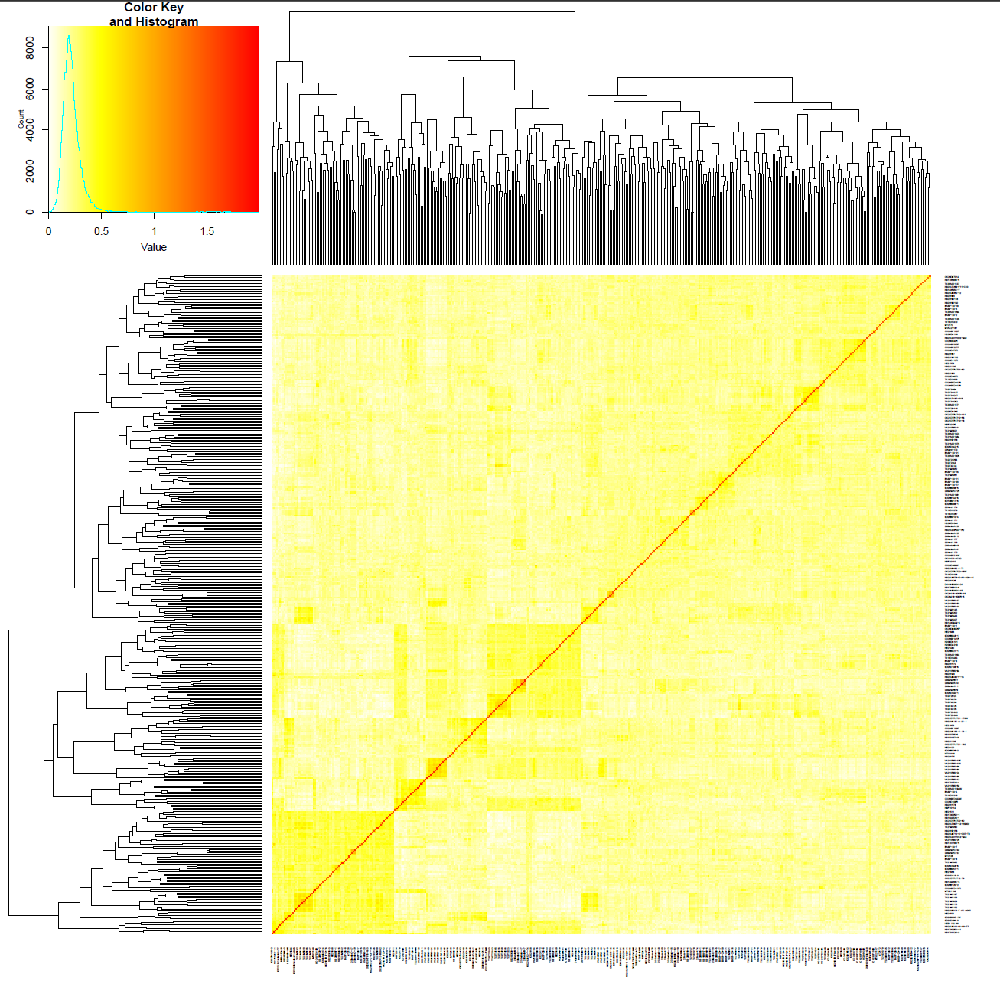
Supplementary Figure 1. Heatmap of the kinship matrix constructed from 15,368 high-quality SNP markers.
Red color indicate higher pairwise relatedness, whereas yellow color represent lower relatedness among genotypes. Hierarchical clustering dendrograms are shown along the top and left sides, illustrating the genetic relationships and grouping patterns among individuals. The color key and value distribution histogram are displayed in the upper-left corner.
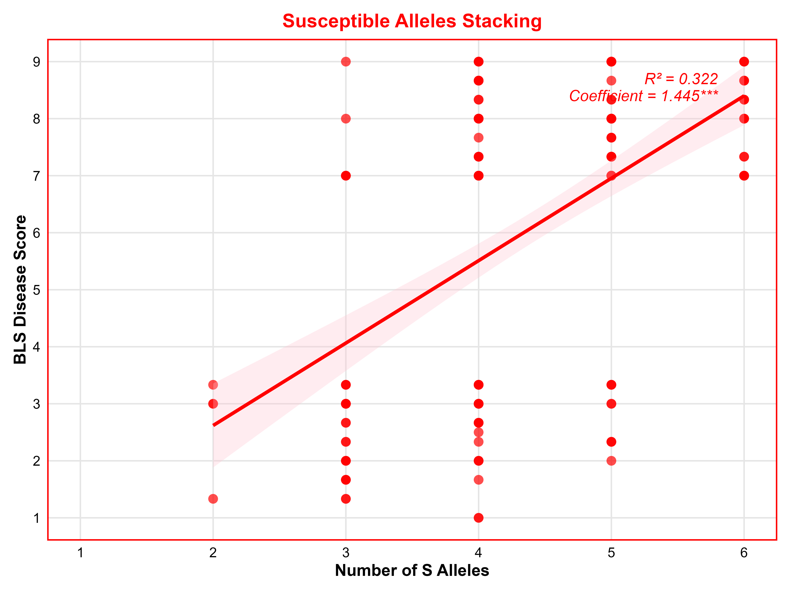
Supplementary Figure 2. Additive effects of identified MTAs on Bacterial Leaf Streak (BLS) disease severity. The x-axis depicts the number of Susceptible Loci and y-axis shows BLS disease severity on a scale of 1 to 9, where 1 is highly resistant and 9 is susceptible. The number of susceptible (S) alleles at the identified marker–trait associations (MTAs) showed clear additive effects on BLS disease score. Increasing S-allele was associated with increased disease severity, resulted in higher BLS scores. Lines indicate linear regression fit with 95% confidence intervals.

Supplementary Table 3: List of the highly resistant wheat breeding lines against bacterial leaf streak disease, with the corresponding favorable or resistant alleles at the significant MTAs detected in this study.
Resistance allele |  | TT | AA | CC | CC | AA | AA | GG
ID | BLS_score | S1B_372870844 | S2B_175365127 | S3B_625137880 | S3D_618866799 | S4A_440017300 | S4B_322341647 | S6B_548788571
TX21M5528 | 2 | TT | CC | TT | CC | TT | AA | GG
TX21M5629 | 1.667 | GG | CC | TT | GG | TT | AA | GG
CO200034R | 1.667 | TT | AA | TT | GG | TT | AA | GG
23SeniorA-48 | 2 | GG | AA | TT | GG | TT | AA | GG
KS22U6864-1H-1R-R2-A1 | 2 | GG | CC | TT | GG | AA | AA | GG
CO20SF227R | 1.333 | TT | AA | TT | GG | TT | AA | GG
TX21M5111 | 1 | TT | CC | TT | GG | TT | AA | GG
23SeniorC-36 | 1.667 | GG | AA | CC | GG | TT | AA | GG
TX21M5477 | 1.667 | TT | AA | TT | GG | TT | AA | GG
TX21M5440 | 1 | TT | CC | TT | GG | TT | AA | GG
22Nord-169 | 2.5 | GG | CC | CC | GG | TT | AA | GG
VA21HRW-39 | 2 | GG | CC | TT | GG | TT | AA | GG
CO20D068W | 2 | TT | CC | CC | GG | TT | AA | GG
CO20SF163R | 1.333 | GG | AA | CC | GG | TT | AA | GG
CO20D045R | 2 | TT | AA | TT | GG | TT | AA | GG
BASF-23-5 | 1.333 | GT | AA | TT | GG | TT | AA | GG
CO20D036R | 2.333 | TT | CC | TT | GG | TT | AA | GG

