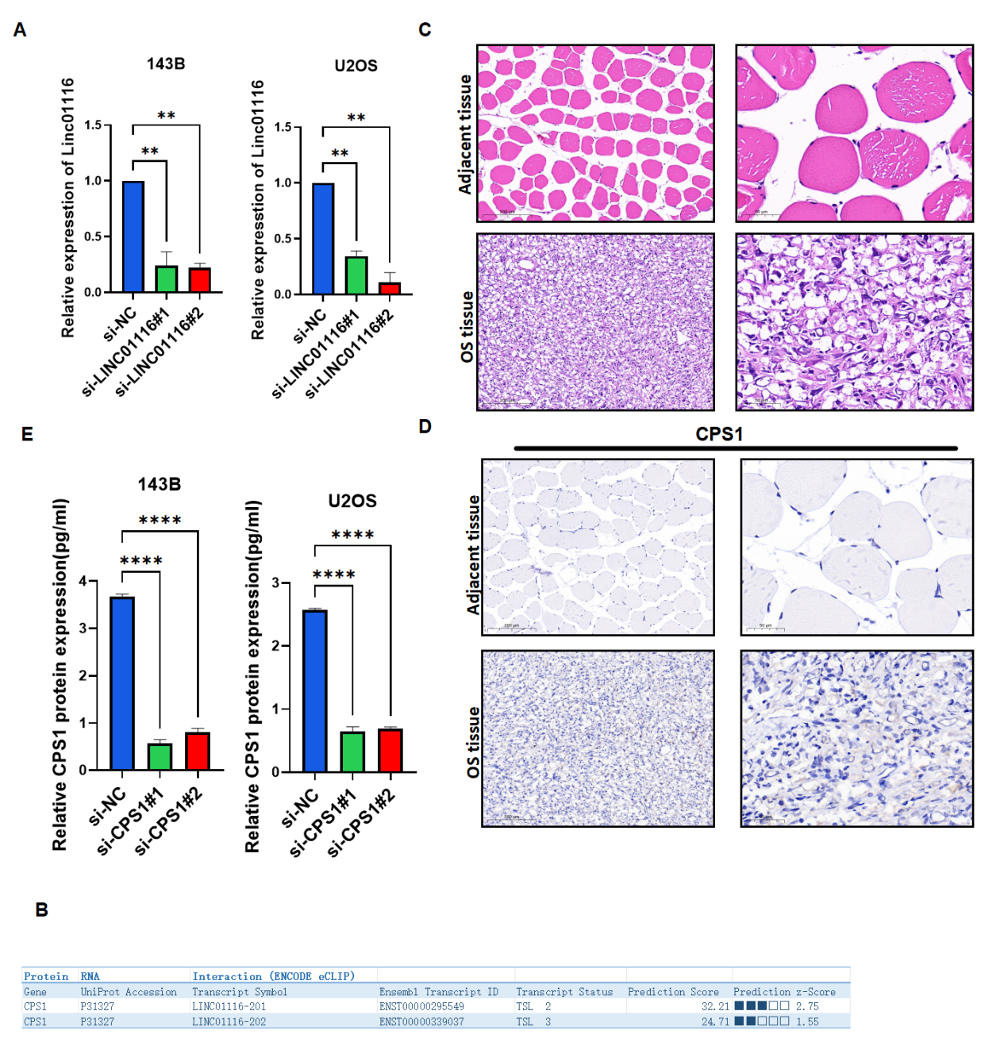

Figure S1 Validation of key experiments and bioinformatic prediction of LINC01116-CPS1 interaction
(A) LINC01116 siRNA knockdown efficiency in 143B and U2OS cells.(B) catRAPID prediction of LINC01116-CPS1 interaction.(C) H&E staining of osteosarcoma and adjacent non-tumor tissues.(D) CPS1 IHC staining of osteosarcoma and adjacent non-tumor tissues.(E) CPS1 siRNA knockdown efficiency in 143B and U2OS cells.

