Starch biotransformation by Lactococcus lactis: three strategies for process optimization
Valérie Laroute, Nathalie Aubry, Pauline Goodwin, Arthur Raymond, Sébastien Nouaille and Muriel Cocaign-Bousquet.

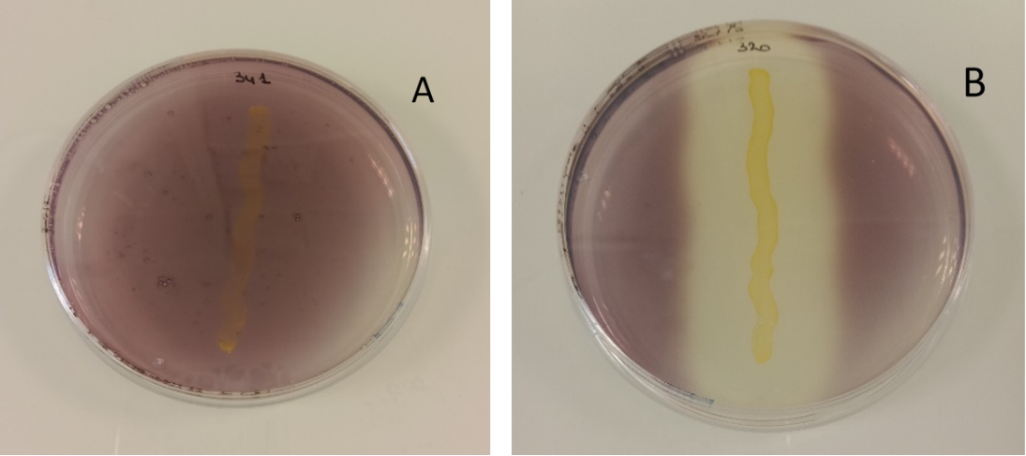
Figure S1: Visualisation of starch degrading activity. IL1403 (A) and IL1403amy+ (B) were striped on LB agar plates containing 0.2 % starch and 1 g/L glucose. After incubation for 72 h at 30°C plates were exposed to iodine staining to color starch. Clear zone indicates starch hydrolysis.

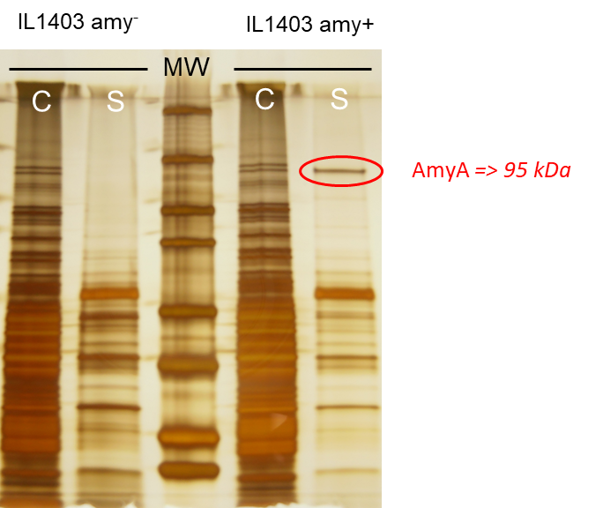
Figure S2: α-amylase secretion in IL1403amy+. SDS-PAGE gel of total proteins was stained with silver nitrate. MW molecular weight marker, C cell pellet, S supernatant fraction for IL1403amy⁻ and IL1403 amy+
From exponentially growing cultures, proteins present in cell and supernatant fractions were prepared as previously described (Nouaille et al. 2004, doi: 10.1128/AEM.70.3.1600-1607.2004) Electrophoresis conditions was performed in absence of β-mercaptoethanol with a 10 % running gel (acrylamide) and 5 % stacking gel. Gels were run at a constant 150 V for 1 h at 25°C. Proteins were stained by the silver method.

Table S1 : Phenotypic characterisation of 14 Lactococcus lactis strains. Genetic charactérisation (*) and hydrolysis casein determination were obtained from Couderc et al., 2022.
The culture of 14 L. lactis was performed in microplate to determine their ability to consume different carbon sources. Overnight cultures (from deepwell plates) in semi-synthetic medium [ glucose (2.5 g/L), yeast extract (YE) (10 g/L) KH₂PO₄ (9 g/L), K₂HPO₄ (7.5 g/L), MgSO₄ 7 H₂O (0.2 g/L), MnSO₄ (0.05 g/L)] grown at 30°C without shaking, were inoculated (1:6) in 200 µL of fresh medium for 3 hours (i.e. until it reached OD₅₈₀ = 0.6-0.8 corresponding to late-exponential phase cells). Inoculation for screening of different carbon sources was at 2.5% with cells from precultures harvested in new microplates containing 200 µL of semi-synthetic medium (initial pH = 6.6) supplemented with lactose, galactose, fructose, sucrose (5 g/L), glucose (1 g/L), maltose, maltotriose or isomaltose (5 g/L). Biomass was estimated hourly in the microplate without sampling for 24 hours by the measurement of OD₅₈₀ with microplate reader (SpectraMax Plus, Molecular Devices).

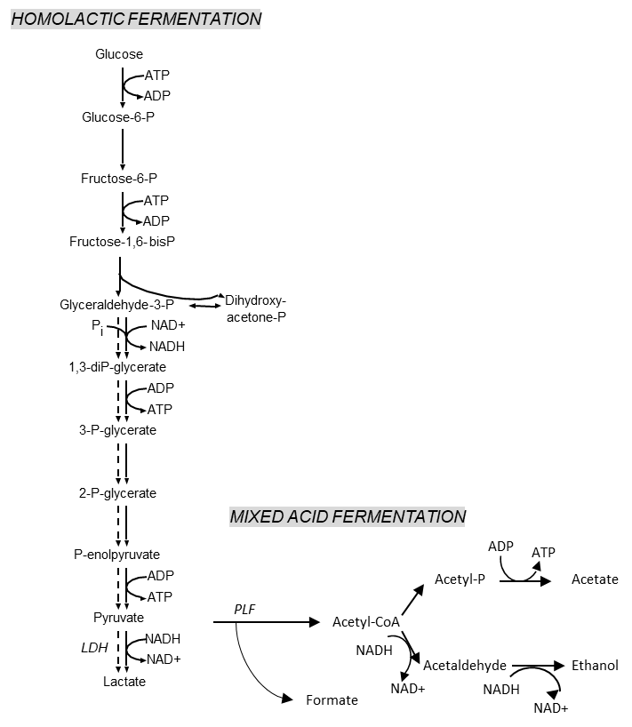
Figure S3: Simplified schema of the homolactic and mixed acid pathway in anaerobic glucose fermentation. LDH = lactate dehydrogenase, PFL = pyruvate formate lyase.

