Supporting Information

Integrated Endotoxin-adsorption and Antibacterial Properties of Platelet-membrane-coated Copper Silicate Hollow Microspheres for Wound Healing
Zaihui Peng¹, Xiaochun Zhang², Long Yuan¹, Yajie Chen³, Ting Li², Hao Tian¹, Dandan Ma¹, Jun Deng³*, Xiaowei Qi¹*, Xuntao Yin²*
- Department of Breast Surgery, Southwest Hospital, Army Medical University, Chongqing 400038, China
- Department of Radiology, Guangzhou Women and Children's Medical Center, Guangzhou Medical University, 510005, Guangzhou, China
- Institute of Burn Research, Southwest Hospital, State Key Lab of Trauma, Burn and Combined Injury, Chongqing Key Laboratory for Disease Proteomics, Army Medical University, 400038 Chongqing, China.
* Corresponding authors: X.T. Y. (xuntaoyin@gmail.com); XW. Q. (qxw9908@foxmail.com); J. D (djun.123@163.com).

Figure S1. (A)Nitrogen adsorption–desorption isotherm and (B)pore size distribution patterns of CSO@PM particles.
Figure S2. XRD pattern of CSO
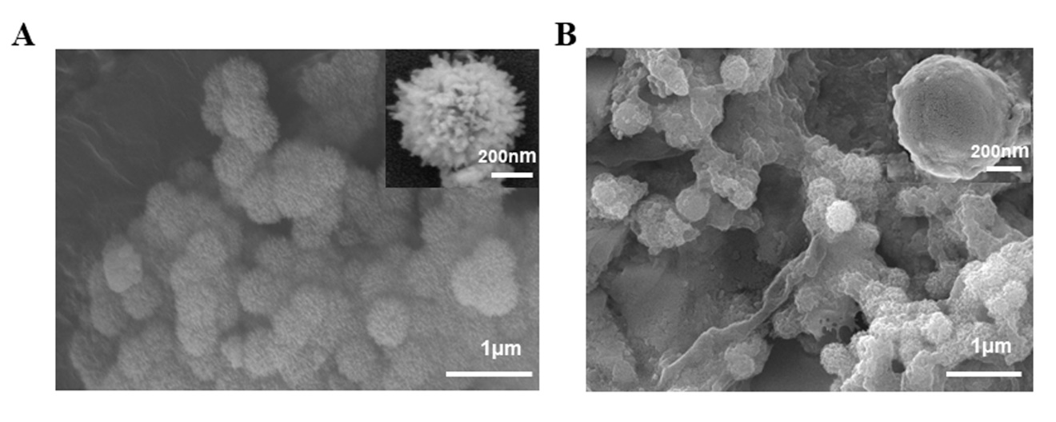
Figure S3. (A) SEM images showing the morphologies of CSO before and (B) after PLT membrane coating.

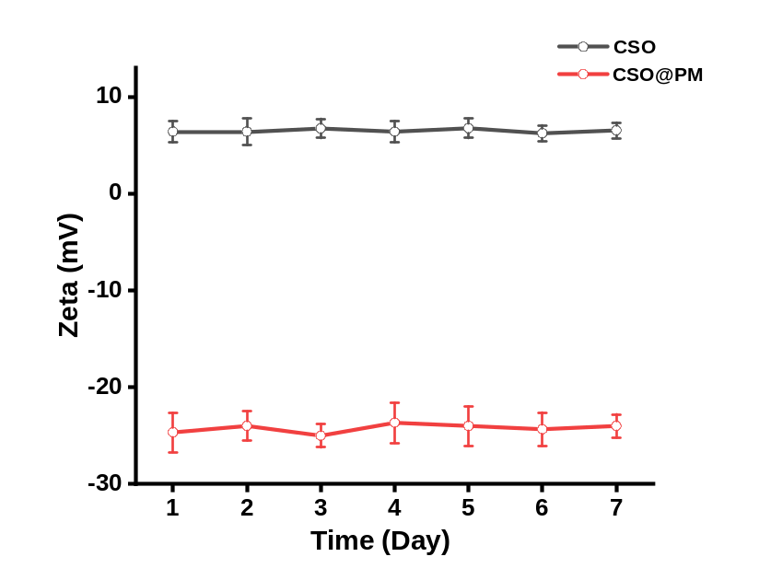
Figure S4. Change in zeta potential of bare CSO and CSO@PM in PBS for 7 days; n = 3.

Figure S5. (A)TEM images of the morphologies of CSO@PM in PBS at 7 days. (B) Change in hydrodynamic diameters of CSO@PM in PBS for 7 days. Data are mean ± SD (n = 3).
Figure S6. UV–vis–NIR spectra of different concentrations of CSO.

Figure S7. (A, B) EDS element maps and spectrum of P. aeruginosa treated with NPs upon laser in SEM observation indicating the element composition is O, Cu and Si
(insert table was mass percent of elements, bar = 2.5 μm, Cps/ev, counts per second
per electron-volt).

Figure S8. (A) Thermal infrared image of temperature evolution on dosed mice upon NIR laser irradiation (50 μg mL⁻¹, 1.5 W cm⁻²). (B) Temperature evolution profile of dosed mice upon NIR laser irradiation.
Figure S9. In vitro hemolysis test of CSO/CSO@PM. Data represent means ± SD (n=3).

Table S1. Primer sequences for qRT-PCR.
Gene | Forward (5’-3’) | Reverse (5’-3’)
Il-1β | CCTTTTGACAGGTCAGTGGGT | GATGAGTTGGGGACTCTCTGG
Il-6 | TCCTTCCTACCCCAATTTCCA | GCACTAGGTTTGCCGAGTAGA
Actin | TGCTGTCCCTGTATGCCTCTG | TGATGTCACGCACGATTTCC

