Supplementary Information
Wafer-scale waveguide-integrated graphene optoelectronic mixers
Shayan Parhizkar^{1,2,*}, Delphine Pommier^{3,*}, Emmanuel Baudin⁴, Stephan Suckow^{1,#}, Pierre Legagneux³, Max C. Lemme^{1,2,#}
¹AMO GmbH, Otto-Blumenthal-Str. 25, 52074 Aachen, Germany
²Chair of Electronic Devices, RWTH Aachen University, Otto-Blumenthal-Str. 2, 52074 Aachen, Germany
³Thales Research and Technology, Palaiseau 91767, France
⁴Laboratoire de Physique de l’Ecole Normale Superieure, ENS, Universite PSL, CNRS, Sorbonne Universite, Universite de Paris, 24 rue Lhomond, 75005 Paris, France
*These authors contributed equally to this work
#email: suckow@amo.de, max.lemme@eld.rwth-aachen.de

Supplementary Note 1: Graphene mobility and sheet resistance
A small graphene piece from the same graphene batch used for GOEM fabrication was transferred onto a 2×2 cm² Si substrate with a 90 nm thermally grown SiO₂ layer. Ti/Au (5 nm + 45 nm) was used to define the electrical contacts for the source and drain electrodes, while the Si substrate functioned as a global back gate. The field-effect mobility of graphene was extracted from four-probe field-effect measurements¹ by using $μ_{F}=\left(\frac{∂\left(\frac{I_{ds}}{V_{diff}}\right)}{∂V_{G}}\right)\frac{Lt_{ox}}{Wε_{r}ε_{0}}$ shown in Supplementary Figure 1a, where $I_{ds}$ is the drain-source current along the graphene channel, $V_{diff}$ is the voltage across the inner contacts, $V_{G}$ is the back gate voltage, L is the length of the channel between the inner contacts, $t_{ox}$ is the SiO₂ thickness, W is the channel width, $ε_{r}$ is the relative permittivity of SiO₂, and $ε_{0}$ is the vacuum permittivity. Direct measurement of the field-effect mobility on the GOEM wafer was not possible due to the lack of a gate to control the doping of graphene. However, since the GOEM and test sample were derived from the same batch of CVD-grown graphene, the mobility of the GOEM wafer cannot exceed the values obtained from the test structure. Sheet resistance was measured using four-probe test structures distributed across the entire wafer, as shown in Supplementary Figure 1b.
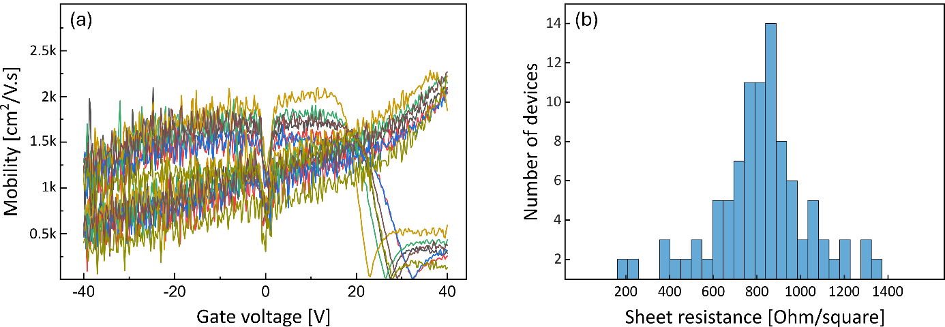
Supplementary Figure 1. (a) Field-effect mobility of graphene on the test sample of Si/SiO₂. (b) Histogram of the sheet resistance of graphene, measured across the entire wafer, with an average of 859 ± 156 Ω/square.

Supplementary Note 2: Optical input and PIC losses
The optical absorption of graphene and the losses associated with metal contacts in the vicinity of the waveguides were characterized using on-wafer optical transmission line structures.
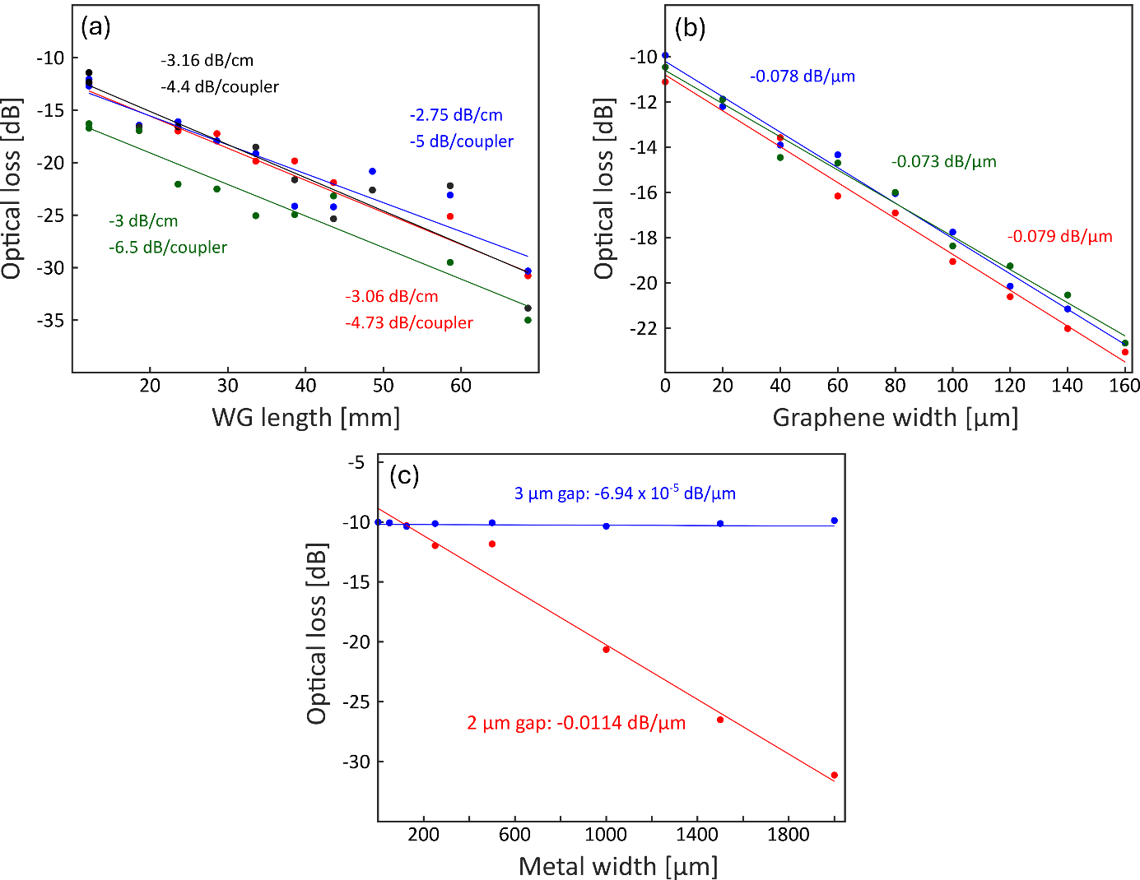
Supplementary Figure 2. (a) Optical losses as a function of optical waveguide length for various dies on the wafer. The average coupling loss is 5.16 dB per coupler, and the average propagation loss is 2.99 dB/cm. (b) Optical losses as a function of graphene width along the waveguide for various dies on the wafer. The average graphene absorption is 0.077 dB/µm. (c) Optical losses as a function of metal width along the waveguide, for channel lengths of 2 and 3 µm. The metal absorption for a 2 µm channel length is 1.14×10⁻² dB/µm, and 6.94×10⁻⁵ dB/µm for a length of 3 µm.

Supplementary Note 3: Raman spectra of graphene
Supplementary Figure 3a shows a representative Raman spectrum of graphene after transfer, exhibiting the characteristic G and 2D peaks of the film. Supplementary Figure 3b presents a histogram of the full width at half maximum (FWHM) of the 2D peak for several devices, measured both directly after transfer and after the complete fabrication process, with all data taken from the center of the GOEM on the waveguides (red circle in the SEM image shown in Supplementary Figure 3d). The 2D peak is known to be highly sensitive to strain variations in graphene, which can strongly affect carrier mobility.^{2–4} Strain variations arise from the initial quality of the graphene film, the roughness of the substrate, and the interactions between the graphene, the substrate, and the encapsulation layer. CVD-grown graphene and graphene encapsulated with amorphous oxides typically show FWHM values of the 2D peaks of 30 to 40 cm⁻¹. In our case, the majority was approximately at 35 cm⁻¹ after transfer, and shifted to values exceeding 40 cm⁻¹ after encapsulation, indicating higher strain and reduced mobility caused by the waveguide topography and the amorphous Al₂O₃ encapsulation layer. Further key parameters of the Raman spectra of graphene are the relative positions of the G and 2D peaks, which are sensitive to variations in both strain and doping.^{5,6} Supplementary Figure 3c shows the distributions of G and the 2D peak positions from a Raman map acquired after transfer (blue) and after complete fabrication (green). These results indicate that, in addition an increased strain, the Al₂O₃ encapsulation caused higher p-doping levels in the graphene layer.⁷ However, the doping of graphene is spatially inhomogeneous even within a single device. The green data points correspond to measurements from a single device, highlighted by the green rectangle in Supplementary Figure 3d.

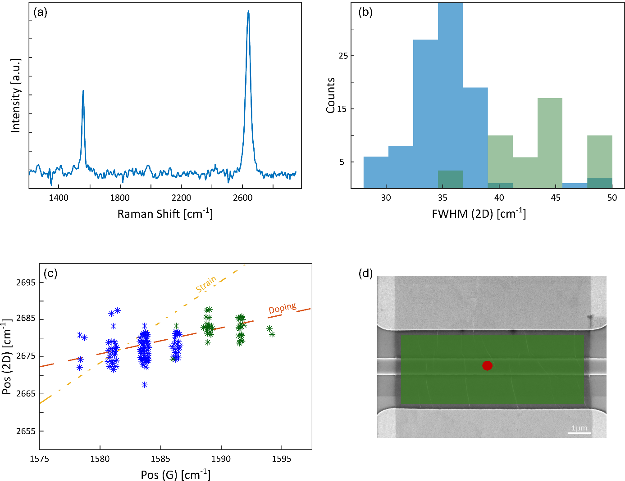
Supplementary Figure 3. (a) Representative Raman spectrum of graphene on a fabricated device. (b) Histogram of the FWHM of the 2D peaks extracted from Raman maps, measured immediately after transfer (blue) and following complete device fabrication (green). (C) 2D versus G peak positions recorded from a die of the wafer in a device region after transfer (blue) and from the graphene channel of a single device from the same die after full fabrication (green). The location of this channel map is indicated by the green rectangle in panel d. The data show an increase in p-doping after encapsulation, together with spatial variation in the doping levels within a single device. (d) SEM image of a device indicating the positions of Raman measurements. The red circle marks the location where the 2D FWHM values in panel b were acquired, and the green rectangle denotes the Raman map of a device channel corresponding to the data in panel c.

Supplementary Note 4: Optical power of the modulated laser light
The optical power from the laser was modulated at frequencies up to 67 GHz using a commercial Mach-Zender modulator (MZM). The optical system output was measured directly with an optical spectrum analyzer (OSA) to characterize the modulated optical power injected into the integrated optical waveguides.
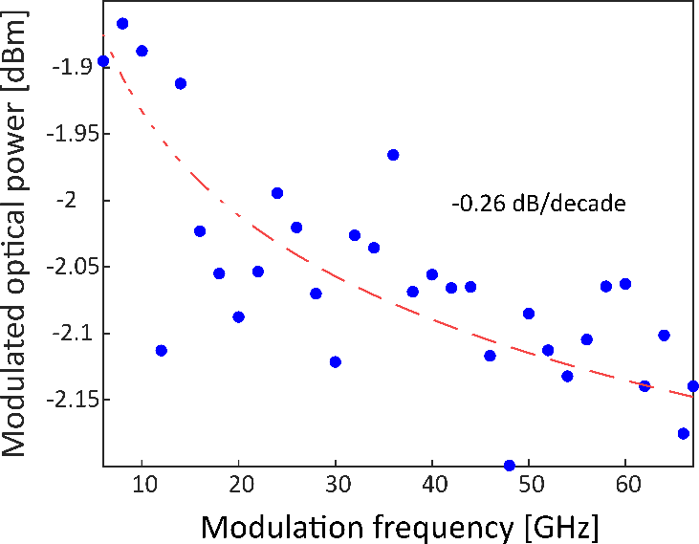
Supplementary Figure 4. Optical power of the modulated light versus the modulation frequency.

Supplementary Note 5: Photocurrent saturation with bias voltages
To understand the origin of the photocurrent nonlinearity presented in Fig. 3 of the main text, we analyze the channel current under dark conditions at low drain bias voltages (Supplementary Figure 5a). Following the approach introduced by Tharrault et al.,⁸ we expand the channel current (I_{ch}) up to third order in the channel voltage (V_{ch}) and introduce a characteristic saturation voltage V_{sat}, which is related to the saturation current through the linear channel conductance via $I_{ch}≈G_{ch}.V_{sat}$. This leads to the expression:
$$I_{ch}≃G_{ch}.V_{ch}\left(1-\frac{1}{2}{\left(\frac{V_{ch}}{V_{sat}}\right)}^{2}\right)$$
Where G_{ch} is the first order channel conductance. This simplified model neglects interband tunnelling and Dirac pinch-off effect (velocity saturation) in graphene at high biases.⁹ In practice, GOEMs operate at low bias voltages where these mechanisms are negligible, and the above expression provides an accurate description of the nonlinearity that gives rise to photocurrent saturation. This expression also reflects the fact that the channel current contains no second-order term in V_{ch}, consistent with the symmetry of the device configuration.
By differntiating the I-V curve, the onset of saturation becomes more apparent in the differential conductance (Supplementary Figure 5b). The conductance decreases with increasing $\left|V_{ch}\right|$. When working with differential conductance rather than the absolute channel current, the corresponding model takes the form:
$$\frac{∂I_{ch}}{∂V_{ch}}≃ V_{ch}\left(1-\frac{3}{2}{\left(\frac{V_{ch}}{V_{sat}}\right)}^{2}\right)$$
The main advantage of analyzing the differential conductance is that the saturation behavior becomes directly visible. Accordingly, we fit the differential conductance curve using the above model, obtaining excellent agreement with a saturation voltage of 3.1 V. For the photocurrent response, the above relations can be rewritten as:
$I_{ph}≃G_{ph}\frac{∂I_{ch}}{∂G_{ch}} ≃ G_{ph}V_{ch}\left(1-\frac{3}{2}{\left(\frac{V_{ch}}{V_{sat}}\right)}^{2}\right)$ where $G_{ph}=\frac{∂G_{ch}}{∂P_{opt}}P_{opt}$ is the photoconductance as a function of optical power (P_{opt}). Using the calculated saturation voltage of 3.1 V, the resulting model reproduces the nonlinear dependence of the GOEM photocurrent on the applied bias voltage (Supplementary Figure 5c). This confirms that the observed photocurrent nonlinearity arises solely from the intrinsic DC response of the GOEM channel.
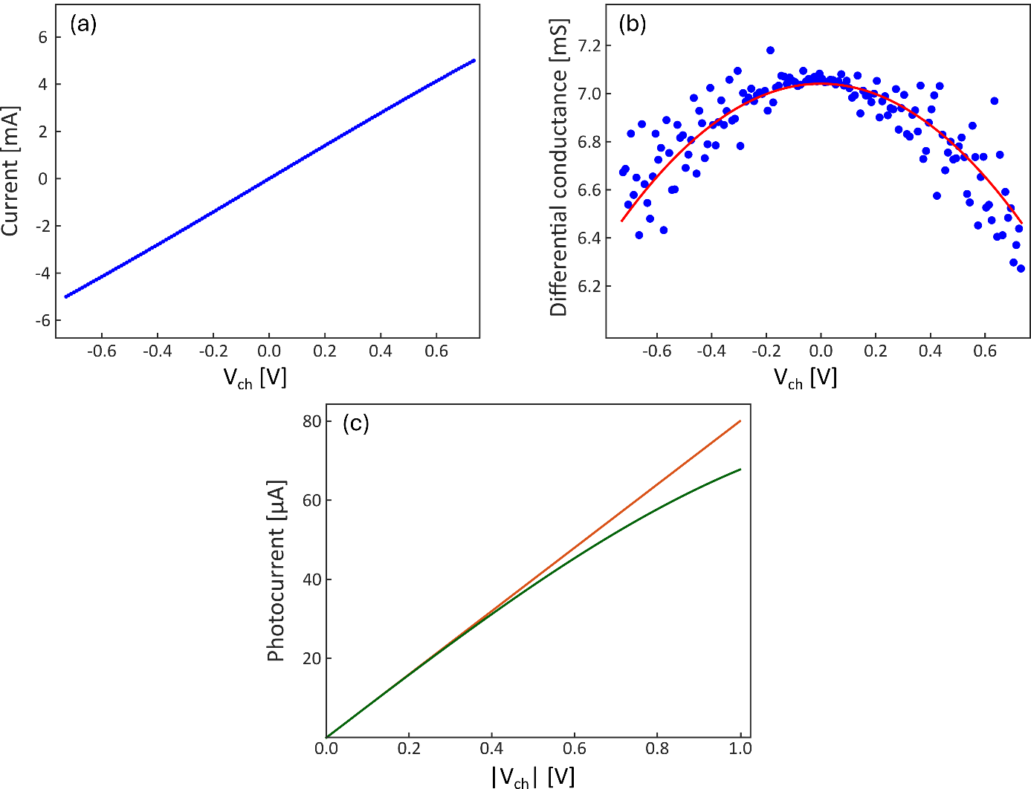
Supplementary Figure 5. (a) Current-voltage (I−V) curve of a representative GOEM in dark conditions. (b) Differential conductance extracted from I−V curve in panel a. It shows the gradual suppression of conductance with increasing voltage. The solid red line shows a fit to the third-order saturation model, yielding a saturation voltage of 3.1 V. (c) Photocurrent as a function of $\left|V_{ch}\right|$, showing nonlinearity originating from the intrinsic DC response of the GOEM channel. The green curve corresponds to the photocurrent predicted using the extracted saturation voltage of 3.1 V, while the orange line indicates the expected response for a purely linear device.

Supplementary Note 6: Statistical photodetection performance of GOEMs
The distribution of the photodetected power, averaged over the photodetection bandwidth of DC−37 GHz, is shown in Supplementary Figure 6. As the channel width increases from 10 to 40 μm, the photodetected power rises, consistent with the increased active area of the wider channels. However, increasing the width does not continuously improve the performance. Instead, the photodetected power saturates at around 40 μm despite the increase in total optical absorption.
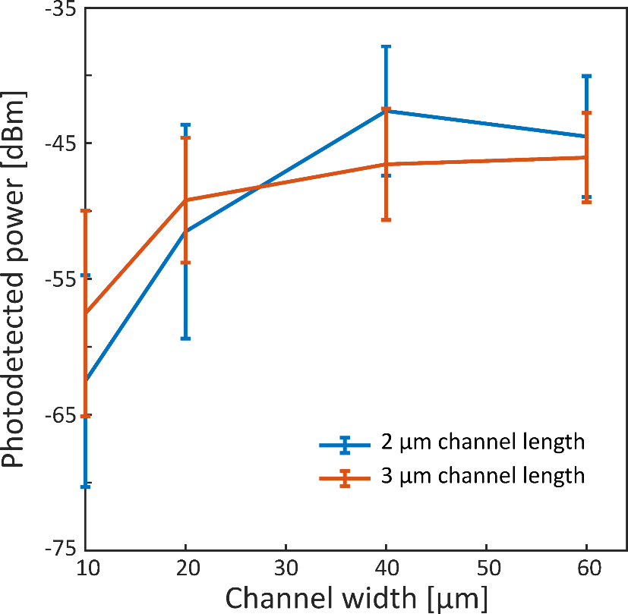
Supplementary Figure 6. Photodetected power averaged over the DC−37 GHz bandwidth for devices with channel lengths of 2 μm (blue) and 3 μm (red). Error bars indicate the standard deviation across all measured devices.

Supplementary Note 7: Optical loss versus channel width
We observed that the optical power attenuation in the graphene channel can reach up to 70% for a channel width of 60 µm, as shown in Supplementary Figure 7. The optical loss % was calculated relative to a reference measurement performed on a waveguide structure without any graphene. In addition to graphene absorption, the metal electrodes also contribute to the total channel loss, as shown in Supplementary Figure 7, where devices with L = 2 μm exhibit slightly higher losses than those with L = 3 μm. We attribute the sublinear behavior to spatial non-uniformities in the illumination of the graphene channel along the waveguide. The region near the optical input experiences higher LO power, while the other side receives weaker illumination due to absorption along the propagation path, leading to a corresponding variation in the local channel conductance. As discussed in the main text, this spatially varying illumination profile provides a consistent explanation for the reduction in mixing efficiency observed for channel widths exceeding 40 μm.
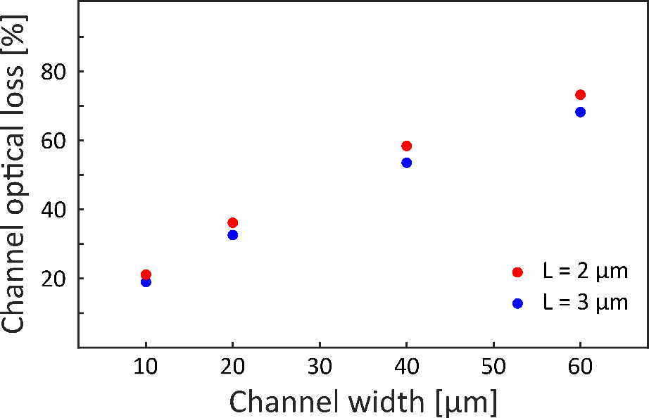
Supplementary Figure 7. Optical loss as a function of graphene channel width for two channel lengths.
Supplementary Note 8: Measurement setup
The measurement setup is shown schematically in Supplementary Figure 8, and a detailed description is provided in the Methods section of the main text.
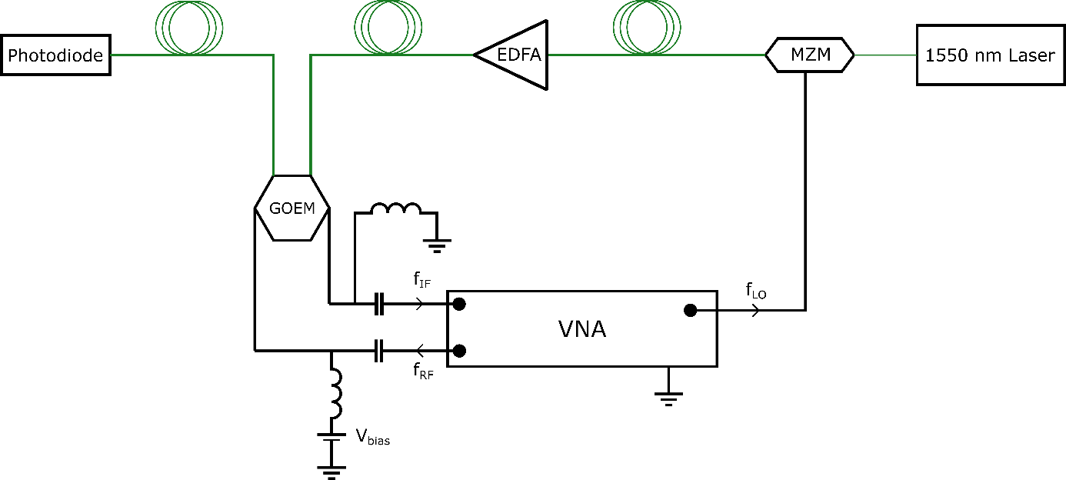
Supplementary Figure 8. Schematic diagram of the measurement setup. Green lines denote optical connections, and black lines indicate electrical connections.
References:
(1) Zhong, H.; Zhang, Z.; Xu, H.; Qiu, C.; Peng, L.-M. Comparison of Mobility Extraction Methods Based on Field-Effect Measurements for Graphene. AIP Advances 2015, 5 (5), 057136. https://doi.org/10.1063/1.4921400.
(2) Yamada, T.; Okigawa, Y.; Hasegawa, M.; Watanabe, K.; Taniguchi, T. Relationship between Mobility and Strain in CVD Graphene on H-BN. AIP Advances 2020, 10 (8), 085309. https://doi.org/10.1063/5.0019621.
(3) Canto, B.; Otto, M.; Powell, M. J.; Babenko, V.; O’Mahony, A.; Knoops, H. C. M.; Sundaram, R. S.; Hofmann, S.; Lemme, M. C.; Neumaier, D. Plasma-Enhanced Atomic Layer Deposition of Al2O3 on Graphene Using Monolayer hBN as Interfacial Layer. Advanced Materials Technologies 2021, 6 (11), 2100489. https://doi.org/10.1002/admt.202100489.
(4) Couto, N. J. G.; Costanzo, D.; Engels, S.; Ki, D.-K.; Watanabe, K.; Taniguchi, T.; Stampfer, C.; Guinea, F.; Morpurgo, A. F. Random Strain Fluctuations as Dominant Disorder Source for High-Quality On-Substrate Graphene Devices. Phys. Rev. X 2014, 4 (4), 041019. https://doi.org/10.1103/PhysRevX.4.041019.
(5) Tyagi, A.; Mišeikis, V.; Martini, L.; Forti, S.; Mishra, N.; M. Gebeyehu, Z.; A. Giambra, M.; Zribi, J.; Frégnaux, M.; Aureau, D.; Romagnoli, M.; Beltram, F.; Coletti, C. Ultra-Clean High-Mobility Graphene on Technologically Relevant Substrates. Nanoscale 2022, 14 (6), 2167–2176. https://doi.org/10.1039/D1NR05904A.
(6) Neumann, C.; Reichardt, S.; Venezuela, P.; Drögeler, M.; Banszerus, L.; Schmitz, M.; Watanabe, K.; Taniguchi, T.; Mauri, F.; Beschoten, B.; Rotkin, S. V.; Stampfer, C. Raman Spectroscopy as Probe of Nanometre-Scale Strain Variations in Graphene. Nat Commun 2015, 6 (1), 8429. https://doi.org/10.1038/ncomms9429.
(7) Das, A.; Pisana, S.; Chakraborty, B.; Piscanec, S.; Saha, S. K.; Waghmare, U. V.; Novoselov, K. S.; Krishnamurthy, H. R.; Geim, A. K.; Ferrari, A. C.; Sood, A. K. Monitoring Dopants by Raman Scattering in an Electrochemically Top-Gated Graphene Transistor. Nature Nanotech 2008, 3 (4), 210–215. https://doi.org/10.1038/nnano.2008.67.
(8) Tharrault, M.; Grimaldi, E.; Pommier, D.; Hamidouche, L.; Berger, P.; Combrie, S.; Baili, G.; Rostischer, M.; Taniguchi, T.; Watanabe, K.; Plaçais, B.; Baudin, E.; Legagneux, P. High-Speed Optoelectronic Graphene Sampler at 1.55 Μm Reaching Intrinsic Performances. Advanced Electronic Materials 2023, 9 (10), 2300260. https://doi.org/10.1002/aelm.202300260.
(9) Wilmart, Q.; Boukhicha, M.; Graef, H.; Mele, D.; Palomo, J.; Rosticher, M.; Taniguchi, T.; Watanabe, K.; Bouchiat, V.; Baudin, E.; Berroir, J.-M.; Bocquillon, E.; Fève, G.; Pallecchi, E.; Plaçais, B. High-Frequency Limits of Graphene Field-Effect Transistors with Velocity Saturation. Applied Sciences 2020, 10 (2), 446. https://doi.org/10.3390/app10020446.

