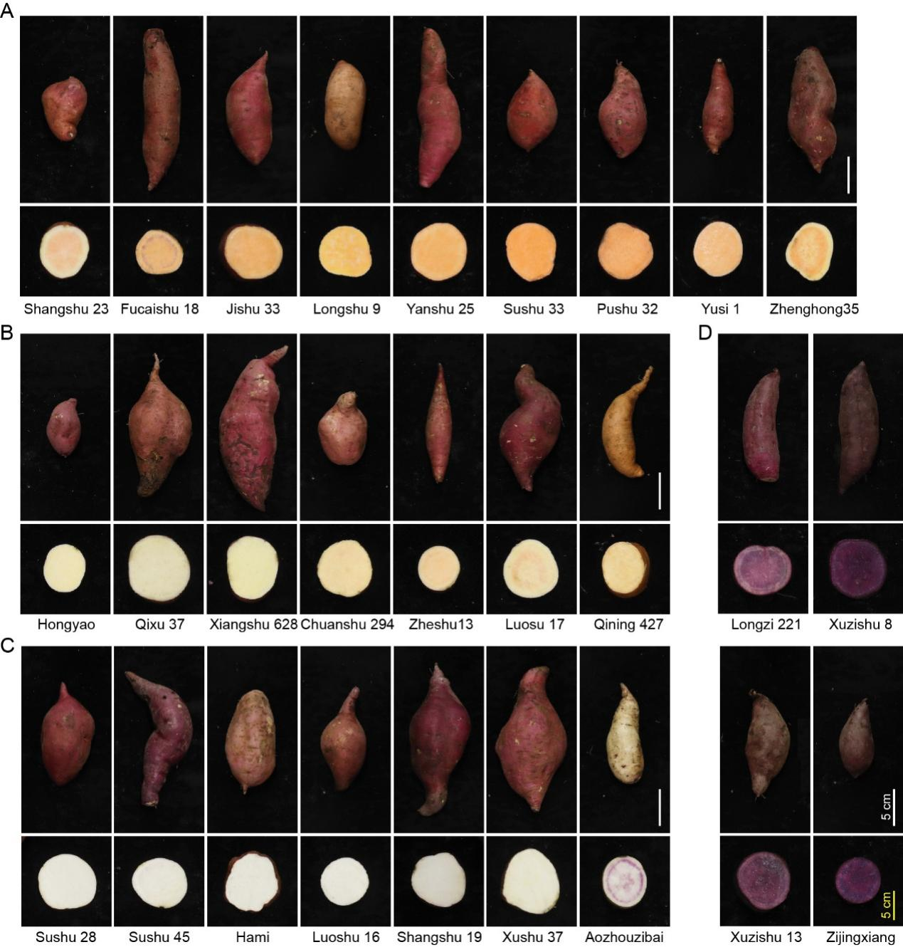
Supplemental Fig. S1 Phenotypes of the hybrid sweet potato population used in this study. Representative images of whole tubers and their corresponding cross-sections from the four flesh-color groups are shown: A orange-red (n=9), B yellow (n=7), C white (n=7), and D purple (n=4). Scale bar, 5 cm.
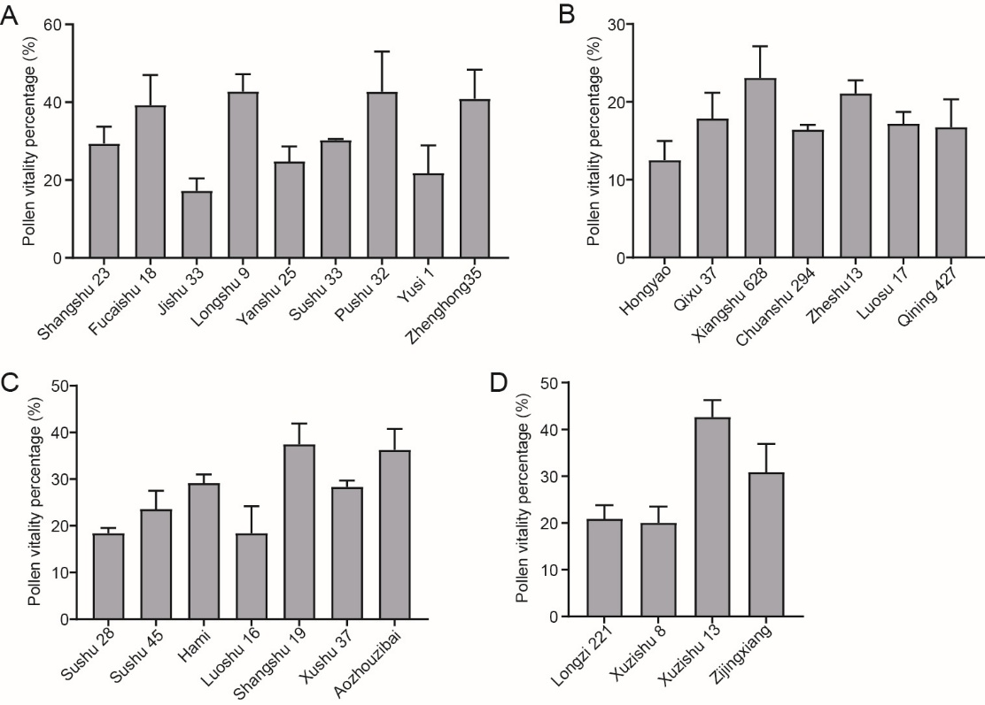
Supplemental Fig. S2 Assessment of pollen viability across the 27 hybrid sweet potato accessions. A Orange-red sweet potato varieties. B Yellow sweet potato varieties. C White sweet potato varieties. D Purple sweet potato varieties. Data points represent individual measurements, with the mean ± SD indicated. n = 3.
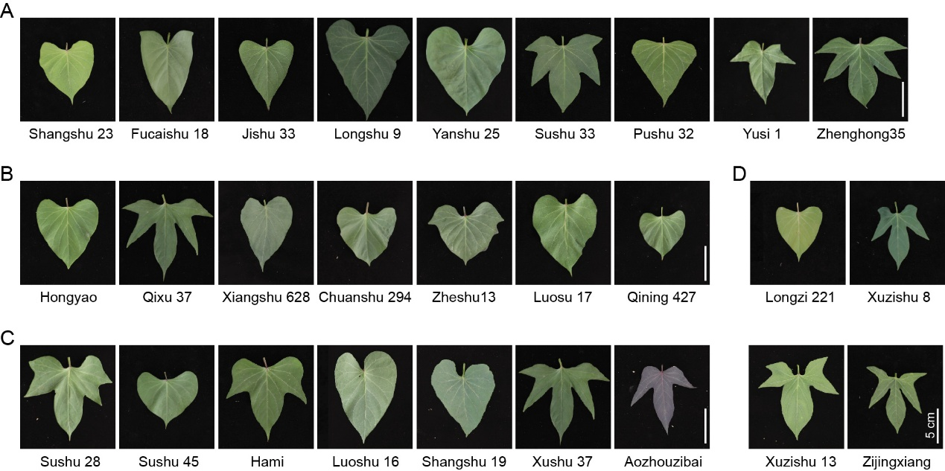
Supplemental Fig. S3 Diversity in leaf morphology observed in the hybrid sweet potato population. A Orange-red sweet potato varieties. B Yellow sweet potato varieties. C White sweet potato varieties. D Purple sweet potato varieties. Representative leaves from selected accessions are shown. Scale bar, 5 cm.
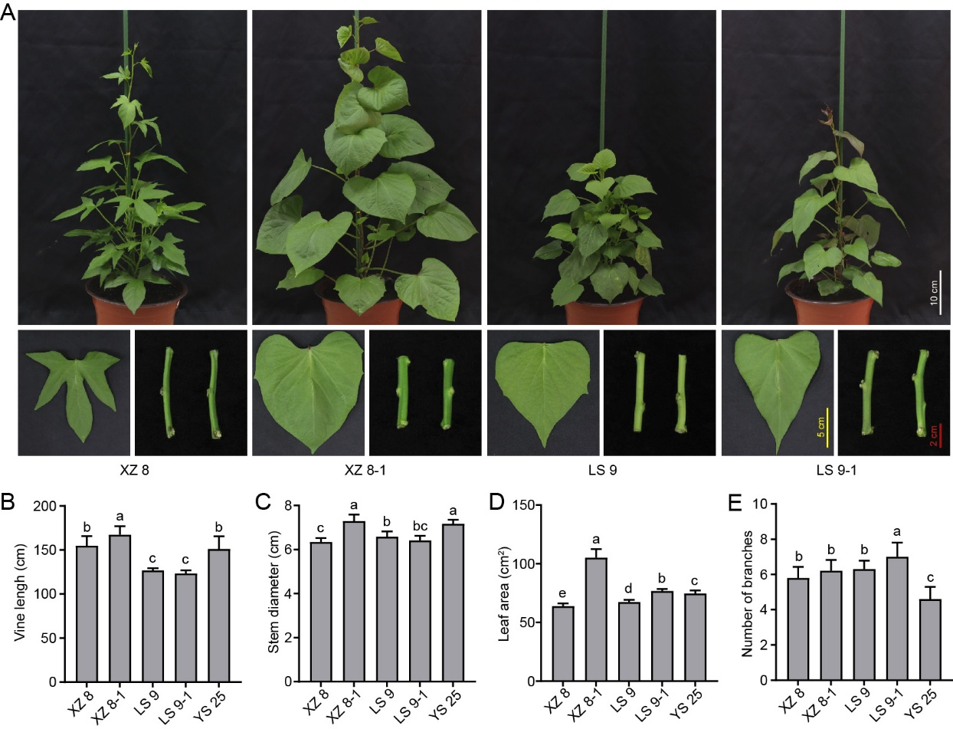
Supplemental Fig. S4 Vegetative growth characteristics of sweet potato varieties XZ 8-1 and LS 9-1. A Representative images. B Vine length. C Stem diameter. D Leaf area. E Branch number. Measurements were taken at the peak vegetative growth stage. Data represent mean ± SD (n = 10). Different letters above bars denote significant differences among genotypes (p < 0.05).

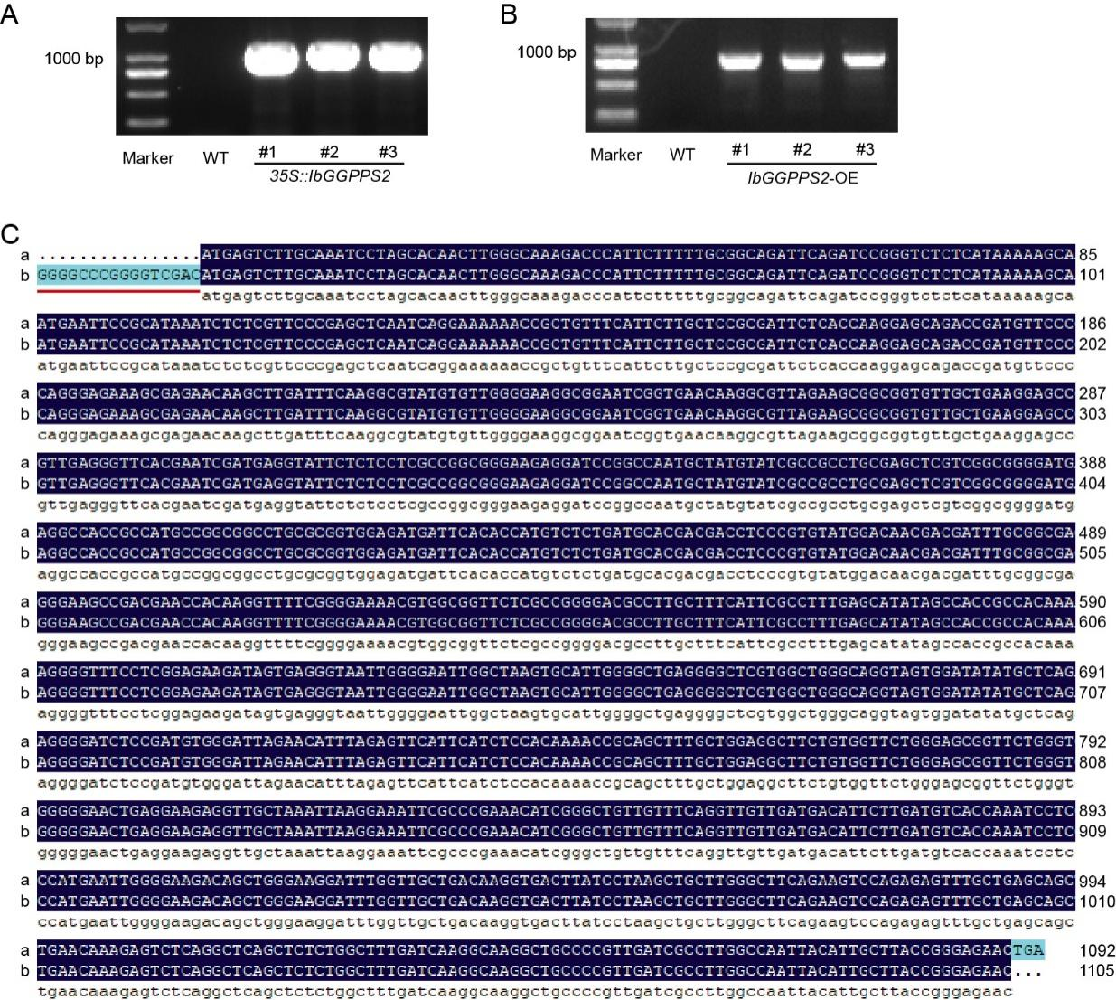
Supplemental Fig. S5 Molecular characterization of transgenic plants overexpressing IbGGPPS2. A Transgene amplification from transgenic 35S::IbGGPPS2 Arabidopsis genomic DNA. B Transgene amplification from transgenic IbGGPPS2-OE sweet potato genomic DNA. C The PCR amplification products and sequencing results of the CDS of IbGGPPS2 with partial vector site in IbGGPPS2-OE plants. “a” represents CDS of IbGGPPS2 from Taizhong 6 genome database (http:// sweetpotao.com). “b” represents sequencing results of the CDS of IbGGPPS2 with partial vector site in IbGGPPS2-OE plants. The sequence marked with a red underline is from 35S of overexpression vector.
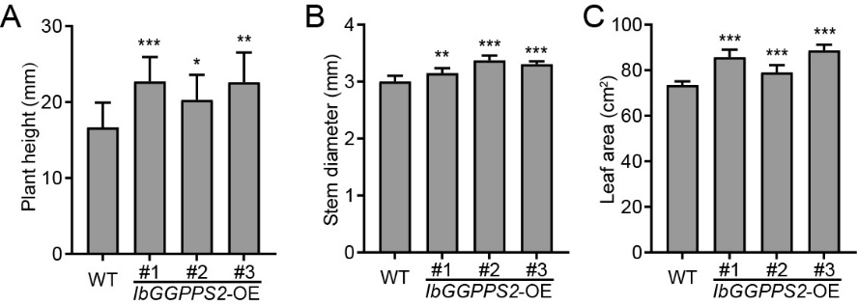
Supplemental Fig. S6 Plant growth and morphological traits of 20-day-old WT and IbGGPPS2-OE sweet potato seedlings: A plant height, B stem diameter, C leaf area. n = 10.

