Figure S1. The swelling and degradation properties of hydrogels in PBS at 37 ℃

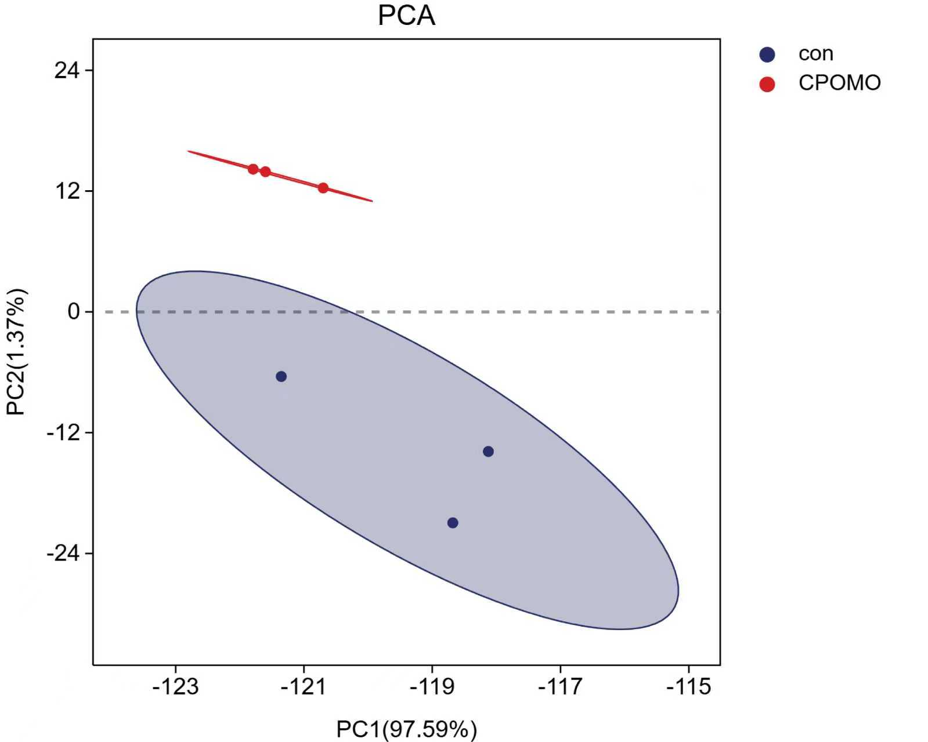
Figure S2. PCA detection of samples between the two groups.

