Title:
Microbial Metabolic Configuration Reweights Plant Growth–Defense Regulatory Networks in Nicotiana benthamiana

Journal:
Plant Growth Regulation

Authors:
Seung-A Kim^{1†}, Jihyun F. Kim², Soohyun Oh¹, Beom Seok Kim³, Eui-Hwan Chung³, Seungill Kim¹, and Sun-Hyung Kim^{1,*}

Corresponding author: Sun-Hyung Kim. Adress: Department of Environmental Horticulture, University of Seoul, Seoul 02504, Republic of Korea. E-mail address: pgel2006@gmail.com

Supporting Information:
Table S1. Primers used for qRT-PCR analysis.
Table S2. Raw gene counts per treatment in Nicotiana benthamiana
Table S3. DESeq2 differentially expression results for Nicotiana benthamiana transcriptomes
Table S4. KEGG pathway and functional classification of Nicotiana benthamiana transcriptomes using eggNOG-mapper
Table S5. Gene Ontology (GO) functional annotation of Nicotiana benthamiana transcriptomes based on InterProScan
Figure S1. Variation in survival of Bacillus subtilis JS as a function of UV-C irradiation time
Figure S2. Promotion of lateral root development in Nicotiana benthamiana by Bacillus subtilis strains.
Figure S3. Broad-spectrum antifungal activity of JS and MT
Figure S4. Qualitative GC–MS profiling of volatile organic compounds emitted from bacterial culture broths
Figure S5. Top 10 GO enrichments in JS vs. Mock and MT vs. Mock comparisons
Figure S6. KEGG Pathway Analysis of MT vs. JS
Figure S7. Heatmap of selected genes of interest related to hormones and secondary metabolites

Figure S1. Variation in survival of Bacillus subtilis JS as a function of UV-C irradiation time

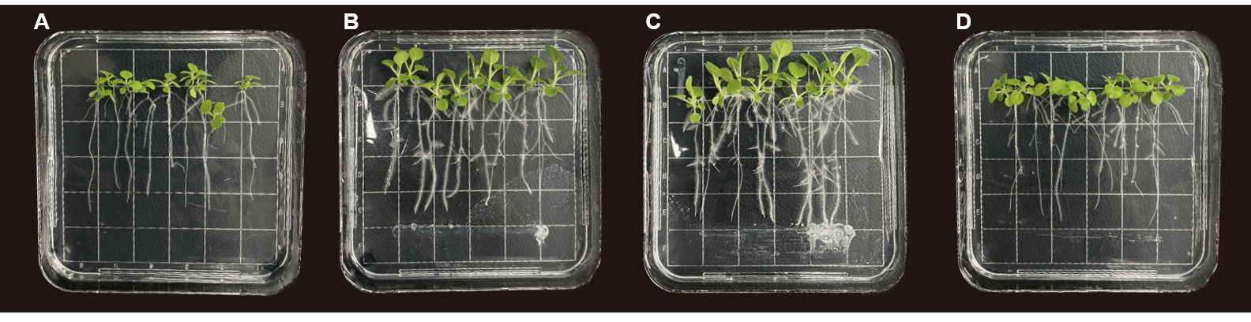
Figure S2. Promotion of lateral root development in Nicotiana benthamiana by Bacillus subtilis strains. Representative images showing root system architecture of N. benthamiana seedlings under different bacterial treatments: A, Mock; B, JS; C, MT; D, EC. Compared with Mock and EC, seedlings exposed to JS and MT exhibited a pronounced increase in lateral root formation, characterized by higher branching density and altered root system architecture, while primary root elongation was less affected

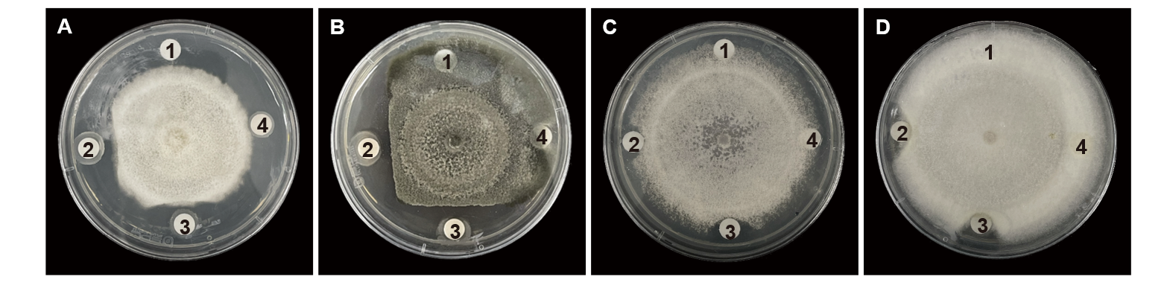
Figure S3. Broad-spectrum antifungal activity of JS and MT. Antifungal assays showing the inhibitory effects of bacterial treatments on the mycelial growth of major phytopathogenic fungi: A, Colletotrichum scovillei; B, Alternaria alternata; C, Fusarium oxysporum; D, Fusarium solani. Fungal colonies were co-cultivated with bacterial treatments positioned at fixed locations on the plate: 1, Mock; 2, JS; 3, MT; 4, EC. Both JS and MT markedly suppressed radial mycelial expansion compared with Mock and EC, whereas no apparent difference in antifungal efficacy was observed between JS and MT.

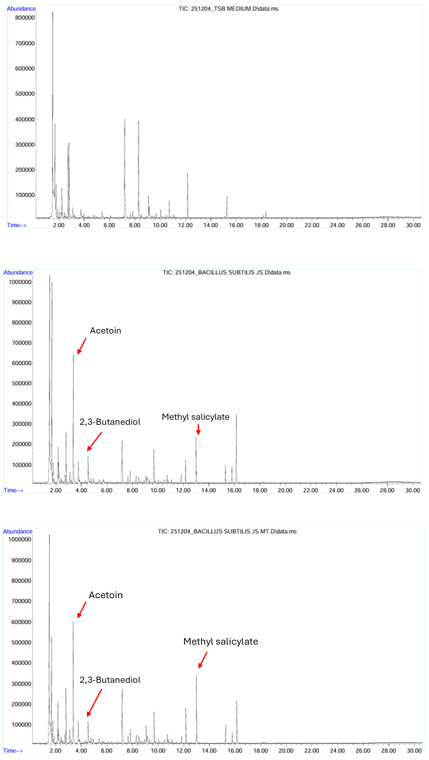
Figure S4. Qualitative GC–MS profiling of volatile organic compounds emitted from bacterial culture broths. Total ion chromatograms obtained by gas chromatography–mass spectrometry (GC–MS) analysis of volatile organic compounds (VOCs) collected from culture broths of the indicated bacterial treatments. The upper panel shows the total ion chromatograms of uninoculated TSB medium (Mock), while the middle and lower panels represent VOC profiles from Bacillus subtilis JS and the JS mutant strains, respectively. Several prominent peaks were specifically detected in bacterial cultures but were absent or markedly reduced in the medium control, including acetoin, 2,3-butanediol, and methyl salicylate, as tentatively identified by mass spectral library matching. The analysis was qualitative, and compound identities were not further validated using authentic standards or quantitative measurements.

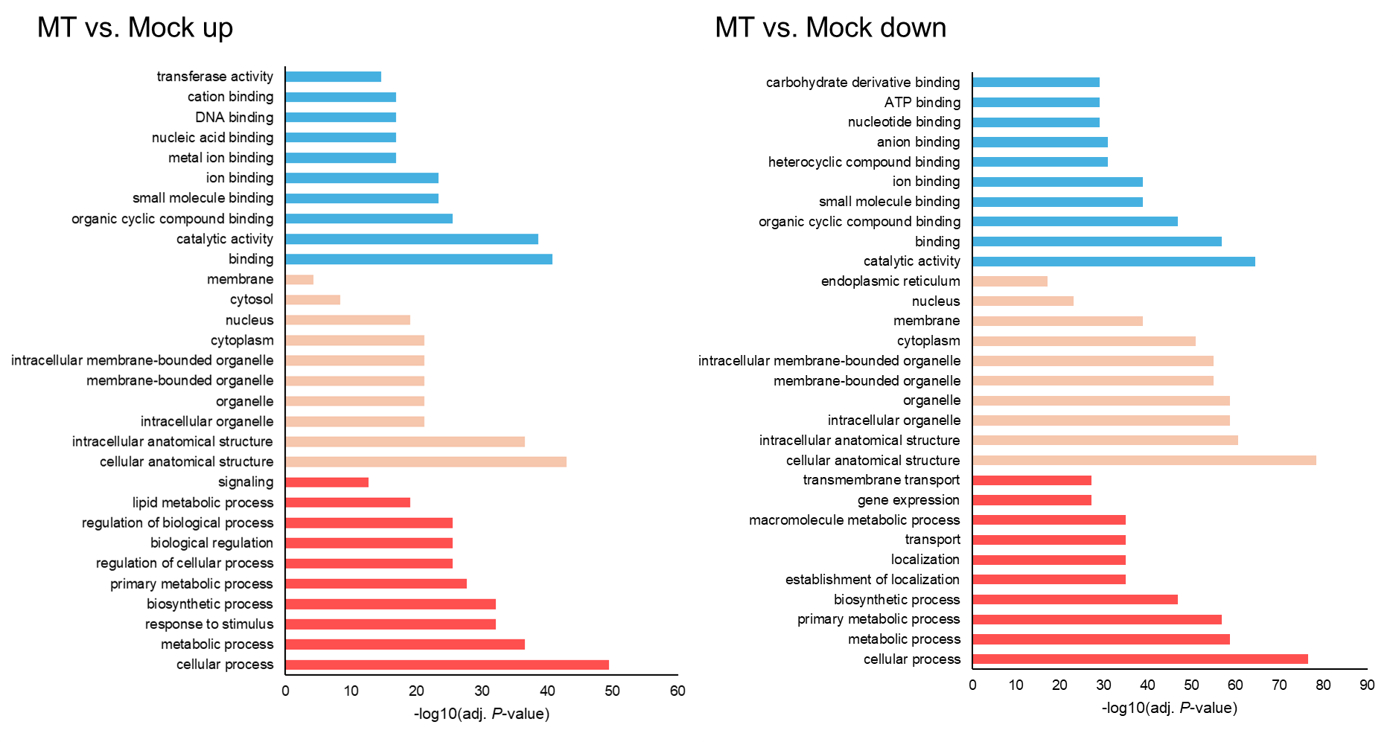
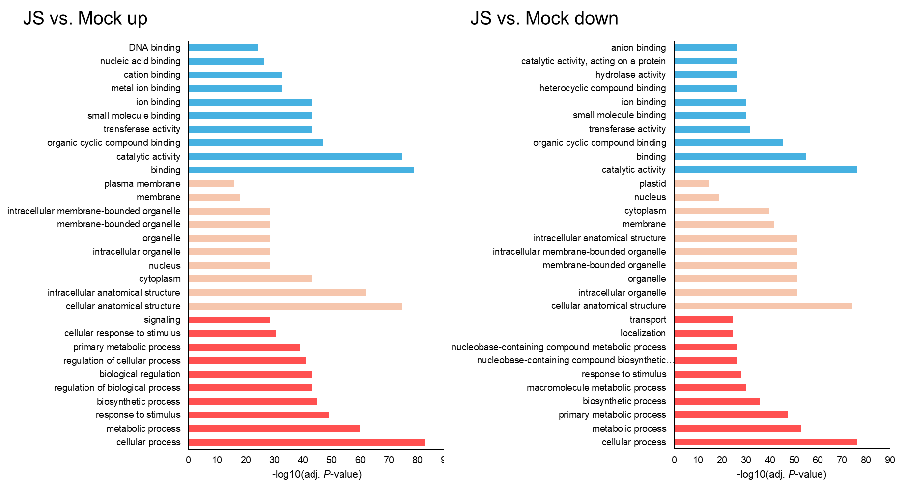
Figure S5. Top 10 GO enrichments in JS vs. Mock and MT vs. Mock comparisons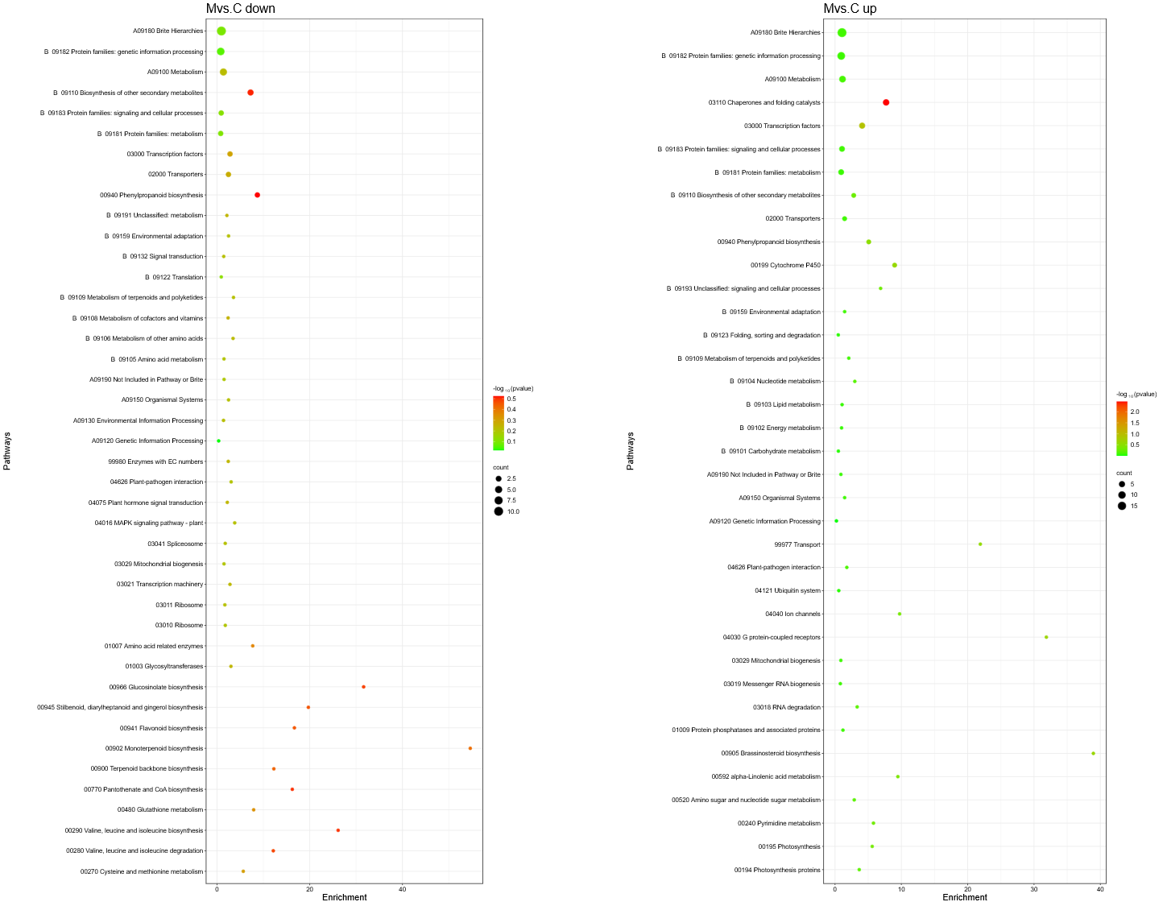
Figure S6. KEGG Pathway Analysis of MT vs. JS (Statistical Significance Not Considered)
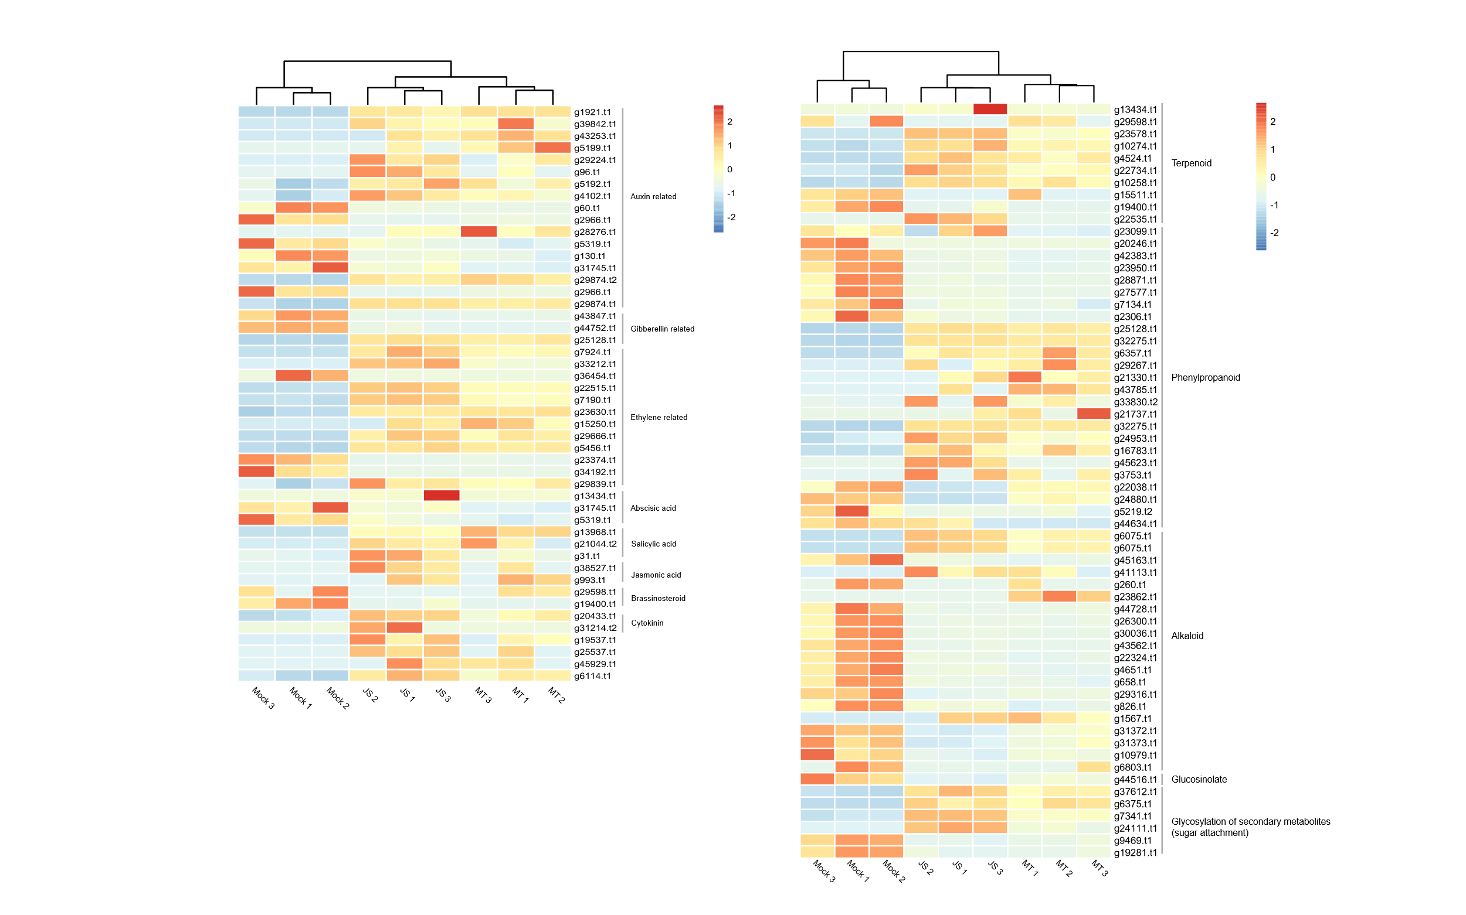
Figure S7. Heatmap of selected genes of interest related to hormones and secondary metabolites

