Appendices
Appendix 1 – Search Strategy

Medline

# | Query | Results from 15 Oct 2024
1 | exp Students, Medical/ | 46,719
2 | medical student*.mp. | 58,472
3 | exp Education, Medical, Undergraduate/ or undergraduate medical student*.mp. | 29,939
4 | exp Schools, Medical/ | 28,579
5 | 1 or 2 or 3 or 4 | 106,918
6 | "service learning".mp. | 1,530
7 | exp Student Run Clinic/ | 196
8 | student led clinic*.mp. | 74
9 | 6 or 7 or 8 | 1,786
10 | 5 and 9 | 356
11 | exp Educational Measurement/ | 171,865
12 | impact*.mp. | 1,833,461
13 | benefi*.mp. | 1,440,220
14 | drawback*.mp. | 44,230
15 | outcome*.mp. | 3,481,200
16 | experienc*.mp. | 1,556,224
17 | 11 or 12 or 13 or 14 or 15 or 16 | 6,947,383
18 | 10 and 17 | 256

Embase

'outcome assessment' closest to 'educational measurement' as search term
exploded 'experience' to cover this

1 exp medical student/ 101002
2 medical student*.mp. 118876
3 undergraduate medical student*.mp. 3804
4 exp medical school/ 79509
5 1 or 2 or 3 or 4 175962
6 "service learning".mp. 1732
7 exp student-run clinic/ 369
8 student led clinic*.mp. 85
9 6 or 7 or 8 2143
10 5 and 9 459
11 exp outcome assessment/ 934668
12 impact*.mp. 2546678
13 benefi*.mp. 1986943
14 drawback*.mp. 54457
15 outcome*.mp. 4893243
16 exp experience/ 43815
17 11 or 12 or 13 or 14 or 15 or 16 8152940
18 9 and 10 and 17 246

Web of science

Subject headings adapted to compensate for lack of mesh headings. Filtered by date retrospectively - 299 when limited to past 10 years.

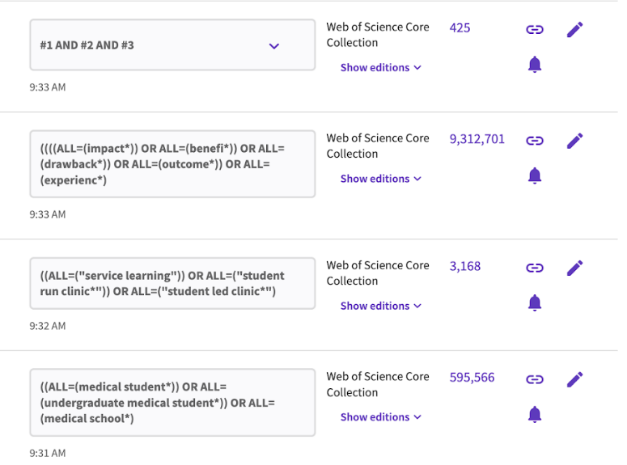

Pubmed

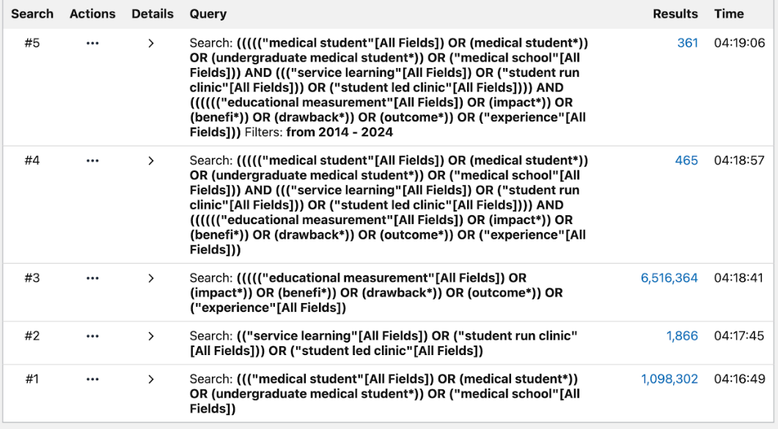
Education research complete

