Microfibrillated cellulose prepared by electron beam irradiated pre-treatment – a comparison of various influencing factors with regard to material and process
Johanna Fischer, Michael Thomas Müller, Katrin Thümmler, Björn Günther, Daria Mikhailova, Steffen Fischer

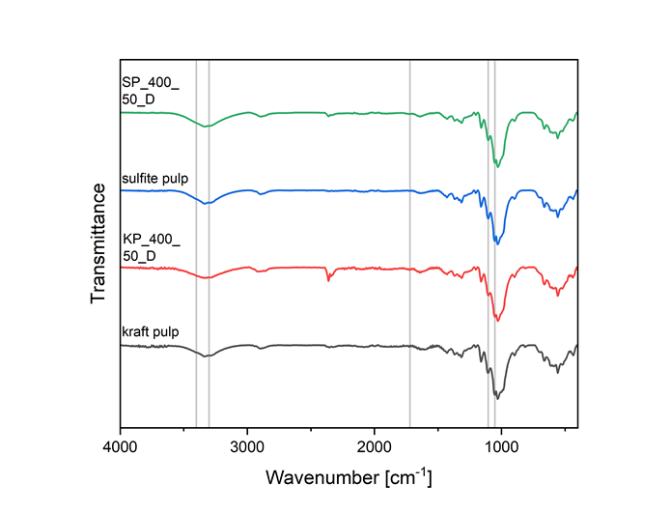
Figure S1 IR spectra of irradiated and non-irradiated kraft and sulfite pulp samples
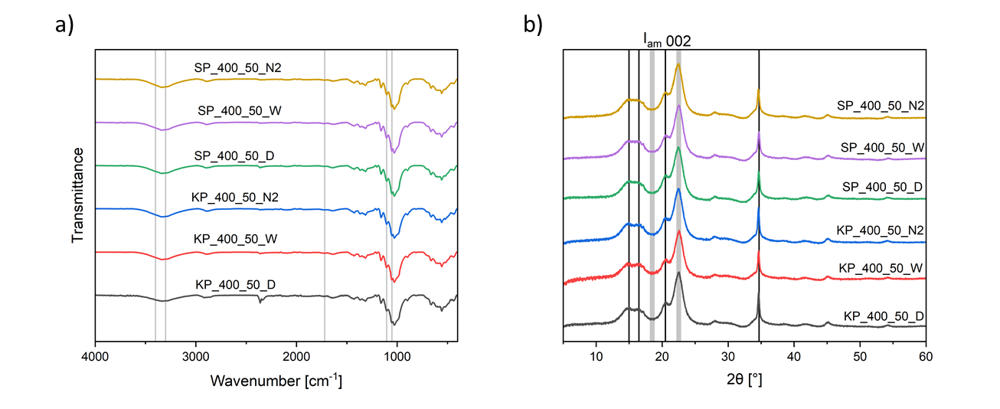
Figure S2 a) IR spectra and b) X-ray diffraction patterns of irradiated kraft and pulp samples under different conditions (dose: 400 kGy, dose rate: 1.41 kGy s⁻¹)
Table S1 Comparison of the values for the Fibre Width measured using the Fibre Tester and the d50-values of the particle size meausrements for SP_400_50_D
Dose [kGy] | Fibre Width (Fibre Tester) [µm] | d50 (Particle size measurement) [µm]
100 | 23.1 | 24.9
400 | 28.7 | 28.7

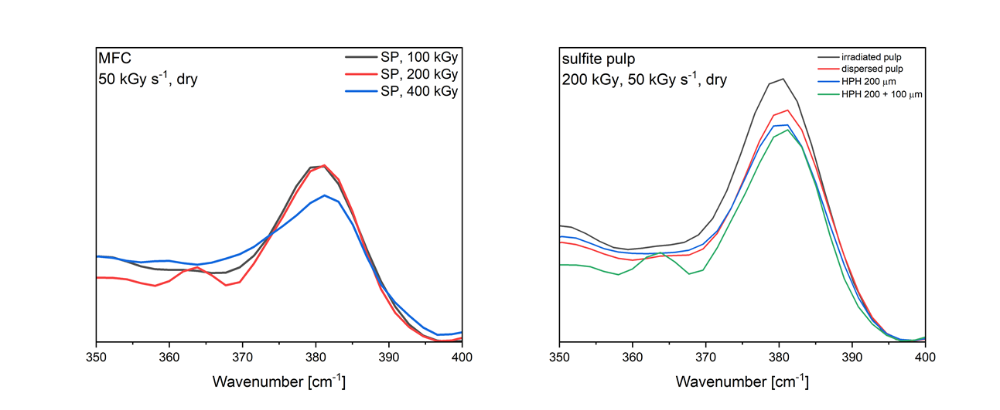
Figure S3 Raman spectra for a) MFCs prepared from irradiated sulfite pulp at different dose and b) irradiated sulfite pulp and different steps in the MFC preparation process for SP_200_50_D

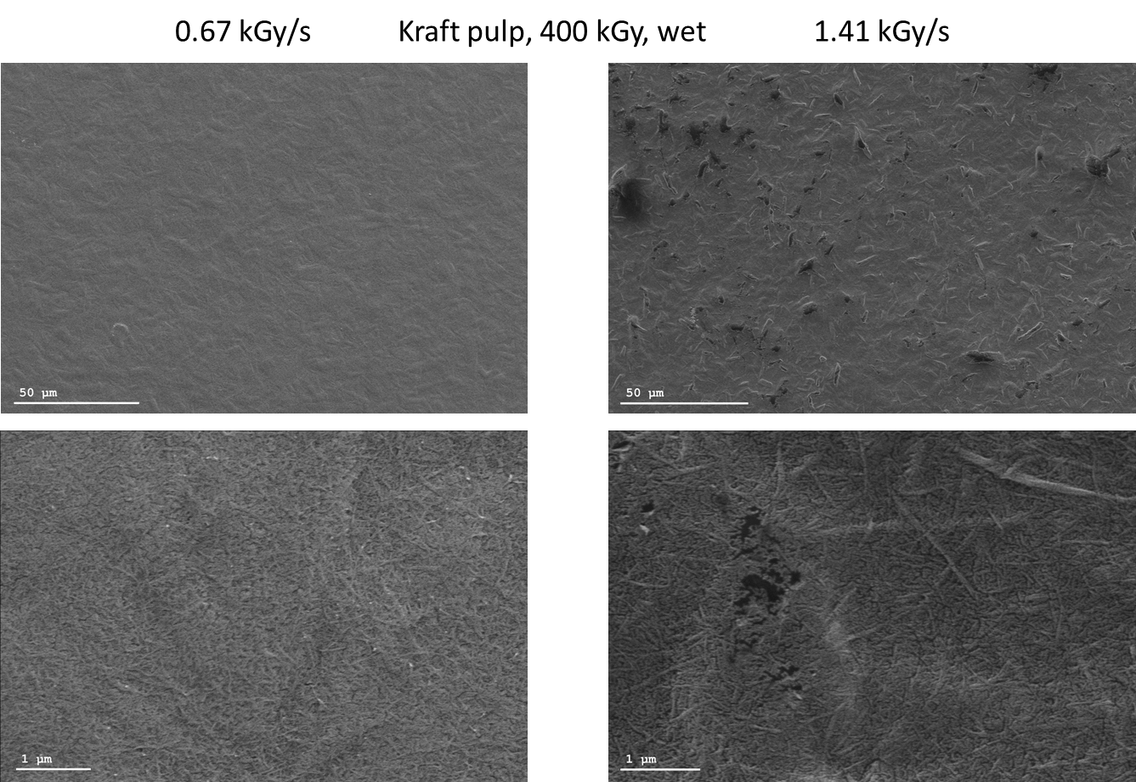
Figure S4 SEM images of MFC prepared from irradiated wet kraft pulp sheets at 400 kGy with different dose rates

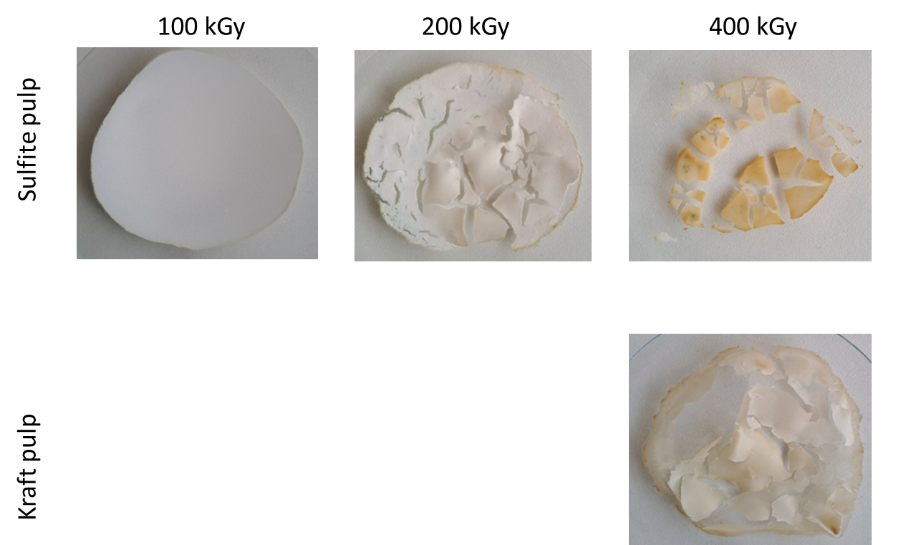
Figure S5 Images of dried microfibrillated cellulose prepared from pulp with various irradiation dose (1.41 kGy s⁻¹, dry sheets)

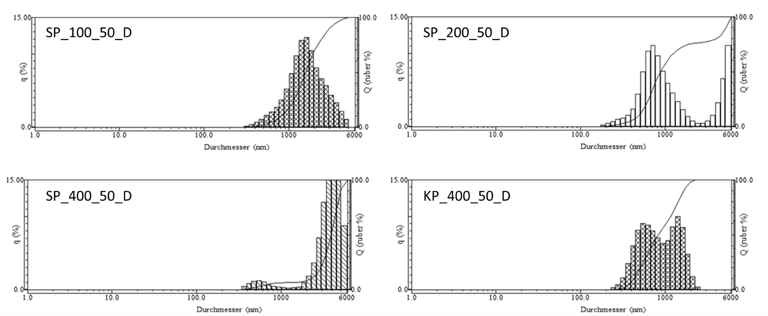
Figure S6 Particle size distribution of microfibrillated cellulose measured by dynamic light scattering

