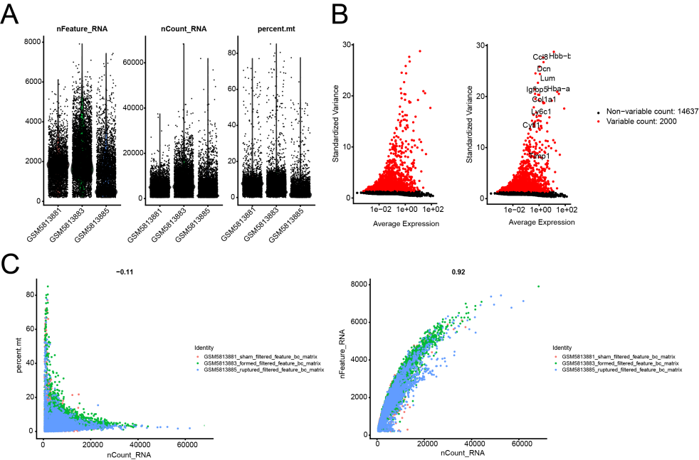
Supplementary Figure 1. Single-cell RNA sequencing data preprocessing and quality control.
(A) Scatter plot showing the selection of high-quality cells based on the number of detected genes and the percentage of mitochondrial genes. (B) Feature selection of highly variable genes. Red dots represent highly variable genes, while black dots represent non-variable genes. (C) Principal component analysis (PCA) of the gene expression profiles from the three samples (sham, formed, and ruptured groups).

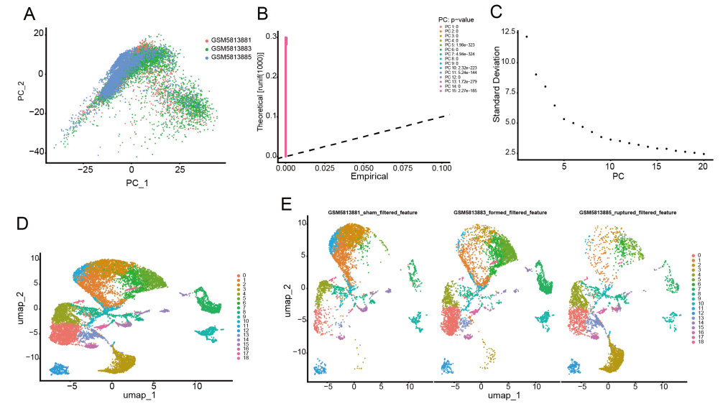
Supplementary Figure 2. Dimensionality reduction and clustering analysis of single-cell data.
(A) PCA of the single-cell gene expression data. (B) Statistical significance assessment of principal components using the Jackstraw method. The dashed line indicates a P-value cutoff of 0.05. (C) Elbow plot showing the standard deviation of each principal component. (D) Uniform manifold approximation and projection (UMAP) dimensionality reduction and clustering of single cells. Cells are color-coded by their cluster identity. (E) UMAP plots showing the distribution of single cells from the sham, formed, and ruptured groups. Each dot represents a single cell, color-coded by its sample origin.

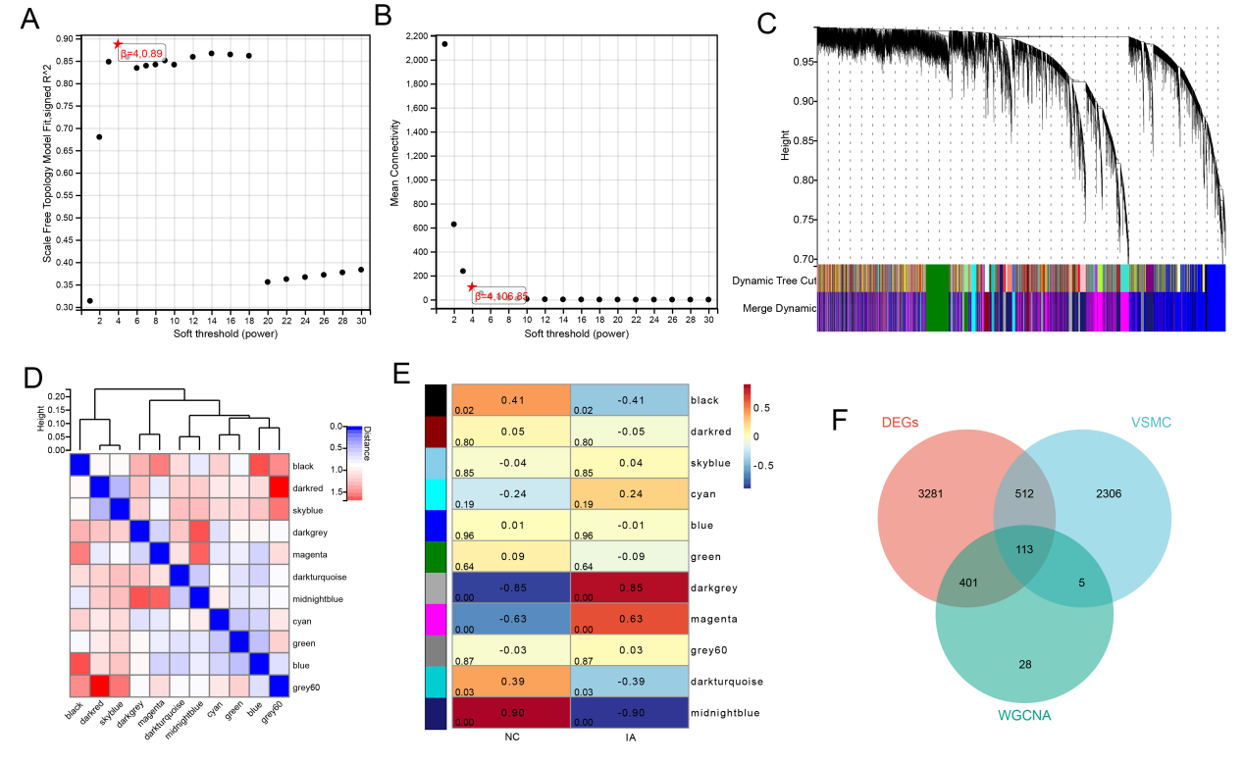
Supplementary Figure 3. Weighted gene co-expression network analysis (WGCNA).
(A) Analysis of the scale-free fit index for various soft-thresholding powers (β). (B) Analysis of the mean connectivity for various soft-thresholding powers. (C) Dendrogram showing the clustering of genes into different modules based on the topological overlap matrix (TOM). (D) Heatmap of the eigengene adjacency, indicating the relationship between modules. (E) Module-trait relationship heatmap. Each row corresponds to a module eigengene, and each column corresponds to a clinical trait. The correlation coefficient and p-value are shown in each cell. (F) Venn diagram illustrating the overlap between DEGs, VSMC marker genes, and WGCNA hub genes.

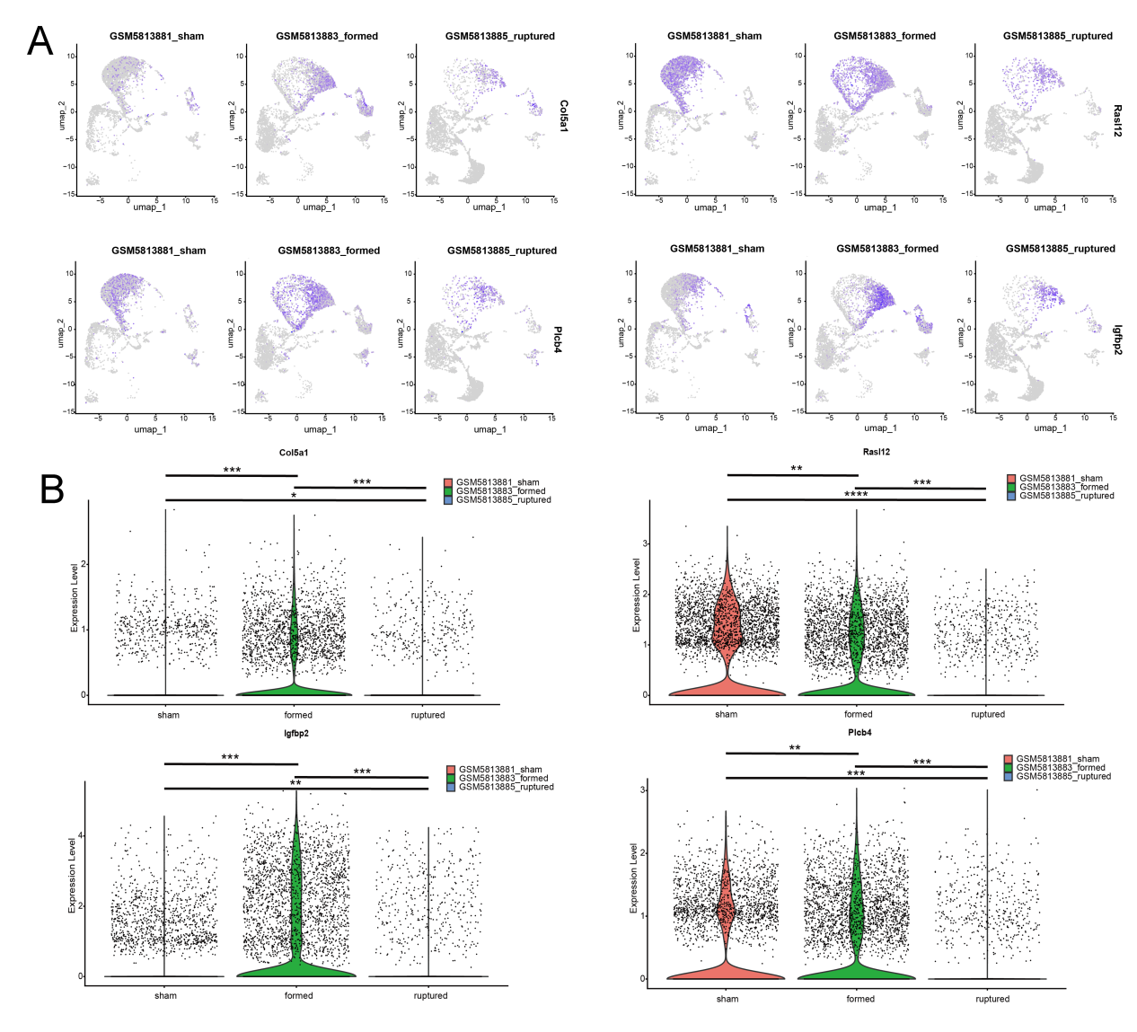
Supplementary Figure 4. Single-cell level expression analysis of key genes.
(A) UMAP plots displaying the expression patterns of key genes (COL5A1, IGFBP2, RASL12, and PLCB4) across different cell subpopulations in the sham, formed, and ruptured groups. (B) Violin plots comparing the expression levels of key genes among the sham, formed, and ruptured groups at the single-cell level. Statistical significance was determined using the Wilcoxon rank-sum test. *P < 0.05, **P < 0.01, ***P < 0.001,****P < 0.0001.

