Supplementary Material
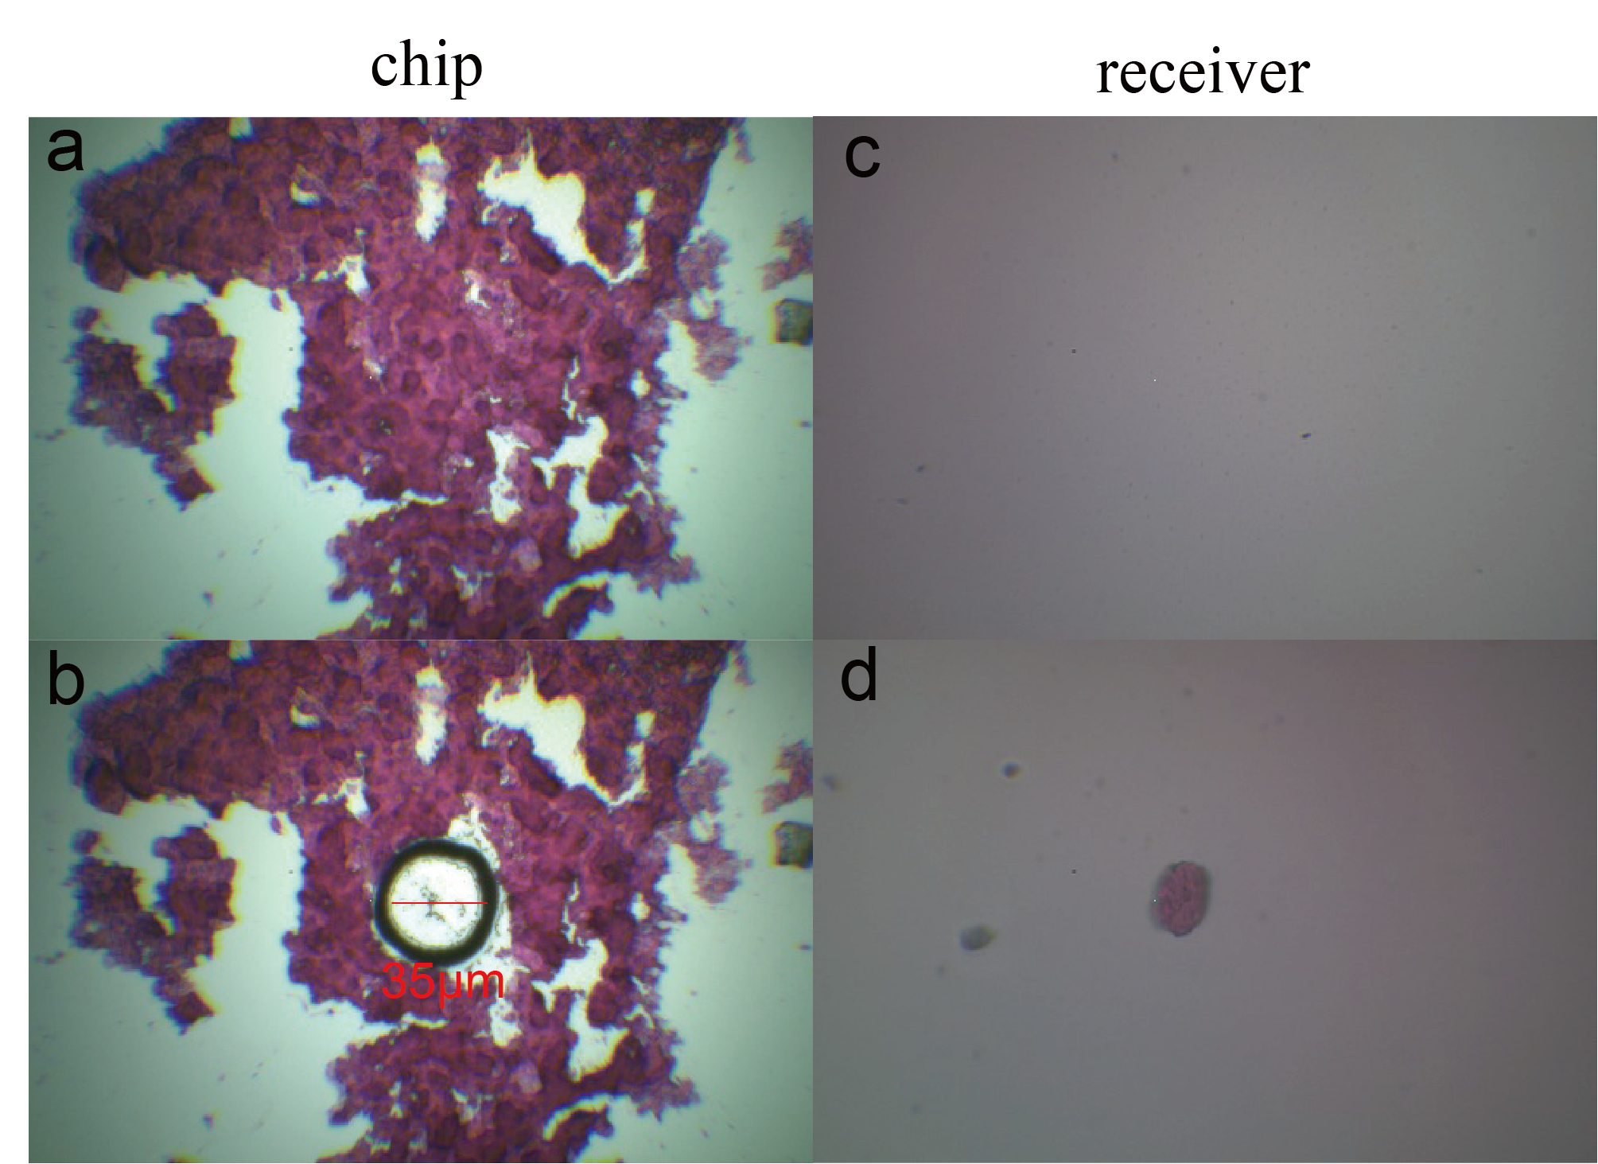
Figure S1. Microscopic images of the chip and receivers before and after tissue excision.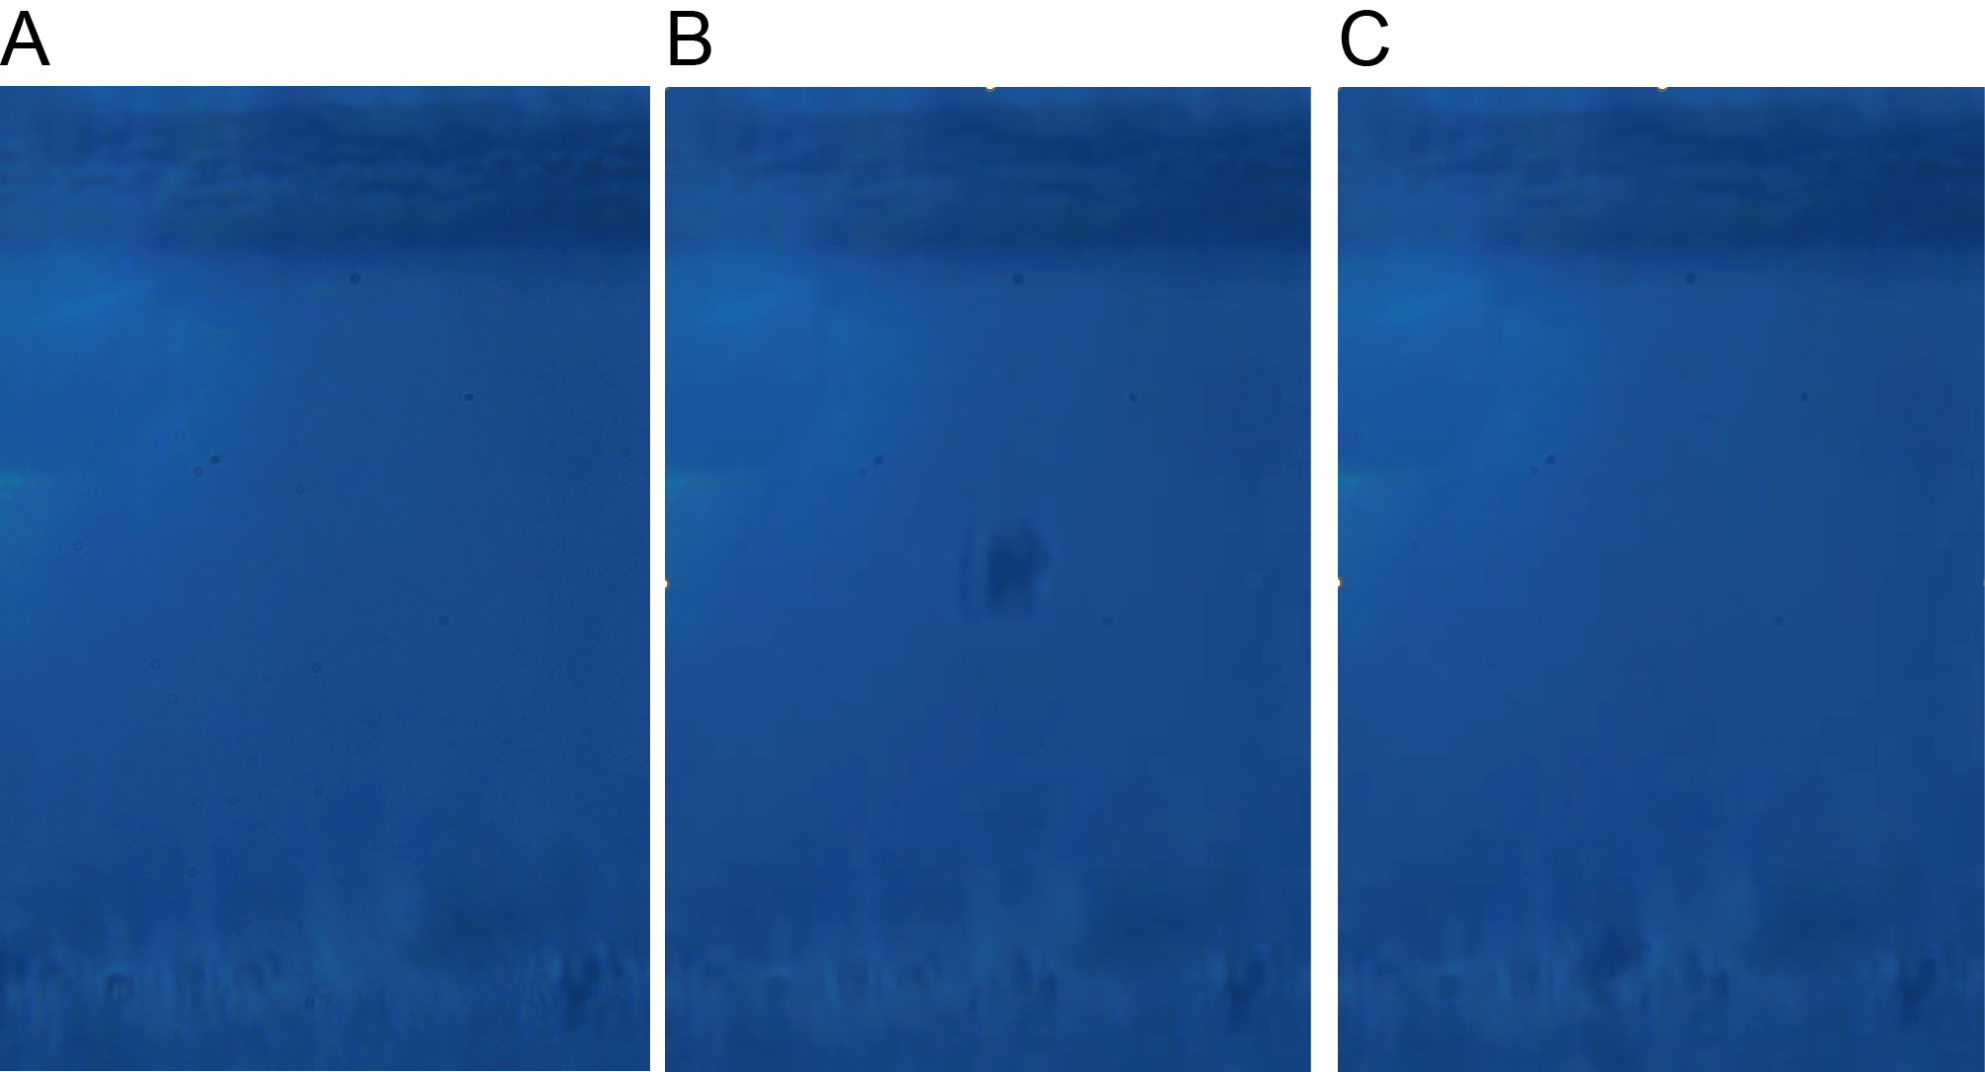
Figure S2. High-speed camera recording of the laser microdissection process. (A) Before laser microdissection. (B) During laser microdissection, cells are being transferred. (C) After laser microdissection, the receiver has captured the cells.
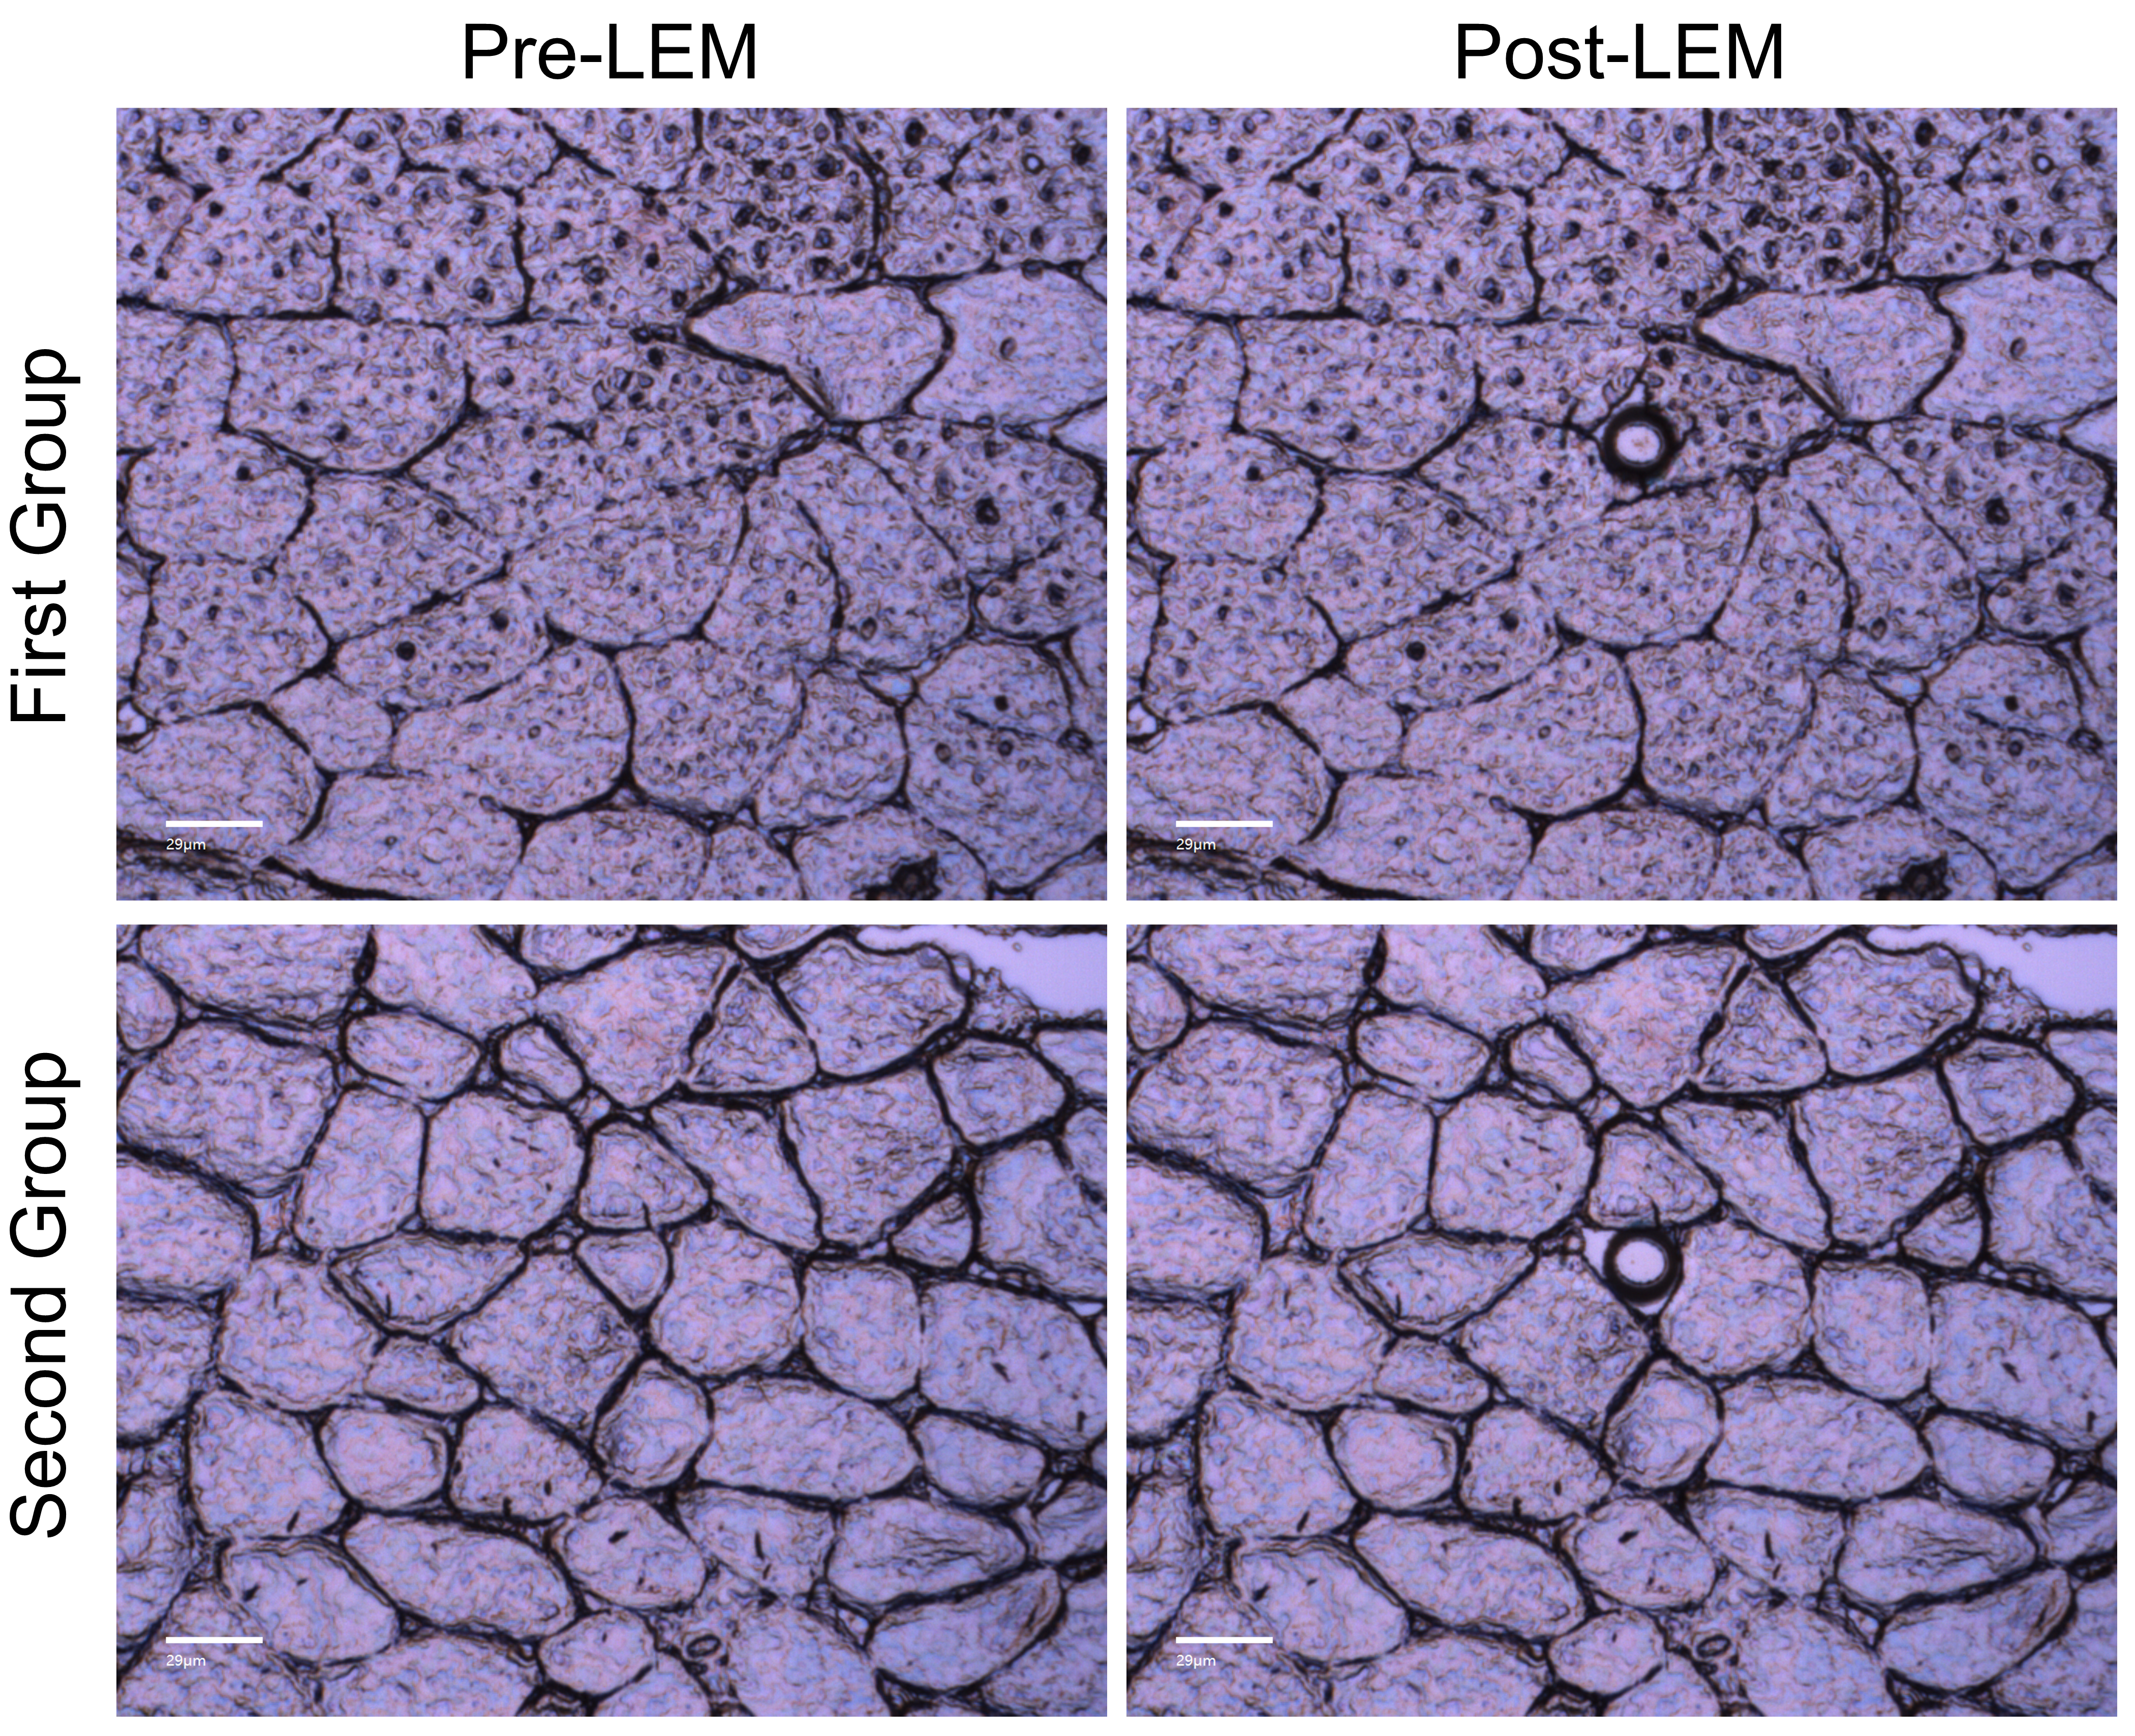
Figure S3. Consistency of laser microdissection spot size across different biological replicates. The spot diameter was 20μm.
Figure S4. Quantitative measurement of staining intensity in different muscle fibers.

