Supplementary Figures

Figure S1. Flow diagram of patient selection in the derivation and validation cohorts
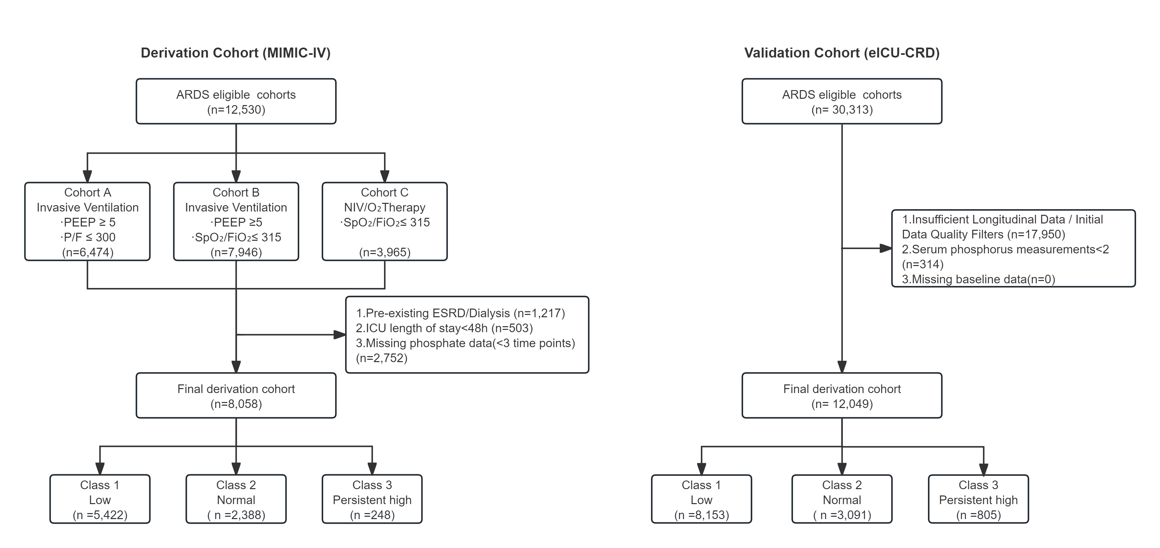

Flow diagram illustrating the inclusion and exclusion process for the MIMIC-IV derivation cohort and the eICU-CRD validation cohort, resulting in the final study populations. All analyses were referenced to Time Zero (T₀), defined as the initiation of respiratory support in both databases.

ARDS in MIMIC-IV was identified according to the 2023 Global ARDS Definition, whereas ARDS in eICU-CRD was operationally defined using ICD diagnosis codes and documented mechanical ventilation. The number of excluded patients at each step is displayed within the respective panels.

Abbreviations: ARDS, acute respiratory distress syndrome; MIMIC-IV, Medical Information Mart for Intensive Care IV; eICU-CRD, eICU Collaborative Research Database; T₀, initiation of respiratory support.

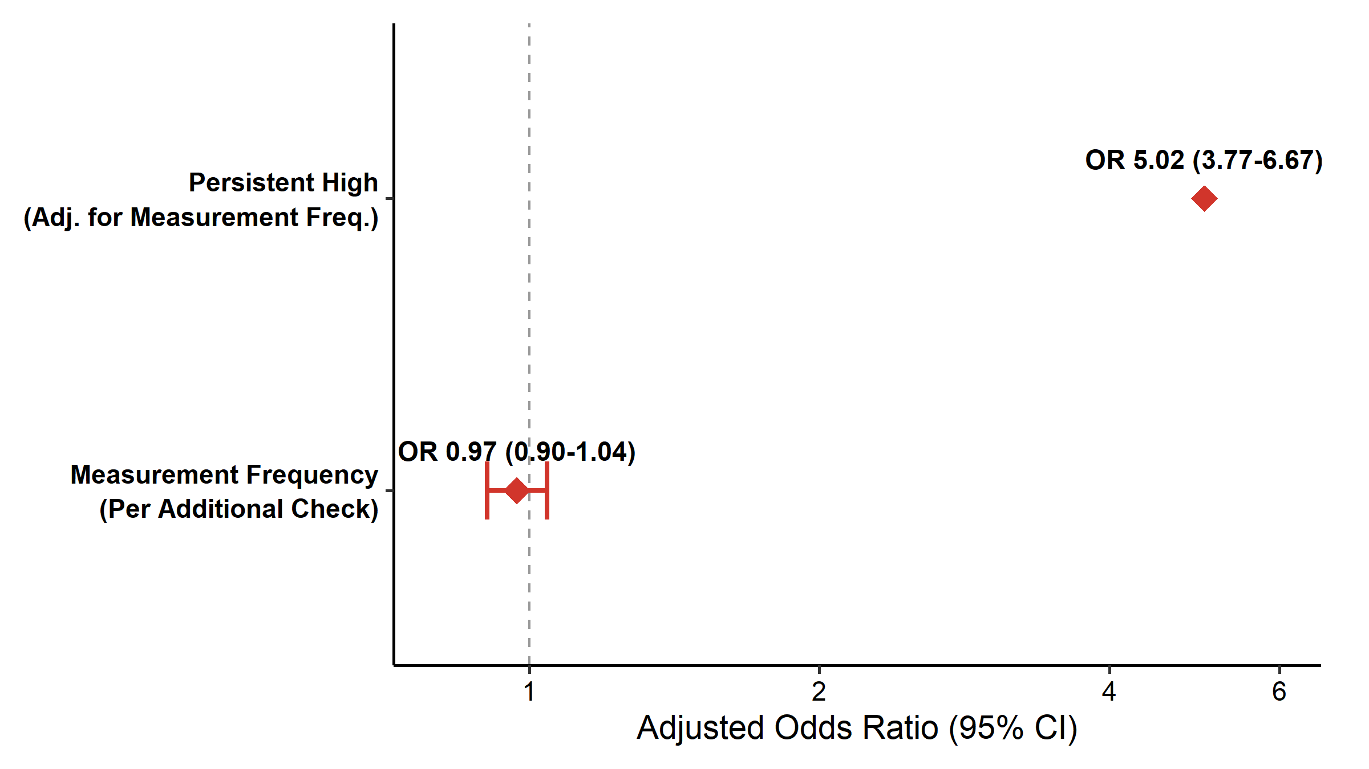
Figure S2. Sensitivity analysis adjusting for measurement frequency

Forest plot displaying adjusted odds ratios (ORs) for 30-day mortality comparing the Persistent High phosphate trajectory pattern with the Normal trajectory pattern (reference group). The primary multivariable model was additionally adjusted for the total number of serum phosphate measurements obtained during the 7-day observation window, entered as a continuous covariate. This analysis was conducted to assess potential surveillance bias related to differential measurement frequency.

Abbreviations: OR, odds ratio; CI, confidence interval.

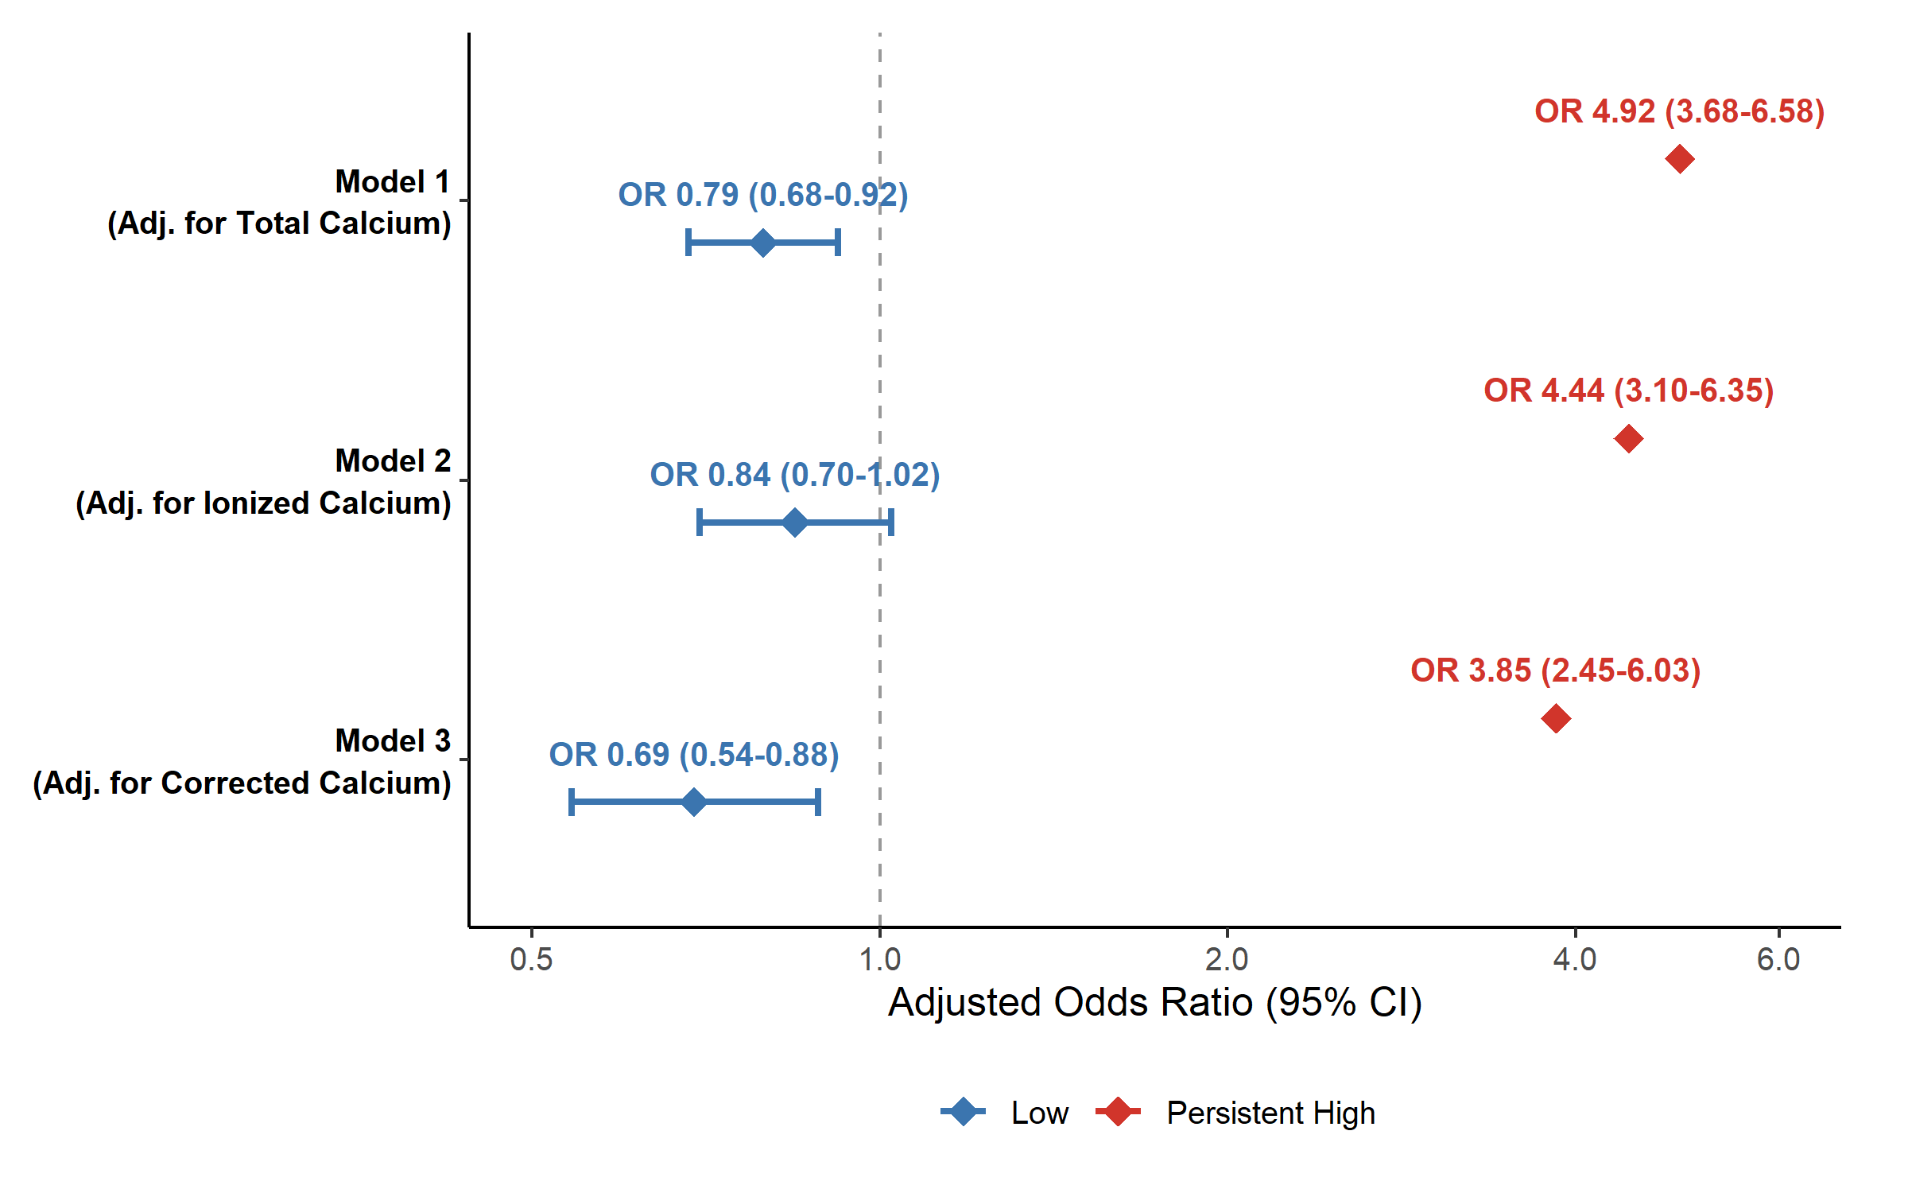
Figure S3. Sensitivity analyses adjusting for calcium homeostasis

Forest plot displaying adjusted odds ratios (ORs) for 30-day mortality comparing the Low and Persistent High phosphate trajectory patterns with the Normal trajectory pattern (reference group) across three sequential models. Total calcium, ionized calcium, and albumin-corrected calcium were each entered individually into the baseline multivariable model to avoid multicollinearity. All models were additionally adjusted for age, illness severity (SOFA in MIMIC-IV or APACHE IV in eICU-CRD), Charlson Comorbidity Index, and other prespecified baseline covariates.

Abbreviations: OR, odds ratio; CI, confidence interval; SOFA, Sequential Organ Failure Assessment; APACHE IV, Acute Physiology and Chronic Health Evaluation IV; CCI, Charlson Comorbidity Index.

Figure S4. Sensitivity analyses adjusting for acute kidney injury (AKI) severity
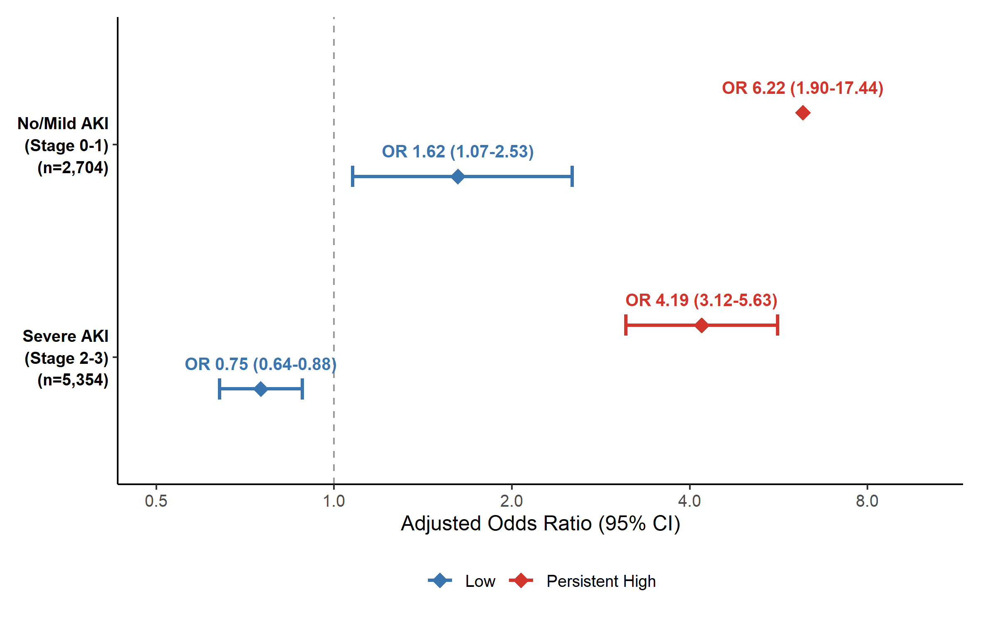
Forest plot displaying adjusted odds ratios (ORs) for 30-day mortality stratified by baseline KDIGO-defined AKI stage at Time Zero (T₀): No or Mild AKI (Stage 0–1) versus Severe AKI (Stage 2–3). AKI stage was defined according to KDIGO criteria based on changes in serum creatinine and/or urine output. The Normal phosphate trajectory pattern served as the reference group.

Abbreviations: AKI, acute kidney injury; KDIGO, Kidney Disease: Improving Global Outcomes; OR, odds ratio; CI, confidence interval.

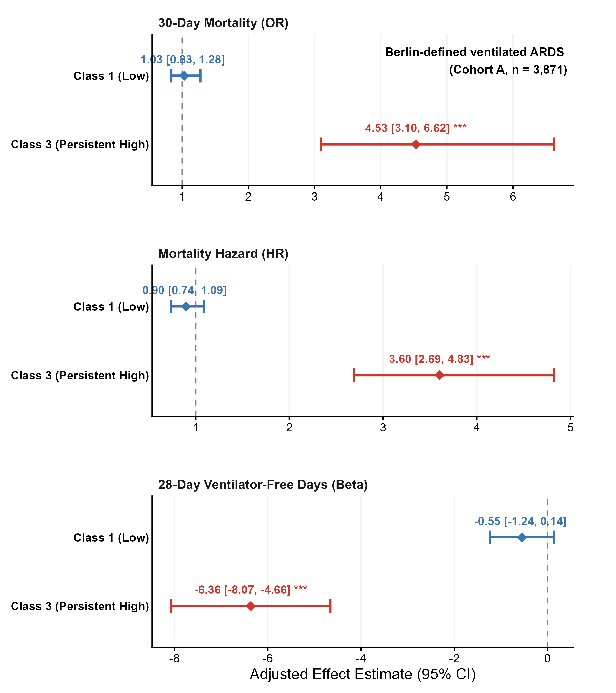
Figure S5. Sensitivity analysis restricted to Berlin-defined ventilated ARDS (Cohort A)

Forest plots displaying adjusted effect estimates for the association between serum phosphate trajectory patterns and clinical outcomes in patients with Berlin-defined ARDS receiving invasive mechanical ventilation (Cohort A, n = 3,871). Outcomes include 30-day mortality (odds ratios, ORs), time-to-death (hazard ratios, HRs), and 28-day ventilator-free days (VFD-28; β coefficients). Patients who died before day 28 were assigned a value of zero ventilator-free days.

Trajectory patterns were identified using latent class mixed models (LCMM), with the Normal trajectory pattern serving as the reference group. The Low and Persistent High trajectory patterns were each compared with the Normal pattern. All models were adjusted using the same covariates as in the primary analysis, including age, sex, SOFA score, Charlson Comorbidity Index, baseline creatinine, total calcium, pH, lactate, and baseline respiratory parameters.

Effect estimates are presented with 95% confidence intervals. Asterisks indicate statistical significance at P < 0.001.

Abbreviations: ARDS, acute respiratory distress syndrome; OR, odds ratio; HR, hazard ratio; VFD-28, 28-day ventilator-free days; SOFA, Sequential Organ Failure Assessment; CI, confidence interval.

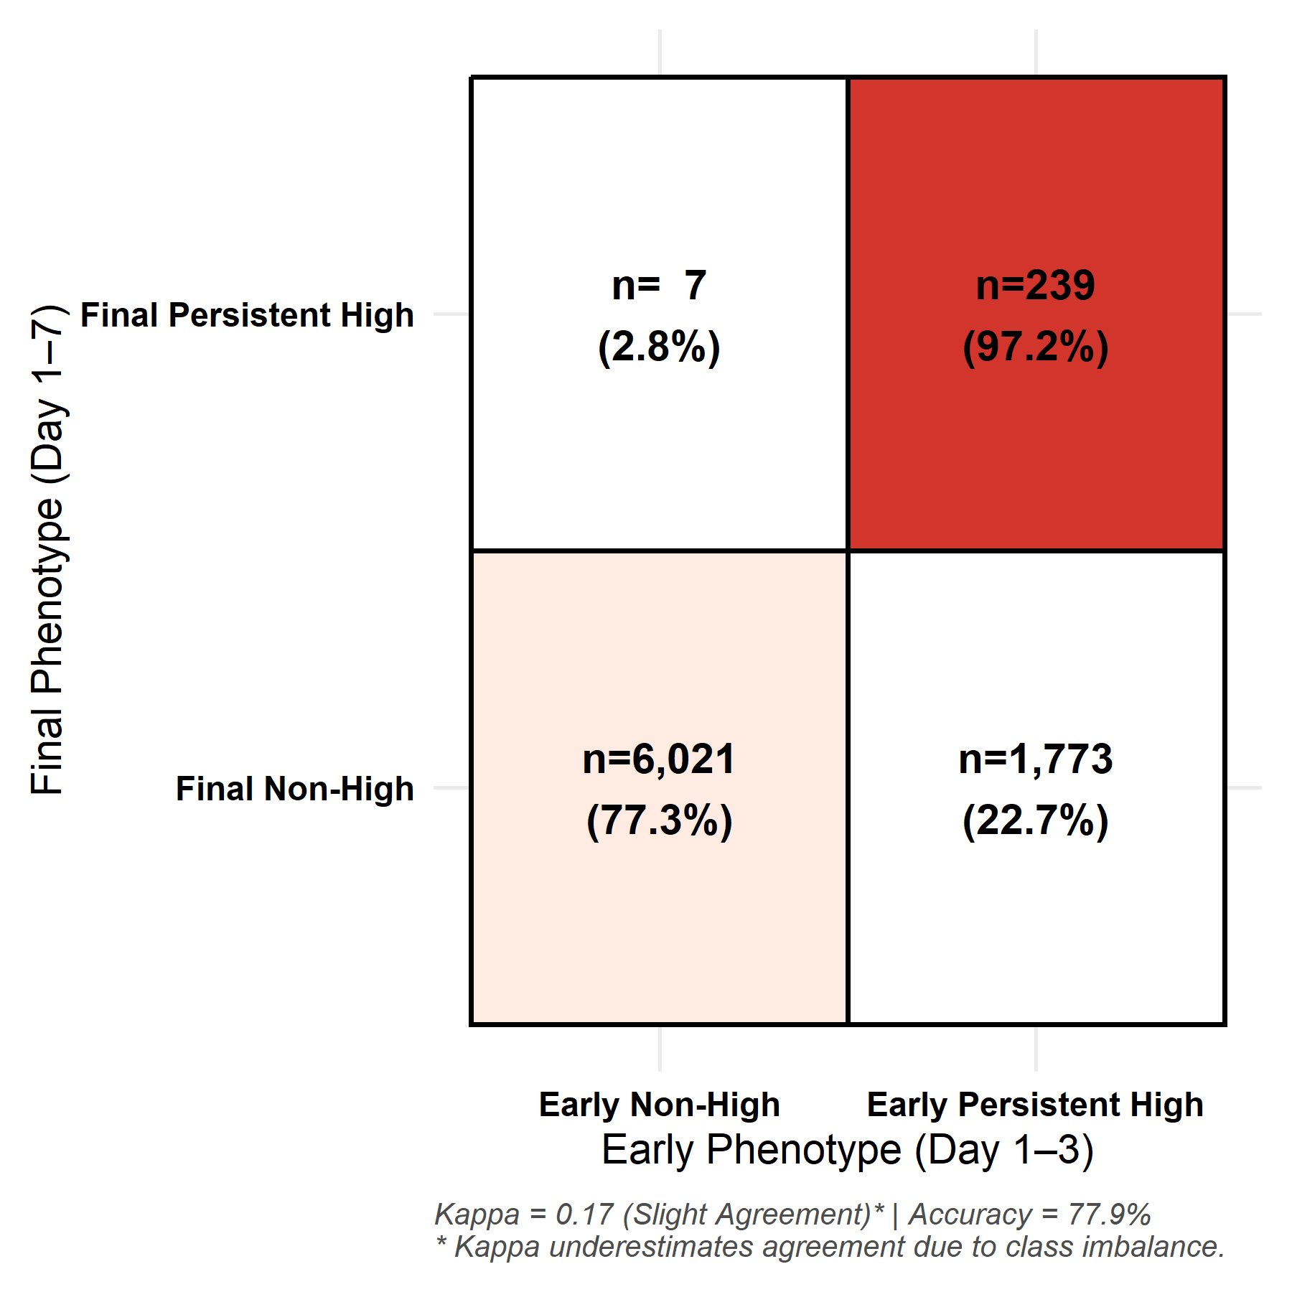
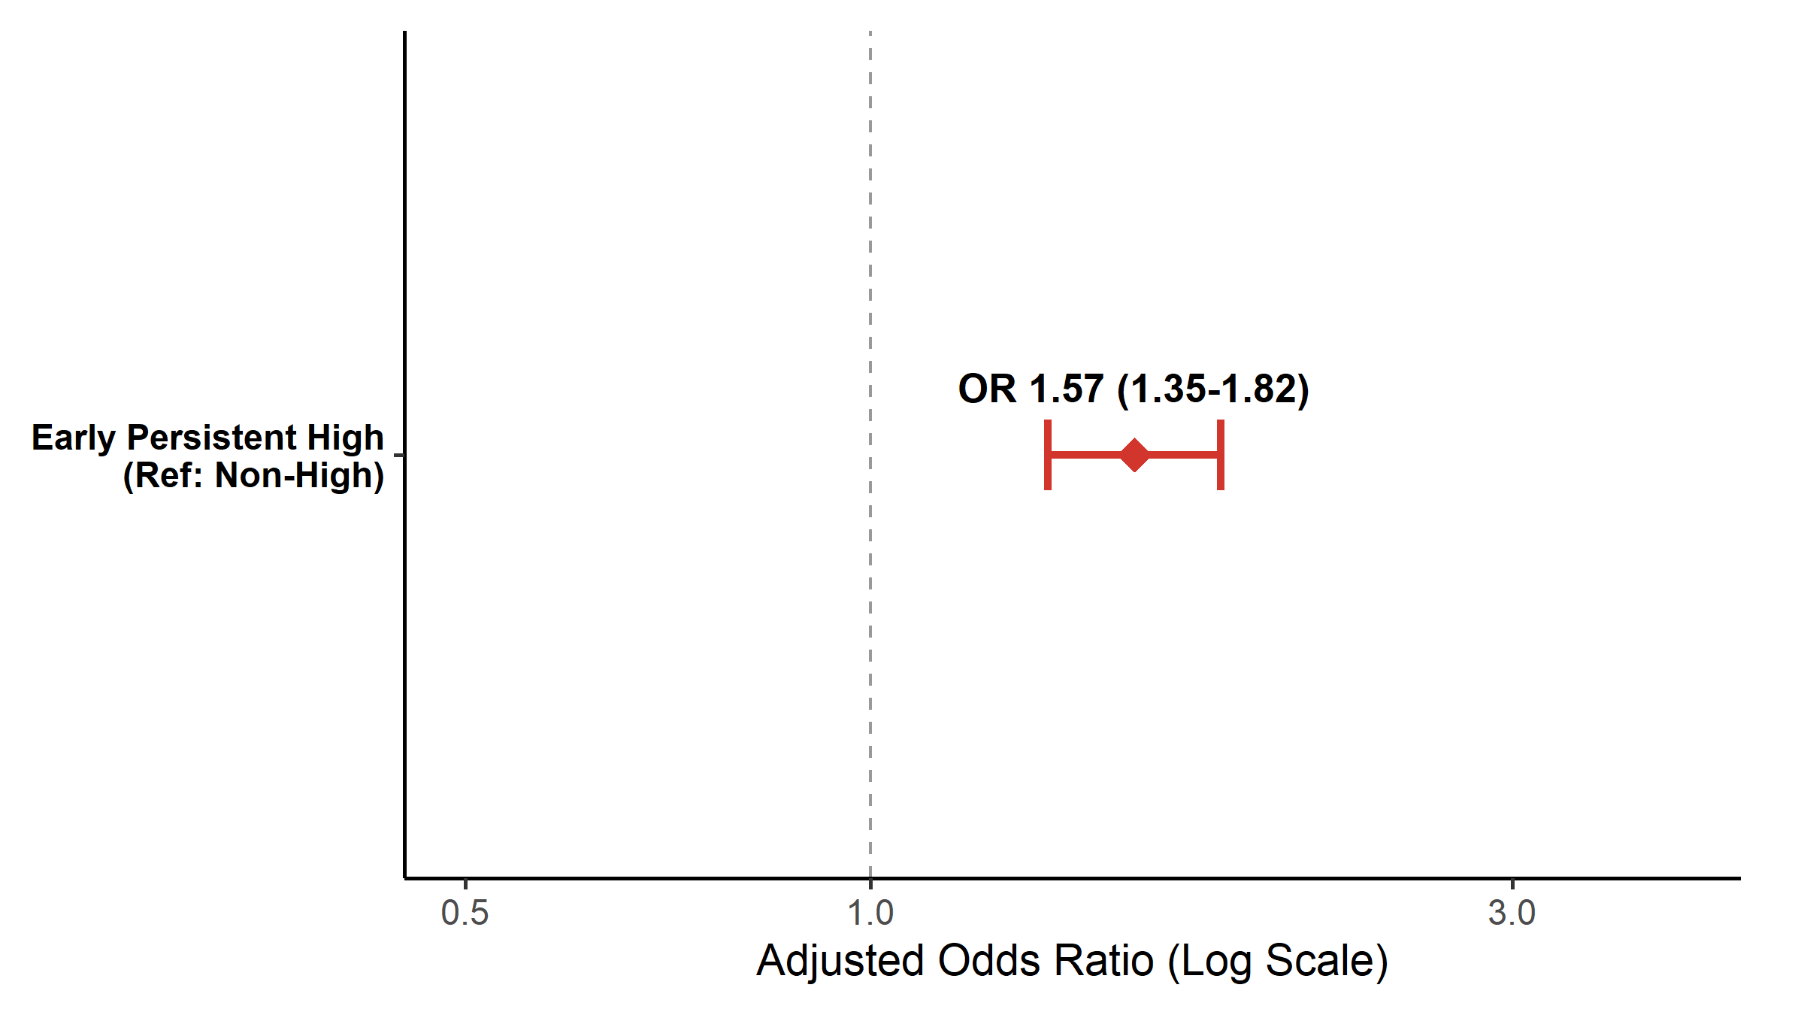
Figure S6. Early identification of the Persistent High trajectory pattern and its association with outcomes

(A) Agreement matrix comparing trajectory patterns identified using early data (first 72 hours after T₀) with those derived from the full 7-day observation window. Cohen’s κ and overall classification accuracy are reported to quantify agreement. Given class imbalance, κ may underestimate the degree of agreement.

(B) Forest plot displaying adjusted odds ratios (ORs) for 30-day mortality comparing the Early Persistent High trajectory pattern with all other early trajectory patterns combined.

Abbreviations: OR, odds ratio; CI, confidence interval; κ, Cohen’s kappa.

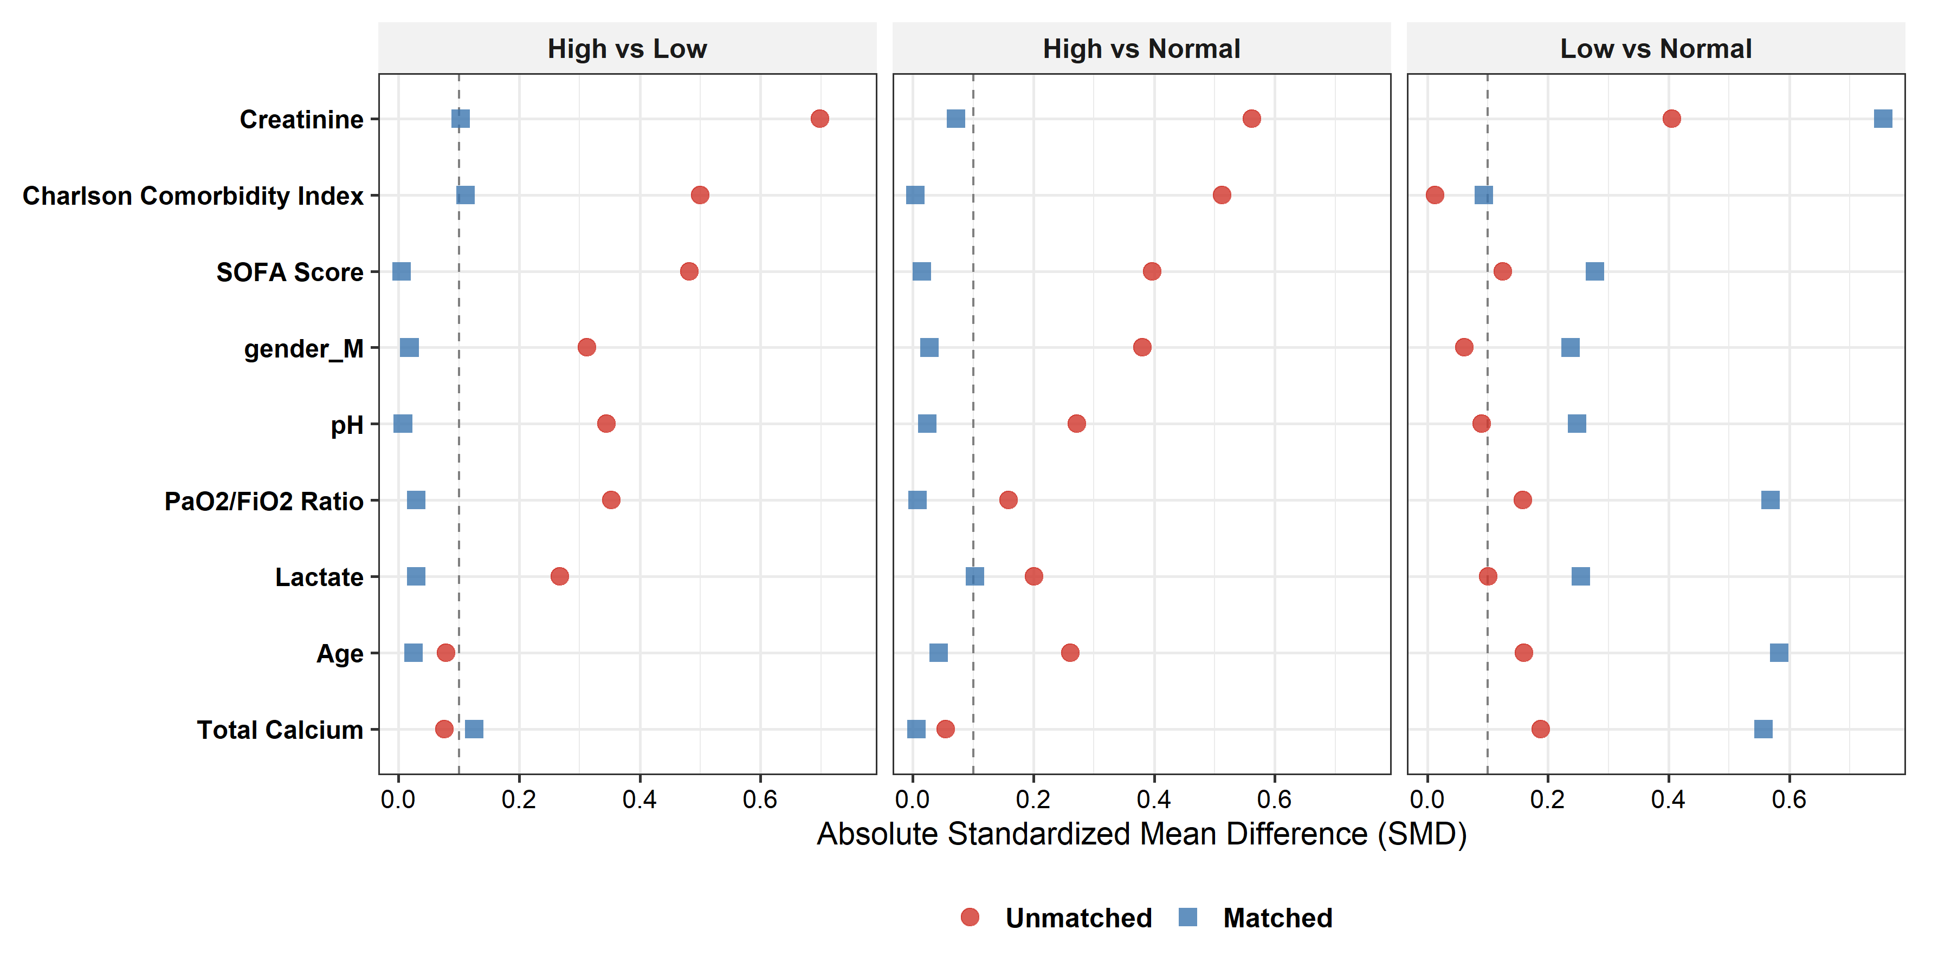
Figure S7. Covariate balance before and after propensity score matching

Love plot displaying absolute standardized mean differences (SMDs) for baseline covariates before (red circles) and after (blue squares) 1:1 propensity score matching. After matching, all variables demonstrated an absolute SMD < 0.1, indicating acceptable covariate balance. The vertical dashed line denotes the conventional threshold of 0.1. Propensity score matching was conducted as a complementary analysis to assess robustness rather than to establish causality.

Abbreviations: SMD, standardized mean difference; SOFA, Sequential Organ Failure Assessment; PSM, propensity score matching.

