Supplementary Material

Nature-based solutions in mountain catchments reduce impact of anthropogenic climate change on hydrological drought severity
Holden PB ^{a*}, Rebelo AJ ^{b}, Wolski P ^{c}, Odoulami RC ª, Lawal KA ª, Kimutai J ^{a,d}, Nkemelang T ª, New MG ª
ª African Climate and Development Initiative, University of Cape Town, South Africa
^{b} Department of Conservation Ecology and Entomology, Stellenbosch University, South Africa
^{c} Climate System Analysis Group, University of Cape Town, South Africa
^{d} Kenya Meteorological Department, Kenya
*Corresponding author: petra.holden@uct.ac.za

Section 1 Simulated streamflow for Climate-IAT States
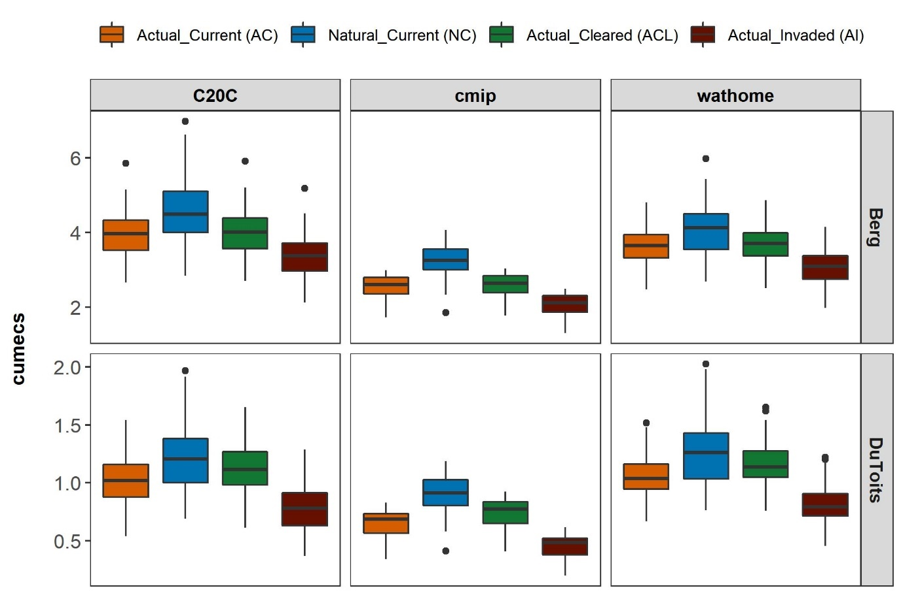
Supplementary Fig. 1 Boxplots showing spread of mean simulated daily streamflow (cumecs) for the drought period (2015-2017) across each climate model experiments (C20C = 50 ensemble members from ECHAM 5.4; cmip = 27 models with one ensemble member each; wathome = 68 ensemble members) with (Actual - A) and without (Natural - N) anthropogenic influence on atmospheric conditions in terms of greenhouse gasses concentrations for three Invasive Alien Tree (IAT) states: fully invaded catchment (Invaded - I), fully cleared catchment (Cleared - CL), invasions during the drought period (Current - C) (refer to Table 1 in the manuscript). The thick black line is the median, the box is the interquartile range (IQR with Q1 = 25th and Q3 = 75th percentiles), whiskers are Q1 - 1.5/IQR and Q3 + 1.5*IQR and dots are outliers.

Section 2 Estimating confidence intervals for attribution measures

Although we have a relatively large number of ensemble members per climate model experiment, so we can derive quite robust estimates of the attribution measures (Severity Ratio [SR] and Fraction of Attributable Severity [FAS]) we use bootstrapping to estimate 95% confidence intervals more robustly for the median values. Specifically, to calculate the SR and FAS while accounting for uncertainty for each climate-IAT state we used a bootstrapping approach to resample the simulations for each climate model experiment. For each simulation we calculated a moving three-year mean of annual mean daily streamflow (in cumecs), which we used to define the severity (S) of the drought event for the specific ensemble member (S_{i}). We then calculated the ensemble mean (x̅) for each climate model experiment per Climate-IAT state (i.e., calculated x̅_{NC}, x̅_{AC,} x̅_{AI,} x̅_{ACL} for W@home, C20C and CMIP5 ensemble members). We considered the ensemble mean (x̅) to represent the common signal of the severity of the drought for each climate model scenario for each Climate-IAT state¹.
To estimate the distribution of SR and FAS and thus uncertainty for each Climate-IAT state per climate model experiment, we bootstrapped the above process of generating an ensemble mean per climate model experiment for each Climate-IAT state. This entailed resampling the drought events (i.e., the estimates of the mean three-year daily streamflow for each climate model experiment) 1000 times and calculating the ensemble mean (x̅) for each new ensemble of ensemble members. This resulted in 1000 ensemble means (x̅) for the drought event for each Climate-IAT state per climate model experiment, and thus 1000 estimates of the SR and FAS for each Climate-IAT state per climate model experiment. We considered this to be a reasonable representation of the final signal and uncertainty for each Climate-IAT state per climate model experiment¹.

Section 3 Attribution of reduced rainfall and increase in reference evapotranspiration to anthropogenic climate change
To determine the attributable human influence on the reduced rainfall and increase in evapotranspiration (Supplementary Fig. 2 and Fig. 4), we calculated a Severity Ratio (SR) and Fraction of Attributable Severity (FAS) using the same methods as described in Section 2.1 in the manuscript. The inputs for this were bias corrected mean rainfall and reference evapotranspiration over the drought period for the Atmospheric General Circulation Models (AGCMs) and for the driest three years for CMIP5 i.e., the Coupled General Circulation Models (CGCMs). All equations remained the same for rainfall but the SR equation for reference evapotranspiration was inverted to S_{i}/S₀ to account for the fact that greater reference evapotranspiration results in higher evaporative demand and more severe drought. We conducted the same bootstrapping process as described in Section 2.1 in the manuscript and above in Supplementary Section 2 to calculate medians and confidence intervals, including multi-model synthesis results.
All model experiments showed a significant increase in the severity of the meteorological drought attributable to anthropogenic climate change through changes to both rainfall and reference evapotranspiration. Both subcatchments showed a significant impact of anthropogenic climate change on the lack of rainfall by a mean factor of 1.12 (95%CI: 1.07/1.08-1.17) in comparison to a preindustrial climate. This included 10.8% (95%CI: 7.1-14.5) and 10.9% (95%CI: 6.9-14.9) of the meteorological drought attributable to human influence on changes in rainfall (Supplementary Fig. 3 and Table 1). This is in comparison to only 1.95% (95%CI: 1.67-2.22) attributable to human influence on changes in reference evapotranspiration and a SR of 1.02 (95%CI: 1.02-1.02) (Supplementary Fig. 5 and Table 2).
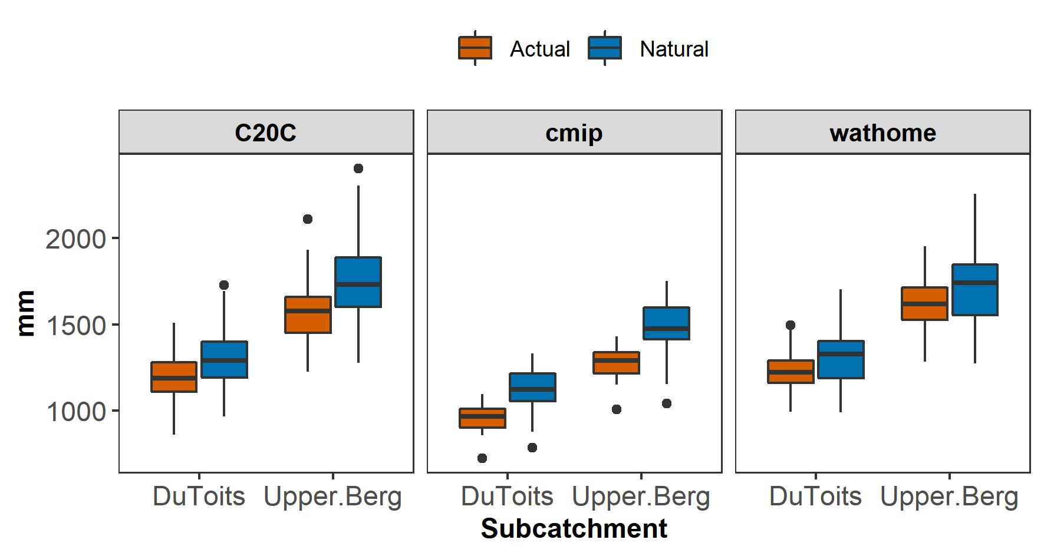
Supplementary Fig. 2 Boxplots showing spread of simulated total annual rainfall during the drought for the three model experiments (C20C = 50 ensemble members from ECHAM 5.4; cmip = 27 models with one ensemble member each; wathome = 68 ensemble members) with and without anthropogenic influence on atmospheric conditions in terms of greenhouse gas concentrations. For C20C and wathome these are the actual drought years but for CMIP5 these are the driest three years over a 31-period centred on the drought years (see Methods 2.4.1 Climate Models and States in the manuscript for more detail). The thick black line is the median, the box is the interquartile range (IQR with Q1 = 25th and Q3 = 75th percentiles), whiskers are Q1 - 1.5/IQR and Q3 + 1.5*IQR and the dots are the outliers.

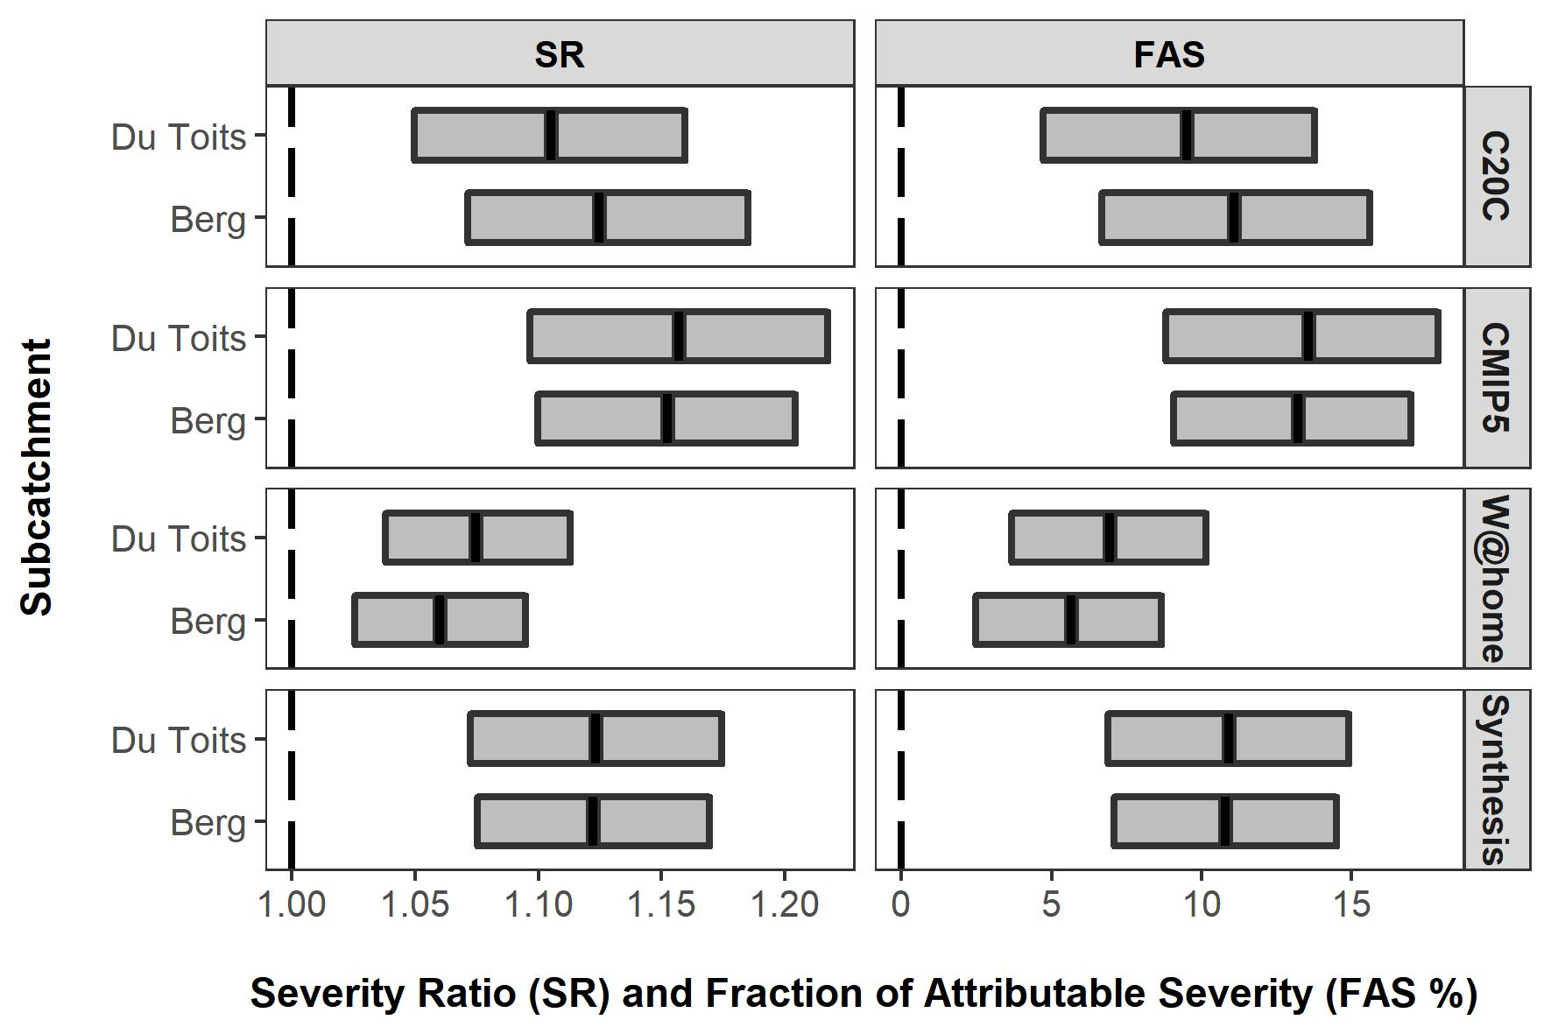
Supplementary Fig. 3 The severity (Severity Ratio (SR) and Fraction of Attributable Severity (FAS)) of the three year mean precipitation during the drought attributable to anthropogenic climate change (Natural/Actual) based on atmosphere-only (W@home, C20C) and coupled (CMIP5) general circulation model experiments. Climate model experiments show the bootstrapped ensemble medians with 95% quantiles (0.025 - 0.975 quantiles, referred to as 95%CI) and the synthesis shows the mean of the model experiment medians, with equal weighting and 95% confidence intervals generated using the pooled standard deviation of the climate model experiments.
Supplementary Table 1 Median Severity Ratio (SR) and Fraction of Attributable Severity (FAS) (with 95% confidence intervals) for the Upper Berg and Du Toits, shown separately for all model experiments and synthesis across model experiments. Table format of results shown in Supplementary Fig. 3 above.
Name | model | Upper Berg (95% CI) |  | Du Toits (95% CI)
Name | model | SR | FAS | SR | FAS
Natural/Actual | C20C | 1.12 (1.07, 1.19) | 11.1 (6.7, 15.6) | 1.11 (1.05, 1.16) | 9.5 (4.7, 13.8)
Natural/Actual | CMIP5 | 1.15 (1.1, 1.2) | 13.2 (9.1, 17) | 1.16 (1.1, 1.22) | 13.6 (8.8, 17.9)
Natural/Actual | W@home | 1.06 (1.03, 1.09) | 5.7 (2.5, 8.7) | 1.07 (1.04, 1.11) | 6.9 (3.7, 10.1)
Natural/Actual | Synthesis | 1.12 (1.08, 1.17) | 10.8 (7.1, 14.5) | 1.12 (1.07, 1.17) | 10.9 (6.9, 14.9)

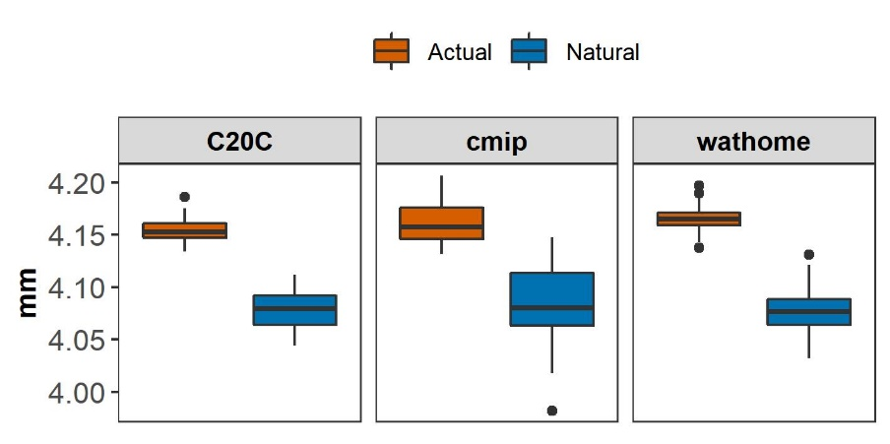
Supplementary Fig. 4 Boxplots showing spread of simulated average daily reference evapotranspiration during the drought for the three model experiments (C20C = 50 ensemble members from ECHAM 5.4; cmip = 27 models with one ensemble member each; wathome = 68 ensemble members) with and without anthropogenic influence on atmospheric conditions in terms of greenhouse gasses concentrations. For C20C and wathome these are the actual drought years but for CMIP5 these are the driest three years over a 31-period centred on the drought years (see Methods 2.4.1 Climate Models and States in the manuscript for more detail). The thick black line is the median, the box is the interquartile range (IQR with Q1 = 25th and Q3 = 75th percentiles), whiskers are Q1 - 1.5/IQR and Q3 + 1.5*IQR and the dots are the outliers.
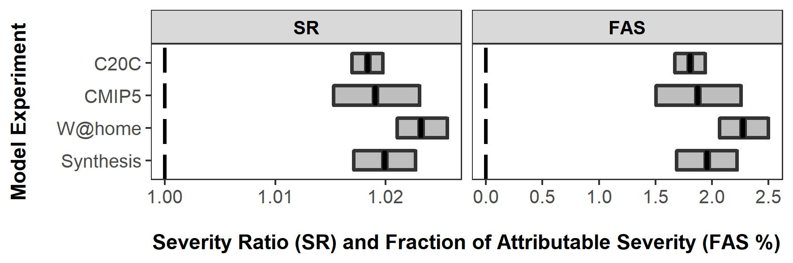
Supplementary Fig. 5 The severity (Severity Ratio (SR) and Fraction of Attributable Severity (FAS)) of the three year mean reference evapotranspiration during the drought attributable to anthropogenic climate change (Natural/Actual) based on atmosphere-only (W@home, C20C) and coupled (CMIP5) general circulation model experiments. Climate model experiments show the bootstrapped ensemble medians with 95% quantiles (0.025 - 0.975 quantiles, referred to as 95%CI) and the synthesis shows the mean of the model experiment medians, with equal weighting and 95% confidence intervals generated using the pooled standard deviation of the climate model experiments.
Supplementary Table 2 Median Severity Ratio (SR) and Fraction of Attributable Severity (FAS) (with 95% confidence intervals) for the Upper Berg and Du Toits, shown separately for all model experiments and synthesis across model experiments. Table format of results shown in Supplementary Fig. 5 above.
Name | model | Upper Berg and Du Toits (95% CI)
Name | model | SR | FAS
Natural/Actual | C20C | 1.018 (1.017, 1.02) | 1.805 (1.669, 1.938)
Natural/Actual | CMIP5 | 1.019 (1.015, 1.023) | 1.87 (1.505, 2.256)
Natural/Actual | W@home | 1.023 (1.021, 1.026) | 2.27 (2.065, 2.499)
Natural/Actual | Synthesis | 1.02 (1.017, 1.023) | 1.954 (1.686, 2.222)

Section 4 The relative role of human influence on the climate on changes in reference evapotranspiration versus rainfall on hydrological drought
To understand the relative role of anthropogenic climate change influence on the lack of rainfall versus increases in reference evapotranspiration in changing hydrological drought severity we redid the weather@home simulations for Actual Current scenario, but we used the Natural reference evapotranspiration in place of the Actual reference evapotranspiration. We then reran the attribution analysis following the same process outlined in section 2.1 and further elaborated on in Supplementary Material Section 2.
So here we assessed the difference between the increase in severity of the hydrological drought attributable to human influence on the climate (including both changes to rainfall and reference evapotranspiration) versus only changes in rainfall (Supplementary Fig 2-5 above). We compared the severity of the hydrological drought attributable to human influence on the climate, under observed land cover state (i.e., NC/AC) versus that attributable to human influence on only the lack of rainfall, under observed land cover state (referred to as NC/etN&prA-C).
We found that although increases in reference evapotranspiration can be attributed to anthropogenic climate change, they played a marginal role in increased hydrological drought severity attributable to climate change compared to the role of human influence on the lack of rainfall. For example, we found that human influence on the climate on the lack of rainfall contributed between 97 and 99% to the increase in the severity of the hydrological drought (the SR values) and 90 and 85% to the severity of the hydrological drought that was attributable to anthropogenic climate change (the FAS values) (Supplementary Fig 6 and Table 3).
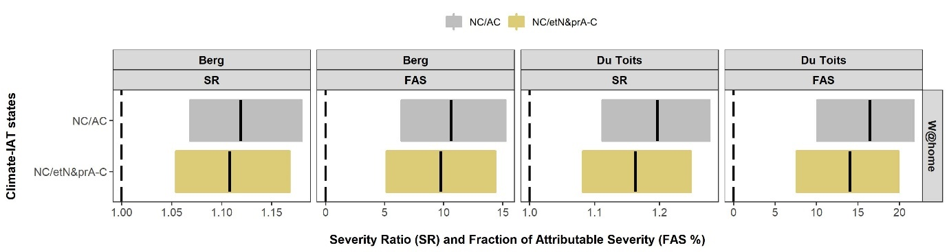
Supplementary Fig. 6 Attributable hydrological drought severity to anthropogenic climate change influence on rainfall versus reference evapotranspiration. The severity (Severity Ratio (SR) and Fraction of Attributable Severity (FAS)) of the hydrological drought attributable to anthropogenic climate change influence on both rainfall and reference evapotranspiration (NC/AC) compared to anthropogenic climate change influence on only rainfall (NC/etN&prA-C). Showing results for one climate model experiment (weather@home [W@home]) including the median of the bootstrapped ensemble means with 95% quantiles (0.025 - 0.975 quantiles, referred to as 95%CI).

Supplementary Table 3 Attributable hydrological drought severity to anthropogenic climate change influence on rainfall versus reference evapotranspiration. Median Severity Ratio (SR) and Fraction of Attributable Severity (FAS) (with 95% confidence intervals) for the Upper Berg and Du Toits for one Climate Model experiment – Weather@home (W@home). Table format of results shown in Supplementary Fig. 6 above.
Climate- observed land cover state | Upper Berg |  | Du Toits
Climate- observed land cover state | SR (95% CI) | FAS (95% CI) | SR (95% CI) | FAS (95% CI)
NC/AC | 1.12 (1.07, 1.18) | 10.7 (6.4, 15.2) | 1.2 (1.11, 1.28) | 16.4 (10.1, 21.7)
NC/etN&prA-C | 1.11 (1.05, 1.17) | 9.7 (5.2, 14.4) | 1.16 (1.08, 1.25) | 14 (7.6, 19.9)
Difference | 0.01 | 1 | 0.04 | 2.4
Rainfall contribution | 99.1% | 90.7% | 97.2% | 85.4%

Section 5 Hydrological model validation
Supplementary Table 4 Daily streamflow statistics (cumecs) for the simulated compared to the observed for the Upper Berg and Du Toit's subcatchments (for more information on model performance see²).
Statistic | Upper Berg |  | Du Toits
Statistic | Observed | Simulated | Observed | Simulated
Gauge | G1H076 |  | H6H007
Dates | 2009-2017 |  | 1978-1991
Years | 8 |  | 13
Mean | 2.02 | 1.95 | 1.18 | 1.08
% difference |  | -3.41 |  | -8.47
Std. dev | 4.87 | 3.46 | 2.10 | 2.04
CV | 2.41 | 1.77 | 1.77 | 1.86
Min | 0.04 | 0.16 | 0.09 | 0.14
Max | 67.35 | 45.54 | 35.90 | 24.40
r |  | 0.77 |  | 0.78
r2 |  | 0.60 |  | 0.61
PBIAS% |  | -4.40 |  | -10.10
NSE |  | 0.59 |  | 0.58
NSE(log) |  | 0.81 |  | 0.74

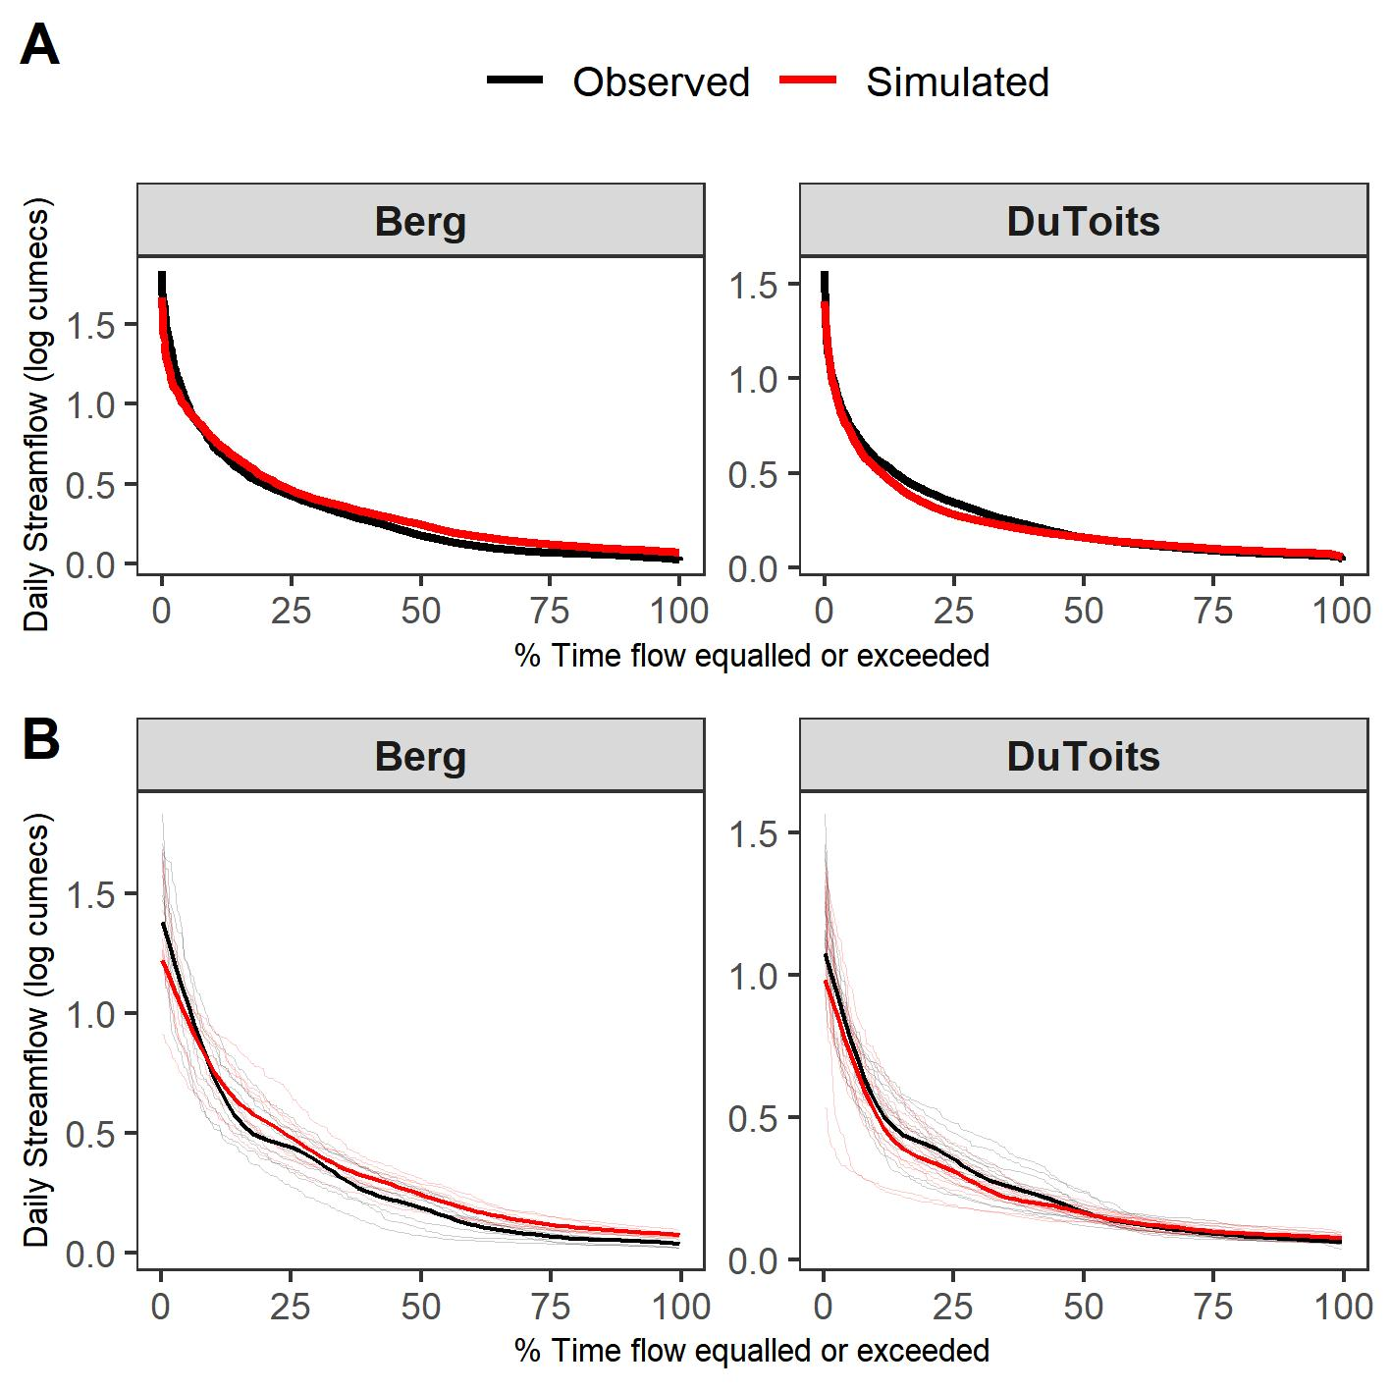
Supplementary Fig. 7 Flow Duration Curves showing logged mean simulated daily streamflow (cumecs) for the observed and simulated streamflow for model validation periods shown in Supplementary Table 4 above. A: FDCs for the full validation time periods; B: Annual FDCs for all years in the validation period (for more information on model performance see²). Dark lines show smoothed conditional means of all the annual values at each quantile and lighter lines are individual values for each year in the validation period. Conditional means are based on a generalised additive model with integrated smoothness using a cubic regression spline: geom_smooth()` using method = 'gam' and formula 'y ~ s(x, bs = "cs")¹.

Section 6 CMIP5 Models used in this study
Supplementary Table 5 Summary of the CMIP5 models simulations used in this study
Model name | Modelling centre | Horizontal resolution (longitude x latitude) | Reference | Full reference
ACCESS1-0 | Commonwealth Scientific and Industrial Research Organisation / Bureau of Meteorology | 1.875° × 1.25° | Bi et al (2013) | Bi D, Dix M, Marsland S, et al (2013) The ACCESS coupled model: description, control climate and evaluation. Aust Meteorol Oceanogr J 63:41–64. https://doi.org/10.22499/2.6301.004
ACCESS1-3
BCC-CSM1-1 | Beijing Climate Center / China Meteorological Administration | 2.8125° × 2.7906 | Wu et al (2014) | Wu T, Song L, Li W, et al (2014) An overview of BCC climate system model development and application for climate change studies. Acta Meteorol Sin 28:34–56. https://doi.org/10.1007/s13351-014-3041-7
CanESM2 | Canadian Centre for Climate Modelling and Analysis | 2.8125° × 2.7906 | Arora et al (2011) | Arora VK, Scinocca JF, Boer GJ, et al (2011) Carbon emission limits required to satisfy future representative concentration pathways of greenhouse gases. Geophys Res Lett 38:n/a-n/a. https://doi.org/10.1029/2010GL046270
CCSM4 | National Center for Atmospheric Research | 1.25° × 0.9424° | Gent et al 2011 | Gent PR, Danabasoglu G, Donner LJ, et al (2011) The Community Climate System Model Version 4. J Clim 24:4973–4991. https://doi.org/10.1175/2011JCLI4083.1
CESM1-BGC | National Science Foundation, Department of Energy, National Center for Atmospheric Research | 1.25° × 0.9424° | Hurrell et al 2013 | Hurrell JW, Holland MM, Gent PR, et al (2013) The Community Earth System Model: A Framework for Collaborative Research. Bull Am Meteorol Soc 94:1339–1360. https://doi.org/10.1175/BAMS-D-12-00121.1
CESM1-CAM5
CMCC-CESM | Centro Euro-Mediterraneo per i Cambiamenti Climatici | 3.75° × 3.4431° | Vichi et al (2011)  Cherchi et al (2018) | Vichi M, Manzini E, Fogli PG, et al (2011) Global and regional ocean carbon uptake and climate change: sensitivity to a substantial mitigation scenario. Clim Dyn 37:1929–1947. https://doi.org/10.1007/s00382-011-1079-0 Cherchi A, Fogli PG, Lovato T, et al (2018) Global mean climate and main patterns of variability in the CMCC‐CM2 coupled model. J Adv Model Earth Syst 2018MS001369. https://doi.org/10.1029/2018MS001369
CMCC-CM | Centro Euro-Mediterraneo per i Cambiamenti Climatici | 0.75° × 0.7484° | Vichi et al (2011)  Cherchi et al (2018)
CMCC-CMS | Centro Euro-Mediterraneo per i Cambiamenti Climatici | 3.75° × 3.7111° | Vichi et al (2011)  Cherchi et al (2018)
CNRM-CM5 | Centre National de Recherches Météorologiques / Centre Européen de Recherches et de Formation Avancée en Calcul Scientifique | 1.40625° × 1.4008° | Voldoire et al (2013) | Voldoire A, Sanchez-Gomez E, Salas y Mélia D, et al (2013) The CNRM-CM5.1 global climate model: description and basic evaluation. Clim Dyn 40:2091–2121. https://doi.org/10.1007/s00382-011-1259-y
CSIRO-Mk3-6-0 | Commonwealth Scientific and Industrial Research Organization in collaboration with the Queensland Climate Change Centre of Excellence | 1.875° × 1.8653° | Rotstayn et al (2009) | Rotstayn LD, Collier MA, Dix MR, et al (2009) Improved simulation of Australian climate and ENSO-related rainfall variability in a global climate model with an interactive aerosol treatment. Int J Climatol. https://doi.org/10.1002/joc.1952
GFDL-CM3 | National Oceanic and Atmospheric Administration / Geophysical Fluid Dynamic Laboratory | 2.5 ° × 2.0° | Donner et al (2011) | Donner LJ, Wyman BL, Hemler RS, et al (2011) The Dynamical Core, Physical Parameterizations, and Basic Simulation Characteristics of the Atmospheric Component AM3 of the GFDL Global Coupled Model CM3. J Clim 24:3484–3519. https://doi.org/10.1175/2011JCLI3955.1
GFDL-ESM2G |  | 2.0° × 2.0225° | Donner et al (2011)
GFDL-ESM2M |  | 2.5° × 2.0225 | Donner et al (2011)
INM-CM4 | Institute for Numerical Mathematics | 2.0° × 1.5° | Volodin et al (2010) | Dufresne J-L, Foujols M-A, Denvil S, et al (2013) Climate change projections using the IPSL-CM5 Earth System Model: from CMIP3 to CMIP5. Clim Dyn 40:2123–2165. https://doi.org/10.1007/s00382-012-1636-1
IPSL-CM5A-LR | Institut Pierre Simon Laplace | 3.75° × 1.8947° | Dufresne et al (2013) | Dufresne J-L, Foujols M-A, Denvil S, et al (2013) Climate change projections using the IPSL-CM5 Earth System Model: from CMIP3 to CMIP5. Clim Dyn 40:2123–2165. https://doi.org/10.1007/s00382-012-1636-1
IPSL-CM5A-MR | Institut Pierre Simon Laplace | 2.5° × 1.2676° | Dufresne et al (2013)
IPSL-CM5B-LR | Institut Pierre Simon Laplace | 3.75° × 1.8947° | Dufresne et al (2013)
MIROC5 | Atmosphere and Ocean Research Institute, The University of Tokyo / National Institute for Environmental Studies / Japan Agency for Marine-Earth Science and Technology | 1.41° × 1.41° | Watanabe et al (2010) | Watanabe M, Suzuki T, O’ishi R, et al (2010) Improved Climate Simulation by MIROC5: Mean States, Variability, and Climate Sensitivity. J Clim 23:6312–6335. https://doi.org/10.1175/2010JCLI3679.1
MIROC-ESM | Japan Agency for Marine-Earth Science and Technology / Atmosphere and Ocean Research Institute, The University of Tokyo / National Institute for Environmental Studies | 2.8125° × 2.7906 | Watanabe et al (2011) | Watanabe S, Hajima T, Sudo K, et al (2011) MIROC-ESM: model description and basic results of CMIP5-20c3m experiments. Geosci Model Dev Discuss 4:1063–1128. https://doi.org/10.5194/gmdd-4-1063-2011
MIROC-ESM-CHEM
MPI-ESM-LR | Max Planck Institute for Meteorology | 1.875° × 18653 | Marsland et al (2003) | Marsland SJ, Haak H, Jungclaus JH, et al (2003) The Max-Planck-Institute global ocean/sea ice model with orthogonal curvilinear coordinates. Ocean Model 5:91–127. https://doi.org/10.1016/S1463-5003(02)00015-X
MPI-ESM-MR | Max Planck Institute for Meteorology | 1.875° × 18653 | Marsland et al (2003)
MRI-CGCM3 | Meteorological Research Institute | 1.125° × 1.12148° | Yukimoto et al (2011) | Yukimoto S, Adachi Y, Hosaka M, et al (2012) A New Global Climate Model of the Meteorological Research Institute: MRI-CGCM3 - Model Description and Basic Performance. J Meteorol Soc Japan 90A:23–64. https://doi.org/10.2151/jmsj.2012-A02
MRI-ESM1
NorESM1-M | Norwegian Climate Centre | 2.5 ° × 1.8947° | Bentsen et al (2013) | Bentsen M, Bethke I, Debernard JB, et al (2013) The Norwegian Earth System Model, NorESM1-M – Part 1: Description and basic evaluation of the physical climate. Geosci Model Dev 6:687–720. https://doi.org/10.5194/gmd-6-687-2013

Section 7 Climate model evaluation
Climate models were evaluated pre-bias correction for the hydrological modelling domain (Supplementary Fig. 8 green box 19-20ºE, 34-33ºS) and a broader domain (Supplementary Fig. 8 blue box 16-26ºE, 36-27ºS) in the southwestern Cape of South Africa.
We evaluated spatial, zonal, meridional and seasonal correlations between the climate models and two precipitation datasets using monthly data: i) the precipitation observations from the University of East Anglia Climate Research Unit (CRU); and ii) reanalysis data from the European Centre for Medium-Range Weather Forecasts (ECMWF – ERA version 5: ERA5). All climate model datasets were regridded to the observation data (0.5° × 0.5°).
Supplementary Fig. 8 A map of south-western parts of South Africa showing the selected hydrological modelling domain in a green box (lon. 19-20ºE, lat. 34-33ºS) and the broader domain in a blue box (lon. 16-26ºE, lat. 36-27ºS).
Models were able to capture the spatial pattern of winter rainfall over the south-western Cape of South Africa (spatial in Supplementary Fig. 9). Spatial correlations between the models and the observations ranged from 0.49 (bcc-csm1-1 with CRU) to 0.94 (HadRM3P with ERA5), implying that the models are able to simulate the spatial structures of the winter rainfall patterns close to observations. Largest spatial discrepancies were for zonal analyses with average negative correlations for nine of the CMIP5 models. Furthermore, one model showed poor season cycle correlations (CESM1-BGC). On average model performance was reasonable with average correlations ranging from 0.43 and 0.89. Furthermore, we evaluated post-bias correction seasonal correlations with each specific driving rainfall station and found that bias correction removed existing season cycle discrepancies from the models (Supplementary Fig. 10 and 11).

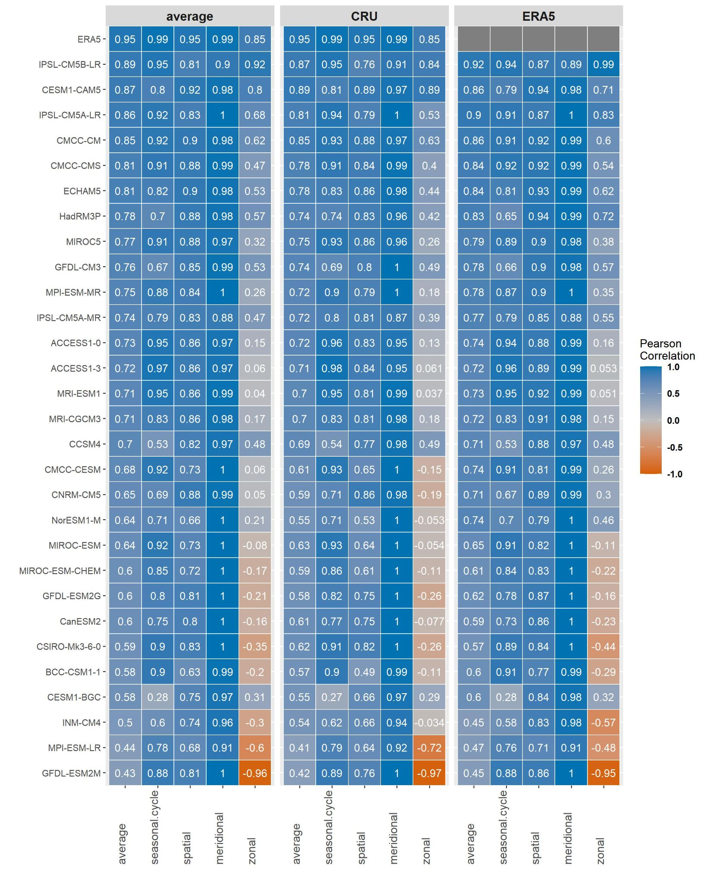
Supplementary Fig 9 Correlation coefficients for models used in the study and observations (CRU) and reanalysis (ERA5), including an average across observations and the reanalysis data, showing the performance of the models in terms of capturing the season cycle and meridional and zonal patterns of rainfall of the hydrological modelling domain and the spatial, patterns of rainfall for the broader domain in the southwestern Cape.

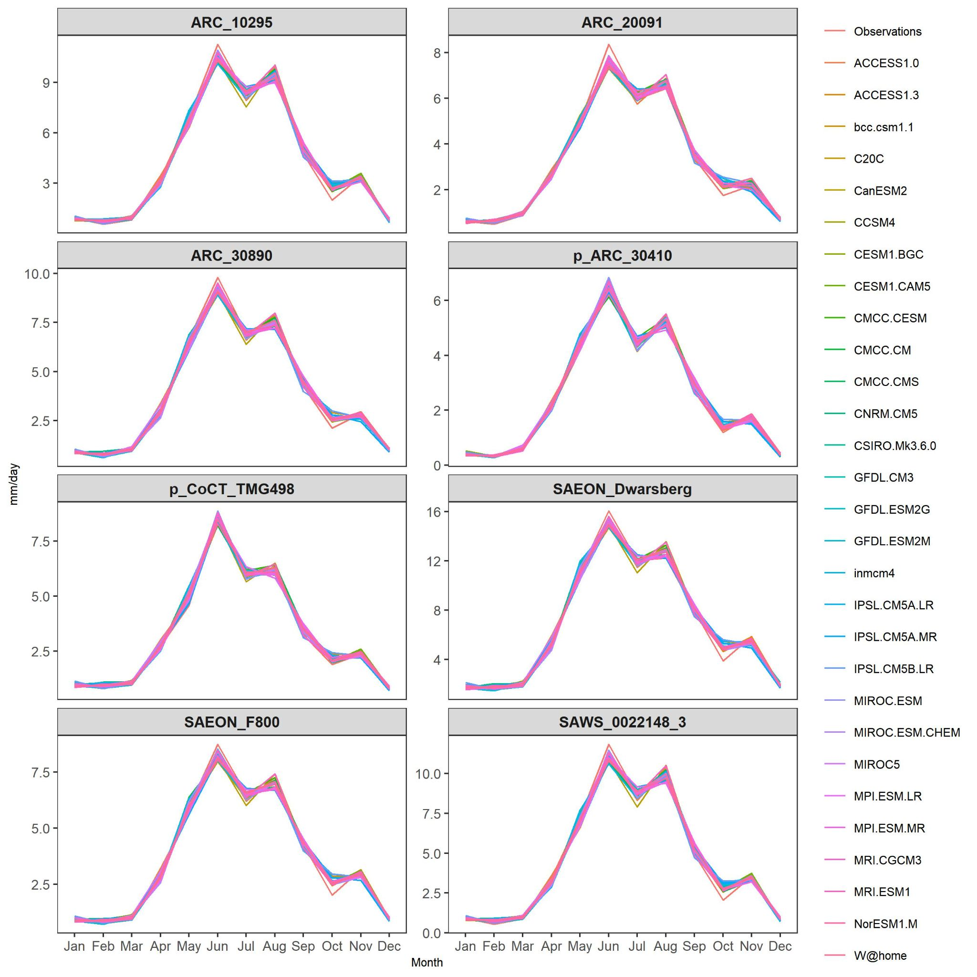 Supplementary Fig. 10 Seasonal cycle of rainfall (mm day-1) for all rainfall stations used to drive the hydrological models (observations) compared to biased corrected model data.
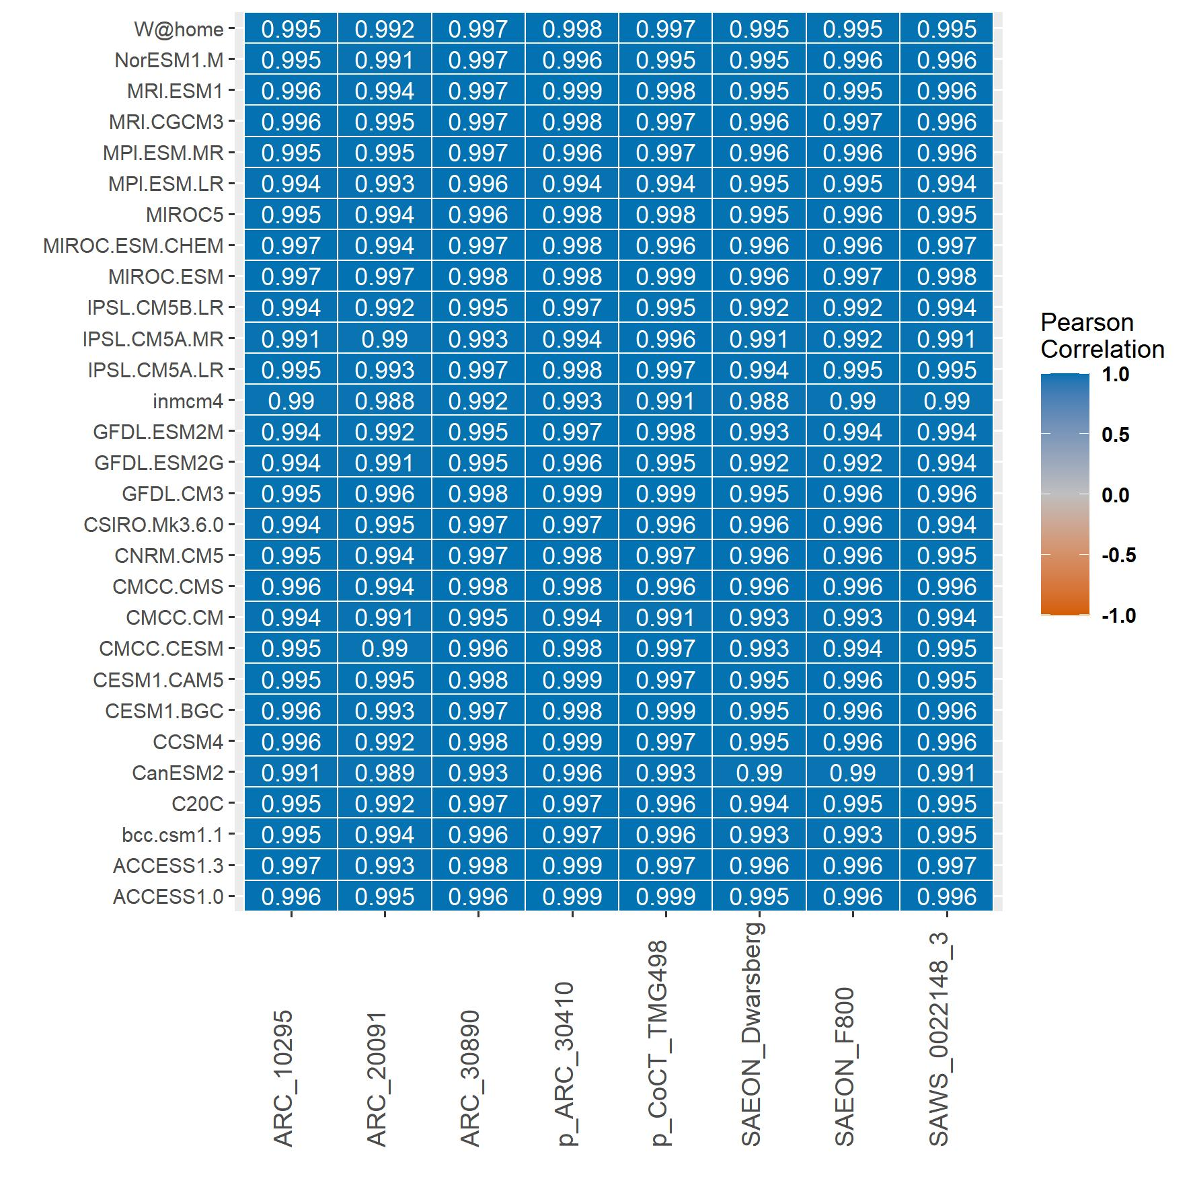 Supplementary Fig. 11 Correlation coefficients for seasonal cycle of rainfall between post biased corrected model data and rainfall stations used to drive the hydrological models compared.

Literature Cited
1 R Core Team. R: A language and environment for statistical computing. (R Foundation for Statistical Computing. URL https://www.R-project.org/, 2020).
2 Rebelo, A. J., Holden, P.B., Hallowes, J., Eady, B., Cullis, J.D., Esler, K.J., New M.G. The hydrological benefits of investing in ecological infrastructure: Alien clearing in the Berg and Breede Catchments, South Africa. Journal of Hydrology (submitted).

