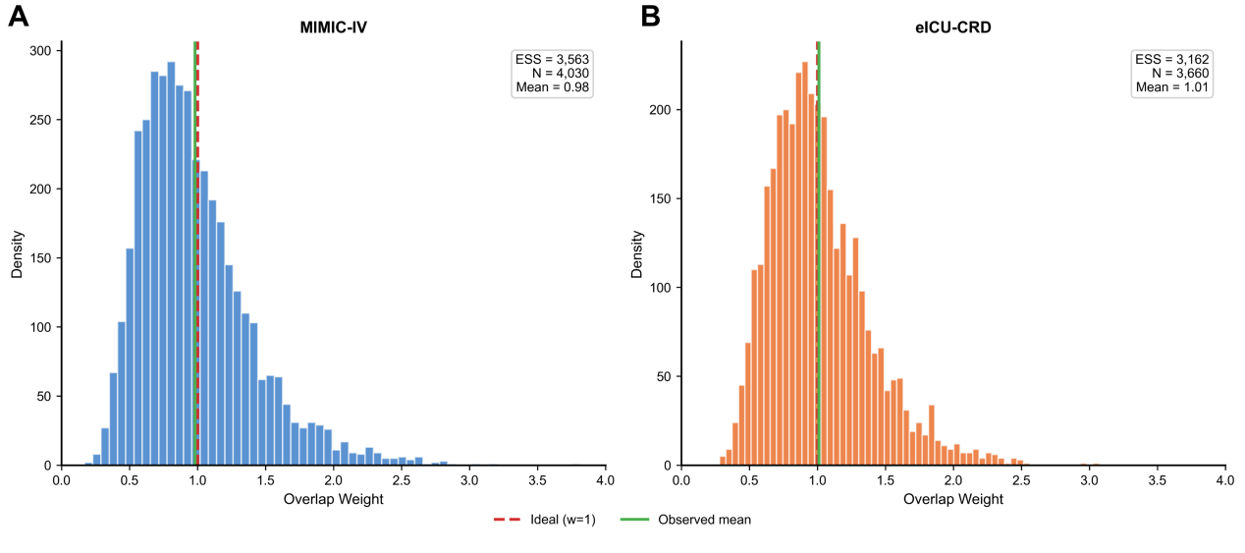
Supplementary Figure S1. Distribution of overlap weights in MIMIC-IV and eICU-CRD
- Distribution of overlap weights in MIMIC-IV for the comparison of early (0–6 h) versus delayed (6–24 h) vasopressin initiation. The red dashed line indicates the ideal weight (w = 1), and the green solid line indicates the observed mean overlap weight. The effective sample size (ESS), total sample size (N), and mean weight are shown in the inset.
B. Distribution of overlap weights in eICU-CRD, with the same annotations as in panel A.

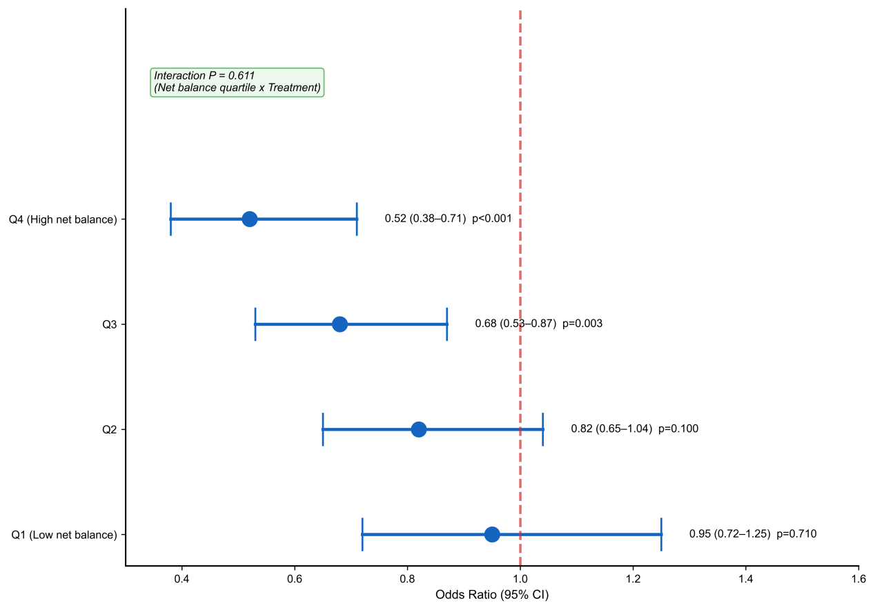
Supplementary Figure S2. Stratified association by net fluid balance quartiles
Association between early versus delayed vasopressin initiation and in-hospital mortality stratified by quartiles of net fluid balance (Q1 lowest to Q4 highest). Points indicate adjusted odds ratios and whiskers indicate 95% confidence intervals. The vertical dashed line indicates an odds ratio of 1.0. The interaction P value corresponds to the treatment-by-quartile interaction term from the prespecified model (net fluid balance quartile × treatment), as annotated in the figure.

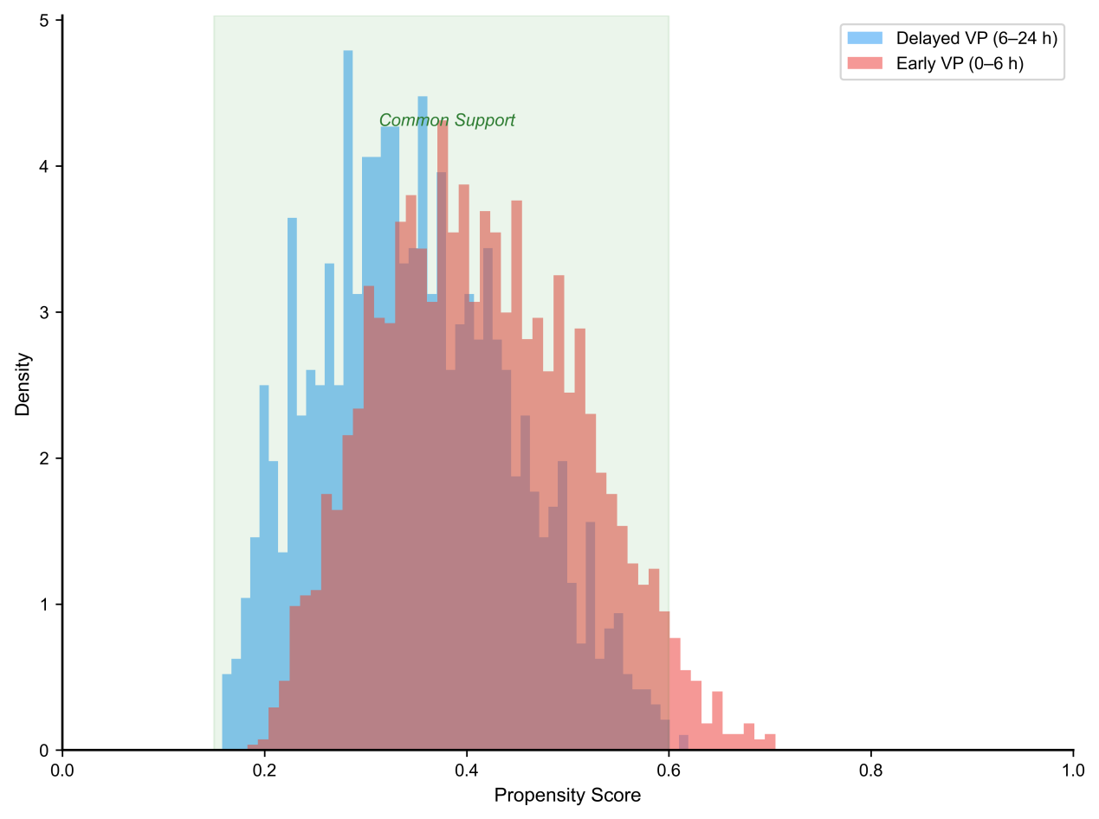
Supplementary Figure S3. Propensity score overlap in eICU-CRD
Distribution of propensity scores for early versus delayed vasopressin initiation among eligible patients in eICU-CRD. The shaded region indicates the area of common support. Propensity scores were estimated using the same prespecified covariates and time window as in the primary analysis.

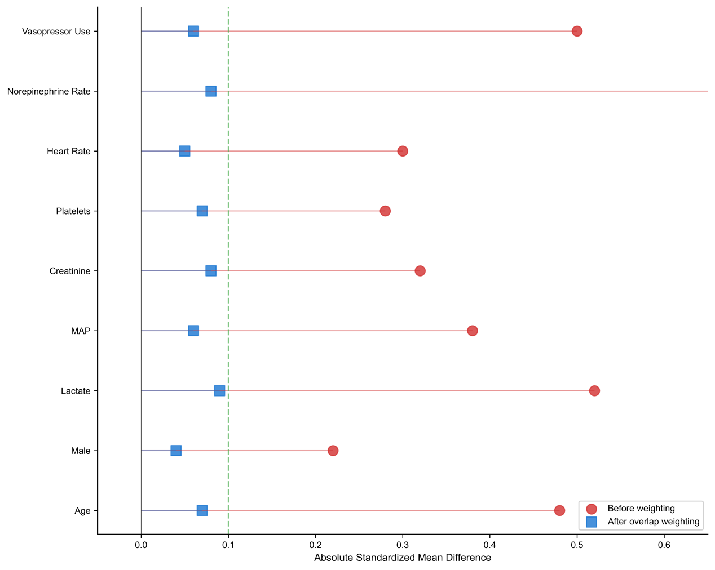
Supplementary Figure S4. Covariate balance before and after overlap weighting in eICU-CRD
Absolute standardized mean differences (SMDs) for prespecified covariates comparing early versus delayed vasopressin initiation in eICU-CRD, before and after propensity score overlap weighting. The vertical dashed line marks an absolute SMD of 0.1, with values below this threshold considered indicative of adequate covariate balance.

