Supplementary Figures for “Heavy ion escape from Martian wake enhanced by magnetic reconnection”
Lei Wang^{1,2,3}, Can Huang*^{1,2,3}, Yasong S. Ge*^{1,2,3}, Aimin Du^{1,2,3}, Rongsheng Wang⁴, Tielong Zhang^{5,6} and Jinqiao Fan^{1,2,3}
¹ Key Laboratory of Earth and Planetary Physics, Institute of Geology and Geophysics, Chinese Academy of Sciences, Beijing, China
² Innovation Academy for Earth Science, Chinese Academy of Sciences, Beijing,
China
³ College of Earth and Planetary Sciences, University of Chinese Academy of Sciences, Beijing, China
⁴CAS Key Laboratory of Geospace Environment, Department of Geophysics and Planetary Science, University of Science and Technology of China, Hefei, Anhui,
China
⁵Institute of Space Science and Applied Technology, Harbin Institute of Technology,
Shenzhen, China
⁶Space Research Institute, Austrian Academy of Sciences, Graz, Austria
*Correspondence to: Can Huang, huangcan@mail.iggcas.ac.cn
Supplementary Fig. 1: The variation of clock angle near the current sheet’s crossing event. MAVEN orbit projection during 09:05:00–10:10:00 UT on the L_{CS}-ρ_{CS} plane, where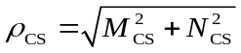. The dashed and dotted lines represent the nominal positions of the bow shock and magnetic pile-up boundary, with parameters from Trotignon et al. (2006)¹. The solid line denotes the trajectory of MAVEN from nominal bow shock to the vicinity of the observed site. The circles with arrows denote the clock angles of the magnetic field vector projected on the M_{CS}-N_{CS} plane at four different times (09:35:00 UT, 09:45:00 UT, 09:55:00 UT, and 10:05:00 UT, respectively). The short vertical lines mark the beginning of the clock angle in a clockwise direction.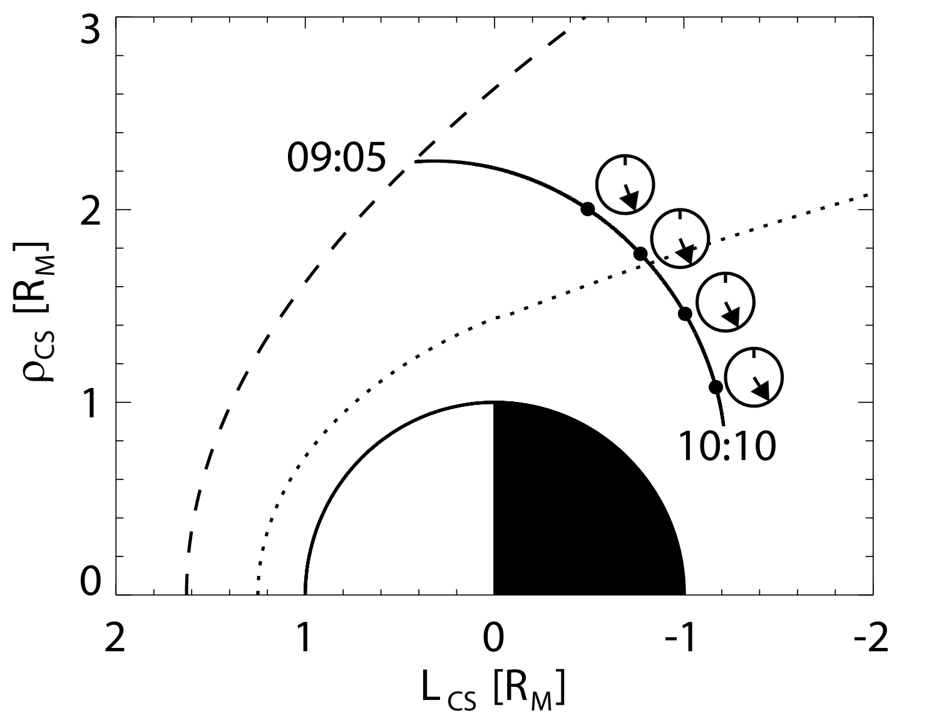
References
- Trotignon, J. G., Mazelle, C., Bertucci, C. & Acuña, M. H. Martian shock and magnetic pile-up boundary positions and shapes determined from the Phobos 2 and Mars Global Surveyor data sets. Planetary and Space Science 54, 357-369, (2006).

