Evolution of Pressure-Induced Shear Amorphization in
Rare-earth Hexaboride
Rajamallu Karre¹, Yidi Shen², Shuangxi Song¹, Yixuan Hu¹, Simanta Lahkar¹, Xiaodong Wang¹, Bikramjit Basu³, Qi An², Kolan Madhav Reddy¹
¹School of Materials Science and Engineering, Shanghai Jiao Tong University, Shanghai 200240, China
²Department of Chemical and Materials Engineering, University of Nevada-Reno, Reno, NV 89557, USA
³Materials Research Center, Indian Institute of Science, Bangalore 560012, India

Supplementary Materials contains
Supplementary Text
Supplementary Fig. S1. Thin TEM specimen preparation by FIB technique.
Supplementary Fig. S2. TEM observation of cross-sectioned indent from the rectangular (011) surface.
Supplementary Fig. S3. The atomic structure viewing along shear direction of [120].
Supplementary Fig.S4. The failure process of EuB₆ under ideal shear deformation along (110)[1$\overline{\text{1}}$0].

Supplementary Text
Indentation cross-section specimen using Focused Ion milling. The large trenches around the selected region are milled (Supplementary Figure 1(b)) using high energy Ga⁺ ions by tilting the sample to an angle of ~52º. This procedure is performed at beam voltage 30 KeV and beam current 3 nA. Then, TEM foil is lifted-out by a microprobe and attached to a copper grid using Pt deposition. In order to attain the uniform thickness and reduced stress effects, milling was carried out on both sides of the sample by a series of tilting ±1.5º relative to 52º under low energy beam condition. This foil was finally achieved to electron transparence by thinning down to a thickness < 80 nm (Supplementary Figure 1(d)).

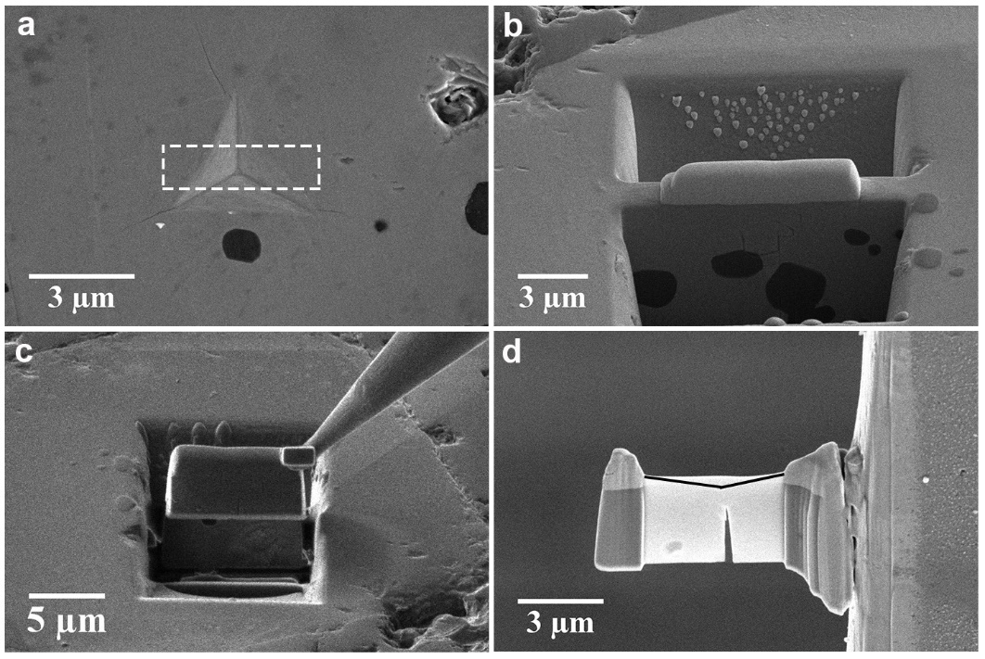
Figure S1. Thin TEM specimen preparation by FIB technique. a, The cross-sectional TEM foil to be cut is shown by the rectangle box on the indent surface. b, Two trenches are made around the selected region by FIB milling. c, Thin foil is lifted out by a microprobe. d, Side view of foil thinned <80 nm attached to the TEM Cu grid.

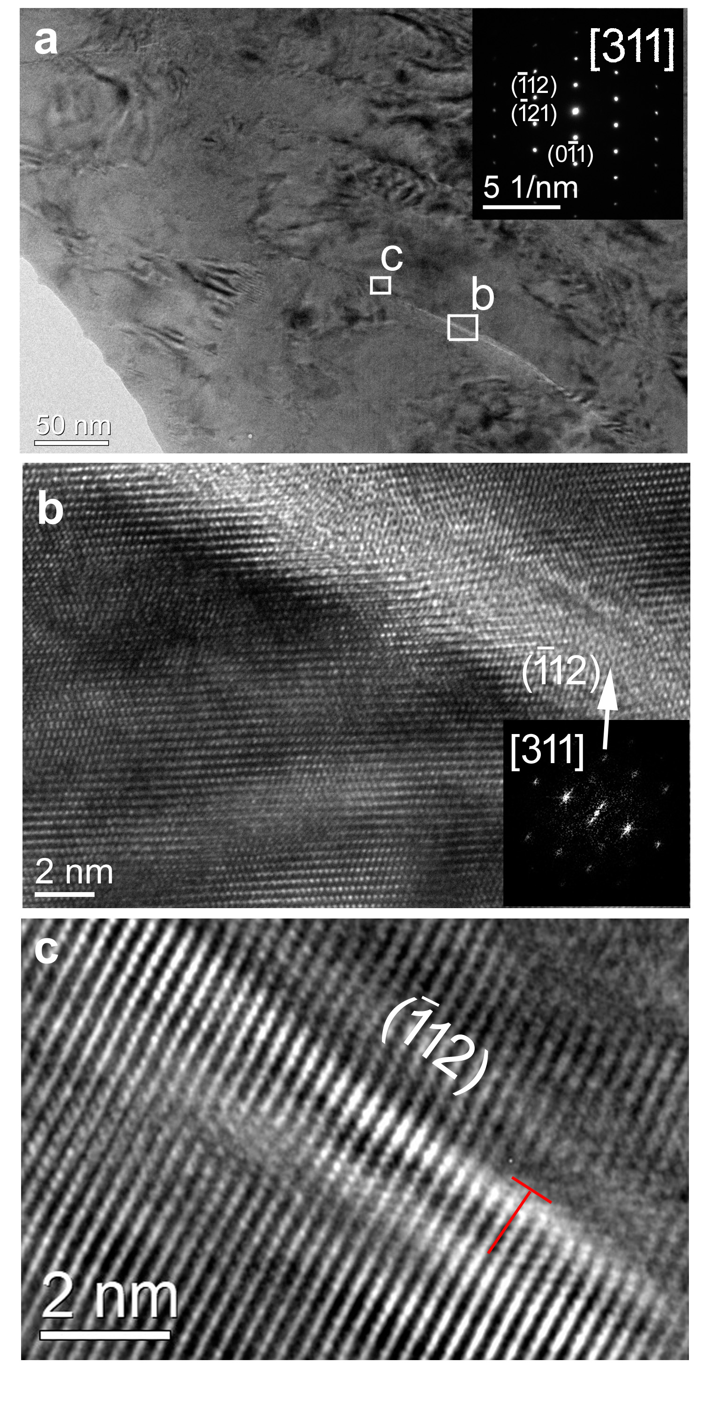

Figure S2. TEM observation of cross-sectioned indent from the rectangular (011) surface. a, Low magnification TEM shows the nanoscale band with length of 200 nm. b, HRTEM taken from the band (a) is evidence of amorphous structure. Inset FFT shows that crystal is projected along the [311] direction and amorphous band roughly aligned to $\left(1\overline{1}2\right)$ plane. c, HRTEM taken from tip of band (indicated area in Fig. 2a) reveal the dislocation pairs.

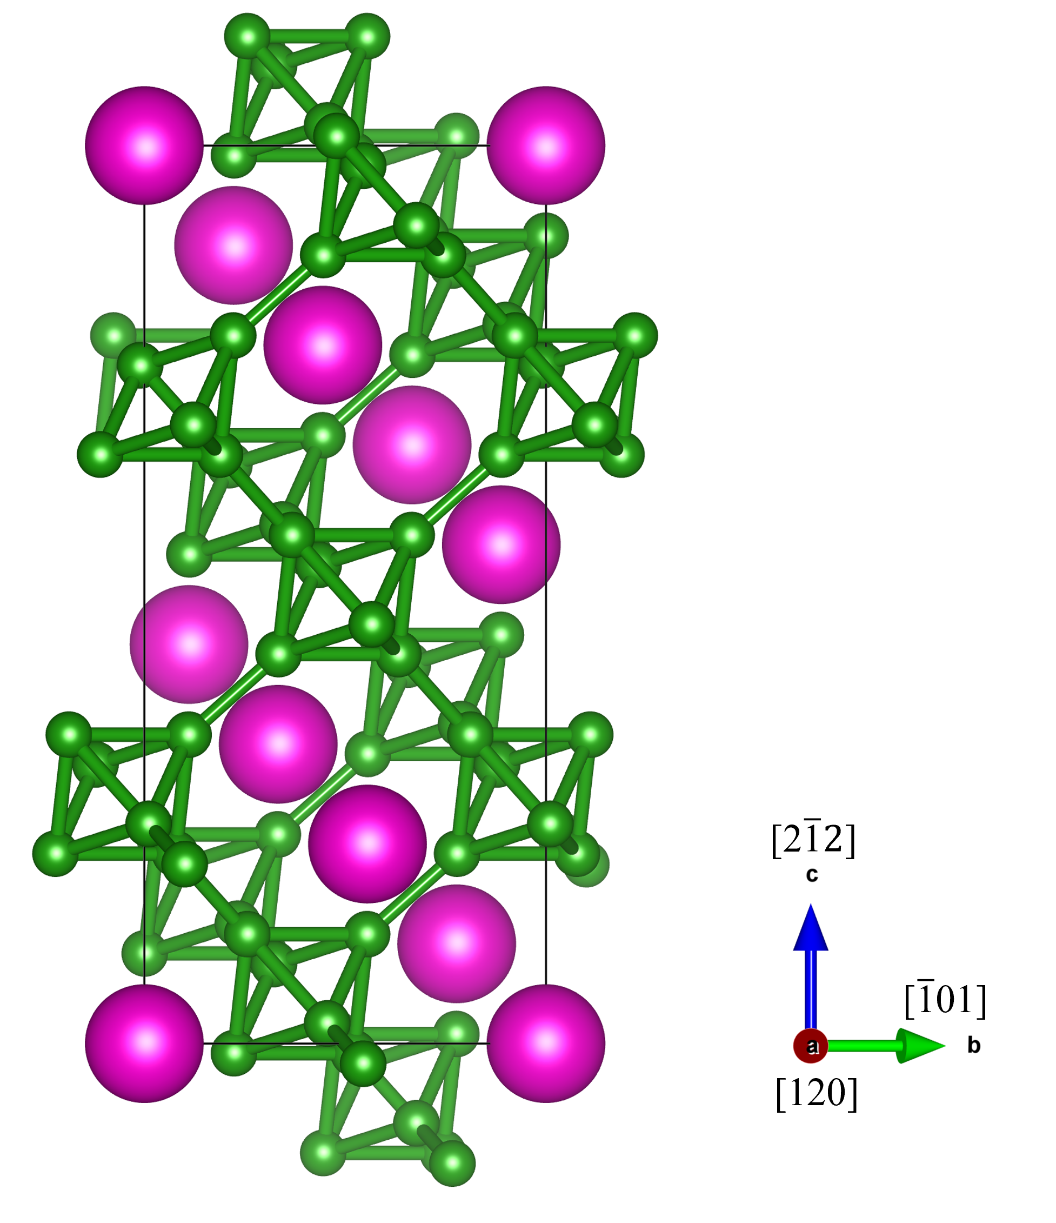

Figure S3. The atomic structure of EuB₆ viewing along shear direction of [120].

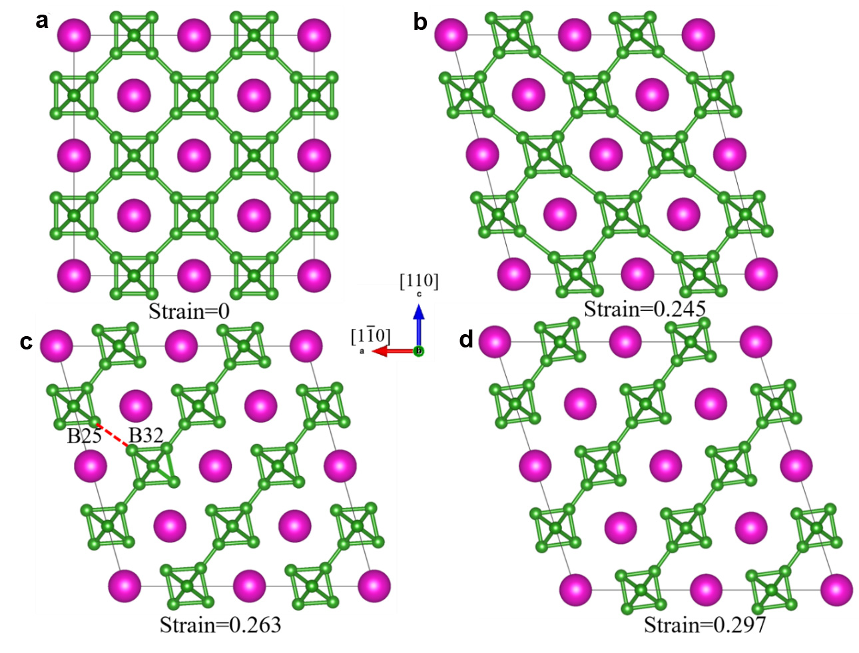
Figure S4. The failure process of EuB₆ under ideal shear deformation along (110)[1$\overline{\text{1}}$0]. a, the intact structure; b, the structure at 0.245 strain with ideal strength; c, the structure at 0.263 strain in which B25-B32 bond breaks; d, the structure at 0.297 strain in which the B25 and B32 atoms are further stretched far from each other.

