Content
Supplementary Tables 3
Table S1. Search Strategy Used in Embase. 3
Table S2. Search Strategy Used in PubMed. 4
Table S3. Definition of Exposure Used in This Study. 7
Table S4. Malignant Neoplasms Classification Framework From WHO Global Health Estimates 2021. 8
Table S5. Characteristics of Included Studies. 9
Table S7. Detailed Parameters of Dose-Response Meta-Analysis on Parity and Site-Specific Cancers. 14
Table S8. Detailed Parameters of Dose-Response Meta-Analysis on Age at First Birth and Site-Specific Cancers. 15
Supplementary Figures 17
Figure S1. Quality of Included Studies. 17
Figure S2. Funnel Plot Assessing Reporting Bias in the Meta-Analysis of Parous Status and Breast Cancer. 18
Figure S3. Funnel Plot Assessing Reporting Bias in the Meta-Analysis of Parous Status and Corpus uteri cancer. 19
Figure S4. Funnel Plot Assessing Reporting Bias in the Meta-Analysis of Parous Status and Thyroid Cancer. 20
Figure S5. Funnel Plot Assessing Reporting Bias in the Meta-Analysis of Parous Status and Ovary Cancer. 21
Figure S6. Funnel Plot Assessing Reporting Bias in the Meta-Analysis of Parous Status and Kidney Cancer. 22
Figure S7. Funnel Plot Assessing Reporting Bias in the Meta-Analysis of Parous Status and Bladder Cancer. 23
Figure S8. Funnel Plot Assessing Reporting Bias in the Meta-Analysis of Parous Status and Colon and rectum cancers. 24
Figure S9. Funnel Plot Assessing Reporting Bias in the Meta-Analysis of Parous Status and Lymphomas, multiple myeloma. 25
Figure S10. Forest Plot of Parous Status and Breast Cancer Association from Case-Control Studies. 26
Figure S11. Forest Plot of Parous Status and Breast Cancer Association from Cohort Studies. 26
Figure S12. Forest Plot of Parous Status and Breast Cancer Association from Both Case-Control and Cohort Studies. 27
Figure S13. Forest Plot of Parous Status and Corpus Uteri Cancer Association from Case-Control Studies. 28
Figure S14. Forest Plot of Parous Status and Corpus Uteri Cancer Association from Cohort Studies. 28
Figure S15. Forest Plot of Parous Status and Corpus Uteri Cancer Association from Both Case-Control and Cohort Studies. 29
Figure S16. Forest Plot of Parous Status and Thyroid Cancer Association from Case-Control Studies. 30
Figure S17. Forest Plot of Parous Status and Thyroid Cancer Association from Cohort Studies. 30
Figure S18. Forest Plot of Parous Status and Thyroid Cancer Association from Both Case-Control and Cohort Studies. 31
Figure S19. Forest Plot of Parous Status and Ovary Cancer Association from Case-Control Studies. 32
Figure S20. Forest Plot of Parous Status and Ovary Cancer Association from Cohort Studies. 32
Figure S21. Forest Plot of Parous Status and Ovary Cancer Association from Both Case-Control and Cohort Studies. 33
Figure S22. Forest Plot of Parous Status and Kidney Cancer Association from Case-Control Studies. 34
Figure S23. Forest Plot of Parous Status and Kidney Cancer Association from Cohort Studies. 34
Figure S24. Forest Plot of Parous Status and Kidney Cancer Association from Both Case-Control and Cohort Studies. 35
Figure S25. Forest Plot of Parous Status and Bladder Cancer Association from Cohort Studies. 36
Figure S26. Forest Plot of Parous Status and Bladder Cancer Association from Both Case-Control and Cohort Studies. 36
Figure S27. Forest Plot of Parous Status and Colon and Rectum Cancers Association from Case-Control Studies. 37
Figure S28. Forest Plot of Parous Status and Colon and Rectum Cancers Association from Both Case-Control and Cohort Studies. 37
Figure S29. Forest Plot of Parous Status and Lymphomas, Multiple Myeloma Association from Case-Control Studies. 38
Figure S30. Forest Plot of Parous Status and Lymphomas, Multiple Myeloma Association from Both Case-Control and Cohort Studies. 38
Reference 39

Supplementary Tables

Table S1. Search Strategy Used in Embase.
Number | Term | Results
#1 | 'pregnancy'/de | 828,507
#2 | 'pregnan*':ti,ab,kw | 865,873
#3 | 'obstetric*':ti,ab,kw | 190,446
#4 | 'abortion':ti,ab,kw | 73,330
#5 | 'fetal death':ti,ab,kw | 10,874
#6 | 'foetal death':ti,ab,kw | 838
#7 | 'fetal demise':ti,ab,kw | 4,159
#8 | 'foetal demise':ti,ab,kw | 126
#9 | 'miscarriage*':ti,ab,kw | 34,331
#10 | 'stillbirth':ti,ab,kw | 17,579
#11 | 'pregnancy'/exp | 921,389
#12 | 'labor'/exp | 50,485
#13 | 'parity'/exp | 49,668
#14 | 'human reproductive':ti,ab,kw | 1,937
#15 | 'human reproduction':ti,ab,kw | 7,971
#16 | 'reproductive procedure'/exp | 1,921
#17 | 'reproductive technique':ti,ab,kw | 718
#18 | 'labor*':ti,ab,kw | 1,201,100
#19 | 'labour*':ti,ab,kw | 58,102
#20 | 'gestation*':ti,ab,kw | 373,169
#21 | 'cesarean section'/exp | 140,570
#22 | 'cesarean sections':ti,ab,kw | 5,968
#23 | 'caesarean section':ti,ab,kw | 34,511
#24 | 'caesarean sections':ti,ab,kw | 5,460
#25 | 'abdominal delivery':ti,ab,kw | 535
#26 | 'abdominal deliveries':ti,ab,kw | 109
#27 | #1 OR #2 OR #3 OR #4 OR #5 OR #6 OR #7 OR #8 OR #9 OR #10 OR #11 OR #12 OR #13 OR #14 OR #15 OR #16 OR #17 OR #18 OR #19 OR #20 OR #21 OR #22 OR #23 OR #24 OR #25 OR #26 | 2,657,302
#28 | 'female'/exp | 12,836,170
#29 | 'woman':ti,ab,kw | 376,253
#30 | women':ti,ab,kw | 1,766,443
#31 | #28 OR #29 OR #30 | 13,080,297
#32 | 'neoplasm'/exp | 6,441,336
#33 | 'cancer':ti,ab,kw | 3,390,349
#34 | 'cancer*':ti,ab,kw | 3,522,678
#35 | tumor*':ti,ab,kw | 2,606,111
#36 | 'tumour*':ti,ab,kw | 464,120
#37 | 'neoplasm*':ti,ab,kw | 380,878
#38 | 'carcinoma*':ti,ab,kw | 1,130,990
#39 | 'sarcoma*':ti,ab,kw | 153,869
#40 | #32 OR #33 OR #34 OR #35 OR #36 OR #37 OR #38 OR #39 | 7,481,603
#41 | 'incidence'/exp | 745,621
#42 | 'incidence rate':ti,ab,kw | 75,425
#43 | 'odds ratio'/exp | 33,804
#44 | 'incident':ti,ab,kw | 152,138
#45 | 'risk ratio':ti,ab,kw | 39,051
#46 | 'hazard ratio':ti,ab,kw | 212,083
#47 | #41 OR #42 OR #43 OR #44 OR #45 OR #46 | 1,117,904
#48 | 'adult'/exp | 11,932,258
#49 | 'adults':ti,ab,kw | 1,100,950
#50 | #48 OR #49 | 12,192,015
#51 | 'cohort analysis'/exp | 1,227,840
#52 | 'cohort':ti,ab,kw | 1,501,570
#53 | 'case control study'/exp | 241,565
#54 | 'case-control':ti,ab,kw | 221,583
#55 | 'prospective study'/exp | 941,588
#56 | 'prospective study':ti,ab,kw | 265,186
#57 | 'retrospective study'/exp | 1,692,271
#58 | 'retrospective':ti,ab,kw | 1,399,871
#59 | #51 OR #52 OR #53 OR #54 OR #55 OR #56 OR #57 OR #58 | 241,105
#60 | #27 AND #31 AND #40 AND #47 AND #59 | 6,907

Table S2. Search Strategy Used in PubMed.
Number | Term | Results
#1 | "Pregnancy"[Mesh] | 1,042,326
#2 | "pregnan*"[Tiab] | 648,471
#3 | "Obstetric*"[tiab] | 1,067
#4 | "Abortion"[tiab] | 63,346
#5 | "Fetal death"[tiab] | 8,974
#6 | "Foetal death"[tiab] | 558
#7 | "Fetal demise"[tiab] | 2,270
#8 | "Foetal demise"[tiab] | 77
#9 | "Miscarriage*"[tiab] | 19,873
#10 | "Stillbirth"[tiab] | 12,256
#11 | "Gravidity"[Mesh] | 1,363
#12 | "Labor, obstetric"[Mesh] | 49,625
#13 | "parity"[Mesh] | 27,114
#14 | "Human Reproductive"[Tiab] | 1,601
#15 | "Human Reproduction"[Tiab] | 3,368
#16 | "Reproductive Techniques"[Mesh] | 172,910
#17 | "Reproductive Technique"[Tiab] | 465
#18 | "labor*"[Tiab] | 843,019
#19 | "labour*"[Tiab] | 40,934
#20 | "gestation*"[Tiab] | 263,331
#21 | "Cesarean Section"[Mesh] | 55,329
#22 | "Cesarean Sections"[Tiab] | 4,276
#23 | "Caesarean Section"[Tiab] | 20,590
#24 | "Caesarean Sections"[Tiab] | 3,017
#25 | "Abdominal Delivery"[Tiab] | 339
#26 | "Abdominal Deliveries"[Tiab] | 84
#27 | (#1 OR #2 OR #3 OR #4 OR #5 OR #6 OR #7 OR #8 OR #9 OR #10 OR #11 OR #12 OR #13 OR #14 OR #15 OR #16 OR #17 OR #18 OR #19 OR #20 OR #21 OR #22 OR #23 OR #24 OR #25 OR #26) | 1,376,815
#28 | "woman"[Tiab] | 276,180
#29 | "women"[Tiab] | 1,261,402
#30 | "female"[Mesh] | 9,936,088
#31 | (#28 OR #29 OR #30) | 10,178,875
#32 | "Neoplasms"[Mesh] | 4,026,083
#33 | "Cancer"[Tiab] | 2,351,837
#34 | "cancer*"[Tiab] | 2,450,752
#35 | "tumor*"[Tiab] | 1,881,967
#36 | "tumour*"[Tiab] | 321,660
#37 | "neoplasm*"[Tiab] | 327,548
#38 | "carcinoma*"[Tiab] | 821,187
#39 | "sarcoma*"[Tiab] | 119,356
#40 | (#32 OR #33 OR #34 OR #35 OR #36 OR #37 OR #38 OR #39) | 5,272,918
#41 | "Incidence"[Mesh] | 312,055
#42 | "Incidence Rate"[Tiab] | 38,461
#43 | "Odds Ratio"[Mesh] | 95,410
#44 | "incident"[Tiab] | 112,940
#45 | "Risk Ratio"[Tiab] | 31,008
#46 | "Hazard Ratio"[Tiab] | 152,397
#47 | (#41 OR #42 OR #43 OR #44 OR #45 OR #46) | 674,506
#48 | "adult"[Mesh] | 8,205,045
#49 | "adults"[Tiab] | 824,125
#50 | (#48 OR #49) | 8,480,038
#51 | "Cohort Studies"[Mesh] | 2,658,706
#52 | "Cohort"[Tiab] | 896,273
#53 | "Case-Control Studies"[Mesh] | 1,542,479
#54 | "Case-Control"[Tiab] | 167,232
#55 | "Prospective Studies"[Mesh] | 699,143
#56 | "Prospective Study"[Tiab] | 172,025
#57 | "Retrospective Studies"[Mesh] | 1,234,787
#58 | "Retrospective"[Tiab] | 847,360
#59 | (#51 OR #52 OR #53 OR #54 OR #55 OR #56 OR #57 OR #58) | 241,105
#60 | (#27 AND #31 AND #40 AND #47 AND #50 AND #59) | 2,078

Table S3. Definition of Reproductive History in This Study.
No. | Exposure | Definition | Explanation
1 | parous | Whether the participants had a full-term pregnancy or live birth. | - For studies that did not clearly distinguish between pregnancy and full-term pregnancy, 'pregnancy' = 'full-term pregnancy'.  - If 'abortion', 'miscarriage' and other words were mentioned to mean that the whole process of pregnancy was not completed, this study made a distinction, and 'pregnancy' ≠ 'full-term pregnancy'.  - Some other words describe the same meaning as full-term pregnancy or their meaning can be included, and they are considered to be the same in this study, such as' full-term pregnancy '=' Live birth '=' birth '=' parous'.
2 | parity | The number of full-term pregnancies of the participants. | - In this study, parity is the meaning of parity, considering the situation of multiple births, so "parity" ≠ "Number of children" in this study.  - The case of possible synonymy is the same as that described in exposure 1.
3 | age at first birth | Age at first full-term pregnancy of the participants. | "Birth" was defined in the same way as exposure 1.

Table S4. Malignant Neoplasms Classification Framework from WHO Global Health Estimates 2021.
No. | Cancer Type
1. | Mouth and oropharynx cancers
 | a. | Lip and oral cavity
 | b. | Nasopharynx
 | c. | Other pharynx
2. | Oesophagus cancer
3. | Stomach cancer
4. | Colon and rectum cancers
5. | Liver cancer
 | a. | Liver cancer secondary to hepatitis B
 | b. | Liver cancer secondary to hepatitis C
 | c. | Liver cancer secondary to alcohol use
 | d. | Other liver cancer
6. | Pancreas cancer
7. | Trachea, bronchus, lung cancers
8. | Melanoma and other skin cancers
 | a. | Malignant skin melanoma
 | b. | Non-melanoma skin cancer
9. | Breast cancer
10. | Cervix uteri cancer
11. | Corpus uteri cancer
12. | Ovary cancer
13. | Prostate cancer
14. | Testicular cancer
15. | Kidney cancer
16. | Bladder cancer
17. | Brain and nervous system cancers
18. | Gallbladder and biliary tract cancer
19. | Larynx cancer
20. | Thyroid cancer
21. | Mesothelioma
22. | Lymphomas, multiple myeloma
 | a. | Hodgkin lymphoma
 | b. | Non-Hodgkin lymphoma
 | c. | Multiple myeloma
23. | Leukaemia
24. | Other malignant neoplasms

Table S5. Characteristics of Included Studies.
Author | Design | Country | Race | Cancer Type | Sample size
(Ewertz & Duffy, 1988) | case-control | Denmark | Danish | Breast cancer | 2,822
(Layde et al., 1989) | case-control | America | NA | Breast cancer | 9,135
(Peters et al., 1990) | case-control | USA, Canada, western Europe | White | Colon and rectum cancers | 654
(Parazzini et al., 1991) | case-control | Italy | NA | Ovary cancer | 328
(Kalache et al., 1993) | case-control | Brazil | NA | Breast cancer | 1,018
(John et al., 1993) | case-control | USA | NA | Ovary cancer | 475
(Cantor et al., 1993) | case-control | USA | American | Brain and nervous system cancers | 1,896
(Adami et al., 1994) | case-control | Sweden | Swedish | Ovary cancer | 23,976
(Marcus et al., 1995) | case-control | USA | NA | Colon and rectum cancers | 3,094
(Galanti et al., 1995) | case-control | Sweden | NA | Thyroid cancer | 8,428
(Clavel-Chapelon et al., 1995) | case-control | France | white | Breast cancer | 1,037
(Chow et al., 1995) | case-control | USA | NA | Kidney cancer | 392
(Talamini et al., 1996) | case-control | Italy | NA | Breast cancer | 5,157
(Ramon, 1996) | case-control | Spain | NA | Breast cancer | 368
(Lambe, Thörn, et al., 1996) | case-control | Sweden | Swedish | Melanoma and other skin cancers | 28,667
(Tavani et al., 1996) | case-control | Italy | NA | Gallbladder and biliary tract cancer | 408
(Wu et al., 1996) | case-control | Chinese, Japanese or Filipino | Asian Americans | Breast cancer | 1,260
(Lambe, Hsieh, et al., 1996) | case-control | Sweden | Swedish | Breast cancer | 76,692
(Galanti et al., 1996) | case-control | Sweden, Norway | NA | Thyroid cancer | 532
(Takezaki et al., 1996) | case-control | Japan | NA | Thyroid cancer | 26,760
(Tavani et al., 1997) | case-control | Italy | NA | Lymphomas, multiple myeloma | 767
(Adami et al., 1997) | case-control | Sweden | Swedish | Lymphomas, multiple myeloma | 10,464
(Ngelangel et al., 1998) | case-control | the Philippines | NA | Cervix uteri cancer | 737
(Smith et al., 1998) | case-control | USA | white | Melanoma and other skin cancers | 541
(Karlson et al., 1998) | case-control | Sweden | NA | Pancreas cancer | 6,088
(Negri et al., 1999) | case-control | / | NA | Thyroid cancer | 5,946
(Tavani et al., 1999) | case-control | Italy | NA | Breast cancer | 1,247
(Gao et al., 2000) | case-control | China | Chinese | Breast cancer | 3,015
(Fioretti et al., 2000) | case-control | Italy | Italian | Other malignant neoplasms | 609
(Titus-Ernstoff et al., 2001) | case-control | USA | NA | Ovary cancer | 1,086
(Fioretti et al., 2000) | case-control | USA | NA | Thyroid cancer | 984
(Rastad et al., 2001) | case-control | Sweden | NA | Other malignant neoplasms | 10,800
(Chiaffarino et al., 2001) | case-control | Italy | NA | Ovary cancer | 3,442
(Riman et al., 2001) | case-control | Sweden | NA | Ovary cancer | 4,092
(Riman et al., 2001) | case-control | Sweden | Swedish | Lymphomas, multiple myeloma | 8,124
(Kuru et al., 2002) | case-control | Turkey | NA | Breast cancer | 1,114
(Yen et al., 2003) | case-control | Taiwan, China | Fukien, Hakka, Aborigine, Mainland | Ovary cancer | 455
(Muñoz et al., 2002) | case-control | NA | NA | Cervix uteri cancer | 2,055
(Sanchez-Zamorano et al., 2003) | case-control | Mexico | NA | Ovary cancer | 112
(Xu et al., 2004) | case-control | China | NA | Corpus uteri cancer | 1,666
(Wrensch et al., 2003) | case-control | USA | White | Breast cancer | 571
(Zhang et al., 2004) | case-control | USA | NA | Lymphomas, multiple myeloma | 1,318
(Truong et al., 2005) | case-control | New Caledonia(South Pacific) | Melanesian | Thyroid cancer | 647
(Okamura et al., 2006) | case-control | Japan | NA | Corpus uteri cancer | 251
(Brinton et al., 2007) | case-control | Poland | Polish | Corpus uteri cancer | 2,476
(Peterson et al., 2008) | case-control | USA | America | Breast cancer | 3,462
(Brindel et al., 2008) | case-control | French Polynesia | Polynesian,Poly~Asian,Poly~European | Thyroid cancer | 525
(Lee et al., 2008) | case-control | USA | NA | Lymphomas, multiple myeloma | 1,427
(Huo et al., 2008) | case-control | Nigeria | NA | Breast cancer | 1,388
(Bahmanyar et al., 2008) | case-control | Sweden | Swedish | Stomach cancer | 16,704
(Phipps et al., 2008) | case-control | USA | NA | Breast cancer | 2,499
(Fujita et al., 2008) | case-control | Japan | Japanese | Cervix uteri cancer | 2,411
(Zucchetto et al., 2008) | case-control | Italy | NA | Kidney cancer | 819
(Wernli et al., 2009) | case-control | USA | NA | Colon and rectum cancers | 2,078
An(Lo et al., 2010) | case-control | Egypt | NA | Colon and rectum cancers | 860
(Tsilidis et al., 2010) | case-control | 10 European countries | NA | Colon and rectum cancers | 337,802
(Purdue et al., 2011) | case-control | USA | Black,White | Kidney cancer | 1,043
(Dietrich et al., 2011) | case-control | USA | NA | Bladder cancer | 670
(Pocobelli et al., 2011) | case-control | USA | NA | Corpus uteri cancer | 3,846
(Hajian-Tilaki & Kaveh-Ahangar, 2011) | case-control | Iran | NA | Breast cancer | 300
(Setiawan et al., 2012) | case-control | USA | NA | Corpus uteri cancer | 25,233
(Islam et al., 2012) | case-control | Japan | Japanese | Breast cancer | 2,118
(Lu & Lagergren, 2012) | case-control | Sweden | NA | Oesophagus cancer | 7,964
(Palmer et al., 2014) | case-control | USA | African American | Breast cancer | 15,999
(Anic et al., 2014) | case-control | USA | Caucasian, Non~Caucasian | Brain and nervous system cancers | 1,449
(Nguyen et al., 2016) | case-control | Vietnam | NA | Breast cancer | 1,798
(Hajiebrahimi et al., 2016) | case-control | Sweden | NA | Breast cancer | 16,654
(Pasalich et al., 2013) | case-control | China | Asian | Ovary cancer | 1,000
(Brinton et al., 2017) | case-control | Ghana | African | Breast cancer | 4,363
(Ellingjord-Dale et al., 2017) | case-control | Norway | Norwegian | Breast cancer | 38,826
(Balekouzou et al., 2017) | case-control | CAR | CAR's population | Breast cancer | 522
Camilla(Sköld et al., 2018) | case-control | Denmark, Norway, Finland, Sweden | NA | Ovary cancer | 118,821
Isabelle(Romieu et al., 2018) | case-control | America | NA | Breast cancer | 576
(Rennert et al., 2020) | case-control | Israel | JEWS | Colon and rectum cancers | 5,200
(Vohra et al., 2019) | case-control | Nepali | NA | Trachea, bronchus, lung cancers | 494
(Feng et al., 2019) | case-control | China | Chinese | Mouth and oropharynx cancers | 1,364
(Wang et al., 2021) | case-control | China | NA | Thyroid cancer | 4,522
(Bryk et al., 2021) | case-control | Finland | Finnish | Ovary cancer | 3,030
(Sung et al., 2023) | case-control | Korean | NA | Ovary cancer | 2,655
(Leon, 1989) | cohort | UK | NA | Breast cancer | 113,263
(Vatten & Kvinnsland, 1992) | cohort | Norwegian | NA | Breast cancer | 29,981
(Albrektsen et al., 1994) | cohort | Norway | Norwegian | Breast cancer | 1,071,795
(Albrektsen et al., 1995) | cohort | Norway | Norwegian | Breast cancer | 765,756
(Albrektsen et al., 1996) | cohort | Norway | Norwegian | Ovary cancer | 1,145,076
(Troisi et al., 1997) | cohort | USA | NA | Colon and rectum cancers | 57,529
(Albrektsen et al., 1997) | cohort | Norway | Norwegian | Ovary cancer | 1,145,076
(Wohlfahrt et al., 2001) | cohort | Denmark | NA | Breast cancer | 1,529,512
(Cerhan et al., 2002) | cohort | USA | White | Lymphomas, multiple myeloma | 37,934
Julie(Palmer et al., 2003) | cohort | USA | African~American | Breast cancer | 56,725
(Skinner et al., 2003) | cohort | USA | NA | Pancreas cancer | 115,471
(Tamakoshi, Wakai, Kojima, Watanabe, Hayakawa, Toyoshima, Yatsuya, Kondo, Tokudome, Hashimoto, Suzuki, Suzuki, et al., 2004) | cohort | Japan | NA | Colon and rectum cancers | 38,420
(Tamakoshi, Wakai, Kojima, Watanabe, Hayakawa, Toyoshima, Yatsuya, Kondo, Tokudome, Hashimoto, Suzuki, Ito, et al., 2004) | cohort | Japan | NA | Colon and rectum cancers | 36,629
(Navarro Silvera et al., 2006) | cohort | Canada | NA | Brain and nervous system cancers | 89,835
(Tamakoshi et al., 2005) | cohort | Japan | NA | Breast cancer | 38,159
(Wernli et al., 2006) | cohort | China | NA | Corpus uteri cancer | 267,400
(Lujan-Barroso et al., 2020) | cohort | Europe | NA | Bladder cancer | 333,919
(Cantwell et al., 2006) | cohort | USA | Caucasian, African, Hispanic, Asian | Bladder cancer | 61,430
(Kabat et al., 2007) | cohort | Canada | NA | Kidney cancer | 89,821
Jennifer(Lin et al., 2007) | cohort | USA | NA | Colon and rectum cancers | 39,876
(Weiss et al., 2008) | cohort | China | NA | Trachea, bronchus, lung cancers | 73,358
(Butt et al., 2009) | cohort | Sweden | Swedish | Breast cancer | 16,459
(Pham et al., 2009) | cohort | Japan | Asian | Thyroid cancer | 379,281
(Dossus et al., 2010) | cohort | 10 European countries (Denmark, France, Germany, Greece, Italy, the Netherlands, Norway, Spain, Sweden and United Kingdom) | NA | Corpus uteri cancer | 302,618
(Palmer et al., 2011) | cohort | USA | African American | Breast cancer | 59,000
(Kabat et al., 2011) | cohort | USA | NA | Brain and nervous system cancers | 225,355
(Green et al., 2012) | cohort | UK | NA | Stomach cancer | 1,319,409
(Weibull et al., 2013) | cohort | Sweden | NA | Bladder cancer | 2,009,811
(Karami et al., 2013) | cohort | USA | NA | Kidney cancer | 283,952
Nan(Song et al., 2015) | cohort | Korean | NA | Breast cancer | 3,430
(Fortner et al., 2015) | cohort | Denmark, France, Germany, Greece, Italy, the Netherlands, Norway, Spain, Sweden and the United Kingdom | NA | Ovary cancer | 334,225
(Tan et al., 2015) | cohort | Singapore | Chinese | Trachea, bronchus, lung cancers | 28,222
(Gay et al., 2015) | cohort | Singapore | Asian | Ovary cancer | 28,234
(Paltiel et al., 2016) | cohort | Israel and Palestine | NA | Ovary cancer | 42,956
(Teng et al., 2017) | cohort | Japan | Japanese | Pancreas cancer | 45,617
(Zabuliene et al., 2017) | cohort | Lithuanian | NA | Thyroid cancer | 868,105
(Makiuchi et al., 2017) | cohort | Japan | NA | Gallbladder and biliary tract cancer | 55,786
(Sponholtz et al., 2017) | cohort | USA | black | Corpus uteri cancer | 47,555
(Nichols et al., 2019) | cohort | NA | NA | Breast cancer | 889,944
(Tanaka et al., 2019) | cohort | Japan | Japanese | Lymphomas, multiple myeloma | 54,185
(Husby et al., 2019) | cohort | Denmark | NA | Corpus uteri cancer | 2,311,332
(Steponavičiene et al., 2018) | cohort | Lithuanian | NA | Breast cancer | 819,222
(Alvarez et al., 2021) | cohort | Norway | Norwegian | Pancreas cancer | 172,472
(Yin et al., 2024) | cohort | Japan, Korea, China, and Singapore | Asian | Trachea, bronchus, lung cancers | 308,949
(Abe et al., 2024) | cohort | USA | African American, Native Hawaiian, Japanese American, Latino, White | Papillary thyroid cancer | 118,334
*NA: represents that there is no clear description in the original article.

Table S7. Detailed Parameters of Dose-Response Meta-Analysis on Parity and Site-Specific Cancers.
Cancer Type | Model Type | Model χ² (p) | β for linear relationship (p) | β for non-linear relationship (p) | RES (95%CI)  for linear relationship | I² (%)
Breast cancer | Quadratic | *93.832 (<0.001) | *-0.076 (0.009) | -0.008 (0.209) | 0.927 (0.876-0.981) | 56.5
Ovary cancer | Linear | *6.386 (0.012) | *-0.146 (0.011) | / | 0.864 (0.741-0.969) | 73.0
Thyroid cancer | Quadratic | *6.955 (0.031) | 0.104 (0.184) | -0.005 (0.673) | / | 20.5
Colon and rectum cancers | Quadratic | 2.564 (0.278) | 0.093 (0.332) | -0.021 (0.228) | / | 66.0
Corpus uteri cancer | Quadratic | *13.942 (<0.001) | *-0.344 (<0.001) | 0.034 (0.085) | 0.709 (0.584-0.861) | 89.4
Trachea, bronchus, lung cancers | Quadratic | *8.813 (0.012) | *-0.232 (0.005) | *0.030 (0.003) | 0.794 (0.676-0.932) | 54.8
Bladder cancer | Quadratic | *12.524 (0.002) | -0.056 (0.607) | -0.005 (0.841) | / | 58.9
Kidney cancer | Quadratic | *7.313 (0.026) | 0.062 (0.352) | 0.005 (0.750) | / | 0.0
Lymphomas, multiple myeloma | Quadratic | 2.511 (0.285) | -0.052 (0.246) | 0.006 (0.527) | / | 17.9
Pancreas cancer | Quadratic | 2.402 (0.301) | -0.102 (0.137) | 0.014 (0.350) | / | 46.9
Cervix uteri cancer | Linear | 0.285 (0.593) | 0.095 (0.593) | / | / | 91.0
Brain and nervous system cancers | Linear | 2.298 (0.123) | -0.077 (0.130) | / | / | 71.8
*: Statistically significant difference with α=0.05.

Table S8. Detailed Parameters of Dose-Response Meta-Analysis on Age at First Birth and Site-Specific Cancers.
Cancer Type | Model Type | Model χ²(p) | β for linear relationship (p) | β for non-linear relationship (p) | RES (95%CI)  for linear relationship | I ²(%)
Breast cancer | Linear | *24.461 (<0.001) | *0.026 (<0.001) | / | 1.027 (1.016-1.038) | 69.8
Melanoma and other skin cancers | Linear | *21.158 (<0.001) | *0.025 (<0.001) | / | 1.025 (1.014-1.036) | 0.0
Gallbladder and biliary tract cancer | Linear | 0.425 (0.515) | 0.020 (0.515) | / | 1.020 (0.961-1.083) | 18.7
Other malignant neoplasms | Linear | 0.361 (0.548) | 0.031 (0.548) | / | 1.031 (0.934-1.138) | 73.3
Lymphomas, multiple myeloma | Quadratic | 0.581 (0.748) | 0.033 (0.446) | -0.0007 (0.447) | / | 0.0
Oesophagus cancer | Quadratic | 2.280 (0.320) | 0.211 (0.151) | -0.0043 (0.141) | / | 12.8
Kidney cancer | Quadratic | 3.511 (0.173) | 0.376 (0.094) | -0.0080 (0.087) | / | 0.0
Corpus uteri cancer | Quadratic | 8.903 (0.112) | 0.239 (0.073) | *-0.0057 (0.045) | / | 52.2
Ovary cancer | Quadratic | 1.871 (0.392) | -0.257 (0.250) | 0.0047 (0.265) | / | 59.4
Colon and rectum cancers | Quadratic | 0.628 (0.731) | -0.094 (0.460) | 0.0018 (0.452) | / | 55.1
Thyroid cancer | Quadratic | 4.514 (0.105) | *-0.396 (0.035) | *0.0082 (0.034) | 0.673 (0.463-0.975) | 0.0
Pancreas cancer | Quadratic | *21.970 (<0.001) | -0.366 (0.118) | 0.0069 (0.149) | / | 6.2
Trachea, bronchus, lung cancers | Quadratic | 2.357 (0.308) | -0.297 (0.290) | 0.0063 (0.270) | / | 70.6
Brain and nervous system cancers | Quadratic | 1.135 (0.567) | -0.219 (0.387) | 0.0045 (0.406) | / | 40.2
Bladder cancer | Quadratic | *23.399 (<0.001) | -0.063 (0.259) | 0.0008 (0.461) | / | 0.0
Stomach cancer | Linear | 1.115 (0.291) | -0.010 (0.291) | / | 0.990 (0.971-1.009) | 0.0
*: Statistically significant difference with α=0.05.

Table S9. GRADE Summary of Findings Table.
Exposure & Outcome | Effect (RR, 95% CI) | Number of Studies / Participants | Certainty of Evidence (GRADE) | Reasons for Rating
Ever-parous vs. nulliparous — Breast cancer | 0.79 (0.67–0.91) | 38 studies; >6 million women | Moderate ⬆⬆ | Upgraded for large effect, strong consistency, dose–response relationship
Ever-parous — Ovarian cancer | 0.86 (0.74–0.97) | 22 studies; ~3 million women | Moderate ⬆⬆ | Upgraded for biological plausibility & consistent protective effect
Ever-parous — Endometrial cancer | 0.71 (0.58–0.86) | 18 studies; ~2 million women | High ⬆⬆⬆ | Robust effect, low heterogeneity, strong mechanistic evidence
Ever-parous — Lung cancer | 0.79 (0.68–0.93) | 10 studies; ~1.5 million women | Moderate ⬆⬆ | Consistent association; limited mechanistic clarity prevents rating as high
Ever-parous — Kidney cancer | 1.21 (1.01–1.46) | 7 studies; ~800,000 women | Low ⬇ | Upgraded for large sample, but downgraded for heterogeneity & possible residual confounding
Parity (per live birth) — Breast cancer | ↓7–15% per birth | 25 studies | Moderate ⬆⬆ | Clear linear dose–response; moderate heterogeneity
Parity — Ovarian cancer | ↓10–20% per birth | 14 studies | Moderate ⬆⬆ | Consistent dose–response & strong biological rationale
Age at first birth (per year) — Breast cancer | 1.03 (1.02–1.04) | 26 studies | High ⬆⬆⬆ | Very consistent effect; clear linear dose–response; low risk of bias
Age at first birth — Skin cancer | 1.03 (1.01–1.04) | 8 studies | Moderate ⬆⬆ | Moderate consistency, smaller effect size
Age at first birth — Endometrial cancer (non-linear) | U-shaped | 11 studies | Low–Moderate | Downgraded for heterogeneity; upgraded for clear non-linear pattern
Age at first birth — Thyroid cancer (non-linear) | U-shaped | 7 studies | Low | Moderate inconsistency, possible residual confounding
Parity — Triple-negative breast cancer | Increased risk in parous women | 6 studies | Low–Moderate | Subtype heterogeneity; fewer studies; consistent direction
Parity — Epithelial ovarian cancer | Protective | 12 studies | Moderate ⬆⬆ | Clear trend across multiple subtype analyses
* Certainty of evidence was assessed following the GRADE framework, considering study limitations, inconsistency, indirectness, imprecision, and publication bias. Evidence from observational studies starts at low certainty but can be upgraded for large effect sizes, clear dose–response relationships, biological plausibility, and consistency across analyses. Most associations in this review were upgraded due to large sample sizes, robust sensitivity analyses, and coherent dose–response patterns.

Supplementary Figures
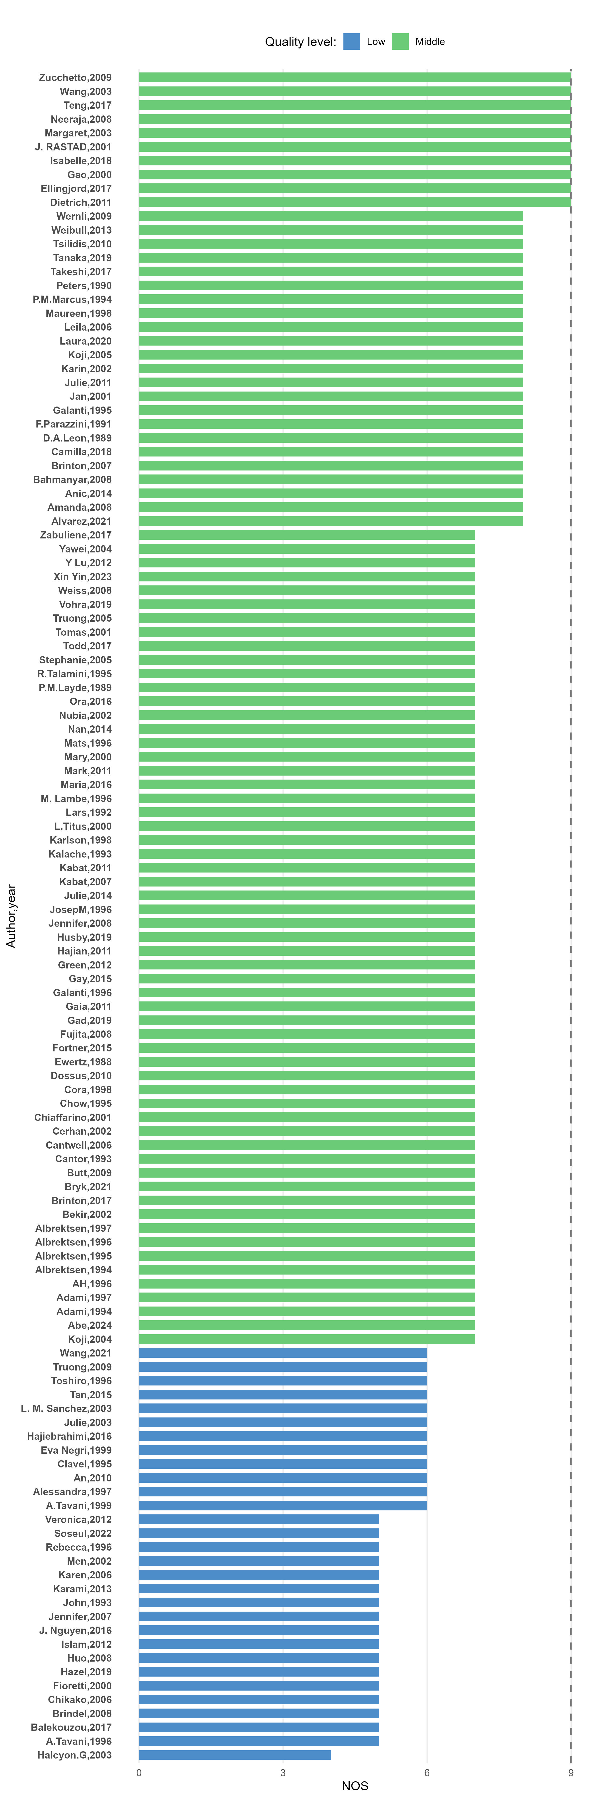

Figure S1. Quality of Included Studies.

Figure S2. Funnel Plot Assessing Reporting Bias in the Meta-Analysis of Parous Status and Breast Cancer.
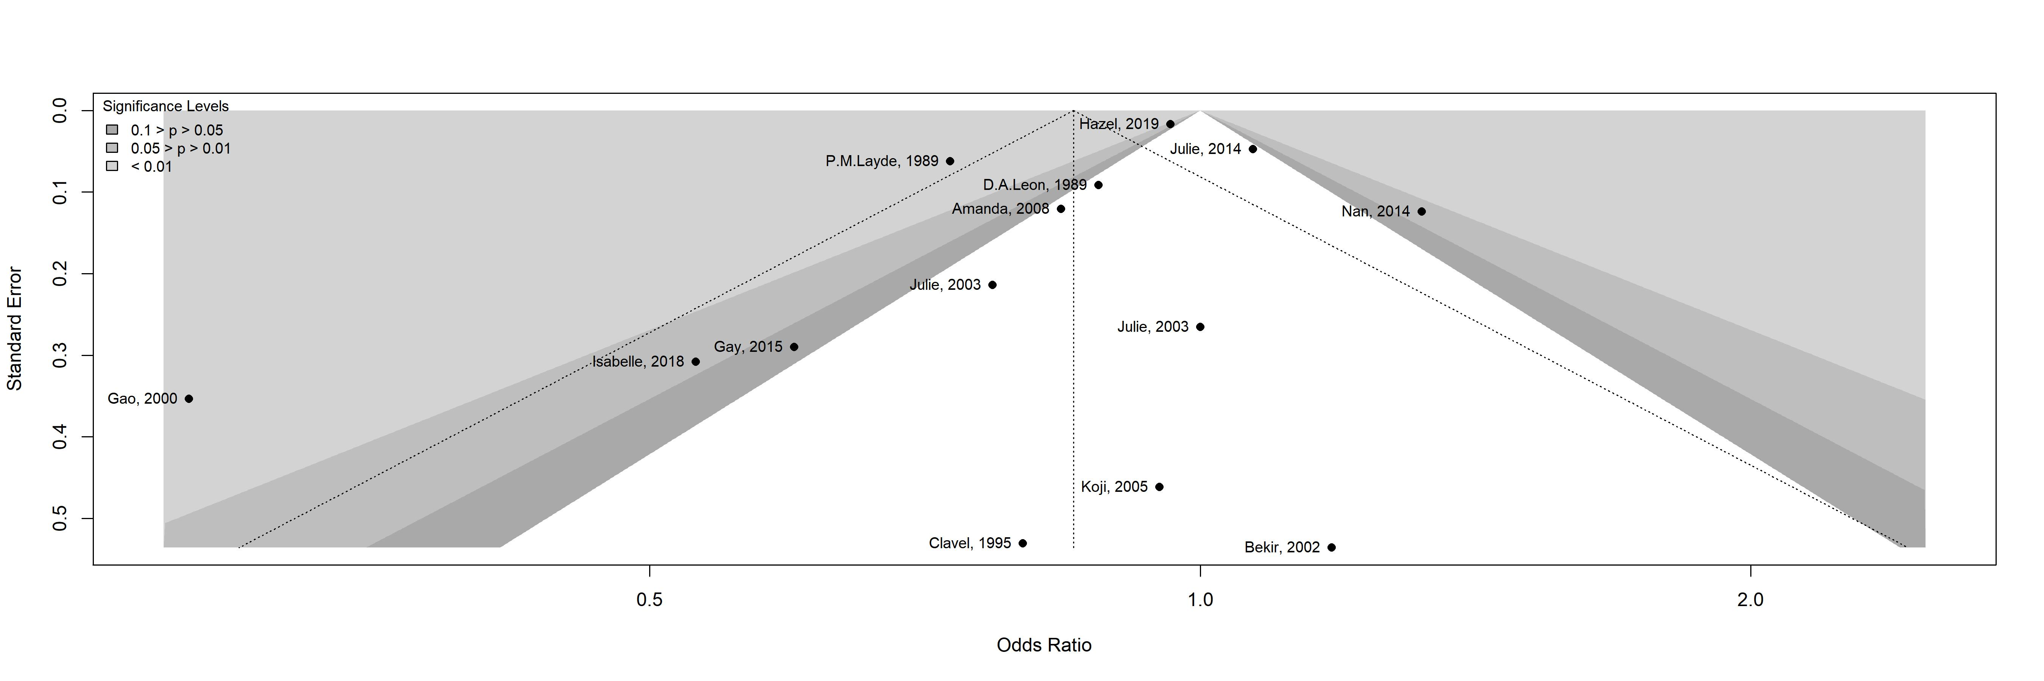

Figure S3. Funnel Plot Assessing Reporting Bias in the Meta-Analysis of Parous Status and Corpus uteri cancer.
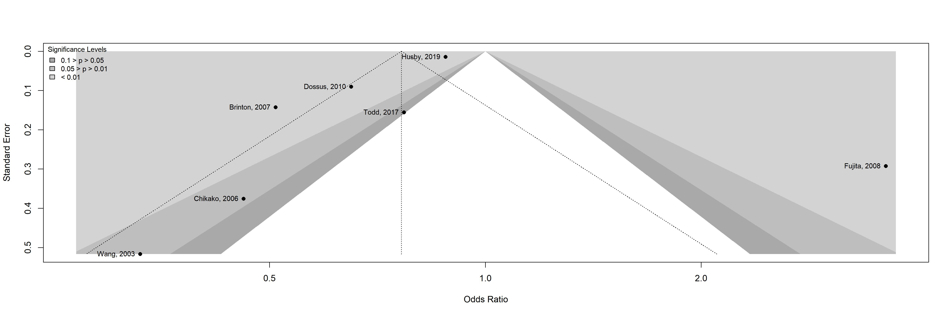

Figure S4. Funnel Plot Assessing Reporting Bias in the Meta-Analysis of Parous Status and Thyroid Cancer.
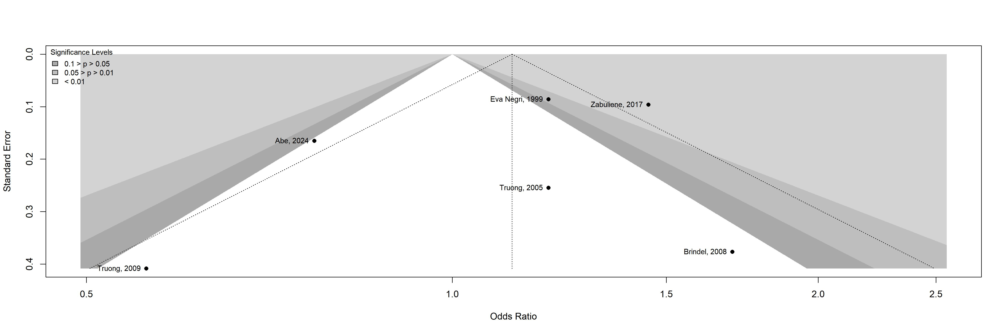

Figure S5. Funnel Plot Assessing Reporting Bias in the Meta-Analysis of Parous Status and Ovary Cancer.
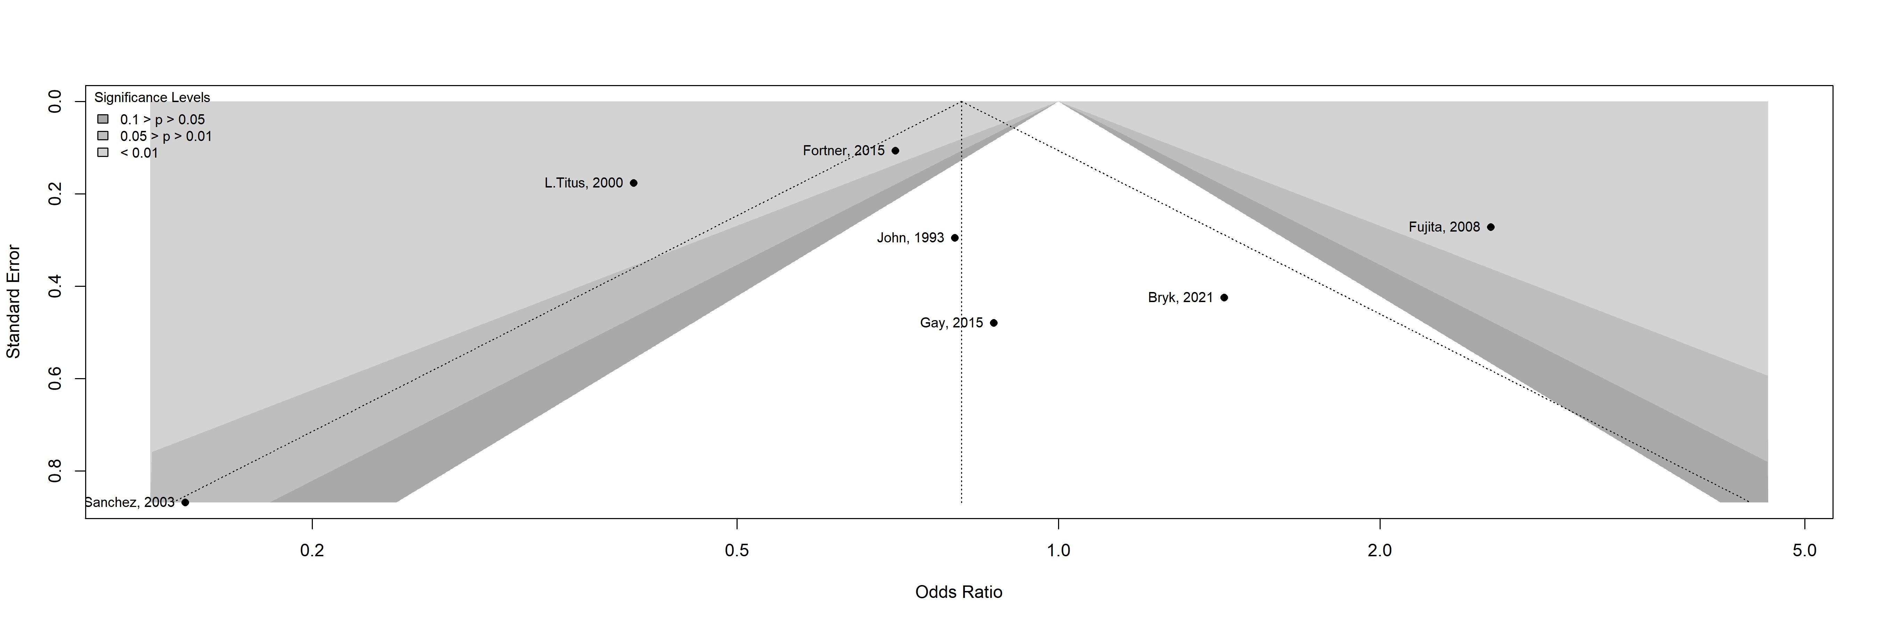

Figure S6. Funnel Plot Assessing Reporting Bias in the Meta-Analysis of Parous Status and Kidney Cancer.
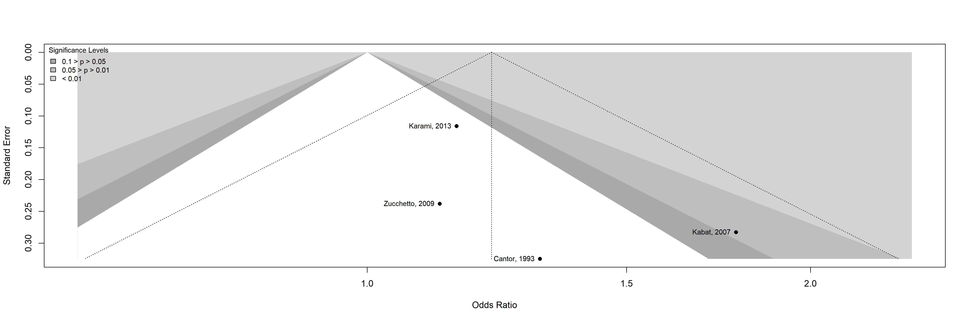

Figure S7. Funnel Plot Assessing Reporting Bias in the Meta-Analysis of Parous Status and Bladder Cancer.
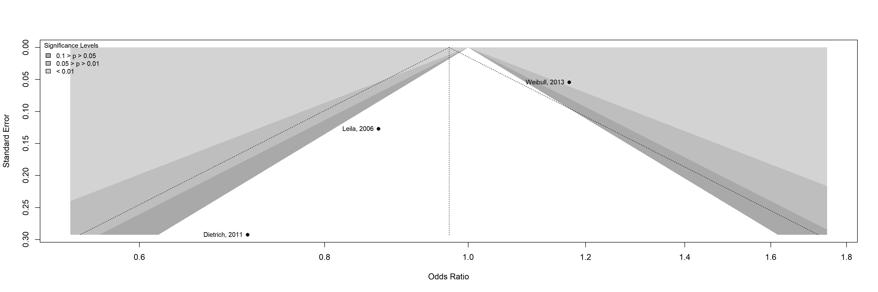

Figure S8. Funnel Plot Assessing Reporting Bias in the Meta-Analysis of Parous Status and Colon and rectum cancers.
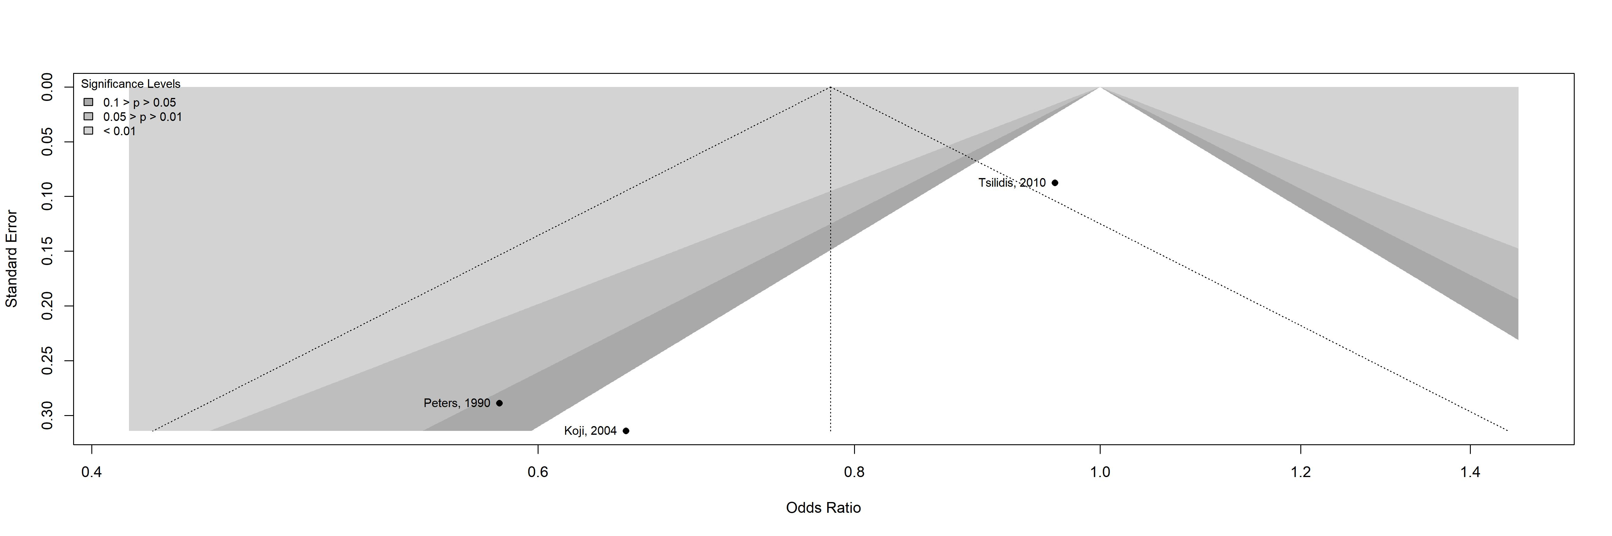

Figure S9. Funnel Plot Assessing Reporting Bias in the Meta-Analysis of Parous Status and Lymphomas, multiple myeloma.
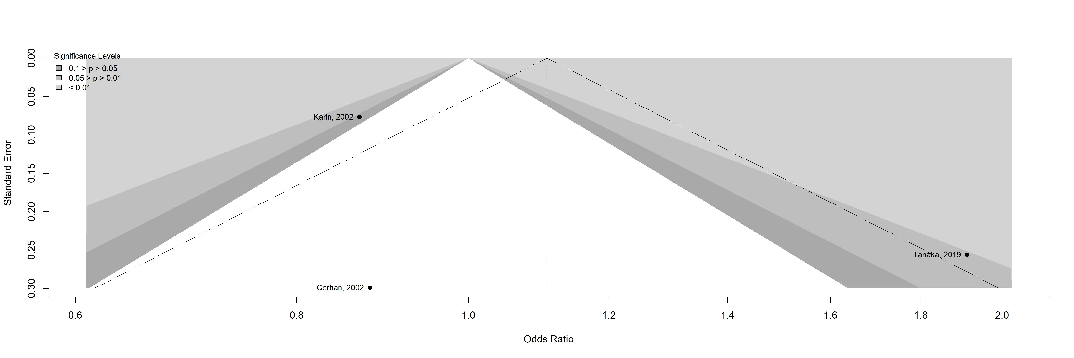

Figure S10. Forest Plot of Parous Status and Breast Cancer Association from Case-Control Studies.
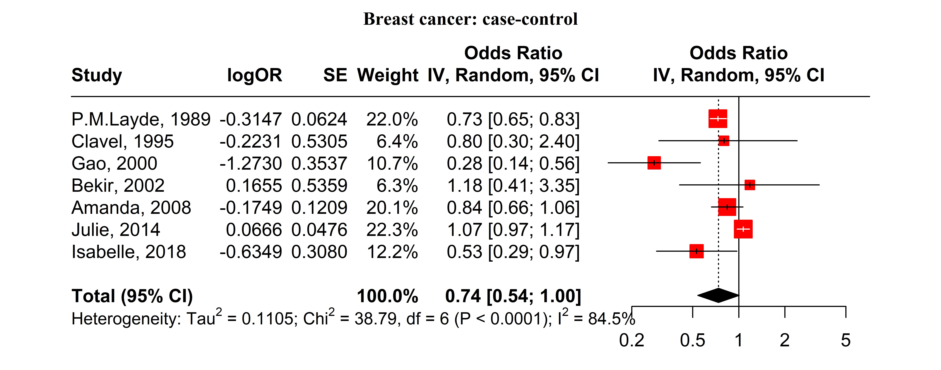

Figure S11. Forest Plot of Parous Status and Breast Cancer Association from Cohort Studies.
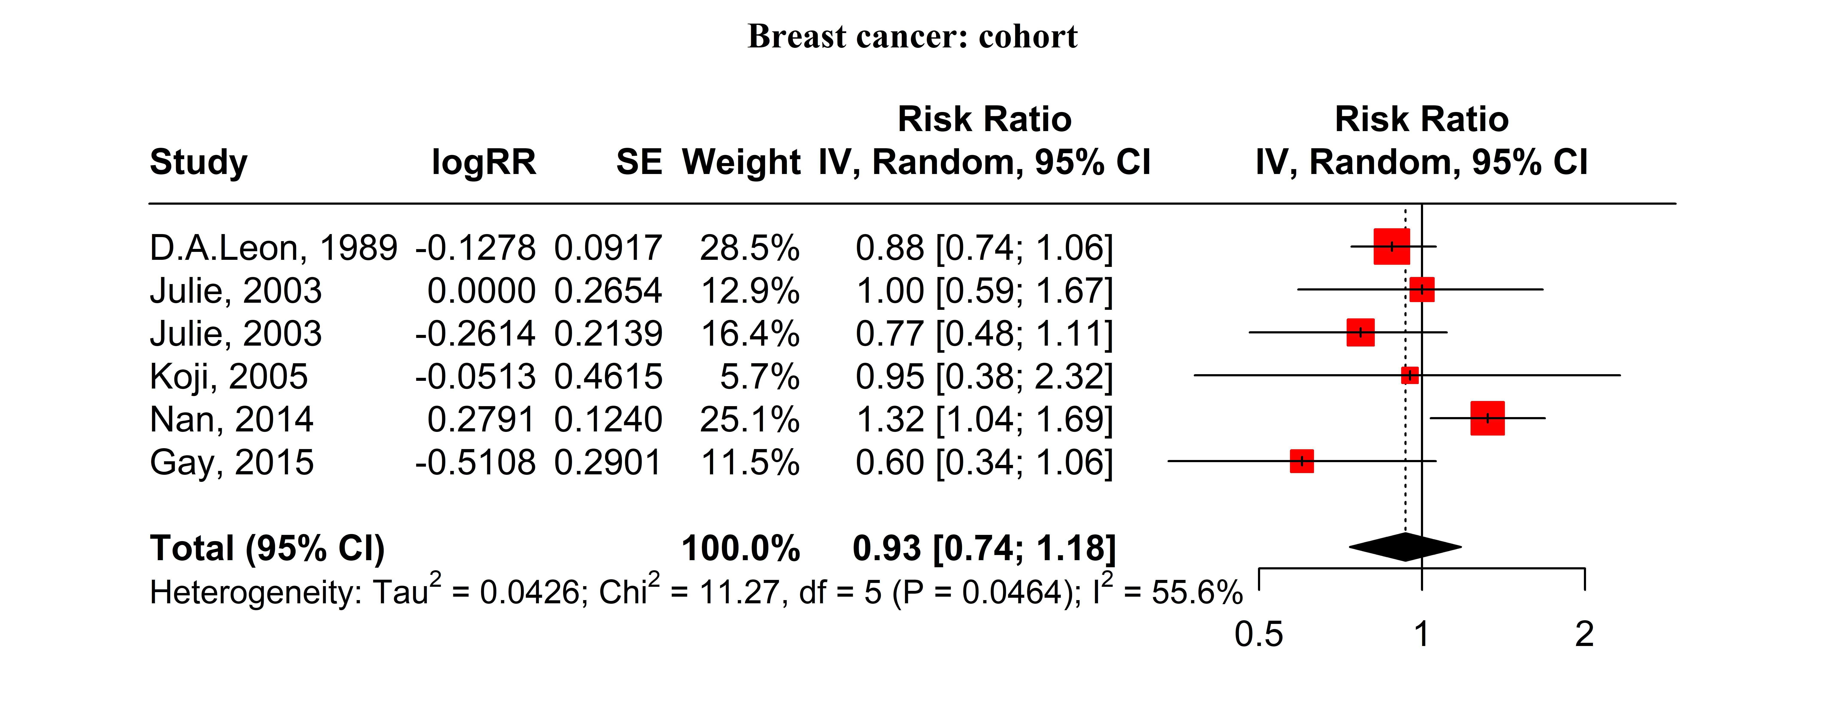

Figure S12. Forest Plot of Parous Status and Breast Cancer Association from Both Case-Control and Cohort Studies.
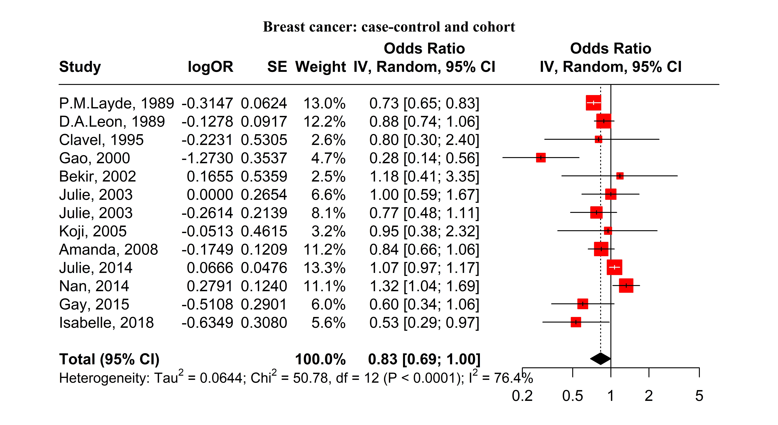

Figure S13. Forest Plot of Parous Status and Corpus Uteri Cancer Association from Case-Control Studies.
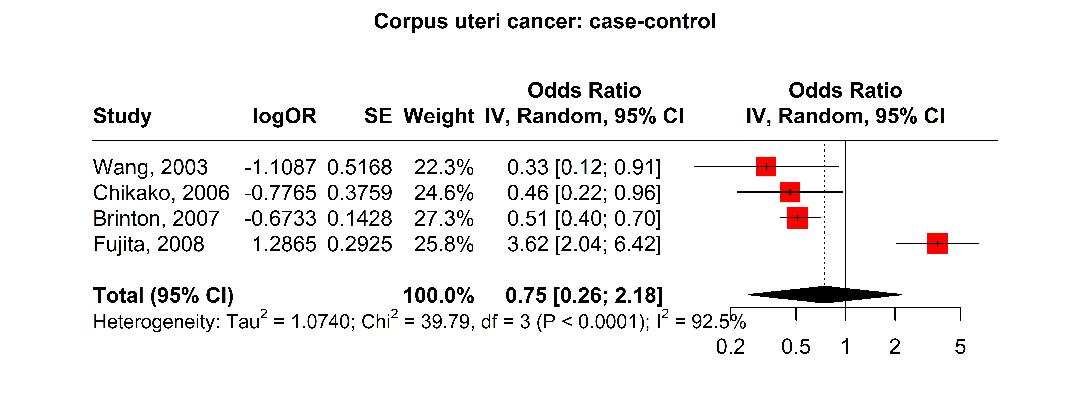

Figure S14. Forest Plot of Parous Status and Corpus Uteri Cancer Association from Cohort Studies.
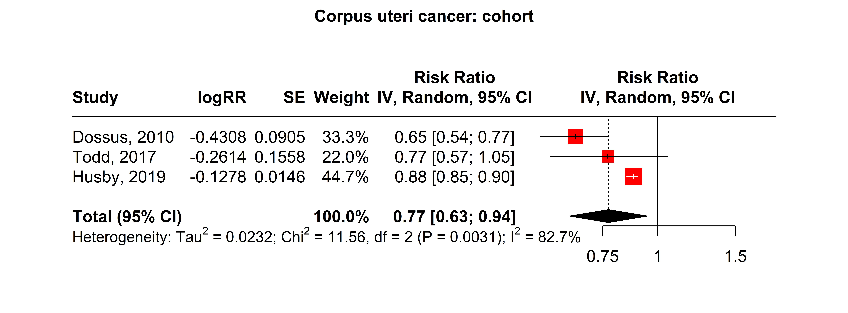

Figure S15. Forest Plot of Parous Status and Corpus Uteri Cancer Association from Both Case-Control and Cohort Studies.
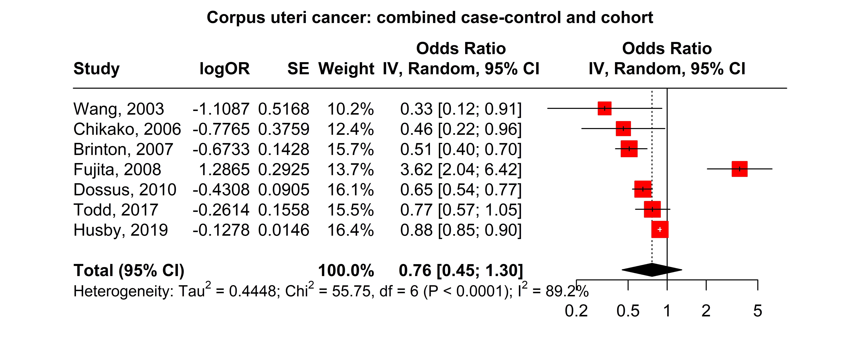

Figure S16. Forest Plot of Parous Status and Thyroid Cancer Association from Case-Control Studies.
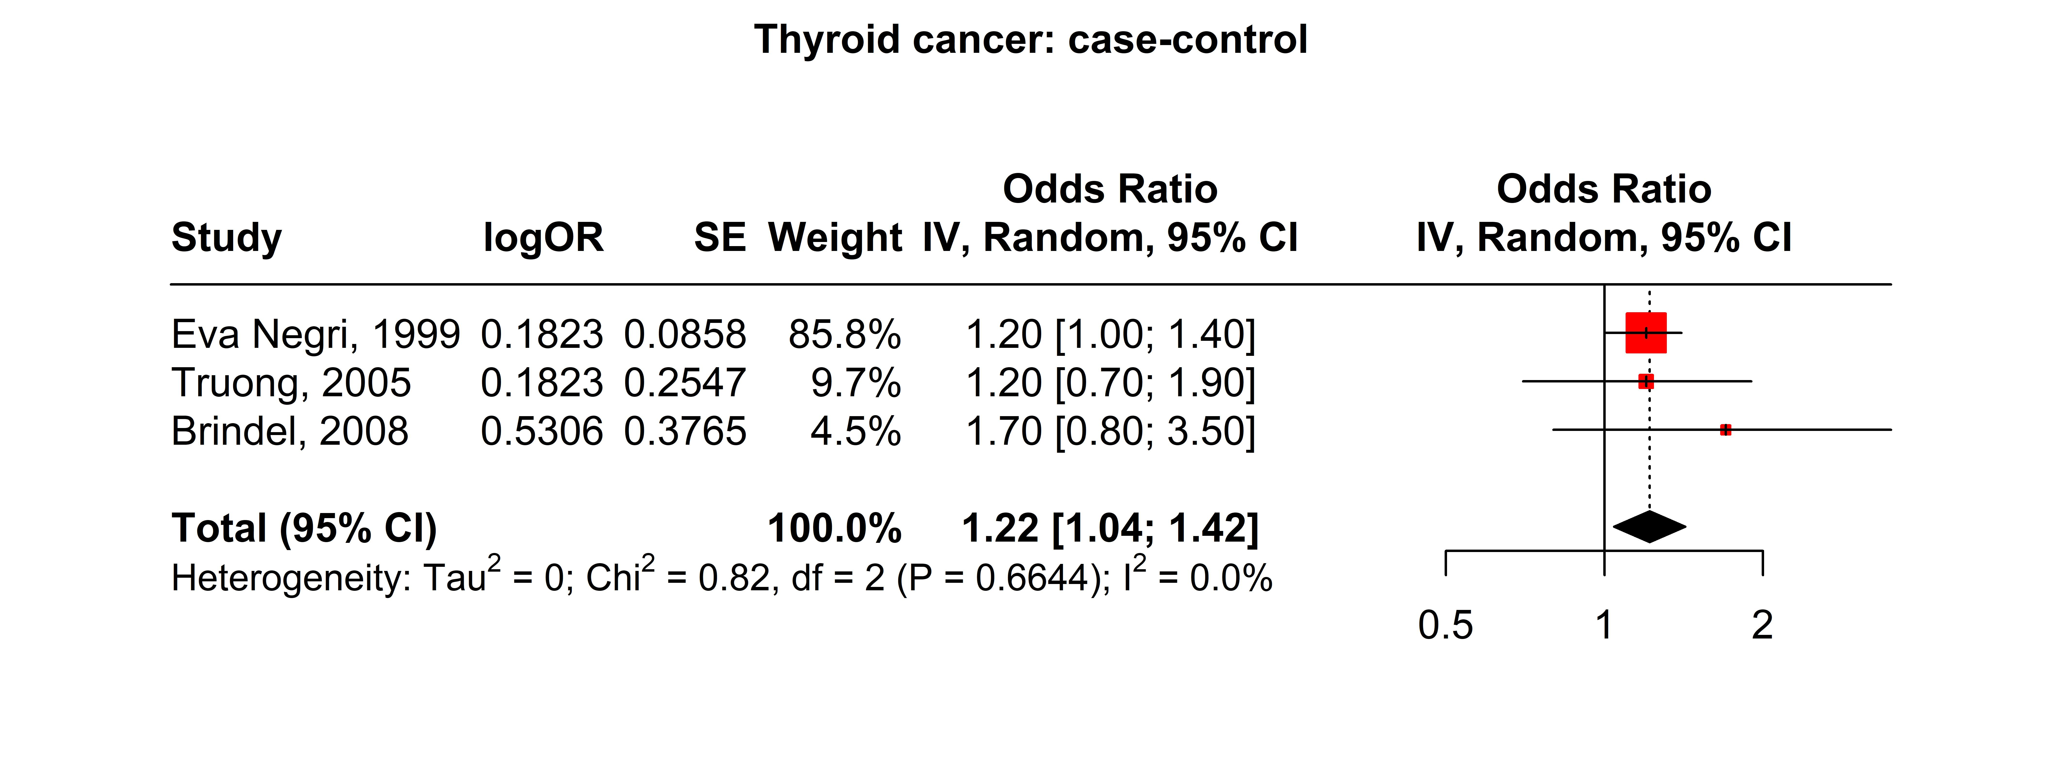

Figure S17. Forest Plot of Parous Status and Thyroid Cancer Association from Cohort Studies.
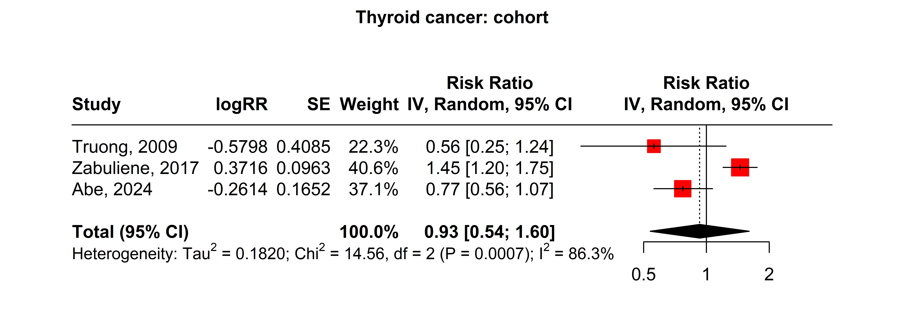

Figure S18. Forest Plot of Parous Status and Thyroid Cancer Association from Both Case-Control and Cohort Studies.
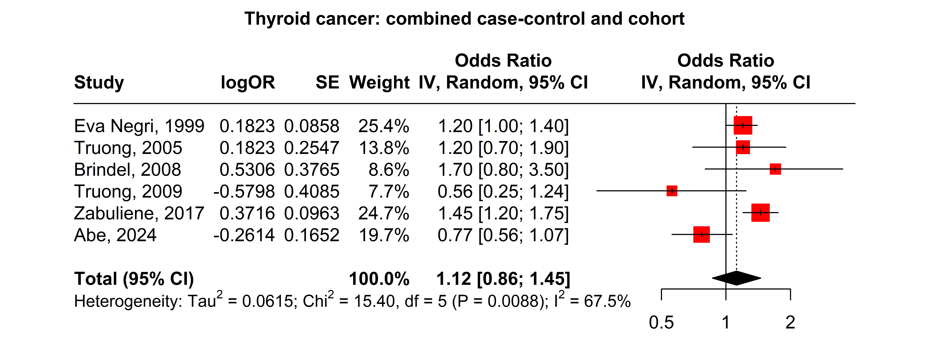

Figure S19. Forest Plot of Parous Status and Ovary Cancer Association from Case-Control Studies.
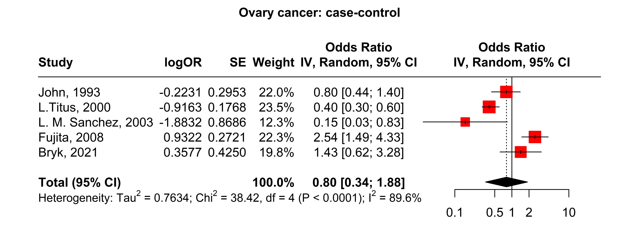

Figure S20. Forest Plot of Parous Status and Ovary Cancer Association from Cohort Studies.
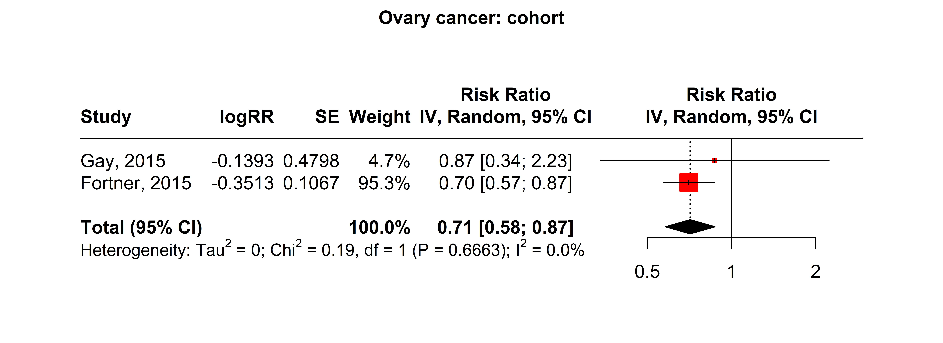

Figure S21. Forest Plot of Parous Status and Ovary Cancer Association from Both Case-Control and Cohort Studies.
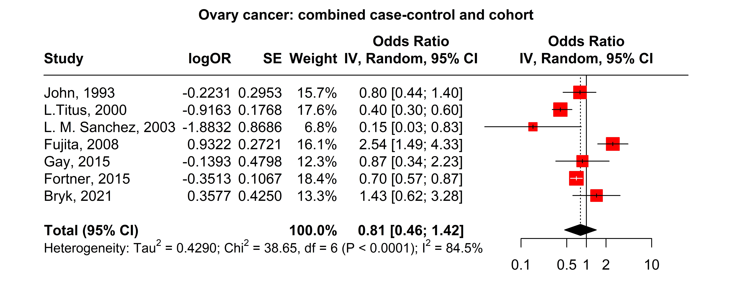

Figure S22. Forest Plot of Parous Status and Kidney Cancer Association from Case-Control Studies.
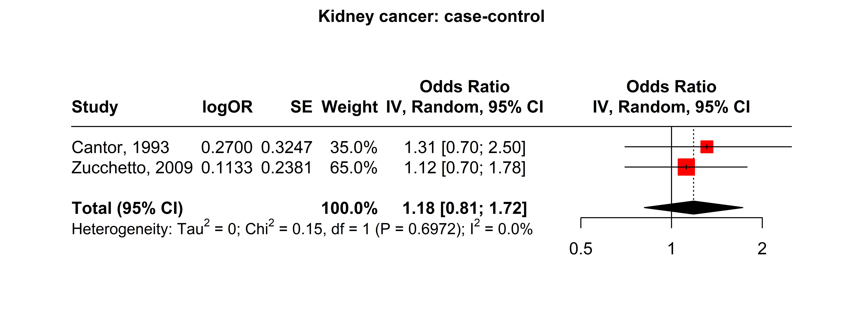

Figure S23. Forest Plot of Parous Status and Kidney Cancer Association from Cohort Studies.
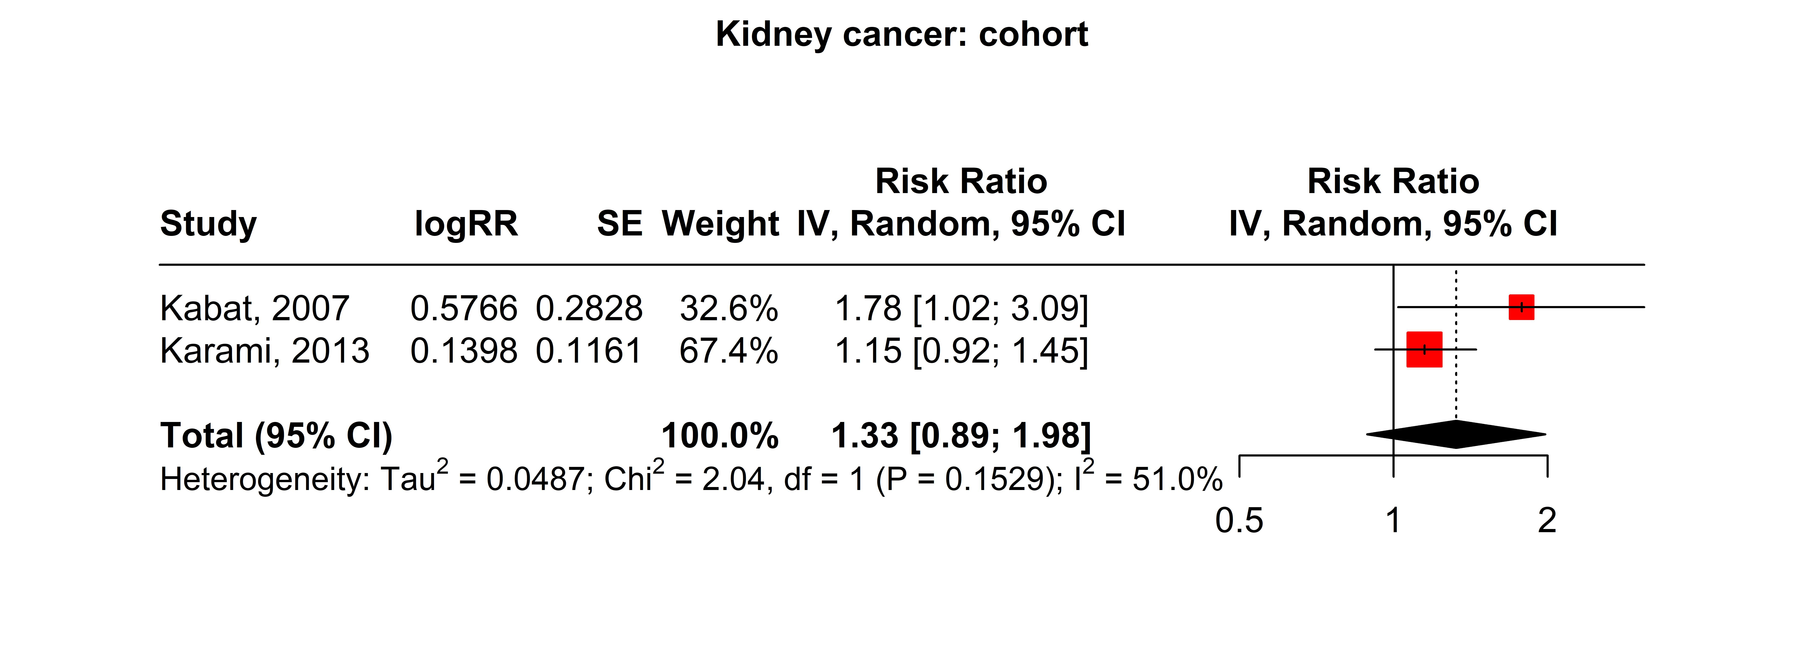

Figure S24. Forest Plot of Parous Status and Kidney Cancer Association from Both Case-Control and Cohort Studies.
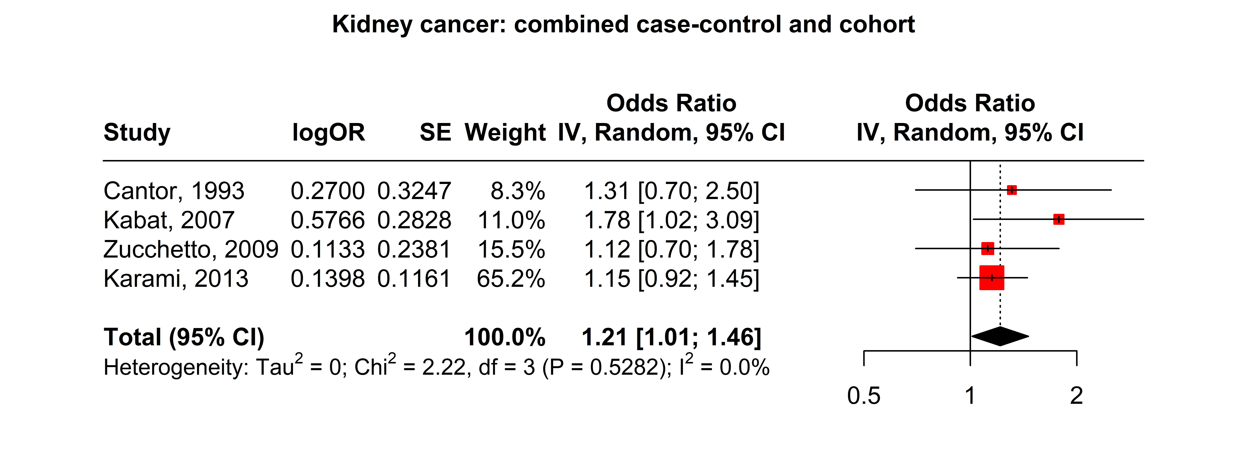

Figure S25. Forest Plot of Parous Status and Bladder Cancer Association from Cohort Studies.
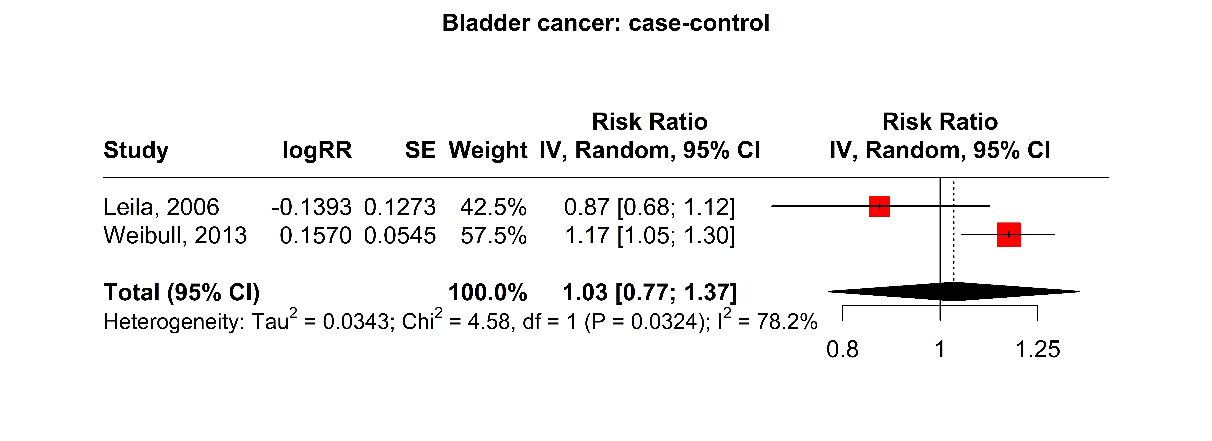

Figure S26. Forest Plot of Parous Status and Bladder Cancer Association from Both Case-Control and Cohort Studies.
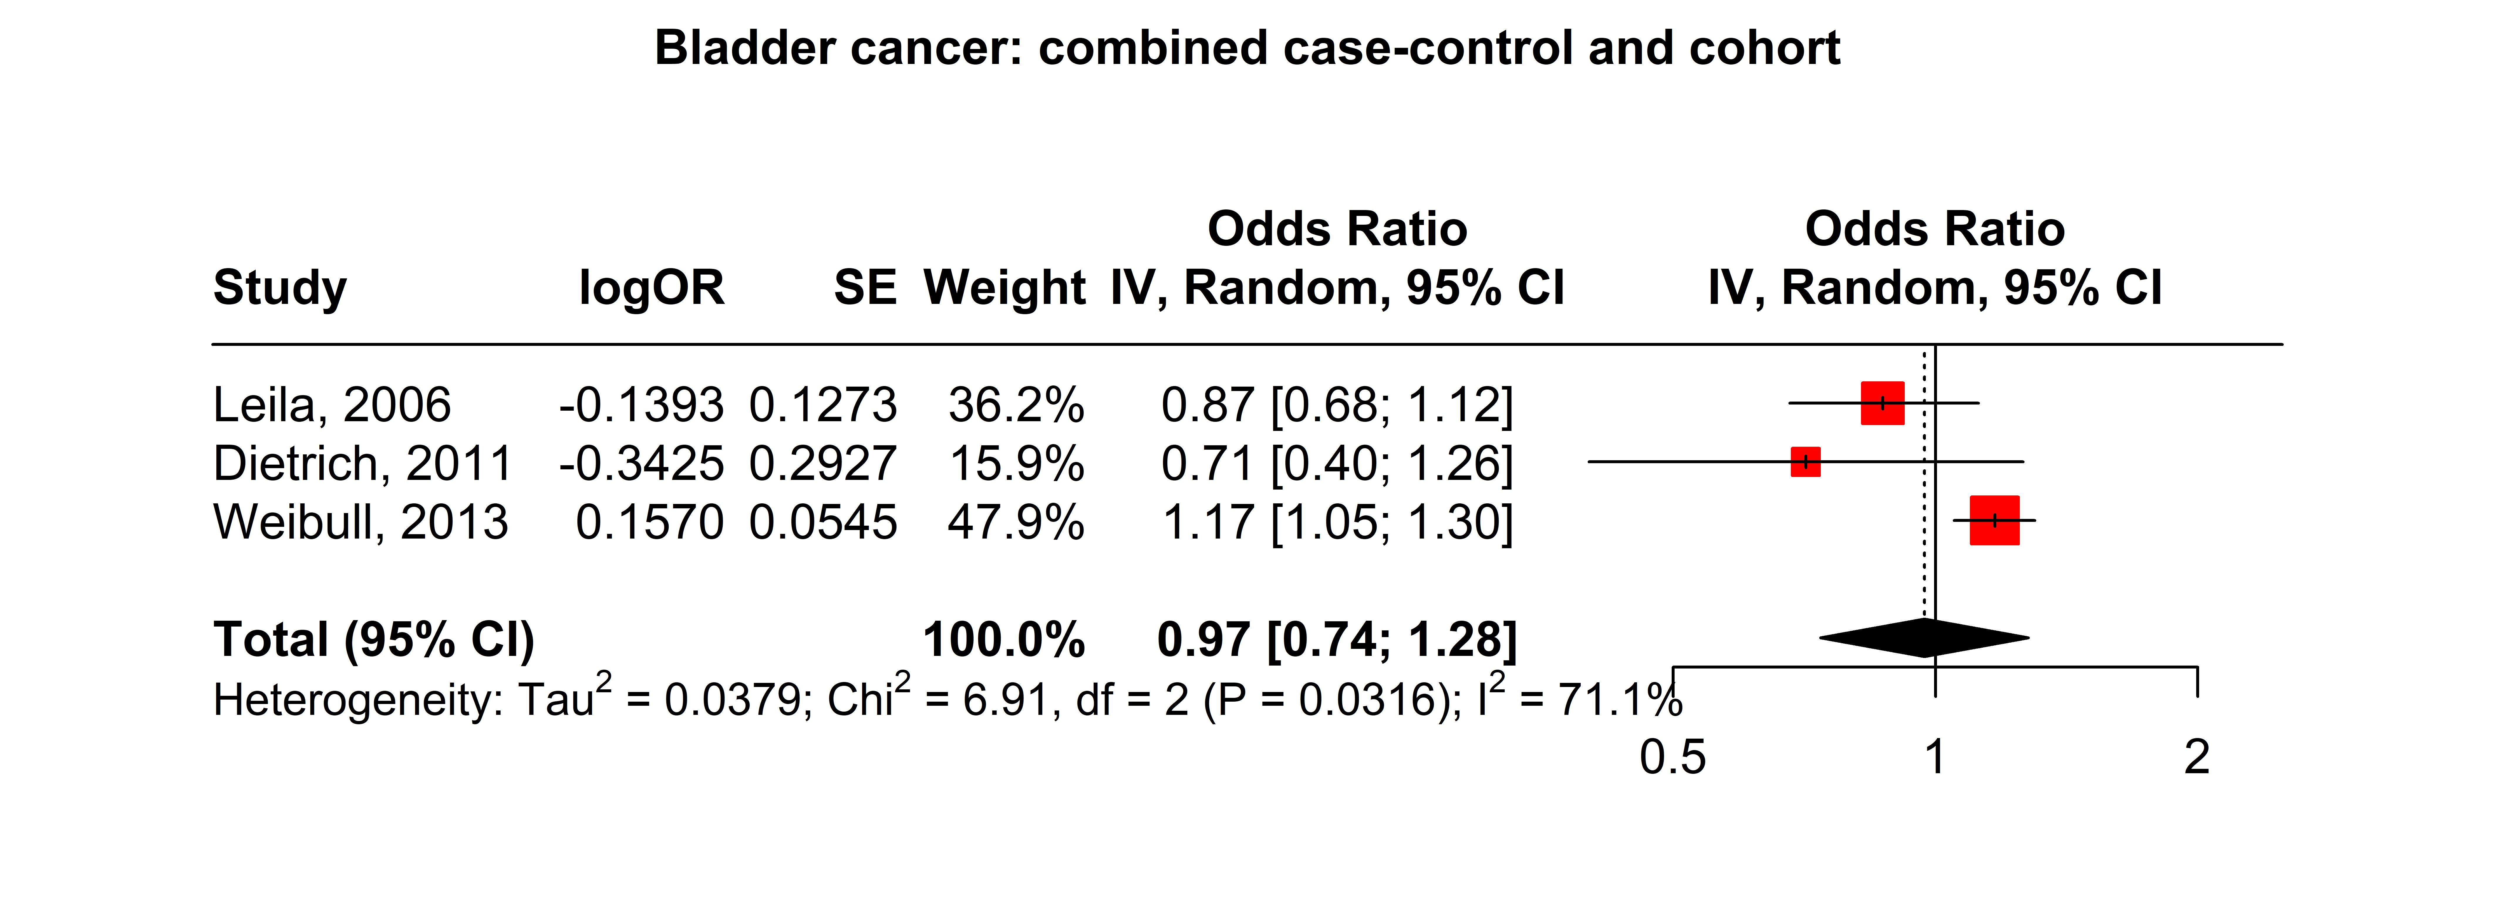

Figure S27. Forest Plot of Parous Status and Colon and Rectum Cancers Association from Case-Control Studies.
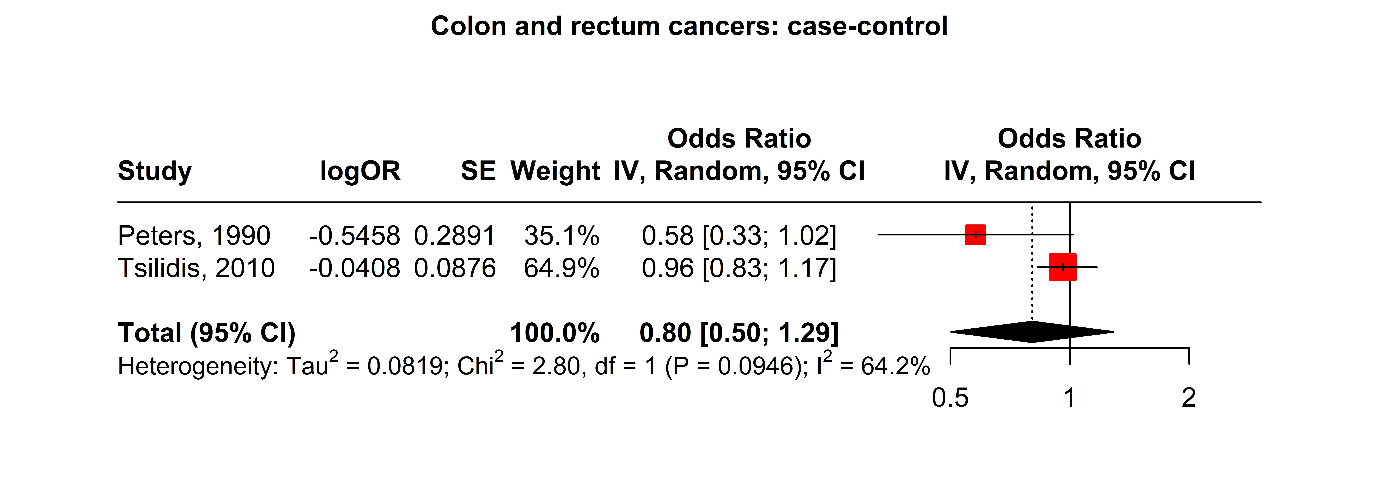

Figure S28. Forest Plot of Parous Status and Colon and Rectum Cancers Association from Both Case-Control and Cohort Studies.
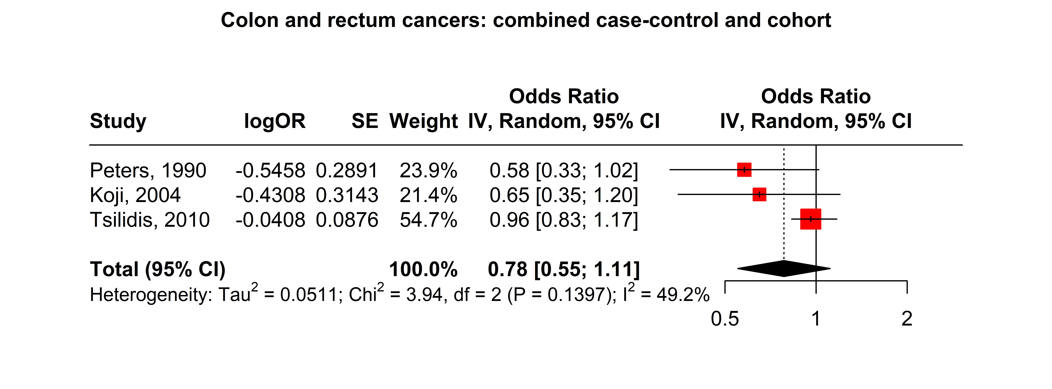

Figure S29. Forest Plot of Parous Status and Lymphomas, Multiple Myeloma Association from Case-Control Studies.
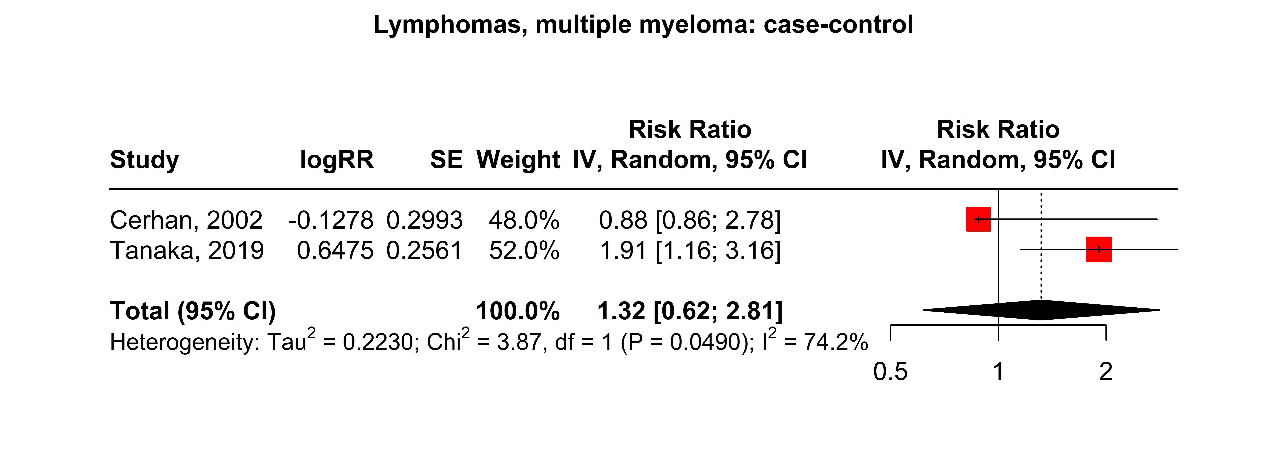

Figure S30. Forest Plot of Parous Status and Lymphomas, Multiple Myeloma Association from Both Case-Control and Cohort Studies.
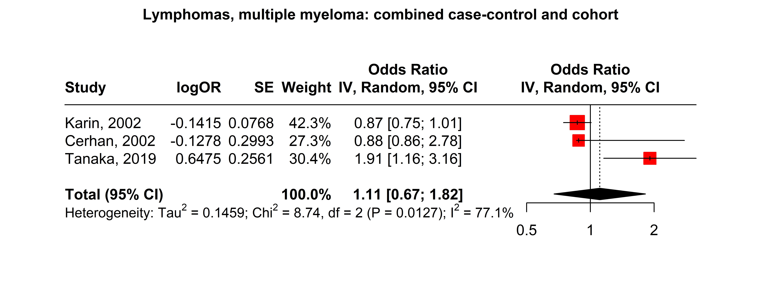

Reference
Abe, J. V., Park, S. Y., Haiman, C. A., Le Marchand, L., Hernandez, B. Y., Ihenacho, U., & Wilkens, L. R. (2024). Reproductive Factors and Thyroid Cancer Risk: The Multiethnic Cohort Study. Journal of Womens Health, 33(9), 1158–1165. https://doi.org/10.1089/jwh.2023.0947
Adami, H. O., Hsieh, C. C., Lambe, M., Trichopoulos, D., Leon, D., Persson, I., Ekbom, A., & Janson, P. O. (1994). Parity, age at first childbirth, and risk of ovarian cancer. Lancet, 344(8932), 1250–1254. https://doi.org/10.1016/s0140-6736(94)90749-8
Adami, H. O., Tsaih, S., Lambe, M., Hsieh, C., Adami, J., Trichopoulos, D., Melbye, M., & Glimelius, B. (1997). Pregnancy and risk of non-Hodgkin's lymphoma: a prospective study. International Journal of Cancer, 70(2), 155–158. https://doi.org/10.1002/(sici)1097-0215(19970117)70:2<155::aid-ijc3>3.0.co;2-w
Albrektsen, G., Heuch, I., & Kvåle, G. (1996). Reproductive factors and incidence of epithelial ovarian cancer: A Norwegian prospective study. Cancer Causes and Control, 7(4), 421–427. https://doi.org/10.1007/BF00052668
Albrektsen, G., Heuch, I., & Kvåle, G. (1997). Full-term pregnancies and incidence of ovarian cancer of stromal and germ cell origin: A Norwegian prospective study. British Journal of Cancer, 75(5), 767–770. https://doi.org/10.1038/bjc.1997.136
Albrektsen, G., Heuch, I., Tretli, S., & Kvale, G. (1994). Breast cancer incidence before age 55 in relation to parity and age at first and last births: A prospective study of one million Norwegian women. Epidemiology, 5(6), 604–611. https://doi.org/10.1097/00001648-199411000-00008
Albrektsen, G., Heuch, I., Tretli, S., & Kvale, G. (1995). Is the risk of cancer of the corpus uteri reduced by a recent pregnancy? A prospective study of 765,756 Norwegian women. International Journal of Cancer, 61(4), 485–490. https://doi.org/10.1002/ijc.2910610410
Alvarez, A., Borch, K. B., & Rylander, C. (2021). Reproductive factors, use of exogenous hormones, and pancreatic cancer incidence: The Norwegian women and cancer study. Clinical Epidemiology, 13, 67–80. https://doi.org/10.2147/CLEP.S268556
Anic, G. M., Madden, M. H., Nabors, L. B., Olson, J. J., LaRocca, R. V., Thompson, Z. J., Pamnani, S. J., Forsyth, P. A., Thompson, R. C., & Egan, K. M. (2014). Reproductive factors and risk of primary brain tumors in women. Journal of Neuro-Oncology, 118(2), 297–304. https://doi.org/10.1007/s11060-014-1427-0
Bahmanyar, S., Lambe, M., Zendehdel, K., Nyrén, O., Boffetta, P., & Ye, W. (2008). Parity and risk of stomach cancer by sub-site: a national Swedish study. British Journal of Cancer, 98(7), 1295–1300. https://doi.org/10.1038/sj.bjc.6604283
Balekouzou, A., Yin, P., Pamatika, C. M., Bekolo, C. E., Nambei, S. W., Djeintote, M., Kota, K., Mossoro-Kpinde, C. D., Shu, C., Yin, M., Fu, Z., Qing, T., Yan, M., Zhang, J., Chen, S., Li, H., Xu, Z., & Koffi, B. (2017). Reproductive risk factors associated with breast cancer in women in Bangui: a case-control study. BMC Womens Health, 17(1), 14. https://doi.org/10.1186/s12905-017-0368-0
Brindel, P., Doyon, F., Rachédi, F., Boissin, J. L., Sebbag, J., Shan, L., Chungue, V., Sun, L. Y., Bost-Bezeaud, F., Petitdidier, P., Paoaafaite, J., Teuri, J., & de Vathaire, F. (2008). Menstrual and reproductive factors in the risk of differentiated thyroid carcinoma in native women in French Polynesia: a population-based case-control study. American Journal of Epidemiology, 167(2), 219–229. https://doi.org/10.1093/aje/kwm288
Brinton, L. A., Awuah, B., Nat Clegg-Lamptey, J., Wiafe-Addai, B., Ansong, D., Nyarko, K. M., Wiafe, S., Yarney, J., Biritwum, R., Brotzman, M., Adjei, A. A., Adjei, E., Aitpillah, F., Edusei, L., Dedey, F., Nyante, S. J., Oppong, J., Osei-Bonsu, E., Titiloye, N.,…Figueroa, J. D. (2017). Design considerations for identifying breast cancer risk factors in a population-based study in Africa. International Journal of Cancer, 140(12), 2667–2677. https://doi.org/10.1002/ijc.30688
Brinton, L. A., Sakoda, L. C., Lissowska, J., Sherman, M. E., Chatterjee, N., Peplonska, B., Szeszenia-Dabrowska, N., Zatonski, W., & Garcia-Closas, M. (2007). Reproductive risk factors for endometrial cancer among Polish women. British Journal of Cancer, 96(9), 1450–1456. https://doi.org/10.1038/sj.bjc.6603731
Bryk, S., Katuwal, S., Haltia, U. M., Tapper, J., Tapanainen, J. S., & Pukkala, E. (2021). Parity, menopausal hormone therapy, and risk of ovarian granulosa cell tumor – A population-based case-control study. Gynecologic Oncology, 163(3), 593–597. https://doi.org/10.1016/j.ygyno.2021.09.013
Butt, S., Borgquist, S., Anagnostaki, L., Landberg, G., & Manjer, J. (2009). Parity and age at first childbirth in relation to the risk of different breast cancer subgroups. International Journal of Cancer, 125(8), 1926–1934. https://doi.org/10.1002/ijc.24494
Cantor, K. P., Lynch, C. F., & Johnson, D. (1993). Reproductive factors and risk of brain, colon, and other malignancies in Iowa (United States). Cancer Causes Control, 4(6), 505–511. https://doi.org/10.1007/bf00052425
Cantwell, M. M., Lacey, J. V., Jr., Schairer, C., Schatzkin, A., & Michaud, D. S. (2006). Reproductive factors, exogenous hormone use and bladder cancer risk in a prospective study. International Journal of Cancer, 119(10), 2398–2401. https://doi.org/10.1002/ijc.22175
Cerhan, J. R., Habermann, T. M., Vachon, C. M., Putnam, S. D., Zheng, W., Potter, J. D., & Folsom, A. R. (2002). Menstrual and reproductive factors and risk of non-Hodgkin lymphoma: The Iowa Women's Health Study (United States). Cancer Causes and Control, 13(2), 131–136. https://doi.org/10.1023/A:1014354105164
Chiaffarino, F., Pelucchi, C., Parazzini, F., Negri, E., Franceschi, S., Talamini, R., Conti, E., Montella, M., & La Vecchia, C. (2001). Reproductive and hormonal factors and ovarian cancer. Annals of Oncology, 12(3), 337–341. https://doi.org/10.1023/a:1011128408146
Chow, W. H., McLaughlin, J. K., Mandel, J. S., Blot, W. J., Niwa, S., & Fraumeni, J. F., Jr. (1995). Reproductive factors and the risk of renal cell cancer among women. International Journal of Cancer, 60(3), 321–324. https://doi.org/10.1002/ijc.2910600307
Clavel-Chapelon, F., Launoy, G., Auquier, A., Gairard, B., Brémond, A., Piana, L., Lansac, J., & Renaud, R. (1995). Reproductive factors and breast cancer risk. Effect of age at diagnosis. Annals of Epidemiology, 5(4), 315–320. https://doi.org/10.1016/1047-2797(95)00099-s
Dietrich, K., Demidenko, E., Schned, A., Zens, M. S., Heaney, J., & Karagas, M. R. (2011). Parity, early menopause and the incidence of bladder cancer in women: A case-control study and meta-analysis. European Journal of Cancer, 47(4), 592–599. https://doi.org/10.1016/j.ejca.2010.10.007
Dossus, L., Allen, N., Kaaks, R., Bakken, K., Lund, E., Tjonneland, A., Olsen, A., Overvad, K., Clavel-Chapelon, F., Fournier, A., Chabbert-Buffet, N., Boeing, H., Schütze, M., Trichopoulou, A., Trichopoulos, D., Lagiou, P., Palli, D., Krogh, V., Tumino, R.,…Riboli, E. (2010). Reproductive risk factors and endometrial cancer: the European Prospective Investigation into Cancer and Nutrition. International Journal of Cancer, 127(2), 442–451. https://doi.org/10.1002/ijc.25050
Ellingjord-Dale, M., Vos, L., Tretli, S., Hofvind, S., Dos-Santos-Silva, I., & Ursin, G. (2017). Parity, hormones and breast cancer subtypes - results from a large nested case-control study in a national screening program. Breast Cancer Research, 19(1), 10. https://doi.org/10.1186/s13058-016-0798-x
Ewertz, M., & Duffy, S. W. (1988). Risk of breast cancer in relation to reproductive factors in Denmark. British Journal of Cancer, 58(1), 99–104. https://doi.org/10.1038/bjc.1988.172
Feng, R. M., Chang, E. T., Liu, Z., Liu, Q., Cai, Y., Zhang, Z., Chen, G., Huang, Q. H., Xie, S. H., Cao, S. M., Zhang, Y., Yun, J., Jia, W. H., Zheng, Y., Liao, J., Chen, Y., Lin, L., Ernberg, I., Huang, G.,…Ye, W. (2019). Reproductive history and risk of nasopharyngeal carcinoma: A population-based case-control study in southern China. Oral Oncol, 88, 102–108. https://doi.org/10.1016/j.oraloncology.2018.11.025
Fioretti, F., Tavani, A., Gallus, S., Negri, E., Franceschi, S., & La Vecchia, C. (2000). Menstrual and reproductive factors and risk of soft tissue sarcomas. Cancer, 88(4), 786–789. https://doi.org/10.1002/(SICI)1097-0142(20000215)88:4<786::AID-CNCR8>3.0.CO;2-M
Fortner, R. T., Ose, J., Merritt, M. A., Schock, H., Tjønneland, A., Hansen, L., Overvad, K., Dossus, L., Clavel-Chapelon, F., Baglietto, L., Boeing, H., Trichopoulou, A., Benetou, V., Lagiou, P., Agnoli, C., Mattiello, A., Masala, G., Tumino, R., Sacerdote, C.,…Kaaks, R. (2015). Reproductive and hormone-related risk factors for epithelial ovarian cancer by histologic pathways, invasiveness and histologic subtypes: Results from the EPIC cohort. International Journal of Cancer, 137(5), 1196–1208. https://doi.org/10.1002/ijc.29471
Fujita, M., Tase, T., Kakugawa, Y., Hoshi, S., Nishino, Y., Nagase, S., Ito, K., Niikura, H., Yaegashi, N., & Minami, Y. (2008). Smoking, earlier menarche and low parity as independent risk factors for gynecologic cancers in Japanese: a case-control study. The Tohoku Journal of Experimental Medicine, 216(4), 297–307. https://doi.org/10.1620/tjem.216.297
Galanti, M. R., Hansson, L., Lund, E., Bergström, R., Grimelius, L., Stalsberg, H., Carlsen, E., Baron, J. A., Persson, I., & Ekbom, A. (1996). Reproductive history and cigarette smoking as risk factors for thyroid cancer in women: A population-based case-control study. Cancer Epidemiology Biomarkers and Prevention, 5(6), 425–431.
Galanti, M. R., Lambe, M., Ekbom, A., Sparén, P., & Pettersson, B. (1995). Parity and risk of thyroid cancer: a nested case-control study of a nationwide Swedish cohort. Cancer Causes Control, 6(1), 37–44. https://doi.org/10.1007/bf00051679
Gao, Y. T., Shu, X. O., Dai, Q., Potter, J. D., Brinton, L. A., Wen, W., Sellers, T. A., Kushi, L. H., Ruan, Z., Bostick, R. M., Jin, F., & Zheng, W. (2000). Association of menstrual and reproductive factors with breast cancer risk: results from the Shanghai Breast Cancer Study. International Journal of Cancer, 87(2), 295–300. https://doi.org/10.1002/1097-0215(20000715)87:2<295::aid-ijc23>3.0.co;2-7
Gay, G. M. W., Lim, J. S. P., Chay, W. Y., Chow, K. Y., Tan, M. H., & Lim, W. Y. (2015). Reproductive factors, adiposity, breastfeeding and their associations with ovarian cancer in an Asian cohort. Cancer Causes and Control, 26(11), 1561–1573. https://doi.org/10.1007/s10552-015-0649-6
Green, J., Roddam, A., Pirie, K., Kirichek, O., Reeves, G., & Beral, V. (2012). Reproductive factors and risk of oesophageal and gastric cancer in the Million Women Study cohort. British Journal of Cancer, 106(1), 210–216. https://doi.org/10.1038/bjc.2011.525
Hajian-Tilaki, K. O., & Kaveh-Ahangar, T. (2011). Reproductive factors associated with breast cancer risk in northern Iran. Medical Oncology, 28(2), 441–446. https://doi.org/10.1007/s12032-010-9498-z
Hajiebrahimi, M., Cnattingius, S., Lambe, M., & Bahmanyar, S. (2016). Pregnancy history and risk of premenopausal breast cancer—a nested case-control study. International Journal of Epidemiology, 45(3), 816–824. https://doi.org/10.1093/ije/dyv293
Huo, D., Adebamowo, C. A., Ogundiran, T. O., Akang, E. E., Campbell, O., Adenipekun, A., Cummings, S., Fackenthal, J., Ademuyiwa, F., Ahsan, H., & Olopade, O. I. (2008). Parity and breastfeeding are protective against breast cancer in Nigerian women. British Journal of Cancer, 98(5), 992–996. https://doi.org/10.1038/sj.bjc.6604275
Husby, A., Wohlfahrt, J., & Melbye, M. (2019). Pregnancy duration and endometrial cancer risk: Nationwide cohort study. Bmj, 366. https://doi.org/10.1136/bmj.l4693
Islam, T., Matsuo, K., Ito, H., Hosono, S., Watanabe, M., Iwata, H., Tajima, K., & Tanaka, H. (2012). Reproductive and hormonal risk factors for luminal, HER2-overexpressing, and triple-negative breast cancer in Japanese women. Annals of Oncology, 23(9), 2435–2441. https://doi.org/10.1093/annonc/mdr613
John, E. M., Whittemore, A. S., Harris, R., & Itnyre, J. (1993). Characteristics relating to ovarian cancer risk: collaborative analysis of seven U.S. case-control studies. Epithelial ovarian cancer in black women. Journal of the National Cancer Institute, 85(2), 142–147. https://doi.org/10.1093/jnci/85.2.142
Kabat, G. C., Navarro Silvera, S. A., Miller, A. B., & Rohan, T. E. (2007). A cohort study of reproductive and hormonal factors and renal cell cancer risk in women. British Journal of Cancer, 96(5), 845–849. https://doi.org/10.1038/sj.bjc.6603629
Kabat, G. C., Park, Y., Hollenbeck, A. R., Schatzkin, A., & Rohan, T. E. (2011). Reproductive factors and exogenous hormone use and risk of adult glioma in women in the NIH-AARP Diet and Health Study. International Journal of Cancer, 128(4), 944–950. https://doi.org/10.1002/ijc.25413
Kalache, A., Maguire, A., & Thompson, S. G. (1993). Age at last full-term pregnancy and risk of breast cancer. Lancet, 341(8836), 33–36. https://doi.org/10.1016/0140-6736(93)92497-h
Karami, S., Daugherty, S. E., Schonfeld, S. J., Park, Y., Hollenbeck, A. R., Grubb, R. L., Hofmann, J. N., Chow, W. H., & Purdue, M. P. (2013). Reproductive factors and kidney cancer risk in 2 us cohort studies, 1993-2010. American Journal of Epidemiology, 177(12), 1368–1377. https://doi.org/10.1093/aje/kws406
Karlson, B. M., Wuu, J., Hsieh, C. C., Lambe, M., & Ekbom, A. (1998). Parity and the risk of pancreatic cancer: a nested case-control study. International Journal of Cancer, 77(2), 224–227. https://doi.org/10.1002/(sici)1097-0215(19980717)77:2<224::aid-ijc10>3.0.co;2-b
Kuru, B., Ozaslan, C., Ozdemir, P., Dinç, S., Camlibel, M., & Alagöl, H. (2002). Risk factors for breast cancer in Turkish women with early pregnancies and long-lasting lactation--a case-control study. Acta Oncol, 41(6), 556–561. https://doi.org/10.1080/02841860214964
Lambe, M., Hsieh, C. C., Chan, H. W., Ekbom, A., Trichopoulos, D., & Adami, H. O. (1996). Parity, age at first and last birth, and risk of breast cancer: a population-based study in Sweden. Breast Cancer Research and Treatment, 38(3), 305–311. https://doi.org/10.1007/bf01806150
Lambe, M., Thörn, M., Sparén, P., Bergström, R., & Adami, H. O. (1996). Malignant melanoma: Reduced risk associated with early childbearing and multiparity. Melanoma Research, 6(2), 147–153. https://doi.org/10.1097/00008390-199604000-00010
Layde, P. M., Webster, L. A., Baughman, A. L., Wingo, P. A., Rubin, G. L., & Ory, H. W. (1989). The independent associations of parity, age at first full term pregnancy, and duration of breastfeeding with the risk of breast cancer. Cancer and Steroid Hormone Study Group. Journal of Clinical Epidemiology, 42(10), 963–973. https://doi.org/10.1016/0895-4356(89)90161-3
Lee, J. S., Bracci, P. M., & Holly, E. A. (2008). Non-Hodgkin lymphoma in women: Reproductive factors and exogenous hormone use. American Journal of Epidemiology, 168(3), 278–288. https://doi.org/10.1093/aje/kwn119
Leon, D. A. (1989). A prospective study of the independent effects of parity and age at first birth on breast cancer incidence in England and Wales. International Journal of Cancer, 43(6), 986–991. https://doi.org/10.1002/ijc.2910430606
Lin, J., Zhang, S. M., Cook, N. R., Manson, J. E., Buring, J. E., & Lee, I. M. (2007). Oral contraceptives, reproductive factors, and risk of colorectal cancer among women in a prospective cohort study. American Journal of Epidemiology, 165(7), 794–801. https://doi.org/10.1093/aje/kwk068
Lo, A. C., Soliman, A. S., Khaled, H. M., Aboelyazid, A., & Greenson, J. K. (2010). Lifestyle, occupational, and reproductive factors and risk of colorectal cancer. Dis Colon Rectum, 53(5), 830–837. https://doi.org/10.1007/DCR.0b013e3181d320b1
Lu, Y., & Lagergren, J. (2012). Reproductive factors and risk of oesophageal cancer, a population-based nested case-control study in Sweden. British Journal of Cancer, 107(3), 564–569. https://doi.org/10.1038/bjc.2012.285
Lujan-Barroso, L., Botteri, E., Caini, S., Ljungberg, B. F., Roswall, N., Tjønneland, A., Bueno-De-Mesquita, B., Gram, I. T., Tumino, R., Kiemeney, L. A., Liedberg, F., Stocks, T., Gunter, M. J., Murphy, N., Cervenka, I., Fournier, A., Kvaskoff, M., Haggstrom, C., Overvad, K.,…Duell, E. J. (2020). Menstrual factors, reproductive history, hormone use, and urothelial carcinoma risk: a prospective study in the EPIC cohort. Cancer Epidemiology Biomarkers and Prevention, 29(8), 1654–1664. https://doi.org/10.1158/1055-9965.EPI-20-0184
Makiuchi, T., Sobue, T., Kitamura, T., Sawada, N., Iwasaki, M., Sasazuki, S., Yamaji, T., Shimazu, T., & Tsugane, S. (2017). Reproductive factors and gallbladder/bile duct cancer: A population-based cohort study in Japan. European Journal of Cancer Prevention, 26(4), 292–300. https://doi.org/10.1097/CEJ.0000000000000260
Marcus, P. M., Newcomb, P. A., Young, T., & Storer, B. E. (1995). The association of reproductive and menstrual characteristics and colon and rectal cancer risk in Wisconsin women. Annals of Epidemiology, 5(4), 303–309. https://doi.org/10.1016/1047-2797(94)00097-d
Muñoz, N., Franceschi, S., Bosetti, C., Moreno, V., Herrero, R., Smith, J. S., Shah, K. V., Meijer, C. J., & Bosch, F. X. (2002). Role of parity and human papillomavirus in cervical cancer: the IARC multicentric case-control study. Lancet, 359(9312), 1093–1101. https://doi.org/10.1016/s0140-6736(02)08151-5
Navarro Silvera, S. A., Miller, A. B., & Rohan, T. E. (2006). Hormonal and reproductive factors and risk of glioma: A prospective cohort study. International Journal of Cancer, 118(5), 1321–1324. https://doi.org/10.1002/ijc.21467
Negri, E., Dal Maso, L., Ron, E., La Vecchia, C., Mark, S. D., Preston-Martin, S., McTiernan, A., Kolonel, L., Yoshimoto, Y., Jin, F., Wingren, G., Rosaria Galanti, M., Hardell, L., Glattre, E., Lund, E., Levi, F., Linos, D., Braga, C., & Franceschi, S. (1999). A pooled analysis of case-control studies of thyroid cancer. II. Menstrual and reproductive factors. Cancer Causes Control, 10(2), 143–155. https://doi.org/10.1023/a:1008880429862
Ngelangel, C., Muñoz, N., Bosch, F. X., Limson, G. M., Festin, M. R., Deacon, J., Jacobs, M. V., Santamaria, M., Meijer, C. J., & Walboomers, J. M. (1998). Causes of cervical cancer in the Philippines: a case-control study. Journal of the National Cancer Institute, 90(1), 43–49. https://doi.org/10.1093/jnci/90.1.43
Nguyen, J., Le, Q. H., Duong, B. H., Sun, P., Pham, H. T., Ta, V. T., Kotsopoulos, J., Narod, S. A., & Ginsburg, O. (2016). A Matched Case-Control Study of Risk Factors for Breast Cancer Risk in Vietnam. International Journal of Breast Cancer, 2016. https://doi.org/10.1155/2016/7164623
Nichols, H. B., Schoemaker, M. J., Cai, J., Xu, J., Wright, L. B., Brook, M. N., Jones, M. E., Adami, H. O., Baglietto, L., Bertrand, K. A., Blot, W. J., Boutron-Ruault, M. C., Dorronsoro, M., Dossus, L., Eliassen, A. H., Giles, G. G., Gram, I. T., Hankinson, S. E., Hoffman-Bolton, J.,…Sandler, D. P. (2019). Breast cancer risk after recent childbirth: A pooled analysis of 15 prospective studies. Annals of Internal Medicine, 170(1), 22–30. https://doi.org/10.7326/M18-1323
Okamura, C., Tsubono, Y., Ito, K., Niikura, H., Takano, T., Nagase, S., Yoshinaga, K., Terada, Y., Murakami, T., Sato, S., Aoki, D., Jobo, T., Okamura, K., & Yaegashi, N. (2006). Lactation and risk of endometrial cancer in Japan: A case-control study. The Tohoku Journal of Experimental Medicine, 208(2), 109–115. https://doi.org/10.1620/tjem.208.109
Palmer, J. R., Boggs, D. A., Wise, L. A., Ambrosone, C. B., Adams-Campbell, L. L., & Rosenberg, L. (2011). Parity and lactation in relation to estrogen receptor negative breast cancer in African American women. Cancer Epidemiology Biomarkers and Prevention, 20(9), 1883–1891. https://doi.org/10.1158/1055-9965.EPI-11-0465
Palmer, J. R., Viscidi, E., Troester, M. A., Hong, C. C., Schedin, P., Bethea, T. N., Bandera, E. V., Borges, V., McKinnon, C., Haiman, C. A., Lunetta, K., Kolonel, L. N., Rosenberg, L., Olshan, A. F., & Ambrosone, C. B. (2014). Parity, lactation, and breast cancer subtypes in African American women: results from the AMBER Consortium. Journal of the National Cancer Institute, 106(10). https://doi.org/10.1093/jnci/dju237
Palmer, J. R., Wise, L. A., Horton, N. J., Adams-Campbell, L. L., & Rosenberg, L. (2003). Dual effect of parity on breast cancer risk in African-American women. Journal of the National Cancer Institute, 95(6), 478–483. https://doi.org/10.1093/jnci/95.6.478
Paltiel, O., Tajuddin, S. M., Polanker, Y., Yazdgerdi, S., Manor, O., Friedlander, Y., Harlap, S., & Calderon-Margalit, R. (2016). Grand multiparity and reproductive cancer in the Jerusalem Perinatal Study Cohort. Cancer Causes and Control, 27(2), 237–247. https://doi.org/10.1007/s10552-015-0701-6
Parazzini, F., Restelli, C., La Vecchia, C., Negri, E., Chiari, S., Maggi, R., & Mangioni, C. (1991). Risk factors for epithelial ovarian tumours of borderline malignancy. International Journal of Epidemiology, 20(4), 871–877. https://doi.org/10.1093/ije/20.4.871
Pasalich, M., Su, D., Binns, C. W., & Lee, A. H. (2013). Reproductive factors for ovarian cancer in southern Chinese women. Journal of Gynecologic Oncology, 24(2), 135–140. https://doi.org/10.3802/jgo.2013.24.2.135
Peters, R. K., Pike, M. C., Chang, W. W. L., & Mack, T. M. (1990). Reproductive factors and colon cancers. British Journal of Cancer, 61(5), 741–748. https://doi.org/10.1038/bjc.1990.166
Peterson, N. B., Huang, Y., Newcomb, P. A., Titus-Ernstoff, L., Trentham-Dietz, A., Anic, G., & Egan, K. M. (2008). Childbearing recency and modifiers of premenopausal breast cancer risk. Cancer Epidemiology Biomarkers and Prevention, 17(11), 3284–3287. https://doi.org/10.1158/1055-9965.EPI-08-0577
Pham, T. M., Fujino, Y., Mikami, H., Okamoto, N., Hoshiyama, Y., Tamakoshi, A., Matsuda, S., & Yoshimura, T. (2009). Reproductive and menstrual factors and thyroid cancer among Japanese women: The Japan collaborative cohort study. Journal of Womens Health, 18(3), 331–335. https://doi.org/10.1089/jwh.2008.1038
Phipps, A. I., Malone, K. E., Porter, P. L., Daling, J. R., & Li, C. I. (2008). Reproductive and hormonal risk factors for postmenopausal luminal, HER-2-overexpressing, and triple-negative breast cancer. Cancer, 113(7), 1521–1526. https://doi.org/10.1002/cncr.23786
Pocobelli, G., Doherty, J. A., Voigt, L. F., Beresford, S. A., Hill, D. A., Chen, C., Rossing, M. A., Holmes, R. S., Noor, Z. S., & Weiss, N. S. (2011). Pregnancy history and risk of endometrial cancer. Epidemiology, 22(5), 638–645. https://doi.org/10.1097/EDE.0b013e3182263018
Purdue, M. P., Colt, J. S., Graubard, B., Davis, F., Ruterbusch, J. J., DiGaetano, R., Karami, S., Wacholder, S., Schwartz, K., & Chow, W. H. (2011). A case-control study of reproductive factors and renal cell carcinoma among black and white women in the United States. Cancer Causes and Control, 22(11), 1537–1544. https://doi.org/10.1007/s10552-011-9830-8
Ramon, J. M. (1996). Age at first full-term pregnancy, lactation and parity and risk of breast cancer: A case-control study in Spain. European Journal of Epidemiology, 12(5), 449–453. https://doi.org/10.1007/BF00143995
Rastad, J., Ekbom, A., Hultin, H., Wuu, J., Lundgren, E., Hsieh, C. C., & Lambe, M. (2001). Childbearing and the risk of parathyroid adenoma--a dominant cause for primary hyperparathyroidism. Journal of Internal Medicine, 250(1), 43–49. https://doi.org/10.1046/j.1365-2796.2001.00849.x
Rennert, G., Rennert, H. S., Pinchev, M., Gruber, S. B., & Lavie, O. (2020). Hormonal and reproductive factors and reduction in the risk of colorectal cancer. European Journal of Cancer Prevention, 29(3), 229–237. https://doi.org/10.1097/cej.0000000000000538
Riman, T., Dickman, P. W., Nilsson, S., Correia, N., Nordlinder, H., Magnusson, C. M., & Persson, I. R. (2001). Risk factors for epithelial borderline ovarian tumors: Results of a Swedish case - Control study. Gynecologic Oncology, 83(3), 575–585. https://doi.org/10.1006/gyno.2001.6451
Romieu, I., Biessy, C., Carayol, M., His, M., Torres-Mejía, G., Ángeles-Llerenas, A., Sánchez, G. I., Jaramillo, R., Navarro, E., Porras, C., Ocampo, R., Rodriguez, A. C., Garmendia, M. L., Bustamante, E., Olivier, M., Porter, P., & Rinaldi, S. (2018). Reproductive factors and molecular subtypes of breast cancer among premenopausal women in Latin America: the PRECAMA study. Scientific reports, 8(1), 13109. https://doi.org/10.1038/s41598-018-31393-7
Sanchez-Zamorano, L. M., Salazar-Martinez, E., De Los Rios, P. E., Gonzalez-Lira, G., Flores-Luna, L., & Lazcano-Ponce, E. C. (2003). Factors associated with non-epithelial ovarian cancer among Mexican women: a matched case-control study. International Journal of Gynecological Cancer, 13(6), 756–763. https://doi.org/10.1111/j.1525-1438.2003.13604.x
Setiawan, V. W., Pike, M. C., Karageorgi, S., Deming, S. L., Anderson, K., Bernstein, L., Brinton, L. A., Cai, H., Cerhan, J. R., Cozen, W., Chen, C., Doherty, J., Freudenheim, J. L., Goodman, M. T., Hankinson, S. E., Lacey, J. V., Jr., Liang, X., Lissowska, J., Lu, L.,…De Vivo, I. (2012). Age at last birth in relation to risk of endometrial cancer: pooled analysis in the epidemiology of endometrial cancer consortium. American Journal of Epidemiology, 176(4), 269–278. https://doi.org/10.1093/aje/kws129
Skinner, H. G., Michaud, D. S., Colditz, G. A., Giovannucci, E. L., Stampfer, M. J., Willett, W. C., & Fuchs, C. S. (2003). Parity, reproductive factors, and the risk of pancreatic cancer in women. Cancer Epidemiology Biomarkers and Prevention, 12(5), 433–438.
Sköld, C., Bjørge, T., Ekbom, A., Engeland, A., Gissler, M., Grotmol, T., Madanat-Harjuoja, L., Gulbech Ording, A., Stephansson, O., Trabert, B., Tretli, S., Troisi, R., Sørensen, H. T., & Glimelius, I. (2018). Preterm delivery is associated with an increased risk of epithelial ovarian cancer among parous women. International Journal of Cancer, 143(8), 1858–1867. https://doi.org/10.1002/ijc.31581
Smith, M. A., Fine, J. A., Barnhill, R. L., & Berwick, M. (1998). Hormonal and reproductive influences and risk of melanoma in women. International Journal of Epidemiology, 27(5), 751–757. https://doi.org/10.1093/ije/27.5.751
Song, N., Choi, J. Y., Sung, H., Jeon, S., Chung, S., Song, M., Park, S. K., Han, W., Lee, J. W., Kim, M. K., Yoo, K. Y., Ahn, S. H., Noh, D. Y., & Kang, D. (2015). Tumor subtype-specific associations of hormone-related reproductive factors on breast cancer survival. PLoS ONE, 10(4). https://doi.org/10.1371/journal.pone.0123994
Sponholtz, T. R., Palmer, J. R., Rosenberg, L., Hatch, E. E., Adams-Campbell, L. L., & Wise, L. A. (2017). Reproductive factors and incidence of endometrial cancer in U.S. black women. Cancer Causes and Control, 28(6), 579–588. https://doi.org/10.1007/s10552-017-0880-4
Steponavičiene, L., Vanseviciute, R., Zabuliene, L., Jasilionis, D., & Smailyte, G. (2018). Reproductive factors and breast cancer risk in Lithuanian women: A population-based cohort study. European Journal of Cancer, 92, S30. https://doi.org/10.1016/S0959-8049(18)30316-2
Sung, S., Hong, Y., Kim, B. G., Choi, J. Y., Kim, J. W., Park, S. Y., Kim, J. H., Kim, Y. M., Lee, J. M., Kim, T. J., & Park, S. K. (2023). Stratifying the risk of ovarian cancer incidence by histologic subtypes in the Korean Epithelial Ovarian Cancer Study (Ko-EVE). Cancer Medicine, 12(7), 8742–8753. https://doi.org/10.1002/cam4.5612
Takezaki, T., Hirose, K., Inoue, M., Hamajima, N., Kuroishi, T., Nakamura, S., Koshikawa, T., Matsuura, H., & Tajima, K. (1996). Risk factors of thyroid cancer among women in Tokai, Japan. Journal of Epidemiology, 6(3), 140–147. https://doi.org/10.2188/jea.6.140
Talamini, R., Franceschi, S., La Vecchia, C., Negri, E., Borsa, L., Montella, M., Falcini, F., Conti, E., & Rossi, C. (1996). The role of reproductive and menstrual factors in cancer of the breast before and after menopause. European Journal of Cancer, 32(2), 303–310. https://doi.org/10.1016/0959-8049(95)00615-X
Tamakoshi, K., Wakai, K., Kojima, M., Watanabe, Y., Hayakawa, N., Toyoshima, H., Yatsuya, H., Kondo, T., Tokudome, S., Hashimoto, S., Suzuki, K., Ito, Y., & Tamakoshi, A. (2004). A prospective study on the possible association between having children and colon cancer risk: Findings from the JACC Study. Cancer Science, 95(3), 243–247. https://doi.org/10.1111/j.1349-7006.2004.tb02210.x
Tamakoshi, K., Wakai, K., Kojima, M., Watanabe, Y., Hayakawa, N., Toyoshima, H., Yatsuya, H., Kondo, T., Tokudome, S., Hashimoto, S., Suzuki, K., Suzuki, S., Kawado, M., Ozasa, K., Ito, Y., Tamakoshi, A., Mori, M., Motohashi, Y., Tsuji, I.,…Tajima, K. (2004). A prospective study of reproductive and menstrual factors and colon cancer risk in Japanese women: Findings from the JACC study. Cancer Science, 95(7), 602–607. https://doi.org/10.1111/j.1349-7006.2004.tb02494.x
Tamakoshi, K., Yatsuya, H., Wakai, K., Suzuki, S., Nishio, K., Lin, Y., Niwa, Y., Kondo, T., Yamamoto, A., Tokudome, S., Toyoshima, H., Tamakoshi, A., Mori, M., Motohashi, Y., Tsuji, I., Nakamura, Y., Iso, H., Mikami, H., Inaba, Y.,…Fukuda, K. (2005). Impact of menstrual and reproductive factors on breast cancer risk in Japan: Results of the JACC study. Cancer Science, 96(1), 57–62. https://doi.org/10.1111/j.1349-7006.2004.00010.x
Tan, H. S., Tan, M. H., Chow, K. Y., Chay, W. Y., & Lim, W. Y. (2015). Reproductive factors and lung cancer risk among women in the Singapore Breast Cancer Screening Project. Lung Cancer, 90(3), 499–508. https://doi.org/10.1016/j.lungcan.2015.10.003
Tanaka, S., Sawada, N., Yamaji, T., Shimazu, T., Goto, A., Iwasaki, M., Inoue, M., & Tsugane, S. (2019). Female reproductive factors and risk of lymphoid neoplasm: The Japan Public Health Center-based Prospective Study. Cancer Science, 110(4), 1442–1452. https://doi.org/10.1111/cas.13962
Tavani, A., Gallus, S., La Vecchia, C., Negri, E., Montella, M., Dal Maso, L., & Franceschi, S. (1999). Risk factors for breast cancer in women under 40 years. European Journal of Cancer, 35(9), 1361–1367. https://doi.org/10.1016/S0959-8049(99)00139-2
Tavani, A., Negri, E., & La Vecchia, C. (1996). Menstrual and reproductive factors and biliary tract cancers. European Journal of Cancer Prevention, 5(4), 241–247. https://doi.org/10.1097/00008469-199608000-00004
Tavani, A., Pregnolato, A., Vecchia, C. L., & Franceschi, S. (1997). A case-control study of reproductive factors and risk of lymphomas and myelomas. Leukemia Research, 21(9), 885–888. https://doi.org/10.1016/S0145-2126(97)00062-3
Teng, Y., Saito, E., Abe, S. K., Sawada, N., Iwasaki, M., Yamaji, T., Shimazu, T., Sasazuki, S., Inoue, M., & Tsugane, S. (2017). Female reproductive factors, exogenous hormone use, and pancreatic cancer risk: The Japan Public Health Center-based prospective study. European Journal of Cancer Prevention, 26(5), 378–384. https://doi.org/10.1097/CEJ.0000000000000358
Titus-Ernstoff, L., Perez, K., Cramer, D. W., Harlow, B. L., Baron, J. A., & Greenberg, E. R. (2001). Menstrual and reproductive factors in relation to ovarian cancer risk. British Journal of Cancer, 84(5), 714–721. https://doi.org/10.1054/bjoc.2000.1596
Troisi, R., Schairer, C., Chow, W. H., Schatzkin, A., Brinton, L. A., & Fraumeni, J. F., Jr. (1997). Reproductive factors, oral contraceptive use, and risk of colorectal cancer. Epidemiology, 8(1), 75–79. https://doi.org/10.1097/00001648-199701000-00012
Truong, T., Orsi, L., Dubourdieu, D., Rougier, Y., Hémon, D., & Guénel, P. (2005). Role of goiter and of menstrual and reproductive factors in thyroid cancer: A population-based case-control study in New Caledonia (South Pacific), a very high incidence area. American Journal of Epidemiology, 161(11), 1056–1065. https://doi.org/10.1093/aje/kwi136
Tsilidis, K. K., Allen, N. E., Key, T. J., Bakken, K., Lund, E., Berrino, F., Fournier, A., Olsen, A., Tjønneland, A., Overvad, K., Boutron-Ruault, M. C., Clavel-Chapelon, F., Byrnes, G., Chajes, V., Rinaldi, S., Chang-Claude, J., Kaaks, R., Bergmann, M., Boeing, H.,…Riboli, E. (2010). Oral contraceptives, reproductive history and risk of colorectal cancer in the European prospective investigation into cancer and nutrition. British Journal of Cancer, 103(11), 1755–1759. https://doi.org/10.1038/sj.bjc.6605965
Vatten, L. J., & Kvinnsland, S. (1992). Pregnancy-related factors and risk of breast cancer in a prospective study of 29981 Norwegian women. European Journal of Cancer, 28(6-7), 1148–1153. https://doi.org/10.1016/0959-8049(92)90476-i
Vohra, S. N., Sapkota, A., Lee, M. L. T., Pun, C. B., Thakur, B., Siwakoti, B., Wiesenfeld, P. L., Hashibe, M., & Dallal, C. M. (2019). Reproductive and hormonal factors in relation to lung cancer among Nepali women. Frontiers in Oncology, 9(MAY). https://doi.org/10.3389/fonc.2019.00311
Wang, M., Gong, W. W., He, Q. F., Hu, R. Y., & Yu, M. (2021). Menstrual, reproductive and hormonal factors and thyroid cancer: a hospital-based case–control study in China. BMC Womens Health, 21(1). https://doi.org/10.1186/s12905-020-01160-w
Weibull, C. E., Eloranta, S., Altman, D., Johansson, A. L. V., & Lambe, M. (2013). Childbearing and the risk of bladder cancer: A nationwide population-based cohort study. European Urology, 63(4), 733–738. https://doi.org/10.1016/j.eururo.2013.01.005
Weiss, J. M., Lacey, J. V., Shu, X. O., Ji, B. T., Hou, L., Yang, G., Li, H., Rothman, N., Blair, A., Gao, Y. T., Chow, W. H., & Zheng, W. (2008). Menstrual and reproductive factors in association with lung cancer in female lifetime nonsmokers. American Journal of Epidemiology, 168(11), 1319–1325. https://doi.org/10.1093/aje/kwn257
Wernli, K. J., Ray, R. M., Gao, D. L., De Roos, A. J., Checkoway, H., & Thomas, D. B. (2006). Menstrual and reproductive factors in relation to risk of endometrial cancer in Chinese women. Cancer Causes Control, 17(7), 949–955. https://doi.org/10.1007/s10552-006-0034-6
Wernli, K. J., Wang, Y., Zheng, Y., Potter, J. D., & Newcomb, P. A. (2009). The relationship between gravidity and parity and colorectal cancer risk. Journal of Womens Health, 18(7), 995–1001. https://doi.org/10.1089/jwh.2008.1068
Wohlfahrt, J., Andersen, P. K., Mouridsen, H. T., & Melbye, M. (2001). Risk of late-stage breast cancer after a childbirth. American Journal of Epidemiology, 153(11), 1079–1084. https://doi.org/10.1093/aje/153.11.1079
Wrensch, M., Chew, T., Farren, G., Barlow, J., Belli, F., Clarke, C., Erdmann, C. A., Lee, M., Moghadassi, M., Peskin-Mentzer, R., Quesenberry, C. P., Souders-Mason, V., Spence, L., Suzuki, M., & Gould, M. (2003). Risk factors for breast cancer in a population with high incidence rates. Breast Cancer Research, 5(4). https://doi.org/10.1186/bcr605
Wu, A. H., Ziegler, R. G., Pike, M. C., Nomura, A. M. Y., West, D. W., Kolonel, L. N., Horn-Ross, P. L., Rosenthal, J. F., & Hoover, R. N. (1996). Menstrual and reproductive factors and risk of breast cancer in Asian-Americans. British Journal of Cancer, 73(5), 680–686. https://doi.org/10.1038/bjc.1996.118
Xu, W. H., Xiang, Y. B., Ruan, Z. X., Zheng, W., Cheng, J. R., Dai, Q., Gao, Y. T., & Shu, X. O. (2004). Menstrual and reproductive factors and endometrial cancer risk: Results from a population-based case-control study in urban Shanghai. International Journal of Cancer, 108(4), 613–619. https://doi.org/10.1002/ijc.11598
Yen, M. L., Yen, B. L., Bai, C. H., & Lin, R. S. (2003). Risk factors for ovarian cancer in Taiwan: A case-control study in a low-incidence population. Gynecologic Oncology, 89(2), 318–324. https://doi.org/10.1016/S0090-8258(03)00088-X
Yin, X., Kishida, R., Abe, S. K., Islam, M. R., Rahman, M. S., Saito, E., Lan, Q., Blechter, B., Merritt, M., Choi, J. Y., Shin, A., Katagiri, R., Shu, X. O., Sawada, N., Tamakoshi, A., Koh, W. P., Tsuji, I., Nagata, C., Park, S. K.,…Seow, W. J. (2024). Association between reproductive factors with lung cancer incidence and mortality: A pooled analysis of over 308,000 females in the Asia cohort consortium. International Journal of Cancer, 154(12), 2090–2105. https://doi.org/10.1002/ijc.34866
Zabuliene, L., Jasilionis, D., Miseikyte-Kaubriene, E., Stukas, R., Kaceniene, A., & Smailyte, G. (2017). Parity and Risk of Thyroid Cancer: a Population-Based Study in Lithuania. Hormones and Cancer, 8(5-6), 325–329. https://doi.org/10.1007/s12672-017-0308-3
Zhang, Y., Holford, T. R., Leaderer, B., Boyle, P., Zahm, S. H., Zhang, B., Zou, K., Morton, L. M., Owens, P. H., Flynn, S., Tallini, G., & Zheng, T. (2004). Menstrual and reproductive factors and risk of non-Hodgkin's lymphoma among Connecticut women. American Journal of Epidemiology, 160(8), 766–773. https://doi.org/10.1093/aje/kwh278
Zucchetto, A., Talamini, R., Dal Maso, L., Negri, E., Polesel, J., Ramazzotti, V., Montella, M., Canzonieri, V., Serraino, D., La Vecchia, C., & Franceschi, S. (2008). Reproductive, menstrual, and other hormone-related factors and risk of renal cell cancer. International Journal of Cancer, 123(9), 2213–2216. https://doi.org/10.1002/ijc.23750

