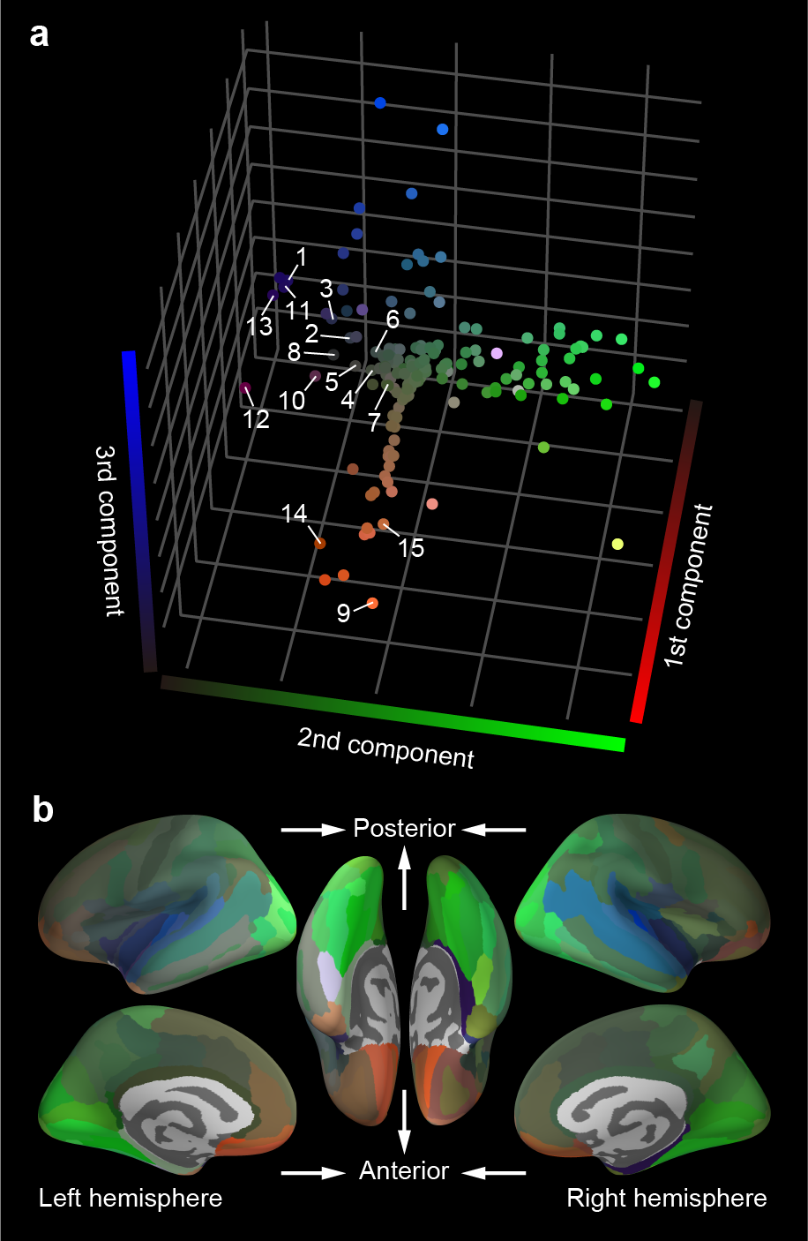

Supplementary Fig. 1 | Representational variability across brain regions visualized using the conventional dimension reduction method. a, Natural audiovisual representations in individual regions mapped onto a 3D representational space that was estimated using isomap⁶⁷, which is a conventional nonlinear dimension reduction method. Conventions are the same as those in Fig. 3a. b, Cortical mapping of the 3D representations of CRDMs using the same RGB colormap used in a. Similar to the UMAP method, three different groups of CRDM representations were identified in the 3D space: occipitotemporal visual region (green), superior temporal auditory region (blue), and prefrontal regions (orange). The differentiation was clearer in the UMAP space (Fig. 3).

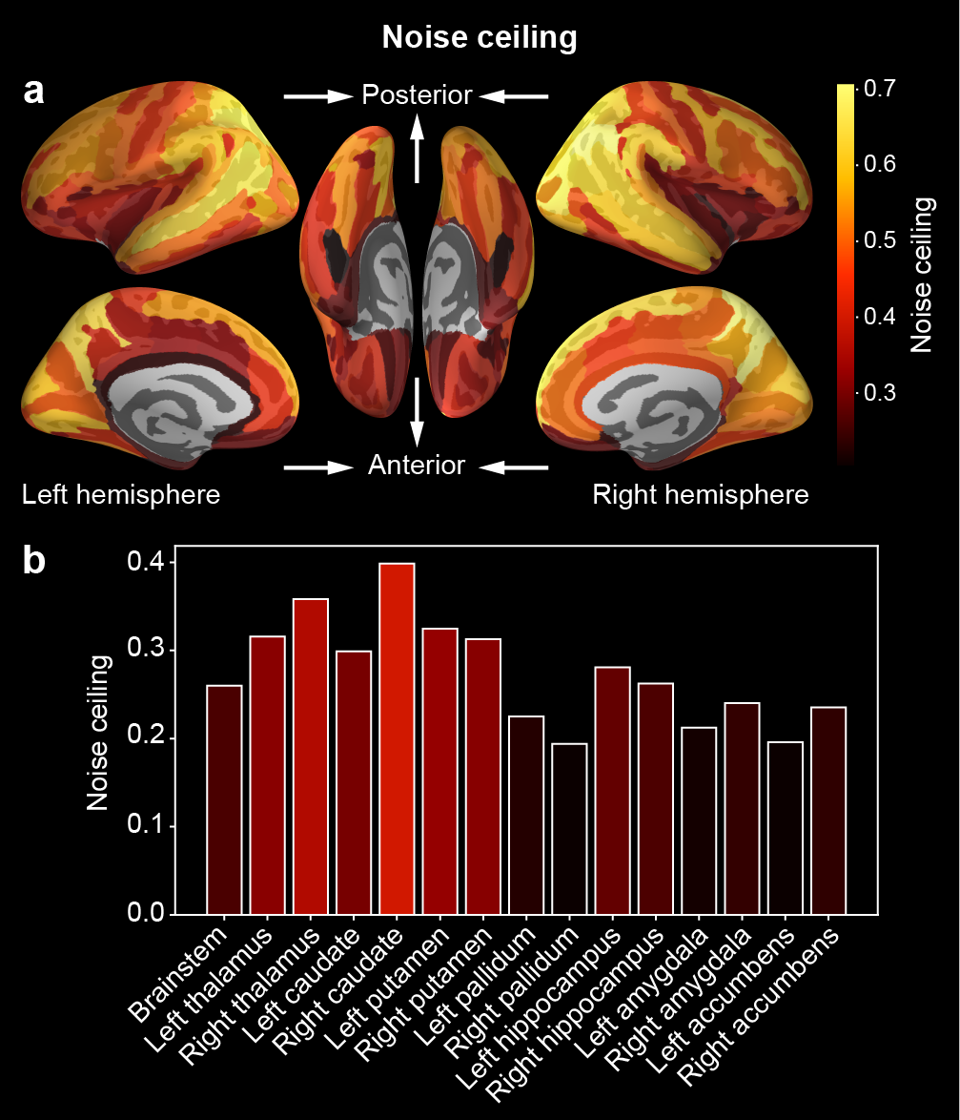

Supplementary Fig. 2 | Noise ceiling in each brain region. a, Cortical mapping of the noise ceiling. The noise ceiling that reflected the upper bound of CRDM similarity across individuals for each brain region was computed to correct twin-pair CRDM similarity to allow fair comparisons across regions (see Methods). The noise ceiling obtained for each clip was averaged over all clips and mapped onto the cortical surface. Brighter locations indicate regions with higher noise ceiling (correlation coefficient). b, Noise ceiling in subcortical regions. Each bar indicates the noise ceiling for each subcortical region. The colors of the bars are determined using the same colormap used in a. The variability of noise ceiling across cortical and subcortical regions was highly consistent with that of reproducibility for repetitive stimulations (Fig. 2; Pearson correlation, r = 0.942, P < 10⁻⁷⁷). This is not surprising because fMRI signals with less noise should produce higher representational reproducibility across both individuals and repeated stimulations. See also Supplementary Data 2.

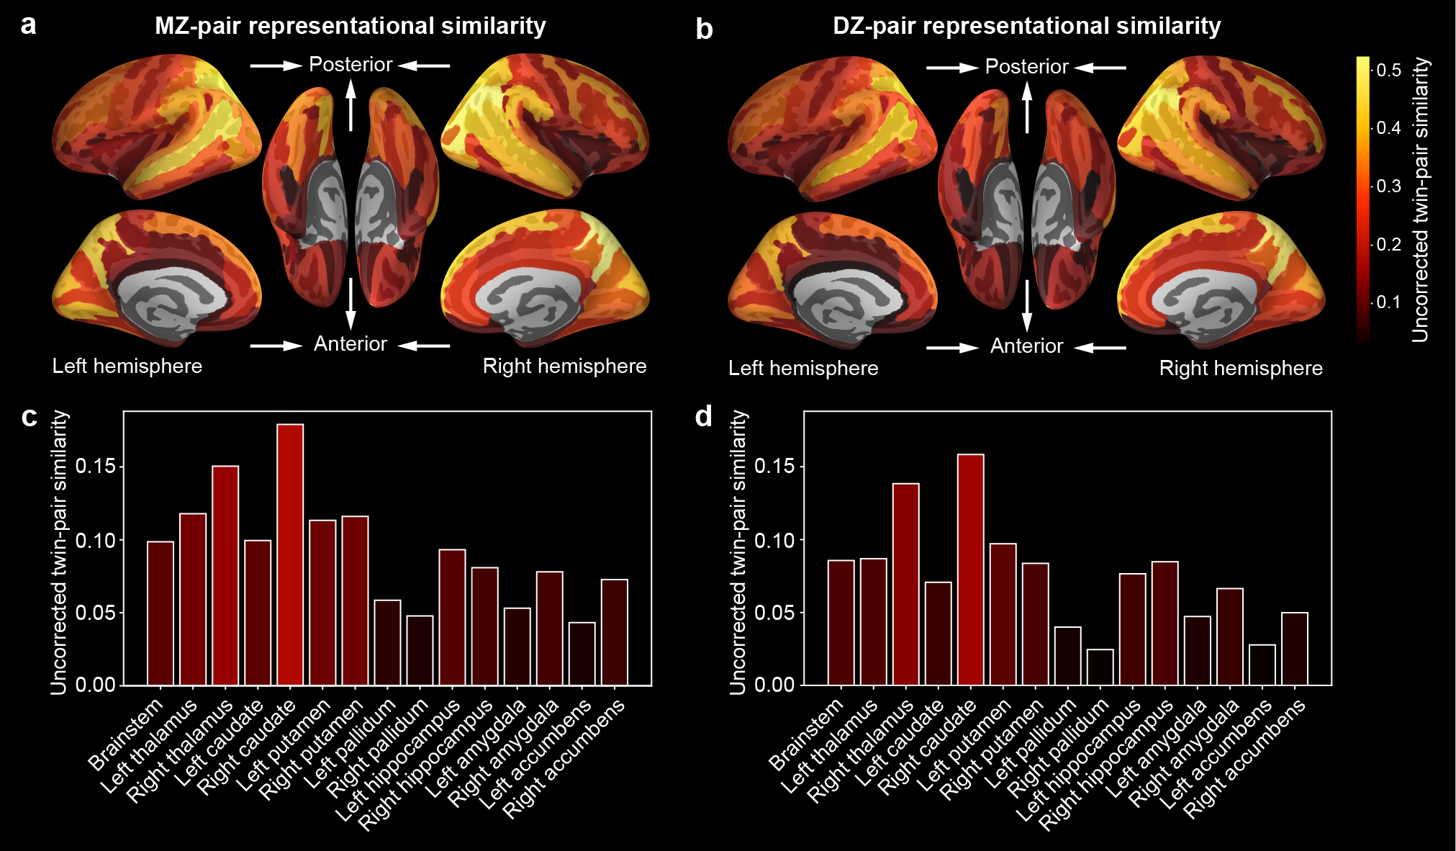

Supplementary Fig. 3 | Twin-pair representational similarity calculated without noise-ceiling correction. The uncorrected twin-pair CRDM similarity in each of cortical (a–b) and subcortical (c–d) region for MZ (a and c) and DZ (b and d) pairs. Conventions are the same as those in Fig. 4. See also Supplementary Data 4.

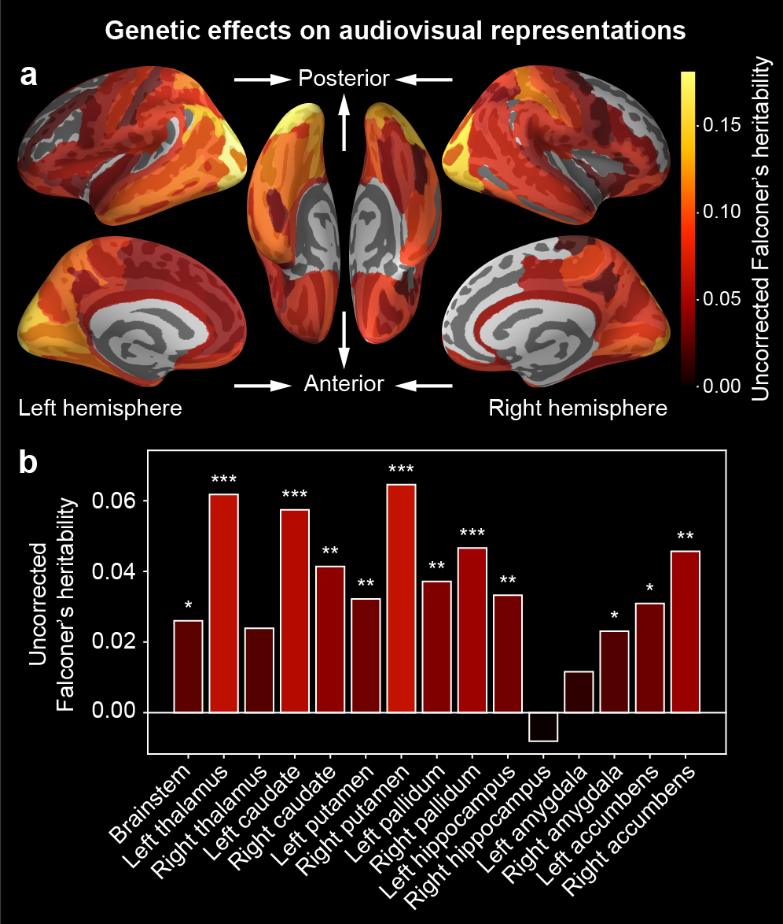

Supplementary Fig. 4 | Heritability calculated without noise-ceiling correction. In each of the cortical (a) and subcortical (b) regions, Falconer’s heritability was computed from twin-pair CRDM similarity obtained without noise-ceiling correction. Conventions are the same as those in Fig. 5. Note that the statistical significance of the genetic effects (i.e., the difference between MZ- and DZ-pair similarities) was identical, regardless of whether noise-ceiling correction was used or not. See also Supplementary Data 6.

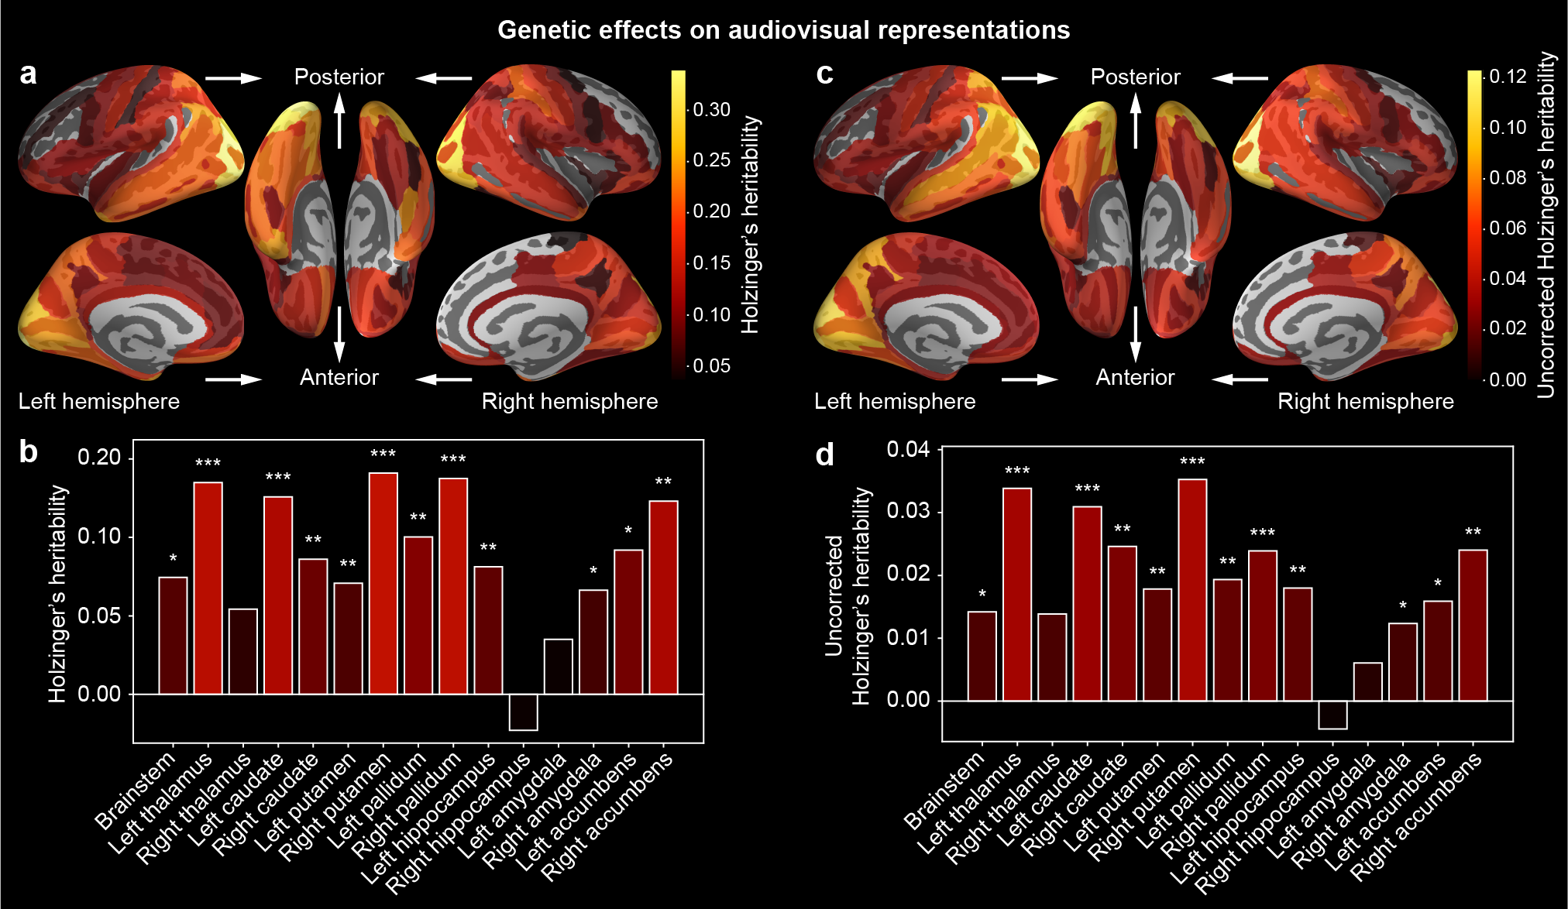

Supplementary Fig. 5 | Holzinger’s heritability. The same analysis as in Fig. 5 and Supplementary Fig. 4 but using Holzinger’s heritability as an alternative measure of genetic effects. The heritability calculated with (a–b) and without (c–d) noise-ceiling correction is separately shown in each cortical (a and c) and subcortical region (b and d). See also Supplementary Data 5 and 6.

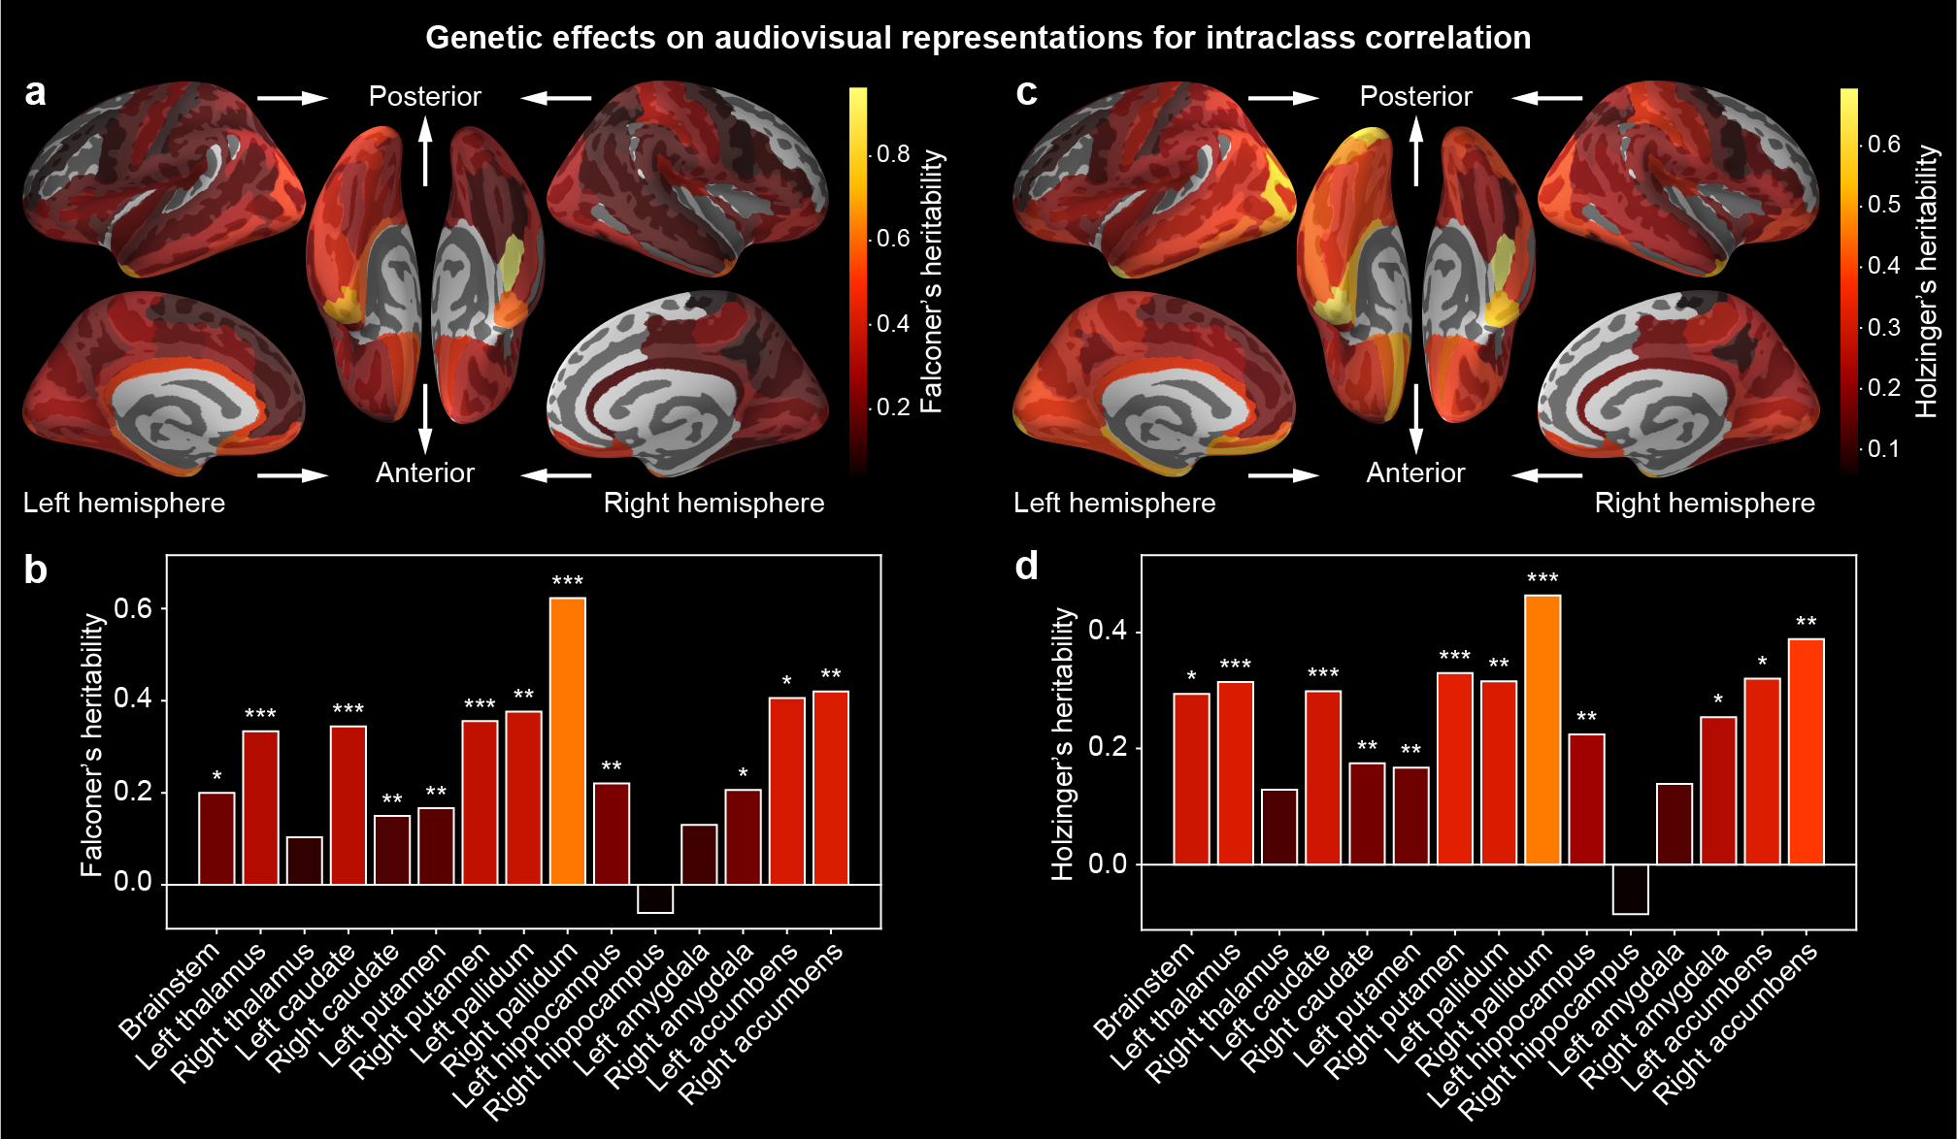

Supplementary Fig. 6 | Genetic effects on twin-pair representational similarity evaluated using intraclass correlation. The same analysis as in Fig. 5 and Supplementary Fig. 4 but using intraclass correlation as an alternative measure of twin-pair CRDM similarity. The Falconer’s (a–b) and Holzinger’s (c–d) heritability after noise-ceiling correction is shown in each cortical (a and c) and subcortical region (b and d). See also Supplementary Data 7.

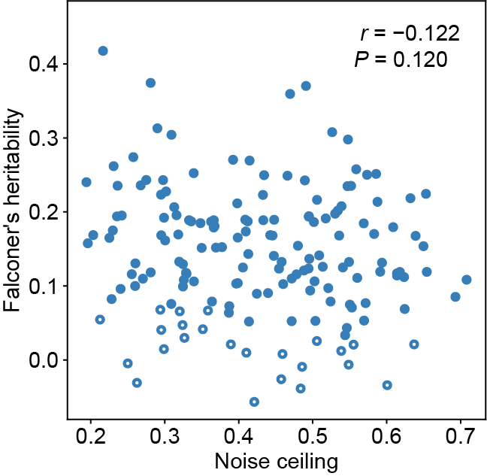

Supplementary Fig. 7 | No association between heritability and noise ceiling. The Pearson correlation between Falconer’s heritability and noise ceiling was examined to exclude the possibility that the high heritability in specific brain regions was caused solely by overestimation due to the correction with low noise ceiling in those regions. We found no significant correlation (r = −0.122, P = 0.120). Each dot represents a single brain region; filled and open dots denote regions with or without significant genetic effects of audiovisual representations (P < 0.05, FDR corrected), respectively.

Supplementary Table 1 | Number of movie clips belonging to each category
Categories | Number of clips
Movie trailer | 119
Animation movie trailer | 17
Short movie | 35
Animation short movie | 24
Natural scenery | 29
Slideshow | 12

