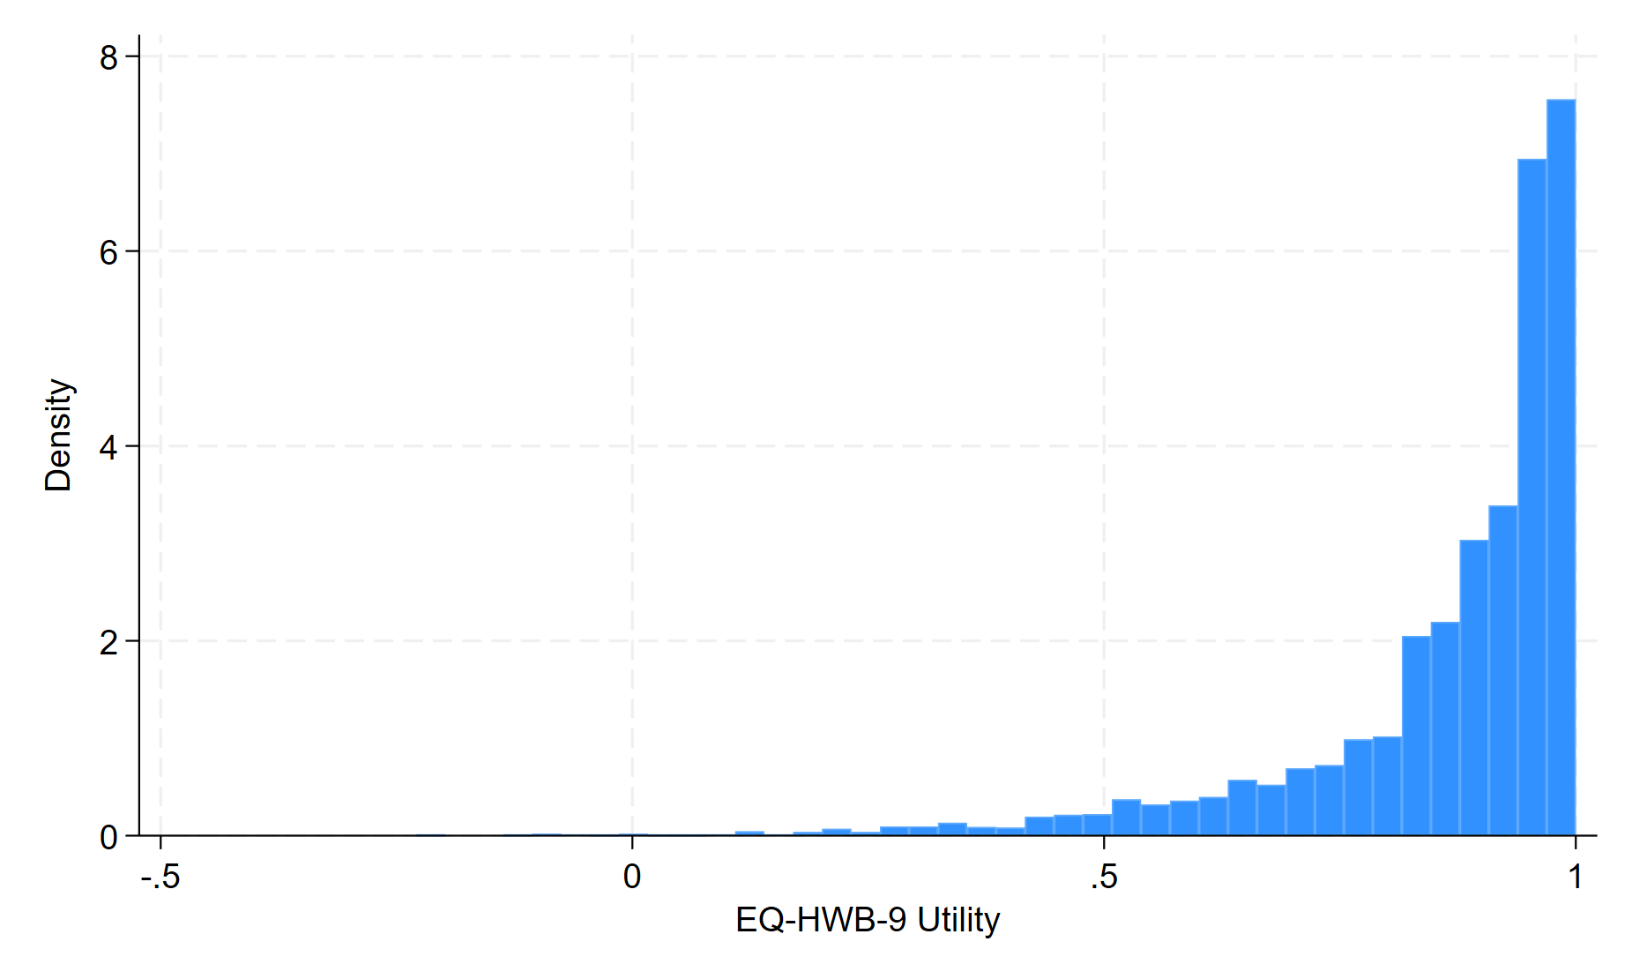
Figure S1. Distribution of EQ-HWB-9 utility scores.
Density histogram of EQ-HWB-9 utility scores in the study sample, illustrating the overall distribution and upper-bound clustering.

