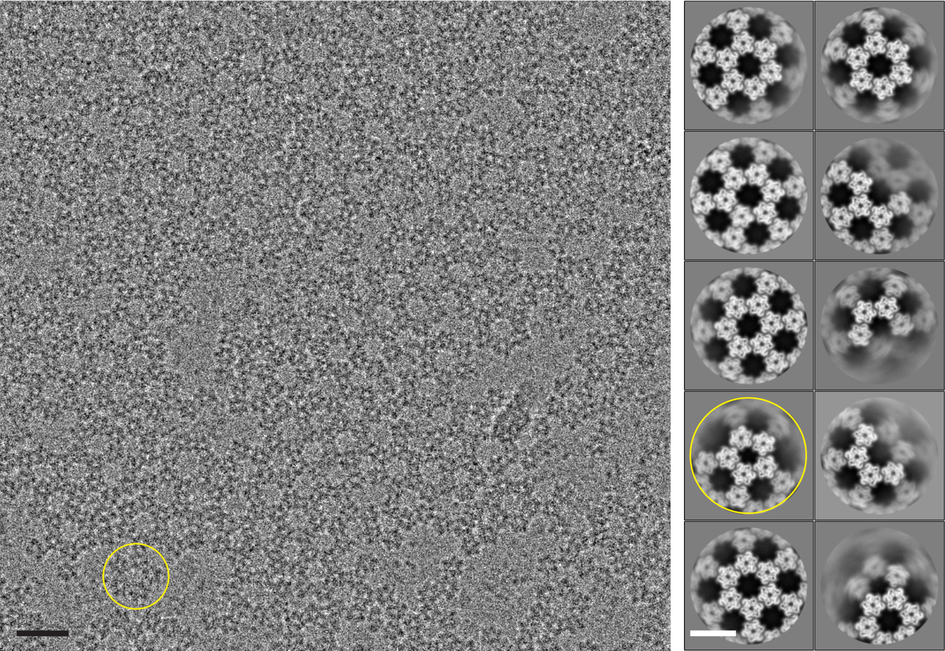

Supplementary Figure 1. Variations in the building blocks of the honeycomb lattice
Cryo-electron micrograph of purified D13 trimer vitrified on a holey grid without additional graphene oxide support film (left) and representative class averages of concentric rings of trimers (right). Spontaneous in situ formation of honeycomb-like lattice patches was observed at the air-water interface when prepared without graphene oxide film (Supplementary Video 1). Majority of concentric rings are composed of six trimers (sextet) whereas rings of five trimers (quintet) were also found (yellow circle). Scale bars, 20 nm and 10 nm in the micrograph and class averages, respectively.

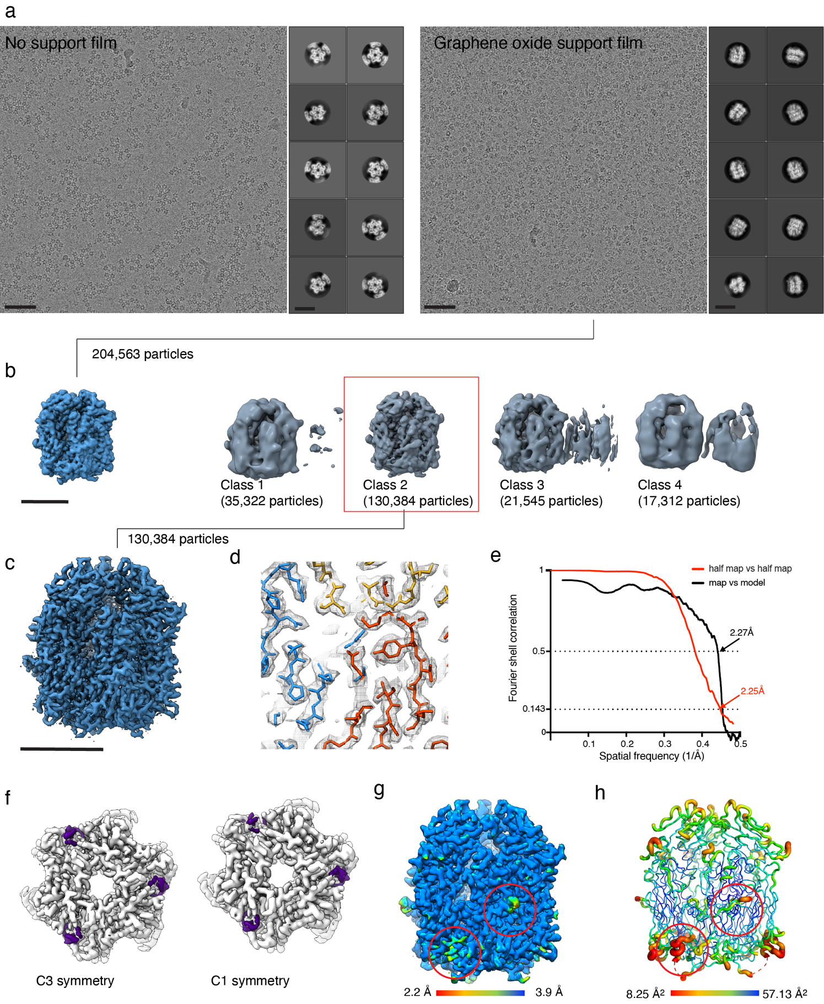

Supplementary Figure 2. D13 trimer cryo-EM image processing
a, A representative cryo-electron micrograph and 2D class averages (inset). b, 3D classification without symmetry imposition. Particles that belong to the best 3D class (Class 3) were selected for subsequent 3D refinement. c, Iso-electron potential surface contoured at 3.0σ of the final 3D reconstruction of the D13 trimer. d, Representative fitting of atomic model in the cryo-EM map displayed as iso-electron potential mesh surface contoured at 5.0σ above average. e, Fourier shell correlation between the half maps (red curve), and between the final map and model-generated density (black curve). f, D13 trimer structure refined using C3 symmetry and without symmetry imposition, viewed from the base of the trimer, along the symmetry axis. g, Local resolution estimation of C3 symmetry-imposed 3D reconstruction and h, variation of atomic B-factor assigned to each residue during model refinement in tube representation, viewed perpendicular to symmetry axis. Examination of the cryo-EM maps and the corresponding refined atomic models indicated relatively poor local resolution at the N-terminal loop and tail helix that participate in domain swapping between the monomers (aa1-14, yellow circle) and the loop that connects β-strands B and C of N-terminal jelly roll domain (aa 46-49, red circle), suggesting increased flexibility of this structural element. Unsharpened cryo-EM maps were used to maintain visibility of less resolved regions. The figure shows iso-electron potential surfaces contoured at 5.0σ above average potential. Scale bars, 50 nm in a, 5 nm in the inset of a, and 5 nm in b, c.

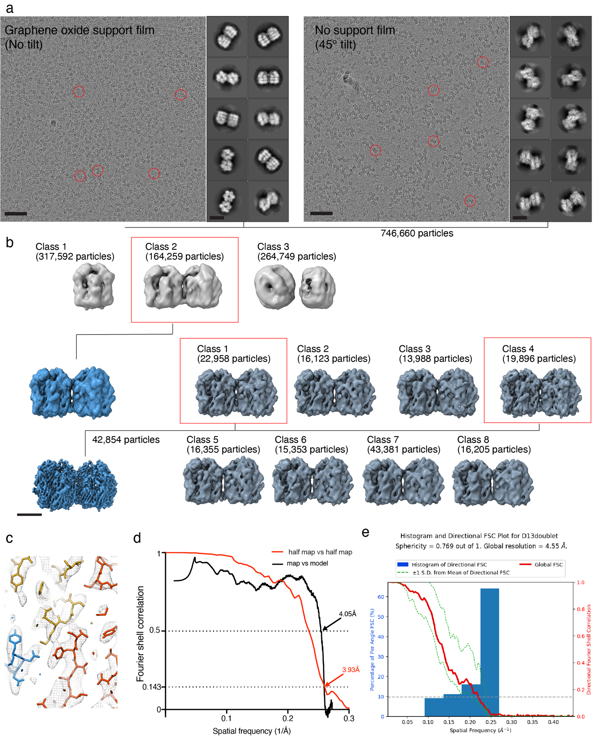

Supplementary Figure 3. Cryo-EM image processing of D13 trimer doublet
a, Representative cryo-electron micrographs and 2D class averages (right insets). A small sub-population of D13 trimer doublets were found in the micrographs of the trimer sample on graphene oxide film (left). Micrograph of the sample prepared without graphene oxide film were recorded while the microscope stage was tilted to 45° (right). In the absence of graphene support film, the particles were preferentially oriented and spontaneously assembled into multimers at the air-water interface. b, Image processing workflow. A 3D classification without symmetry imposition was performed. Then the particle images that belong in the best 3D class (blue box) were used for the 3D refinement, and further 3D classification without particle image alignment was performed. Final refined 3D reconstruction (contoured at 3.0σ) was generated from the images that belong in the 3D classes exhibiting clear structural details (red boxes). d, Examples of molecular fitting of the atomic model into the cryo-EM map. e, Fourier shell correlation between the half maps and between the map and model-generated density, indicating approximately 3.9 Å resolution. f, 3D Fourier shell correlation plot indicating anisotropic resolution of the reconstruction. Scale bars, 50 nm and 10 nm in upper and lower panels in a, respectively, and 5 nm in b.

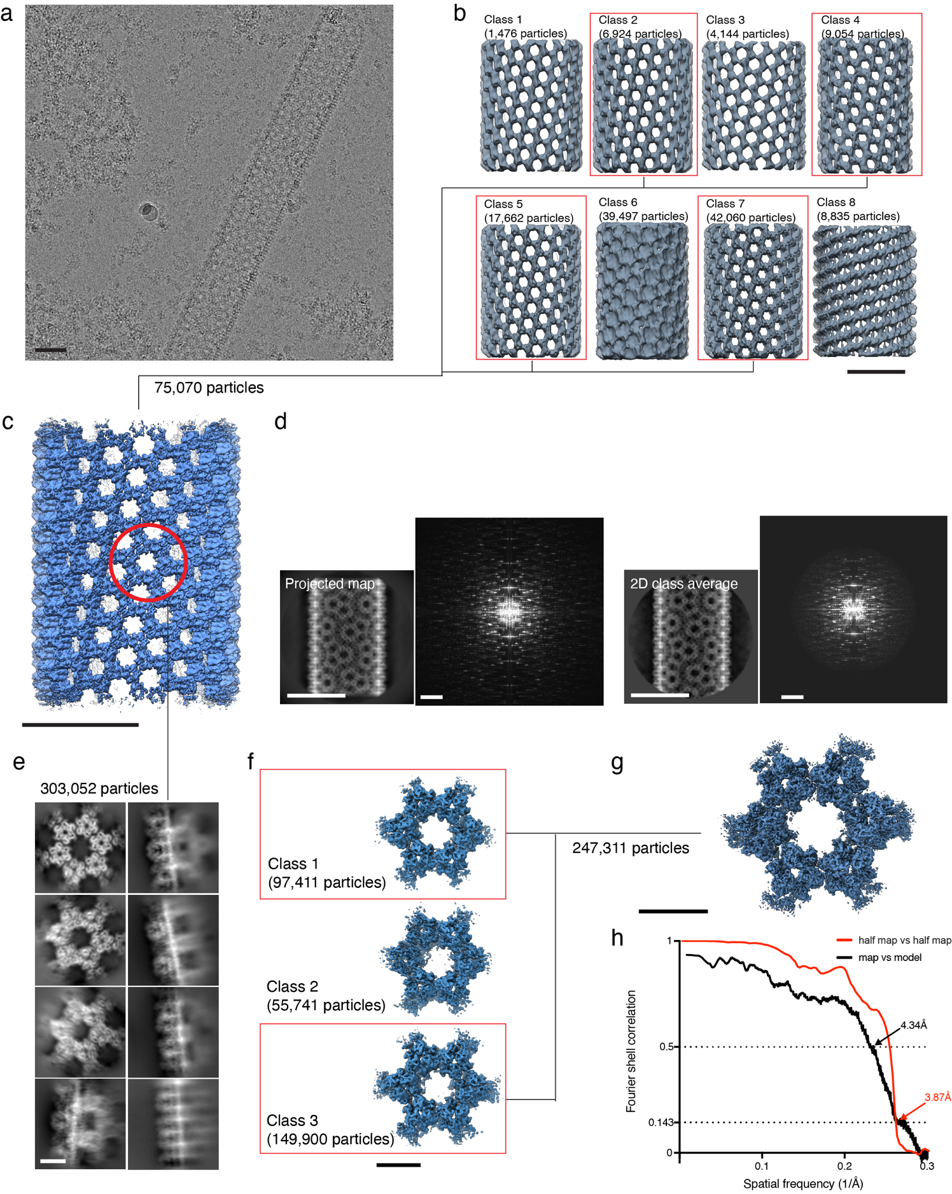

Supplementary Figure 4. Cryo-EM image processing of the D13 tubular assembly
a, Representative cryo-electron micrograph of the tubular D13 assembly in vitreous ice. b, 3D classes of the assemblies displaying varying diameters. Diameters of the tubes were 92 nm, 89 nm, 96 nm, 85 nm, 90 nm, 84 nm, 88 nm and 92 nm, in the order from class 1 to class 8. c, Final 3D reconstruction at 7.3 Å resolution (iso-surface contoured at 5.0σ), obtained from particle images that belong to good 3D classes (red boxes in b). e, Comparison between the projected 3D reconstruction and its power spectrum (left) and a class average and its power spectrum (right). f, Representative 2D class averages from the signal-subtracted sextet particle images. Target region within the helical tube reconstruction is shown in red circle in e. f, 3D classes of the sextet. g, Final 3D reconstruction and h, the FSC plot between the half maps, and between the map and model-generated density. Scale bars, 50 nm in a-d and 5 nm⁻¹ in the power spectrum in d, respectively, and 10 nm in e-g.

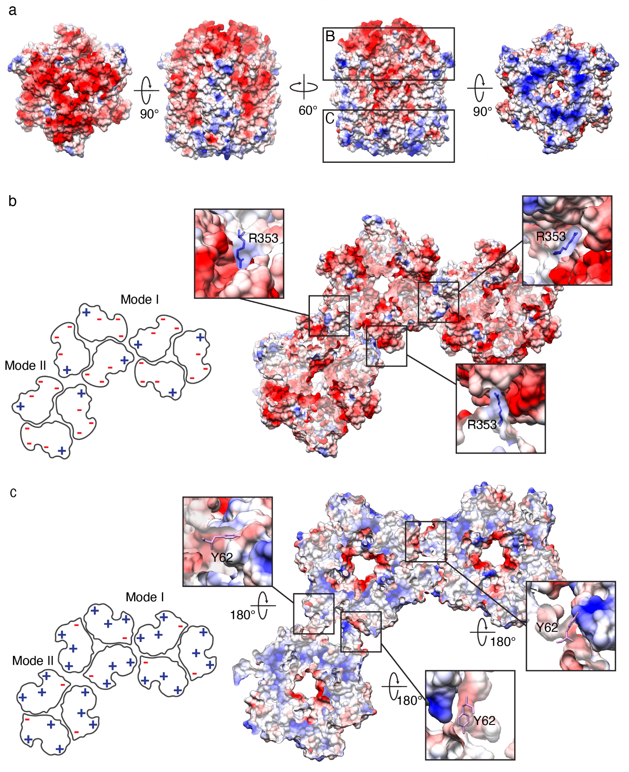

Supplementary Figure 5. D13 inter-trimer electrostatic interactions and critical residues
a, Electrostatic potential map of volume-rendered D13 trimer structure. Coulombic surface coloring in UCSF chimera was used. Overall, membrane-distant region is predominantly negatively charged, and the membrane-proximal lower part is positively charged. Charge distribution alternates along the circumference of the trimer, resulting in cogwheel-like inter-trimer interfaces between oppositely charged surfaces. b, Alternating surface charge distribution at the head-to-head interface. Positively charged regions along the protrusion of the C-terminal jelly roll and the head domain intermesh with the negatively charged grooves at the junction between the monomers. In both mode I and mode II arrangements, R353 extends out toward negatively charged counterparts at the interfaces. c, Alternating surface charge distribution at the base-to-base interface. Small patches of negatively charged region that include Y62 are in contact with their positively charged counterparts at the interfaces.

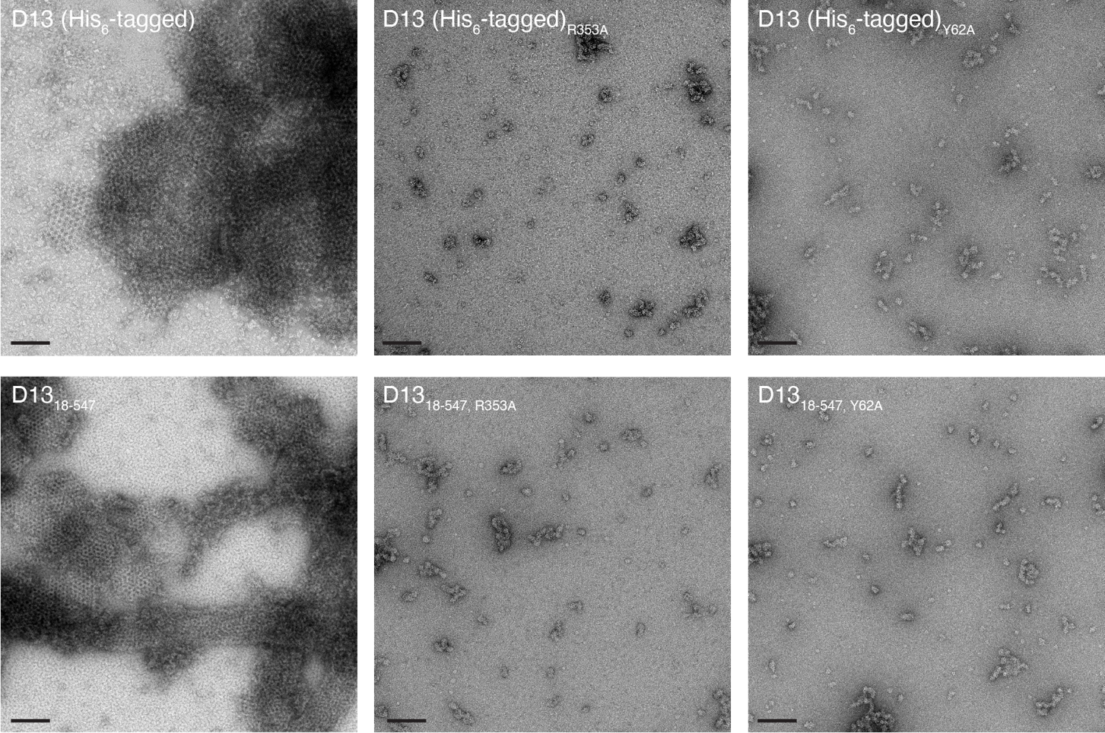

Supplementary Figure 6. The effect of mutations to critical residues involved in inter-trimer electrostatic interactions
Effect of mutations to critical residues on the D13 self-assembly on His₆-tagged wtD13 and N-terminal deletion mutant D13₁₈₋₅₄₇. R353 and Y62 residues were selected as targets for point mutations to alanine as they were deemed to be most critical in the stabilization of inter-trimer interactions in both mode I and mode II arrangements. Based on our cryo-EM structures, R353 either forms a salt bridge with D325 of the neighboring trimer in the mode I arrangement, or it is engaged in electrostatic interactions with nearby charged and polar residues in the mode II arrangement. Y62 forms cation-π interactions with R498 and R446 in mode I and mode II arrangements, respectively. Without mutation, D13 assembles into spherical IV-like particles or tubes under low salt buffer condition (left panel and Supplementary Video 1 and Supplementary Fig. 4a). Under the same low salt condition, none of the mutants forms large assembly products. Instead, they form small random aggregates (middle and right panels). Scale bars, 100 nm.

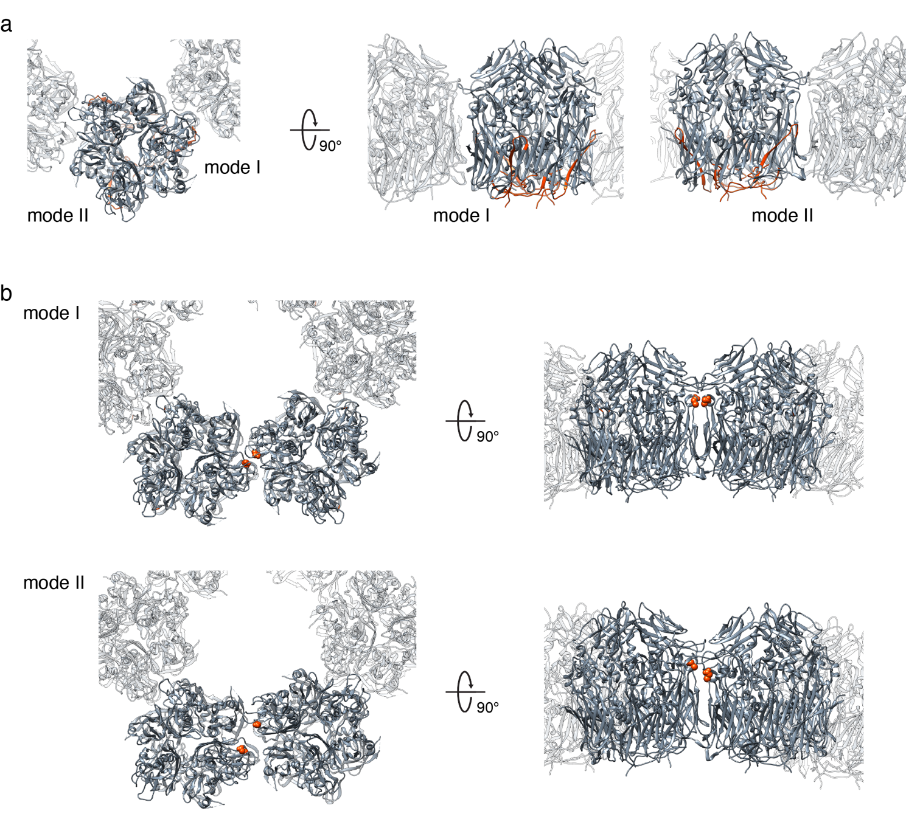
Supplementary Figure 7. Inter-trimer interactions and previously reported residues for which mutations lead to rifampicin resistance or aberrant scaffold assembly
a, Ribbon illustration of inter-trimer interfaces of mode I and mode II arrangements. Rifampicin binding site and the residues in which mutation confers rifampicin resistance are shown in red. In both inter-trimer arrangements, these residues are distal from inter-trimer contacts. b, Mode I and II inter-trimer arrangements with D513 position highlighted as red sphere. Mutation of this residue to glycine leads to an aberrant phenotype of the planar honeycomb-like assembly in vivo and the abrogation of scaffold assembly. The residues are proximal in mode I arrangement at the inter-timer interface, along the local 2-fold symmetry axis (upper panel). However, the interaction between these residues was not resolved clearly in the cryo-EM map. These residues are too far apart for electrostatic interaction in the mode II arrangement (lower panel).
Supplementary Table 1. Cryo-EM data collection, refinement and validation statistics.

 | wtD13 trimer  (EMD-31949 / PDB 7VFD) | His₆-tagged D13 trimer  (EMD-31950 / PDB 7VFE) | D13₁₈₋₅₄₇ trimer  (EMD-31951 / PDB 7VFF) | D13 trimer doublet  (EMD-31952 / PDB 7VFG) | D13 trimer tubular assembly  (EMD-31953) | D13 trimer sextet  (EMD-31954 / PDB 7VFH)
Data collection and processing
Microscope | Titan Krios | Titan Krios | Talos Arctica | Talos Arctica | Titan Krios | Titan Krios
Detector | Falcon 3EC | Falcon 3EC | Falcon 3EC | Falcon 3EC | K2 Summit GIF | K2 Summit GIF
Magnification | 155,000 | 155,000 | 92,000 | 92,000 | 105,000 | 105,000
Voltage (kV) | 300 | 300 | 200 | 200 | 300 | 300
Electron exposure (e⁻/ Å²) | 50 | 50 | 50 | 50 | 50 | 50
Defocus range (μm) | 0.5 – 1.5 | 0.5 – 1.5 | 0.6 – 1.2 | 0.5 – 5.0 | 0.5 – 2.5 | 0.5 – 2.5
Pixel size (Å) | 0.518 | 0.518 | 1.12 | 1.12 | 1.39 | 1.39
Processing software | Relion 3.1.0 | Relion 3.1.0 | Relion 3.1.0 | Relion 3.1.0 | Relion 3.1.0 | Relion 3.1.0
Symmetry imposed | C1, C3 | C3 | C3 | C2 | Helical  (76.98 twist / 33.86 rise) | C1
Initial particle images (no.) | 668,437 | 284,340 | 743,834 | 835,797 | 194,960 | 303,052
Final particle images (no.) | 130,384 | 173,354 | 156,813 | 164,259 | 75,070 | 247,311
Map resolution (Å)  FSC threshold | 2.63 (C1),  2.25 (C3)*  0.143 | 2.63  0.143 | 4.10  0.143 | 3.93  0.143 | 7.33  0.143 | 3.87  0.143
Model refinement
Processing software | PHENIX 1.18 | PHENIX 1.18 | PHENIX 1.18 | PHENIX 1.18 | N/A | PHENIX 1.18
Initial model used (PDB code) | 6BEI | 6BEI | 6BEI | 6BEI |  | 6BEI
Model resolution (Å)  FSC threshold | 2.27  0.5 | 2.64  0.5 | 4.06  0.5 | 4.05  0.5 |  | 4.34  0.5
Map sharpening B factor (Å²) | -14.98 | -38.98 | -216.59 | -133.31 |  | -8.42
Model composition  Non-hydrogen atoms  Protein residues | 13245  1623 | 12630  1587 | 12579  1581 | 25044  3162 |  | 75471  9486
B factors (Å²) | 21.39 | 27.88 | 31.81 | 70.96 |  | 27.25
R.m.s. deviations  Bond length (Å)  Bond angles (°) | 0.004  0.523 | 0.008  0.575 | 0.007  0.717 | 0.007  0.782 |  | 0.003  0.610
Validation  MolProbability score  Clashscore  Poor rotamers (%) | 1.41  3.69  0.60 | 1.71  2.86  3.08 | 1.26  2.36  0.41 | 1.40  3.80  0.45 |  | 1.27  2.31  0.00
Ramachandran plot  Favored (%)  Allowed (%)  Disallowed (%) | 96.25  3.75  0.00 | 96.19  3.81  0.00 | 96.37  3.63  0.00 | 96.42  3.58  0.00 |  | 96.19  3.81  0.00
*Model refinement for wtD13 trimer was only performed using C3-symmetry-imposed map.

Supplementary Information 1. Primer sequences

Name | Sequences 5’-
D13₁₈₋₅₃₇Fw | AATGGCGCCCGGTCTAATGTCTTCGCAGTCGATAGTC
D13₁₈₋₅₃₇Rv | CCCAAGCTTTTAGTTATTATCTCCCATAATCTTGG
D13_{R353A}Fw | GTTTGGAACAGCGAAAAATTCTTTTATATATAACATTTCTAAAAAG
D13_{R353A}Rv | ATTAGCAGATTAGTATGAAGATAAAC
D13_{Y62A}Fw | TAGGGATCAGGCGATTACTGCGC
D13_{Y62A}Rv | ATTTCGAAGCTAGCGATAG

Supplementary Video 1. Electron tomography of immature poxvirus-like particles in amorphous ice
Tomographic reconstruction of immature Vaccinia-virus like particles imaged in vitreous ice (cryo-ET). The sample was an assembly product of His₆-tagged D13 protein in sample buffer containing 50 mM Tris-HCl (pH 8.0) and 150 mM NaCl. The particles were characterized by spherical morphology with continuous curvature and honeycomb-like pattern resembling the authentic viral scaffold of immature Vaccinia virus. The video shows a planar section (x,y direction) moving through the volume in the z direction. Semi-regular patches and aggregates near the level of gold fiducial markers (black spheres) at z planes above or below the virus-like particles indicate that unassembled D13 can spontaneously assemble at the air-water interface of the liquid sample before freezing.

